**Report on Fatal Police Shootings in the United States**

**Prepared by: *Nipun Juneja 23csu215***

**Dataset: fatal-police-shootings-data.csv**

**Tools: Python (Pandas, Matplotlib) in Jupyter Notebook**

**1. Introduction**

This report presents a detailed analysis of fatal police shootings across the United States. It uses public data to assess patterns based on state, year, race, mental health, gender, and the use of body cameras.

**2. Data Overview**

Initial exploration of the dataset was performed using Pandas.

import pandas as pd

import matplotlib.pyplot as plt

df = pd.read_csv("fatal-police-shootings-data.csv")

print(df.head())

print(df.info())

**3. State-wise Distribution of Fatal Police Shootings**

To identify hotspots, we calculated the number of incidents per state and visualized the top 15.

state_counts = df['state'].value_counts()

top_states = state_counts.head(15)

*Top 15 States with Highest Fatal Police Shootings*

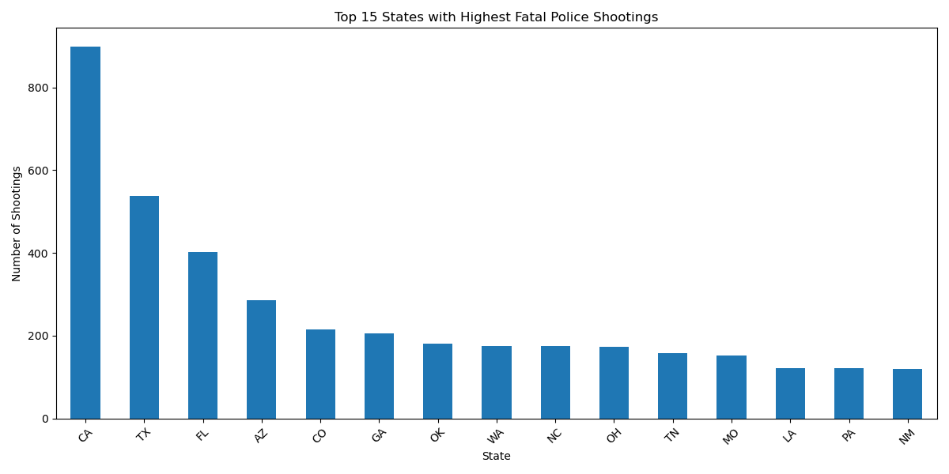

**4. Unarmed Individuals Analysis**

**a. Total Number of Unarmed Victims**

unarmed_count = df[df['armed'] == 'unarmed'].shape[0]

**b. Racial and Gender Distribution**

unarmed_df = df[df['armed'] == 'unarmed']

race_counts_unarmed = unarmed_df['race'].value_counts()

gender_counts_unarmed = unarmed_df['gender'].value_counts()

*Racial Distribution of Unarmed Individuals Killed*

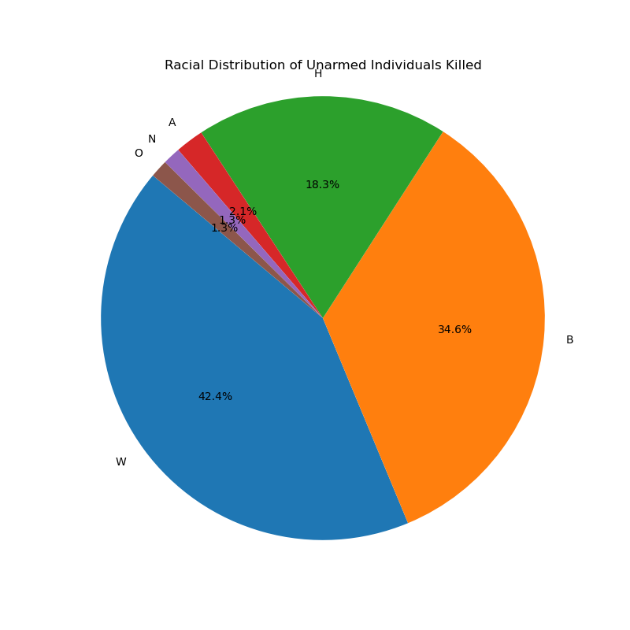

Even though we can see that the majority of people killed are White, but that does not tell us the right picture, we have to look at the distribution in overall percentage. Whites make up 60.81%, Hispanic 18.48%, Black 12.16%, Asians 5.24%, Native 0.65%. But this does not align with the ratio of people killed by the police. This implies Blacks and Hispanics are disproportionately killed as compared to Asians and Whites.

*Gender Distribution of Unarmed Individuals Killed*

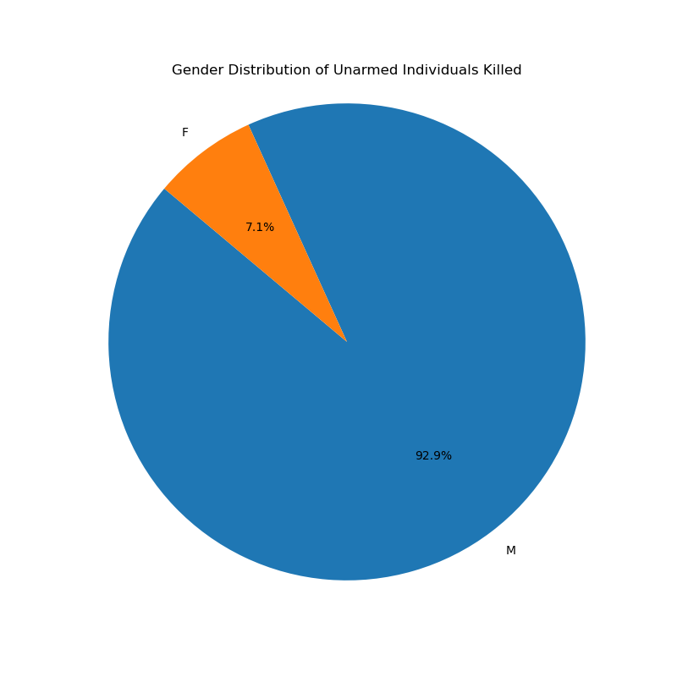

**5. Year-wise Trend of Fatal Police Shootings**

The dataset was analyzed over time to understand how incidents changed annually.

df['date'] = pd.to_datetime(df['date'], format='mixed')

df['year'] = df['date'].dt.year

year_counts = df['year'].value_counts().sort_index()

*Year-wise Trend of Fatal Police Shootings*

**6. Shootings Without Body Camera Evidence**

The presence of a body camera during incidents is critical for accountability. This section compares the number of shootings that occurred without body camera footage over the years.

*Year-wise Killings in Absence of Body Camera*

Key Insight:  
Despite increasing awareness and calls for transparency, a significant proportion of killings still occurred in the absence of body camera footage from 2015 to 2020. A sharp drop in 2021 may indicate changes in policy, reporting, or data coverage.

**7. Total vs. No-Body-Cam Shootings (Comparison)**

To provide better context, we compare overall shootings and those lacking body camera footage.

*Total Shootings vs. Shootings without Body Camera, Year by Year*

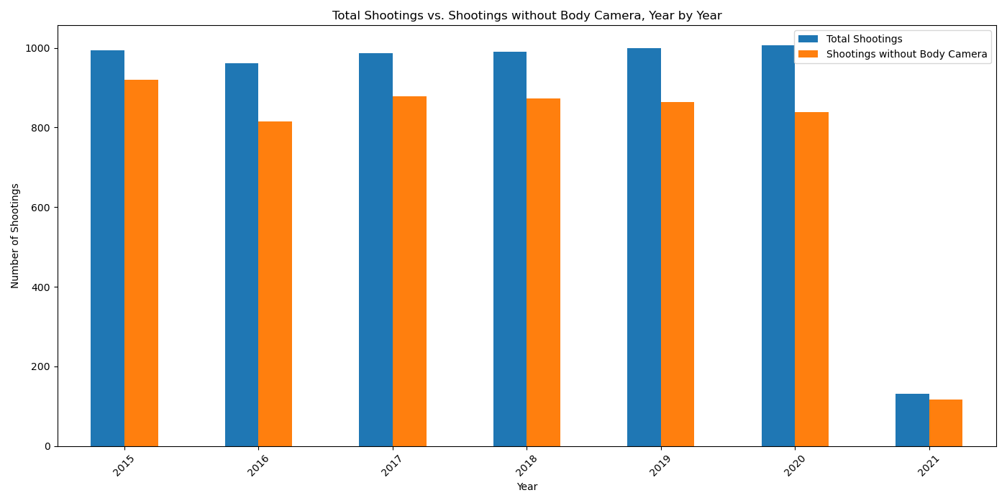

Key Insight:  
On average, 80–90% of all police shootings had no body camera footage available. There is an urgent need to mandate body cam usage in all law enforcement operations.

**8. Mental Illness & Racial Disparities**

This section analyzes the number of mentally ill individuals fatally shot, categorized by race and age group.

*Distribution of Mentally Ill Individuals Killed, by Age and Race*

Key Observations:

* White individuals made up the largest group across all age brackets.
* The 31–40 age group is the most vulnerable among the mentally ill.
* Black and Hispanic individuals are also significantly represented, highlighting systemic issues.

**9. Conclusion**

* Fatal shootings are unevenly distributed across states.
* A notable portion of victims were unarmed.
* Racial and gender disparities exist, particularly among unarmed and mentally ill individuals.
* Use of body cameras remains inconsistent.
* Targeted reforms in accountability, mental health interventions, and equipment policy (e.g., body cams) are necessary.