**CAT-CERT 2022 Web Study #2**

**202221162 김민재**

**목차**

1. 4.6 스터디 실습
2. 회원가입 꾸미기
3. 조사과제
4. 계산기
5. 디지털 시계
6. **4.6 실습**

**#1**

|  |
| --- |
| **<html>**  **<head>**  **<title> cert html 2 실습#1 22김민재 </title>**  **<style>**  **td {**  **text-align: center;**  **}**  **div {**  **border: 4px solid;**  **border-color: 8EFBFD;**  **border-radius: 50px;**  **}**  **</style>**  **</head>**  **<body>**  **<table><tr><td><div style="border: 3px solid blue; border-radius: 20px">**  **<table border="0" width="500px" height="100px" name="test1">**  **<tr>**  **<td colspan="3">**  **<div style="background-color: magenta; font-weight: bold; color: white" width="500px"> 2022 CAT-Security Study mentor </div>**  **</td>**  **</tr>**  **<tr>**  **<td width="45px">**  **<div style="background-color: F3D84B"> 이름 </div>**  **</td>**  **<td width="110px">**  **<div style="background-color: F3D84B"> 학과 </div>**  **</td>**  **<td width="30px">**  **<div style="background-color: F3D84B"> 성별 </div>**  **</td>**  **</tr>**  **<tr>**  **<td>**  **<div> 정지용 </div>**  **</td>**  **<td>**  **<div> 컴퓨터정보공학부 </div>**  **</td>**  **<td>**  **<div> 남 </div>**  **</td>**  **</tr>**  **<tr>**  **<td>**  **<div> 류형호 </div>**  **</td>**  **<td>**  **<div> 컴퓨터정보공학부 </div>**  **</td>**  **<td>**  **<div> 남 </div>**  **</td>**  **</tr>**  **<tr>**  **<td>**  **<div> 박혜윤 </div>**  **</td>**  **<td>**  **<div> 컴퓨터정보공학부 </div>**  **</td>**  **<td>**  **<div> 여 </div>**  **</td>**  **</tr>**  **</table>**  **</div></td></tr></table>**  **</body>**  **</html>** |

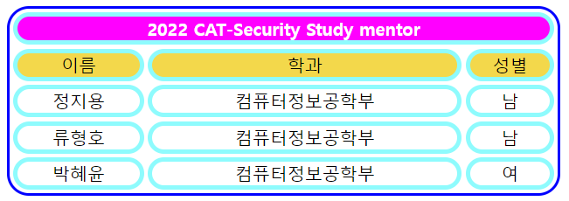

**#2**

|  |
| --- |
| **<html>**  **<head>**  **<title> cert html 2 실습#2 22김민재 </title>**  **</head>**  **</html>**  **<script>**  **var [a, b, c] = prompt("숫자 입력").split(" ");**  **alert("\n1번쨰 입력 값 : " + a + "\n2번쨰 입력 값 : " + b + "\n3번쨰 입력 값 : " + c);**  **document.write("입력한 수 : " + a + " " + b + " " + c);**    **a = parseInt(a), b = parseInt(b), c = parseInt(c);**  **if (a > b) {[a,b] = [b,a];}**  **if (b > c) {[b,c] = [c,b];}**    **document.write("<br>가장큰수 : " + c);**  **</script>** |

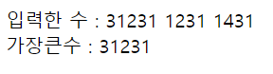

**#3**

|  |
| --- |
| **<html>**  **<head>**  **<title> cert html 2 실습#3 22김민재 </title>**  **<style>**  **div {**  **border: 2px dashed red;**  **}**  **</style>**  **</head>**  **<body>**  **<table><tr><td><div style="border: 4px solid blue"><table><tr>**  **<td><div></div></td>**  **<td><div></div></td>**  **<td><div></div></td>**  **<td><div></div></td>**  **<td><div></div></td>**  **<td><div></div></td>**  **<td><div></div></td>**  **<td><div></div></td>**  **<td><div></div></td>**  **</tr></table></div></td></tr></table>**  **</body>**  **</html>**  **<script>**  **var num = prompt("몇단??");**    **for (var i = 1; i < 10; i++) {**  **document.getElementsByTagName("div")[i].innerHTML = num + "X" + i + "=" + num * i;**  **}**  **</script>** |



**#4**

|  |
| --- |
| **<html>**  **<head>**  **<title> cert html 2 실습#4 22김민재 </title>**  **</head>**  **<body style="background-color: blue">**  **<table border="0" align="center" width="300px" height="100px" name="rgb">**  **<tr>**  **<td style="background-color: red" onmouseover="color('red')"></td>**  **<td style="background-color: blue" onmouseover="color('blue')"></td>**  **<td style="background-color: green" onmouseover="color('green')"></td>**  **</tr>**  **</table>**    **<script>**  **function color(rgb) {**  **document.body.style.backgroundColor = rgb;**  **}**  **</script>**  **</body>**  **</html>** |

1. **회원가입 꾸미기**

|  |
| --- |
| **<html>**  **<head>**  **<meta method="utf-8">**  **<title>LOVCAT - sign up</title>**  **<style>**  **@font-face {**  **src: url("./훈하얀고양이.ttf");**  **font-family: "cat";**  **}**  **\* {**  **font-family: "cat";**  **color: black;**  **font-size: 20px;**  **}**  **body {**  **background-image: url("background_0.png");**  **}**    **#table {**  **box-shadow: 0 0 15px black;**  **border-radius: 10px;**  **border: 5px solid #555555;**  **background-color: #FFFFFF;**  **width: 460px;**  **height: 460px;**  **margin: 110px 0 150px 0;**  **}**  **#table td {**  **padding: 15px;**  **position: relative;**  **}**    **input {**  **width: 95%;**  **margin: 8px 0;**  **}**  **input[type=text], input[type=password] {**  **padding: 12px 20px;**  **display: inline-block;**  **border: 1px solid #ccc;**  **box-sizing: border-box;**  **border-radius: 4px;**  **}**  **input[type=submit] {**  **background-color: #000000;**  **border: 4px solid #000000;**  **color: white;**  **padding: 14px 20px;**  **cursor: pointer;**  **height: 60px;**  **}**  **input[type=submit]:focus {**  **border: 4px solid #999999;**  **}**  **input[type=submit]:hover {**  **background-color: #555555;**  **border: 4px solid #555555;**  **}**  **input[type=submit]:active {**  **background-color: #000000;**  **border: 4px solid #FFFFFF;**  **font-size: 17px;**  **}**    **#catonboard {**  **position: absolute;**  **height: 100px;**  **width: 100px;**  **left: 140px;**  **bottom: 441.5px;**  **}**  **</style>**  **</head>**  **<body><center>**  **<form method="post" action="">**  **<table id="table">**  **<tr><td>**  **<img id="catonboard" src="catonboard.png">**  **<center><h1>Sign up</h1></center>**  **<label for="nickname">NICKNAME</label><center>**  **<input type="text" id="nickname" name="nickname" placeholder="Your nickname.." autocomplete="off" autofocus>**    **</center><label for="id">ID</label><center>**  **<input type="text" id="id" name="id" placeholder="Your ID.." autocomplete="off">**    **</center><label for="password">PASSWORD</label><center>**  **<input type="password" id="password" name="password" placeholder="Your password..">**    **</center><label for="cpassword">CONFIRM PASSWORD</label><center>**  **<input type="password" id="cpassword" name="cpassword" placeholder="Confirm your password..">**    **<input type="submit" value="Submit">**  **</center></td></tr>**  **</table>**  **</form>**  **</center></body>**  **</html>** |

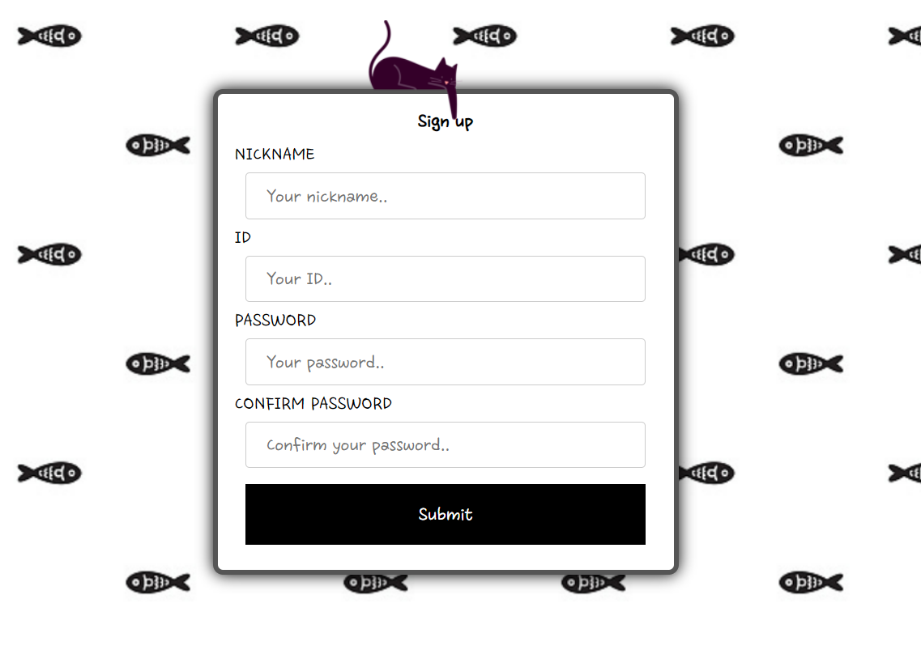

1. **조사 과제**

**#1 Javascript 내장 함수**

**- document.write()**

str을 출력한다.

**- parseFloat()**

문자열을 파싱하여 부동 소수점 수로 반환한다.

**- parseInt()**

문자열을 파싱하여 정수로 반환합니다.

**- Number()**

전달받은 객체의 값을 숫자로 반환합니다.

**- String()**

전달받은 객체의 값을 문자열로 반환합니다.

**- isFinite()**

전달된 값이 유한한 수인지를 검사하여 그 결과를 반환합니다.

**- isNaN()**

전달된 값이 NaN인지를 검사하여 그 결과를 반환합니다.

- **setInterval()**

주기적으로 인자를 실행하는 함수.

**- clearInterval()**

현재 진행되고 있는 함수의 진행을 **멈춘**다.

**- Date()**

시간의 특정 지점을 나타내는 Date 객체를 플랫폼에 종속되지 않는 형태로 생성한다.

**#2 Server-Side & Client-Side**

- **Client-Side**

클라이언트(사용자) 측에서 처리하는 것. 사용자가 입력한 것을 받아 HTML로 만들어 크롬 등의 어플리케이션에 해석하여 표시한다. ex) JavaScript

**- Server-Side**

서버(제공자) 측에서 즉시 처리하는 것. 클라이언트로 보낼 웹 페이지(HTML, JavaScript 등)를 만들며, 중요한 작업들(DB 등)을 수행한다.

1. **계산기**

|  |
| --- |
| **<html>**  **<head>**  **<title> cert html 2 계산기 22김민재 </title>**  **<style>**  **\* {**  **position: relative;**  **z-index: 1;**  **}**  **#num {**  **font-size: 50;**  **font-weight: 700;**  **}**  **#formula {**  **text-align: right;**  **vertical-align: bottom;**  **color: gray;**  **}**  **#num {**  **text-align: right;**  **vertical-align: top;**  **}**  **tr:hover {z-index: 0;}**  **td.gray:hover, td.white:hover, td#cal:hover {**  **background-color: E1E1E1;**  **border: 2px solid #C1C1C1;**  **box-shadow: 0px 0px 50px 5px gray;**  **z-index: 0;**  **}**  **td.gray:active, td.white:active {**  **background-color: C6C6C6;**  **border: 2px solid #B3B3B3;**  **z-index: 0;**  **}**  **td#cal:hover {**  **background-color: 489CDE;**  **border: 2px solid #3A7EB2;**  **}**  **td#cal:active {**  **background-color: 0078D7;**  **border: 2px solid #0070C8;**  **}**  **td {**  **border: 0px;**  **text-align: center;**  **width: 80px;**  **}**  **.gray {**  **background-color: F0F0F0;**  **border: 2px solid #F0F0F0;**  **}**  **.white {**  **background-color: FFFFFF;**  **border: 2px solid #FFFFFF;**  **font-weight: 700;**  **}**  **#cal {**  **background-color: 8ABAE0;**  **}**  **</style>**  **</head>**  **<body>**  **<table style="z-index: 0; background-color: E6E6E6; box-shadow: 0px 0px 10px 1px gray" border="1" width="320px" height="517px" name="calc">**  **<tr>**  **<td style="text-align: left" colspan="4" height="17px"><h5>계산기<h5></td>**  **</tr>**  **<tr>**  **<td id="formula" colspan="4" height="75px"></td>**  **</tr>**  **<tr>**  **<td id="num" colspan="4" height="125px">0</td>**  **</tr>**  **<tr>**  **<td class="gray">CE</td> <td class="gray">C</td> <td class="gray">&lArr;</td> <td id="cal">=</td>**  **</tr>**  **<tr>**  **<td class="white">7</td> <td class="white">8</td> <td class="white">9</td> <td class="gray"> / </td>**  **</tr>**  **<tr>**  **<td class="white">4</td> <td class="white">5</td> <td class="white">6</td> <td class="gray"> * </td>**  **</tr>**  **<tr>**  **<td class="white">1</td> <td class="white">2</td> <td class="white">3</td> <td class="gray"> - </td>**  **</tr>**  **<tr>**  **<td class="white">+/-</td> <td class="white">0</td> <td class="white">.</td> <td class="gray"> + </td>**  **</tr>**  **</table>**    **<script>**  **var isSymbol = 0, calend = 0;**  **for (var i = 0; i < 12; i++)**  **document.getElementsByClassName("white")[i].onclick = function() {click(this)};**  **document.getElementsByClassName("white")[9].onclick = function() {negative()};**  **for (var i = 0; i < 7; i++)**  **document.getElementsByClassName("gray")[i].onclick = function() {symbol(this)};**  **document.getElementById("cal").onclick = function() {cal()};**    **function start() {**  **num = document.getElementById("num").innerHTML;**  **formula = document.getElementById("formula").innerHTML;**  **}**    **function end() {**  **document.getElementById("num").innerHTML = num;**  **document.getElementById("formula").innerHTML = formula;**  **}**    **function size() {**  **if (String(num).length > 10) {**  **document.getElementById("num").style.fontSize = 30;**  **}**  **else {**  **document.getElementById("num").style.fontSize = 50;**  **}**  **}**    **function click(tmp) {**  **start();**  **var isDot = 0, tmp2 = 0;**  **for (var i = 0; i < num.length; i++) {**  **if (num[i] == '.') {**  **isDot = 1;**  **break;**  **}**  **}**  **if (calend) {**  **formula = "";**  **num = '0';**  **calend = 0;**  **}**  **num2 = num;**  **if (num2[0] == '-') {**  **tmp2++;**  **num2 = num2.slice(1,num2.length);**  **}**  **if (num2.slice(0, 2) == "0.") {**  **tmp2 += 2 - isDot;**  **}**  **if (num.length - tmp2 - isDot < 15 || isSymbol) {**  **switch (tmp.innerHTML) {**  **case '.':**  **if (isDot)**  **break;**  **default:**  **if (num == '0' || isSymbol) {**  **num = tmp.innerHTML;**  **}**  **else {**  **num += tmp.innerHTML;**  **}**  **break;**  **}**  **if (num == '.') {**  **num = "0.";**  **}**  **size();**  **isSymbol = 0;**  **}**  **else {**  **alert("한번에 포함 가능한 숫자는 15개 입니다.");**  **}**  **end();**  **}**    **function negative() {**  **start();**  **if (num[0] == '-') {**  **num = num.slice(1,num.length);**  **}**  **else if (num != "0") {**  **num = '-' + num;**  **}**    **if (num == null || num == "-") {**  **num = 0;**  **}**  **isSymbol = 0;**  **size();**  **end();**  **}**    **function symbol(tmp) {**  **console.log(tmp.innerHTML);**  **start();**  **switch(tmp.innerHTML) {**  **case "CE":**  **num = 0;**  **if (calend) {**  **formula = "";**  **calend = 0;**  **}**  **isSymbol = 0;**  **break;**  **case 'C':**  **num = 0;**  **formula = "";**  **isSymbol = 0;**  **break;**  **case "⇐":**  **if (calend) {**  **formula = "";**  **}**  **else if (isSymbol != 1) {**  **num = num.slice(0, -1);**  **if (num == '-' || num == "-0" || num == "") {**  **num = 0;**  **}**  **}**  **break;**  **default:**  **if (calend) {**  **formula = num + tmp.innerHTML;**  **calend = 0;**  **isSymbol = 1;**  **}**  **else if (isSymbol == 0) {**  **formula = eval(formula + num) + tmp.innerHTML;**  **isSymbol = 1;**  **}**  **else {**  **formula = formula.slice(0, -3) + tmp.innerHTML;**  **}**  **num = formula.slice(0, -3);**  **break;**  **}**  **size();**  **end();**  **}**    **function cal() {**  **start();**  **tmp = num;**  **num = eval(formula + num);**  **formula = formula + tmp + ' =';**  **calend = 1;**  **size();**  **end();**  **}**  **</script>**  **</body>**  **</html>** |

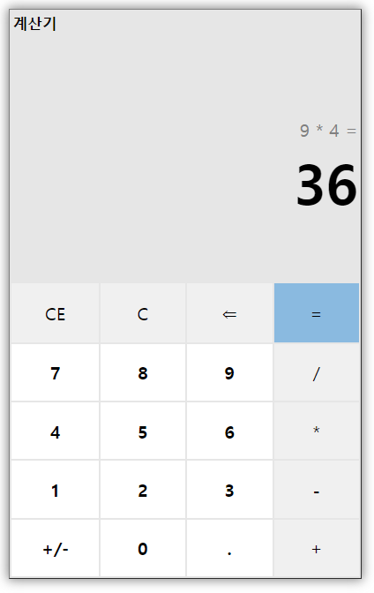

1. **디지털 시계**

|  |
| --- |
| **<html> <! DS-DIGIT.TTF 파일이 같은 디렉토리에 있어야 합니다.>**  **<head>**  **<title> cert html 2 디지털 시계 22김민재 </title>**  **<style>**  **@font-face {**  **src : url("./DS-DIGIT.TTF");**  **font-family: "dig";**  **}**  **\* {**  **font-family: "dig";**  **color: red;**  **}**  **td {**  **width: 14vmin;**  **text-align: right;**  **}**  **.col {**  **width: 5vmin;**  **}**  **#blink {**  **color: black;**  **}**  **</style>**  **</head>**  **<body align="center" style="background-color: black">**  **<div style="font-size: 15vmin"><br> Time is... </div>**  **<div>**  **<table align="center" style="font-size: 25vmin">**  **<tr>**  **<td></td> <td></td> <td class="col"></td> <td></td> <td></td> <td class="col" id="blink"></td> <td></td> <td></td> <td width="5vmin"></td>**  **</tr>**  **</table>**  **</div>**  **<div id="date" style="font-size: 5vmin"></div>**  **</body>**  **</html>**  **<script>**  **function getTime() {**  **var day = new Date(), timeall = ':';**  **var time = [day.getHours(), day.getMinutes(), day.getSeconds()];**    **for (var i = 0; i < 3; i++) {**  **if (time[i] < 10) {**  **time[i] = '0' + time[i];**  **}**  **timeall += ":" + time[i];**  **}**  **for (var i = 0; i < 8; i++) {**  **document.getElementsByTagName('td')[i].innerHTML = timeall[i+2];**  **}**  **var blink = document.getElementById('blink').style.color;**  **document.getElementById('blink').style.color = (blink == 'black') ? 'red' : 'black';**    **days = ['SU.','MO.','TU.','WE.','TH.','FR.','SA.'];**  **months = ['JAN.','FEB.','MAR.','APR.','MAY.','JUN.','JUL.','AUG.','SEP.','OCT.','NOV.','DEC'];**  **var date = document.getElementById('date').innerHTML;**  **date = day.getFullYear() + '.' + (day.getMonth()+1) + '.' + day.getDate() + ' ' + days[day.getDay()] + ' ' + months[day.getMonth()];**  **document.getElementById('date').innerHTML = date;**  **}**  **getTime();**  **setInterval(getTime, 1000);**    **</script>** |

