**Curriculum Vitae**

**June Luis Bermudez**

Baobaoan, Butuan City Agusan del Norte 8600 juneluiszb@gmail.com | +639501693079

# Objective

Highly skilled Information Technology professional with a Bachelor of Science degree in Information Technology and expertise in ICT programming. Seeking a Web Development job to leverage academic excellence, practical experience in web developing and software engineering, and strong interpersonal skills to contribute effectively to bringing ideals to life.

# Education

Bachelor of Science in Information Technology (2022-Present) Caraga State University

Ampayon, Butuan City 8600

Computer Systems Servicing NCII (April 2022) Fr. Urios Institute of Technology Inc.

Ampayon, Butuan City 8600

# Work Experience

Printer Technician at Beige Ink Station

Dagahoy Butuan City, Agusan Del Norte

August - September 2021

# Awards and Achievements

Completed the Philippine TVET Competency Assessment and Certification System Technical Education and Skills Development Authority (TESDA)

Fr. Urios Institute of Technology Inc.

# Skills

* Proficient in ICT programming with expertise in EDP Programming Proficiency
* Proficient in HTML/CSS, JavaScript, Laravel, and Tailwind for web development
* Comprehensive understanding of computers and computer networks
* Excellent interpersonal and social skills for effective team collaboration
* Commitment to continuous learning and staying updated on technological advancements

# Portfolio



Project Name: 3J Gaming Shop

Project Description: Developed with Bootstrap, I was assigned to do the design

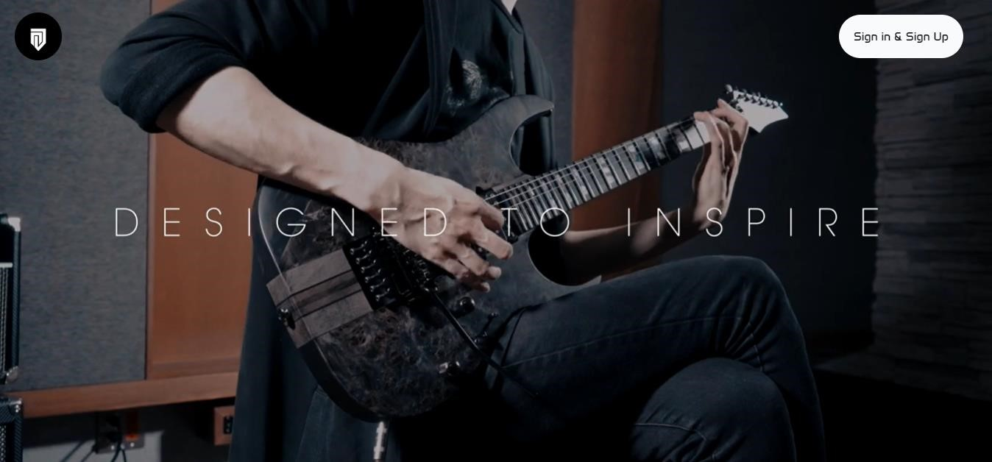

Project Name: 3J Custom Guitars

Project Description: Developed with Tailwind, also, I did the design

Check my GitHub for more: https://github.com/c9n0thing