Proposal

Topic: Detailed analysis and prediction about NBA

Team members:

Yun He(yuh95)

Yuening Zhu(yuz162)

Alan Chu(tic50)

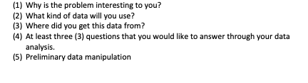

Reason the problem is interesting:

There are several NBA fans in our team.

Data to use:

Data of NBA players’ performances and other relative information, like scoring, assists, rebounds, weight, height, etc.

Data Sources:

<https://stats.nba.com/players/list/>

<https://basketball.realgm.com/>

<https://github.com/ikhlaqsidhu/data-x/tree/master/03-tools-webscraping-crawling_api_afo>

<https://www.kesci.com/home/dataset/599a6e66c8d2787da4d1e21d>

Questions:

1. Who can be chosen as All-Star?
2. The trend of players’ overall percentage each year during careers.
3. The relationship between players’ performances and his last contract year / seniority.
4. The relationship between players’ physical fitness and different positions.
5. The relationship between players’ score and positions.

Players: (2000-2018)

name, age, height, weight,