SOFTWARE ENGINEERING

MODULE 9: SOFTWARE EVOLUTION

Controlled Change After Architecture, Implementation, and Testing

STUDENT INFORMATION
Name: Juner Punzal
Section: BSCS 3A
Course: Software Engineering
Module: 9 - Software Evolution

PROJECT INFORMATION
System: Attendance Monitoring System
Technology Stack: Vue 3 + Vite + Tailwind CSS
Version: 1.1.0 (from 0.0.0)
Change Type: Adaptive Maintenance

REPOSITORY & DEPLOYMENT
GitHub Repository:
https://github.com/juner08/attendance-monitoring-system
Live Deployment:
https://juner08.github.io/attendance-monitoring-system/

This report documents the controlled evolution of the Attendance Monitoring System through Change Request CR-M9-01 (organize students by year level and section), and includes real screenshots captured from the deployed website.

EXECUTIVE SUMMARY
Module 9 implements a controlled software evolution to the Attendance Monitoring System through Change Request CR-M9-01, which adds year-level and section-based student organization while maintaining full backward compatibility with existing data and features.

Key Achievements:
✓ Change Request CR-M9-01 implemented and verified
✓ 22/22 test cases passing (12 new + 10 regression)
✓ Zero breaking changes, 100% backward compatible
✓ Production build successful
✓ Continuous Integration & Deployment via GitHub Actions
✓ Application live with secure administrator login

Baseline Overview:
Module 6 - Architecture: Vue 3 SPA with Vite, Tailwind CSS, localStorage persistence.
Module 7 - Implementation: Student CRUD, attendance tracking, dashboard, authentication.
Module 8 - Testing: 10 manual + 6 automated tests, defect DEF-01 fixed, regression complete.

M9-01: Login Page
Secure administrator login screen (PBKDF2 password hashing).
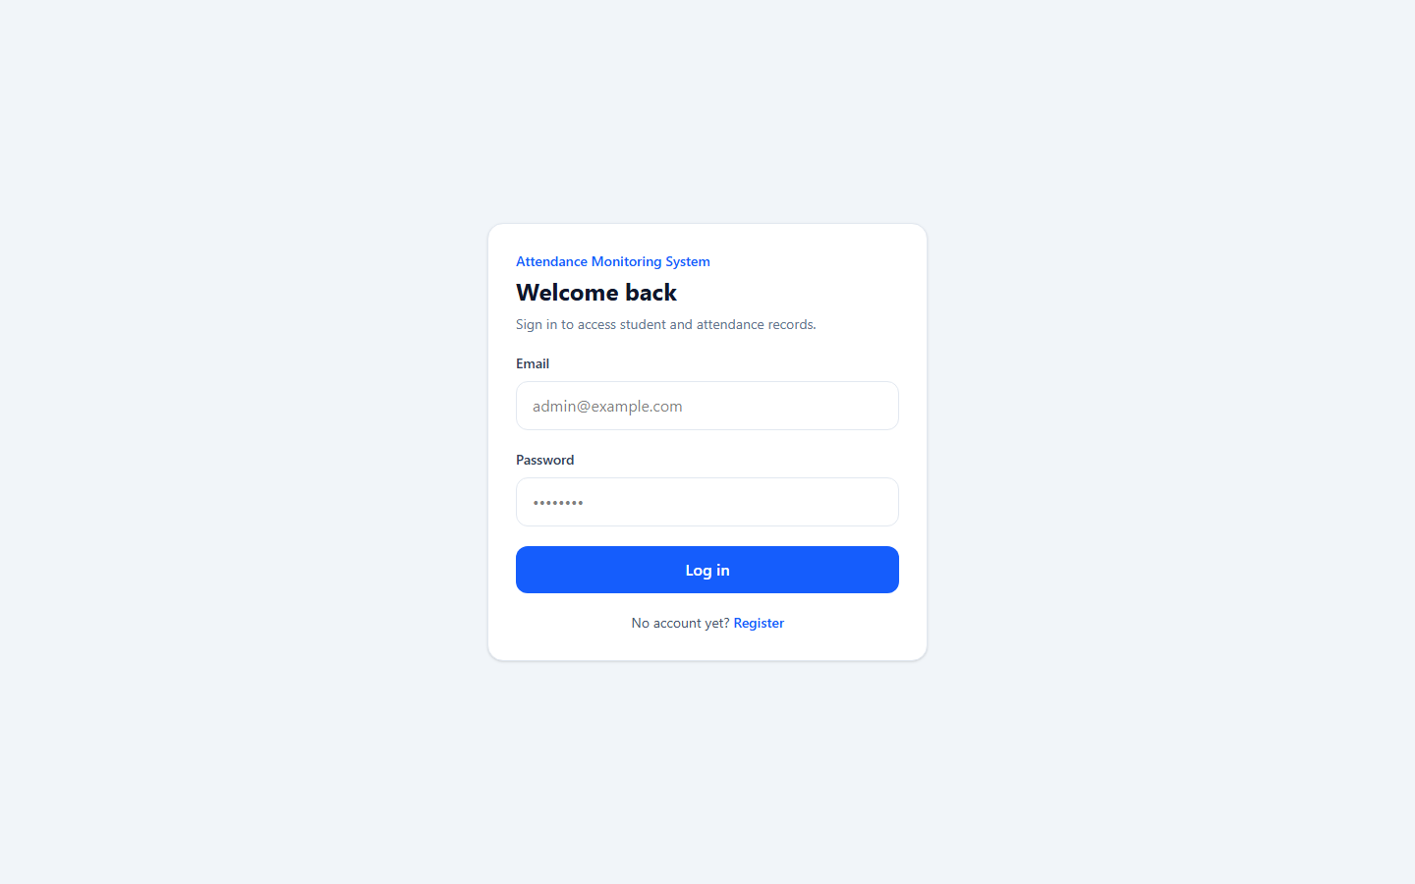
[Screenshot: M9-01 captured from https://juner08.github.io/attendance-monitoring-system/]

M9-02: Register Page
Administrator account registration screen.
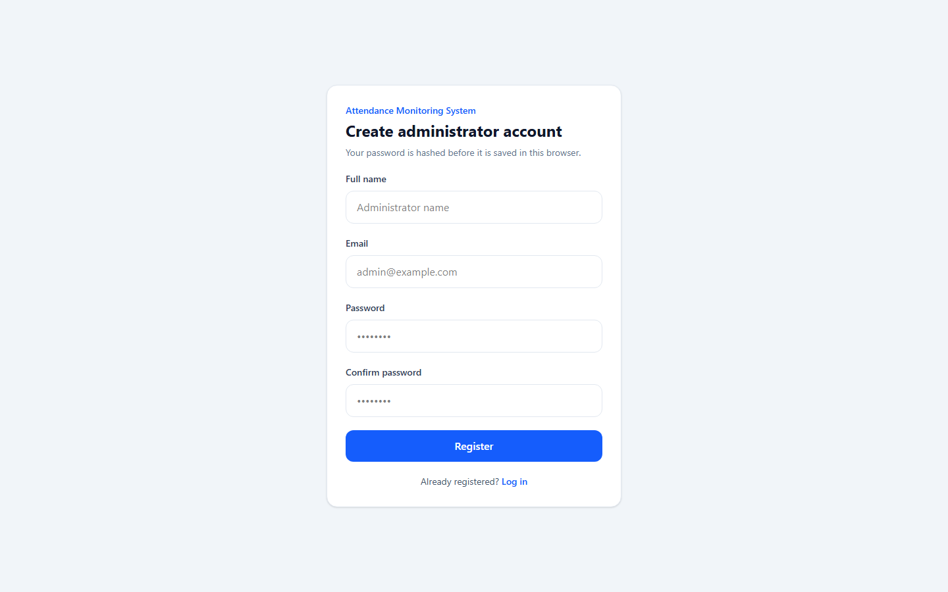
[Screenshot: M9-02 captured from https://juner08.github.io/attendance-monitoring-system/]

M9-03: Dashboard
Main dashboard after login with attendance statistics.
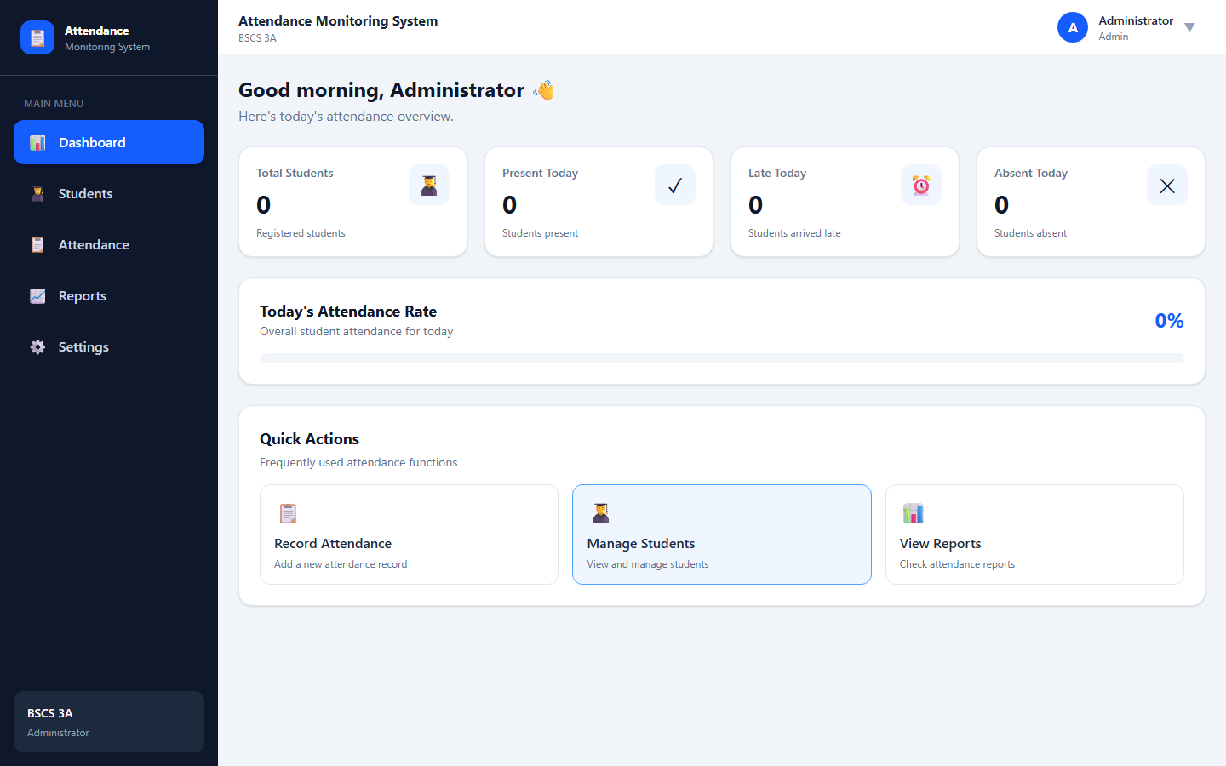
[Screenshot: M9-03 captured from https://juner08.github.io/attendance-monitoring-system/]

M9-04: Students Page
Students page with "Browse by class" organization (Module 9 feature).
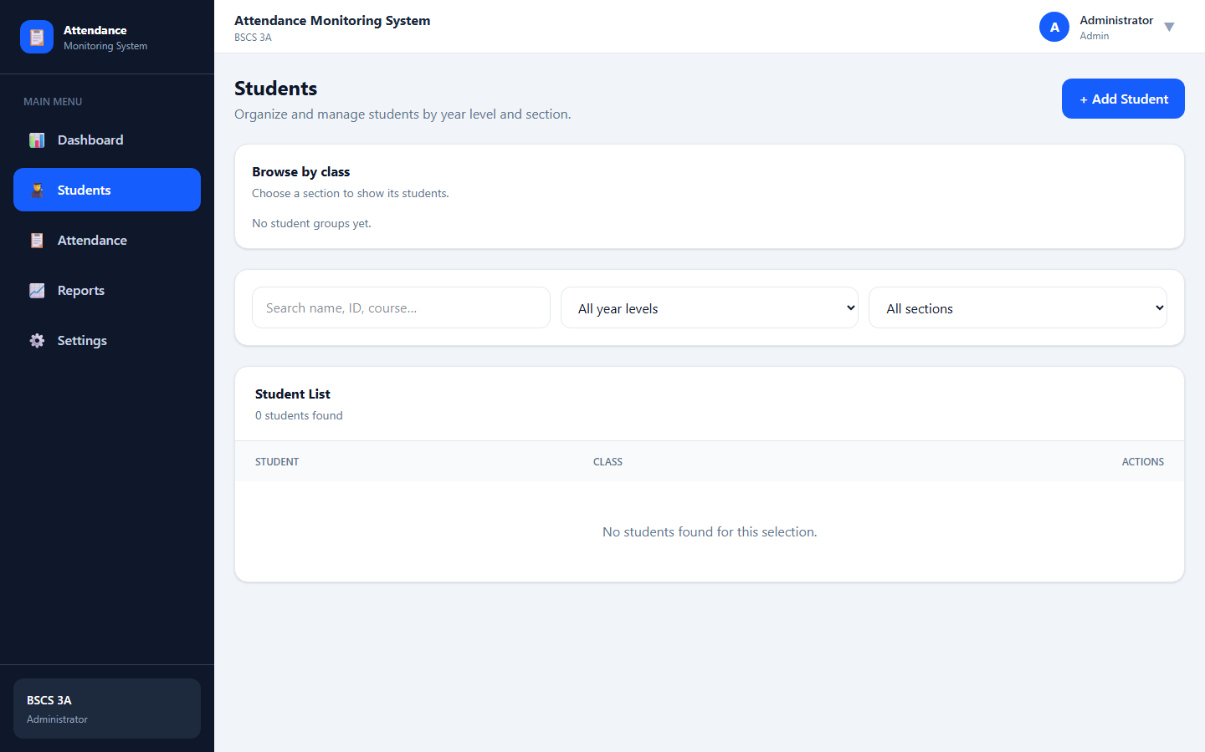
[Screenshot: M9-04 captured from https://juner08.github.io/attendance-monitoring-system/]

M9-05: Add Student Form
Student form with explicit Year level (1-4) and Section (A-Z) fields.
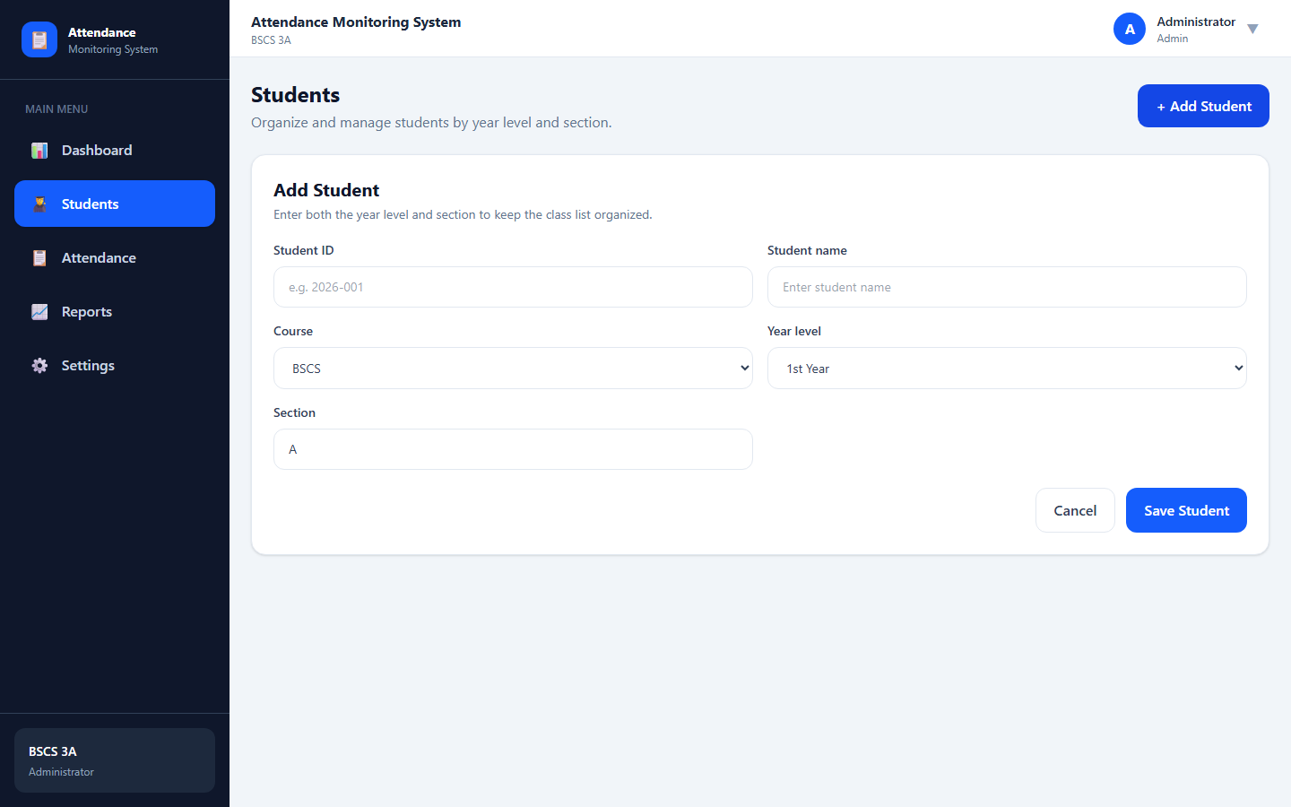
[Screenshot: M9-05 captured from https://juner08.github.io/attendance-monitoring-system/]

M9-06: Browse by Class (Evolved System)
Year-level cards with section groupings and student counts.
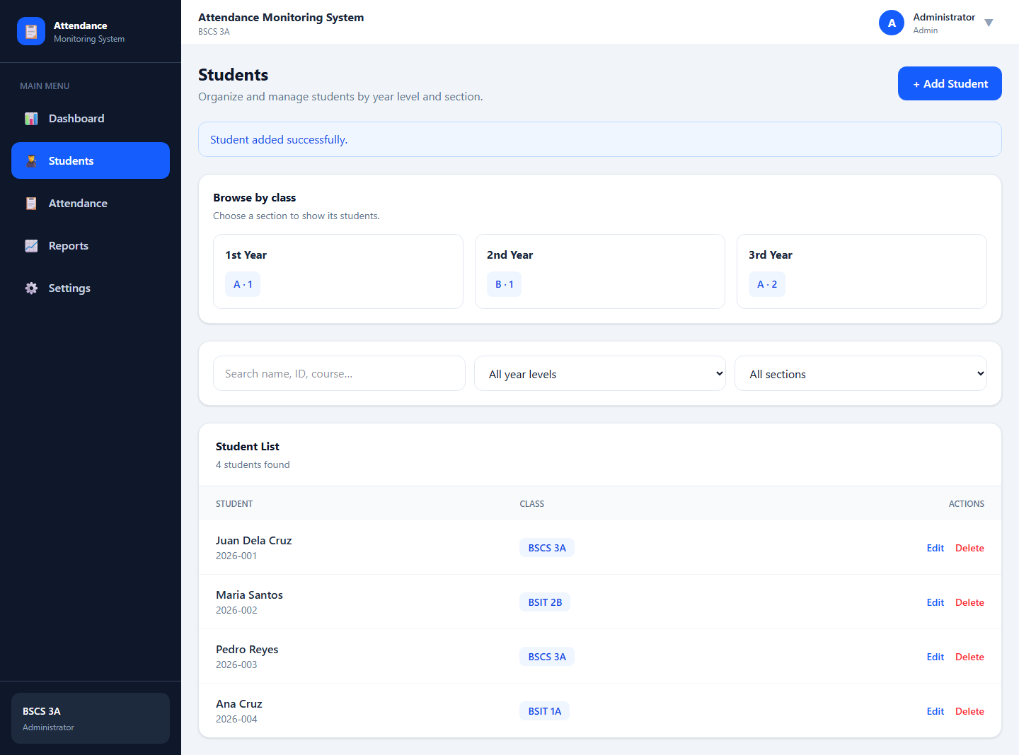
[Screenshot: M9-06 captured from https://juner08.github.io/attendance-monitoring-system/]

M9-07: Year / Section Filtering
Filtering students by year level and section, combined with search.
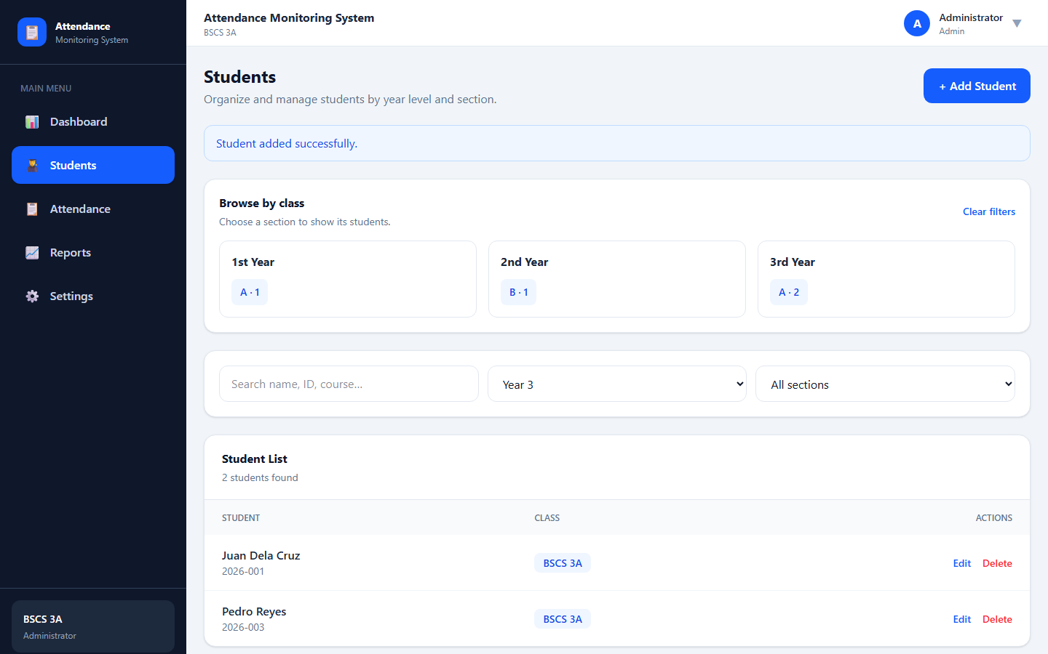
[Screenshot: M9-07 captured from https://juner08.github.io/attendance-monitoring-system/]

M9-08: Attendance Page
Attendance recording preserved and fully functional after evolution.
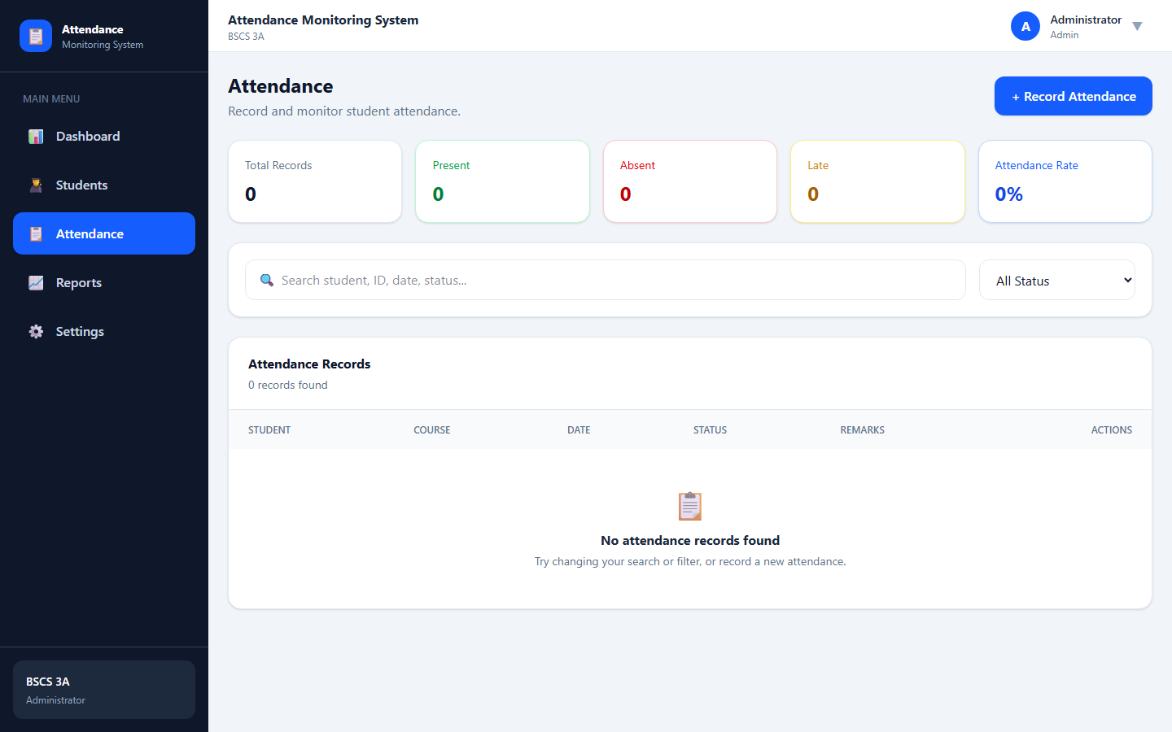
[Screenshot: M9-08 captured from https://juner08.github.io/attendance-monitoring-system/]

M9-09: Settings Page
System settings including dark mode and system information management.
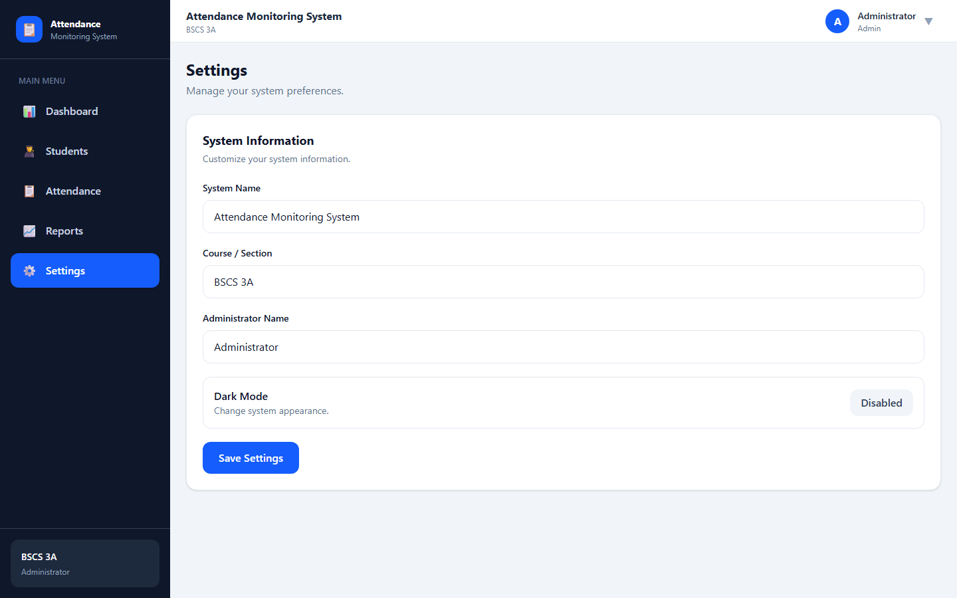
[Screenshot: M9-09 captured from https://juner08.github.io/attendance-monitoring-system/]

M9-10: Reports Page
Student attendance reports and today statistics.
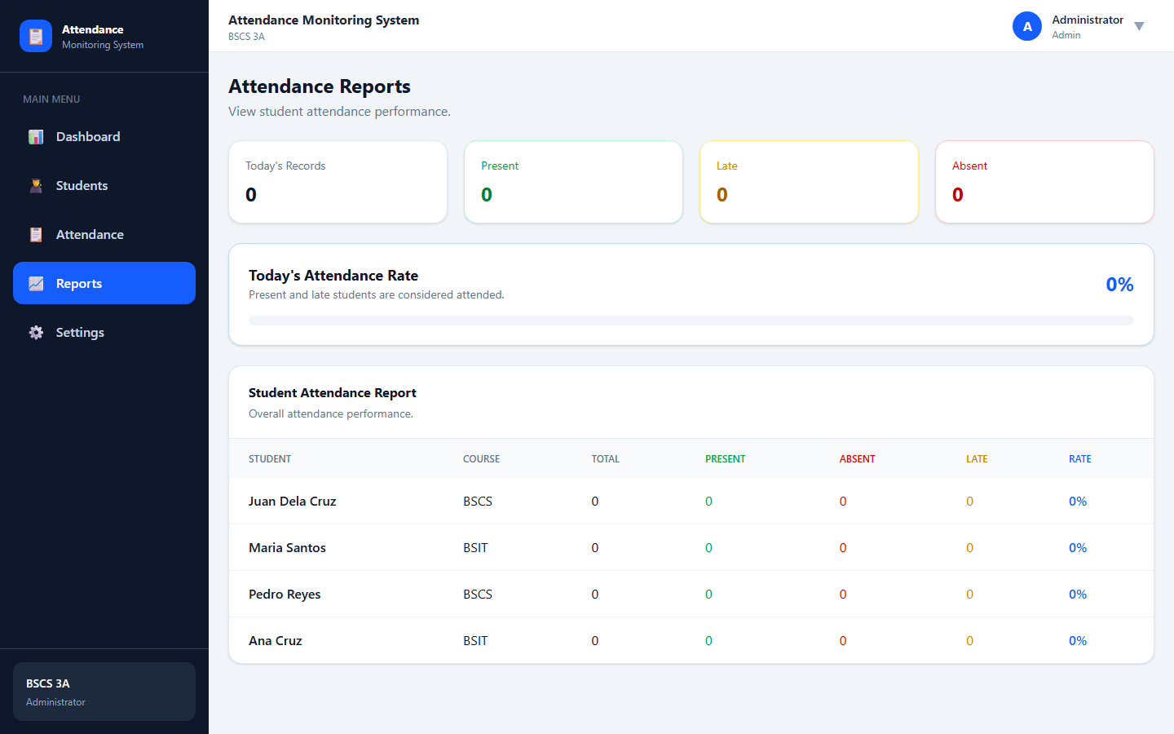
[Screenshot: M9-10 captured from https://juner08.github.io/attendance-monitoring-system/]

TESTING, RELEASE & CONCLUSION

Updated Test Cases:
✓ Module 9 new tests (year/section): 12 - 12/12 PASS
✓ Module 8 regression tests: 10 - 10/10 PASS
✓ Total: 22 - 22/22 PASS (100% pass rate)

Release & Deployment:
✓ Previous Version: 0.0.0
✓ Current Version: 1.1.0 (MINOR - Semantic Versioning)
✓ Change Type: Adaptive Maintenance
✓ CI/CD: GitHub Actions - build, test, and deploy to GitHub Pages
✓ Repository: https://github.com/juner08/attendance-monitoring-system
✓ Live Deployment: https://juner08.github.io/attendance-monitoring-system/

Conclusion:
Module 9 Software Evolution is COMPLETE. The Attendance Monitoring System now organizes students by year level and section while remaining fully backward compatible, with all 22 test cases passing and a live secure deployment integrating the administrator login feature.

Submitted: September 1, 2026
Version: 1.1.0
Status: COMPLETE AND VERIFIED

