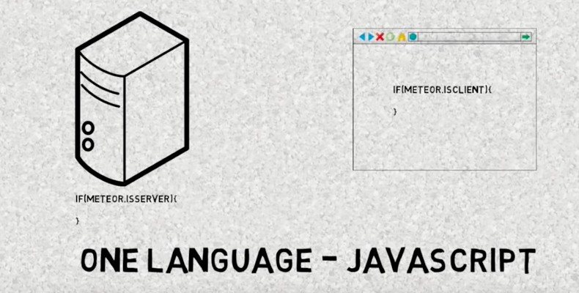

BEFORE :

Load the entire page

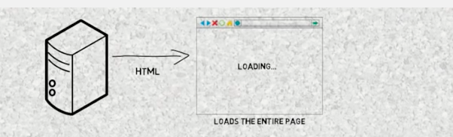

NOW

MeteorJS :

Only the parts of the page that are changing will be downloaded (Data on the wire).

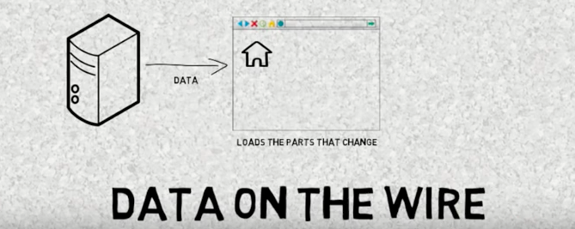

**DB on SERVER communicates with DB on CLIENT(MINIMONGO - MongoDB emulator that runs inside web browser).**

Pushes the change updates without even refreshing the page -> Reactivity achieved with Web socket communication.

