ECharts的特性
丰富的可视化类型。
多种数据格式无需转换直接使用。
千万数据前端使用。
多渲染方案，跨平台使用等。
获取 ECharts 的路径
- 最直接的方法是在ECharts的官方网站中挑选适合您的版本进行下载，不同的打包下载应用于不同的开发者功能与体积的需求，或者您也可以直接下载完整版本；开发环境建议下载源代码版本，包含了常见的错误提示和警告。
- 也可以在 ECharts 的github上下载最新的 release 版本，解压出来的文件夹里的 dist 目录里可以找到最新版本的 echarts 库。
- 由 cdn 引入，你可以在 cdnjs，npmcdn 或者国内的 bootcdn 上找到 ECharts 的最新版本。

使用 Echarts 绘制一个简单的图表
使用 Echarts 绘制图表前需要先有一个有宽高的 DOM 容器，接着通过使用 echarts.init 方法来初始化一个 echarts 实例和使用 setOption 方法生成一个简单的柱状图。

做了一些练习。
option = {
backgroundColor:{
type: 'linear',
x: 0,
y: 0,
x2: 1,
y2: 1,
colorStops: [{
offset: 0, color: 'pink' // 0% 处的颜色
},{
offset: 1, color: 'blue' // 100% 处的颜色
}],
},
title: {
text: '垃圾清运趋势(吨)',
textStyle:{
color:'DeepSkyBlue',
fontSize:25
},
left:50,
top:10,

},
tooltip: {
trigger: 'axis'
},
legend: {
data:['当日清理数','昨日清理数'],
icon: "line",
textStyle:{
color:'white',
fontSize:16
},
right:40,
top:10,
},
grid: {
left: '3%',
right: '4%',
bottom: '3%',
containLabel: true
},
toolbox: {
feature: {
saveAsImage: {}
}
},
xAxis: {
type: 'category',
data : ['3时','5.5时','6时','8.5时','9时','11.5时','12时','14.5时','15时','17.5时','18时','20.5时','21时','22.5时','24时'],
axisLabel: {
interval:1,
textStyle: {
color: 'white'
}
},
axisTick:{
show:false,
},

},
yAxis: {
type: 'value',
axisLabel: {
textStyle: {
color: 'white'
}
},
axisTick:{
show:false,
},
axisLine: {
show: false,
},
min:0,
max:12000,
splitNumber:4,
splitLine: {
lineStyle: {
type:'dotted',
color:'blue'
}
}
},
series: [
{
name:'当日清理数',
type:'line',
data:[5100,3400,5900,5100,9100,6200,6100,3100,3500,4000,4500,6000,4500,4600,4800 ],
symbol:'none',
},
{
name:'昨日清理数',
type:'line',
data:[3200,5100,3400,6500,12000,9000,10000,3500,4500,5000,6000,3500,5800,5000,4200],
symbol:'none',
},
]
};

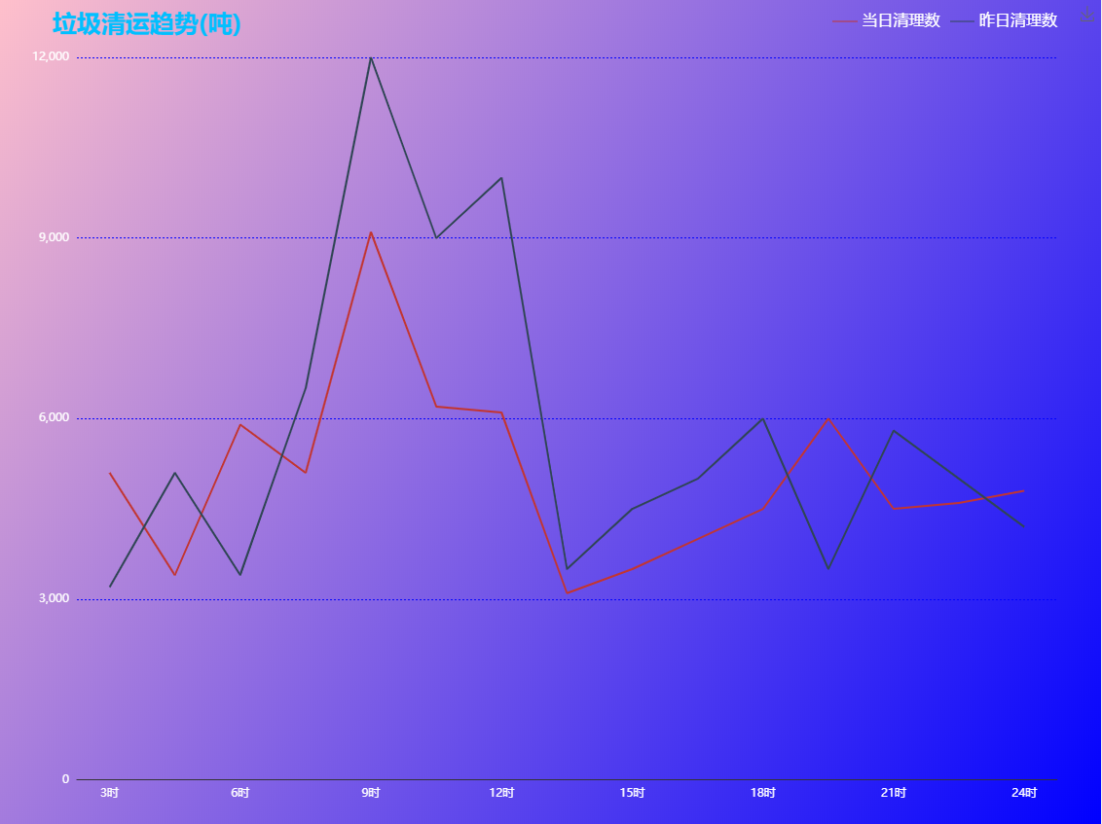

option = {
backgroundColor:{
type: 'linear',
x: 0,
y: 0,
x2: 1,
y2: 1,
colorStops: [{
offset: 0, color: 'pink' // 0% 处的颜色
},{
offset: 1, color: 'green' // 100% 处的颜色
}],
},
title: {
text: '近30日自行解决事件趋势',
textStyle:{
color:'DeepSkyBlue',
fontSize:20
},
left:10,
top:5,

},
color:['blue'],
tooltip: {
trigger: 'axis'
},
legend: {
data:['事件数(件)'],
icon: "line",
textStyle:{
color:'white',
fontSize:16
},
right:40,
top:10,
},
grid: {
left: '3%',
right: '4%',
bottom: '3%',
containLabel: true
},
toolbox: {
feature: {
saveAsImage: {}
}
},
xAxis: {
type: 'category',
data : ['30日','31日','1日','2日','3日','4日','5日','6日','7日'],
axisLabel: {
textStyle: {
color: 'white'
}
},
axisTick:{
show:false,
},

},
yAxis: {
type: 'value',
name:'件',
nameLocation: 'start',
nameTextStyle:{
color:'white',
fontSize:'15'
},
axisLabel: {
textStyle: {
color: 'white'
}
},
axisTick:{
show:false,
},
axisLine: {
show: false,
},

min:0,
max:50,
splitNumber:4,
splitLine: {
lineStyle: {
type:'dotted',
color:'blue'
}
}
},
series: [
{
name:'事件数(件)',
type:'line',
data:['22','12','17','20','16','22','30','32','23','20'],
symbol:'none',
itemStyle : {
normal: {
label:{show: true},
}
}
},
]
};

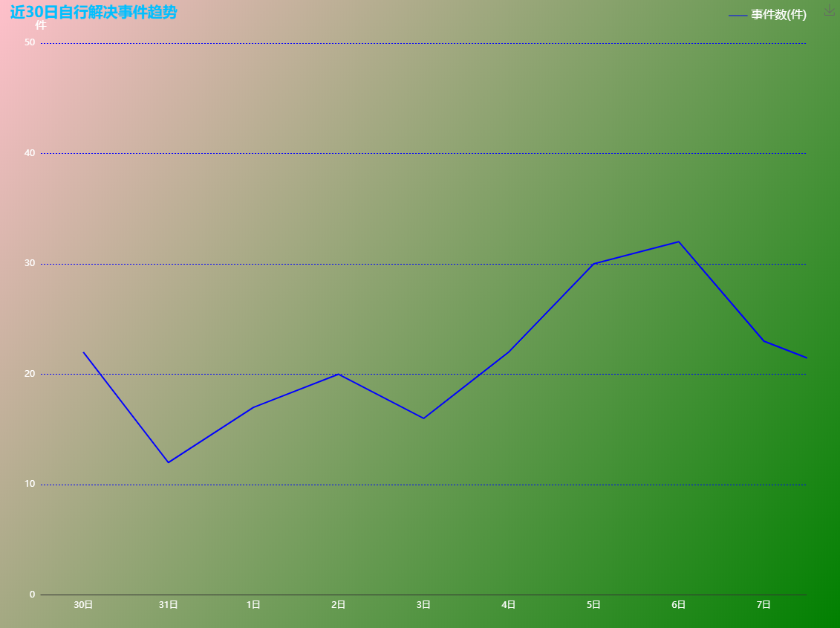

option = {
backgroundColor:{
type: 'linear',
x:0,
y:1,
x2: 1,
y2: 1,
colorStops: [{
offset: 0, color: 'blue' // 0% 处的颜色
},{
offset: 0.2, color: 'black' // 100% 处的颜色
},{
offset: 0.8, color: 'black' // 0% 处的颜色
},{
offset: 1, color: 'blue' // 0% 处的颜色
},],
},
title: {
text: '今日事件趋势',
textStyle:{
color:'DeepSkyBlue',
},
left:30,
},
tooltip : {
trigger: 'axis',
axisPointer: {
type: 'cross',
}
},
legend: {
data:['上报数','立案数','结案数'],
bottom:2,
icon: "line",
textStyle:{
color:'white',
},
},

grid: {
left: '3%',
right: '4%',
bottom: '3%',
containLabel: true
},
xAxis : [
{
type : 'category',
data : ['4时','5.5时','7时','8.5时','10时','11.5时','13时','14.5时','16时','17.5时','19时','20.5时','22时'],
axisLabel: {
interval:1,
textStyle: {
color: 'white'
}
},
axisTick:{
show:false,
},
}
],

yAxis : [
{
type : 'value',
name:'个数',
nameGap:15,
axisLabel:{
textStyle:{
color:'white',
}
},
nameTextStyle:{
color:'white',
fontSize:'15'
},
axisTick:{
show:false,
},
axisLine: {
show: false,
},
min:0,
max:500,
splitLine: {
lineStyle: {
type:'dotted',
color:' MidnightBlue'
}
}
}
],
series : [
{
name:'上报数',
type:'line',
areaStyle: {
opacity:0.4
},
data:[320,240,280,290,300,240,350,400,320,400,300,280,290],
symbol:'none',
},
{
name:'立案数',
type:'line',
areaStyle: {
opacity:0.4
},
data:[110,120,140,150,160,180,200,210,220,240,260,270,280],
symbol:'none',
},
{
name:'结案数',
type:'line',
areaStyle: {
opacity:0.4
},
data:[400,450,350,400,320,420,420,450,410,280,400,380,300],
symbol:'none',
}
]
};
option = {
backgroundColor:{
type: 'linear',
x:0,
y:1,
x2: 1,
y2: 1,
colorStops: [{
offset: 0, color: 'blue' // 0% 处的颜色
},{
offset: 0.2, color: 'black' // 100% 处的颜色
},{
offset: 0.8, color: 'black' // 0% 处的颜色
},{
offset: 1, color: 'blue' // 0% 处的颜色
},],
},
title: {
text: '今日事件趋势',
textStyle:{
color:'DeepSkyBlue',
},
left:30,
},
tooltip : {
trigger: 'axis',
axisPointer: {
type: 'cross',
}
},
legend: {
data:['上报数','立案数','结案数'],
bottom:2,
icon: "line",
textStyle:{
color:'white',
},
},

grid: {
left: '3%',
right: '4%',
bottom: '3%',
containLabel: true
},
xAxis : [
{
type : 'category',
data : ['4时','5.5时','7时','8.5时','10时','11.5时','13时','14.5时','16时','17.5时','19时','20.5时','22时'],
axisLabel: {
interval:1,
textStyle: {
color: 'white'
}
},
axisTick:{
show:false,
},
}
],

yAxis : [
{
type : 'value',
name:'个数',
nameGap:15,
axisLabel:{
textStyle:{
color:'white',
}
},
nameTextStyle:{
color:'white',
fontSize:'15',
align:'right'
},
axisTick:{
show:false,
},
axisLine: {
show: false,
},
min:0,
max:500,
splitLine: {
lineStyle: {
type:'dotted',
color:' MidnightBlue'
}
}
}
],
series : [
{
name:'上报数',
type:'line',
areaStyle: {
opacity:0.4
},
data:[320,240,280,290,300,240,350,400,320,400,300,280,290],
symbol:'none',
},
{
name:'立案数',
type:'line',
areaStyle: {
opacity:0.4
},
data:[110,120,140,150,160,180,200,210,220,240,260,270,280],
symbol:'none',
},
{
name:'结案数',
type:'line',
areaStyle: {
opacity:0.4
},
data:[400,450,350,400,320,420,420,450,410,280,400,380,300],
symbol:'none',
}
]
};
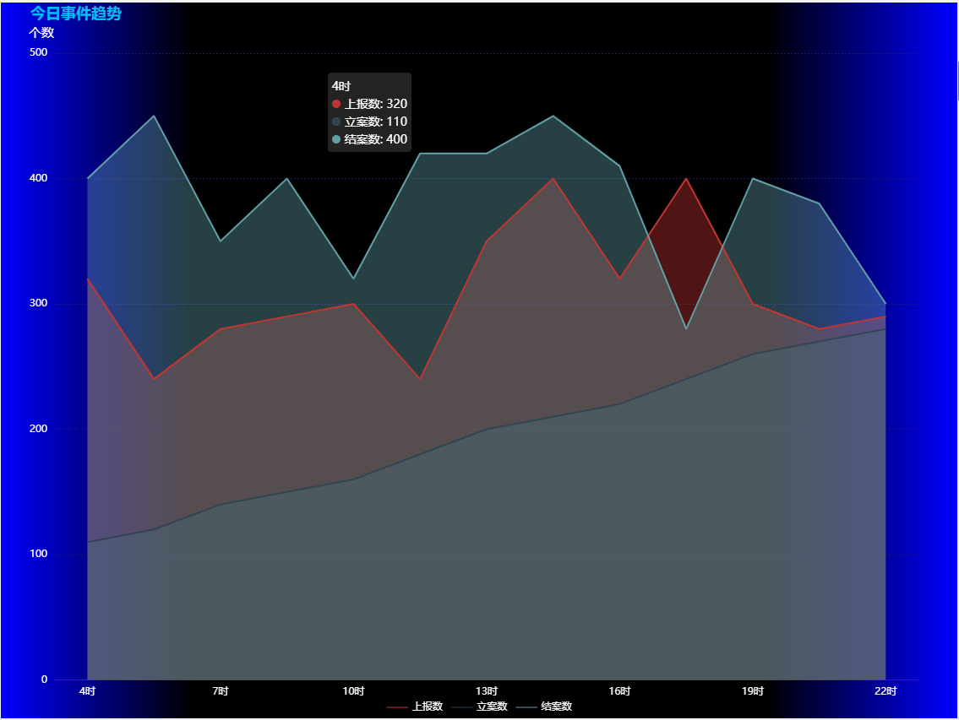

option = {
backgroundColor:{
type: 'linear',
x:0,
y: 0,
x2: 1,
y2: 1,
colorStops: [{
offset: 0, color: 'black' // 0% 处的颜色
},{
offset: 1, color: 'blue' // 100% 处的颜色
}],
},
tooltip: {
trigger: 'item',//触发类型
formatter: "{a} <br/>{b}: {c} ({d}%)"//{a}（系列名称），{b}（数据项名称），{c}（数值）, {d}（百分比）
},
legend: {
orient: 'vertical',
x: 'left',
data:['','','本年审批服务款'],
textStyle:{},
show:false,
},
series: [
{
name:'访问来源',
type:'pie',
radius: ['50%', '70%'],
avoidLabelOverlap: false,
hoverAnimation:false,//不开启放大动画
label: {
normal: {
show: true,
position: 'center',
textStyle:{
fontSize: 50,
color:'white'
}
},
/* emphasis: {
show: true,
textStyle: {
fontSize: '30',
fontWeight: 'bold'
}
}*/
},
labelLine: {
normal: {
show: false
}
},
data:[
{value:335, name:''},
{value:310, name:''},
{value:234, name:'本年审批服务款'},
]
}
]
};
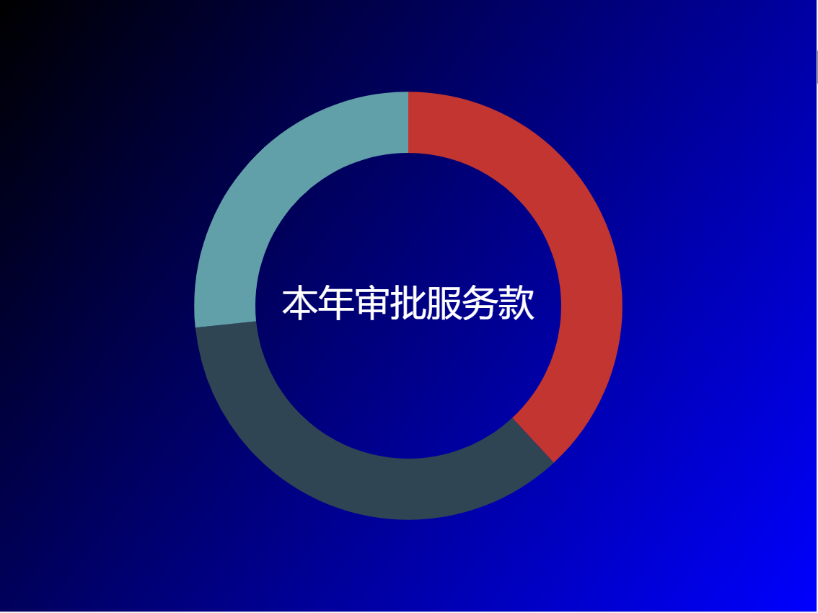

option = {
backgroundColor:{
type: 'linear',
x: 0,
y: 0,
x2: 1,
y2: 1,
colorStops: [{
offset: 0, color: 'pink' // 0% 处的颜色
},{
offset: 1, color: 'green' // 100% 处的颜色
}],
},
title : {
},
tooltip : {
trigger: 'item',
formatter: "{a} <br/>{b} : {c} ({d}%)"
},
legend: {
orient: 'vertical',
left: 'left',
show:false,
},
series : [
{
name: '访问来源',
type: 'pie',
radius : '55%',
center: ['50%', '60%'],
data:[
{value:100, name:'农业水事务'},
{value:100, name:'城乡社区'},
{value:100, name:'节能环保'},
{value:100, name:'卫生健康'},
{value:100, name:'社会保障与就业'},
{value:100, name:'文体传媒'},
{value:100, name:'科学技术'},
{value:100, name:'教育'},
{value:100, name:'公共安全'},
{value:100, name:'住房保障输出'},
],

labelLine:{
length:50,
length2:100,
lineStyle:{
color:'white'
},
},
itemStyle: {
emphasis: {
shadowBlur: 10,
shadowOffsetX: 10,
shadowColor: 'rgba(0, 0, 0, 0.5)'
}
},
label:{
formatter:' · {b} {d}%\n\n',
fontSize:20,
padding: [0, -120],
color:'white'
}
}
]
};
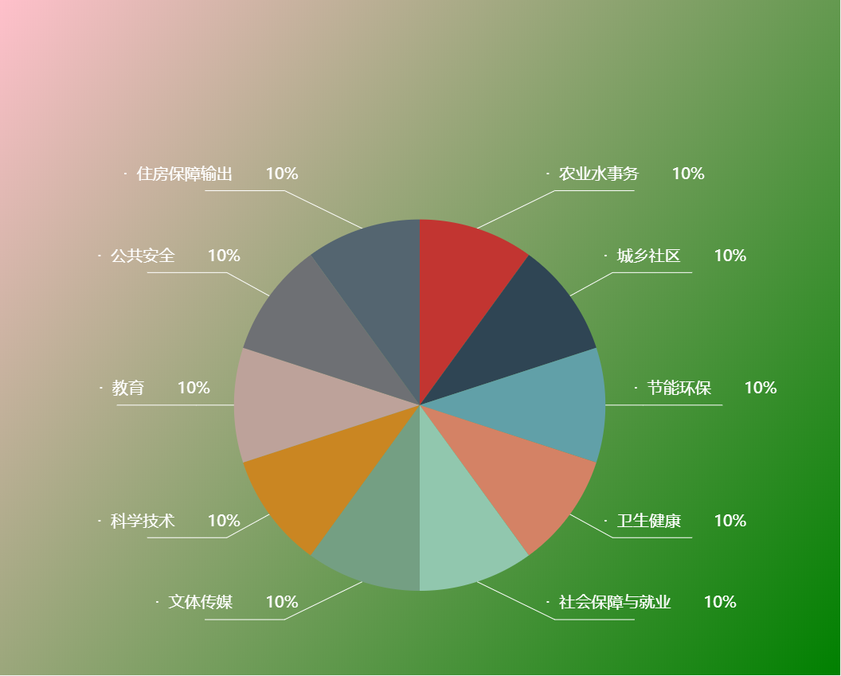

option = {
backgroundColor:{
type: 'linear',
x: 0,
y: 0,
x2: 1,
y2: 1,
colorStops: [{
offset: 0, color: 'pink' // 0% 处的颜色
},{
offset: 1, color: 'green' // 100% 处的颜色
}],
},
title : {
},
tooltip : {
trigger: 'item',
formatter: "{a} <br/>{b} : {c} ({d}%)"
},
legend: {
orient: 'vertical',
left: 'left',
show:false,
},
series : [
{
name: '访问来源',
type: 'pie',
radius: ['50%', '70%'],
center: ['50%', '50%'],
data:[
{value:100, name:'农业水事务'},
{value:100, name:'城乡社区'},
{value:100, name:'节能环保'},
{value:100, name:'卫生健康'},
{value:100, name:'社会保障与就业'},
],

labelLine:{
length:50,
length2:150,
lineStyle:{
color:'white'
},
},
itemStyle: {
emphasis: {
shadowBlur: 10,
shadowOffsetX: 10,
shadowColor: 'rgba(0, 0, 0, 0.5)'
}
},
label:{
formatter:'{d}% \n\n{b}',
fontSize:20,
padding: [0, -100],
color:'white'
}
}
]
};
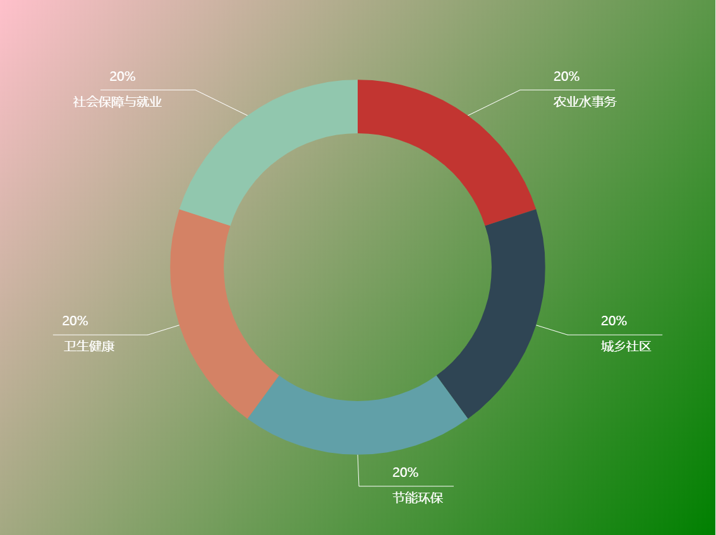

option = {
backgroundColor:{
type: 'linear',
x: 0,
y: 0,
x2: 1,
y2: 1,
colorStops: [{
offset: 0, color: 'pink' // 0% 处的颜色
},{
offset: 1, color: 'green' // 100% 处的颜色
}],
},
color:['blue','red'],
legend: {
data:['总收入','总支出'],
icon: "line",
right:20,
top:10,
},
title: {
text: '历年财政收支情况',
textStyle:{
color:'DeepSkyBlue',
fontSize:20,
},
left:5,
},
tooltip: {},
xAxis: {
type: 'category',
data : ['2009','2010','2011','2012','2013','2014','2015','2016','2017','2018','2019'],
axisLabel:{
textStyle:{
color:'white',
}
}
},
yAxis: {
type : 'value',
name:'万元',
axisLabel:{
textStyle:{
color:'white',
}
},
splitLine: {
lineStyle: {
type:'dotted',
color:' MidnightBlue'
}
},
nameTextStyle:{
color:'white',
fontSize:'15',
align:'right'
},
min:0,
max:500,
},
series: [
{
name:'总收入',
type:'bar',
data:[320,240,280,290,300,240,350,400,320,400,300],
},
{
name:'总支出',
type:'bar',
data:[110,120,140,150,160,180,200,210,220,240,270],
},
]
};
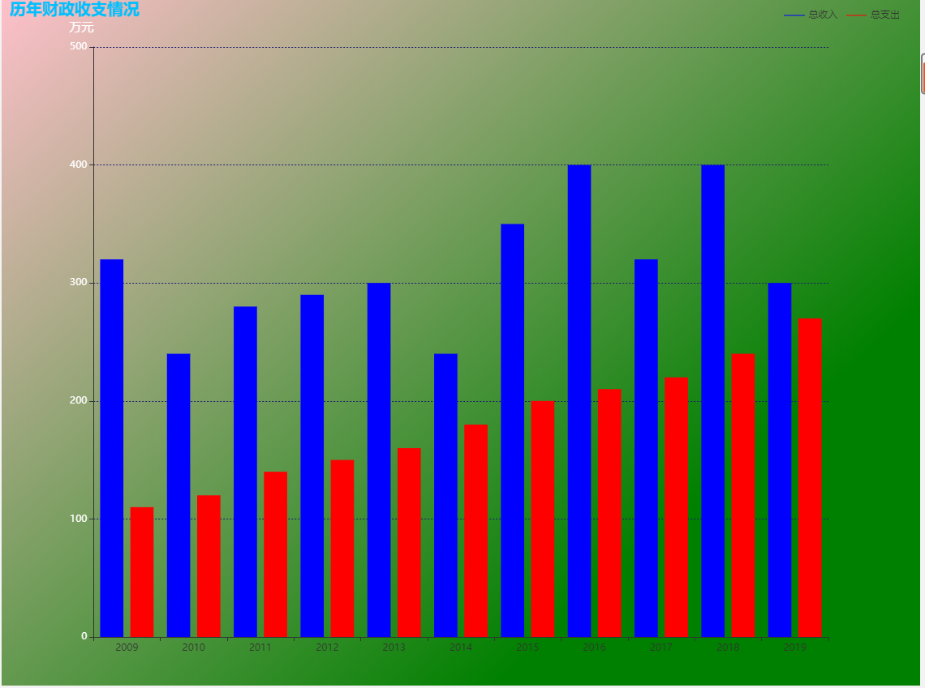

option = {
backgroundColor:{
type: 'linear',
x: 0,
y: 0,
x2: 1,
y2: 1,
colorStops: [{
offset: 0, color: 'pink' // 0% 处的颜色
},{
offset: 1, color: 'green' // 100% 处的颜色
}],
},
color:['blue','red'],
legend: {
data:['总收入','总支出'],
icon: "line",
right:20,
top:10,
},
title: {
text: '历年财政收支情况',
textStyle:{
color:'DeepSkyBlue',
fontSize:20,
},
left:5,
},
tooltip: {},
xAxis: {
type: 'category',
data : ['2009','2010','2011','2012','2013','2014','2015','2016','2017','2018','2019'],
axisLabel:{
textStyle:{
color:'white',
},
rotate:45
},
axisTick:{
show:false,
},
},
yAxis: {
type : 'value',
name:'万元',
axisLabel:{
textStyle:{
color:'white',
}
},
axisTick:{
show:false,
},
splitLine: {
lineStyle: {
type:'dotted',
color:' MidnightBlue'
}
},
nameTextStyle:{
color:'white',
fontSize:'15',
align:'right'
},
min:0,
max:500,
},
series: [
{
name:'总收入',
type:'bar',
data:[320,240,280,290,300,240,350,400,320,400,300],
},
{
name:'总支出',
type:'bar',
data:[110,120,140,150,160,180,200,210,220,240,270],
barGap:-1
},
]
};
