ROS Qt Creator 플러그인
https://rosindustrial.org/news/2019/7/3/new-release-ros-qt-creator-491-with-ros2-support

https://ros-qtc-plugin.readthedocs.io/en/latest/index.html#

설치
https://ros-qtc-plugin.readthedocs.io/en/latest/_source/How-to-Install-Users.html

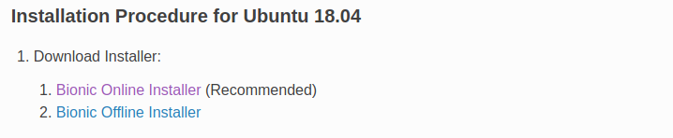

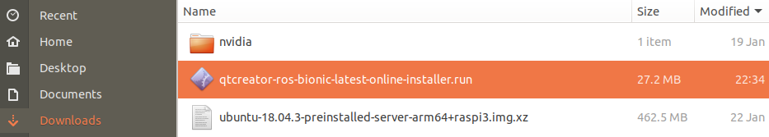

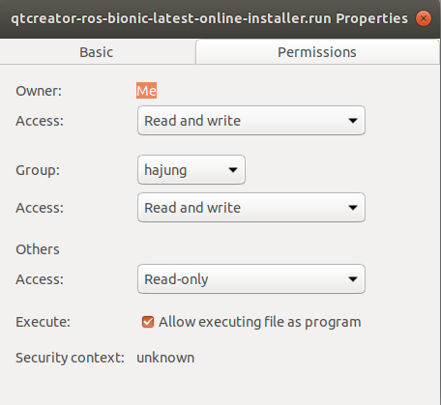

New Project
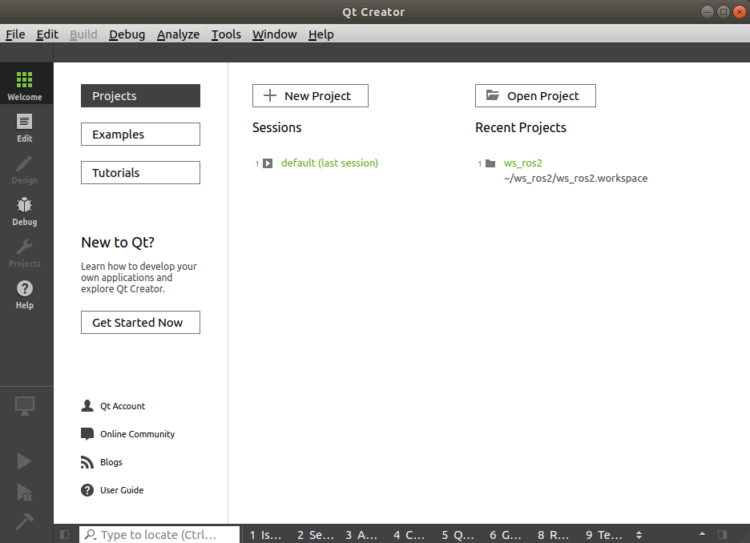

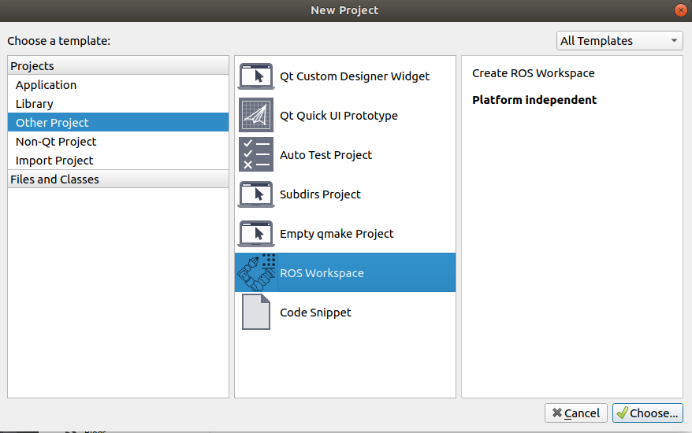

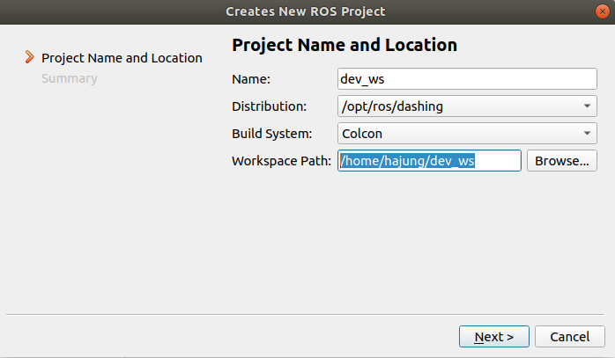

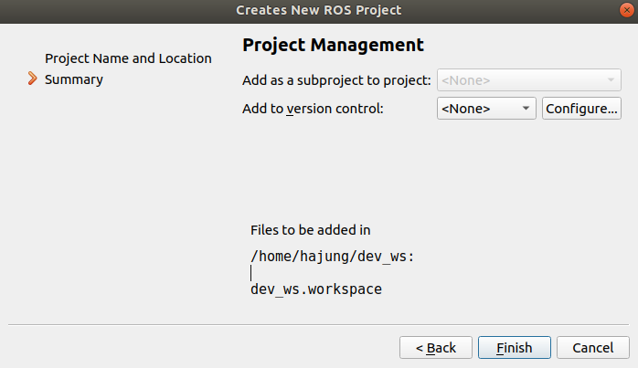

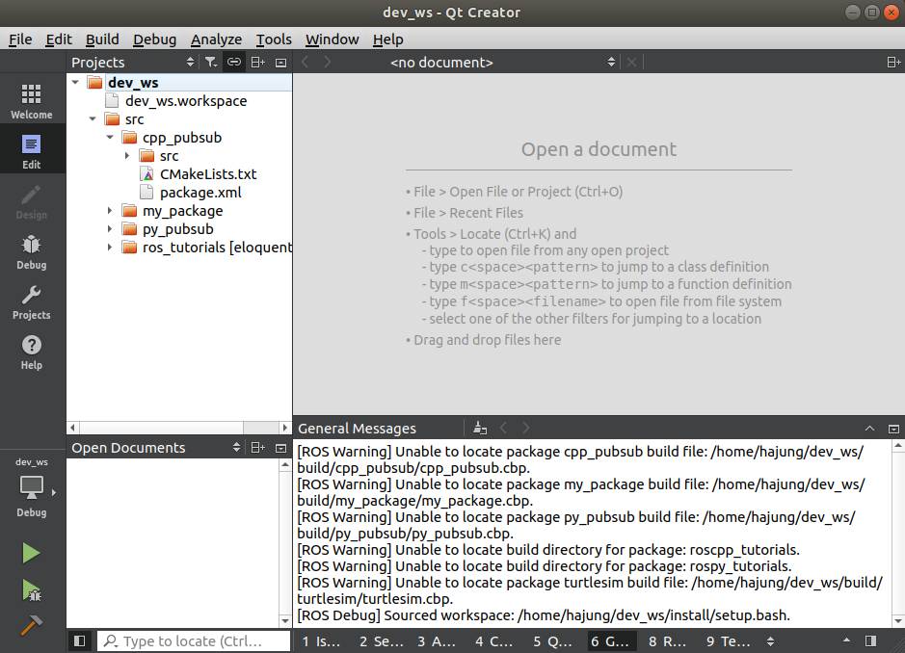

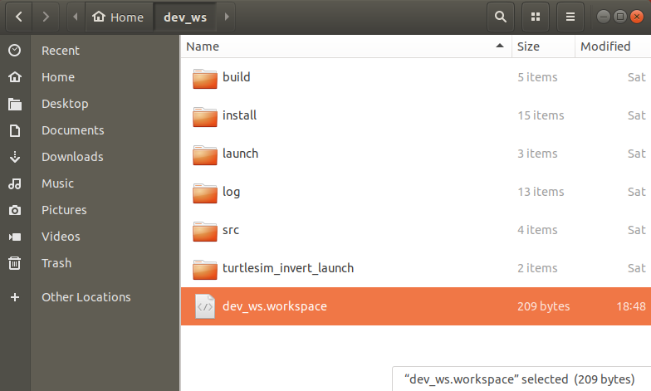

빌드환경 구축

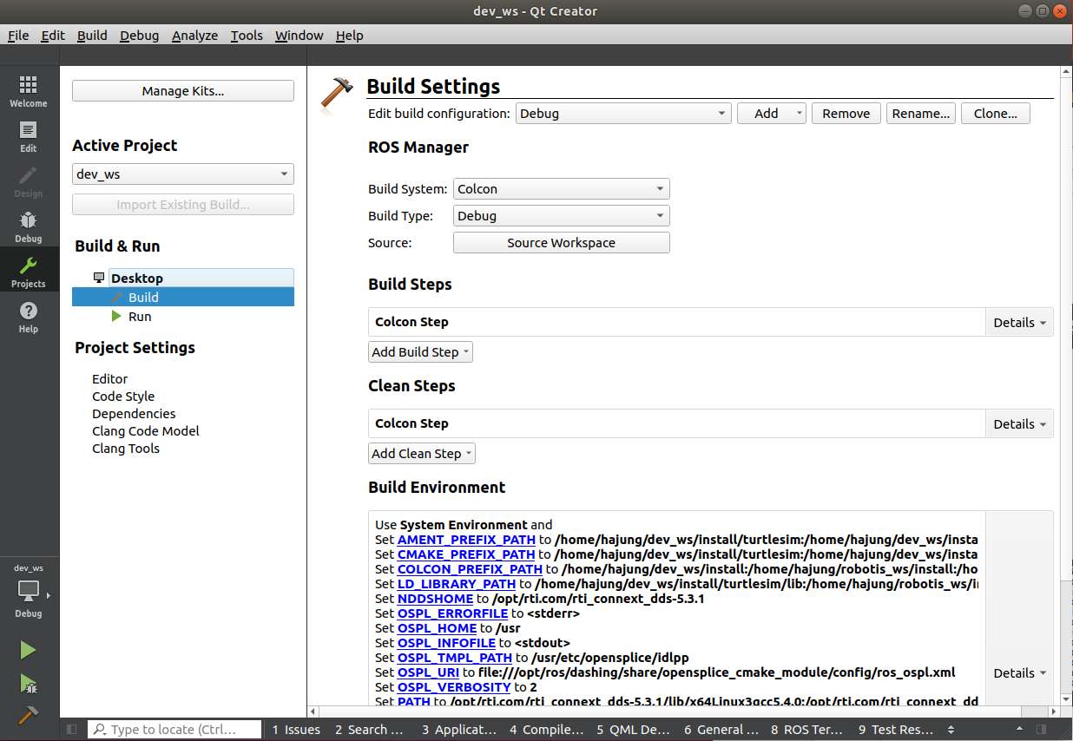
Build System : Colcon
Build Type : Debug

Build Steps
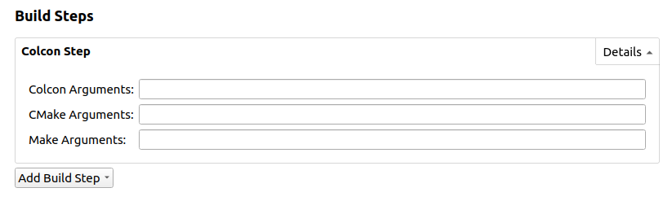
Clean Steps

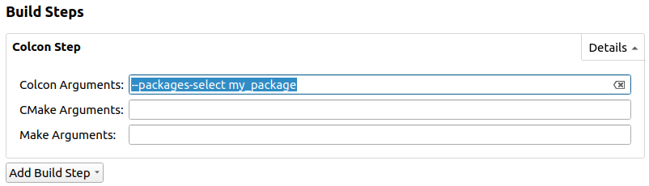
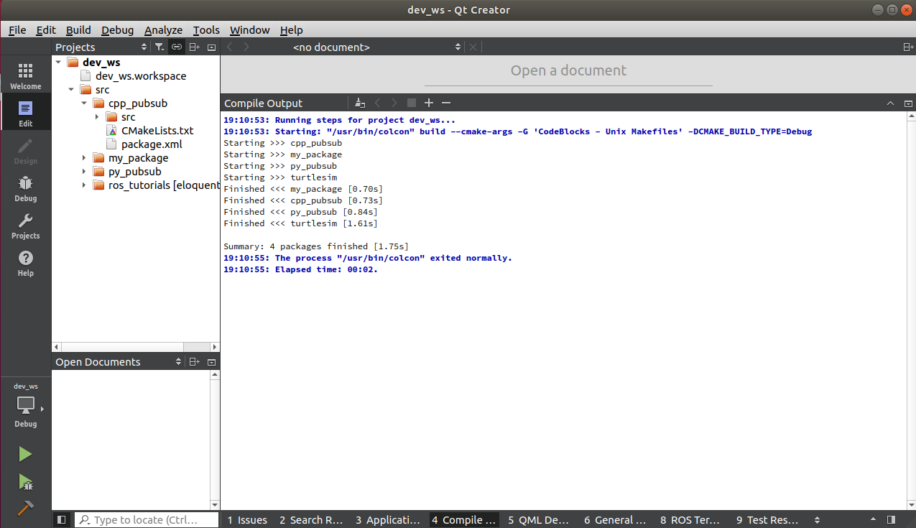

--packages-select my_package

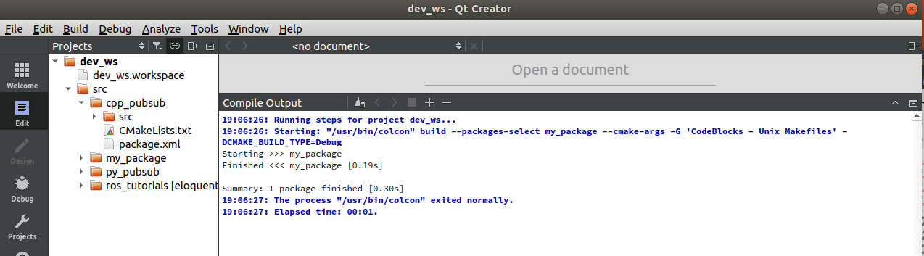

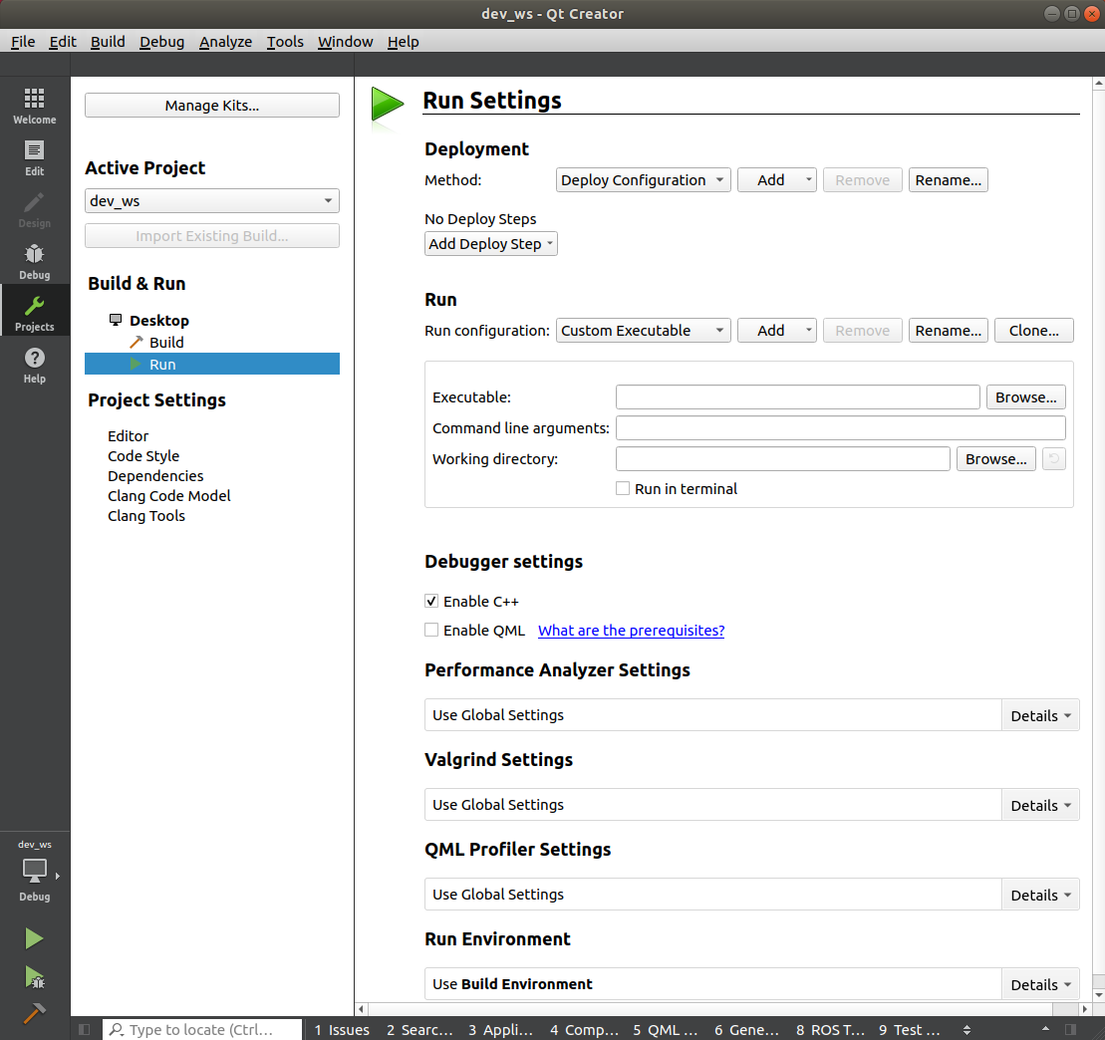

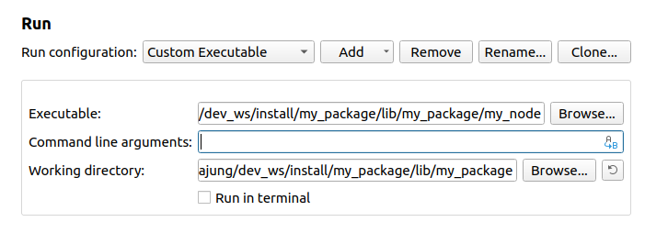

Debugging

Set Break Point로서 Breakpoint 설정
Debug → Start and Debugging on Main() 수행하면 Main() 함수에서 Breakpoint 걸림
그런데 python 으로 작성된 노드는 Main() 함수에서 Breakpoint 걸리지 않음 → 원인??

