Hospital System

Use Cases

By: Trevor Appelt, Vince Lepatan, Prabhat Thapa

Contents

1. Patient 2

1.1 List of Patients 3

1.2 Add new Patient 4

1.21 Add Patient Information 4

1.22 Add Account Information 6

1.23 Add Appointment Information 7

1.24 Add Billing Information 7

1.25 Add Record Information 8

1.3 Individual Patient Information 9

1.31 View Patient Info 10

1.32 View Account Info 10

1.33 View Appointment Info 11

1.34 View Bill Info 12

1.35 View Record Info 12

1.4 Alter Appointment 13

1.31 Make an Appointment 13

1.32 Delete an Appointment 15

1.4 Change Bill 16

2. Employee 18

2.1 List of Employees 19

List of Nurses 19

List of Doctors 19

List of Receptionists 20

List of Janitors 21

List of Technicians 22

# 1. Patient

1) Login to the Hospital System with the username (admin) and password (password) then click ‘submit’.

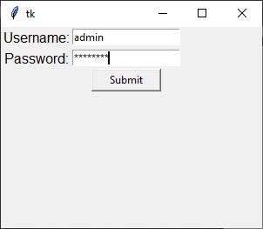

2) Select ‘Patient’

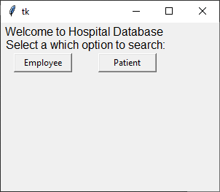

## 1.1 List of Patients

1) Select ‘List of Patients’

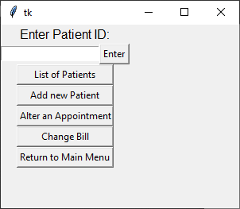

2) A new popup will appear listing the current patient information.

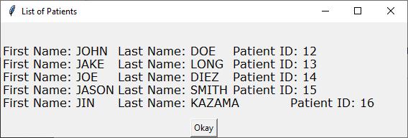

3) Click ‘Okay’ to dismiss the popup

## 1.2 Add new Patient

1) Select ‘Add new Patient’



### 1.21 Add Patient Information

1) Select ‘Patient Info.’

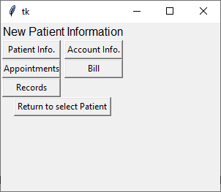

2) Enter in the fields then click ‘Save’

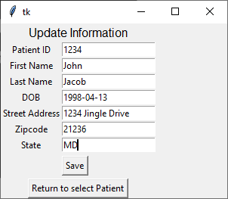

3) Click ‘Return to select Patient’



Before Changes: 

After Changes:

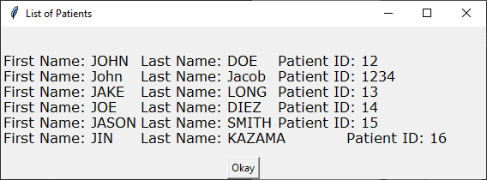

### 1.22 Add Account Information

1) Select ‘Account Info.’



2) Enter the information in the fields then click ‘Save’

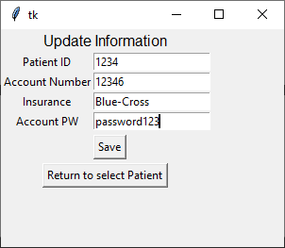

3) Click ‘Return to Select Patient’

### 1.23 Add Appointment Information

1) Select ‘Appointments’



2) Enter the information in the fields then click ‘Save’

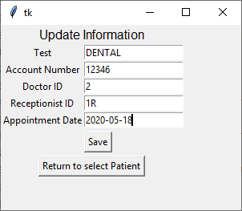

3) Click ‘Return to Select Patient’

### 1.24 Add Billing Information

1) Select ‘Bill’



2) Enter the information in the fields then click ‘Save’

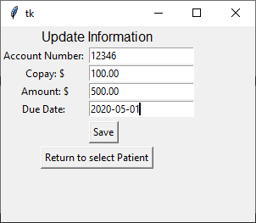

3) Click ‘Return to Select Patient’

### 1.25 Add Record Information

1) Select ‘Records



2) Enter the information in the fields then click ‘Save’

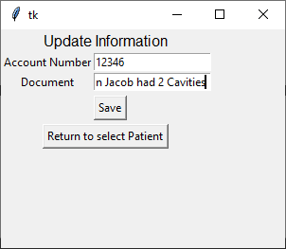

3) Click ‘Return to Select Patient’

## 1.3 Individual Patient Information

1) Enter the Account Number of the patient in the field then press ‘Enter’

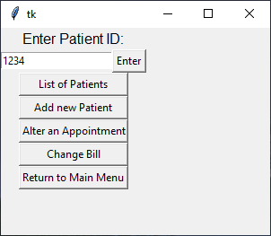

### 1.31 View Patient Info

1) Select ‘Patient Info.’

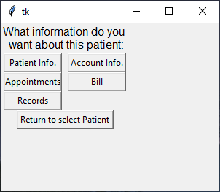

2) A new popup will appear with patient information

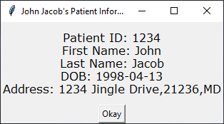

3) Click ‘Okay’ to dismiss the popup

### 1.32 View Account Info

1) Select ‘Account Info.’



2) A new popup will appear with Account information

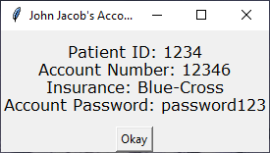

3) Click ‘Okay’ to dismiss the popup

### 1.33 View Appointment Info

1) Select ‘Appointments



2) A new popup will appear with Appointment information

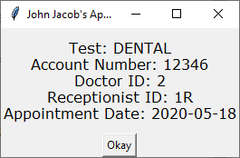

3) Click ‘Okay’ to dismiss the popup

### 1.34 View Bill Info

1) Select ‘Bill’



2) A new popup will appear with Bill information

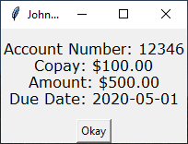

3) Click ‘Okay’ to dismiss the popup

### 1.35 View Record Info

1) Select ‘Records’



2) A new popup will appear with Record information

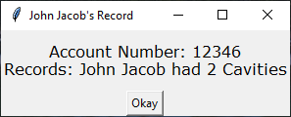

3) Click ‘Okay’ to dismiss the popup

## 1.4 Alter Appointment

1) Select ‘Alter an Appointment’

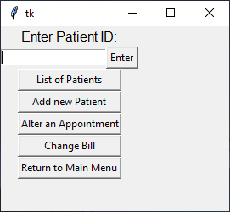

### 1.31 Make an Appointment

1) Select ‘Make an Appointment’

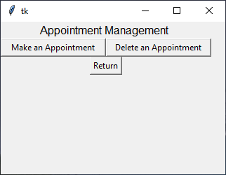

2) Enter the information in the fields then click ‘Save’

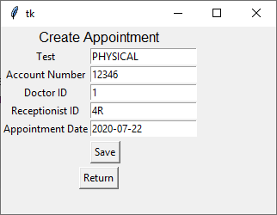

Before:



After:

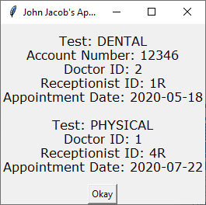

### 1.32 Delete an Appointment

1) Select ‘Delete an Appointment’



2) Enter the Information then click ‘Save’

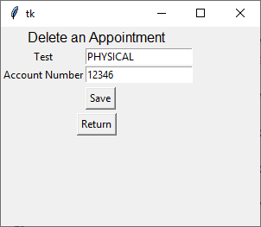

Before:



After:

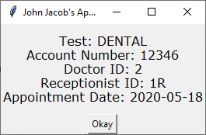

## 1.4 Change Bill

1) Select ‘Change Bill’

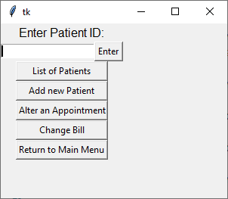

2) Enter the information then click ‘Save’

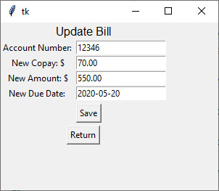

Before:

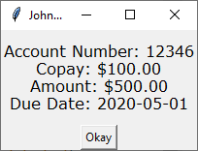

After:

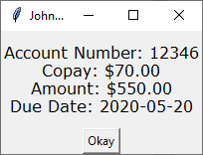

# 2. Employee

1) Login to the Hospital System with the username (admin) and password (password) then click ‘submit’.



2) Select ‘Employee’



## 2.1 List of Employees

### List of Nurses

1) Select ‘Nurse’

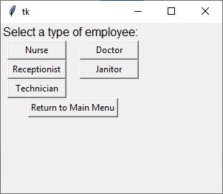

2) A new popup will appear with the list of Nurses

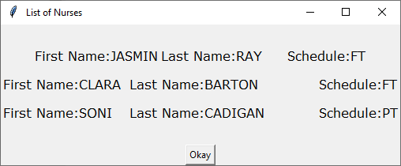

3) Click ‘Okay’ to dismiss the popup

### List of Doctors

1) Select ‘Doctor’



2) A new popup will appear with the list of Doctors

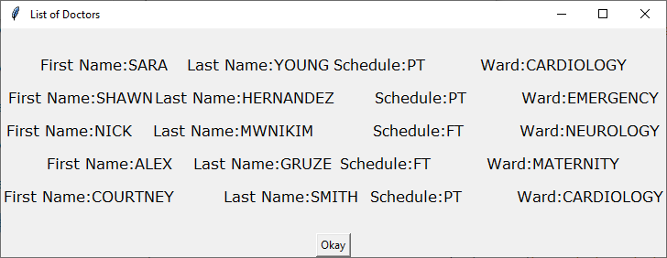

3) Click ‘Okay’ to dismiss the popup

### List of Receptionists

1) Select ‘Receptionist’



2) A new popup will appear with the list of Receptionists

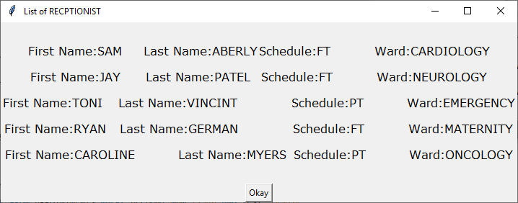

3) Click ‘Okay’ to dismiss the popup

### List of Janitors

1) Select ‘Janitor’



2) A new popup will appear with the list of Janitors

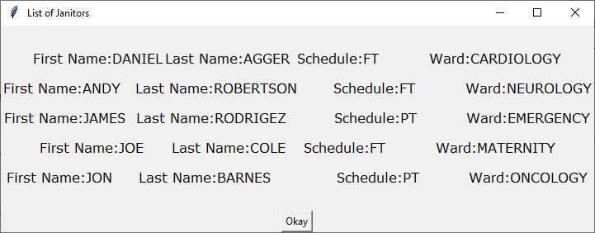

3) Click ‘Okay’ to dismiss the popup

### List of Technicians

1) Select ‘Technician’



2) A new popup will appear with the list of Technicians

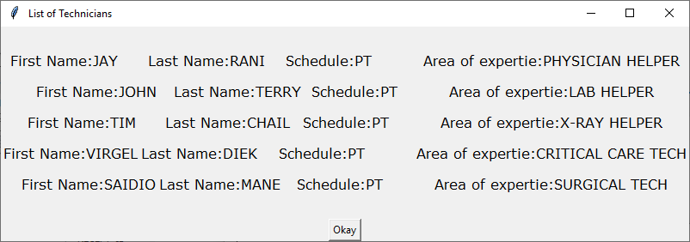

3) Click ‘Okay’ to dismiss the popup