业务频道 编辑

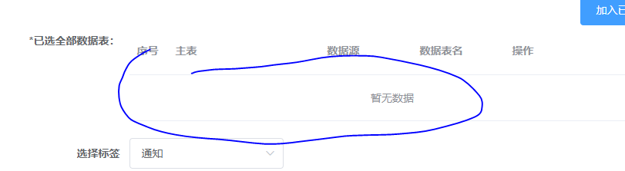

接口没返回tables

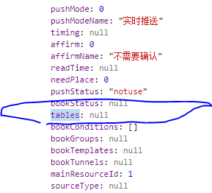

新建时的接口tables

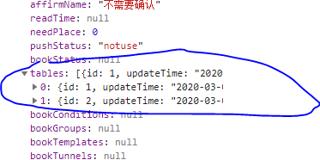

解决：/detail接口返回[tables]即可

权限 -编辑保存 /user/role

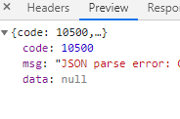

{"code":10500,"msg":"JSON parse error: Cannot deserialize instance of `java.util.ArrayList<com.gocom.smartpush.model.SmRole>` out of START_OBJECT token; nested exception is com.fasterxml.jackson.databind.exc.MismatchedInputException: Cannot deserialize instance of `java.util.ArrayList<com.gocom.smartpush.model.SmRole>` out of START_OBJECT token\n at [Source: (PushbackInputStream); line: 1, column: 1]","data":null}

频道推送 – 频道订阅 -订阅状态修改

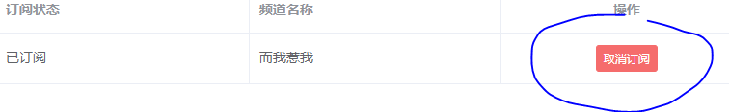

business-channel/book

问题：编辑后的接口能提交成功，但读取后状态未更新

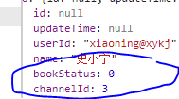 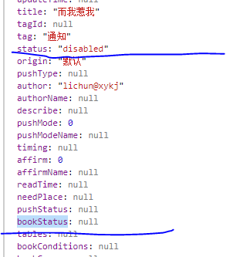

最好是沿用status：str

频道推送—复制

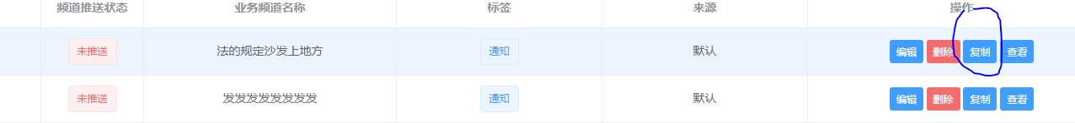

频道推送 = 自定义业务频道

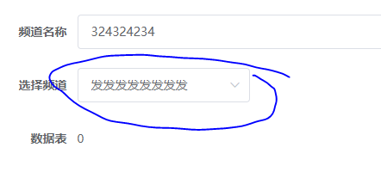 /source/detail?id=5

抛错 {"code":10400,"msg":"5 查找为空","data":null}