ElderSens Router Wifi Configuration Instructions

|  |  |  |
| --- | --- | --- |
| Version | Remarks | Update date& Modifier |
| 1.0.0 | Configuration Instructions | 2018.04.04叶家俊 |
| 1.0.1 | Add 1-2 | 2018.04.10叶家俊 |

* 1. Configuring WiFi by wireless network

1-1-1 Setup network environment.

To configure ElderSensRouter network, ElderSensRouter and PC must first connect to the same network. ElderSensRouter itself can automatically connect to the wireless network named "SM919" and password"zhcfx906" by default. So before configuring, please confirm that you have opened the hotspot or WiFi that sets the wireless network name to the "SM919" password as "zhcfx906".

1-1-2 Start the connection.

After setting up the WiFi environment, connect the ElderSensRouter to the power supply, and set up your PC connection network.

1-1-3 Get the IP address of ElderSensRouter.

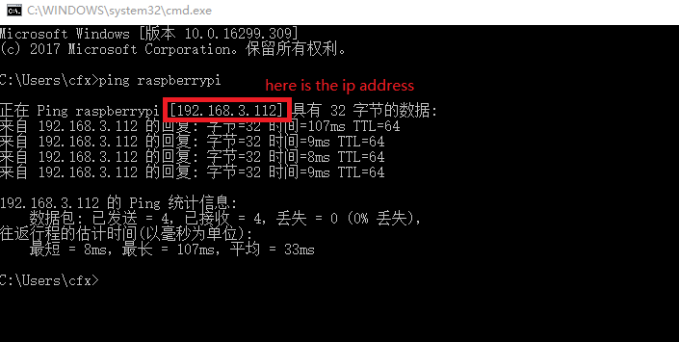Open the command line window of the windows system PC, enter the command "Ping raspberrypi", and get the IP address after receiving the response data. As shown in the following figure.

1-1-4 Connect EldersSensRouter by SSH.

On the PC side, open the putty software, input the IP address from the previous step, connect EldersSensRouter.

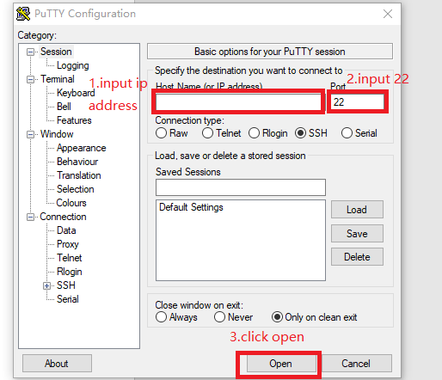

1-1-5 Login.

When SSH connects to ElderSensRouter, it will ask for input account and password, enter the account name "HK", and password "hkhkhk".

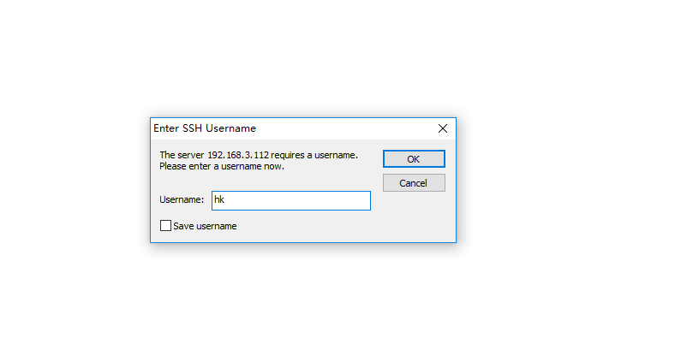

1-1-6 Open configuration file.

After entering the account, you can enter the command :

"vi /etc/wpa_supplicant/wpa_supplicant.conf" then click enter,to enter the configuration file to configure the network.

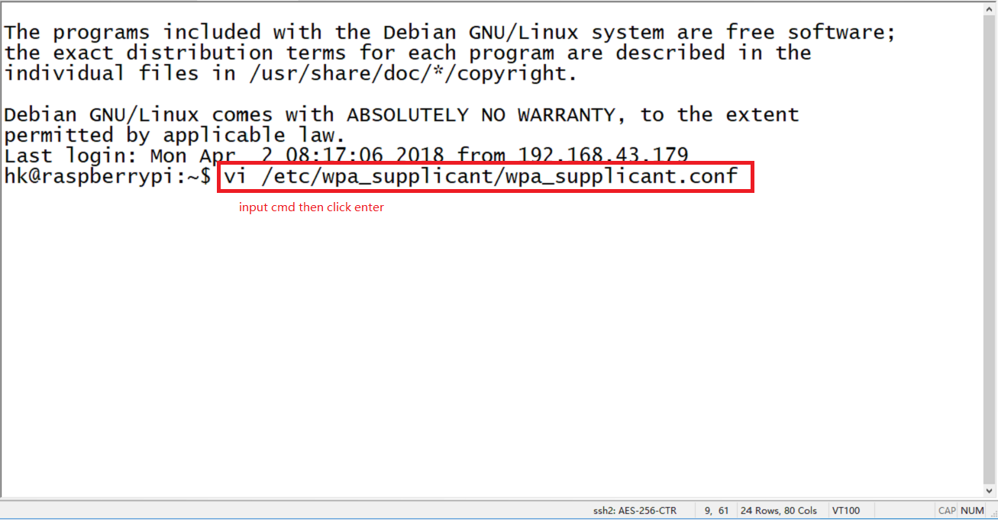

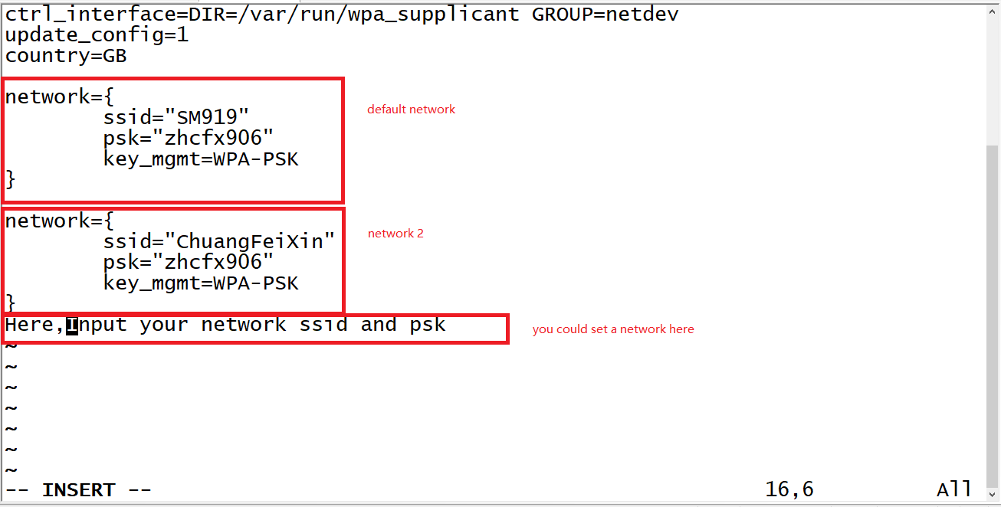1-1-7 Edit configuration file.

After open the configuration file, click the keyboard key“i”I into the edit mode, you can see that the configuration file has set up several networks. After the edit is completed, click the keyboard Esc button, and then enter ":wq" to save and exit.

1-1-8 Do reboot.

After that, we will go back to the command line mode, enter the command "sudo reboot", and confirm that ElderSensRouter will be restarted. After restarting, the network will be automatically set up according to priority.

1-2 Configuring WiFi using network lines

1-2-1 open the PC local wired network sharing item.

The connection between ElderSensRouter and PC can be built through the network cable. It is necessary to open the PC local wired network sharing item first.

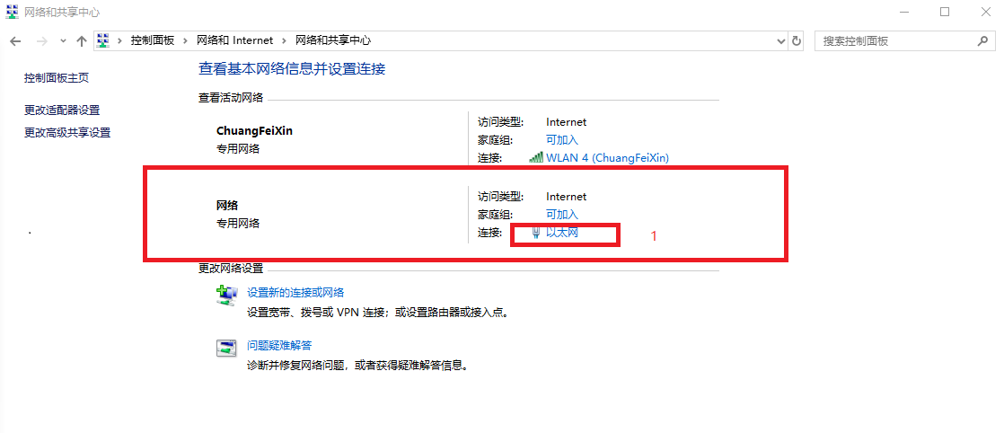

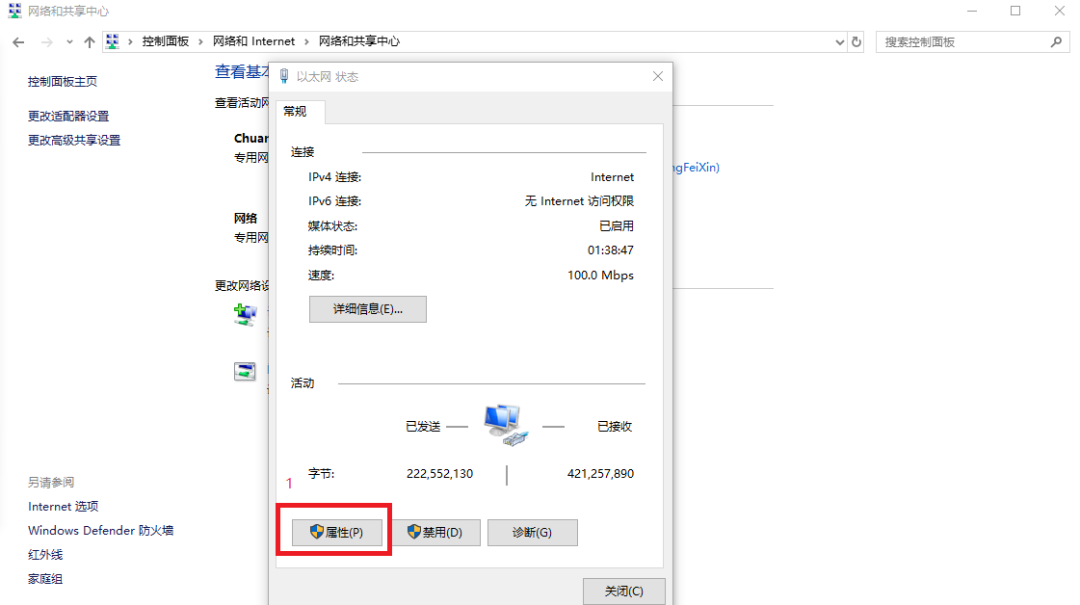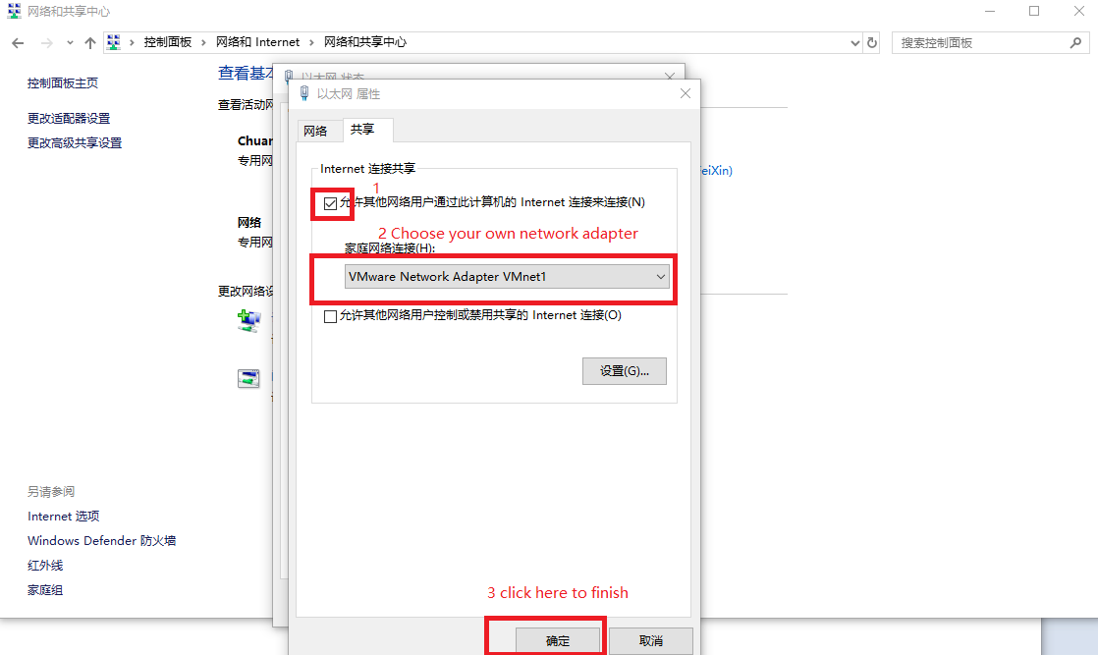

1-2-2

Then we could do the same things,connect Router with ssh,the same as steps 1-1-3 to 1-1-8.

Be careful

Please save the default network, so that it can still reset after the network settings are wrong.