SmartSearch Reranker Investigation
Comprehensive Report — Text-Format A/B Testing, Infrastructure Debugging, and Graded-Relevance (NDCG@10) Evaluation
cyberfaces_rag · branch local-test · repos: SmartSearch (this repo) and Desktop/RCAC/cyberfaces_rag (sibling extraction repo) · 2026-08-26

This report consolidates every experiment run in this investigation, in order: the original text-format A/B test (Fixed-Pool/MCC, 35 queries), the infrastructure debugging required to get a usable GPU run on Purdue's Anvil cluster, the large-scale graded-relevance evaluation (NDCG@10, 1,035 queries), and the corpus-completeness investigation that followed from it — including recovering real content for 14 previously-unreachable documents from a sibling repo. It closes with consolidated findings and recommendations.

1. System Architecture
SmartSearch is a two-stage course search engine for the CyberFaCES cyber-training platform: hybrid retrieval (semantic + lexical) followed by one of three reranking strategies. The diagram below reflects the pipeline as exercised throughout this investigation, including the document-text variants and evaluation methods layered on top for testing.
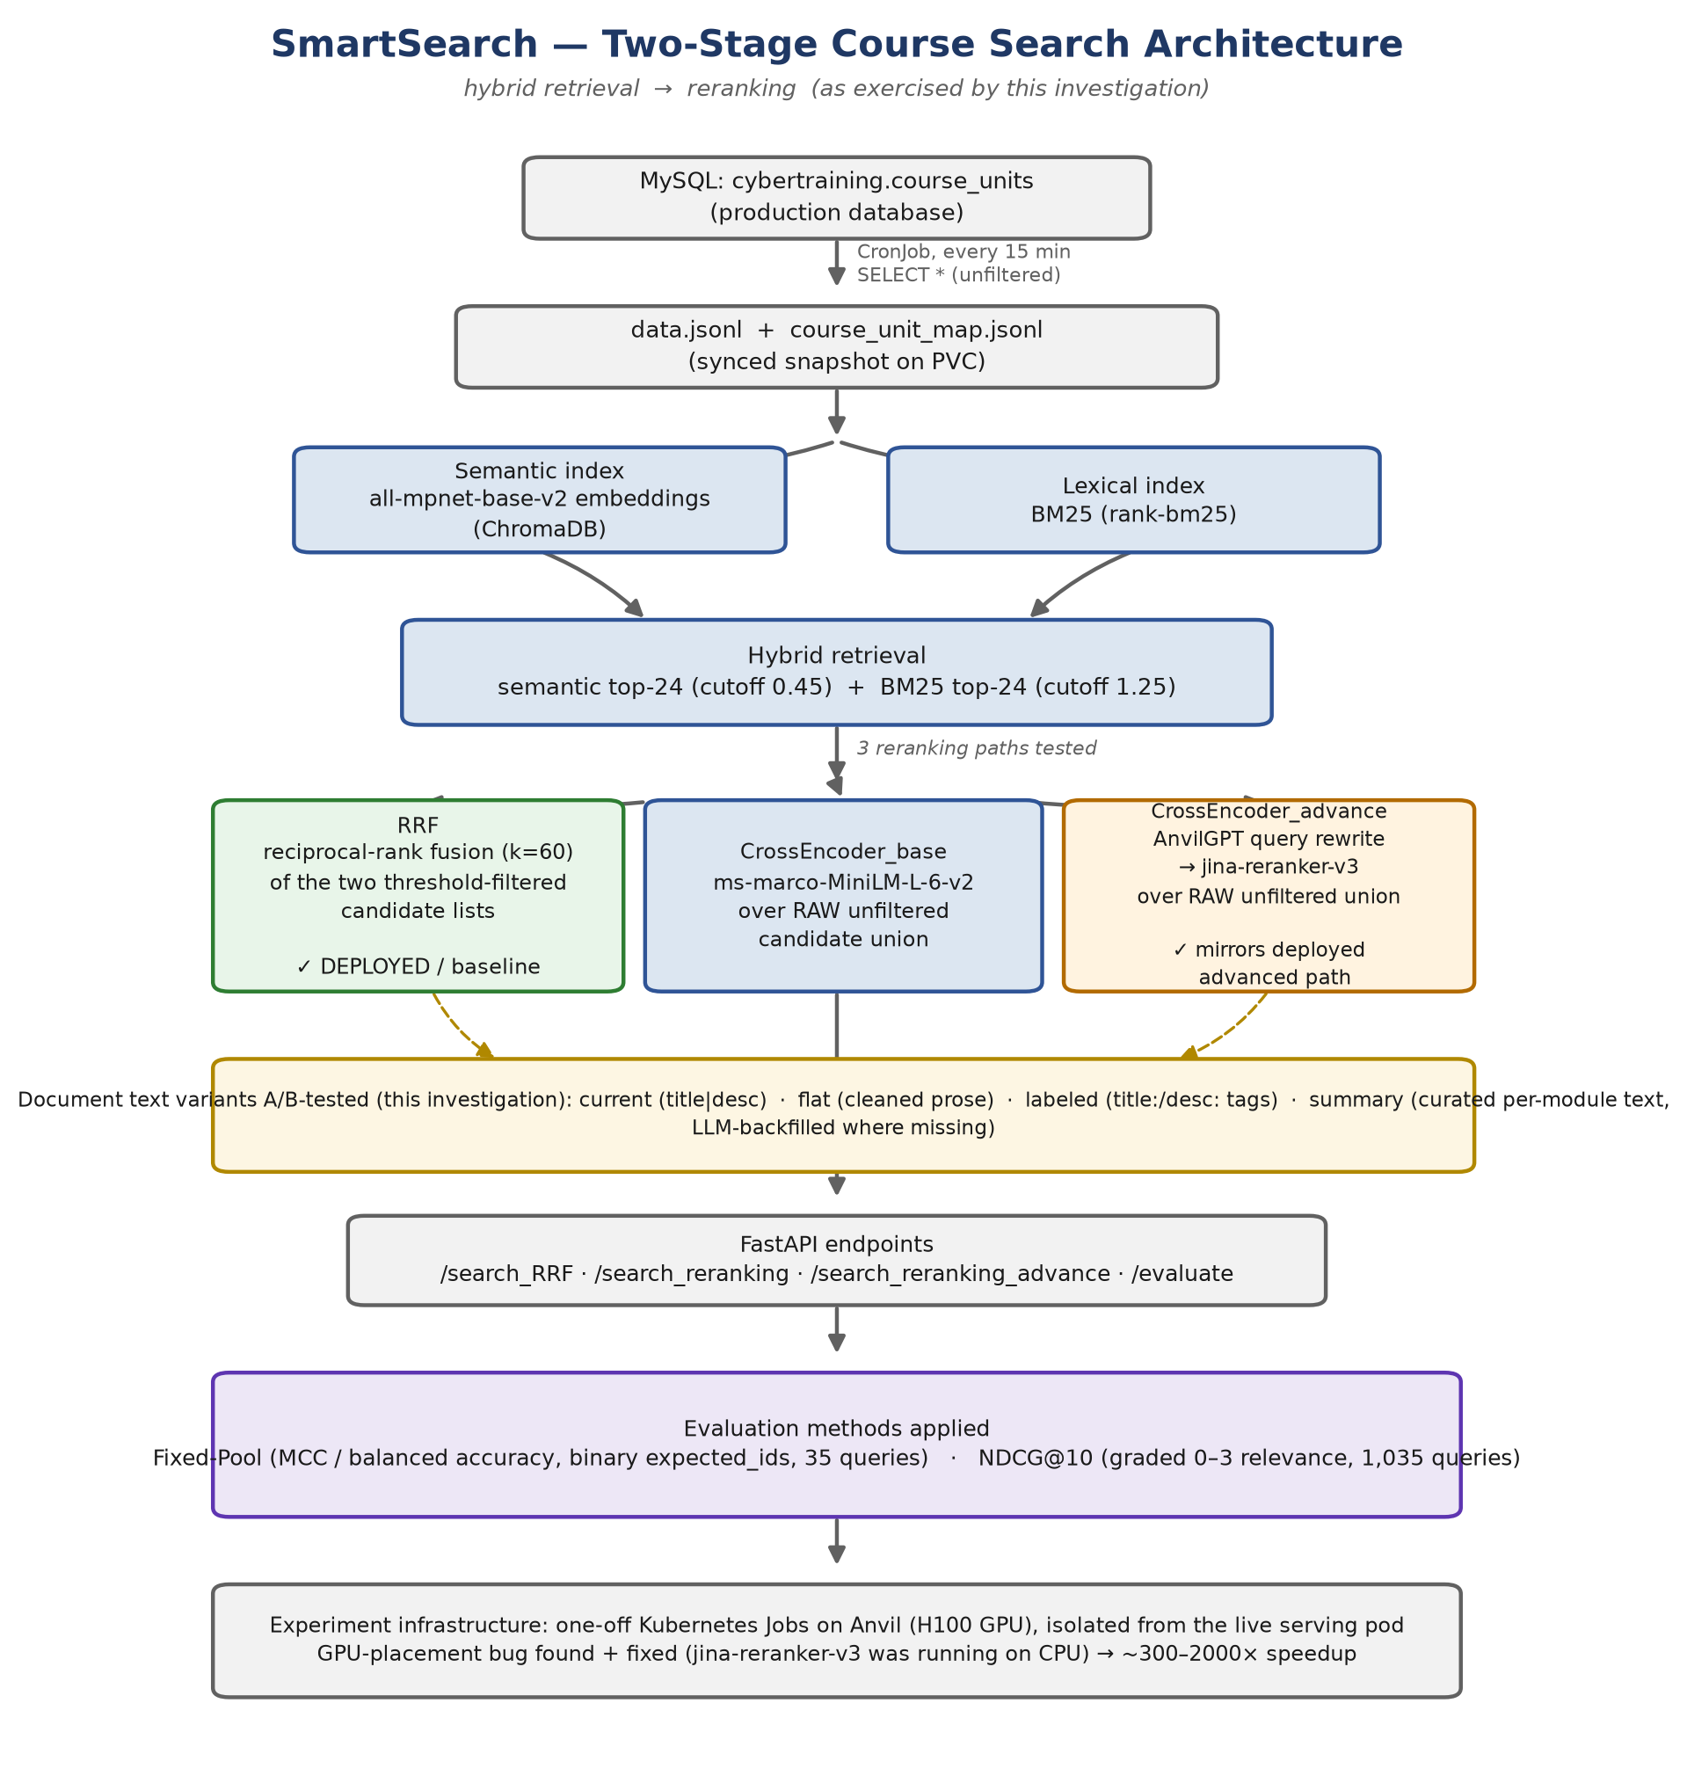

1.1 Component summary
- Data source: MySQL cybertraining.course_units, synced unconditionally (no WHERE filter) every 15 minutes into data.jsonl + course_unit_map.jsonl on a PVC.
- Retrieval: semantic search via sentence-transformers/all-mpnet-base-v2 embeddings in ChromaDB, plus BM25 lexical search (rank-bm25) — each returning the top 24 candidates, each pre-filterable by a calibrated threshold (semantic > 0.45, BM25 > 1.25).
- Reranking — three methods compared throughout: RRF (reciprocal-rank fusion of the threshold-filtered lists, k=60 — the deployed default), CrossEncoder_base (cross-encoder/ms-marco-MiniLM-L-6-v2 over the raw unfiltered candidate union), and CrossEncoder_advance (AnvilGPT query rewrite + jinaai/jina-reranker-v3 over the raw unfiltered union — mirrors the deployed advanced path).
- Serving: FastAPI endpoints (/search_RRF, /search_reranking, /search_reranking_advance, /evaluate), deployed to the cyberfaces-dev namespace on Anvil.

2. Baseline (prior to this investigation)
The starting point was analysis already committed to the repo (SMARTSEARCH_HANDOFF.md), showing the cross-encoder and LLM rerankers classifying substantially worse than RRF — not on recall, but on precision/specificity (over-admission of false positives), on the original 35-query Fixed-Pool evaluation:
Method | micro-Precision | micro-Recall | predicted-pos/query | total FP | mean MCC
CrossEncoder (jina-v3 + QE) | 0.33 | 0.85 | ~18 of ~39 | 430 | 0.36
LLM scoring (gpt-oss:120b) | 0.39 | 0.95 | ~17 | 369 | 0.45
RRF @1.25 | 0.65 | 0.85 | ~9 of ~40 | 114 | 0.68

The leading hypothesis for a contributing cause was document text formatting — specifically the “|” separator injected between title and description in the deployed text (title = “X|Y”). The dominant hypothesized cause, however, was structural: the rerankers reprocess the full unfiltered candidate union instead of pre-filtering by threshold the way RRF does.

3. Phase 1 — Text-Format A/B Test (Fixed-Pool / MCC, 35 queries)

3.1 Method
flatten_ab_eval.py reproduces the repo's exact Fixed-Pool scoring logic and builds each document's text four ways:
- current — title + "|" + description (what the app does today).
- flat — HTML/entities stripped, structural symbols (incl. “|”) removed, collapsed to prose.
- labeled — explicit field labels: “title: … description: …”.
- summary — curated per-module text from summaries/*.md (LLM-backfilled where the catalog had no description). 238 of 336 docs covered; the remaining 98 fall back to current text.

3.2 Results
Method | Text variant | bAcc (mean/med) | MCC (mean/med) | Total FP
RRF | current | 0.861 / 0.892 | 0.680 / 0.691 | 114
RRF | flat | 0.853 / 0.904 | 0.664 / 0.691 | 112
RRF | labeled | 0.844 / 0.881 | 0.644 / 0.699 | 123
RRF | summary | 0.824 / 0.821 | 0.548 / 0.549 | 192
CrossEncoder_base | current | 0.709 / 0.625 | 0.468 / 0.426 | 15
CrossEncoder_base | flat | 0.710 / 0.625 | 0.471 / 0.441 | 15
CrossEncoder_base | labeled | 0.696 / 0.625 | 0.441 / 0.427 | 11
CrossEncoder_base | summary | 0.759 / 0.717 | 0.530 / 0.481 | 80
CrossEncoder_advance | current | 0.708 / 0.700 | 0.270 / 0.255 | 448
CrossEncoder_advance | flat | 0.717 / 0.720 | 0.283 / 0.272 | 470
CrossEncoder_advance | labeled | 0.736 / 0.756 | 0.314 / 0.318 | 393
CrossEncoder_advance | summary | 0.675 / 0.652 | 0.227 / 0.233 | 373

3.3 Findings
- Flattening text (removing “|” and other structural symbols) has almost no effect on any method — all deltas within a few hundredths. Text formatting is not the driver of the rerankers' precision problem.
- labeled framing is a small, consistent net positive for CrossEncoder_advance only (FP 448→393, MCC 0.270→0.314); negligible-to-negative for RRF and CrossEncoder_base.
- summary text is a net negative for RRF (MCC 0.680→0.548) and CrossEncoder_advance (0.270→0.227); it improves aggregate scores for CrossEncoder_base but by inflating false positives 5× (15→80) — a recall/precision trade, not a clean win.
- Caveat carried forward: only 238/336 docs had a curated summary at this point, so the summary corpus was a patchwork of two text styles — addressed later in Phase 3/4.

4. Phase 2 — Infrastructure Debugging on Anvil
Running the harness required GPU-cached models and the ANVILGPT_API secret, both only available on Purdue's Anvil cluster. Several real infrastructure issues surfaced and were fixed along the way.

4.1 Isolation from production
Running all three methods inside the live serving pod's 4Gi memory limit hit an OOM kill (exit 137). Fixed by running as isolated one-off Kubernetes Jobs with dedicated memory/GPU budgets, so the live service was never at risk — its restart count stayed at 0 throughout every experiment.

4.2 GPU contention on the shared cluster
The Job initially requested a MIG GPU slice, but all slices cluster-wide were in use by other tenants. Rescheduled onto a full H100 node instead (tolerating the gpu:h100 taint).

4.3 The real bottleneck: reranker running on CPU, not GPU
The first full run took ~3.5–4 minutes per query for CrossEncoder_advance — at that rate the full experiment would have taken 6+ hours. GPU utilization sampling showed 0% throughout, initially pointing at the external AnvilGPT API. Direct timing tests disproved that (an isolated call with the exact same prompt returned in 0.92s). Instrumenting the script with per-step timing found the real cost:
Step | Before fix | After fix
LLM query rewrite (AnvilGPT) | 1–2s | 1–2s (unchanged — never the problem)
Candidate pooling | ~0.01s | ~0.01s
jina-reranker-v3 rerank() | 298–390s | 0.15–1.75s

Root cause: AutoModel.from_pretrained(ADV_CE_MODEL, trust_remote_code=True).eval() never moved the model onto the GPU — transformers defaults to CPU unless the device is set explicitly. A 28-layer Qwen3-based transformer (jina-reranker-v3's backbone) was running its forward pass over a multi-thousand-token prompt on 1–2 CPU cores. Adding an explicit .to("cuda") produced a ~300–2000× speedup on that step, cutting total run time from a projected 6+ hours to ~6–8 minutes.
Side finding, not yet fixed: production's own load_rerankers() in app/main.py loads jina-reranker-v3 the exact same way — AutoModel.from_pretrained(..., trust_remote_code=True) with no .to("cuda") either, and the one line that would print its device is commented out. This strongly suggests the live /search_reranking_advance endpoint may also be running its reranker on CPU in production. Recommended as a high-priority follow-up to verify and fix separately.

4.4 Result durability and error resilience
- Two full runs were lost to unattended process gaps: a background watcher died, and the Job's default 1-hour cleanup (ttlSecondsAfterFinished) deleted the pod — and its logs — before results could be retrieved. Fixed by extending the Job's TTL to 24 hours.
- A later 1,035-query run crashed entirely on a single transient AnvilGPT 400 error, losing all progress (no retry, no per-query isolation, no checkpointing existed yet). Fixed with three changes: retries with backoff on the LLM call, per-query try/except isolation (a failure in one query no longer aborts the run — it's logged and counted separately), and periodic partial-result checkpointing every 20 queries.
- With these fixes in place, a subsequent run hit the same class of transient error on query 816 and continued to completion cleanly, with the failure isolated and counted rather than fatal.

5. Phase 3 — Graded-Relevance Evaluation (NDCG@10, 1,035 queries)

5.1 Why a new metric and dataset
The user supplied a much larger, graded-relevance ground truth set — final_evaluation_dataset.jsonl, 10,428 rows collapsing to 1,035 unique queries, each judged against ~10 documents on a 0–3 relevance scale — a fundamentally different evaluation than the binary Fixed-Pool method. This required a new ranking-based harness (ndcg_eval.py) rather than reusing the Fixed-Pool classification logic:
- RRF ranking: reproduces the app's real RRF fusion formula (reciprocal-rank fusion, k=60) over the threshold-filtered candidate lists, producing an actual top-10 ranked list (not just an above/below-threshold split).
- CrossEncoder_advance ranking: reuses the LLM-rewrite + jina-reranker-v3 scoring, sorted, top 10.
- NDCG@10 computed per query (DCG over the top 10 divided by the ideal DCG for that query), aggregated by mean/median over all unique queries.

5.2 Corpus-gap discovery
29 of the 346 document IDs referenced in the ground truth — including a contiguous block, IDs 343-367 — don't exist in this project's corpus at all. This was verified directly, not inferred:
- Queried the live production database directly (via a lightweight read-only Kubernetes Job): 310 rows, max ID 317. None of the 29 IDs present.
- Confirmed the sync mechanism does an unconditional SELECT * (no WHERE clause) every 15 minutes, so this is not a sync-lag or filtering artifact — it is the genuinely current database state.
- The three available snapshots (live DB max 317, this repo's data.jsonl max 342, the eval set's references up to 367) form a strictly increasing sequence — consistent with content that existed at some point and was later removed from the database, rather than a parsing or filtering bug.

5.3 Handling the gap in scoring
Per query, both the actual ranking and the ideal (IDCG) ranking are restricted to corpus-present judged documents, so no method is penalized for a gap outside its control. Queries left with zero corpus-present judged documents are excluded from the aggregate and counted separately (never silently scored as 0).

5.4 Result: summary variant, original 336-doc corpus
Method | n_scored | n_excluded | NDCG@10 mean/median
RRF (summary) | 995 | 40 | 0.441 / 0.463
CrossEncoder_advance (summary) | 995 | 40 | 0.447 / 0.461

Notably, CrossEncoder_advance edges out RRF here (0.447 vs. 0.441) — the opposite ranking from the Fixed-Pool/MCC result. NDCG@10 only scores the order of the top 10, so it doesn't penalize CrossEncoder_advance's known over-admission problem the way a fixed-threshold classification metric does. This flip is revisited and clarified in section 6.

6. Phase 4 — Corpus Recovery from the Sibling Repo

6.1 Initial attempt and correction
The user pointed at a sibling repository, /Users/shubham/Desktop/RCAC/cyberfaces_rag, believed to contain the missing documents. Its data.jsonl was checked first and found identical in coverage to this repo's (still missing all 29 IDs). A raw MySQL dump (dump.sql) in that repo was then hand-parsed with a regex-based script — which appeared to confirm the same 300-row, max-ID-307 result as the live production database, i.e. an even smaller/older snapshot.
The user then pointed out that one specific file — summaries/unit_353__unit-353.md in the sibling repo — clearly had substantial real content, directly contradicting the conclusion that the 343-367 block was entirely empty. That correction was right: only ID 343 itself had been checked before generalizing to the whole range.

6.2 Corrected survey
A full byte-size survey of the sibling repo's summaries/unit_XXX__*.md files across the missing-ID range found a genuine mix — about half have real, substantial content (extracted from actual attached lesson files via that repo's extract_courses_full.py pipeline — PDFs, notebooks, markdown — independent of the course_units database table), and about half are still 51-byte empty stubs:
Has real content | Still stub/empty
123, 342, 351–357, 359–361, 365, 366 (14 IDs) | 48, 49, 50, 343–350, 358, 362–364, 367 (15 IDs)

To confirm the dump.sql result rigorously rather than trust a hand-rolled parser (which had already produced one wrong read on this same file), the dump was loaded into a real, throwaway local MySQL 8.0 instance via Docker. The authoritative result matched the earlier parse: 300 rows, max ID 307 — this sibling repo's database dump is an older/smaller snapshot than even this repo's data.jsonl, and does not contain any of the 29 missing IDs either. The recoverable content exists only in the file-extraction pipeline's output, not the database layer.

6.3 Corpus extension and re-run
The 14 documents with real content were extracted into synthetic doc entries (title from YAML frontmatter, body as description) and merged into the corpus alongside the existing 336 — bringing it to 350 documents — with the same content also folded into the “summary” text-variant lookup. The remaining 15 stub-only IDs remain unrecoverable from any source checked (this repo, the sibling repo's dump, or the live production database).
Method | Corpus | n_scored | n_excluded | NDCG@10 mean/median
RRF (summary) | 336 docs | 995 | 40 | 0.441 / 0.463
RRF (summary) | 350 docs | 995 | 40 | 0.474 / 0.491
CrossEncoder_advance (summary) | 336 docs | 995 | 40 | 0.447 / 0.461
CrossEncoder_advance (summary) | 350 docs | 995 | 40 | 0.466 / 0.479

n_scored/n_excluded stayed identical between the two corpus sizes — the 40 fully-excluded queries specifically reference IDs that are still missing even after recovery. But both methods improved measurably for queries that already had partial judged-document coverage (RRF +0.033 mean, CrossEncoder_advance +0.019 mean), confirming the 14 recovered documents were genuinely relevant to real queries.

7. Final Apples-to-Apples Comparison: summary vs. current, under NDCG@10
The NDCG@10 runs above only ever used the “summary” text variant. To directly answer whether switching to summary text actually improves retrieval — as opposed to the separate question of corpus completeness — the “current” variant was also run through the identical harness, against the same extended 350-document corpus and the same 1,035 queries.
Method | Variant | n_scored | n_excluded/errors | NDCG@10 mean/median
RRF | current | 995 | 40 / 0 | 0.477 / 0.496
RRF | summary | 995 | 40 / 0 | 0.474 / 0.491
CrossEncoder_advance | current | 995 | 39 / 1 | 0.498 / 0.510
CrossEncoder_advance | summary | 995 | 40 / 0 | 0.466 / 0.479

Conclusion: switching to summary text does not improve retrieval — if anything, it hurts. For RRF the difference is noise-level (0.477 vs. 0.474). For CrossEncoder_advance, current text is meaningfully better than summary text (0.498 vs. 0.466, a ~3.2-point gap on 995 scored queries) — the opposite of what "richer curated text should help" would predict. This directly confirms the Phase 1 Fixed-Pool/MCC result (summary was worse for both of these methods there too), now under a completely different metric and a corpus without the earlier summary-coverage confound.

8. Consolidated Findings
- Document text formatting is not the lever for reranker precision. Across two independent metrics (Fixed-Pool/MCC and NDCG@10) and two corpus states (336 and 350 docs), summary text is neutral-to-negative for RRF and clearly negative for CrossEncoder_advance. Only labeled shows a small, consistent positive effect, and only for CrossEncoder_advance.
- RRF vs. CrossEncoder_advance's relative ranking depends heavily on the metric. Fixed-Pool/MCC strongly favors RRF (0.68 vs. ~0.23-0.31 MCC) because it penalizes over-admission past a fixed threshold — CrossEncoder_advance's known weakness. NDCG@10 shows the two methods much closer, and even flipping in CrossEncoder_advance's favor with the original 336-doc corpus, because it only scores the top-10 order and doesn't penalize excess lower-ranked false positives the way Fixed-Pool does.
- The dominant root cause of the rerankers' weakness remains architectural, per the original handoff: combine_advance_reranking reranks the full unfiltered candidate union instead of pre-filtering by threshold the way RRF does — not document text formatting.
- A real, high-impact infrastructure bug was found and fixed in the experiment harness: jina-reranker-v3 was running on CPU instead of GPU due to a missing .to("cuda") call, a ~300–2000× slowdown. The same pattern appears in production's load_rerankers() and has not been verified/fixed there.
- The ground-truth eval set (final_evaluation_dataset.jsonl) references 29 document IDs that don't exist in any database or file source checked — this repo, the sibling repo's SQL dump, or the live production database. About half of those (14) have recoverable real content via a file-extraction pipeline in the sibling repo, independent of any database table; the other 15 remain genuinely unrecoverable stubs.
- The eval set's provenance is still unresolved: a teammate (Jungha) stated the summaries/*.md files were the source, but that doesn't account for the 343-367 ID block, which isn't in that folder as it currently exists either. This needs direct follow-up with the dataset's author.

9. Recommendations / Next Steps
- Implement the structural fix identified in the original handoff: filter the candidate pool by threshold before reranking (mirror combine_manual_rrf's pre-filtering inside combine_advance_reranking). This remains the highest-leverage, best-evidenced lever across every experiment in this investigation.
- Verify and, if confirmed, fix the same GPU-placement bug in production's load_rerankers() (app/main.py) — uncomment/add the device check, add .to("cuda") if missing. This could materially affect production reranking latency.
- Do not pursue summary text further as a precision fix — it's now been tested against two metrics and two corpus states with a consistent negative-to-neutral result. If pursuing a text-format change at all, labeled is the only variant with a consistent (if modest) positive effect, and only for CrossEncoder_advance.
- Resolve the eval-set corpus provenance gap with Jungha before treating any further NDCG numbers as final — confirm what snapshot the query/relevance judgments for IDs 343-367 were actually generated against.
- Recalibrate the reranker decision threshold (currently a fixed -0.1, inconsistent with the deployed -0.3) only after the candidate-filtering fix is in place — the current threshold was tuned against an unfiltered, over-admitting pool and is not meaningful in isolation.

Generated from flatten_ab_eval.py and ndcg_eval.py, run as Kubernetes Jobs in the cyberfaces-dev namespace on Anvil (H100 GPU). Raw per-query timing, error logs, and result JSONs are preserved in the corresponding job pods (24h TTL) and local scratch logs referenced throughout this investigation.

