Project 3 Written Report

Yaoqi Lei, Haechan Jung, Yuhang Mao

The target of project 3 is to use gravitational waves to observe a black hole merger.

Gravitational waves are transient displacement in a gravitational field – generated by the relative motion of gravitating masses – that radiate outward from their source at the speed of light. Gravitational waves transport energy as gravitational radiation, a form of radiant energy like electromagnetic radiation. In gravitational-wave astronomy, observations of gravitational waves are used to infer data about the sources of gravitational waves. Sources that can be studied this way include binary star systems composed of white dwarfs, neutron stars, and black holes; events such as supernovae; and the formation of the early universe shortly after the Big Bang. In Einstein’s view: Space can have moved ‘ripples’, called gravitational waves.

A black hole is a region of spacetime wherein gravity is so strong that no matter or electromagnetic energy (e.g. light) can escape it. Anyway, this is a very massive object. That means its motion produces gravitational waves that are easier to observe.

To finish the project 3. We intercept a packet of gravitational wave events from the gwpy database. Which have the raw data from LIGO. Then we De-noise the data to let the data from nonsense to meaningful event like the plot below. There is a significant peak at the center of the plot. That is the event that we are looking for.

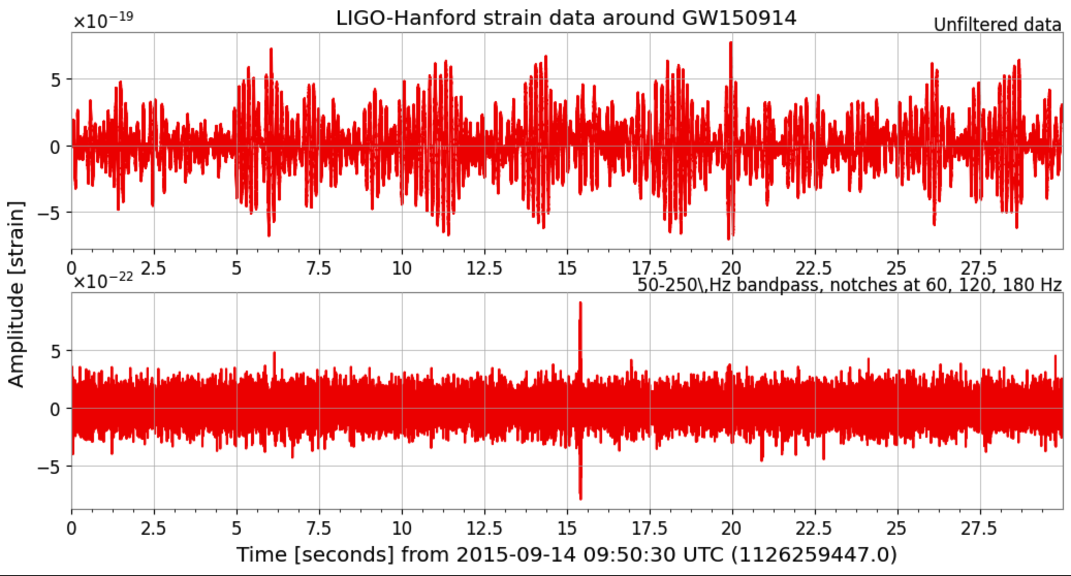

We enlarged the peak portion and overlapped the LIGO-Hanford and LIGO-Livingston data. We can see that as the two black holes move closer together, the gravitational waves get stronger and stronger. But when they merged, the gravitational waves suddenly fell back to normal levels.

The last step is to draw a time-frequency graph and use colors to indicate normalized energy. I like this graph a lot. Because it can show the energy change of the event and the gravitational waves frequency at same time. It can tell us that when two black holes come together, not only do gravitational waves get stronger, they also spin faster between them.

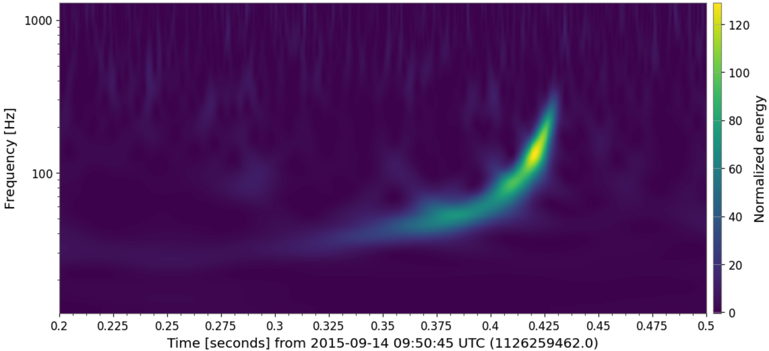

At the end, we calculate the mass of two black holes, black hole 1 is 66.83 solar masses and black hole 2 is 33.41 solar masses.

The energy release because of this merger is about 5.01 solar masses or 8.97e47 Joules.

AI statement:

We used Gemini when coding.

Contribution statement

The presentation and written report are done by our three based on Lei’s code.