The writing report of project 2

Yaoqi Lei, Jung Haenchen, Yuhang Mao

The goal of Project 2 is to determine the ages of the universe and calculate Hubble Constant.

We start with Hubble Constant; Hubble Constant is the rate of change between the velocity that the celestial body gets away from us and how far that celestial body is away from us. It can be seen as a slope of a linear function. So, we can get Hubble Constant equal to velocity divided by distance. Velocity and distance can easily be linked to a very basic physical formula: time is equal to distance divided by speed. If we build up these two relationships, we can work out the formular “T=1/H”, “T” is time that means age of the universe here and ”H” is Hubble Constant.

When coding, first we processed data and calculated the slope and the intercept with this code. Then we use linear approximation to approximate a function to describe the relationship between velocity and distance, distance as x-axis and velocity as y-axis. The result of all the data is “y=49x+6325”, which use Mpc as the unit of distance and use km/s as the unit of velocity. We get the slope here. However, before we calculate the inverse of the slope value, we could identify those points that are less than 4000Mpc away from us are dense, while points that are more than 4000Mpc away from us are sparse. Higher variance lower reliability of estimated linear function! As data points are closer to the line, the variance of data is lower, which means our prediction based on this linear function will be closer to the actual parameter, the actual age of the universe. Since the density level of the data can roughly separate all data into two parts. So, we did linear approximation to each part of the data independently. And we get “y=52x+3900” for the data inside 4000Mpc and” y=46x+4072” for the data outside 4000Mpc. So now we put all together: the separated groups and the original linear function we’ve showed before. They have different values of slopes, but the sizes of the gaps are not significant. In detail, we can see the slope when distance is less than 4000 megaparsec is steeper than the other. The rate of change in the velocity is lower when the distance increases. Based on different groups of data, we get 3 different ages for the universe: 21Gyr, 20Gyr and 19Gyr.

All in all, there are no big differences to each output. There isn’t evidence that makes to question the linear function. Hence, we can assume the linear function is reliable enough to estimate the age of the universe. The age of the universe is 20 Gyr.

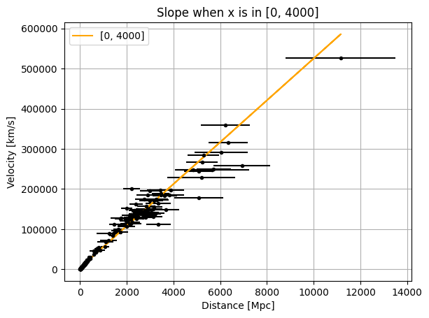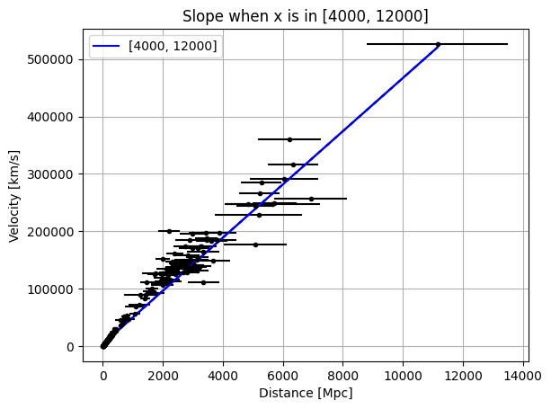

Contribution statement

The PowerPoint for the Presentation was done by Jung. Written reports are done by Lei and Mao.

AI statement:

We used Gemini when coding.