Detail Specification

Jungtin Shoes Shop – version 2020

Documented by :

**Minh Thien & Duc Huy**

# Table of Contents

1. Team Introduction
2. Case study
3. Database design
4. System design
5. Screenshot
6. Conclusion & discussion
7. Contribution

# Team Introduction

**Introduction**

System had been designed with team includes 3 members(1 leader & 2 partners)

## Contact Information

**Mr. Thinh**

**-----------------------------------------------------------------------**

Full name : Thinh Nguyen Trung

Email : [thinhntse140344@fpt.edu.vn](mailto:thinhntse140344@fpt.edu.vn)

Contact Number : 0903999309

Address: 321 Hoang Mai, 9 District, Ho Chi Minh city

**Mr. Thien**

**-----------------------------------------------------------------------**

Full name : Le Duc Minh Thien

Email : thienldmse140995@fpt.edu.vn

Contact Number : 0832654488

Address: _

**Mr. Huy**

**-----------------------------------------------------------------------**

Full name : Nguyen Duc Huy

Email : huyndse140422@fpt.edu.vn

Contact Number : 0909093999

Address: _

# Case study

This is a web application intended for small shoes shops. The system is designed for simple customer target, with functions such as product management, order management for managers, admin.

And in addition, the customer-friendly interface allows research, viewing, surfing to find out information about the product hence promote purchases

# Database Design

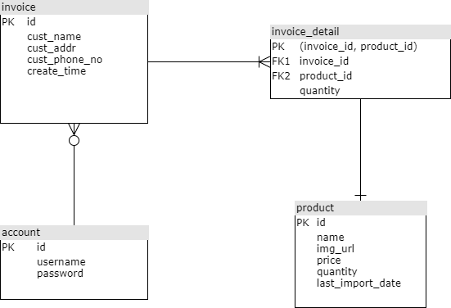

# System Design

## Usecase Diagram

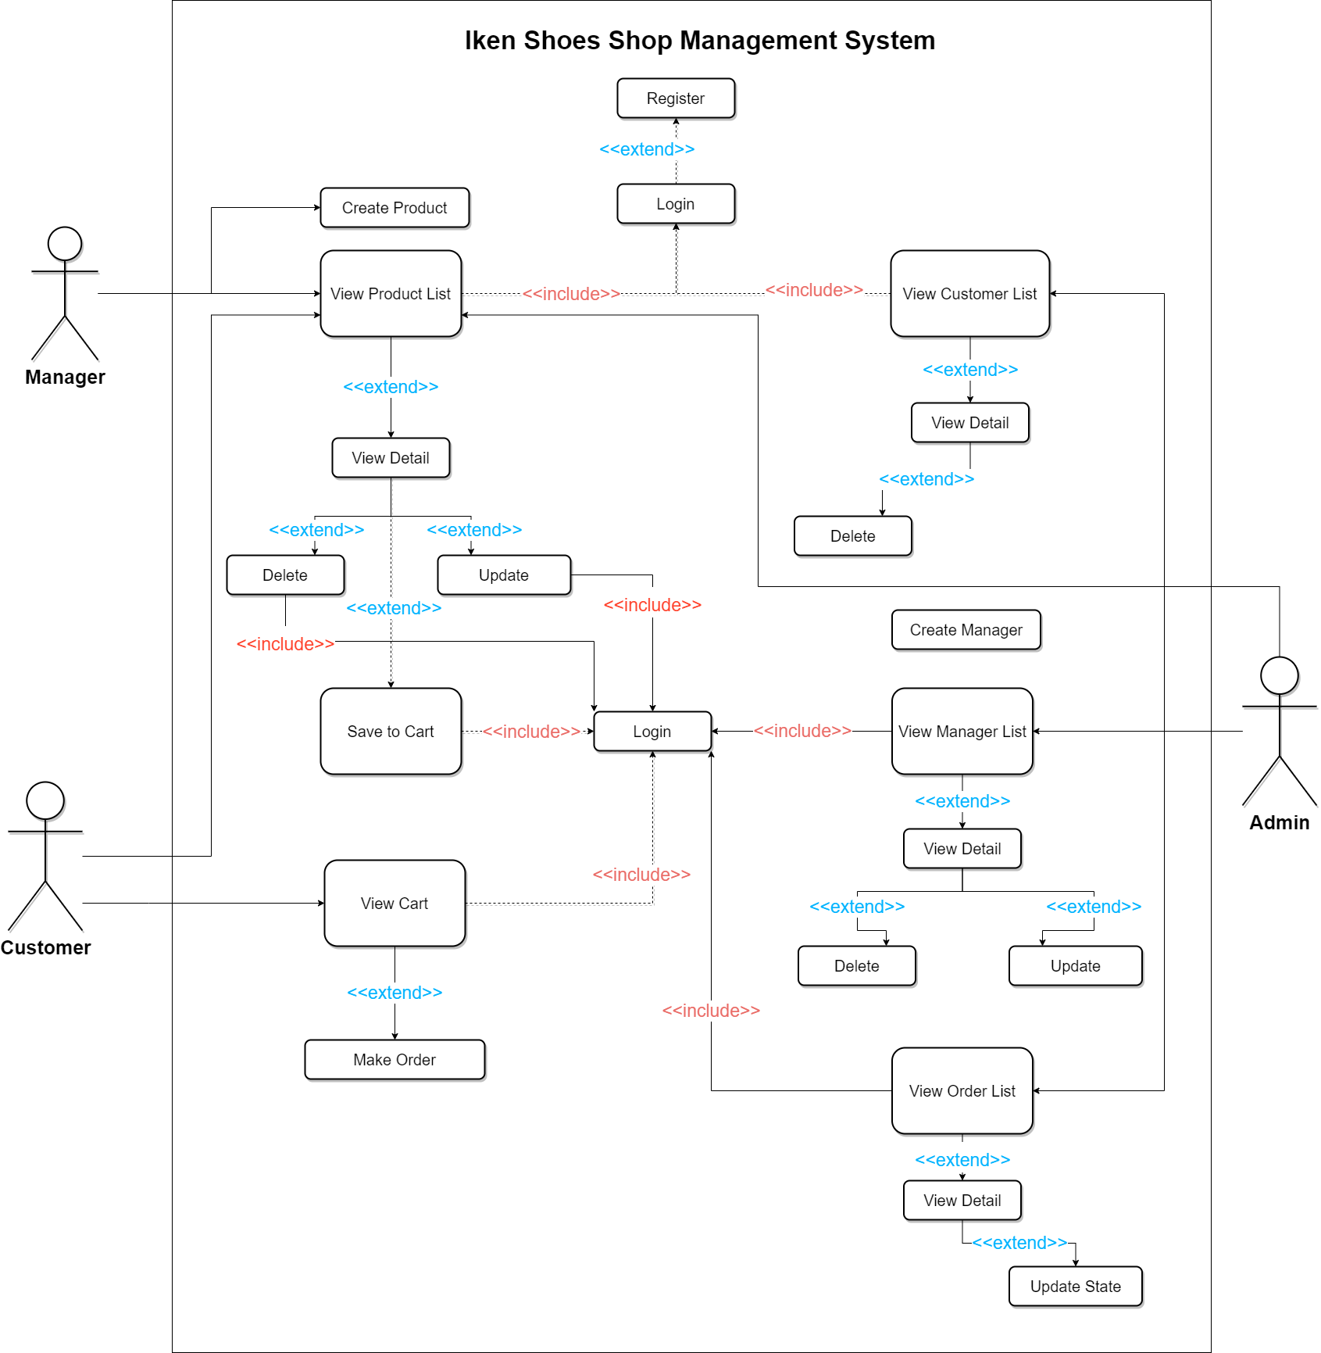

## Class Diagram

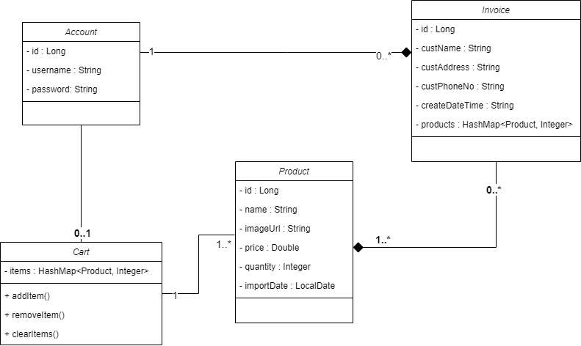

# Screenshots

### Home

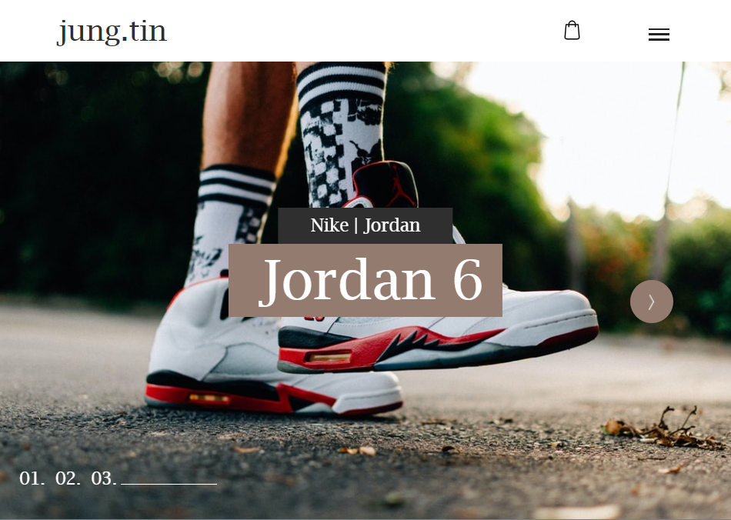

### Product List

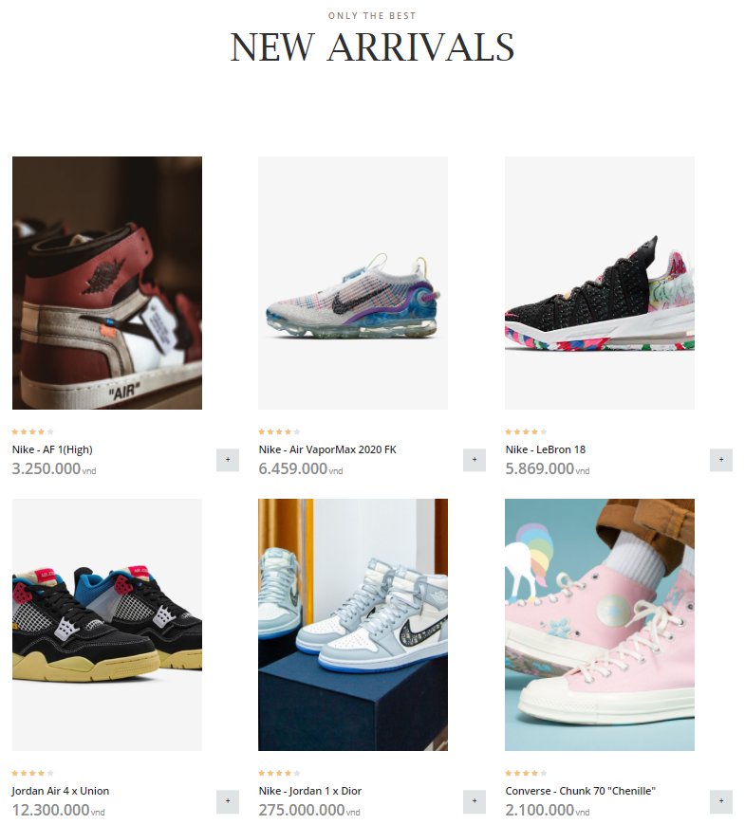

### Product Detail

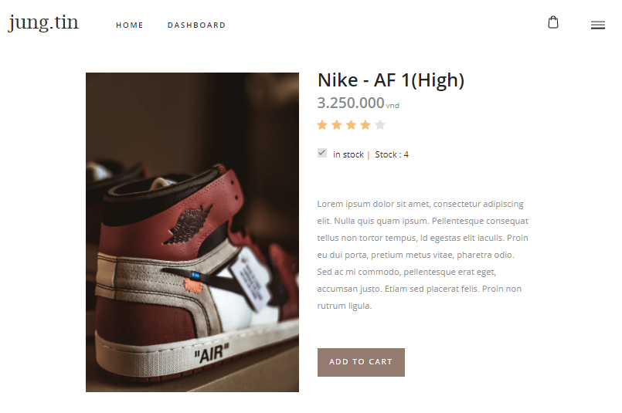

### Cart

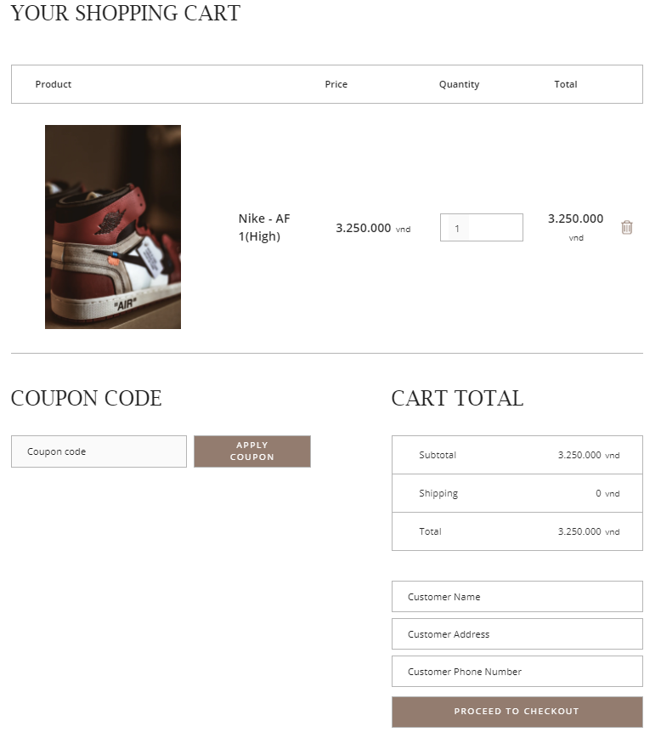

### Login

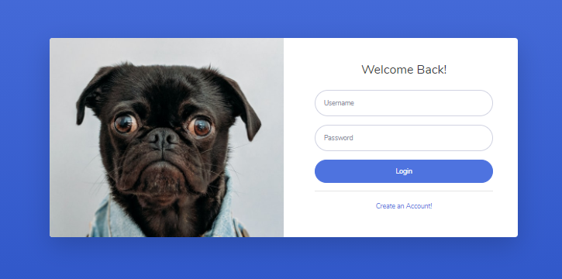

### Register



### Product

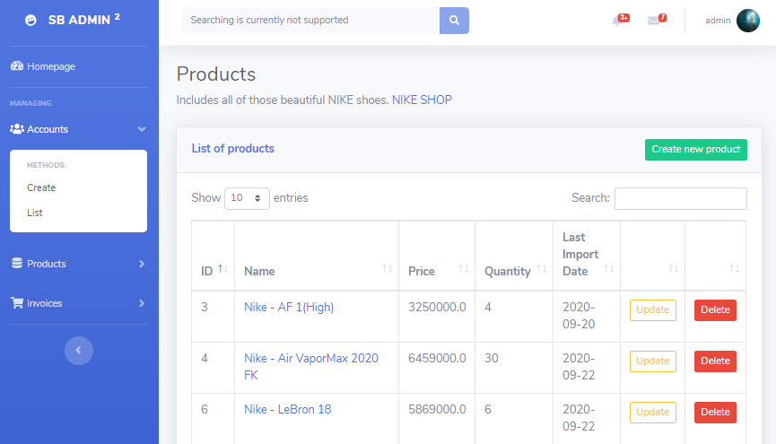

### Product Form

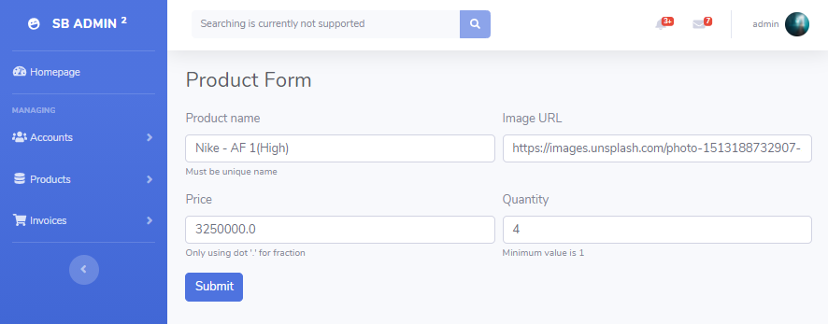

### Account

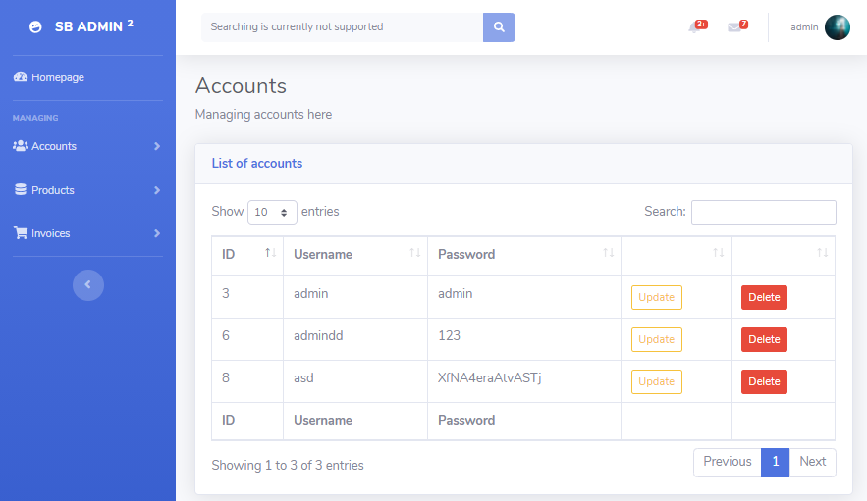

### Account Form

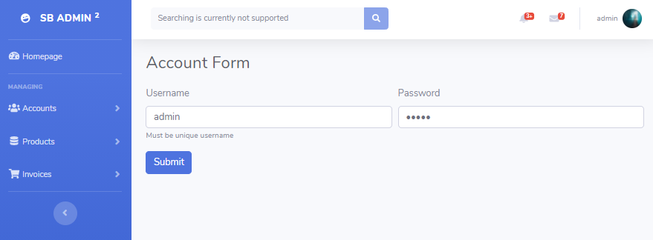

### Invoices

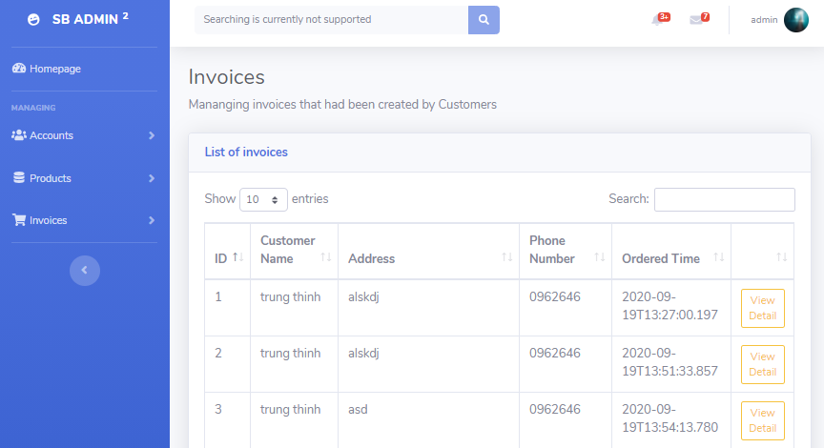

### Details

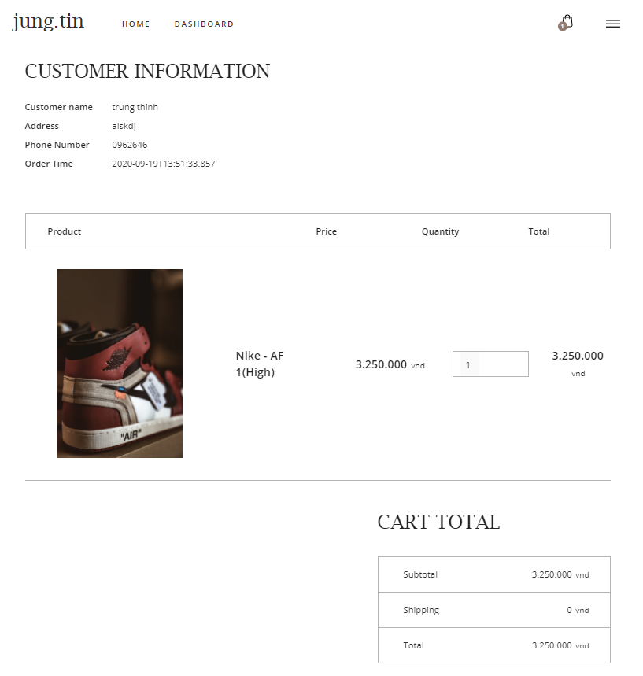

# Conclusion & discussion

Pros :

This is a simple, straightforward application that can be used by anyone who doesn't need webmaster knowledge

The ability to customize according to the store owner's demands is higher-chance

Cons :

It takes time to build existed functionality that if using cms will be better supported

SEO is not supported much 🡪 the important aspect of sales website has lost

Spend a lot of time & money on upgrades and maintenance

If in the future, using this project as a real project, there are some places that must be improved:

* Developing accounts for customers (storing customer information)
* Register with email verification
* Integrating payment system by card
* Optimize seo for the website
* Allow posting images by file or url
* Integrated cloud image-optimizer
* Integrated wysiwyg editor for manager, admin
* Integrated social network features: like, share, comment
* Integrating direct message system for customers
* Integrate Web analyst for the owner

# Contribution

|  |  |  |  |  |
| --- | --- | --- | --- | --- |
| **Topic** | **Team**  **Effort** | **Trung Thinh** | **Minh Thien** | **Duc Huy** |
| **Database design** | 100% | **100%** | **0%** | **0%** |
| **System design** | 100% | **70%** | **30%** | **0%** |
| **Implementation** | 100% | **30%** | **35%** | **35%** |
| **Documentation** | 100% | **10%** | **50%** | **40%** |