**App Name:** Just Run

**App Tagline:** Workout while exploring your area by running to random landmarks

**Backend Github repo:** https://github.com/Keehoonlee/appdevfinal

**Features:**

Just Run is an exploratory running app that randomly selects a landmark within a given radius for users to run to in a specific time frame. There are three views: Home, Past Workouts, and Run.

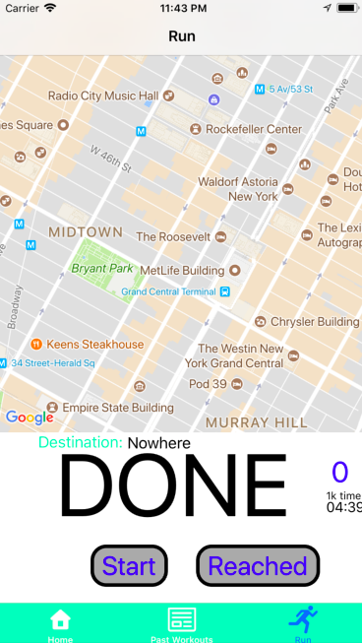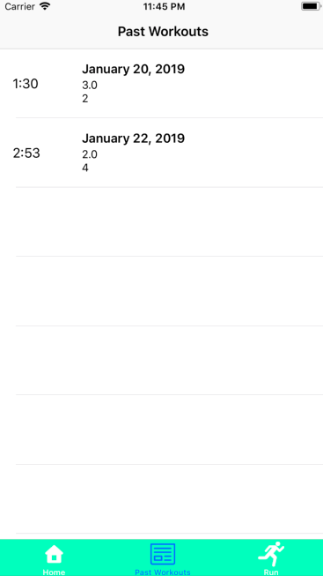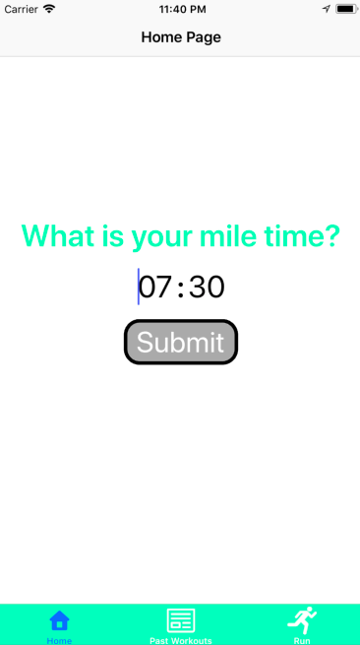

In the Home view, users can set their mile time so that the app knows what pace they run at.

In Past Workouts, users can see details of their previous workouts. Every time a workout is finished, it will be added to the array of previous workouts. **We ran into issues with TabBarController reinitializing views every time a tab was clicked, which caused problems with delegating data between the RunViewController and PastWorkoutsController.

In Run, users can find a landmark based on their pace that they set back in the Home view. First, the app will make a network request to the API created by the backend developer to retrieve a random landmark at that distance. Then, the app makes another network request to Google Places API to draw the route onto the map view. The app also calculates how long it should take to get to the landmark based on user's preferred distance and pace, and creates a timer to help the user keep track of how fast they should run.

**iOS requirements:**

Autolayout: every UI element uses NSLayoutConstraints

TableView: Past Workouts view uses a table view to display each workout's information

Navigation: app uses TabBarController to navigate between Home, Past Workouts, and Run views

API: app uses Google Maps and Google Places API to display the map and draw the walking path from origin to destination.

**Backend requirements:**

Keehoon designed an API using functionalities of Google Places & Google Maps Directions API and deployed it on Amazon Web Services using Digital Ocean. It returns the results in JSON format based on the user’s request. No DB included (talked to Young about this).

Server IP : http://13.59.217.0/api/v0/