AAI3201 Assignment1:

Fine-grained Image Classification of Korean Food

2021147584

Jungwoo Ahn (안정우)

Environment

Used Goolge COLAB GPU (V100)

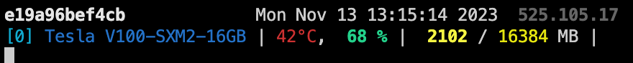

Code

Used PyTorch Deep Learning Framework

Dataset, Dataloader

Since the folder, file structure of the given dataset is like this, I made a new custom pytorch dataset and dataloader as follows ->

Made 3 dictionaries to plot class-wise accuracy.

More implementation details can be found out on GitHub.

Classification with deep multi-layer perceptron (MLP)

* 1. Describe model details (hyperparameters) your have used (e.g., initial learning rate, weight decay and etc.)

두개의

* 1. Why did you choose to use these hyperparameters? (e.g., using cross validation)
  2. Report both the training and testing accuracy in a plot (x: epoch, y: accuracy).
  3. Plot class-wise test accuracy.
  4. What is the possible reasons for the bad performance in some classes
  5. Discuss any ideas to improve the accuracy
  6. Apply your idea to improve the accuracy
  7. Plot class-wise test accuracy and the average test accuracy.

Classification with deep convolutional neural network (CNN)

* 1. Describe model details (hyperparameters) your have used (e.g., initial learning rate, weight decay and etc.)

CNN, CNN_L등 사진첨부 CNN with residual connection

Model_info 소개

* 1. Why did you choose to use these hyperparameters? (e.g., using cross validation)

Scheduler, validation

* 1. Report both the training and testing accuracy in a plot (x: epoch, y: accuracy).

사진

* 1. Plot class-wise test accuracy.

사진

* 1. What is the possible reasons for the bad performance in some classes

사진을 봤더니.. 내가봐도..

* 1. Discuss any ideas to improve the accuracy

Augmentations, grad-vanishing->residual connection, scheduler

* 1. Apply your idea to improve the accuracy

(사진) lr step rate 이외에도 많은 실험을 함. Early stop

* 1. Plot class-wise test accuracy and the average test accuracy.

(사진)