**CS2100 Computer Organisation**

***Remember to bring this along to your lab!***

**Lab #7: Using Logisim I**

(Week 10: 20 – 24 October 2025)

Name: \_\_\_\_\_\_\_\_\_\_\_\_\_\_\_\_\_\_\_\_\_\_\_\_\_\_\_\_\_\_\_\_\_\_\_\_\_\_ Student No: \_\_\_\_\_\_\_\_\_\_\_\_\_\_\_\_\_

Lab Group: \_\_\_\_\_

**Important:** You should complete the report before you come for your lab or you may not have enough time to complete it.

For Monday and Tuesday lab groups, please see point 11.

**Objective:**

You will learn to use **logisim** to analyse a simple circuit and create a 4-bit parallel adder.

**Preparation (before the lab):**

1. Download **logisim** from the website: <http://www.cburch.com/logisim/download.html>

(Logisim has been installed in the computers in the labs.)



2. Run **logisim** and you will see this screen:

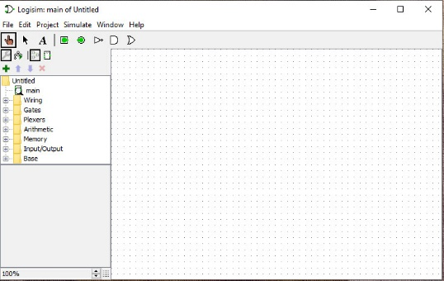

3. Click on “Help” 🡪 “Tutorial” and read “Beginner’s tutorial”. Familiarise yourself with the basic working of the software. Go through the 5 steps in the tutorial and create some simple circuits yourself.

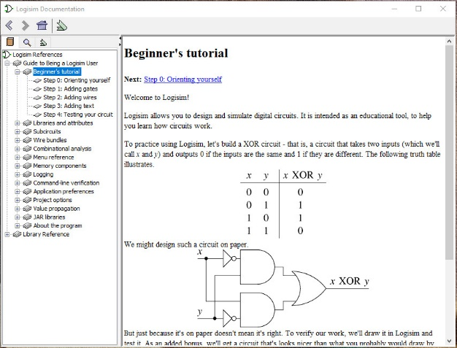

**Procedure:**

1. Download the file **lab8.circ** from Canvas or the CS2100 website.

2. Open **lab8.circ** in Logisim. Select the “Poke” tool lab5_poke_tool and then click on the inputs *X*, *Y* and *Z* to toggle their values, and observe the changes in the outputs.

3. What is the name of the circuit? [1 mark]

Answer: **\_\_\_\_\_\_\_\_\_\_\_\_\_\_\_\_\_\_\_\_\_\_\_\_\_\_\_**

4. The circuit has two outputs *S* and *C*, but they are not labelled. Add the labels correctly. Show your labTA. [2 marks]

For Monday and Tuesday lab groups, as you have no physical lab that day, you do not need to do this. 2 marks will be awarded to you if you submit your report. See point 11 below.

5. Click “Project” 🡪 “Analyze Circuit”. Click on “Table”, and fill in the table below with what you have observed. (If you find that the outputs do not appear in the same column-order as in the table below, you can change the order by clicking on “Outputs”.) [2 marks]

|  |  |  |  |  |
| --- | --- | --- | --- | --- |
| ***X*** | ***Y*** | ***Z*** | ***C*** | ***S*** |
| 0 | 0 | 0 |  |  |
| 0 | 0 | 1 |  |  |
| 0 | 1 | 0 |  |  |
| 0 | 1 | 1 |  |  |
| 1 | 0 | 0 |  |  |
| 1 | 0 | 1 |  |  |
| 1 | 1 | 0 |  |  |
| 1 | 1 | 1 |  |  |

6. Still at “Project” 🡪 “Analyze Circuit”. Click on “Minimized”. Below the K-map of an output you should see the simplified SOP expressions for that output. Write down the simplified SOP expressions for the two outputs *S* and *C*. [2 marks]

*S =* ***\_\_\_\_\_\_\_\_\_\_\_\_\_\_\_\_\_\_\_\_\_\_\_\_\_\_\_\_\_\_\_\_\_\_\_\_\_***

*C =* ***\_\_\_\_\_\_\_\_\_\_\_\_\_\_\_\_\_\_\_\_\_\_\_\_\_\_\_\_\_\_\_\_\_\_\_\_\_***

7. Currently, the circuit you have is in the “main” circuit. Now, click on “Project” 🡪 “Add circuit...”. A pop-up menu will appear asking for the circuit name. Enter the name with the answer you have for part 3 above. This will create a new entry with that name just below “main”. Let’s refer to this name as xxxx here for the subsequent parts.

8. Transfer the circuit you have in “main” (using the select button lab5_select_button and click and hold the left mouse button to select the whole circuit, then press **ctrl-x** to cut) and paste it into the newly created “xxxx” circuit (click on “xxxx” – making sure the magnifying glass is over it – and press **ctrl-v** to paste).

9. Go back to the “main” circuit (which should be empty now). Create a **4-bit parallel adder** here by using 4 copies of the xxxx circuit you have created earlier. A partial diagram is shown below.

* Each xxxx is represented by a block diagram. The labels are indicated in one of the block diagrams below for your reference.
* The 4-bit inputs *X* and *Y* are created by clicking on the input pin button lab5_input_pin and specifying 4 data bits in the attribute table. Likewise, the 5-bit output *S* is created by clicking on the output pin button lab5_output_pin and specifying 5 data bits in the attribute table.
* Splitters (refer to the Logisim tutorial, “Wire bundles” 🡪 “Splitters” for more details) are used to route the different bits in the inputs and outputs.

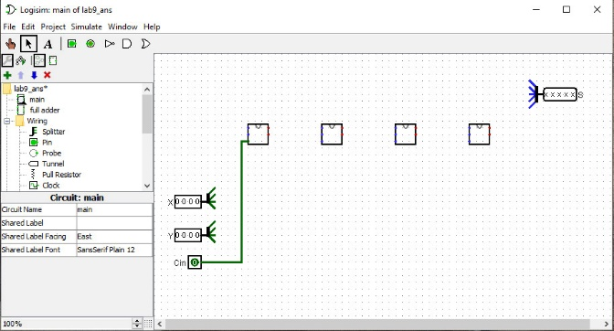

*Xi*

*Yi*

*Zi*

*Si*

*Ci*

**splitter**

10. Show the completed 4-bit parallel adder circuit to your labTA. [8 marks]

11. For Monday and Tuesday lab groups (B28 – B43), you are to email your (a) lab report and (b) your logisim file (.circ) to your labTA, by 22 October 2025, Wednesday, 3pm.

Report: 5 marks

Demonstration: Part 4 (2 marks), Part 10 (8 marks)

Total: 15 marks