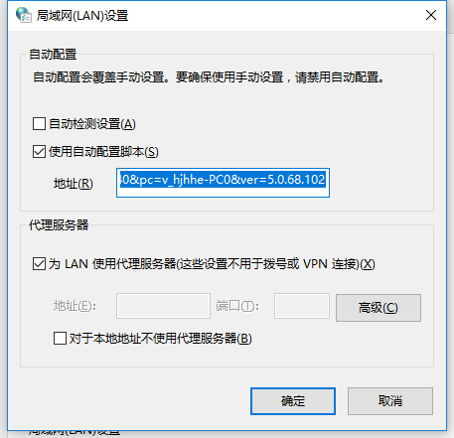

http://txp-01.tencent.com/proxy.pac?ip=10.24.78.40&pc=v_hjhhe-PC0&ver=5.0.68.102