Modern Preview-Only File Viewer
This DOCX sample validates LibreOffice conversion with headings, styled text, a table, and embedded images.
- Bilingual documentation target: zh / en
- Preview-only policy: no edit, no export, no upload
- Commercial-friendly license target: Apache-2.0
Formatted emphasis block
Capability | Status | Notes
Office preview | Supported | LibreOffice + JODConverter
CAD preview | Unsupported | Excluded in v1
Media transcoding | Unsupported | Excluded in v1
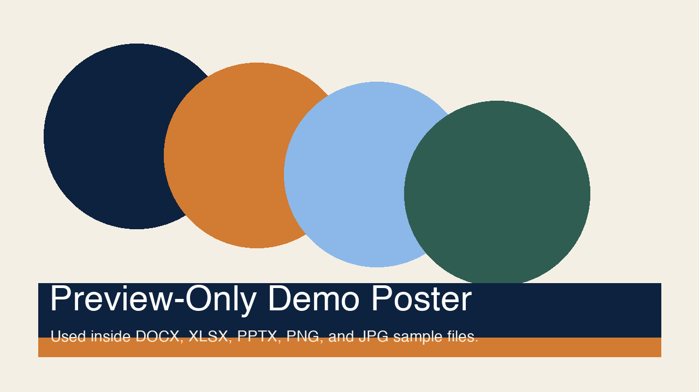
Generated on 2026-03-27.

