Introduction
When calling a subprogram module (named callee), the calling program (named caller) uses a parameter passing method to provide to the callee the input parameters it uses as the operands of its algorithm. When returning, the callee uses parameter passing methods to return its results to the caller (including the value returned by a callee that is a function subprogram module). There are several parameter passing methods: (1) place parameters in main memory locations; (2) place parameters in CPU registers; or (3) place parameters on the run-time stack. Note SPL uses method (3).

To create a subprogram module (the callee), a copy of its instructions is placed in main memory then the caller can execute a CALL instruction. Flow-of-control continues from the caller CALL to the first instruction of the callee. The last instruction executed by the callee is a RETURN instruction. Flow-of-control continues from the callee RETURN to the caller instruction that immediately follows the CALL instruction the caller used to invoke (call, reference) the callee. To effect this CALL-then-RETURN flow-of-control relationship, the CALL instruction pushes the return address (the address of the caller instruction that immediately follows the CALL) on the run-time stack and the callee RETURN instruction pops the return address from the run-time stack into the PC register. The CALL and RETURN mechanism is referred to as subprogram linkage. Because the return addresses are stacked in a LIFO order, subprogram calls can be nested as deeply as needed. For example, consider the following sequence: subprogram A calls subprogram B, B calls C, and then C calls D. When D completes and returns, it should return to C, C should return to B, and B should return to A. The only practical limit to the level of nesting is the size of the run-time stack. Based on http://www.ece.uah.edu/~milenka/cpe323-10S/labs/lab3.pdf on September 20, 2015.

Parameter passing and linkage to SPL FUNCTION subprogram modules
The details concerning parameter passing and linkage to SPL PROCEDURE and HANDLER subprogram modules are very similar to those described below for the SPL FUNCTION subprogram except that PROCEDURE and HANDLER subprogram frames do not have the "callee return value" required by FUNCTION subprogram modules. Note These details concern (A) SPL CALL PROCEDURE module statement and the FUNCTION module reference syntax in <expression> and (C) the STM code generated for subprogram module prologs and epilogs.

(A) SPL “caller” parameter passing and linkage

PUSH #0X0000 ; reserve space in AR for FUNCTION return value
; compute parameter 1 and push on stack
; compute parameter 2 and push on stack
...
; compute parameter n and push on stack
PUSHFB ; save caller FB
CALL callee
POPFB ; restore caller FB
; pop parameter n
...
; pop parameter 2
; pop parameter 1
; pop FUNCTION return value
(B) SPL use of STM run-time stack for parameter passing and linkage

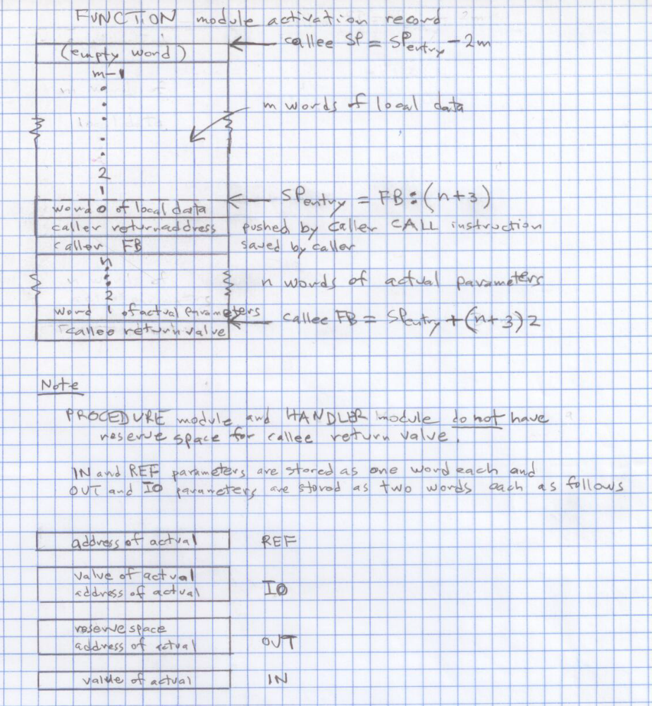
(C) SPL “callee” parameter passing and linkage (prolog and epilog)

; "Add" FUNCTION return value; n words of IN parameters; and
; caller FB and return address to the base of the callee frame
callee PUSHSP ; compute callee FB = SP-on-entry + 2(n+3)
PUSH #2(n+3) ; compute 2(n+3) and code as STM literal
ADDI
POPFB
; "Add" space on run-time stack for m words of local data to
; the end of the callee frame
PUSHSP ; compute callee SP = SP-on-entry + 2m
PUSH #2m ; compute 2m and code as STM literal
SUBI
POPSP
...
body of function
...
; "Delete" space added to run-time stack for m words of local data
PUSHFB ; restore caller SP-on-entry = FB – 2(n+3)
PUSH #2(n+3) ; compute 2(n+3) and code as STM literal
SUBI
POPSP
RETURN ; return to caller

