CS3355 FA23 Survey of Programming Languages

Sakura Programming Language
Juni Ejere – jejere@mail.stmarytx.edu

Sakura is a minimal subset of SPL(Simple Programming Language), which is an amalgamation of high-level programming constructs Dr. Hanna has “run into” during his computing career. Sakura is a free-format language that is inspired by programming languages such as: C++, Python, and JavaScript. The main goals for this language were efficiency, readability, and pleasing aesthetics.

Sakura is designed to support the following language features: specify unnamed literal constants with data types (unsigned) integer, boolean, and string (strings are usually used to label output), name program variables and modules with identifiers, define scalar variables for data types integer and boolean, express computation using expression syntax including unary and binary operators, specify an assignment statement, specify if-statements, specify unbounded pretest- and/or posttest-loop-statements, define main program module, specify an input-statement used for console test input, specify an output-statement used for console formatted-text output, and include comments. Below is a sample program written in Sakura.
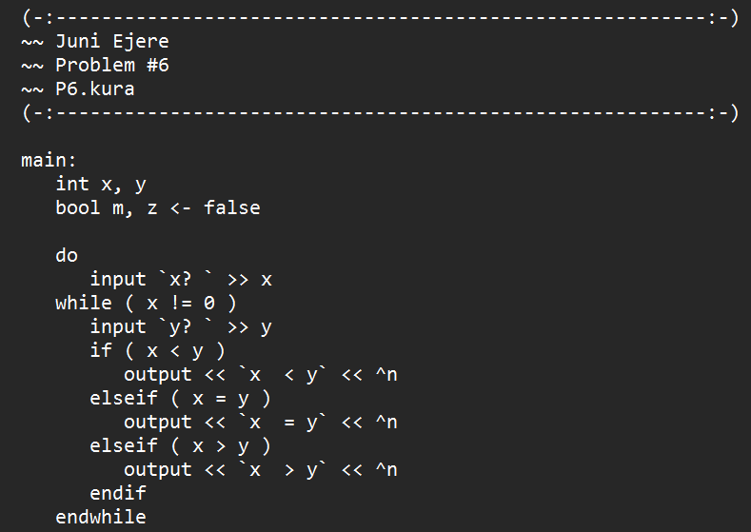

Some of the interesting components and stylistic choices are minimal punctuation requirements, backticks as string delimiters (designed to eliminate the need for escape characters), smiley face nested block comments, multiple L-value variables in a single assignment statement, “^n” as the endline character, and “.kura” as the file extension. The design of this language will appeal most to fans of simplicity while incorporating many beloved features from popular programming languages.

