Introduction
{ Binary code is the most simplistic form of data. It is represented entirely by a binary system of digits consisting of a string of consecutive zeros and ones.

A bit (short for "binary digit") is the smallest unit of measurement used to quantify computer data. It contains a single binary value of 0 or 1.

While a single bit can define a boolean value of True (1) or False (0), an individual bit has little other use.

Taken from:
www.techopedia.com/definition/17052/binary-code
Bit Definition (techterms.com)
}
Problem Statement
{ (Taken from pg. 47 of Levitin and Levitin. Algorithmic Puzzles (C). Oxford University Press, 2011.)

- Have the user input an integer n which will serve as the size for a string of bits (Ex. 11011 for n = 5). Refer to this as a “code.”
- Tell the user to think of their secret code.
- Provide “guesses” of the code by outputting n-bit strings to the user
- For each guess, have the user input how many bits in the guess coincide with the corresponding bits in the secret code ( Ex. Secret Code = 01011; Guess = 11001; User will input 3 because the two strings have the same bits in the second, third, and fifth positions. )
- You should be able to guess any secret n-bit code in no more than n questions.
}
Sample Program Dialog (User code = 11001)
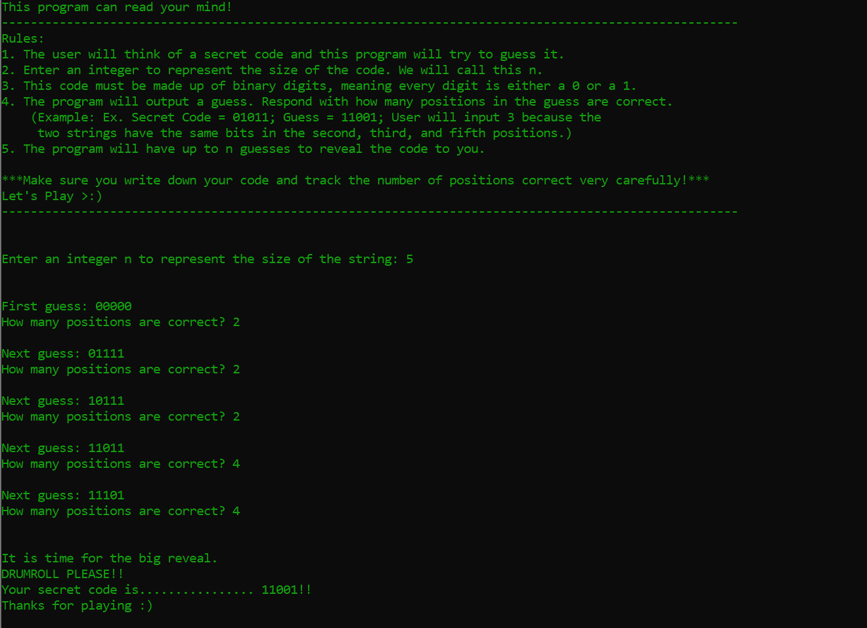
Computational and Critical Thinking Questions
- Boolean is not a data type defined by C. What C standard library must be included to use Boolean data types? Answer: <stdbool.h>
- What would sizeof(bool) typically return? Answer: 1

("\n\nEnter an integer n to represent the size of the string: ");
scanf("%d", &n);
bool secretCode[n+1];

- Consider the previous code. Why does secretCode have a size of n+1? Answer: The 0th element of the array is not used.
- What is the significance of the array named placeHolder? Answer: Holds the initial values of the first guess while testing each position.
- While testing a spot, if it is in the secret code the number of correct positions will be as follows:
n – (number of positions correct first guess) + 1
The variable formula makes use of this expression. Question: If the user’s secret code is 6 bits long and the first guess had 3 positions correct, how many test positions correct will a correct spot have? Answer: 4

int spot = 1;
int correctCount = 0;
int notCorrectCount = 0;
while(spot <= n && notCorrectCount != (n-positions) && correctCount != positions)
{
-----
spot++
}

- The above code is a sneak peek of the while loop used to iterate through each spot, but stops early if all the correct spots are found or all the incorrect spots are found. ( Remember that for a spot to be considered correct, when it is tested the number of positions correct must be equal to the formula given. ) Question: How do we know that all the correct spots are found if it is equal to positions? Answer: The variable positions holds the number of spots that were correct for the first guess. If correctCount reaches this number, then that means all the spots that were correct in the first guess have been found.
- (Continuing 6) How do we know that all the incorrect spots are found if it is equal to n-positions? Answer: The variable positions holds the number of spots that were correct for the first guess. That means that the number of incorrect spots will be the total number of spots minus those that were correct, or (n-positions).
- (Continuing 6 & 7) How come we are saving both the number of correct spots and the number of incorrect spots with each iteration, and not just one? Answer: This ensures that the user's secret code is found within n guesses. By choosing to also count the incorrect spots, it accounts for scenarios where the correct spots may be hiding at the end of the code as well.

for(int alter = 1; alter<=n; alter++)
{
if(alter != spot)
{
testCode[alter] = !( testCode[alter] );
}
}
- The previous code is used to flip each of the other spots except the one being tested. Why does this work? Answer: Using the not (!) symbol before a Boolean value results in the opposite value.
- Why is (a) the array holdsPositionsCorrect initialized to have all false values and (b) holdsPositionsIncorrect initialized to have all true values? Answer: (a) If all the correct positions are found first, by default the rest will be incorrect. (b) If all the incorrect positions are found first, by default the rest will be correct.
//---------------------------------------------------------
// Juni Ejere
// CS2315 Algorithms
// CodeGuessing.c
//---------------------------------------------------------

#include <stdio.h>
#include <stdbool.h>

int main()
{
int n;
printf("This program can read your mind!\n"
"------------------------------------------------------------------------------------------------------\n"
"Rules: \n1. The user will think of a secret code and this program will try to guess it."
"\n2. Enter an integer to represent the size of the code. We will call this n."
"\n3. This code must be made up of binary digits, meaning every digit is either a 0 or a 1."
"\n4. The program will output a guess. Respond with how many positions in the guess are correct."
"\n (Example: Ex. Secret Code = 01011; Guess = 11001; User will input 3 because the "
"\n two strings have the same bits in the second, third, and fifth positions.)"
"\n5. The program will have up to n guesses to reveal the code to you."
"\n\n***Make sure you write down your code and track the number of positions correct very carefully!***"
"\nLet's Play >:)"
"\n------------------------------------------------------------------------------------------------------\n"
"\n\nEnter an integer n to represent the size of the string: ");
scanf("%d", &n);
bool secretCode[n+1];
int positions;

//initializing secretCode
for(int i = 1; i <= n; i++)
{
secretCode[i] = false;
}

printf("\n\nFirst guess: ");
for(int i = 1; i <= n; i++)
{
printf("%d",secretCode[i]);
}
printf("\nHow many positions are correct? ");
scanf("%d", &positions);

if(positions == n) //first guess is correct, terminates the program
{
printf("\n\nHa! I guessed your code :)");
}

else
{
bool testCode[n+1]; //iterates through each spot and tests if that spot is in the secret code
bool placeHolder[n+1]; //holds the value of the first guess while each spot is tested
int testPositions; //holds the number of positions correct that the user inputs while testing
int formula = (n-positions+1); //if a tested spot is correct, the user will input this amount of positions
int spot = 1; //holds the value of the spot being tested in the while loop
int notCorrectCount = 0; //shows how many incorrect spots have been found. There are (n-positions) incorrect spots. if all have been found, the while loop will terminate
int correctCount = 0; //shows how many correct spots have been found. there are (positions) correct spots. if all have been found, the while loop will terminate

bool holdsPositionsIncorrect[n+1]; //holds the incorrect spots
bool holdsPositionsCorrect[n+1];//holds the correct spots
for(int it1 = 1; it1 <= n; it1++) //initializes; when a spot is correct it will be changed to true, the rest are false
{
holdsPositionsCorrect[it1] = false;
}

for(int it1 = 1; it1 <= n; it1++) //initializes; when a spot is incorrect it will be changed to false, the rest are true
{
holdsPositionsIncorrect[it1] = true;
}

for(int hold = 1; hold <= n; hold++) //initializes the placeholder to the first guess
{
placeHolder[hold] = secretCode[hold];
}

//loops through. will terminate either when all of the spots have been tested, or the correct spots have been found
while(spot <= n && notCorrectCount != (n-positions) && correctCount != positions)
{
//RESETS VALUE OF TEST CODE
for(int reset = 1; reset <= n; reset++)
{
testCode[reset] = placeHolder[reset];
}

for(int alter = 1; alter<=n; alter++) //changes every other spot except the one being tested
{
if(alter != spot)
{
testCode[alter] = !( testCode[alter] );
}
}

printf("\nNext guess: ");
for(int display = 1; display <= n; display++) //prints tester guess
{
printf("%d", testCode[display]);
}

printf("\nHow many positions are correct? ");
scanf("%d", &testPositions);

if(testPositions != formula) //if the spot is not correct, save the spot and increment the number of incorrect spots found
{
holdsPositionsIncorrect[spot] = false;
notCorrectCount++;
}
else //if the spot is correct correct, save the spot and increment the number of correct spots found
{
holdsPositionsCorrect[spot] = true;
correctCount++;
}

spot++; //goes to the next spot
}

//AFTER THE WHILE LOOP HAS TERMINATED

if(correctCount == positions) // we found the number of correct spots first, uses values of holdsPositionsCorrect
{
for(int i = 1; i <= n; i++)
{
if(!holdsPositionsCorrect[i]) //if not a correct spot, flip it
{
secretCode[i] = (!secretCode[i]);
}
}
}

else //we found the number of incorrect spots first, uses values of holdsPositionsIncorrect
{
for(int i = 1; i <= n; i++)
{
if(!holdsPositionsIncorrect[i]) //if not an incorrect spot flip it
{
secretCode[i] = (!secretCode[i]);
}
}
}

//Reveals secret code to the user
printf("\n\nIt is time for the big reveal. \nDRUMROLL PLEASE!!"
"\nYour secret code is................ ");
for(int i = 1; i <= n; i++)
{
printf("%d",secretCode[i]);
}
printf("!!\nThanks for playing :)\n");

}

}

