Tabor, John Ignace Laurent F.

2ECE-A

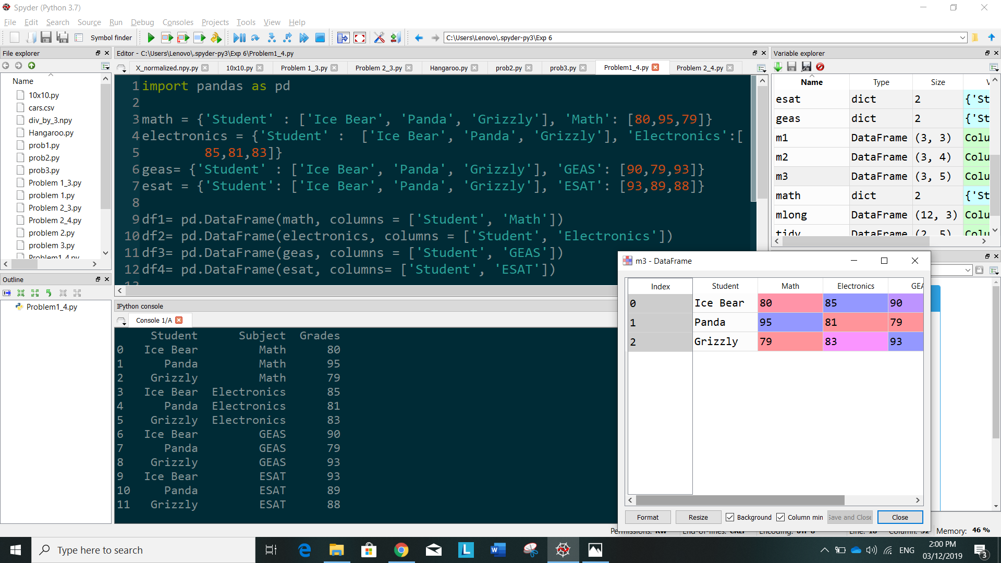**PROBLEM 1 (DATA WRANGLING)**

**PROBLEM 2**

