Title: CP2403/CP3413 — Assignment Part 2 (Portfolio Analytics Edition)
PRACTICAL GROUP: B
DATE: 2025-11-16

Pre-processing notes:
- All selected assets (NVDA, AMD, INTC) and the benchmark (QQQ) were downloaded over the same 3-year period with daily frequency, for it to be consistent.
- Any missing values due to holidays were forward-filled (ffill) and then rows with remaining missing values were dropped (dropna) to avoid misaligned calculators of returns.
- Yahoo Finance sometimes returns a multi-index, the columns were flattened to simple strings.
- The data was sorted by date.
- Daily returns were calculated using percentage change (pct_change) for each asset and benchmark and appended as new columns with the suffix _Return.
- For task 2, generate a new csv file which lists date, ticker and return as columns, sorted by date for easy coding.
- First returns will always be 0.0 for each ticker.

- Choice & rationale
Q1. Which assets (1–3) did you pick and why are they economically related?
We chose NVDA, AMD, and INTC, since those are three major well-known graphic cards company that caught my interest and also strongly linked to AI, and I am interested in their future investment as well.
Q2. Which benchmark fits best and why not the alternatives listed?
After some searching, I decided to go with Nasdaq-100 (QQQ), because I heard that it handles large data fairly well, and mainly targets technology companies.
- Data hygiene
Q3. Show how you aligned dates and removed NAs when assets/benchmarks had different trading days.
All tickers have been merged into a single data index covering the full 3-year period. The raw dataset contained some missing prices, we’re going to forward fill the missing values by propagating the last valid price to fill short gaps, and drop any Nas if it’s still present in the data just in case.
Q4. Did you use returns/changes (not levels) for regressions? Show one row example.
Yes, I used daily percentage returns between 2 available values for each ticker sorted by date (mostly daily) for regressions.
It could be a 1,2 or more days interval, the first row’s return is empty since it’s the first row. After that, we just compute with the usual formula of returns.
- Task 1 — ANOVA
Q5. Which factor did you choose (DoW, Regime, or Vol-terciles) and why is it sensible for your asset?
I chose Volatility Terciles because it is the most sensible and meaningful for my specific task, I focused on tech companies and these assets are known to experience period of very different volatility levels depending on the market conditions.
Q6. What does the ANOVA say and what is the single-sentence “so what?”
The ANOVA shows an extremely strong and statistically significant different in NVDA’s mean returns across volatility terciles (F=590.4, p≈0), this means volatility level has a major effect on how NVDA’s behaves.
NVDA delivers much higher returns during medium and high-volatility periods, meaning the stock performs best when markets are more volatile.
- Task 2 — Chi-Square
Q7. Build the Up/Down vs chosen factor table. Are counts adequate in each cell?
As a common rule for chi-square, expected counts in each cell should be greater than or equal to 5, and all of our cells have counts well above 5, so it is adequate.
Q8. What does χ² and the p-value tell you? State your interpretation.
The χ² value is 8.857, it tells us there is some difference between observed and expected counts, but it’s not statistically significant.
The p-value of our test is 0.06476933071855825, which is greater than 0.05, than means we fail to reject the null hypothesis, Up/Down movement is independent from day of the week.
- Task 3 — Simple regression
Q9. What are α, β, and R²? Provide a one-sentence PM interpretation for β and R².
α (alpha) is the expected return of the ticker when the benchmark return is zero. β (beta): How much the asset’s return changes with respect to movements in the benchmark return, basically the slope/gradient of the linear regression. Where as R² (R-squared) is the percentage of the asset’s return movements can be predicted by the benchmark return.
β tells us how sensitive the ticker is to the benchmark, whereas R² tells us how reliable the benchmark is at predicting the ticker’s return in PM interpretations.
Q10. Show one diagnostic (residual plot or normal QQ) and comment.
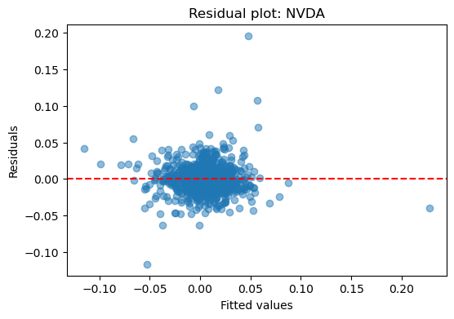
The residuals appear randomly scattered around zero with no obvious pattern, which is what we want. That tells us the linear model is doing a decent job. We do see a few outliers, but they don’t form any trend, so it’s not a big issue, meaning the model is not missing a strong non-linear relationship.
- Task 4 — Multiple regression (REQUIRES 1–2 macros)
Q11. Which macro drivers did you choose (ΔVIX, oil return, Δ10Y, USD return) and why do they matter for your assets?
I chose IEF (Treasury yields proxy) since tech stocks are extremely sensitive to interest rates because their valuations depend heavily on long-term cash flows, in addition, it is widely known and academically supported.
Q12. Compare three model variants (benchmark-only vs +macro1 vs +macro1+macro2). Which wins and why (R²/Adj-R²/AIC)?
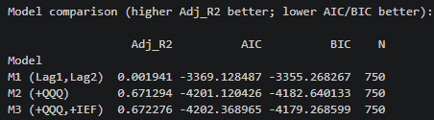
The winner is M2 (QQQ), which presents with high explanatory power, adding IEF gives barely any improvement, not worth.
Q13. What would change your conclusion (regime change, out-of-sample check)?
Regime changes: sometimes the market environment shifts. For example, if the interest rates move a lot, IEF might start having a big impact on our portfolio.
Out of sample testing: Right now, our model is based on past data, if we try it on a completely new period, it could behave differently.
- Task 5 — Polynomial regression
Q15. Why is a quadratic term plausible for your asset/benchmark relation? Show the fitted curve.
A quadratic term is plausible because the impact of benchmark returns on the asset return is not always linear, it allows the regression to capture more realistic approach for the relationship between the two.
This is fitted curve between NVDA_Return and QQQ_Return
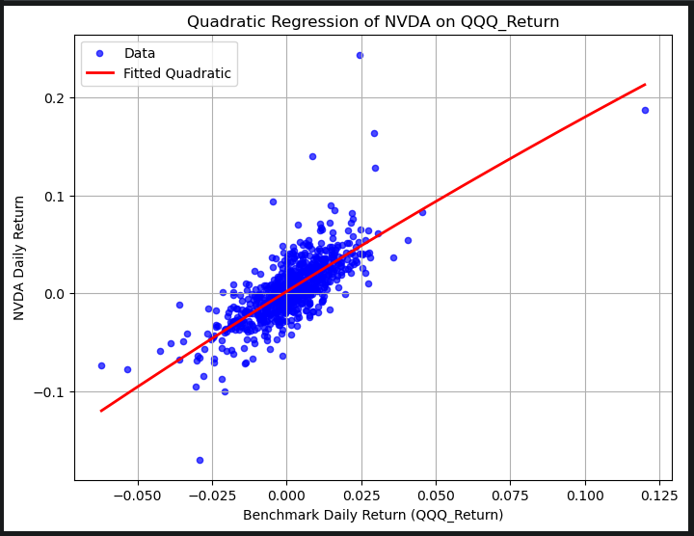
Q16. Did the quadratic term materially improve Adj-R² or AIC? Briefly justify.
Comparing it with our previous task, it did not materially improve the model since the linear term alone captures most of the relationship, the quadratic term adds little explanatory power. Visually, the quadratic equation almost forms a linear term anyway.
- Task 6 — Logistic regression
Q17. What predictors did you use and why? Report the confusion matrix and accuracy.
Lag1 return, since prices often exhibit short-term momentum; yesterday’s movement may influence today’s direction, as well as QQQ_Return as the macro variable because the broad market can affect individual stock direction and tests if it helps predict the stock.
This is the confusion matrix and accuracy for NVDA case:
Confusion matrix:
[[ 1 337]
[ 0 413]]
Accuracy: 0.551

Q18. How would misclassification risk affect a simple trading decision?
Misclassification risk can have a direct impact on simple trading decisions. Take an example when our model predicts “Up” almost all the time, you will frequently lose money when the stock actually goes down (false positives), same goes with false negatives which is the opposite way, we need an accurate model by considering some risk management rules.
- Communication
Q14. What’s your final manager memo (3–4 bullets) that a non-technical audience can use?
- The dominant driver of our portfolio’s returns is broad tech-market exposure, captured by QQQ
- Adding lagged returns (Lag1, Lag2) does not meaningfully improve predictions.
- Including IEF only produces minor improvement.

