Title: CP2403/CP3413 — Assignment Part 2 (Portfolio Analytics Edition)
DATE: 2025-11-16

TASK 1 — ANOVA (Day-of-Week / Regime / Vol-terciles)
Visuals: NVDA Daily Returns by Volatility Tercile
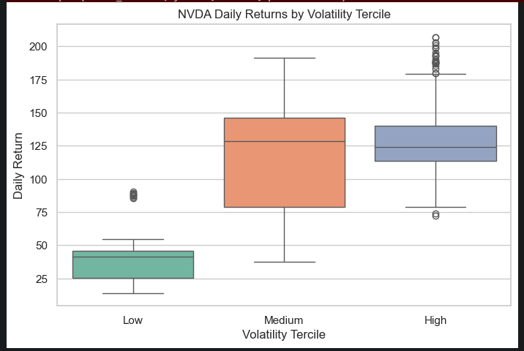

ANOVA
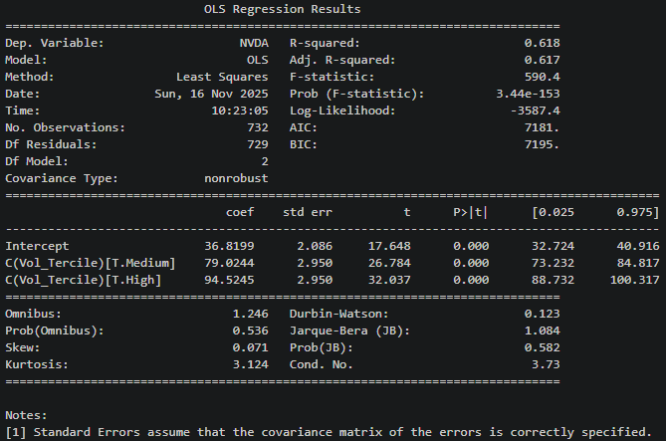
Hypotheses (H0): The mean NVDA returns are the same across all volatility terciles.
Method & Diagnostics: We ran a one-way ANOVA using NVDA’s daily returns as the dependent variable and volatility terciles (Low, Medium, High) as the categorical factor.
Results (F, p-value): F-statistic -> 590.4, p-value -> 3.44 * 10^(-153)
Investor Takeaway: As p-value is far below 0.05, we reject the null hypothesis, there is a strong evidence that NVDA’s mean returns differ across volatility terciles. The regression coefficients indicate that NVDA’s returns increase as volatility rises, medium volatility days have much higher returns then low-volatility days, and high-volatility days have the highest return of them all. From the plot, we can see there are a few outliers on the low volatility days and more frequency on high volatility days, indicating that extreme positive returns are likely when the stock is highly volatile. For investors, the implies that NVDA may deliver superior performance during elevated volatility but may underperform in calm markets, ignoring volatility can lead to missed opportunities.

η² = 0.618303711528056
This means 62% of the variability in NVDA daily returns is explained b which volatility tercile the day belongs to and It has a very large effect size in finance, investors should pay close attention to the volatility level because it strongly predicts high returns or low.

