Title: CP2403/CP3413 — Assignment Part 2 (Portfolio Analytics Edition)

STUDENT NAME: Juninho Chandra
STUDENT ID: 14892639
PRACTICAL GROUP: B
DATE: 2025-11-16

TASK 2 — Chi-Square (Independence)
Table (Up/Down vs DayOfWeek):
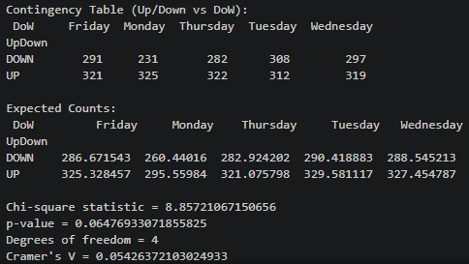
Result (χ², p-value):
χ² / Chi-square statistic = 8.85721067150656
p-value = 0.06476933071855825
Degrees of freedom = 4

Interpretation (1–2 lines): Our null hypothesis is about no association between Up/Down (whether daily return is positive or negative) and Day of Week (independent). And since our p-value is greater than 0.5, there is no evidence that daily returns depend on the day of the week.

Cramer’s V = 0.05426372103024933
Cramer’s V computes how dependent one variable to another, and since the value is very close to 0, we can imply that there’s almost no association between Up/Down and Day of Week.

Visuals:
Stacked bar
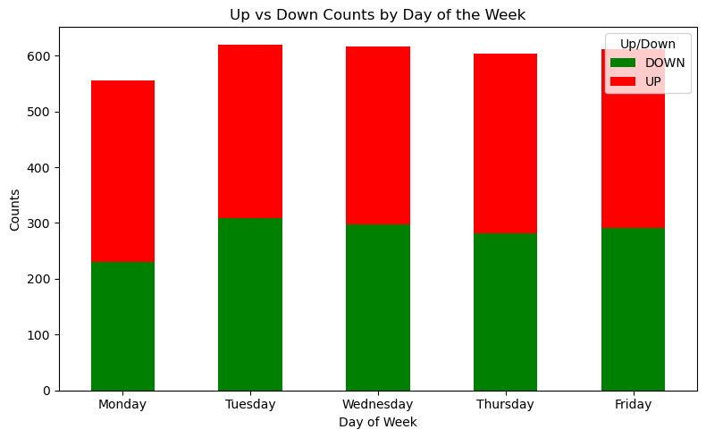
The stacked bar chart implies that the number of Up and Down is consistent after days to days.

