Title: CP2403/CP3413 — Assignment Part 2 (Portfolio Analytics Edition)
DATE: 2025-11-16

TASK 3 — Simple Linear Regression
Model: AssetReturn = α + β × BenchmarkReturn + ε
NVDA
Results (α, β, R²):

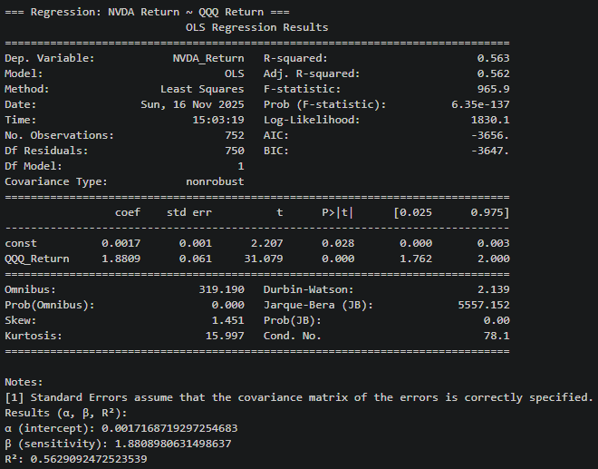
α (intercept): 0.0017168719297254683
β (sensitivity): 1.8808980631498637
R²: 0.5629092472523539

Model = NVDA_Return = 0.0017168719297254683 + 1.8808980631498637 * QQQ_Return + ε

Diagnostic (1 plot + 1 sentence):
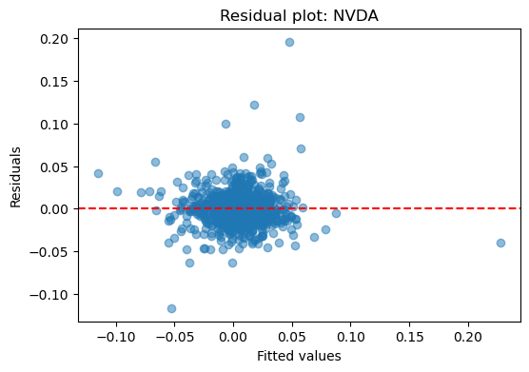
The dots are mostly scattered around 0 residuals with a tiny amount of outliers, which is a good linear regression model.

Interpretation for PM: NVDA return changes, on average, by 1.8808980631498637 for a 1 unit change in QQQ return.

Visuals: Scatter plot with regression line:
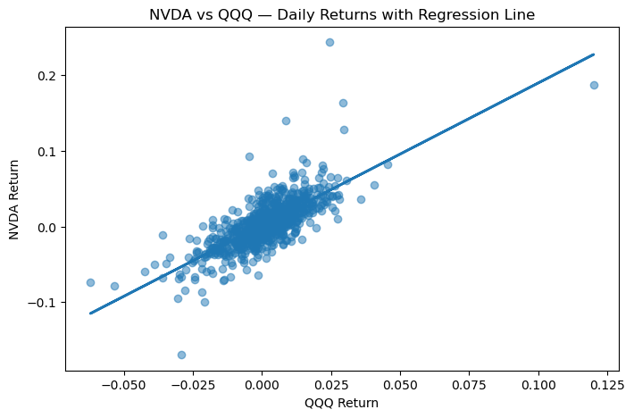
AMD
Results (α, β, R²):
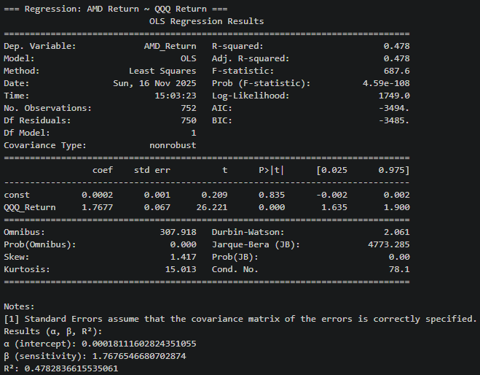
α (intercept): 0.00018111602824351055
β (sensitivity): 1.7676546680702874
R²: 0.4782836615535061

Model = NVDA_Return = 0.00018111602824351055+ 1.7676546680702874 * QQQ_Return + ε

Diagnostic (1 plot + 1 sentence):
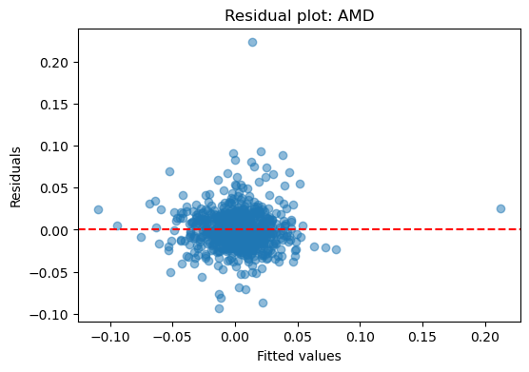
The dots are mostly scattered around 0 residuals with a small amount of outliers, which is a good linear regression model.

Interpretation for PM: AMD return changes, on average, by 1.7676546680702874 for a 1 unit change in QQQ return.

Visuals: Scatter plot with regression line:
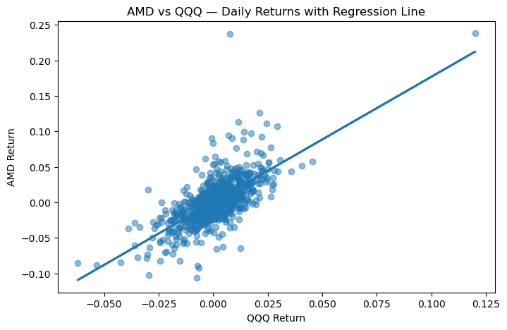

INTC
Results (α, β, R²):
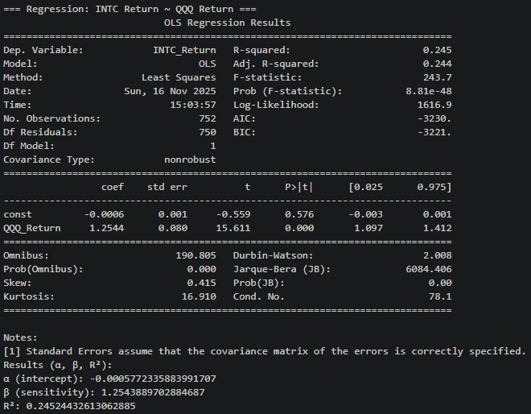
α (intercept): -0.0005772335883991707
β (sensitivity): 1.2543889702884687
R²: 0.24524432613062885

Model = NVDA_Return = -0.0005772335883991707 + 1.2543889702884687 * QQQ_Return + ε

Diagnostic (1 plot + 1 sentence):
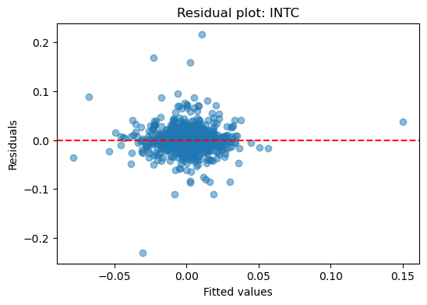
The dots are mostly scattered around 0 residuals with a tiny amount of outliers, which is a good linear regression model.

Interpretation for PM: INTC return changes, on average, by 1.2543889702884687 for a 1 unit change in QQQ return.

Visuals: Scatter plot with regression line:
