Title: CP2403/CP3413 — Assignment Part 2 (Portfolio Analytics Edition)
DATE: 2025-11-16

TASK 4 — Multiple Regression (with 1–2 macro drivers)
Predictors used: QQQ + (Lag1, Lag2) + (QQQ, IEF)
Model Comparison (≥3 specs): brief table with Adj-R² / AIC
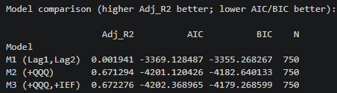
Chosen Model & Why: I would choose (QQQ) model because it delivers almost all the explanatory power where adjusted R-squared jumps significantly. Adding IEF only gives minor improvement, not worth for extra complexity.

Manager Memo:
- The dominant driver of our portfolio’s returns is broad tech-market exposure, captured by QQQ
- Adding lagged returns (Lag1, Lag2) does not meaningfully improve predictions.
- Including IEF only produces minor improvement.

