Title: CP2403/CP3413 — Assignment Part 2 (Portfolio Analytics Edition)
DATE: 2025-11-16

TASK 5 — Polynomial Regression (degree 2)
Why quadratic is plausible: Quadratic is plausible since the relationship between the benchmark returns and asset return is not always linear, by adding more order to the polynomial, we can improve the regression.
NVDA
Results (βs, Adj-R²/AIC) + fitted curve screenshot:
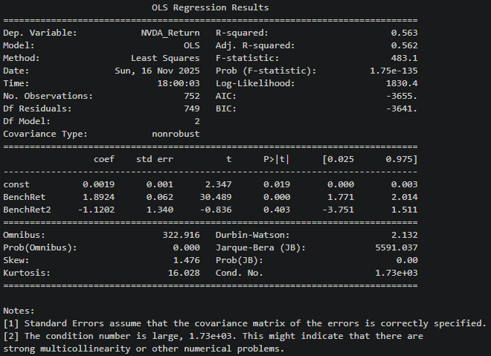

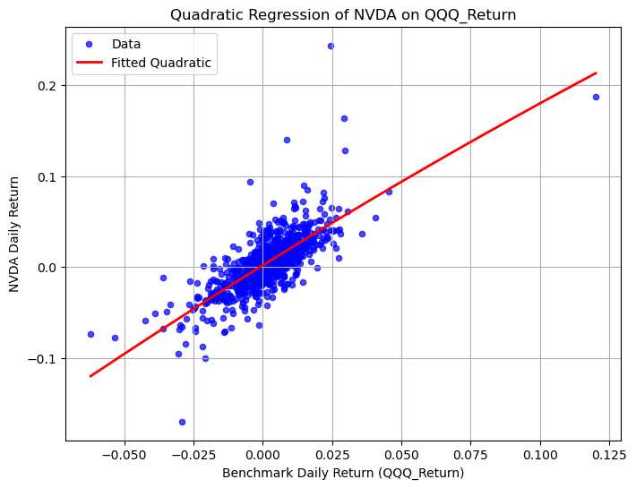
Model: NVDA_Return = 0.0019 + 1.8924 * BenchRet - 1.1202 * BenchRet2
Adj R²: 0.562
AIC = -3655.0

Takeaway: NVDA daily returns move largely in line with QQQ, the model explains about 56% of the return variation, indicating a good fit.

AMD
Results (βs, Adj-R²/AIC) + fitted curve screenshot:
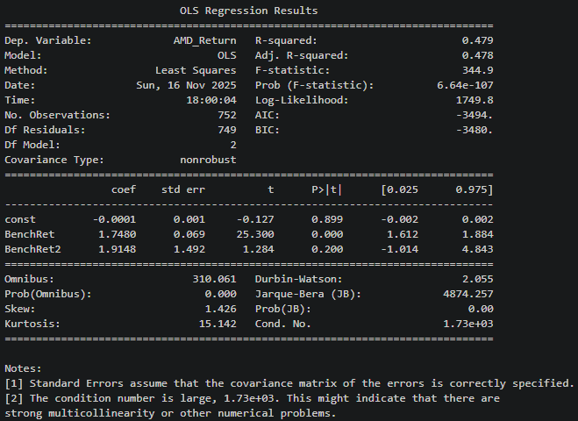
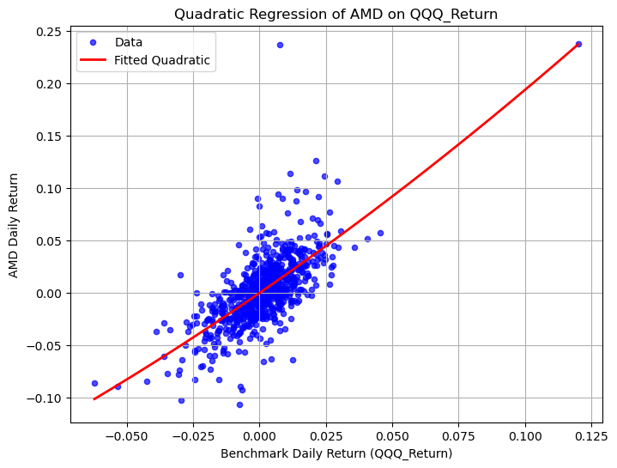
Model: NVDA_Return = -0.0001+ 1.7480 * BenchRet + 1.9148 * BenchRet2
Adj R²: 0.478
AIC = -3494.0

Takeaway: AMD’s daily returns are positively correlated with QQQ, the model explains about 48% of the return variation, showing a moderate fit.

INTC
Results (βs, Adj-R²/AIC) + fitted curve screenshot:
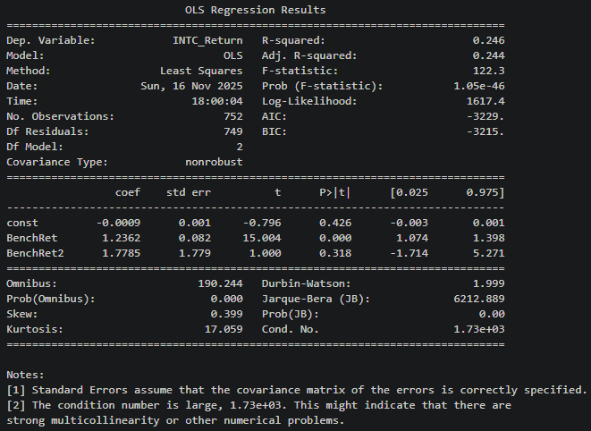
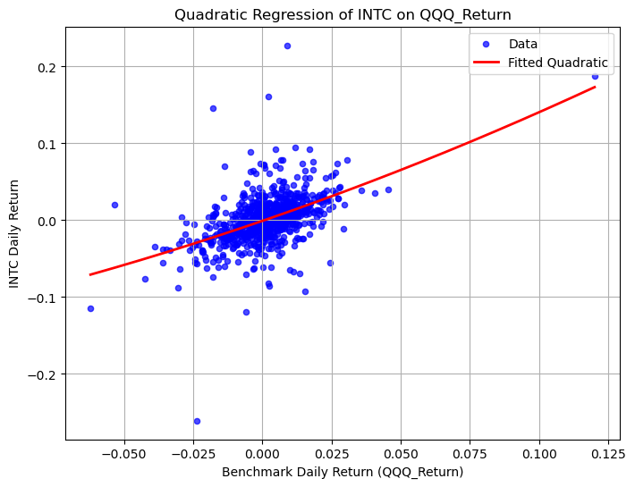

Model: NVDA_Return = -0.0009+ 1.2362 * BenchRet + 1.7785 * BenchRet2
Adj R²: 0.244
AIC = -3229.0

Takeaway: INTC daily returns are positively related to QQQ, but the relationship is weaker than NVDA and AMD. The model only explains 24% of the return variation, indicating a poor fit.

