Title: CP2403/CP3413 — Assignment Part 2 (Portfolio Analytics Edition)
DATE: 2025-11-16

TASK 6 — Logistic Regression (Up vs Down)
Predictors: Lag1 + QQQ_Return as an optional macro.
NVDA
Results: coefficients, confusion matrix (2×2), accuracy
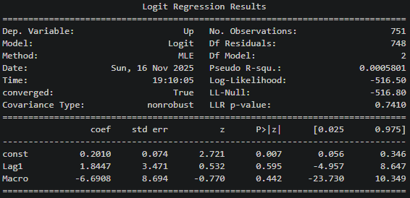

Coefficients =
const -> 0.2010
Lag1 -> 1.8447
Macro -> -6.6908

Confusion matrix =
[[ 1 337]
[ 0 413]]

Accuracy = 0.551

Takeaway: The model barely predicts better than random with the accuracy of 51.7%, so yesterday’s return and the macro provide almost no predictive power for daily Up/Down direction.

Visuals: ROC/AUC plotting
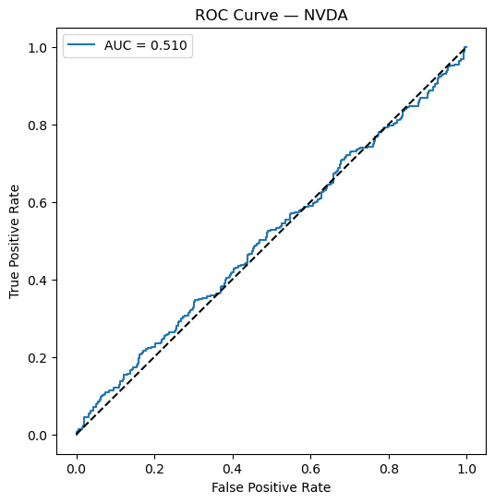
AMD
Results: coefficients, confusion matrix (2×2), accuracy
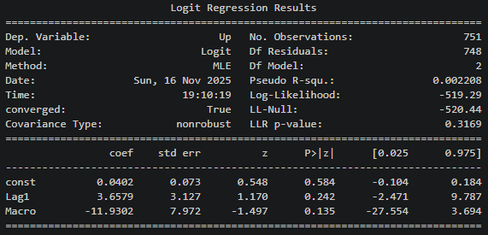

Coefficients =
const -> 0.0402
Lag1 -> 3.6579
Macro -> -11.9302

Confusion matrix:
[[138 231]
[132 250]]

Accuracy = 0.517

Takeaway: The model barely predicts better than random with the accuracy of 51.7%, which is slightly worse than NVDA case, so yesterday’s return and the macro provide almost no predictive power for daily Up/Down direction.

Visuals: ROC/AUC plotting
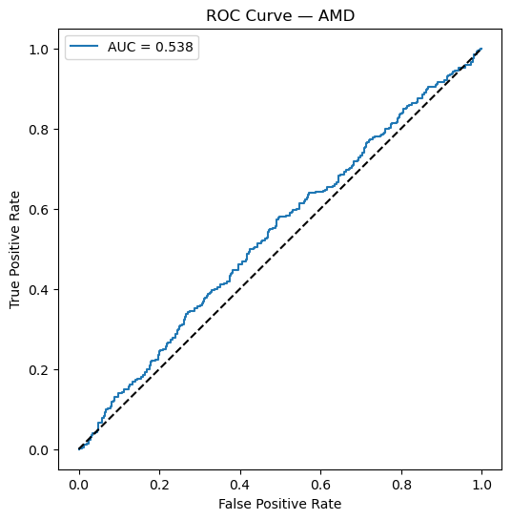
INTC
Results: coefficients, confusion matrix (2×2), accuracy
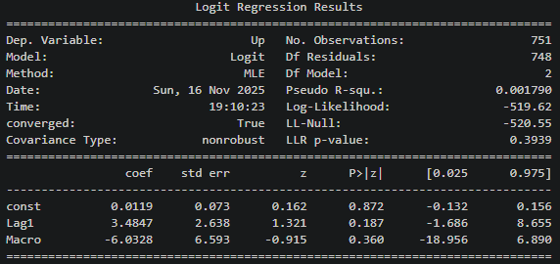

Coefficients =
const -> 0.0119
Lag1 -> 3.4847
Macro -> -6.0328

Confusion matrix:
[[196 178]
[165 212]]

Accuracy = 0.543

Takeaway: The model shows very limited predictive power similar to NVDA case with the accuracy of 54.3%, so the macro variable barely helps in predicting daily Up/Down.
Visuals: ROC/AUC plotting
