Vigenére cipher
Introduction
Vigenère cipher is a type of substitution method used for data encryption in which the original text is hidden by utilizing some different monoalphabetic substitution chippers instead of just one, each plain text has a particular code key that is used for a particular encryption, it is nicknamed as “the unbreakable cipher” due to it being impenetrable.
Background
The cipher was invented in 1553 by the Italian cryptographer Giovan Battista Bellaso, but was attributed to the 16th century French cryptographer Blaise de Vigenère, who devised a similar cipher in 1586.
In 1861, a German army officer and cryptanalyst, Friedrich W. Kasiski, uploaded a solution of repeated-key Vigenère ciphers based on the fact that the cipher generated the same symbols with similar pairings of text and key symbols.
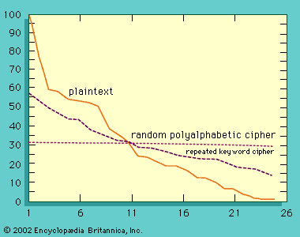
Repetition is the key aspect for cryptanalysts to search; they would split the text into different partitions to analyze each one as a simple alternative cipher. With sufficient cipher text, it would be easy for them to solve for the word. Like the example above, the key word is DECEPTIVE, and the figure shows how the letter frequency of a Vigenère cipher, which more closely resembles a purely random sequence supplied as a base.
Even though periodicity that is exploited by Kasiski, can be eliminated by autokey ciphers, two knowns method can decipher them. The first one assumes that the encrypted text and the key share the same distribution of characters, so if a letter occurs more frequently in a dictionary, the cryptanalyst need to create a larger partition of the ciphertext to reveal it. The second method starts by removing words that occur frequently in the text, suppose an encrypted message in sent to President Jefferson Davis of the Confederate States of America, and then we need to find a probable word that most likely to occur, in this case, “PRESIDENT” might be a reasonable key.
Uses
In contemporary times, the Vigenère cipher is not considered secure enough to use for any real secrets or confidential information. Instead, it is often used by people who enjoy the hobby of geocaching. Geocaching involves hiding small items and leaving clues that will enable others to find them. Different forms of coding can be used, including global positioning satellite (GPS) coordinates, map coordinates, or various forms of ciphers, such as the Vigenère.
A strong cipher
Polyalphabetic Substitution: The Vigenère cipher uses multiple cipher alphabets based on a keyword, unlike simpler monoalphabetic ciphers (like the Caesar cipher) that use a single, fixed shift.
Perceived impregnability: It was widely used in diplomatic in military communications from 16th to 19th century.
Eventual Decryption: It is finally broken by several cryptanalysts such as Kasiski.
Modern Standard
Vulnerability to Cryptanalysis: Several methods such as Index of Coincidence, Firedman test, and more broke the chipper.
Computational Power: Modern computers can do brute-force method in a fraction of a second, especially if the keys are short and common dictionary words are used.
How it works
Suppose we wish to encrypt the plaintext message THE SUN AND THE MAN IN THE MOON, using the keyword KING.
Begin by writing the keyword, repeatedly until its length matches the plaintext message. To define the encrypted text, for each letter in the plaintext, find the intersection of the row given by the corresponding keyword letter and the column given by the plaintext letter itself to pick out the ciphertext letter.
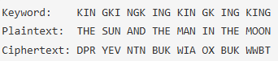
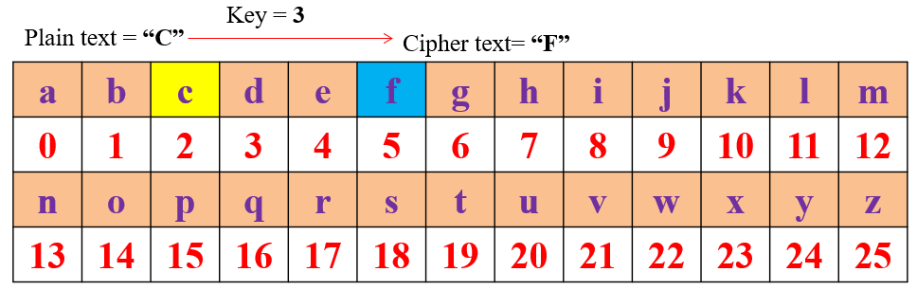
C = Ek(M) = M + 3 (mod 26)
Advantage and Disadvantage
The strength of the cipher is that it is not vulnerable to frequency analysis due to the fact that the cipher rotates through different shifts, so the same plaintext will not always be encrypted to the same ciphertext letter.
The primary weakness of the cipher is the repeating nature of its key. If a cryptanalyst correctly guesses the length of the key, then the ciphertext can be treated as interwoven Caesar ciphers, which, individually, can be easily broken.
Legal and ethical dimensions of cryptographic use
The legal and ethical dimensions of cryptography are deeply interconnected with concerns about privacy, security, government control, and the potential for abuse. The use of cryptography requires balancing the needs of individuals to protect their privacy with the needs of governments and businesses to ensure national security, law enforcement, and other public interests.

