**Comparison of CAPM, Three-Factor Fama-French Model, Fama-French Carhart model and Five-Factor Fama-French Model for the American Stock Market**

**1. Introduction**

What kinds of factors determine the price of an asset? Since Markowitz formulated a model of asset pricing [1], the debate on this question continues. The main determinants of asset prices and risk factors that affect the demand for assets and asset prices have been an important issue in finance theory and practice. One can find enormous number of studies on this issue. Earlier studies in this area are by Markowitz, Sharpe, Ross, Fama and French [1, 2, 3, 4].

Since the literature on asset pricing model (APM) is very well known and can be reached easily in finance textbooks, I do not go into a detailed explanation of evolution of APM. However, I would like to briefly state that all the asset pricing models developed so far have included risk as the most important determinant. For example, [1] defines the expected return and variance of returns on a portfolio as the basic criteria for portfolio selection.

Markowitz’s model requires large data inputs. Because of input drawback, new models have been developed to simplify the inputs to portfolio analysis. William Sharpe’s market model [2] is as follows:

Rit=αi+βi∗RMt+eit

where Rit is the return of stock i in period t, αi is the unique expected return of security i, βi is the sensitivity of stock i to market movements, Rmt is the return on the market in period t and eit is the unique risky return of security i in period t and has a mean of zero and finite variance σ 2 ei , uncorrelated with the market return, pairwise and serially uncorrelated. This equation explains the return on asset i by the return on a stock market index. β in Eq. (1) is a risk measure arising from the relationship between the return on a stock and the market’s return.

Later on, the equilibrium models have been developed. The difference between the market model and the equilibrium model was that asset returns are related to excess market return rather than market return. The first and basic form of the general equilibrium model, which was developed by Sharpe, Lintner and Mossin [2, 4, 5] called capital asset pricing model (CAPM), is given in Eq. (2):

Rit=Rf+β∗i (RMt−Rf)+eit

where Rit is the return of stock i in period t, Rf is risk free rate, βi is the sensitivity of stock i to excess return on a market portfolio, Rmt is the return on the market in period t and eit is the unique risky return of security i in period t and has a mean of zero and variance σ 2 ei .

Black et al. [6] derived a new model of the CAPM by relaxing the assumption of risk-free lending and borrowing. Basu [7] considers a different time series model, which is written in terms of returns in excess of the risk-free rate Rf and shows that returns are positively and linearly related to β, as follows:

it−Rft=αi+βi(RMt−Rft)+eitRit−Rft=αi+βiRMt−Rft+eit E3

While the CAPM is still the most widely accepted description for security pricing, empirical studies found contradicting evidence (see [7, 8, 9, 10, 11, 12, 13, 14]). Therefore, researchers concentrated on finding better models for the behaviour of stock returns and added more explanatory variables into CAPM.

In the early 1990s, one of the most influential researches was by Fama and French [15, 16]. Fama and French [15] reject the market beta associated with the CAPM and instead find that stock size and book-to-market (B/M) ratio better capture the cross-sectional variation in average stock returns. One year later the same researchers proposed that a 3F-FF asset pricing model augmenting the CAPM with size and book-to-market proxies for risk might be a superior description of average returns [16]. After these two influential studies, along with earlier evidence against the CAPM drove the finance community into investigating the reasons behind the anomalies found in [10, 11, 12, 13, 14].

Recent studies have found additional factors that seem to exhibit a strong relationship with average returns. Novy-Marx [17] finds that firms with high profitability generate significantly higher returns than unprofitable firms. Aharoni et al. [18] find that a statistically significant relation exists between an investment proxy and average returns. In the wake of these findings, Fama and French [19] expanded the 3F-FF model with profitability and investment. They reveal that the 5F-FF model performs better than the 3F-FF model in explaining average returns for their sample. The same model was tested using international data [20, 21], and they have found similar results.

1. **Reports**

The formulas for the four models are as follows.

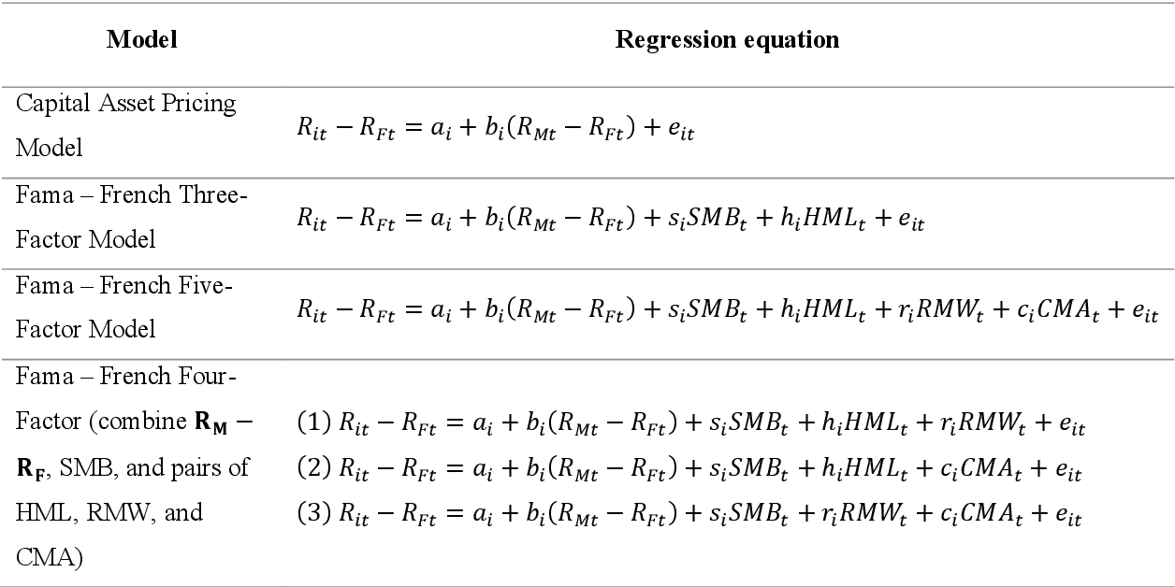

**Questions which factor investing answers**

1. Why different asset have systematically lower or higher average returns?
2. How to manage the asset portfolio with the underlying risks in mind?
3. How to benefit of our ability to bear specific types of risks to generate returns?

Assumes linear relationship between empirical factors and stock returns:

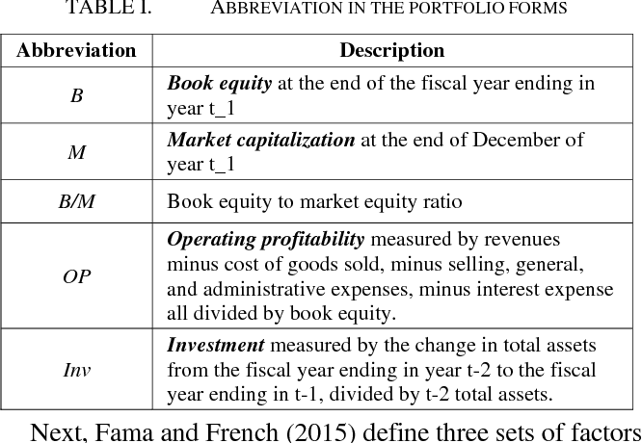

1. Market Factor (MER)
2. Size Factor (SMB)
3. Value Factor (HML)
4. Profitability Factor (RMW)
5. Investment Factor (CMA)

Factors are constructed daily from definitions, as illustrated previously

They are global for the entire stock market

Factor sensitivities are calibrated using regression

1. They represent “reward for taking a specific risk”, which is different for every stock
2. Risk/Reward relationship is expected to hold over time
3. Objective: maximize the model’s predictive power R2

**Market Excess Return (MER)**

1. Market excess return (over RF rate) alone explains around 80% of asset movements
2. Daily returns are ~normally distributed
3. Relationship between returns of the overall market and returns of selected portfolio

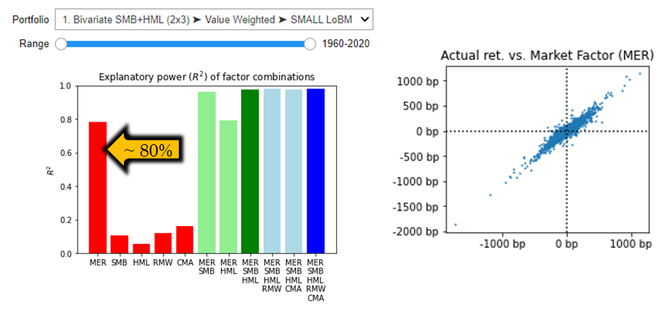

**Size (SMB) factor**

1. Small-cap companies typically bear additional risk premium - was it always the case?
2. Python can help you to see that this factor has a different prevalence in different economic regimes

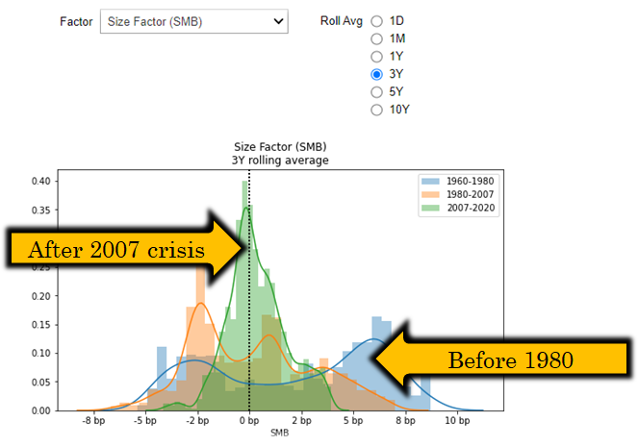

**Value (HML) factor**

1. Value companies trade at higher yields to compensate for lack of growth potential
2. Python can help you to see that this factor has different explanatory power in different market situations and on different portfolios (very interesting)

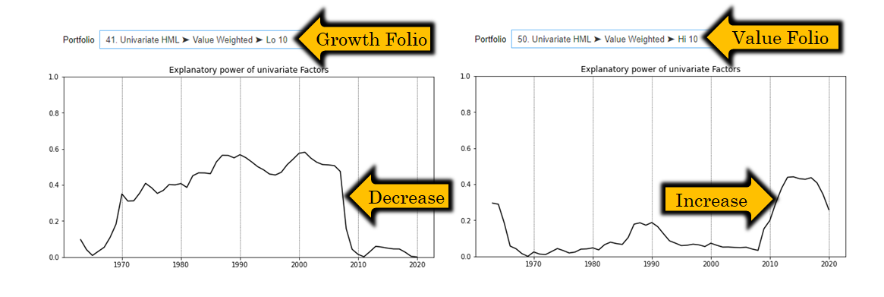

**Profitability and investment factors**

1. Profitability factor> (RMW) to attribute superior returns of companies with robust operating profit margins and strong competitive position among peers
2. Investment factor (CMA) to segment companies based on their capital expenditures
3. Analysts opinion: High capex structurally associated with growth companies, which puts usefulness of this factor in question

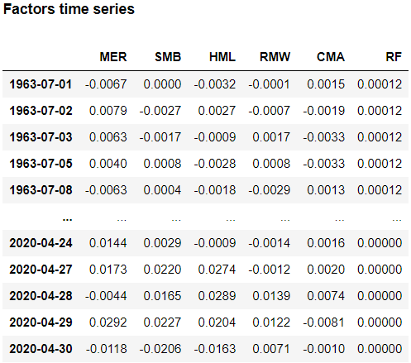

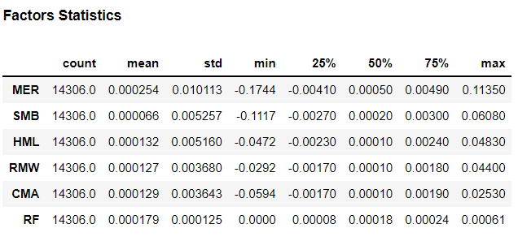

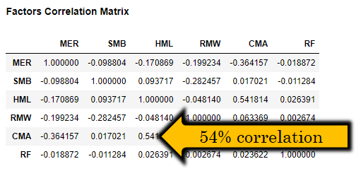

**Evaluating 5-factor model**

1. Analyst opinion: High correlations between risk factors puts usefulness of 5-factor model into question.
2. R2 10-20% for RMW, CMA
3. 5 factor improvement only by 0.2%

The chart for the 4 models is shown below:

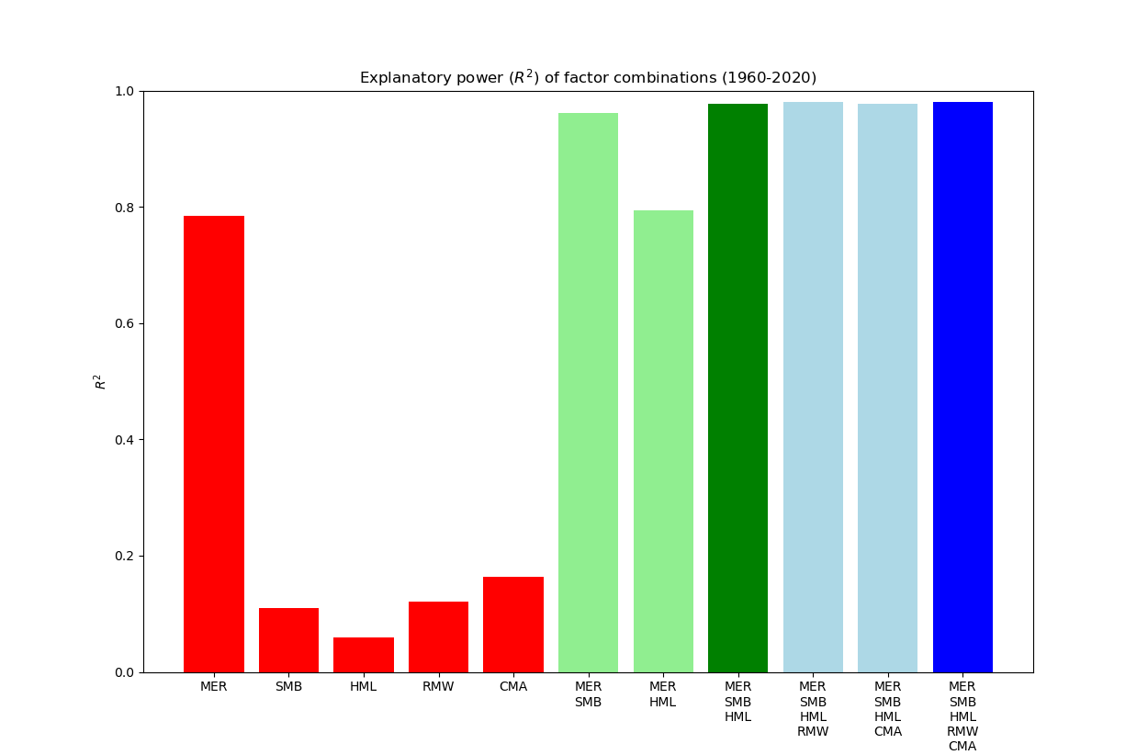

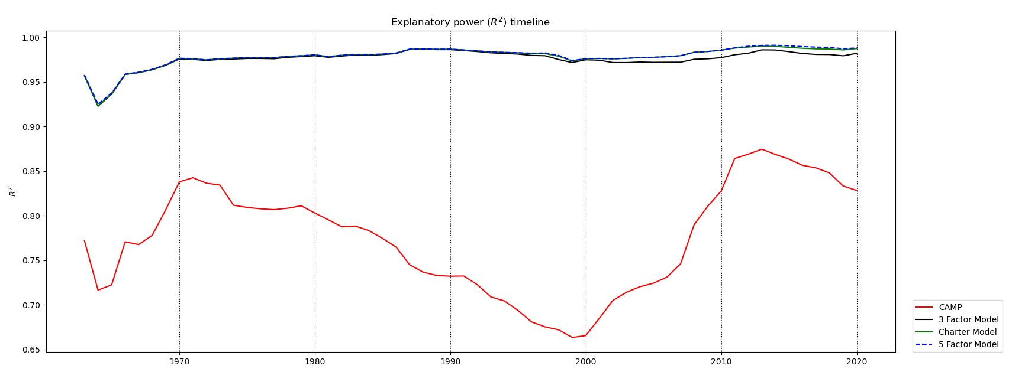

**Result for Research**

One of the main findings is that CAPM and 3F-FF model cannot explain cross-sectional variations in portfolio returns properly. The best suited model (but not perfect) for the Turkish case is 5F-FF model.

As seen elsewhere [17, 19, 20, 21, 22, 23], as the number of explanatory variables increases in the regression portfolios, explanatory power of the equation increases, and the R2 rises. In the Turkish case, although 3F-FF model has high R2 compared to the CAPM, more than half of the intercepts of the 3F-FF model are significant at the 5% level, and this shows that SMB and HML factors alone do not explain the cross-sectional variations of portfolio returns.

Besides testing all intercepts individually, we also tested whether all the pricing errors were jointly equal to zero. Gibbons et al. [24] suggested GRS test statistic to test whether all pricing errors are zero. A GRS test on the joint set of all tested portfolios clearly rejects all tested models as complete descriptions of average returns. The CAPM model elicits the lowest average absolute alpha values of the three tested models throughout all tests but shows a statistically insignificant fGRS value compared to other models. The 5F-FF model shows the strongest performance out of the three models for the sample.

**Description about Program**

This program is written in python and intuitively shows each element of the four models.

The program uses the jupyter notebook to display the corresponding diagrams and explanations.