Name: Naimil Shah

Student No: 200522618  
  
Assignment: Calculator UI Design Wireframe  
  
Course Name: Mobile and Pervasive Computing  
  
Course Code: COMP 3025 – 03  
  
Professor Name: Tom Tsiliopoulos

1. **Design 1**

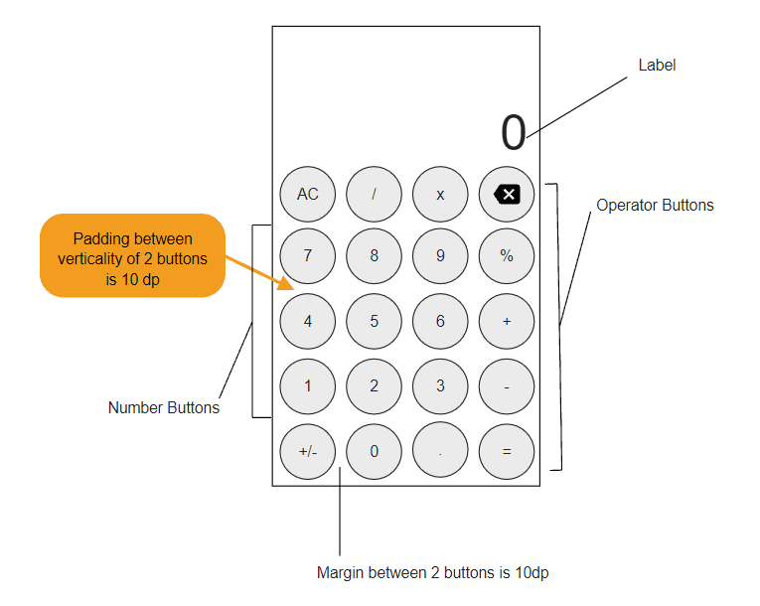

* In Design 1 Text size for TextField is 65sp and padding between border and button is of 10dp on each sides.
* adding between two rows of button is of 10dp
* Margin between 2 buttons is of 10 dp
* In this design there are 9 operator buttons and 11 number buttons totaling to 20 buttons in total
* All buttons are round in shape and all of them have similar text size of 14sp
* The color Spotches for the design are :
* Background : #312F36 ,Operator Buttons: #EB9725 ,Text color:F3F5F0 , Number Button: #35C1EA
* Background: #F3F5F0, Operator Button color : #0013EB, LabelTextColor:#000000, Number Button Color:# 312F36, Number Button Text Color:# F3F5F0, Operator text Button Color: #F3F5F0

1. **Design 2**

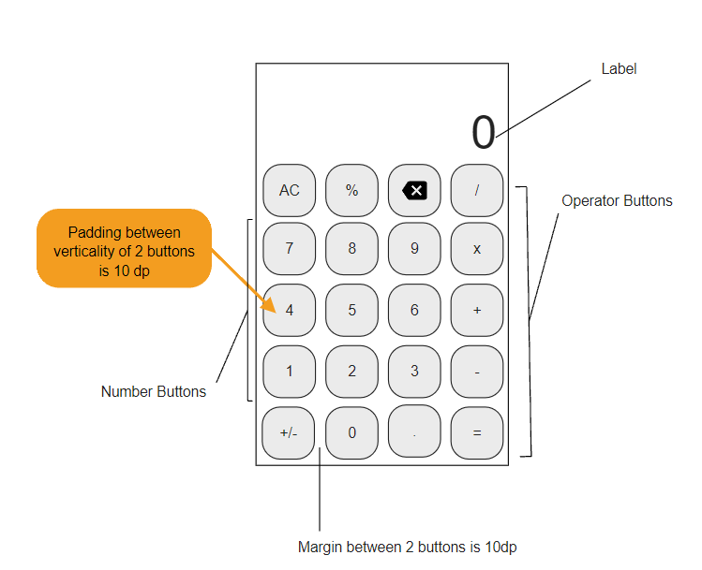

* In Design 2 Text size for TextField is 60sp and padding between border and button is of 10dp on each sides.
* Padding between two rows of button is of 10dp
* Margin between 2 buttons is of 10 dp
* In this design there are 9 operator buttons and 11 number buttons totaling to 20 buttons in total
* All buttons are blocky in shape and all of them have similar text size of 14sp
* The color Spotches for the design are :
* Background: #383862, Operator Buttons: #FAE25A, Backspace and clear button color : #EA7271, Equal Button Color: #50F555, Text Color: #F3F5F0, Number Buttons: #312F36
* Background: # #FAF9ED, Operator Button color: #FBEF96, Backspace and clear button color: #F4BD91, Equal Button Color: #A9F5A1, Text Color: #312F36, Number Button Color:#F3F5F0

**3) Winning Design**



Design 2 is clear winner for me and the winner colour spotch is :

* Background: #383862, Operator Buttons: #FAE25A, Backspace and clear button color : #EA7271, Equal Button Color: #50F555, Text Color: #F3F5F0, Number Buttons: #312F36

1. **Final Screenshot**

