Name: Naimil Shah

Student No: 200522618  
  
Midterm Test: shopping list  
  
Course Name: Mobile and Pervasive Computing  
  
Course Code: COMP 3025 – 03  
  
Professor Name: Tom Tsiliopoulos

1. **Design 1**

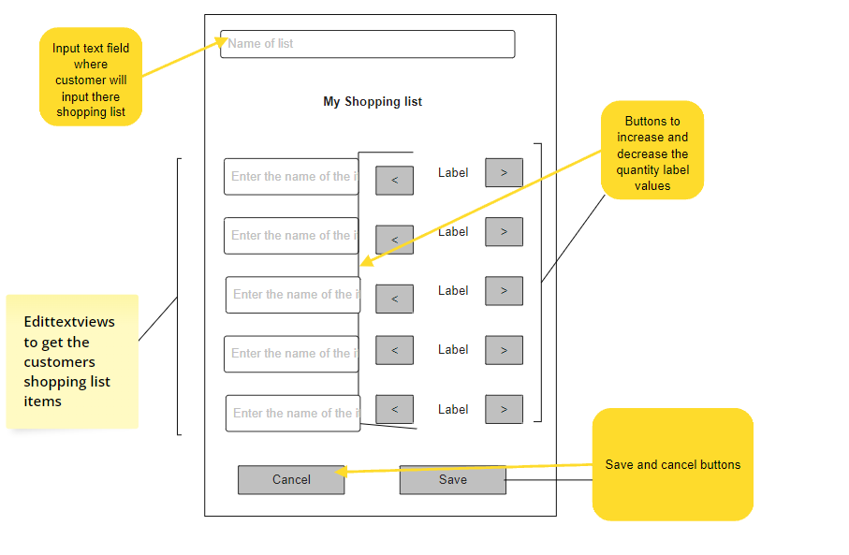

1. **Design 2**

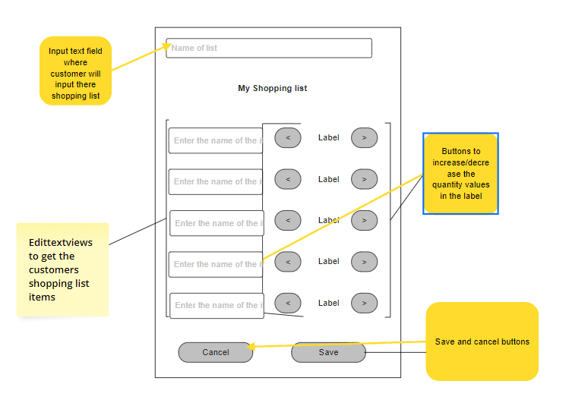

**3) Winning Design**

**Potrait:**



**Landscape:**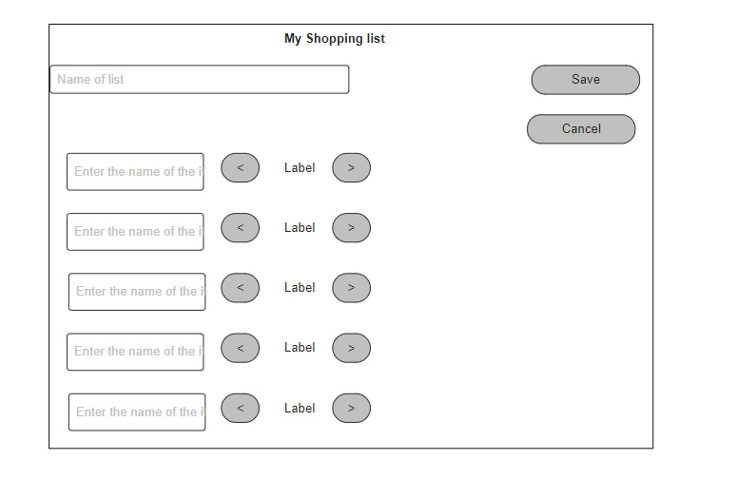

Design 2 is clear winner for me

Specs:

Color spotch 1: Button Color:#ebe726, save and cancel button color: #b4e5eb , background color: #01eb88

Color Spotch 2: Background: #F7B436 , button color: #36C8F7, savea and cancel button color: #364EF7

All 5 label, 5 edittextviews and 10 buttons are inside the tablelayout and eacah line in the table row according to the image

Label for title is bold and is of 25sp and all other labels are of 20sp , rounded button radius is of 30sp and all other values like margin and padding are subject to change depending on orientation

1. **Final Screenshot**

