LUMBAR SPINE BIOMECHANICS
Functional anatomy, kinematics, kinetics, stability and clinical relevance — explained with diagrams and flowcharts

Contents
1. Introduction
2. Functional anatomy of the lumbar spine
3. Lumbar curvature (lordosis) and the lumbosacral junction
4. The motion segment and the three-joint complex
5. The intervertebral disc: structure and mechanics
6. Kinematics: movements of the lumbar spine
7. Kinetics: loads on the lumbar spine
8. Ligaments: passive restraints
9. Muscles, thoracolumbar fascia and intra-abdominal pressure
10. Spinal stability (Panjabi model)
11. Clinical biomechanics (pathomechanics)
12. Flowcharts
13. Summary tables
14. References
Note: values quoted are typical adult ranges from the textbook and research literature; individual values vary with age, sex, method of measurement and pathology. This document is for education and does not replace clinical assessment.

1. Introduction
Biomechanics is the study of forces and motion in living systems. The lumbar spine (L1–L5) is the region of the vertebral column between the thoracic spine and the sacrum. It has two jobs that partly conflict: it must be strong and stable enough to carry the weight of the head, arms and trunk plus any load in the hands, and mobile enough to allow bending, extending, side-bending and twisting. It must also protect the cauda equina and the exiting lumbar nerve roots.
Understanding lumbar biomechanics explains why low back pain is so common, why certain postures and lifting techniques increase risk, and why specific exercises and ergonomic advice are used in rehabilitation.

The three functions in simple terms
- Load bearing — transmits body weight and external loads from the trunk to the pelvis and legs.
- Movement — allows mainly flexion and extension; side-bending is moderate and rotation is small.
- Protection — encloses and protects the cauda equina inside the vertebral canal and nerve roots in the intervertebral foramina.

2. Functional anatomy of the lumbar spine

2.1 The lumbar vertebra
Lumbar vertebrae are the largest vertebrae in the spine because they carry the greatest load. Each vertebra has two main parts:
- Anterior part — vertebral body: large, kidney-shaped, made of cancellous (spongy) bone inside a thin cortical shell. It is designed to resist compression. The body size increases from L1 to L5 as load increases.
- Posterior part — vertebral (neural) arch: pedicles, laminae, a short thick spinous process, two transverse processes, and superior and inferior articular processes. The arch protects neural tissue, provides lever arms for muscles and forms the facet joints.
- Vertebral endplates: thin layers of cartilage and bone on the top and bottom of each body. They bond the disc to the bone, allow nutrition to diffuse into the disc and are the weakest link under pure compression.
- Pars interarticularis: the narrow bridge of bone between the superior and inferior articular processes. It experiences high bending and shear stresses, especially during repeated extension, and is the site of stress fracture (spondylolysis).
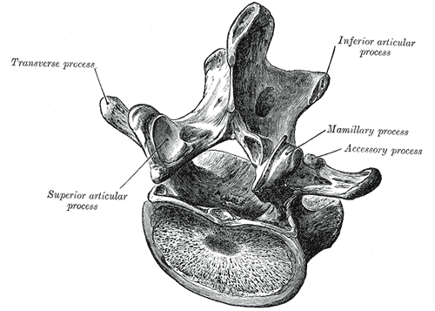
Figure 1. A lumbar vertebra seen from above and behind, showing the body, transverse, articular, mamillary and accessory processes. (Gray's Anatomy, 1918 — public domain, via Wikimedia Commons.)
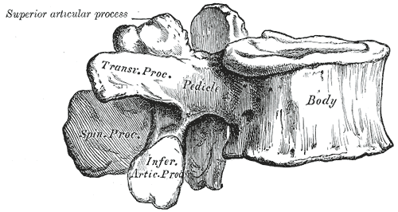
Figure 2. A lumbar vertebra seen from the side: large body anteriorly, pedicle, transverse process, articular processes and a broad, hatchet-shaped spinous process posteriorly. (Gray's Anatomy, 1918 — public domain, via Wikimedia Commons.)

2.2 The facet (zygapophyseal) joints
Each pair of adjacent vertebrae is linked posteriorly by two synovial facet joints, formed by the inferior articular process of the vertebra above and the superior articular process of the vertebra below. Their orientation controls which movements are allowed:
- In the upper lumbar spine the facet surfaces lie mostly in the sagittal plane (vertical, facing medially/laterally). This allows flexion–extension freely but blocks rotation.
- Towards L5–S1 the facets turn progressively towards the frontal (coronal) plane. This lets them resist the forward (anterior) shear of L5 sliding down the inclined sacrum, and allows slightly more rotation.
- The superior facet is concave and faces posteromedially; the inferior facet is convex and faces anterolaterally — they interlock like a "J" shape in cross-section.

2.3 Other key structures
- Intervertebral discs (L1–L2 to L5–S1) — described in Section 5.
- Ligaments — anterior and posterior longitudinal ligaments, ligamentum flavum, interspinous, supraspinous, intertransverse and iliolumbar ligaments (Section 8).
- Muscles — local stabilisers (multifidus, transversus abdominis, deep fibres of psoas and quadratus lumborum) and global movers (erector spinae, rectus abdominis, obliques) (Section 9).
- Thoracolumbar fascia — a strong fascial sheet that links latissimus dorsi, gluteus maximus and the abdominal muscles to the lumbar spine.

3. Lumbar curvature (lordosis) and the lumbosacral junction
Viewed from the side, the lumbar spine is curved convex forwards — this is the lumbar lordosis. A normal lordosis measured from L1 to S1 is roughly 40–60° (with wide individual variation). The apex is usually around L3. The curve is created mainly by wedge-shaped discs (taller in front than behind), with the L5 vertebral body and L5–S1 disc being the most wedged.
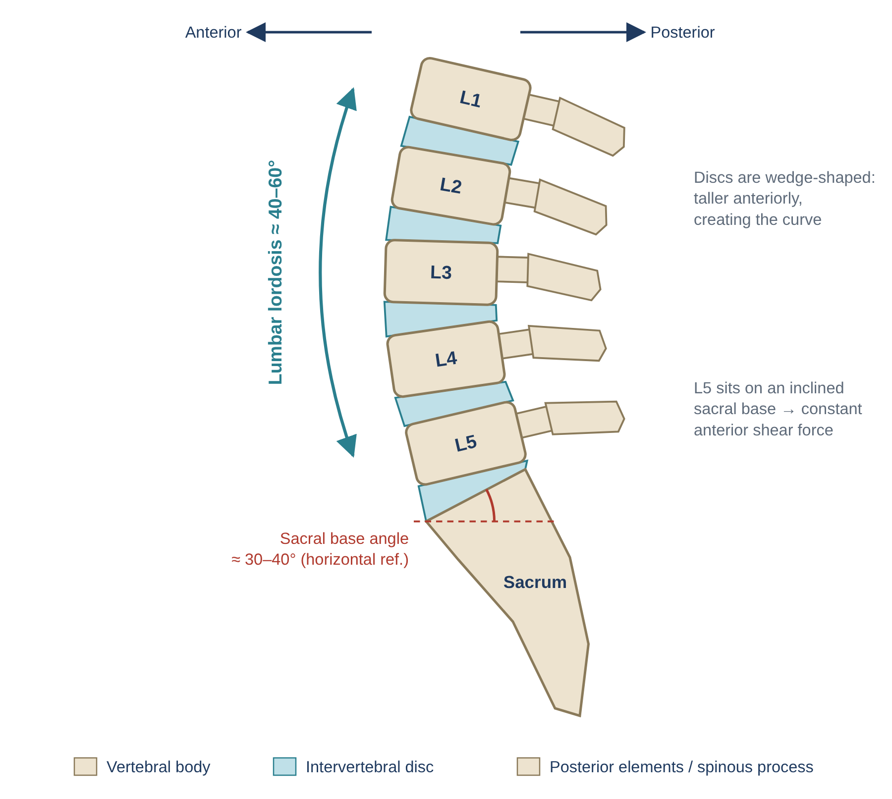
Figure 3. Simplified lateral view of the lumbar spine showing the lordotic curve, wedge-shaped discs and the inclined sacral base.

Why the lordosis matters biomechanically
- Shock absorption: a curved column behaves like a spring. Together with the cervical lordosis and thoracic kyphosis, it can absorb axial loads better than a straight column (the column's resistance to axial load is often quoted as ≈ n² + 1, where n = number of curves).
- Load sharing: in lordosis, more load passes through the posterior elements (facets); when the spine flattens or flexes, more load passes through the disc.
- Muscle efficiency: a neutral lordosis keeps the extensor muscles at an efficient length and line of pull.

The lumbosacral junction (L5–S1)
The top surface of the sacrum (sacral base) is tilted forwards and downwards — the sacral base (Ferguson) angle is typically about 30–40° to the horizontal. Because L5 sits on this slope, gravity produces a constant anterior shear force that tries to slide L5 forward on S1. This shear is resisted by:
- the near-frontal orientation of the L5–S1 facet joints (bony block);
- the iliolumbar ligaments, which tie the L5 transverse processes to the iliac crests;
- the annulus fibrosus of the L5–S1 disc and the anterior longitudinal ligament;
- muscle activity (multifidus, psoas).
Clinical link: an increased sacral base angle (e.g., in hyperlordosis) increases anterior shear at L5–S1. If the pars interarticularis fails (spondylolysis), L5 may slip forwards on S1 — isthmic spondylolisthesis.

Pelvic tilt and lordosis
- Anterior pelvic tilt → sacral base tilts more → lordosis increases (e.g., tight hip flexors, weak abdominals, pregnancy, abdominal obesity).
- Posterior pelvic tilt → sacral base flattens → lordosis decreases (e.g., slumped sitting, tight hamstrings).

4. The motion segment and the three-joint complex
The smallest functional unit of the spine is the motion segment (functional spinal unit): two adjacent vertebrae plus the disc, facet joints and ligaments between them. All spinal biomechanics can be understood by studying how a single motion segment behaves and then adding segments together.
Each motion segment has three joints — one disc in front and two facet joints behind. This is called the three-joint complex (Kirkaldy-Willis). Because the three joints are mechanically linked, damage to one joint inevitably changes the loading of the other two.
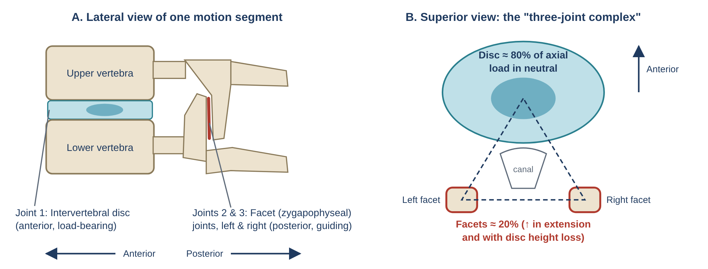
Figure 4. The motion segment. (A) Lateral view: the disc anteriorly and a facet joint posteriorly. (B) Superior view: the disc and the two facet joints form a triangle — the three-joint complex.

Load sharing within the segment
- Neutral standing: the disc carries most of the axial load (commonly cited ≈ 80%), the facets ≈ 20% or less.
- Extension / hyperlordosis: the inferior facets slide down onto the lamina below, so facet load increases markedly (reported up to ~30% or more).
- Disc degeneration: as the disc loses height, the facets come into closer contact and carry a much larger share of load (up to ~70% in severe narrowing in some studies) — one reason facet arthritis follows disc degeneration.
- Flexion: facets carry little compression but resist anterior shear and help limit flexion via their capsules.
- Rotation: the facets are the primary restraint; in rotation one facet is compressed while the opposite facet capsule is stretched.

5. The intervertebral disc: structure and mechanics

5.1 Structure
- Nucleus pulposus — a central gel made mostly of water (≈ 70–90% in the young) held by proteoglycans that attract water. It behaves like a pressurised fluid and spreads load evenly.
- Annulus fibrosus — 15–25 concentric rings (lamellae) of collagen (mainly type I outside, type II inside). Fibres in each lamella run at about 30° to the horizontal (≈ 60–65° to the vertical), and the direction alternates between neighbouring layers — like the plies of a car tyre. This criss-cross pattern resists twisting in both directions and bulging.
- Cartilaginous endplates — connect the disc to the vertebrae and allow nutrition to diffuse in. The adult disc is largely avascular (only the outer annulus has blood vessels and nerves), so it heals poorly.
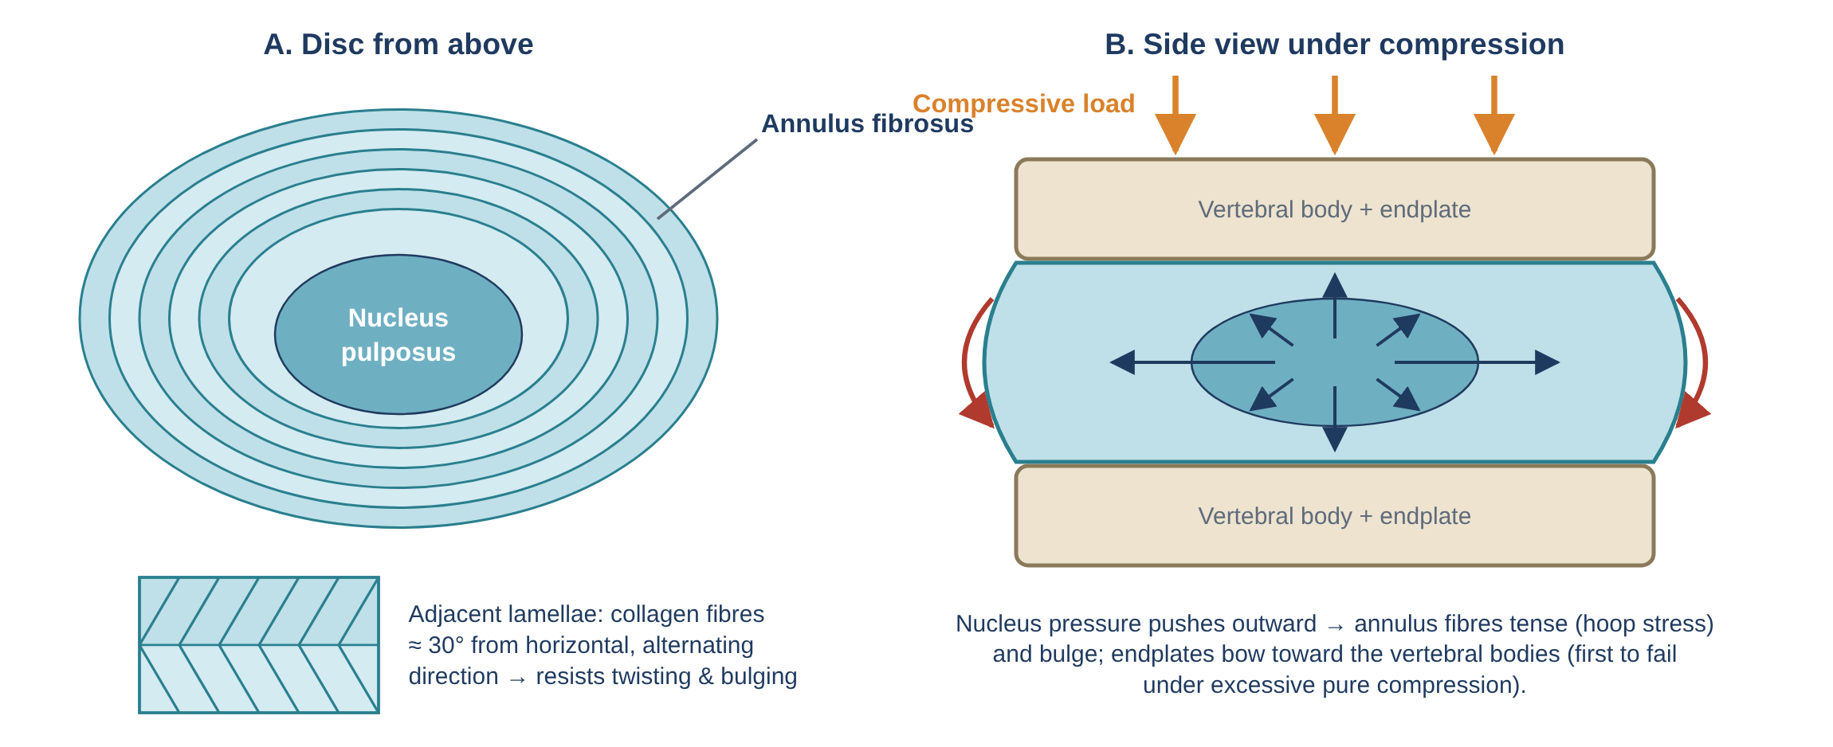
Figure 5. The intervertebral disc. (A) Superior view: nucleus and lamellae of the annulus with alternating fibre directions. (B) Under compression, the pressurised nucleus pushes outward, producing tensile hoop stress in the annulus and bowing of the endplates.

5.2 How the disc carries load
- A compressive load presses the vertebrae together.
- The nucleus, being fluid-like and incompressible, is pressurised (hydrostatic pressure).
- This pressure pushes outwards on the annulus and up/down on the endplates.
- The annulus fibres are stretched — compressive load is converted into tensile (hoop) stress in the annulus, which collagen resists very well.
- The endplates bow slightly into the vertebral bodies, and the load passes to the next vertebra.
Thus the disc works like a hydraulic cushion: it distributes pressure evenly over the endplate and allows small movements between vertebrae.

5.3 Disc behaviour in movement
- Flexion: anterior annulus compressed, posterior annulus stretched; the nucleus is pushed posteriorly.
- Extension: posterior annulus compressed, anterior annulus stretched; the nucleus moves anteriorly.
- Lateral flexion: the nucleus moves towards the convex side (away from the side of bending).
- Rotation: only half of the annular fibres (those oriented in the direction of the twist) are tensioned, so the disc is weakest in torsion; the facets protect it.

5.4 Viscoelastic properties
- Creep: under a constant load, the disc slowly loses height as fluid is squeezed out. Over a day we lose about 1–2 cm of body height, recovered overnight when lying down (unloading lets the nucleus re-imbibe fluid).
- Diurnal variation: discs are most hydrated and stiffest in the early morning — bending loads on the disc and ligaments are higher at this time, which is why forceful flexion soon after waking carries more risk.
- Stress relaxation and hysteresis: the disc dissipates energy during repeated loading (shock absorption), but repeated cycles cause fatigue damage.
- Rate dependence: the disc is stiffer under rapid loading.

5.5 Disc failure
- Under pure compression, the endplate usually fractures first (not the disc) — nuclear material can push into the vertebral body (Schmorl's node).
- Under repeated flexion combined with compression (and rotation), the posterior annulus gradually develops tears through which the nucleus can track — disc herniation (see Flowchart 4).
- With ageing the nucleus dehydrates and becomes fibrous, so pressure is no longer evenly spread; load concentrates on the annulus and endplates.

6. Kinematics: movements of the lumbar spine
Kinematics describes motion without considering forces. Spinal motion is described as osteokinematics (movement of the whole bone, i.e., the trunk) and arthrokinematics (gliding of the joint surfaces). Each motion segment has six degrees of freedom: rotation and translation about three axes.
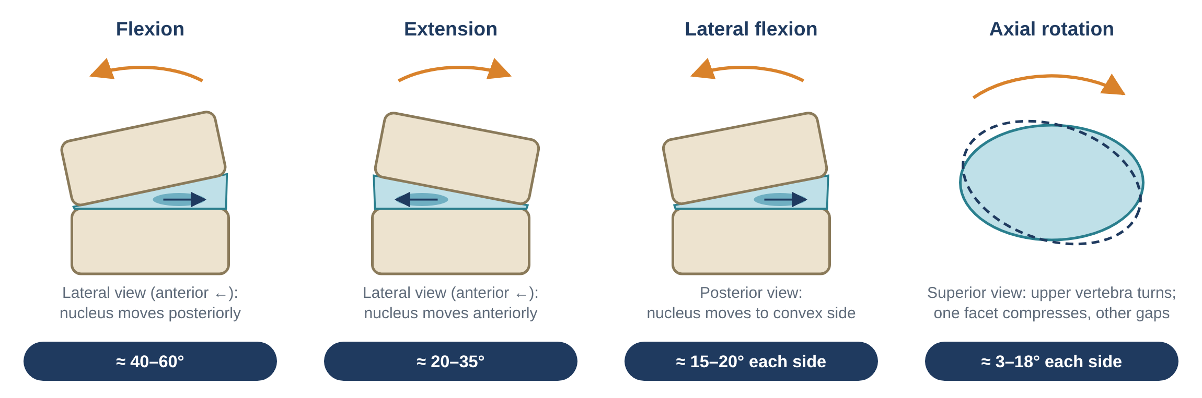
Figure 6. The four basic lumbar movements, with typical total lumbar range of motion (adult).

6.1 Range of motion
Movement | Plane / axis | Typical total lumbar ROM | Main limiting structures
Flexion | Sagittal / frontal axis | ≈ 40–60° | Posterior annulus, PLL, ligamentum flavum, interspinous & supraspinous ligaments, facet capsules, thoracolumbar fascia, back extensors
Extension | Sagittal / frontal axis | ≈ 20–35° | Anterior annulus, ALL, bony contact of spinous processes and inferior facets on laminae, abdominals
Lateral flexion | Frontal / sagittal axis | ≈ 15–20° each side | Contralateral intertransverse ligaments & muscles (QL), facet contact on the concave side
Axial rotation | Transverse / vertical axis | ≈ 3–18° each side (typically ≈ 5°) | Sagittally oriented facets (bony block), annulus fibres, capsules

Segmental contribution: flexion–extension increases from L1–L2 (≈ 12°) to L5–S1 (≈ 17–20°), so the lower two levels — which also carry the most load — are the most mobile and the most frequently injured. Lateral flexion is greatest in the mid-lumbar levels and smallest at L5–S1; rotation is only ≈ 1–2° per level (White & Panjabi).

6.2 Arthrokinematics of the facet joints
Movement | What the inferior facets of the upper vertebra do | Effect on canal / foramen
Flexion | Glide superiorly and anteriorly (upward) on the superior facets below; joint surfaces separate; capsule tightens | Canal and foramina open (larger)
Extension | Glide inferiorly and posteriorly (downward); tips may contact the lamina below; joint is compressed | Canal and foramina close (smaller); ligamentum flavum buckles
Lateral flexion | On the concave (same) side the facet glides down; on the convex side it glides up | Foramen narrows on the side of bending
Rotation | Facet on the side opposite the rotation is compressed; the facet on the same side gaps | Small change; asymmetrical

Clinical link: because extension narrows the canal and foramina, patients with spinal stenosis usually feel worse walking upright (extension) and better sitting or bending forward (flexion) — the "shopping trolley sign".

6.3 Coupled motion
Movements of the spine rarely occur in a single plane. Coupling means that a primary motion is consistently accompanied by a secondary motion. In the lumbar spine, lateral flexion is coupled with axial rotation. Many texts state that in neutral or extension, side-bending is coupled with rotation to the opposite side, and in flexion with rotation to the same side; however, research shows that the lumbar coupling pattern is variable between individuals and levels, so it should not be relied upon rigidly in clinical tests.

6.4 Instantaneous axis of rotation (IAR)
As a vertebra moves, it rotates about an axis that keeps shifting slightly — the instantaneous axis of rotation. In a healthy lumbar segment, the IAR for flexion–extension lies in the posterior part of the disc / anterior to the vertebral canal and moves very little. In a degenerated or injured segment the IAR becomes scattered, which indicates abnormal, poorly controlled motion (segmental instability).

6.5 Lumbopelvic rhythm
Bending forward to touch the toes is shared between the lumbar spine and the hip joints. This coordinated pattern is called the lumbopelvic rhythm (Cailliet). During the first part of forward bending, lumbar flexion dominates; in the later part the pelvis rotates forward on the hips. When returning upright the order reverses: the hips extend first, then the lumbar spine extends. If the hamstrings are tight, the lumbar spine must flex more, increasing disc and ligament strain. The full sequence is shown in Flowchart 2.

Flexion-relaxation phenomenon
Near full trunk flexion, the electrical activity of the erector spinae suddenly falls silent. The moment of the trunk is then supported passively by the stretched posterior ligaments, thoracolumbar fascia, facet capsules and disc. Many people with chronic low back pain lose this relaxation (the muscles stay active), and it is used as an objective sign of altered motor control.

7. Kinetics: loads on the lumbar spine
Kinetics studies the forces that cause or result from motion. The lumbar spine is loaded by body weight, muscle forces, ligament tension, intra-abdominal pressure and external loads. These create five basic types of load:
Load type | What it is | Main structures resisting it
Compression | Pushing vertebrae together along the long axis | Vertebral body, endplate, nucleus & annulus; facets (in extension)
Tension (distraction) | Pulling vertebrae apart | Ligaments, annulus, facet capsules
Shear | Sliding one vertebra forward/backward or sideways on another | Facets (anterior shear), annulus, iliolumbar ligaments, muscles
Bending | Combination of compression on one side and tension on the other (flexion, extension, side-bending) | Disc, ligaments, facets, muscles
Torsion | Twisting around the vertical axis | Facets (primary), annulus (only half its fibres)

7.1 The load pathway
Load from the upper body passes down two "columns": an anterior column of vertebral bodies and discs (carrying most compression) and a posterior column of pedicles, laminae and facet joints (guiding motion, resisting shear and rotation). At L5–S1 the load is transferred to the sacrum, through the sacroiliac joints to the pelvis, and then through the hips to the legs. See Flowchart 1.

7.2 Intradiscal pressure and posture
Classic in-vivo measurements by Nachemson (1960s–1980s) placed a pressure sensor in the L3 disc of volunteers. Expressing the pressure relative to upright standing (100%) gives a simple picture of how posture affects disc loading:
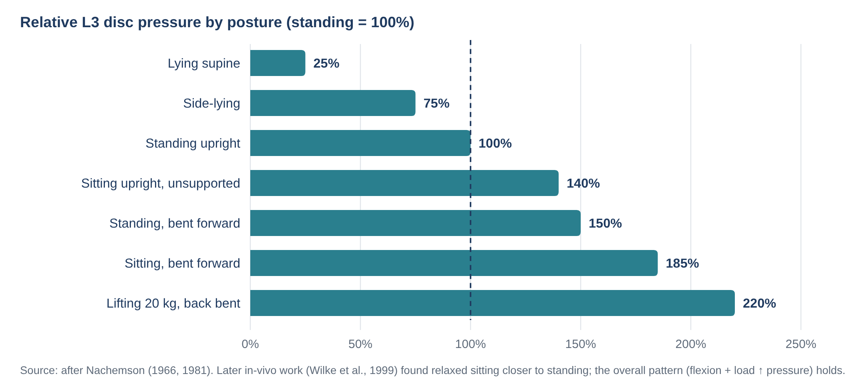
Figure 7. Relative L3 intradiscal pressure in different postures (after Nachemson). Flexion and lifting with a bent back markedly increase disc pressure; lying down unloads it.
- Lying supine gives the lowest pressure (≈ 25%) — the basis for rest positions and overnight disc rehydration.
- Sitting (especially slouched/flexed) produces higher pressures than standing in Nachemson's data, because the pelvis tilts backward and the lumbar spine flexes. Later measurements (Wilke et al., 1999) found relaxed sitting only slightly different from standing, but both studies agree that forward-bent sitting and lifting with a flexed spine give the highest loads.
- Back support, a lumbar roll and a reclined backrest (≈ 110–120°) reduce disc pressure in sitting.

7.3 The spine as a lever: why lifting technique matters
The back extensor muscles act very close to the centre of rotation of the disc — their moment arm is only about 5–6 cm — whereas the weight of the trunk and the load in the hands acts far in front. To balance the forward bending moment, the muscles must produce a force many times larger than the load, and this muscle force adds directly to disc compression.
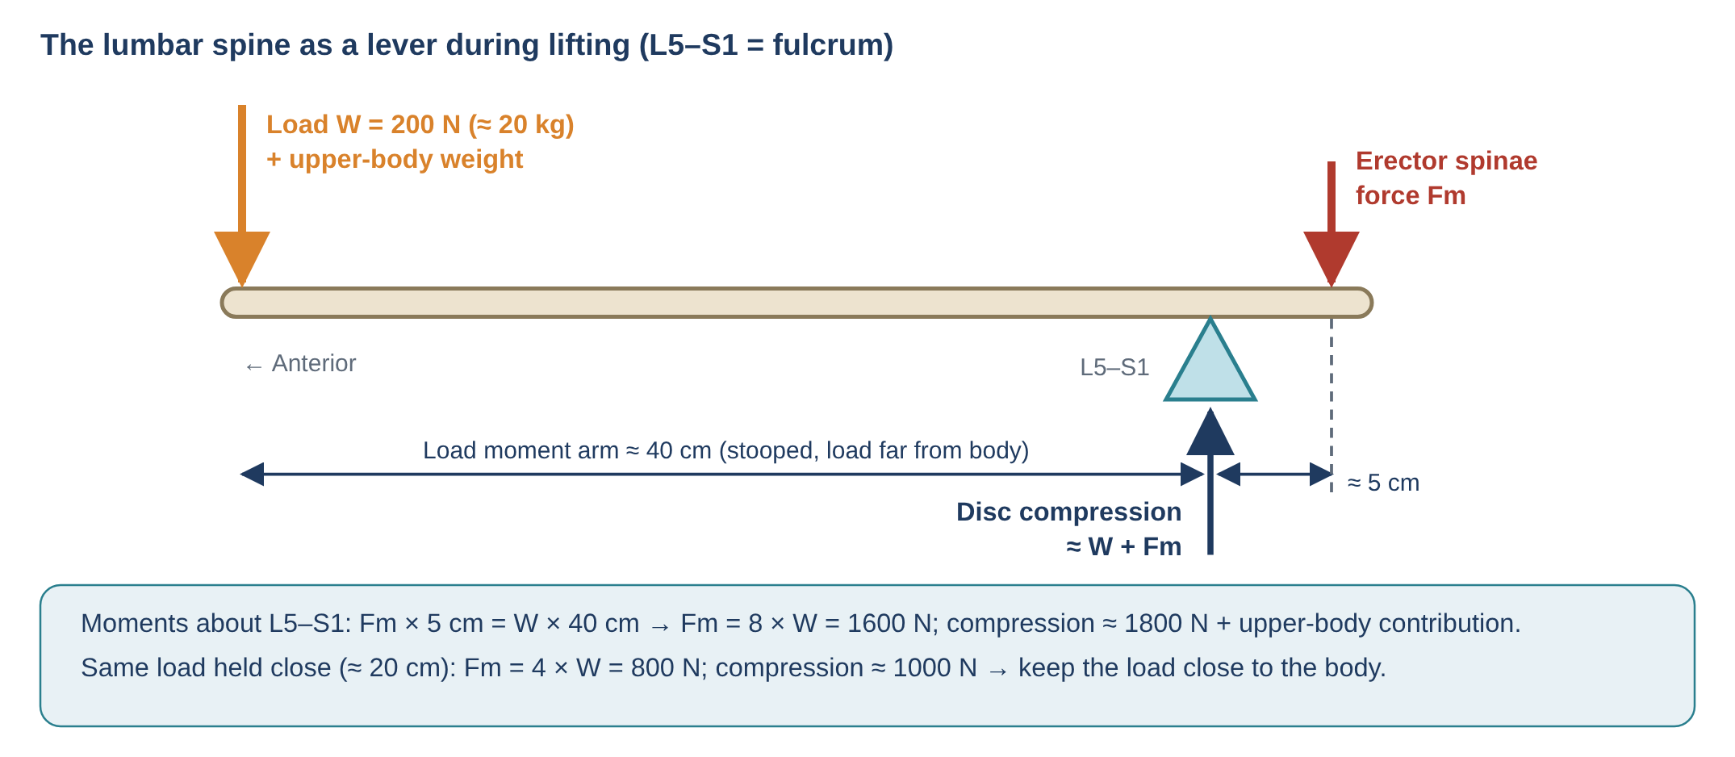
Figure 8. Simplified lever model of lifting. The short moment arm of the erector spinae means that the muscle force (and therefore disc compression) is many times the weight lifted.
Worked example: lifting a 20 kg (≈ 200 N) box held 40 cm in front of L5–S1 requires about 1600 N of extensor muscle force (200 × 40 / 5), giving roughly 1800 N of compression on the disc before the weight of the upper body (≈ 450 N acting ≈ 20 cm in front of the spine in a stoop) is added. Including the trunk, compression readily exceeds 3400 N, the NIOSH "action limit"; above ≈ 6400 N is considered hazardous for most workers.

Practical principles derived from the lever model
- Keep the load close to the body — halving the distance roughly halves the muscle force needed.
- Bend the hips and knees and keep the spine near neutral — this shortens the moment arm and keeps the disc out of end-range flexion where the posterior annulus is vulnerable.
- Avoid twisting while lifting — combined flexion, rotation and compression is the most damaging combination for the disc.
- Lift smoothly, not with sudden jerks (dynamic forces increase loads further).
- Avoid heavy bending immediately after rising, when discs are most hydrated.

7.4 Shear forces
Because of the lordosis and the inclined sacrum, the lower lumbar segments experience significant anterior shear, which increases with forward lean and with hyperlordosis. The lumbar erector spinae (longissimus and iliocostalis lumborum) pull obliquely backward and help counter anterior shear when the spine is near neutral; in full flexion this ability is lost, so the passive tissues (facets, ligaments) take the shear.

8. Ligaments: passive restraints
Ligaments are passive stabilisers: they mainly resist tension and limit end-range motion. Their effectiveness depends on their distance from the axis of rotation — the further posterior a ligament lies, the greater its leverage in resisting flexion.
Ligament | Location | Main biomechanical role
Anterior longitudinal ligament (ALL) | Front of bodies and discs; broad and strong | Limits extension; resists anterior bulging of the disc
Posterior longitudinal ligament (PLL) | Back of bodies inside the canal; narrow in the lumbar region | Limits flexion; reinforces the posterior disc centrally only → herniations tend to be posterolateral
Ligamentum flavum | Connects laminae; ≈ 80% elastin | Pre-tensioned even in neutral — gives intrinsic disc pre-stress; recoils to assist return from flexion; does not buckle into the canal (unless thickened in degeneration)
Interspinous & supraspinous | Between and over spinous processes | Limit flexion; long lever arm; often the first to be sprained in forced flexion
Intertransverse | Between transverse processes | Limit lateral flexion to the opposite side
Facet joint capsules | Around each facet joint | Limit flexion and rotation; rich in mechanoreceptors and nociceptors
Iliolumbar ligament | L5 (± L4) transverse process to iliac crest | Limits anterior shear, lateral flexion and rotation of L5 on S1; key stabiliser of the lumbosacral junction

9. Muscles, thoracolumbar fascia and intra-abdominal pressure
An isolated lumbar spine without muscles buckles under a load of only about 90 N (Crisco & Panjabi). The ability of the living spine to carry thousands of newtons therefore depends on muscles acting like the guy-wires of a mast. Muscles are often grouped into two systems (Bergmark, 1989):
System | Muscles | Biomechanical role
Local (deep) stabilising system | Lumbar multifidus, transversus abdominis (TrA), internal oblique (deep fibres), deep fibres of psoas & quadratus lumborum, diaphragm and pelvic floor | Attach directly to vertebrae; control segmental motion and stiffness, especially within the neutral zone; activate in anticipation of limb movement (feed-forward)
Global (superficial) movement system | Erector spinae (longissimus, iliocostalis), rectus abdominis, external oblique, superficial quadratus lumborum | Large moment arms; produce trunk movement and balance external loads; transfer load between thorax and pelvis

Key points
- Multifidus is the largest and most medial back muscle at the lumbosacral junction. It provides segmental extension and stiffness. After an episode of back pain it often shows atrophy and fatty infiltration at the affected level, which may not recover spontaneously — the rationale for specific retraining.
- Erector spinae produce extension and control flexion eccentrically; their lumbar fibres also resist anterior shear.
- Transversus abdominis acts like a corset. Through its attachment to the thoracolumbar fascia it tensions the fascia and raises intra-abdominal pressure. Its delayed onset has been observed in people with low back pain (Hodges & Richardson).
- Psoas major flexes the hip and, through its attachments to the lumbar vertebrae, adds compression and some stability; when tight it pulls the lumbar spine into increased lordosis.
- Quadratus lumborum is an important lateral stabiliser in the frontal plane (e.g., carrying a load in one hand).

Thoracolumbar fascia (TLF)
The TLF has anterior, middle and posterior layers enclosing the back muscles. Gluteus maximus and latissimus dorsi pull on the posterior layer from opposite sides, and TrA and internal oblique pull on it laterally. Tension in the TLF creates an extensor moment and compresses the sacroiliac joints (force closure), linking arm, trunk and leg muscles into one load-transfer system — e.g., in walking and lifting.

Intra-abdominal pressure (IAP)
Co-contraction of the diaphragm, pelvic floor and abdominal wall turns the abdomen into a pressurised cylinder. IAP stiffens the trunk and may slightly unload the spine, which is the basis of bracing during heavy lifting (and the rationale for weight-lifting belts). Its main benefit is now considered to be increased trunk stiffness rather than a large reduction in disc compression.

10. Spinal stability (Panjabi model)
Spinal stability is the ability of the spine to maintain its normal pattern of displacement under physiological loads, without neurological injury, deformity or incapacitating pain. Panjabi (1992) described three interdependent subsystems:
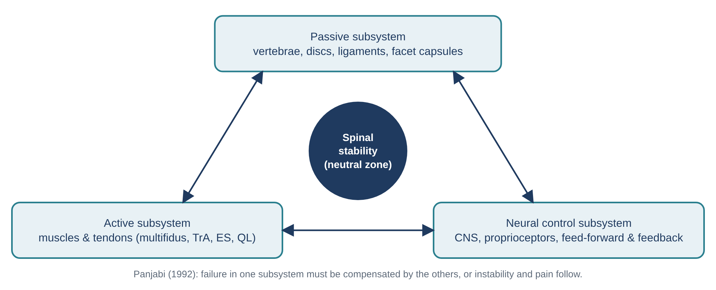
Figure 9. Panjabi's model of spinal stability: three interdependent subsystems control the neutral zone.
- Passive subsystem: bones, discs, ligaments and capsules. Provides stability mainly near the end of range, and acts as a source of sensory information (mechanoreceptors).
- Active subsystem: muscles and tendons, which generate the forces required to stabilise the spine throughout the range.
- Neural control subsystem: receives information from the other two, determines the stability requirements and activates muscles with the correct timing and intensity.

Neutral zone
The neutral zone is the small part of the range near the neutral position where the spine moves with very little internal resistance (a "lax" region in the load–displacement curve). The elastic zone follows, where passive tissues provide increasing resistance. Injury and degeneration enlarge the neutral zone; muscles can reduce it again. Clinical instability is therefore considered a decrease in the capacity of the stabilising system to keep the neutral zone within physiological limits.

11. Clinical biomechanics (pathomechanics)
Condition | Biomechanical mechanism | Typical movement behaviour
Disc herniation | Repeated flexion + compression (± rotation) → posterior annular fissures → nucleus migrates posterolaterally (narrow PLL) → nerve root compression / inflammation | Pain ↑ with sitting, bending, coughing; often ↓ with extension (centralisation)
Facet joint syndrome | Excess facet loading in extension/rotation; facet osteoarthritis secondary to disc height loss | Pain ↑ with extension, extension-rotation, prolonged standing
Spinal stenosis | Disc bulge + facet hypertrophy + ligamentum flavum buckling reduce canal/foraminal space, worsening in extension | Neurogenic claudication; relieved by sitting / flexing forward
Spondylolysis / spondylolisthesis | Repeated extension + rotation stress the pars (athletes: gymnasts, fast bowlers); anterior shear at L5–S1 causes slip | Pain with extension; possible step deformity; hamstring tightness
Segmental (clinical) instability | Enlarged neutral zone, poor motor control, scattered IAR | Painful arc, "catch", aberrant motion, apprehension
Degenerative disc disease | Dehydration of nucleus → loss of height → load shifts to annulus and facets (three-joint complex cascade) | Morning stiffness, pain with sustained postures
Vertebral compression fracture | Compressive load exceeds endplate/body strength (e.g., osteoporosis); anterior wedging ↑ kyphosis | Sudden pain after minor flexion load or fall

The degenerative cascade (Kirkaldy-Willis) describes how injury to one joint of the three-joint complex progresses through stages of dysfunction, instability and re-stabilisation — see Flowchart 3. The mechanism of disc herniation is summarised in Flowchart 4, and a biomechanically based assessment pathway in Flowchart 5.

12. Flowcharts
The following flowcharts summarise the key biomechanical processes described above in a step-by-step format.

Flowchart 1 — Load transmission through the lumbar spine
Shows how body weight and external loads travel from the trunk through the anterior and posterior columns to the pelvis and lower limbs.
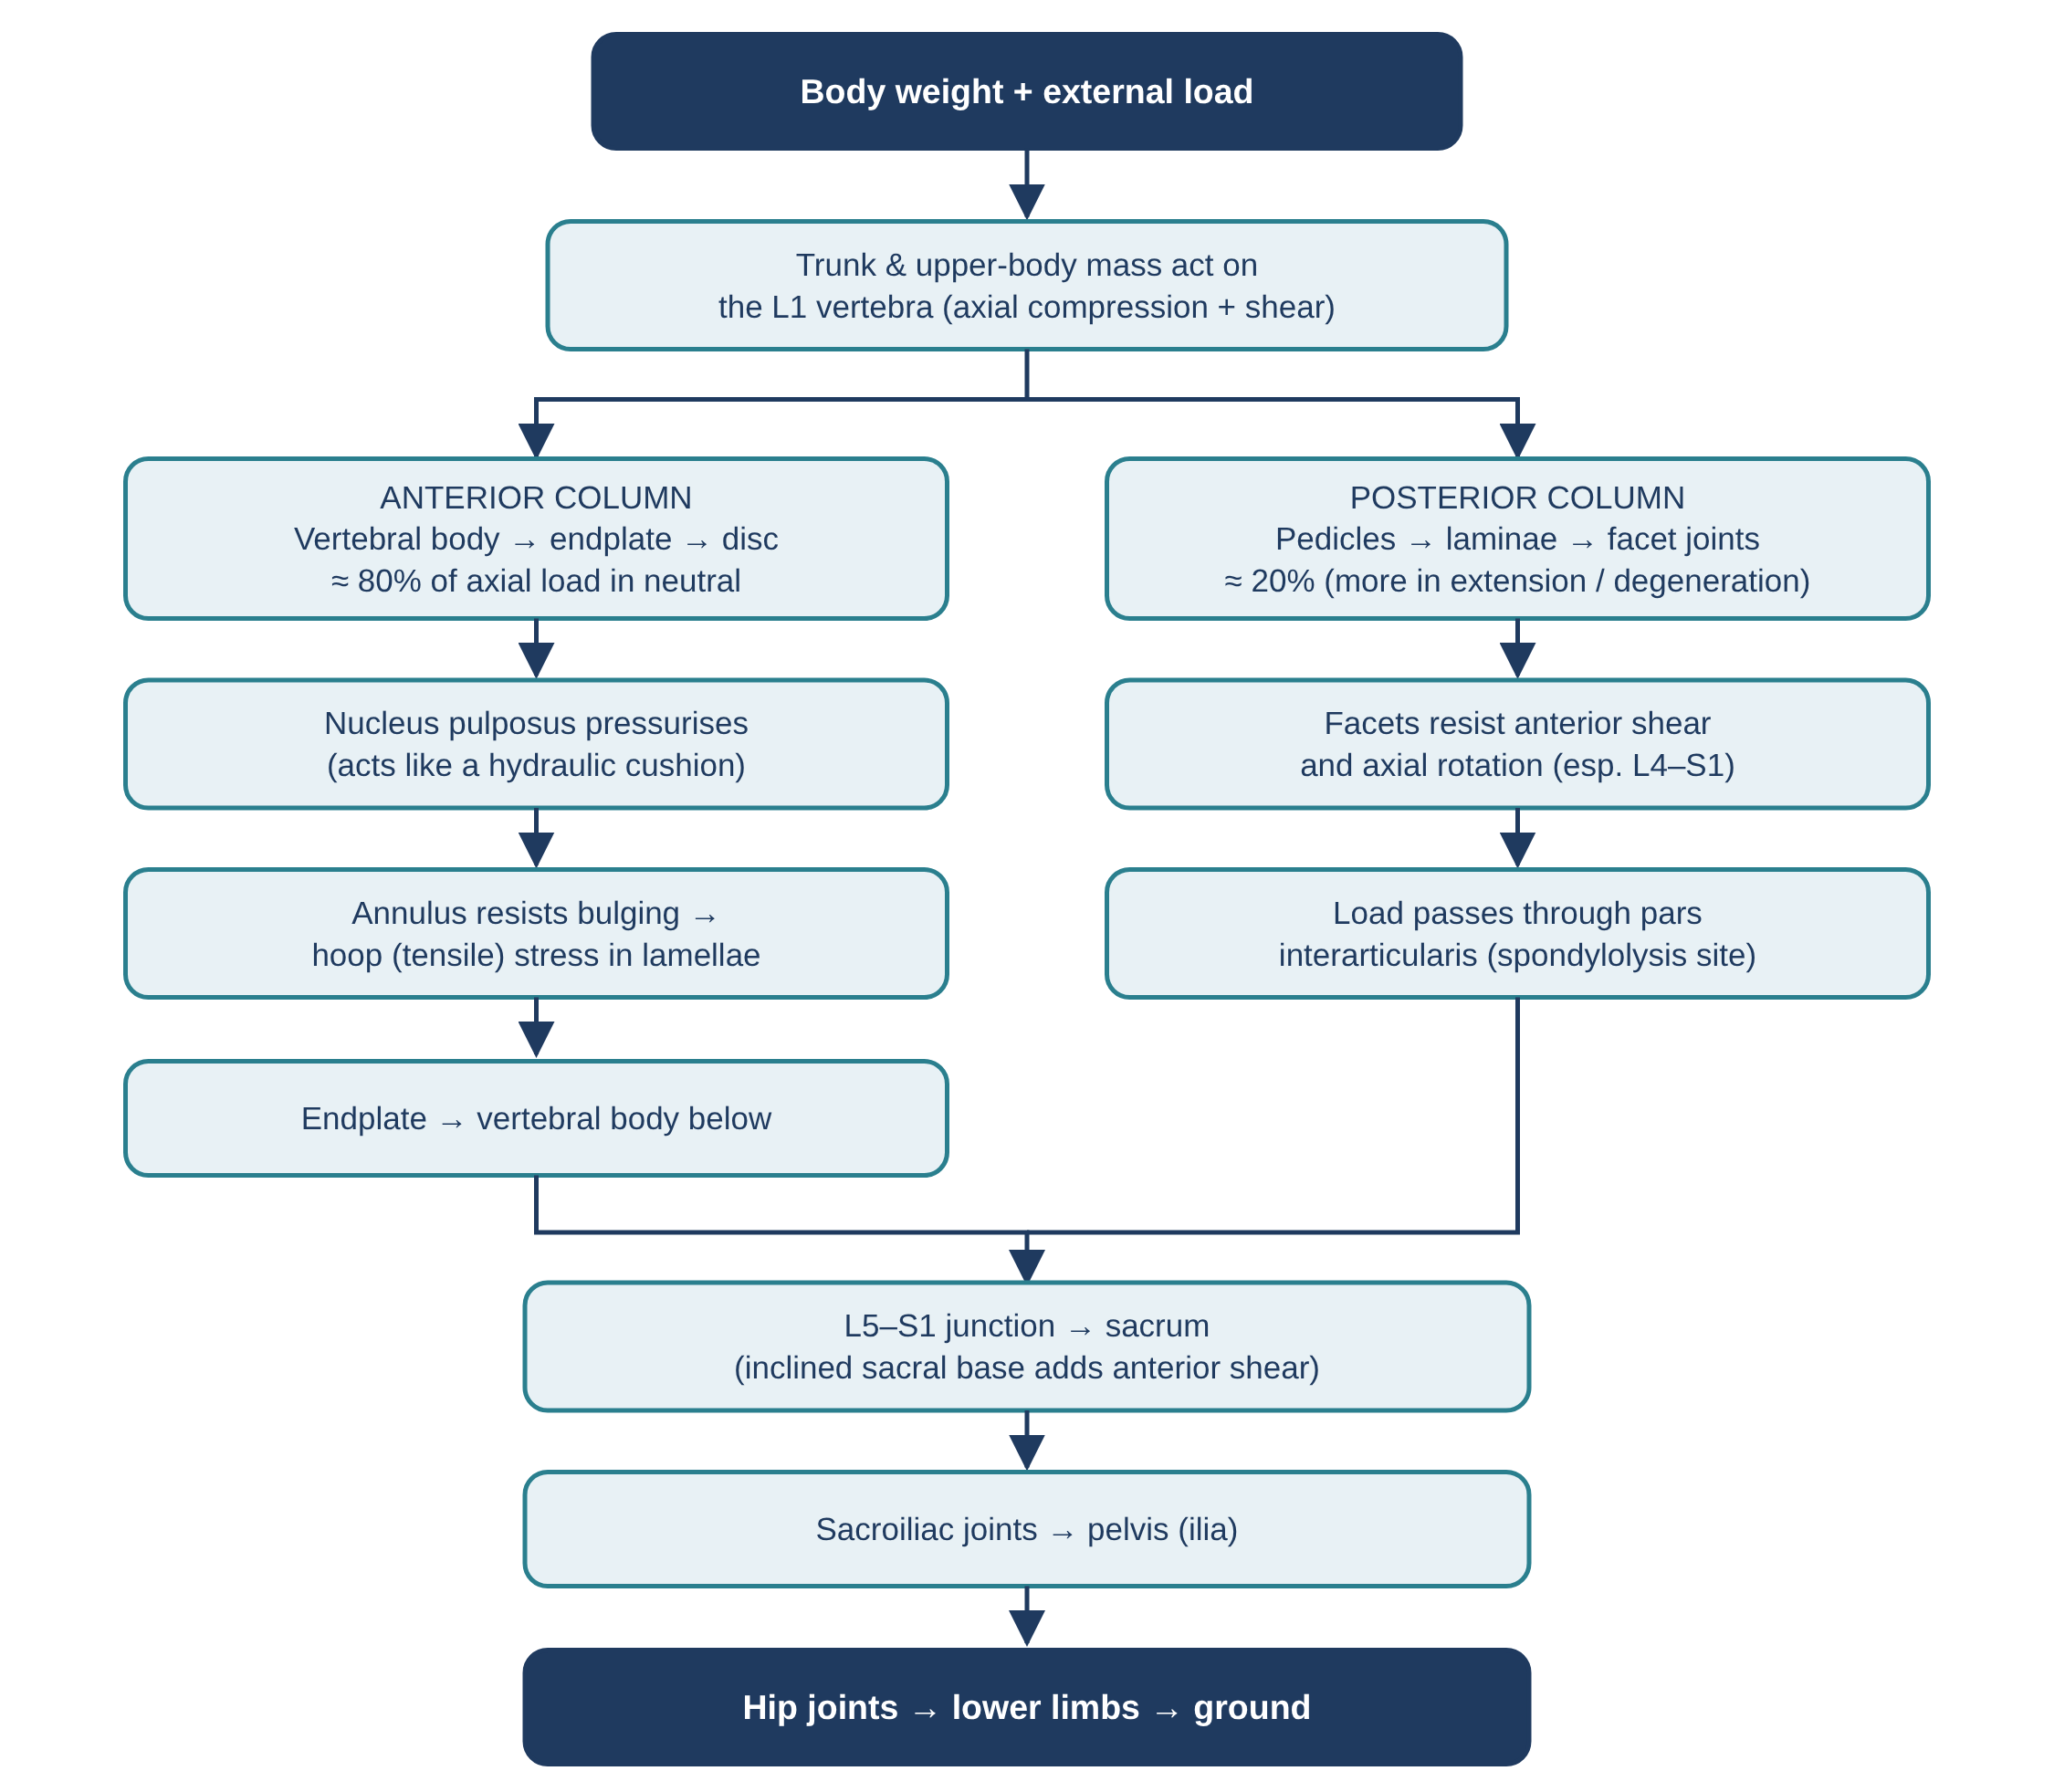
Figure 10. Flowchart 1: load transmission pathway.

Flowchart 2 — Lumbopelvic rhythm during forward bending and return
Shows the sequence of lumbar and hip motion and the muscle actions while bending forward and returning to upright.
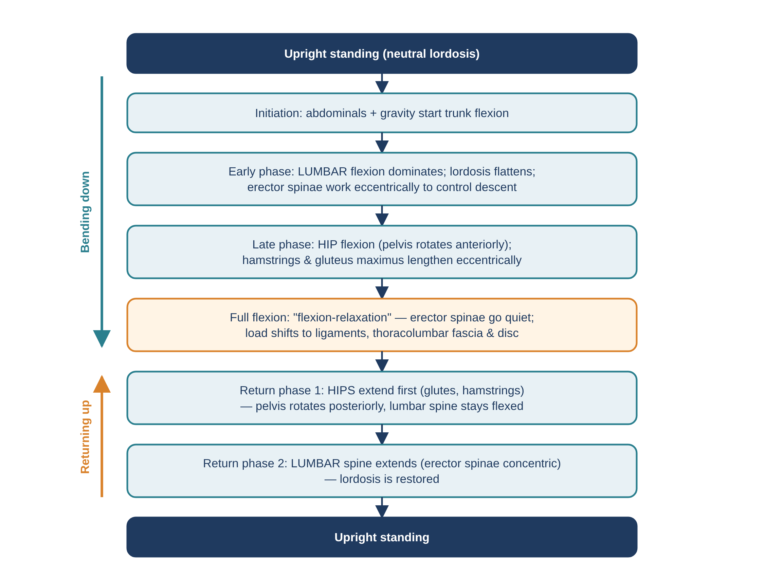
Figure 11. Flowchart 2: lumbopelvic rhythm and flexion-relaxation.

Flowchart 3 — Degenerative cascade of the three-joint complex
Shows how repetitive loading leads through the three Kirkaldy-Willis stages to stenosis and nerve root compression.
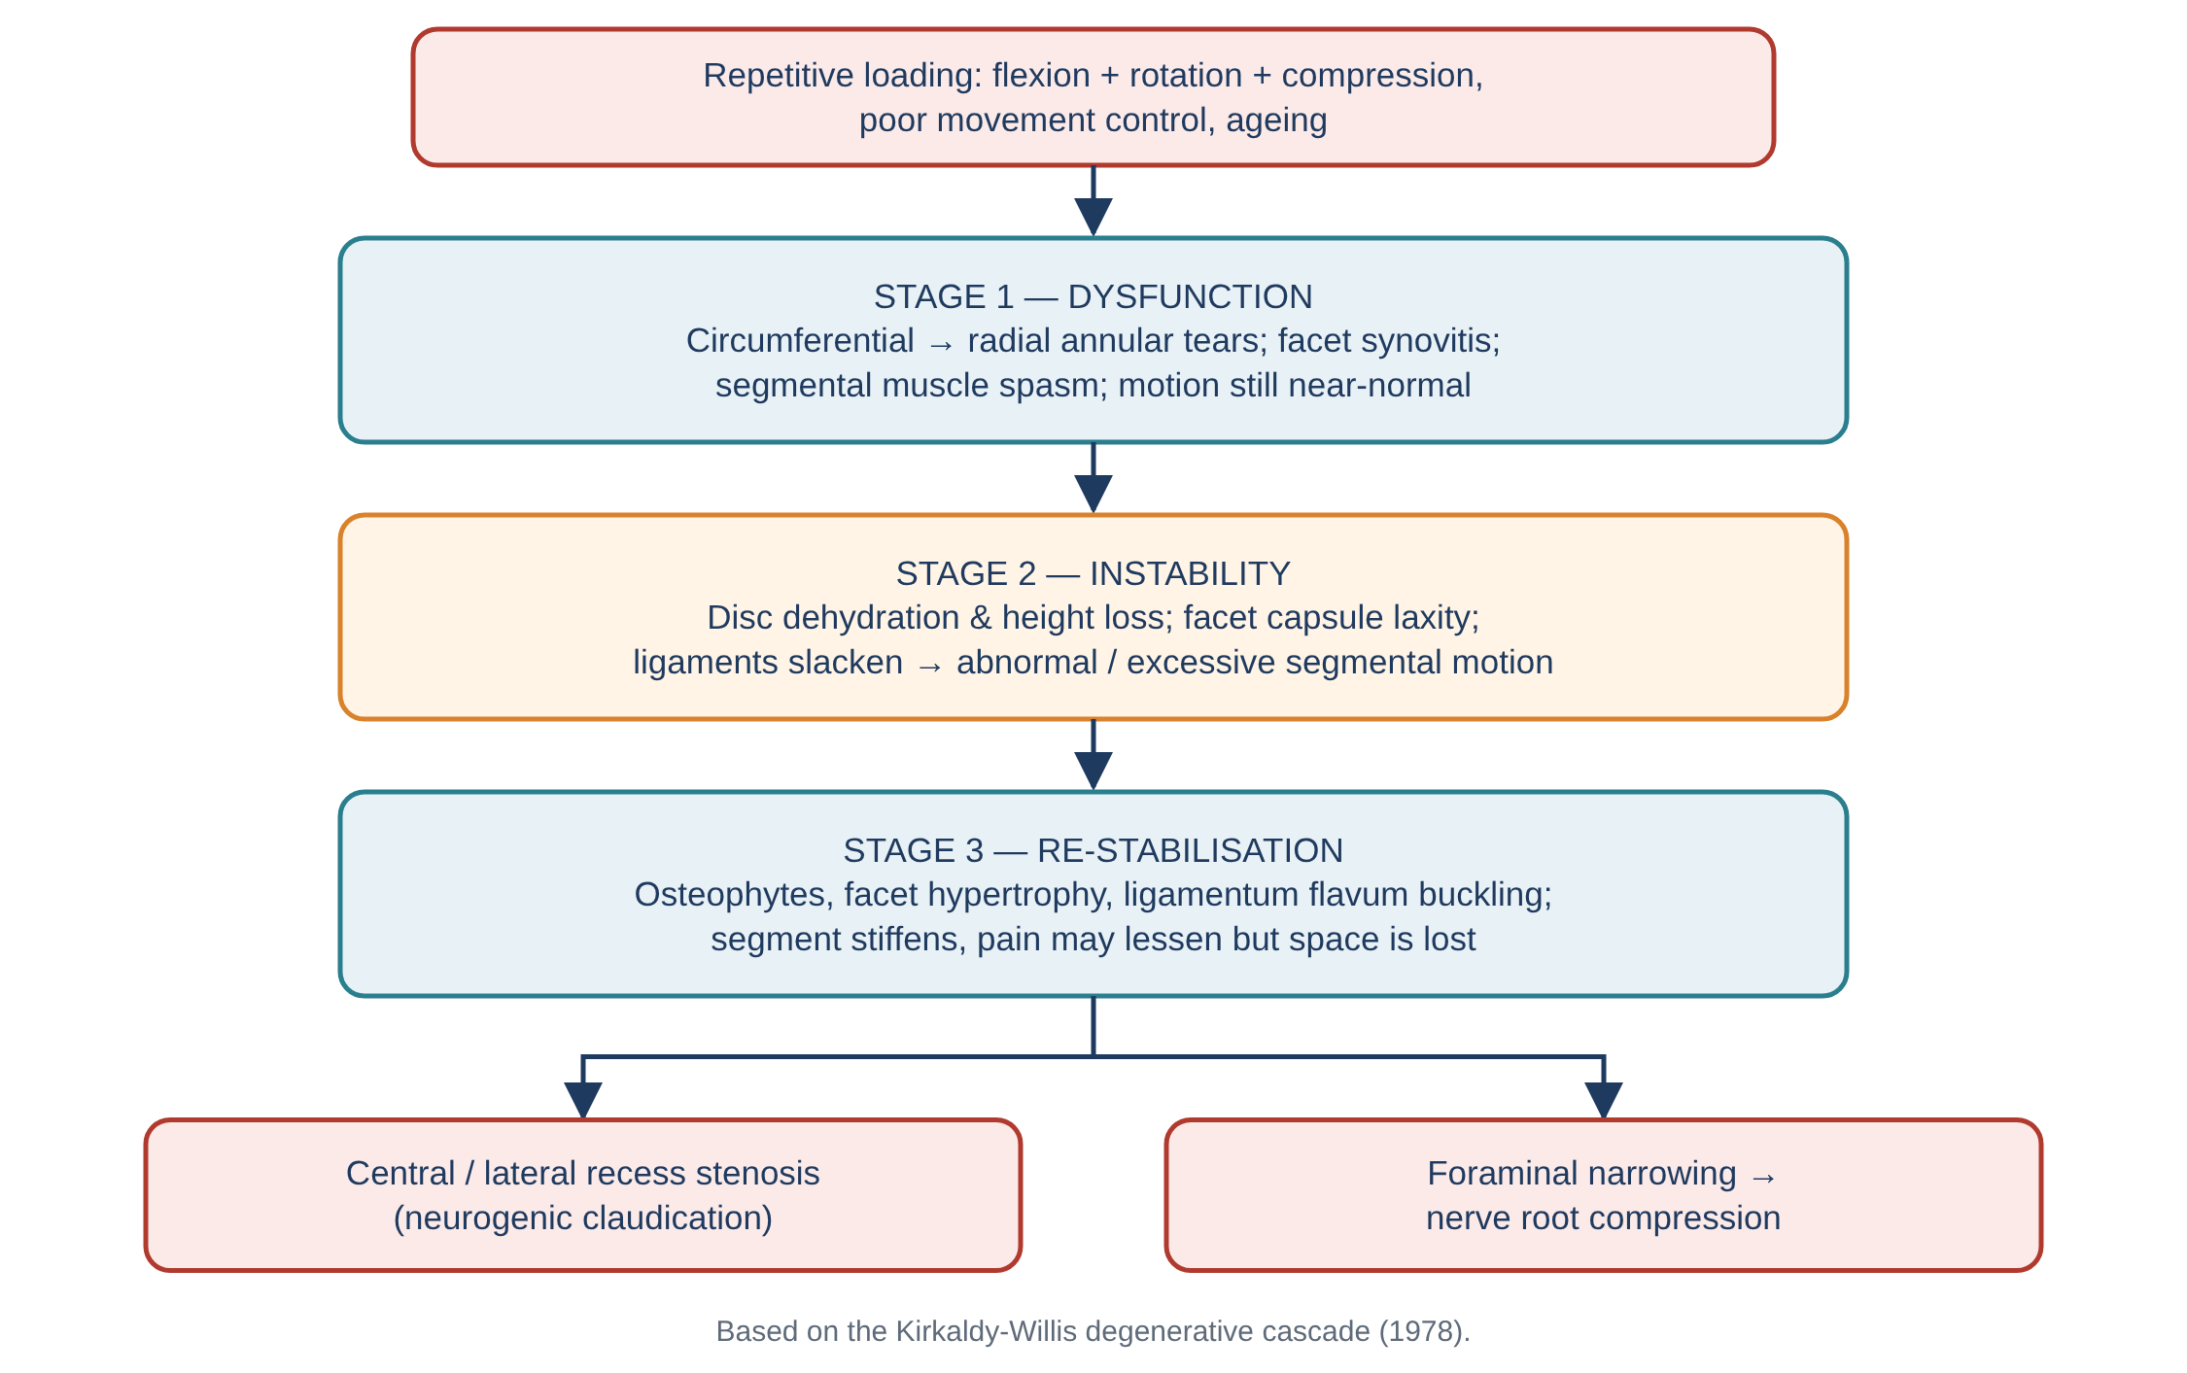
Figure 12. Flowchart 3: degenerative cascade (after Kirkaldy-Willis).

Flowchart 4 — Mechanism of lumbar disc herniation
Shows how repeated loaded flexion leads to posterior migration of the nucleus, annular fissures and posterolateral herniation.
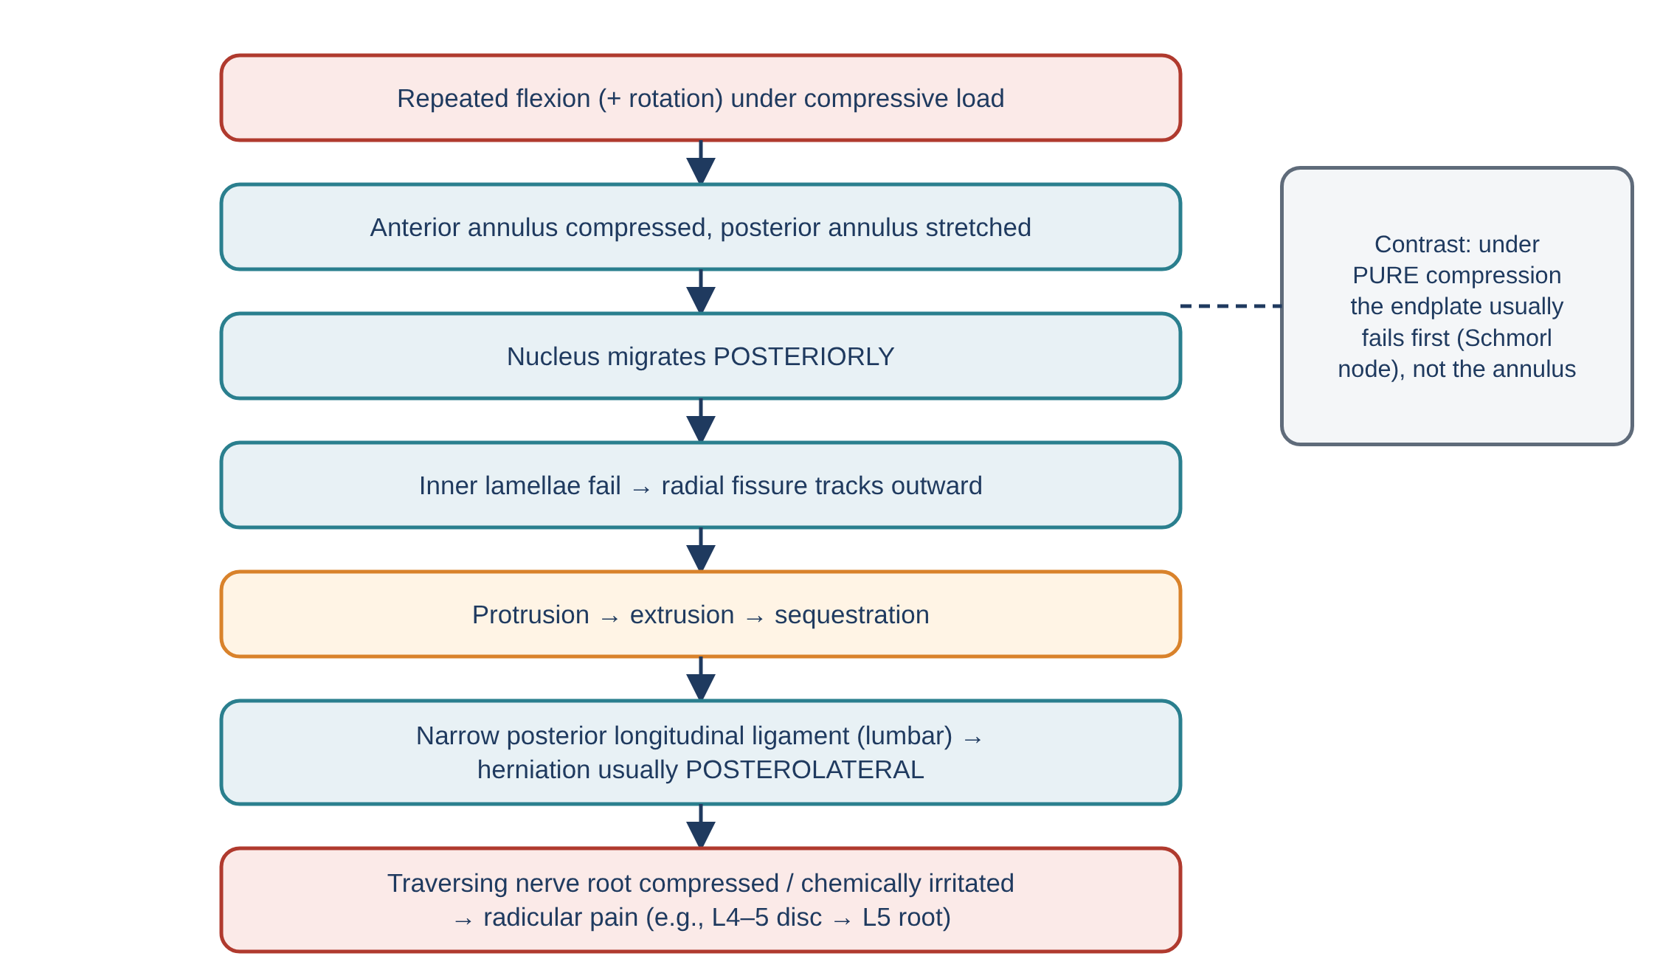
Figure 13. Flowchart 4: biomechanical mechanism of disc herniation.

Flowchart 5 — Biomechanically based clinical reasoning for low back pain
A simplified educational pathway linking movement findings to likely biomechanical patterns and management. It does not replace a full clinical examination.
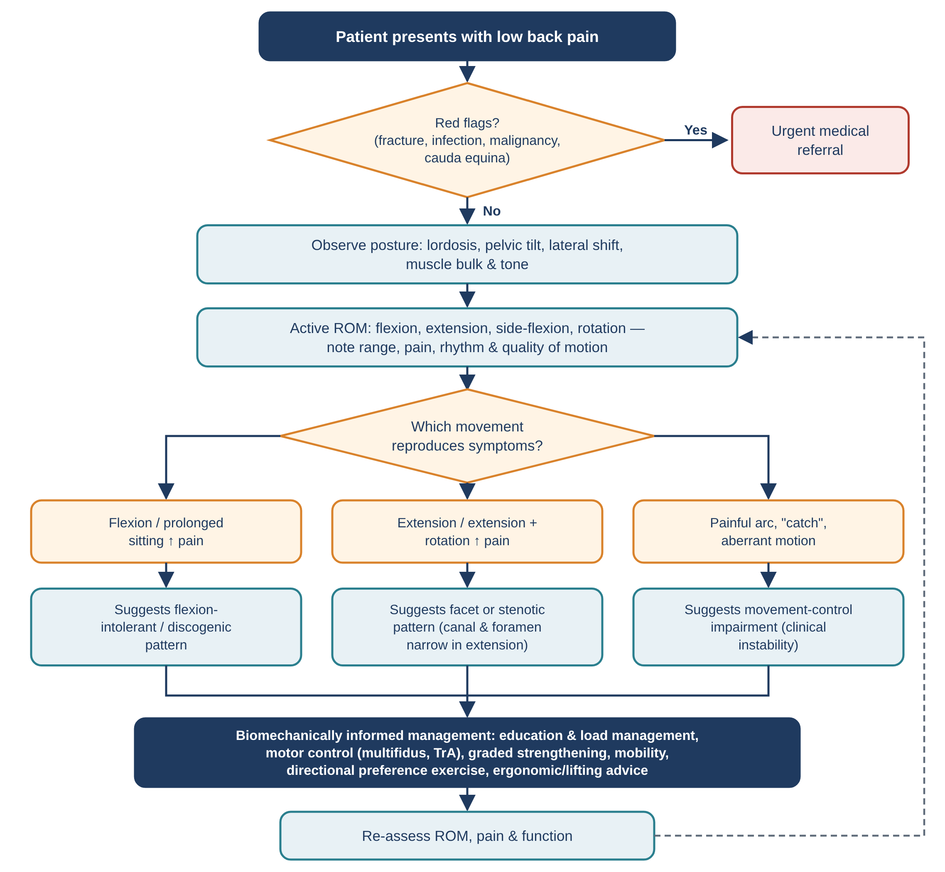
Figure 14. Flowchart 5: assessment and management pathway based on lumbar biomechanics.

13. Summary tables

Quick-reference: key numbers
Parameter | Typical value
Lumbar lordosis (L1–S1) | ≈ 40–60°
Sacral base (Ferguson) angle | ≈ 30–40°
Axial load share in neutral | Disc ≈ 80%, facets ≈ 20%
Total lumbar flexion / extension | ≈ 40–60° / 20–35°
Lateral flexion / rotation (each side) | ≈ 15–20° / 3–18°
Most mobile segments (flex–ext) | L4–L5 and L5–S1
Annulus fibre angle | ≈ 30° to horizontal, alternating layers
Nucleus water content (young adult) | ≈ 70–90%
Daily height loss from disc creep | ≈ 1–2 cm
Erector spinae moment arm | ≈ 5–6 cm
Lumbar spine buckling load without muscles | ≈ 90 N
NIOSH compression action limit / max limit | 3400 N / 6400 N

Key take-home messages
- The lumbar spine is built for load bearing and flexion–extension; its sagittal facets restrict rotation.
- Each motion segment is a three-joint complex — disc and two facets share load and fail together.
- The disc converts compression into annular tension; it is weakest in torsion and in repeated loaded flexion.
- Posture strongly influences disc pressure: flexed sitting and stooped lifting give the highest loads; lying gives the lowest.
- Because back muscles have short lever arms, holding loads close and using the hips and knees greatly reduces spinal compression.
- Stability depends on the passive, active and neural subsystems working together; motor control training targets the neutral zone.
- Extension narrows the canal and foramina; flexion opens them — central to understanding stenosis and facet pain.

14. References
Adams, M. A., Bogduk, N., Burton, K., & Dolan, P. (2013). The Biomechanics of Back Pain (3rd ed.). Churchill Livingstone.
Bergmark, A. (1989). Stability of the lumbar spine: a study in mechanical engineering. Acta Orthopaedica Scandinavica, 60(Suppl. 230), 1–54.
Bogduk, N. (2012). Clinical and Radiological Anatomy of the Lumbar Spine (5th ed.). Churchill Livingstone.
Cailliet, R. (1995). Low Back Pain Syndrome (5th ed.). F. A. Davis.
Crisco, J. J., & Panjabi, M. M. (1992). Euler stability of the human ligamentous lumbar spine. Clinical Biomechanics, 7, 19–26.
Gray, H. (1918). Anatomy of the Human Body (20th ed.). Lea & Febiger. (Figures 1–2, public domain via Wikimedia Commons.)
Hodges, P. W., & Richardson, C. A. (1996). Inefficient muscular stabilization of the lumbar spine associated with low back pain. Spine, 21(22), 2640–2650.
Kirkaldy-Willis, W. H., et al. (1978). Pathology and pathogenesis of lumbar spondylosis and stenosis. Spine, 3(4), 319–328.
Levangie, P. K., & Norkin, C. C. (2011). Joint Structure and Function: A Comprehensive Analysis (5th ed.). F. A. Davis.
Magee, D. J. (2014). Orthopedic Physical Assessment (6th ed.). Saunders.
McGill, S. (2016). Low Back Disorders: Evidence-Based Prevention and Rehabilitation (3rd ed.). Human Kinetics.
Nachemson, A. (1981). Disc pressure measurements. Spine, 6(1), 93–97.
Neumann, D. A. (2017). Kinesiology of the Musculoskeletal System (3rd ed.). Elsevier.
Nordin, M., & Frankel, V. H. (2012). Basic Biomechanics of the Musculoskeletal System (4th ed.). Lippincott Williams & Wilkins.
Panjabi, M. M. (1992). The stabilizing system of the spine. Parts I & II. Journal of Spinal Disorders, 5(4), 383–397.
Waters, T. R., Putz-Anderson, V., Garg, A., & Fine, L. J. (1993). Revised NIOSH equation for the design and evaluation of manual lifting tasks. Ergonomics, 36(7), 749–776.
White, A. A., & Panjabi, M. M. (1990). Clinical Biomechanics of the Spine (2nd ed.). Lippincott.
Wilke, H. J., Neef, P., Caimi, M., Hoogland, T., & Claes, L. E. (1999). New in vivo measurements of pressures in the intervertebral disc in daily life. Spine, 24(8), 755–762.

