LONGISSIMUS THORACIS, MULTIFIDUS & QUADRATUS LUMBORUM
Detailed anatomy, biomechanics and pathomechanics in low back pain
A research-level review with fascicle diagrams, architectural data, evidence tables and flowcharts

Contents
1. Introduction and context
2. Longissimus thoracis — anatomy
3. Longissimus thoracis — biomechanics
4. Longissimus thoracis — pathomechanics in back pain
5. Multifidus — anatomy
6. Multifidus — biomechanics
7. Multifidus — pathomechanics in back pain
8. Quadratus lumborum — anatomy
9. Quadratus lumborum — biomechanics (and the stabiliser debate)
10. Quadratus lumborum — pathomechanics in back pain
11. Side-by-side comparison
12. Clinical assessment
13. Rehabilitation principles
14. Flowcharts
15. Controversies and research gaps
16. References
Abbreviations: LT longissimus thoracis · IL iliocostalis lumborum · ES erector spinae · MF multifidus · QL quadratus lumborum · TP transverse process · TLF thoracolumbar fascia · PSIS posterior superior iliac spine · PCSA physiological cross-sectional area · CSA cross-sectional area · LBP low back pain · RTUS rehabilitative ultrasound imaging · EMG electromyography · MVC maximum voluntary contraction.
Educational document. Values are typical figures from the studies cited and vary with individual, level and method.

1. Introduction and context
The three muscles in this review sit in three different "compartments" around the lumbar spine (Figure 1). Multifidus lies most medially, against the laminae and spinous processes; longissimus thoracis (with iliocostalis lumborum, forming the lumbar erector spinae) lies lateral to it; and quadratus lumborum lies further anterior and lateral, in front of the transverse processes. Their position decides their leverage, and their leverage decides their function.
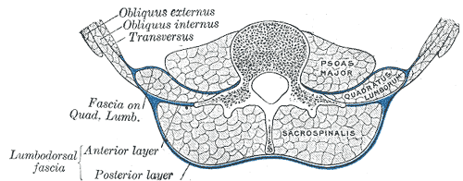
Figure 1. Transverse section of the lumbar region: sacrospinalis (erector spinae, including multifidus medially) behind the transverse processes, quadratus lumborum in front of them, and psoas against the vertebral body, separated by the layers of the lumbodorsal (thoracolumbar) fascia. (Gray's Anatomy, 1918 — public domain, via Wikimedia Commons.)
Ward et al. (2009) weighed the lumbar muscles in cadavers: multifidus 146 g, longissimus thoracis 147 g, iliocostalis lumborum 122 g and quadratus lumborum 41 g. Mass alone is misleading, however. Force depends on PCSA, and multifidus has a PCSA of 23.9 cm² — more than twice that of any other lumbar muscle — because its fibres are short and densely packed. Longissimus, with long fibres, is built for excursion and moment generation over many segments; QL is small and relatively weak but has a large lateral lever.
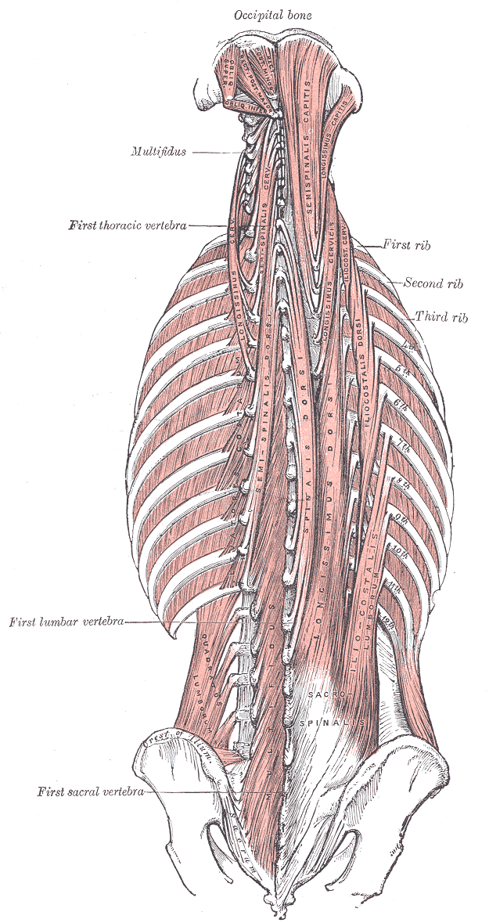
Figure 2. Deep muscles of the back: the erector spinae columns and the transversospinalis group (including multifidus). (Gray's Anatomy, 1918 — public domain, via Wikimedia Commons.)

2. Longissimus thoracis — anatomy
Classical texts describe longissimus as one long muscle running from the sacrum to the ribs. Bogduk (1980) and Macintosh & Bogduk (1987) showed that in the lumbar region it actually consists of two functionally separate parts: a lumbar part that attaches directly to lumbar vertebrae and a thoracic part that acts on the lumbar spine only through long tendons. Iliocostalis lumborum is divided in the same way.
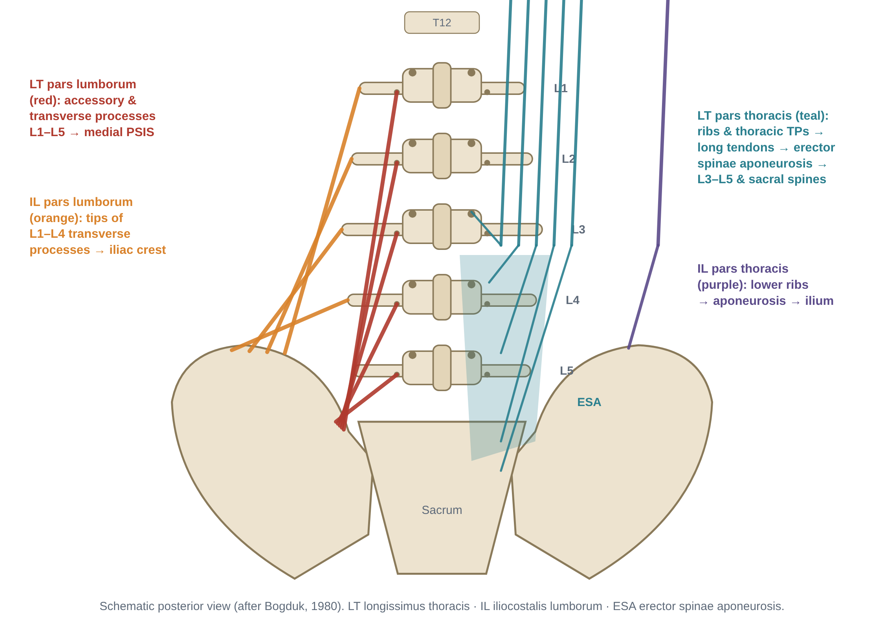
Figure 3. Fascicular anatomy of the lumbar erector spinae (schematic, after Bogduk 1980). Left: lumbar parts of longissimus and iliocostalis. Right: thoracic parts acting through the erector spinae aponeurosis.

2.1 Longissimus thoracis pars lumborum
- Fascicles: five, one from each lumbar vertebra (L1–L5).
- Cranial attachment: the accessory process and the adjacent medial part of the dorsal surface of the transverse process.
- Caudal attachment: the medial aspect of the PSIS and adjacent iliac crest. The L1–L4 fascicles converge on a common tendon, the lumbar intermuscular aponeurosis, which separates longissimus from iliocostalis; the L5 fascicle is deepest and attaches directly to the ilium.
- Orientation: each fascicle runs caudally and laterally, and — in the sagittal plane — backward and downward from the vertebra to the ilium. This obliquity is the basis of its shear function.

2.2 Longissimus thoracis pars thoracis
- Fascicles: about 11–12, arising from the transverse processes and adjacent rib parts of T1/T2–T12.
- Structure: each fascicle has a short muscle belly (several cm) in the thoracic region and a very long caudal tendon. The tendons run side by side to form, together with those of iliocostalis pars thoracis, the erector spinae aponeurosis over the lumbar region.
- Caudal attachment: the spinous processes of the lower lumbar vertebrae (L3–L5) and the sacral spinous processes / dorsal sacrum, in an orderly sequence (higher thoracic fascicles to higher insertion points).
- Consequence: it has no attachment to the lumbar vertebrae between T12 and its insertion. It acts on the lumbar spine as a bowstring spanning the lordosis.

2.3 The companion muscle: iliocostalis lumborum
- Pars lumborum: four fascicles from the tips of the L1–L4 transverse processes and the middle layer of the TLF → iliac crest lateral to the PSIS. Their lateral position gives them a larger lateral-flexion moment arm than longissimus.
- Pars thoracis: from the angles of the lower 7–8 ribs → erector spinae aponeurosis → PSIS, iliac crest and sacrum. No lumbar vertebral attachment.

2.4 Innervation, blood supply and tissue properties
Feature | Details
Innervation | Longissimus: intermediate branches of the lumbar dorsal rami (forming an intersegmental plexus). Iliocostalis: lateral branches of the dorsal rami. Innervation is therefore multisegmental — unlike multifidus.
Blood supply | Dorsal branches of the lumbar arteries (and lower posterior intercostal / subcostal arteries for the thoracic parts)
Mass (cadaver) | Longissimus thoracis ≈ 147 g; iliocostalis lumborum ≈ 122 g (Ward et al., 2009)
Architecture | Long fibres and a relatively high fibre-length : muscle-length ratio compared with multifidus — suited to large excursions and producing moment over several segments rather than generating very high force at one segment
Fibre type | Predominantly type I (slow, oxidative) in both sexes; women show a relatively larger type I fibre area than men (Mannion et al., 1997, J Anat). Supports the role of the erector spinae as an endurance/postural muscle.
Fascia | Enclosed with multifidus and iliocostalis in an osteofascial compartment formed by the posterior and middle layers of the TLF, the laminae and the transverse processes — giving the "hydraulic amplifier" effect (increased compartment pressure stiffens the TLF).

3. Longissimus thoracis — biomechanics

3.1 Actions
Part | Bilateral action | Unilateral action | Key mechanical feature
Pars lumborum | Posterior sagittal rotation (extension) of each lumbar vertebra + posterior translation | Lateral flexion (small); minimal axial rotation | Short, oblique fascicles close to the axis: modest extensor moment but a large posterior shear component
Pars thoracis | Extension of the thorax on the pelvis; increases lumbar lordosis (bowstring) | Lateral flexion of the thorax | Largest extensor moment arms over the lumbar spine; generates most of the erector spinae extensor torque

3.2 The shear function and why posture matters
At the lower lumbar levels, gravity and the inclination of the lumbosacral junction produce an anterior shear force that tends to slide each vertebra forward. Because the lumbar fascicles of longissimus and iliocostalis run backward and downward to the ilium, their force has two components (Figure 4A): a compressive component along the spine and a posterior shear component that pulls the vertebra backward.
- Macintosh & Bogduk (1991) used an EMG-driven model of squat lifting and found that the force of these posteriorly directed fascicles increased in proportion to the anterior shear demand — the muscles appear to be recruited specifically to control shear.
- McGill, Hughson & Parks (2000) showed that this protection depends on posture: when the lumbar spine is fully flexed, the fascicles re-orient so that they run almost parallel to the spine, their posterior shear component disappears, and anterior shear must be resisted by the facet joints, disc and ligaments (Figure 4B). Lifting with a neutral lordosis therefore keeps the muscles able to protect against shear.
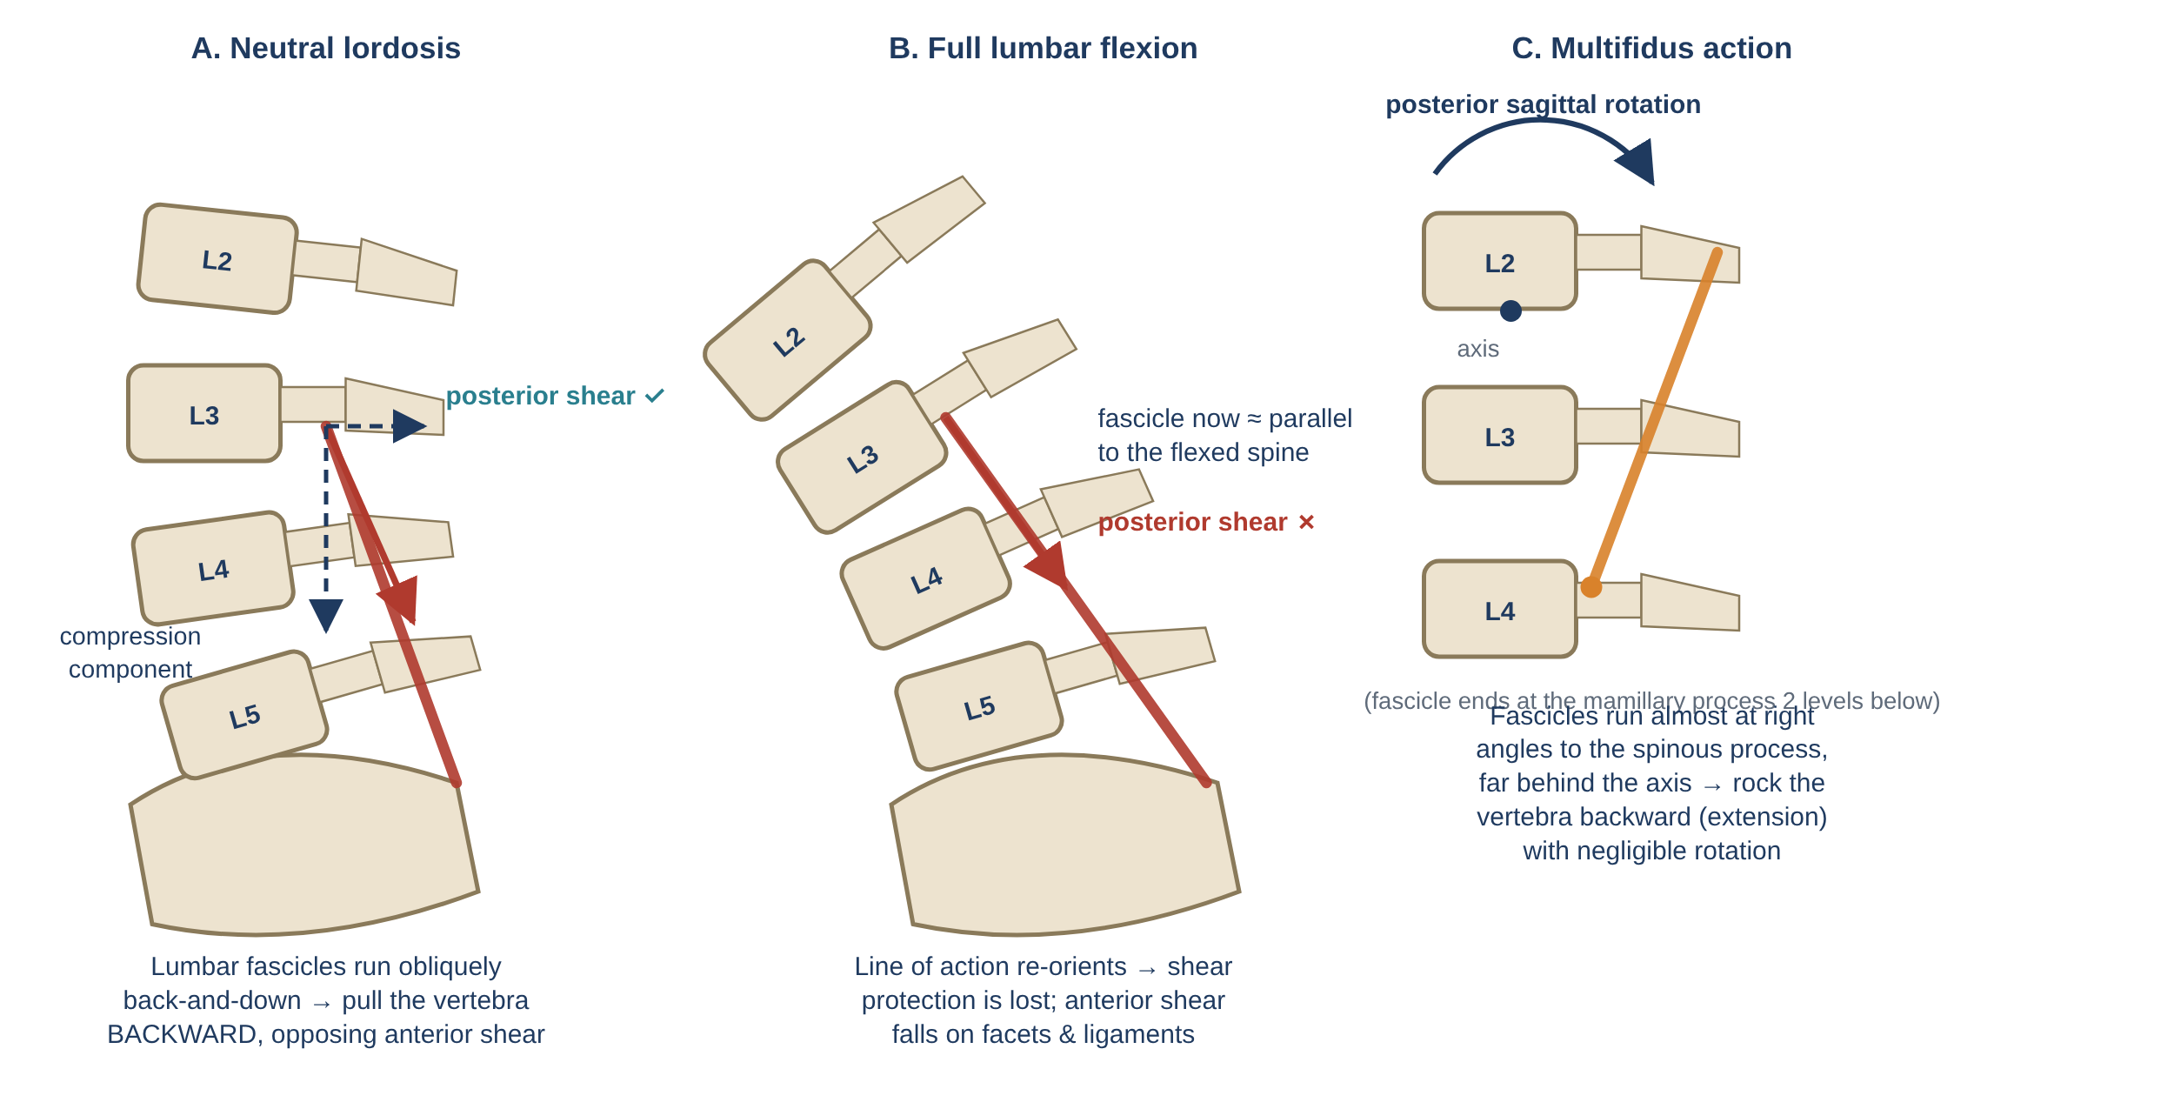
Figure 4. Lines of action (lateral view). (A) In neutral lordosis the lumbar fascicles of longissimus resist anterior shear. (B) In full flexion this ability is lost. (C) Multifidus rocks the vertebra backward (posterior sagittal rotation).

3.3 Eccentric control and flexion-relaxation
- During forward bending, the erector spinae lengthen under tension (eccentric work), controlling the descent of the trunk against gravity.
- Near full flexion the EMG falls silent — the flexion-relaxation phenomenon (FRP). The flexion moment is then resisted passively by the stretched erector spinae tissue itself, the TLF, posterior ligaments and facet capsules.
- On return to upright, the hips extend first (gluteus maximus, hamstrings) and then the erector spinae shorten concentrically to restore the lordosis.

3.4 Role in lifting and posture
- In upright standing the erector spinae are only intermittently active (low % MVC); the line of gravity lies close to the lumbar spine.
- In lifting, extensor demand rises steeply with the horizontal distance of the load (short ≈ 5–6 cm moment arm of the erector spinae vs. a much longer load moment arm), so erector spinae force is the largest single source of lumbar compression.
- Because the thoracic part spans the whole lumbar spine, it can control global posture; the lumbar part provides fine control and shear protection at each segment.

4. Longissimus thoracis — pathomechanics in back pain
Changes in the erector spinae in low back pain fall into two broad, opposing patterns — protective over-activity and deconditioning/fatigability — which may coexist in the same person at different times (see Flowchart 2).
Mechanism | What happens | Evidence (examples)
Protective guarding | ↑ erector spinae activity and trunk co-contraction during movement; reduced movement variability; "splinting" | van Dieën et al., 2003 (review); Hodges & Tucker, 2011 (pain-adaptation theory)
Loss of flexion-relaxation | ES remain active at end-range flexion; passive structures not "trusted"; FRP normalises with recovery | Colloca & Hinrichs, 2005 (review)
Reduced endurance & early fatigue | Faster fall in EMG median frequency during sustained contraction; shorter isometric hold times | Roy et al., 1989; Biering-Sørensen, 1984 (low endurance predicted first-time LBP in men)
Fibre-type change | Relative shift towards fast (type II) fibres and altered fibre size in patients with LBP — reduced fatigue resistance | Mannion et al., 1997 (J Orthop Res)
Loss of shear protection | Fatigue or habitual end-range flexion removes the posterior-shear advantage → anterior shear borne by facets, disc and ligaments | McGill et al., 2000; Macintosh & Bogduk, 1991
Iatrogenic injury | Posterior spinal surgery: retraction pressure/ischaemia and dorsal ramus injury → atrophy, fatty change, "failed back" pain | Kawaguchi et al., 1994, 1996
Degenerative lumbar kyphosis | Severe atrophy and fatty infiltration of the back extensors in older adults → loss of lordosis, forward stoop, sagittal imbalance | Takemitsu et al., 1988
Muscle strain / myofascial pain | Acute overload (eccentric) causes local pain and spasm; generally self-limiting | Clinical; evidence on trigger points is limited

Clinical significance: a patient who bends and lifts with a fully flexed lumbar spine — especially when fatigued — loses the erector spinae's shear protection exactly when shear loads are highest. Hip-hinge training with a neutral spine and extensor endurance training address this mechanism directly.

5. Multifidus — anatomy
Lumbar multifidus is the largest muscle crossing the lumbosacral junction. Dissection shows it is divided by cleavage planes into five bands, one from each lumbar vertebra; each band consists of several fascicles named by their caudal attachments (Macintosh, Valencia, Bogduk & Munro, 1986).
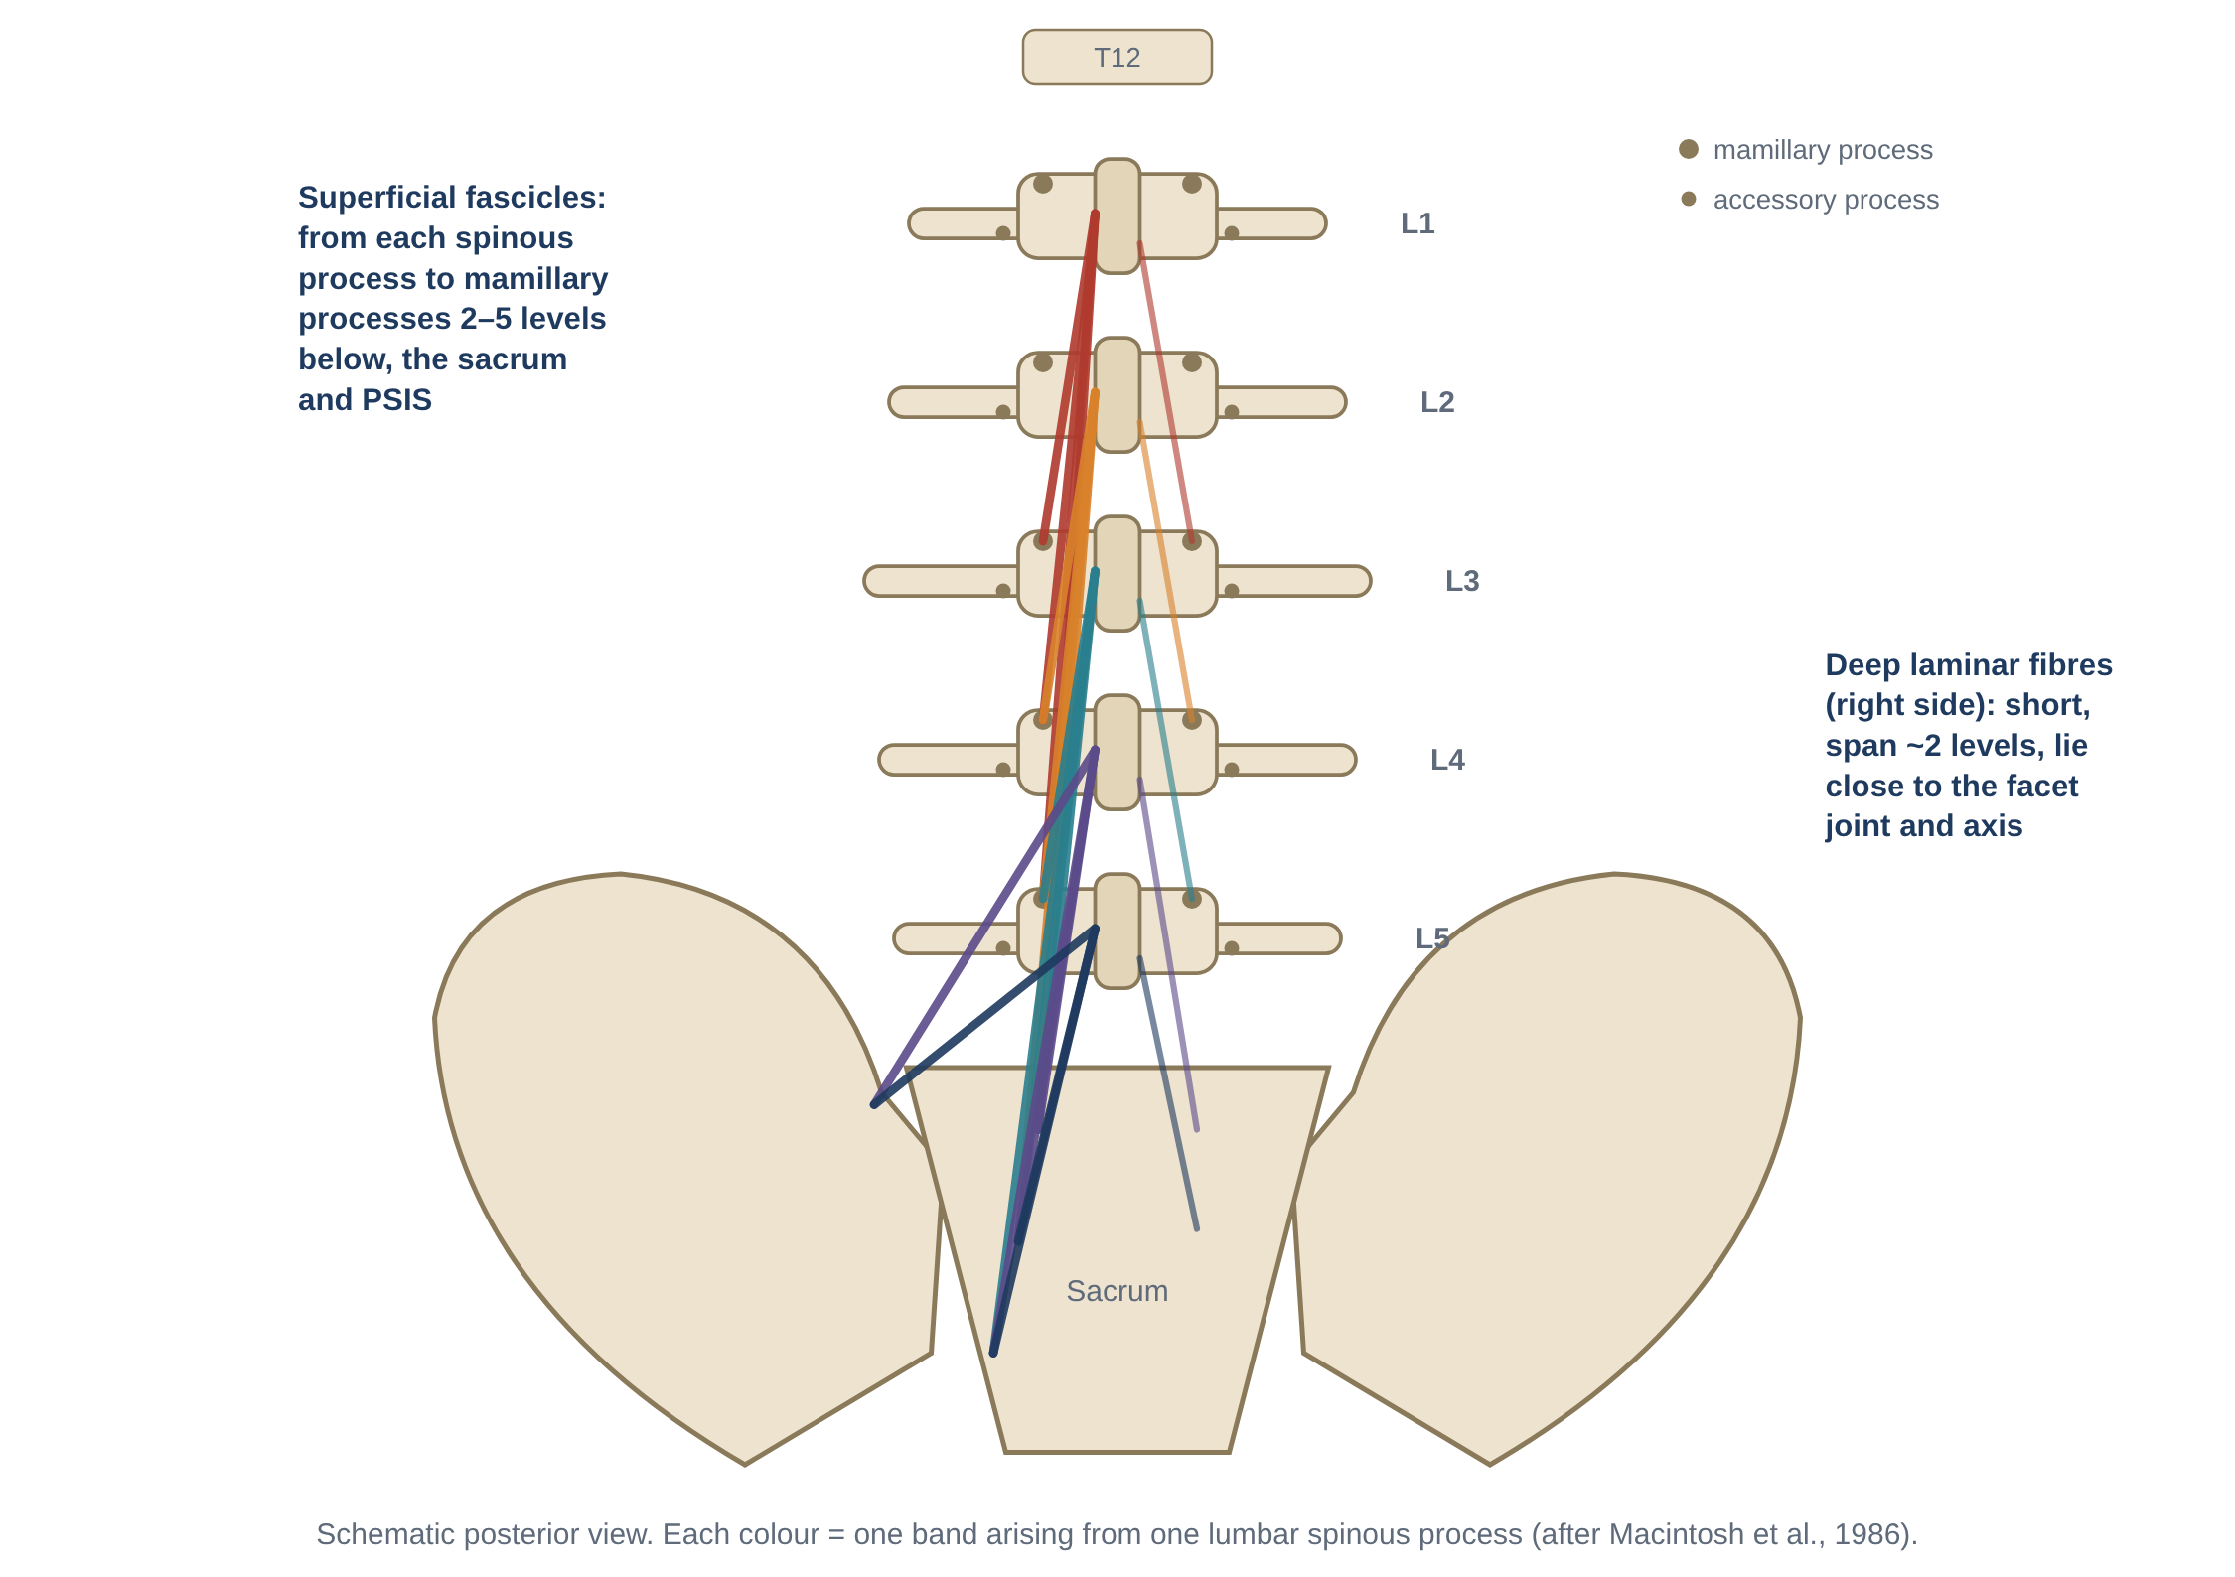
Figure 5. Fascicular anatomy of lumbar multifidus (schematic, after Macintosh et al. 1986). Left: superficial fascicles of the five bands. Right: deep laminar fibres.

5.1 Attachments
- Laminar (deep) fibres: from the caudal edge of the lamina near the base of the spinous process → the mamillary process two levels below (the L4 and L5 laminar fibres reach the sacrum near the L5–S1 facet). These are short, lie close to the facet joints and the axis of rotation.
- Superficial fascicles: from a common tendon on the caudal tip of the spinous process → mamillary processes three, four and five levels below, and — for the lower bands — the PSIS, the dorsal sacrum and adjacent sacroiliac ligaments.
- Fascicles from L1 reach the mamillary processes of L3–L5 and the sacrum/PSIS; fascicles from L5 go entirely to the sacrum and PSIS. The lower bands are therefore the thickest, which is why multifidus is so bulky over the lumbosacral junction.
- Some fibres attach to the capsules of the facet joints, potentially protecting the capsule from being nipped during movement (debated).

5.2 Innervation — the segmental muscle
Each band is innervated by the medial branch of the dorsal ramus of the same segment (e.g., all fascicles from L2 are supplied by the L2 medial branch). This makes multifidus the only lumbar back muscle with strictly segmental (unisegmental) innervation. The same medial branch also supplies the facet joints, interspinous ligament and periosteum at that level — so the joint and the muscle that controls it share a nerve supply. This anatomical link is the basis of the proposed reflex (arthrogenic) inhibition of multifidus after facet or disc injury, and explains why radiofrequency medial branch neurotomy for facet pain also denervates multifidus.

5.3 Architecture (Ward et al., 2009)
Parameter | Value | Meaning
Mass | 146.1 ± 8.7 g | Similar to longissimus
PCSA | 23.9 ± 3.0 cm² | More than twice any other lumbar muscle → highest force capacity
Normalised fibre length | 5.66 ± 0.65 cm | Short fibres
Fibre length : muscle length | 0.21 ± 0.03 | Very low — many short fibres packed along a long muscle ("pennate-like" design)
Sarcomere length (cadaver, neutral) | 2.27 ± 0.06 µm | Shorter than optimum
Sarcomere length in vivo — extension | 1.98 ± 0.15 µm | Ascending limb (lower force)
Sarcomere length in vivo — flexion (~41°) | 2.70 ± 0.11 µm | Near optimum (plateau) → peak force

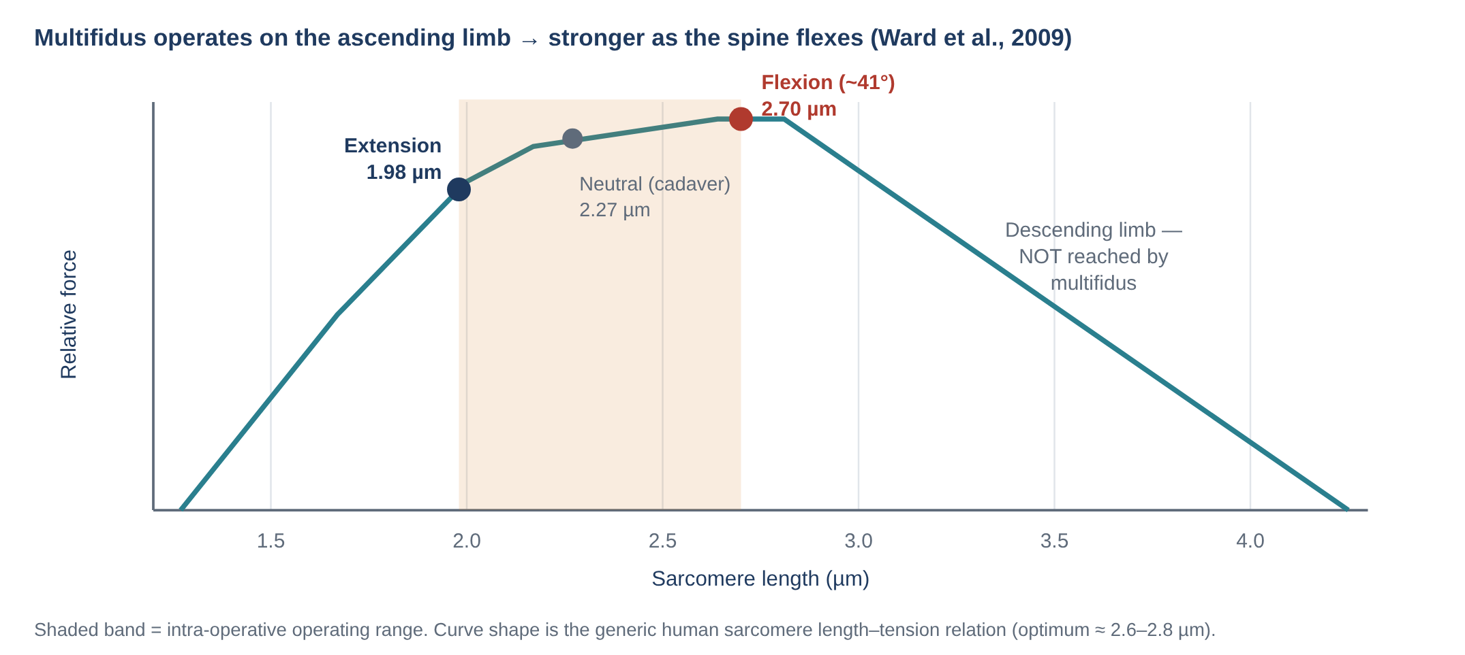
Figure 6. Multifidus sarcomere operating range on the length–tension curve. The muscle never reaches the descending limb, so it becomes stronger as the spine flexes (data: Ward et al., 2009).

5.4 Deep and superficial fibres
- Deep fibres (laminar and short fascicles) are close to the centre of rotation, contain more type I fibres and are tonically active. During rapid arm movements their anticipatory activity is not direction-specific (Moseley, Hodges & Gandevia, 2002), consistent with a segmental stiffening role.
- Superficial fibres (long fascicles) have larger moment arms and their activity is direction-specific, consistent with controlling spinal orientation and producing extensor torque.
- In experimental disc injury, the largest fibre-type changes occur in the deep medial region (Hodges et al., 2014).

6. Multifidus — biomechanics

6.1 Actions
- Posterior sagittal rotation: the fascicles run caudally from the spinous process, almost at right angles to it and far behind the axis of rotation. Their main action is to rock the vertebra backward — segmental extension (Macintosh & Bogduk, 1986; Figure 4C).
- Not a rotator: the horizontal component of the fascicles is tiny. During axial rotation, the abdominal muscles (obliques) produce rotation but also flexion; multifidus contracts to oppose that flexion so pure rotation results.
- Lateral flexion: minimal (small lateral moment arm).
- Lordosis: acting as a bowstring across each segment and spanning to the sacrum, it maintains the lumbar lordosis and compresses the posterior elements.
- Compression and stiffness: its high PCSA and position close to the segments make it ideal for stiffening individual motion segments.

6.2 Segmental stiffness and stability
- Wilke et al. (1995) loaded cadaveric L4–L5 segments with simulated muscle forces: multifidus was responsible for about two-thirds of the muscle-induced increase in segmental stiffness.
- Kaigle et al. (1995) showed in a pig model that muscle activation could restore stiffness to an experimentally destabilised segment.
- Ward et al. (2009) concluded that multifidus is "uniquely designed as a stabiliser": very high PCSA + short fibres + increasing force with flexion means it can resist flexion exactly when the spine is most vulnerable.

6.3 Motor control
- Deep multifidus is active before limb movement (feed-forward) along with transversus abdominis.
- It is one of the few muscles whose activity is maintained at low levels in upright sitting and standing with a neutral lordosis, and reduced in slumped postures (O'Sullivan et al., 2002).
- The dense spindle supply of the deep segmental tissues makes multifidus an important source of proprioceptive feedback about segmental position.

7. Multifidus — pathomechanics in back pain
Multifidus is the most intensively researched muscle in low back pain. Evidence from humans and animal models now describes a time-dependent sequence of change (Flowchart 1):

7.1 Acute phase: rapid, segment-specific inhibition
- Hides et al. (1994): in patients with acute/subacute first-episode LBP, multifidus CSA (ultrasound) was reduced on the symptomatic side at the symptomatic level only — too fast and too localised to be explained by disuse.
- Hodges et al. (2006): in pigs, multifidus CSA fell at the injured segment within 3 days of an experimental disc or nerve-root lesion — consistent with reflex inhibition.

7.2 Subacute phase: inflammation and fibre transformation
- Hodges et al. (2014): after disc lesions in sheep, slow (type I) fibres decreased — most in the deep medial multifidus — and TNF-α gene expression rose on both sides.
- James et al. (2018): pro-inflammatory (M1) macrophages were increased in muscle at 3 and 6 months after disc lesion, and in adipose tissue at 6 months, implicating macrophages and TNF in muscle remodelling.

7.3 Chronic phase: structural remodelling (fat and fibrosis)
- Hodges et al. (2015): months after back injury, multifidus showed structural remodelling of muscle, adipose and connective tissue rather than simple atrophy — total muscle size may look normal while contractile tissue is replaced by fat and fibrous tissue.
- Kjaer et al. (2007): MRI-defined fatty infiltration of multifidus was associated with LBP in adults.
- Ranger et al. (2017, systematic review): multifidus CSA was negatively associated with, and predictive of, LBP up to 12 months; evidence for fat infiltration was conflicting.
- Seyedhoseinpoor et al. (2022, meta-analysis): people with LBP have somewhat smaller multifidus muscles with significantly greater intramuscular fat.

7.4 Recovery is not automatic
- Hides et al. (1996): after acute pain resolved, multifidus CSA did not recover spontaneously at 10 weeks in the control group, but did recover with specific exercise.
- Hides et al. (2001): specific multifidus training reduced recurrence from 84% to 30% at 1 year and from 75% to 35% at 2–3 years.

7.5 Iatrogenic and other causes
- Posterior surgery: multifidus is especially vulnerable to retractor pressure and denervation because of its segmental nerve supply (Kawaguchi et al., 1994, 1996). Muscle-sparing and minimally invasive approaches aim to reduce this.
- Medial branch radiofrequency neurotomy: denervation atrophy of multifidus occurs after successful neurotomy (Dreyfuss et al., 2009); its long-term significance is uncertain.
- Ageing and disc degeneration: fat infiltration increases with age and is associated with disc degeneration and facet arthropathy, making cause-and-effect hard to separate.

7.6 Mechanical consequences
- Reduced multifidus force → less segmental stiffness, especially in flexion where it should be strongest → more motion in the neutral zone and more load on passive tissues.
- Loss of deep, tonic, direction-independent control → reliance on superficial, direction-specific muscles (erector spinae, obliques) → guarding and higher compression.
- Ongoing inflammation and fibrosis may also alter muscle passive stiffness and sensory feedback.

7.7 Treatments targeting multifidus
Approach | Rationale | Evidence summary
Specific motor-control training (isolated "swelling" contraction, progressed into function) | Restore activation, CSA and segmental control | Reduced recurrence after first episode (Hides 2001); for chronic LBP, motor-control exercise is effective but not superior to other exercise (Saragiotto et al., 2016, Cochrane)
RTUS biofeedback | Visual feedback of contraction and CSA | Improves ability to activate multifidus; useful in retraining
Progressive loading (extension exercises, bird-dog, deadlift patterns) | Hypertrophy and strength of a high-PCSA muscle | Can increase multifidus CSA and reduce fat in some studies
Restorative neurostimulation (implanted stimulation of the medial branch) | Repeated contraction of multifidus to restore control in refractory chronic LBP with multifidus dysfunction | Sham-controlled RCT with positive long-term follow-up (Gilligan et al., 2021); selected patients only

8. Quadratus lumborum — anatomy
Quadratus lumborum is a flat, roughly quadrilateral sheet between the 12th rib and the iliac crest, lying in front of the transverse processes and behind psoas and the posterior abdominal viscera.
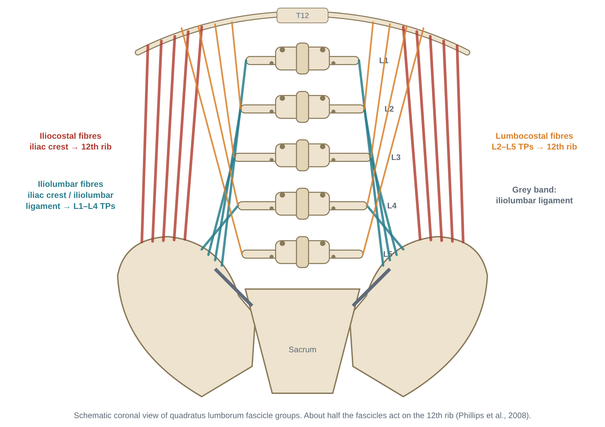
Figure 7. Fascicle groups of quadratus lumborum (schematic). Approximately half of the fascicles act on the 12th rib (Phillips et al., 2008).

8.1 Fascicles and attachments
Fascicle group | From | To | Layer
Iliocostal | Iliac crest (posterior part) and iliolumbar ligament | Medial half of the inferior border of the 12th rib | Mostly posterior (largest group)
Iliolumbar | Iliac crest and iliolumbar ligament | Tips / anterior surfaces of the L1–L4 transverse processes | Intermediate
Lumbocostal | Transverse processes of L2/L3–L5 | 12th rib | Anterior

Phillips, Mercer & Bogduk (2008) dissected six cadavers and recorded each fascicle's attachment, orientation and PCSA. About half of the fascicles act on the 12th rib; the rest act on the lumbar transverse processes. Bilateral fibre arrangement and overlapping layers are variable between individuals.

8.2 Relations
- Anterior: anterior layer of the TLF (quadratus lumborum fascia), kidney, ascending/descending colon, and the subcostal, iliohypogastric and ilioinguinal nerves running across its front — explaining flank and groin referral from this region.
- Posterior: middle layer of the TLF and the erector spinae.
- Medial: psoas major and the lumbar transverse processes.
- Superior: the lateral arcuate ligament of the diaphragm arches over its upper part (Figure 8).
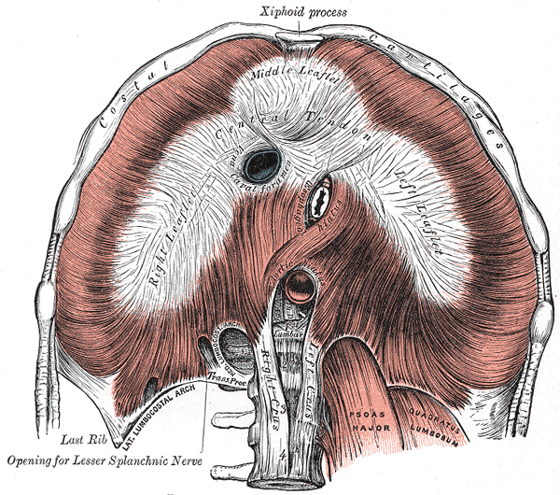
Figure 8. The diaphragm from below: quadratus lumborum passes behind the lateral arcuate ligament, psoas behind the medial arcuate ligament. (Gray's Anatomy, 1918 — public domain, via Wikimedia Commons.)

8.3 Innervation, blood supply and tissue properties
Feature | Details
Innervation | Ventral rami of T12 (subcostal nerve) and L1–L3 (± L4)
Blood supply | Lumbar arteries, subcostal artery, iliolumbar artery
Mass | ≈ 41 g (Ward et al., 2009) — less than one-third of multifidus or longissimus
Architecture | Relatively long fascicles (reported roughly 5–9 cm; Delp et al., 2001) and small PCSA
Development | The iliolumbar ligament is thought to develop from fibres of quadratus lumborum during childhood and adolescence (Luk, Ho & Leong, 1986), underlining the close relation of QL to lumbosacral stability

9. Quadratus lumborum — biomechanics (and the stabiliser debate)

9.1 Actions
- Unilateral, trunk free: lateral flexion of the lumbar spine to the same side.
- Unilateral, trunk fixed: elevation ("hiking") of the ipsilateral pelvis — e.g., swing-leg clearance in gait, or compensating for a weak contralateral hip abductor.
- Bilateral: fixes the 12th rib against the upward pull of the diaphragm during inspiration (and can depress it in forced expiration); weak extension of the lumbar spine.
- Carrying: the QL opposite a load held in one hand works strongly to prevent side-bending towards the load.

9.2 Is QL a major lumbar stabiliser? Two views
 | View 1: important frontal-plane stabiliser | View 2: modest action on the lumbar spine
Key research | McGill et al. (1996): fine-wire EMG showed QL active during flexion, extension and lateral bending tasks, with the highest activation in the side-support (side-bridge) posture | Phillips et al. (2008): fascicle-level modelling showed QL compression force, extensor moment and lateral-bending moment on the lumbar spine are each no more than ~10% of those exerted by erector spinae and multifidus
Argument | Active in many directions → behaves as a stabiliser rather than a pure lateral flexor; attachments to every lumbar TP allow frontal-plane stiffening; large lateral moment arm | Small PCSA and mass; half of its fascicles act on the rib, not the spine; erector spinae and multifidus dominate all lumbar moments
Practical implication | Train with side-bridge and suitcase carries | Its main roles may be rib fixation for breathing and pelvic hiking; lateral stability also relies on obliques and lateral erector spinae

Reconciling the views: EMG shows QL is *recruited* in stabilising tasks; anatomy shows its *capacity* to load the lumbar spine is small. Both can be true — QL probably contributes to lateral stiffness as part of a team (obliques, iliocostalis, contralateral hip abductors) rather than as a dominant stabiliser.

9.3 QL in gait and the lateral sling
- In stance, the stance-side gluteus medius keeps the pelvis level; the swing-side QL helps lift the pelvis so the foot clears the ground.
- QL is part of the lateral sling (gluteus medius/minimus + contralateral adductors + contralateral QL). If gluteus medius is weak, QL often compensates by hitching the pelvis or side-bending the trunk.

10. Quadratus lumborum — pathomechanics in back pain
Mechanism | What happens | Evidence / notes
Acute guarding / spasm | Unilateral QL contraction in acute LBP; may contribute to a lateral shift and painful side-bending or rolling in bed | Clinical observation; consistent with general trunk guarding (van Dieën 2003)
Compensation for weak hip abductors | QL hitches the pelvis or trunk leans over the stance leg → asymmetric lumbar loading and QL overuse | Gluteus medius weakness is common in chronic LBP (Cooper et al., 2016)
Leg-length / pelvic asymmetry | Sustained asymmetric QL activity and lateral lumbar curvature | Biomechanically plausible; clinical evidence of small discrepancies is weak
Asymmetric sport loading | Unilateral hypertrophy / asymmetry in cricket fast bowlers; QL asymmetry associated with development of L4 pars interarticularis injury | Engstrom et al., 2007
Size / composition changes in LBP | Reduced CSA on the painful side reported in some unilateral and acute LBP studies; other studies show no difference — less consistent than multifidus | Kamaz et al., 2007 (CT, chronic LBP); mixed MRI findings
Myofascial pain | Tender points with referral to the iliac crest, sacroiliac region, buttock and greater trochanter | Travell & Simons description; reliability and specificity of trigger points are limited
Neural irritation | Subcostal, iliohypogastric and ilioinguinal nerves on its anterior surface — flank or groin pain may arise from this region | Anatomical; clinical relevance case-based
Visceral / referred mimics | Kidney and retroperitoneal disease can produce flank pain mistaken for QL pain | Always screen non-musculoskeletal causes

11. Side-by-side comparison
Feature | Longissimus thoracis | Multifidus | Quadratus lumborum
Position | Lateral to multifidus, behind TPs | Most medial, on laminae & spinous processes | In front of TPs, lateral
Parts | Pars lumborum (5 fascicles) + pars thoracis (11–12, long tendons) | 5 bands; deep laminar + superficial fascicles | Iliocostal, iliolumbar, lumbocostal fascicles
Innervation | Intermediate branches of dorsal rami (multisegmental) | Medial branch of dorsal ramus (segmental) | Ventral rami T12–L3(4)
Mass (Ward 2009) | ≈ 147 g | ≈ 146 g | ≈ 41 g
Architecture | Long fibres — excursion, moment | Short fibres, PCSA 23.9 cm² — force, stiffness | Moderate fibres, small PCSA
Main action | Extension; lumbar part: posterior shear | Segmental extension (posterior sagittal rotation), stiffness | Lateral flexion, pelvic hike, 12th-rib fixation
Key biomechanics | Shear protection lost in full flexion | Stronger in flexion (ascending limb) | Large lateral lever, modest lumbar loading
Main change in LBP | Guarding, fatigability, loss of FRP | Rapid inhibition → inflammation → fat & fibrosis | Guarding, compensation, asymmetry (mixed evidence)
Key test | Biering-Sørensen endurance; FRP | RTUS / palpation; prone instability test | Side-bridge; Trendelenburg; palpation

12. Clinical assessment

Multifidus
- Palpation in prone: feel for asymmetry in bulk and tone at each level and for the ability to "swell" the muscle under the fingers without moving the spine.
- RTUS: transverse or parasagittal images at each level to compare CSA/thickness side-to-side and the thickness change during contraction (e.g., contralateral arm lift).
- MRI: CSA and fatty infiltration (e.g., Goutallier-type grading or quantitative fat fraction).
- Prone instability test and observation of aberrant movement during flexion/extension.

Longissimus / erector spinae
- Biering-Sørensen test (isometric extensor endurance) and repeated-lift tolerance.
- Flexion-relaxation: surface EMG (where available) or palpation of the erector spinae at end-range flexion.
- Observation of lifting strategy (stoop vs hip hinge), guarding and movement variability.

Quadratus lumborum
- Side-bridge hold time and right–left symmetry (McGill suggests side-to-side difference < 5%).
- Trendelenburg test and gait observation for hip-hiking or lateral trunk lean.
- Palpation in side-lying between the 12th rib and the iliac crest, lateral to the erector spinae.
- Screen for leg-length difference and for visceral causes of flank pain.
Flowchart 4 brings the assessment findings for all three muscles together.

13. Rehabilitation principles
Muscle | Early (control) | Middle (endurance) | Late (strength & function)
Multifidus | Isolated "swelling" contraction with RTUS/palpation feedback; neutral spine in 4-point kneeling and sitting | Bird-dog; prone leg/arm lifts; holds in neutral | Back extension, hip-hinge and deadlift patterns; loaded carries; sport-specific tasks
Longissimus / ES | Reduce over-guarding (breathing, relaxation, movement variability); restore flexion tolerance | Graded isometric extensor endurance (Sørensen-type holds), bird-dog | Hip-hinge lifting with neutral lumbar spine, progressive loading, work-conditioning
Quadratus lumborum | Symptom relief (soft tissue, positioning); correct lateral shift | Side-bridge progressions (knees → feet → with movement) | Suitcase carries, single-arm farmer walks, hip-abductor strengthening, gait retraining

- Choose exercise according to the person's impairments and preferences: overall, different exercise types produce similar average effects in chronic LBP, so engagement and progression matter.
- Combine exercise with education that reduces fear and reassures — muscle guarding is partly driven by perceived threat.
- Always train the hips (gluteus maximus and medius) alongside the trunk muscles.

14. Flowcharts

Flowchart 1 — Time course of multifidus pathomechanics after back injury
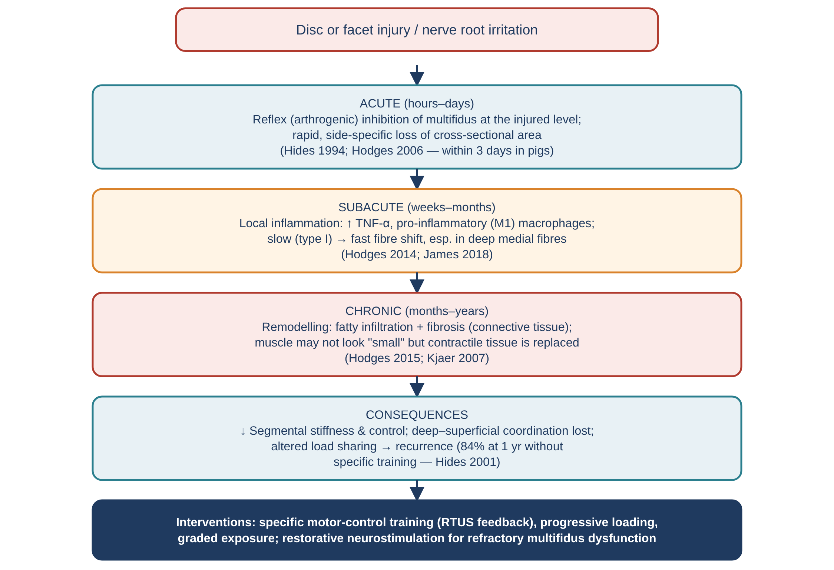
Figure 9. Flowchart 1: from reflex inhibition to inflammation, fat and fibrosis, and the clinical response.

Flowchart 2 — Longissimus / erector spinae pathomechanics
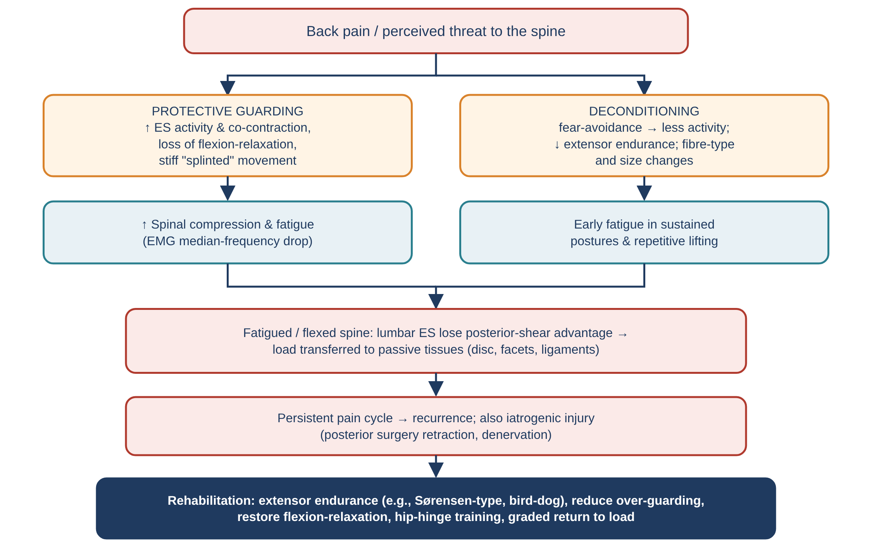
Figure 10. Flowchart 2: guarding and deconditioning pathways and their consequences for spinal loading.

Flowchart 3 — Quadratus lumborum overload
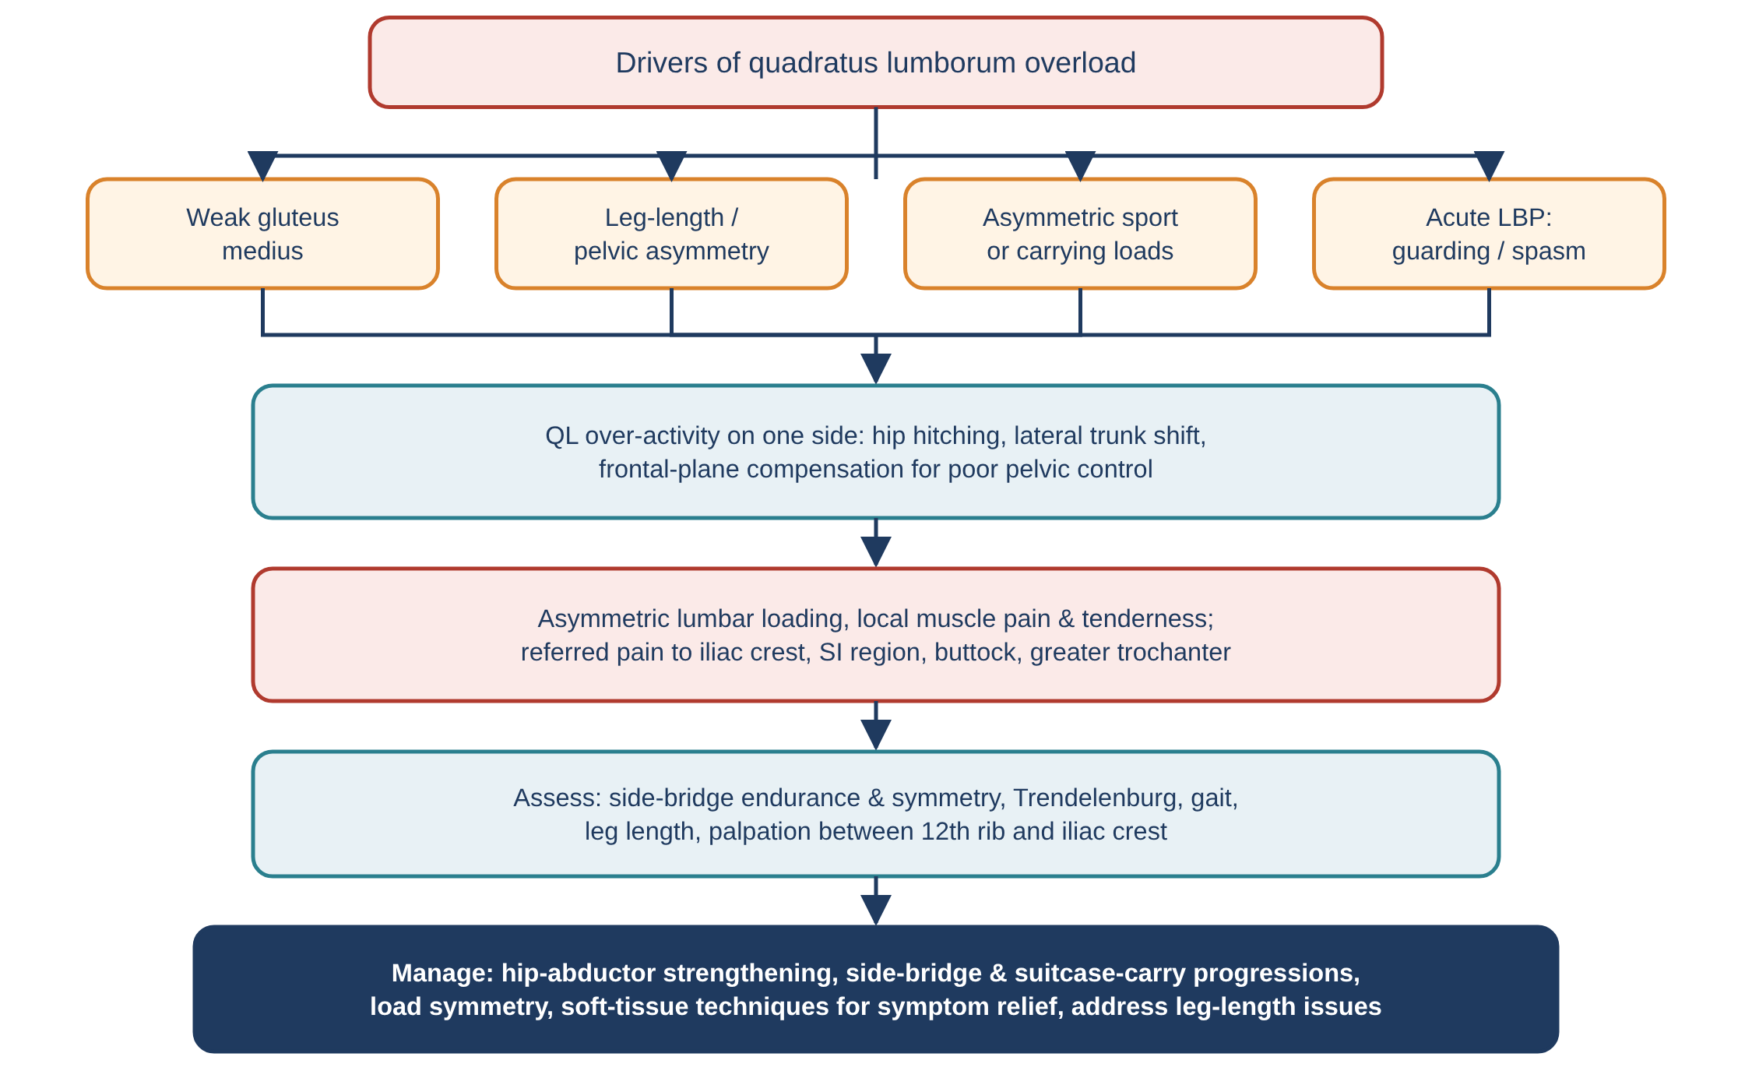
Figure 11. Flowchart 3: drivers, mechanisms, assessment and management of QL-related pain.

Flowchart 4 — Integrated clinical reasoning
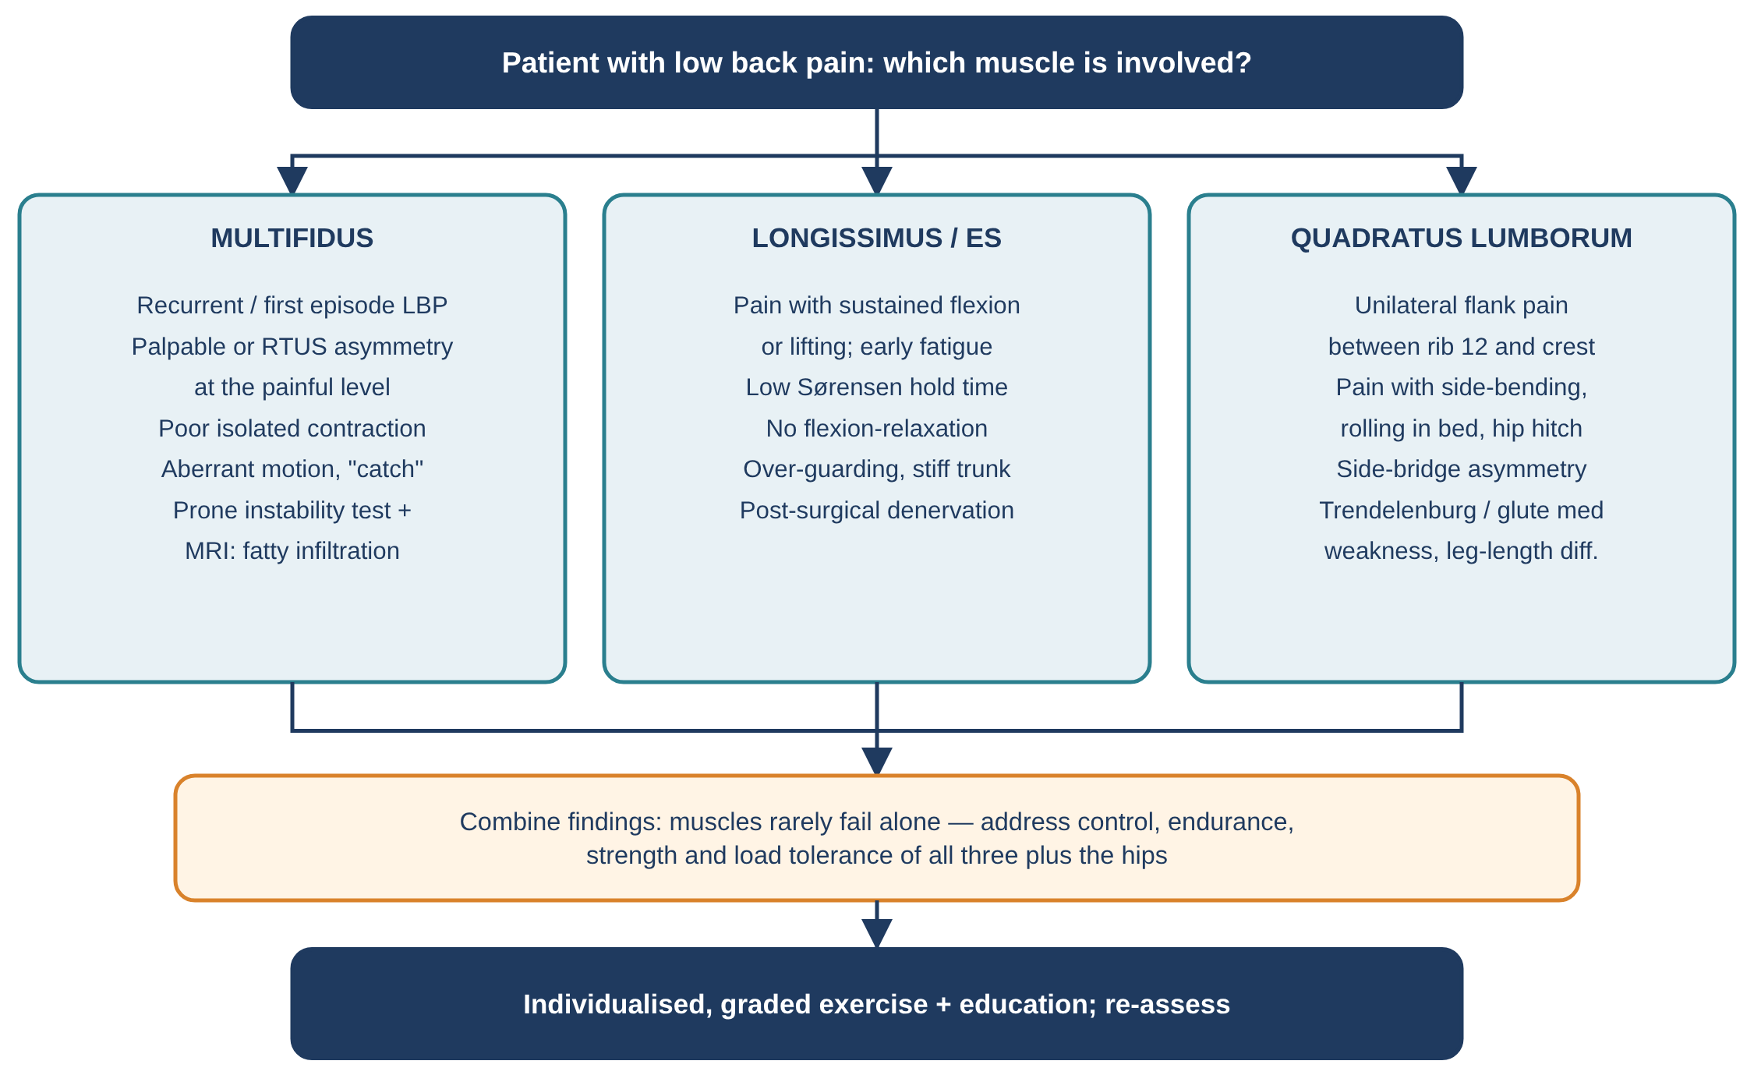
Figure 12. Flowchart 4: which of the three muscles is involved, and what to do.

15. Controversies and research gaps
- Cause or consequence? Most human studies of multifidus fat and size are cross-sectional. Animal models show injury causes muscle change, but whether poor muscle quality *causes* first-time LBP in humans is still uncertain (Ranger et al., 2017 found CSA predictive up to 12 months; fat evidence conflicting).
- Specific vs general exercise: specific multifidus/TrA training reduced recurrence after a first episode (Hides 2001), but in chronic LBP motor-control exercise is not superior to other active exercise (Saragiotto et al., 2016).
- QL as stabiliser: EMG recruitment (McGill 1996) versus small mechanical capacity (Phillips 2008) — more in-vivo modelling is needed.
- Measurement: CSA, fat fraction and RTUS thickness are measured with different methods and levels, making comparison between studies difficult.
- Inflammation pathway: TNF-α and macrophage findings are from animal models; translation to human treatment (e.g., anti-inflammatory targeting) is under investigation.
- Neurostimulation: promising in selected refractory patients, but long-term, independent and cost-effectiveness data are still limited.

16. References
Biering-Sørensen, F. (1984). Physical measurements as risk indicators for low-back trouble over a one-year period. Spine, 9(2), 106–119.
Bogduk, N. (1980). A reappraisal of the anatomy of the human lumbar erector spinae. Journal of Anatomy, 131(3), 525–540.
Bogduk, N. (2012). Clinical and Radiological Anatomy of the Lumbar Spine (5th ed.). Churchill Livingstone.
Colloca, C. J., & Hinrichs, R. N. (2005). The biomechanical and clinical significance of the lumbar erector spinae flexion-relaxation phenomenon: a review. Journal of Manipulative and Physiological Therapeutics, 28(8), 623–631.
Cooper, N. A., et al. (2016). Prevalence of gluteus medius weakness in people with chronic low back pain compared to healthy controls. European Spine Journal, 25(4), 1258–1265.
Delp, S. L., Suryanarayanan, S., Murray, W. M., Uhlir, J., & Triolo, R. J. (2001). Architecture of the rectus abdominis, quadratus lumborum, and erector spinae. Journal of Biomechanics, 34(3), 371–375.
Dreyfuss, P., et al. (2009). The significance of multifidus atrophy after successful radiofrequency neurotomy for low back pain. PM&R, 1(8), 719–722.
Engstrom, C. M., Walker, D. G., Kippers, V., & Mehnert, A. J. (2007). Quadratus lumborum asymmetry and L4 pars injury in fast bowlers: a prospective MR study. Medicine & Science in Sports & Exercise, 39(6), 910–917.
Gilligan, C., et al. (2021). An implantable restorative-neurostimulator for refractory mechanical chronic low back pain: a randomized sham-controlled clinical trial. Pain, 162(10), 2486–2498.
Gray, H. (1918). Anatomy of the Human Body (20th ed.). Lea & Febiger. (Plates via Wikimedia Commons, public domain.)
Hides, J. A., Stokes, M. J., Saide, M., Jull, G. A., & Cooper, D. H. (1994). Evidence of lumbar multifidus muscle wasting ipsilateral to symptoms in patients with acute/subacute low back pain. Spine, 19(2), 165–172.
Hides, J. A., Richardson, C. A., & Jull, G. A. (1996). Multifidus muscle recovery is not automatic after resolution of acute, first-episode low back pain. Spine, 21(23), 2763–2769.
Hides, J. A., Jull, G. A., & Richardson, C. A. (2001). Long-term effects of specific stabilizing exercises for first-episode low back pain. Spine, 26(11), E243–E248.
Hodges, P., Holm, A. K., Hansson, T., & Holm, S. (2006). Rapid atrophy of the lumbar multifidus follows experimental disc or nerve root injury. Spine, 31(25), 2926–2933.
Hodges, P. W., James, G., Blomster, L., et al. (2014). Can proinflammatory cytokine gene expression explain multifidus muscle fiber changes after an intervertebral disc lesion? Spine, 39(13), 1010–1017.
Hodges, P. W., James, G., Blomster, L., et al. (2015). Multifidus muscle changes after back injury are characterized by structural remodeling of muscle, adipose and connective tissue, but not muscle atrophy. Spine, 40(14), 1057–1071.
Hodges, P. W., & Tucker, K. (2011). Moving differently in pain: a new theory to explain the adaptation to pain. Pain, 152(3 Suppl), S90–S98.
James, G., Sluka, K. A., Blomster, L., et al. (2018). Macrophage polarization contributes to local inflammation and structural change in the multifidus muscle after intervertebral disc injury. European Spine Journal, 27(8), 1744–1756.
Kaigle, A. M., Holm, S. H., & Hansson, T. H. (1995). Experimental instability in the lumbar spine. Spine, 20(4), 421–430.
Kamaz, M., et al. (2007). CT measurement of trunk muscle areas in patients with chronic low back pain. Diagnostic and Interventional Radiology, 13(3).
Kawaguchi, Y., Matsui, H., & Tsuji, H. (1996). Back muscle injury after posterior lumbar spine surgery: a histologic and enzymatic analysis. Spine, 21(8), 941–944.
Kjaer, P., Bendix, T., Sorensen, J. S., Korsholm, L., & Leboeuf-Yde, C. (2007). Are MRI-defined fat infiltrations in the multifidus muscles associated with low back pain? BMC Medicine, 5, 2.
Luk, K. D., Ho, H. C., & Leong, J. C. (1986). The iliolumbar ligament: a study of its anatomy, development and clinical significance. Journal of Bone and Joint Surgery (Br), 68(2), 197–200.
Macintosh, J. E., Valencia, F., Bogduk, N., & Munro, R. R. (1986). The morphology of the human lumbar multifidus. Clinical Biomechanics, 1(4), 196–204.
Macintosh, J. E., & Bogduk, N. (1986). The biomechanics of the lumbar multifidus. Clinical Biomechanics, 1(4), 205–213.
Macintosh, J. E., & Bogduk, N. (1987). The morphology of the lumbar erector spinae. Spine, 12(7), 658–668.
Macintosh, J. E., & Bogduk, N. (1991). EMG-driven model of the lumbar back muscles during squat lifting: posteriorly directed erector spinae fascicles increase force with anterior shear demand. Clinical Biomechanics (1991).
Mannion, A. F., Dumas, G. A., Cooper, R. G., et al. (1997). Muscle fibre size and type distribution in thoracic and lumbar regions of erector spinae in healthy subjects without low back pain: normal values and sex differences. Journal of Anatomy, 190(4), 505–513.
Mannion, A. F., Weber, B. R., Dvorak, J., Grob, D., & Müntener, M. (1997). Fibre type characteristics of the lumbar paraspinal muscles in normal healthy subjects and in patients with low back pain. Journal of Orthopaedic Research, 15(6), 881–887.
McGill, S., Juker, D., & Kropf, P. (1996). Quantitative intramuscular myoelectric activity of quadratus lumborum during a wide variety of tasks. Clinical Biomechanics, 11(3), 170–172.
McGill, S. M., Hughson, R. L., & Parks, K. (2000). Changes in lumbar lordosis modify the role of the extensor muscles. Clinical Biomechanics, 15(10), 777–780.
McGill, S. (2016). Low Back Disorders: Evidence-Based Prevention and Rehabilitation (3rd ed.). Human Kinetics.
Moseley, G. L., Hodges, P. W., & Gandevia, S. C. (2002). Deep and superficial fibers of the lumbar multifidus muscle are differentially active during voluntary arm movements. Spine, 27(2), E29–E36.
O'Sullivan, P. B., et al. (2002). The effect of different standing and sitting postures on trunk muscle activity in a pain-free population. Spine, 27(11), 1238–1244.
Phillips, S., Mercer, S., & Bogduk, N. (2008). Anatomy and biomechanics of quadratus lumborum. Proceedings of the Institution of Mechanical Engineers, Part H, 222(2), 151–159.
Ranger, T. A., et al. (2017). Are the size and composition of the paraspinal muscles associated with low back pain? A systematic review. The Spine Journal, 17(11), 1729–1748.
Roy, S. H., De Luca, C. J., & Casavant, D. A. (1989). Lumbar muscle fatigue and chronic lower back pain. Spine, 14(9), 992–1001.
Saragiotto, B. T., et al. (2016). Motor control exercise for chronic non-specific low-back pain. Cochrane Database of Systematic Reviews, CD012004.
Seyedhoseinpoor, T., et al. (2022). Alteration of lumbar muscle morphology and composition in relation to low back pain: a systematic review and meta-analysis. Spine (2022).
Takemitsu, Y., et al. (1988). Lumbar degenerative kyphosis: clinical, radiological and epidemiological studies. Spine, 13(11), 1317–1326.
Travell, J. G., & Simons, D. G. (1992). Myofascial Pain and Dysfunction: The Trigger Point Manual, Vol. 2. Williams & Wilkins.
van Dieën, J. H., Selen, L. P., & Cholewicki, J. (2003). Trunk muscle activation in low-back pain patients, an analysis of the literature. Journal of Electromyography and Kinesiology, 13(4), 333–351.
Ward, S. R., Kim, C. W., Eng, C. M., et al. (2009). Architectural analysis and intraoperative measurements demonstrate the unique design of the multifidus muscle for lumbar spine stability. Journal of Bone and Joint Surgery (Am), 91(1), 176–185.
Wilke, H. J., Wolf, S., Claes, L. E., Arand, M., & Wiesend, A. (1995). Stability increase of the lumbar spine with different muscle groups: a biomechanical in vitro study. Spine, 20(2), 192–198.

