MUSCLES OF THE SPINE
Anatomy and Biomechanics
Erector spinae, multifidus, quadratus lumborum, abdominals, psoas, gluteals, hamstrings, quadriceps and every other muscle that moves, stabilises or loads the spine — with research evidence, diagrams and flowcharts

Contents
1. How muscles influence the spine
2. Classification of spinal muscles
3. Principles of muscle mechanics applied to the spine
4. Posterior (back) muscles: erector spinae, multifidus, short segmental muscles
5. Quadratus lumborum
6. Abdominal muscles and intra-abdominal pressure
7. Diaphragm and pelvic floor
8. Iliopsoas (psoas major, psoas minor, iliacus)
9. Hip and thigh muscles: gluteals, hamstrings, quadriceps, adductors, deep rotators, TFL
10. Latissimus dorsi, thoracolumbar fascia and myofascial slings
11. Pelvic force couples and posture
12. Thoracic and cervical spinal muscles
13. Muscles in everyday function: lifting, walking, sitting, breathing, carrying
14. Muscle changes in low back pain: what the research shows
15. Clinical assessment of spinal muscles
16. Exercise implications
17. Flowcharts
18. Master table: every muscle that influences the spine
19. References
Note: attachments follow standard anatomy texts; numerical values are typical adult figures from the research cited and vary between individuals, levels and measurement methods. Educational document — not a substitute for clinical assessment.

1. How muscles influence the spine
The bony and ligamentous spine on its own is surprisingly weak: a lumbar spine stripped of muscle buckles under a vertical load of only about 90 N — less than the weight of the upper body (Crisco & Panjabi, 1992). The living spine carries loads of several thousand newtons because it is surrounded by muscles that act like the guy-wires of a ship's mast, controlling posture and stiffness in every direction.
Muscles influence the spine in eight main ways:
- Producing movement — generating moments (torques) for flexion, extension, side-bending and rotation.
- Controlling movement — working eccentrically to decelerate the trunk, e.g., erector spinae while bending forward.
- Stiffening and stabilising — co-contraction increases segmental and whole-trunk stiffness, preventing buckling and excessive motion in the neutral zone.
- Compressing the spine — every muscle crossing the spine adds compression; this is the "price" of stability and movement.
- Controlling shear — some fascicles (lumbar erector spinae) pull the vertebrae backward and resist anterior shear.
- Positioning the pelvis — hip muscles (iliopsoas, rectus femoris, glutes, hamstrings) tilt the pelvis, which sets the lumbar curve.
- Tensioning fascia and raising intra-abdominal pressure — abdominals, latissimus dorsi and gluteus maximus tension the thoracolumbar fascia; the diaphragm, pelvic floor and abdominals pressurise the abdomen.
- Sensing — muscle spindles (very dense in the small segmental muscles) provide proprioceptive feedback about spinal position.

2. Classification of spinal muscles

2.1 By location
Group | Muscles | Main effect on the spine
Posterior (back) | Erector spinae (iliocostalis, longissimus, spinalis), multifidus, rotatores, interspinales, intertransversarii; superficial: trapezius, latissimus dorsi, rhomboids, serratus posterior | Extension, eccentric control of flexion, segmental control, posterior shear
Lateral | Quadratus lumborum, intertransversarii laterales, obliques (lateral fibres) | Lateral flexion, frontal-plane stability
Anterior | Rectus abdominis, external & internal obliques, transversus abdominis, psoas major & minor | Flexion, rotation, IAP, compression
Cylinder walls | Diaphragm (roof), pelvic floor (base), transversus abdominis (walls), multifidus (back) | Intra-abdominal pressure, feed-forward stabilisation
Pelvic / hip | Iliacus, rectus femoris, sartorius, TFL, gluteus maximus, medius, minimus, hamstrings, adductors, piriformis & deep rotators | Pelvic tilt → lumbar curve; lumbopelvic rhythm; load transfer
Remote but linked | Quadriceps (vasti), calf muscles, upper-limb muscles | Lifting strategy, posture, kinetic chains

2.2 By function: local vs global (Bergmark, 1989)
 | Local (deep) stabilising system | Global (superficial) movement system
Attachment | Directly to vertebrae (segmental) | Thorax to pelvis — spans many segments
Examples | Multifidus (deep fibres), transversus abdominis, rotatores, interspinales, intertransversarii, posterior fibres of internal oblique, medial QL fibres, (psoas — debated) | Erector spinae (thoracic parts), rectus abdominis, external oblique, lateral QL, latissimus dorsi
Role | Control segmental position & stiffness; proprioception | Produce torque & movement; balance external loads; large-scale stability
Activity | Tonic, low-level, anticipatory (feed-forward), direction-independent | Phasic, direction-specific, higher force
Fibre type | Predominantly type I (slow, fatigue-resistant) | Mixed type I and type II

Research perspective: the local/global model is a useful teaching tool, but no muscle works alone. Cholewicki & McGill (1996) and McGill (2016) showed that stability results from the coordinated co-activation of all trunk muscles, and the most important muscle changes with the task. Training should therefore address both systems.

3. Principles of muscle mechanics applied to the spine

3.1 Factors that decide what a muscle does
- Moment arm (lever arm): the perpendicular distance from the muscle's line of action to the joint's axis. Torque = force × moment arm. A muscle far from the axis (rectus abdominis) produces large torque per newton; a muscle near the axis (psoas) produces little torque but adds compression.
- Line of action: decides which motions are produced and whether the muscle adds shear. Lumbar erector spinae fascicles run obliquely backward-upward, so they pull the upper vertebra posteriorly, resisting anterior shear.
- Physiological cross-sectional area (PCSA): proportional to maximum force. Multifidus has the largest PCSA of the lumbar extensors — about twice that of longissimus — despite its modest size, because its fibres are short and densely packed (Ward et al., 2009).
- Fibre length and sarcomere operating range: long fibres allow large excursion and speed; short fibres favour force and stiffness. Multifidus sarcomeres are short in neutral and lengthen towards optimum in flexion, so it becomes stronger as the spine flexes — well suited to controlling forward bending.
- Fibre type: trunk extensors are predominantly type I (roughly 55–70%), giving endurance for prolonged postural work.
- Activation timing: feed-forward activation prepares the spine before a perturbation; feedback corrects afterwards.
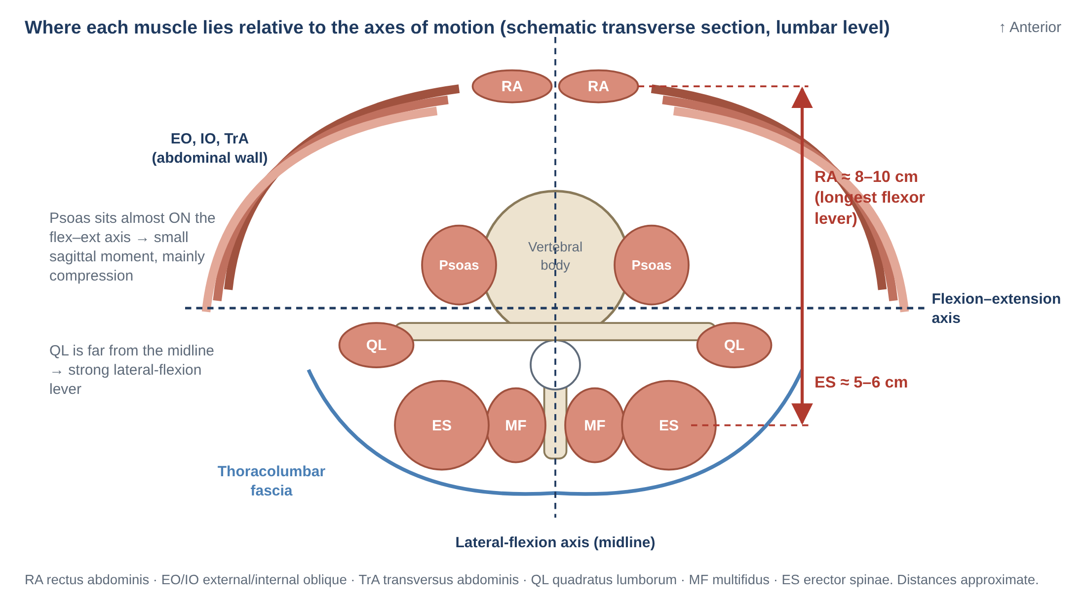
Figure 1. Schematic transverse section of the lumbar region showing the position of each muscle relative to the flexion–extension and lateral-flexion axes.
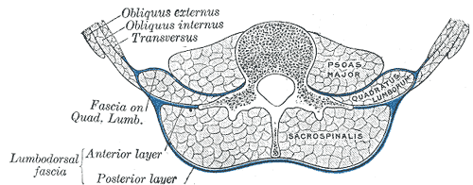
Figure 2. Real transverse section through the lumbar region: psoas major, quadratus lumborum and sacrospinalis (erector spinae), wrapped by the anterior and posterior layers of the lumbodorsal (thoracolumbar) fascia, with the three lateral abdominal muscles. (Gray's Anatomy, 1918 — public domain, via Wikimedia Commons.)

3.2 The lever problem and spinal compression
Because the back extensors act only about 5–6 cm behind the disc, while the upper body and any carried load act far in front, the extensors must generate forces many times larger than the load. These muscle forces pass straight through the disc as compression. In most lifting tasks, muscle force — not the weight lifted — is the largest source of spinal compression (McGill, 2016).

3.3 Co-contraction: stability vs compression
Contracting antagonists together (e.g., abdominals with back extensors) stiffens the spine and protects it from buckling, but also increases compression. Modelling studies show that a modest level of co-contraction — around 1–3% of maximum in quiet standing and roughly 5–10% in demanding tasks — gives sufficient stability (Cholewicki & McGill, 1996). Excessive guarding, as often seen in back pain, adds load without additional benefit.

4. Posterior (back) muscles
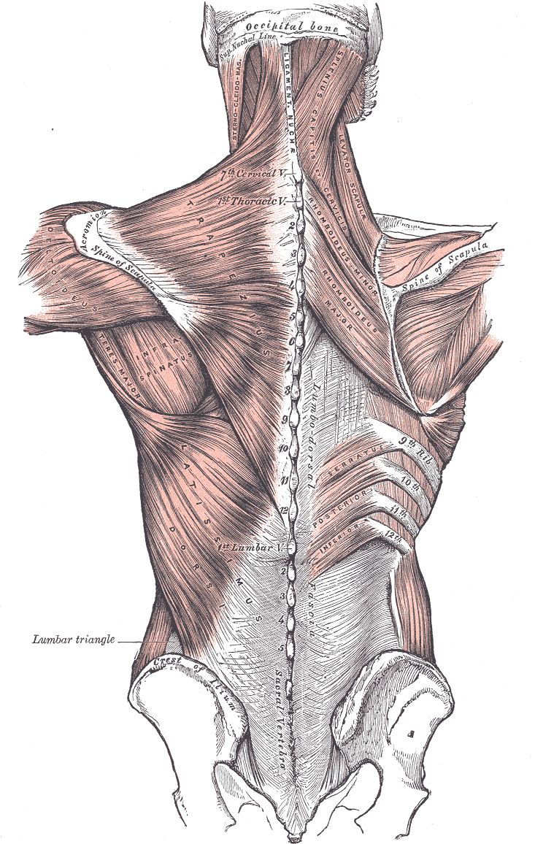
Figure 3. Superficial muscles of the back: trapezius and latissimus dorsi cover the deeper spinal muscles. Note the broad aponeurotic attachment of latissimus dorsi to the thoracolumbar fascia. (Gray's Anatomy, 1918 — public domain, via Wikimedia Commons.)
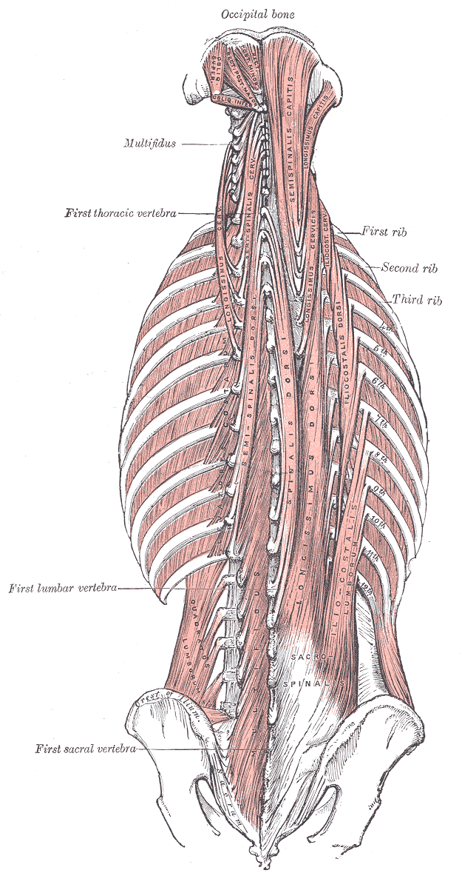
Figure 4. Deep muscles of the back: the erector spinae columns and the deeper transversospinalis group (multifidus, semispinalis, rotatores) running from the sacrum to the skull. (Gray's Anatomy, 1918 — public domain, via Wikimedia Commons.)

4.1 Erector spinae
The erector spinae (sacrospinalis) is the large muscle mass on each side of the spinous processes. It has three columns — iliocostalis (lateral), longissimus (intermediate) and spinalis (medial; rudimentary in the lumbar region). Bogduk (1980) showed that in the lumbar region each of iliocostalis and longissimus has two distinct parts with different biomechanics:
Part | Attachments | Biomechanics
Longissimus thoracis pars lumborum | Accessory & transverse processes of L1–L5 → ilium (posterior superior iliac spine region) | Short lumbar fascicles; posterior sagittal rotation (extension); oblique line of action → posterior translation that resists anterior shear
Iliocostalis lumborum pars lumborum | Tips of L1–L4 transverse processes & middle layer of TLF → iliac crest | As above + lateral flexion (large lateral moment arm); posterior shear
Longissimus thoracis pars thoracis | Thoracic transverse processes & ribs → lumbar spinous processes, sacrum (via erector spinae aponeurosis) | Long fibres; act over the whole lumbar spine with the largest moment arms; main producer of extensor moment; increase lordosis
Iliocostalis lumborum pars thoracis | Lower 7–8 ribs → erector spinae aponeurosis → ilium & sacrum | Extension and lateral flexion of the thorax on the pelvis; ipsilateral rotation (derotation)
Spinalis thoracis | Upper lumbar/lower thoracic spinous processes → upper thoracic spinous processes | Thoracic extension; little lumbar influence

Feature | Details
Innervation | Lateral (iliocostalis) and intermediate (longissimus) branches of the dorsal rami — multisegmental
Actions | Bilateral: extension of the trunk, increased lordosis, eccentric control of flexion. Unilateral: lateral flexion to the same side; iliocostalis assists rotation
Fibre type | Predominantly type I (≈ 55–70%) — postural and endurance muscle
Key biomechanics | Short lumbar fascicles produce posterior shear and segmental extension; long thoracic fascicles produce most of the extensor torque. In full lumbar flexion the lumbar fascicles lose their oblique orientation, so their protection against anterior shear is lost (McGill, Hughson & Parks, 2000) — one reason heavy lifting in full flexion is risky.
Flexion-relaxation | Electrical silence near full trunk flexion; the moment is taken passively by ligaments and fascia. Often absent in chronic low back pain.
Endurance | Poor isometric extensor endurance (Biering-Sørensen test) predicted first-time low back pain in men over one year (Biering-Sørensen, 1984).

4.2 Multifidus
Multifidus is the most medial and, at the lumbosacral level, the largest back muscle. It consists of five overlapping bands, each arising from a lumbar spinous process and lamina and fanning downward to the mamillary processes 2–5 levels below, the posterior iliac crest and the sacrum. Each band is innervated by the medial branch of a single dorsal ramus, so the muscle is arranged segmentally.
Feature | Details
Attachments | Spinous processes & laminae of L1–L5 → mamillary processes of vertebrae 2–5 levels below, posterior superior iliac spine, dorsal sacrum, sacrotuberous region
Innervation | Medial branch of the dorsal ramus of the same segment (segmental)
Actions | Posterior sagittal rotation (segmental extension) — it "rocks" each vertebra backward; increases lordosis; compresses and stiffens the segment; controls flexion. Its moment arm for rotation is tiny — it opposes the flexion that the abdominals produce during twisting rather than producing rotation itself.
Deep vs superficial | Deep fibres (short, near the joint) are tonically active and control segments; superficial fibres (longer) contribute to extension torque and orientation.
Stiffness | In vitro, multifidus produced about two-thirds of the muscle-induced increase in segmental stiffness at L4–L5 (Wilke et al., 1995).
Architecture | Largest PCSA of lumbar extensors, short fibres, sarcomeres reach optimal length in flexion (Ward et al., 2009).
In back pain | Side- and level-specific atrophy appears quickly after a first episode of acute LBP (Hides et al., 1994) and does not recover spontaneously; specific retraining reduced 1-year recurrence from 84% to 30% (Hides et al., 2001). Fatty infiltration of multifidus is associated with LBP in adults (Kjaer et al., 2007).

4.3 Short segmental muscles
- Interspinales: between adjacent spinous processes; weak extensors.
- Intertransversarii (mediales and laterales): between transverse/accessory processes; weak lateral flexors.
- Rotatores: well developed in the thoracic region, rudimentary in the lumbar region; weak rotators.
Their small size and tiny moment arms mean they can produce very little torque. They contain 2–6 times more muscle spindles than the large multisegmental muscles, so their main role is probably proprioceptive — sensing the position and movement of each segment (Nitz & Peck, 1986; McGill, 2016).

4.4 Superficial back muscles
- Trapezius & rhomboids: move the scapula; lower and middle trapezius extend and stabilise the upper thoracic spine and influence thoracic posture (e.g., in kyphosis).
- Serratus posterior inferior (T11–L2 spinous processes → ribs 9–12): respiratory muscle; minor tensioner of the thoracolumbar fascia.
- Latissimus dorsi: see Section 10.

5. Quadratus lumborum (QL)
QL is a flat, quadrilateral muscle on each side of the lumbar spine, lying in front of the erector spinae and behind psoas (see Figures 1 and 2). It is the main frontal-plane stabiliser of the lumbar spine.
Feature | Details
Attachments | Iliac crest & iliolumbar ligament → medial half of the 12th rib and tips of the L1–L4 transverse processes. Three fibre groups: iliocostal, iliolumbar and lumbocostal.
Innervation | Subcostal nerve (T12) and ventral rami of L1–L3 (L4)
Actions | Unilateral: lateral flexion of the lumbar spine; hip "hiking" (elevation of the pelvis) when the trunk is fixed. Bilateral: fixes the 12th rib during inspiration (gives the diaphragm a stable base); assists extension (small moment arm).
Biomechanics | Large lateral moment arm; attaches to every lumbar transverse process, so it can stiffen each segment in the frontal plane. EMG shows QL is active during flexion, extension and lateral bending tasks, i.e., it behaves as a stabiliser rather than a pure lateral flexor (McGill et al., 1996). Highly active in the side-bridge and in one-handed ("suitcase") carrying.
Clinical | Often painful/tight in acute LBP (guarding); a QL "hitch" compensates for weak gluteus medius during gait; leg-length differences load QL asymmetrically.

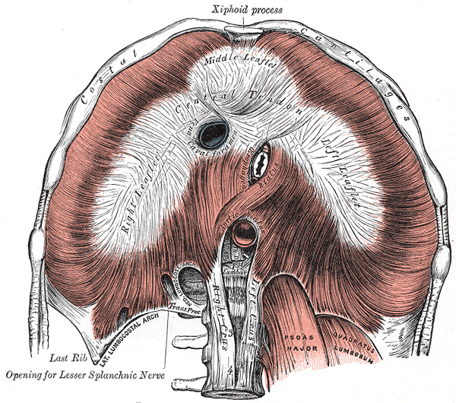
Figure 5. Diaphragm seen from below, with its crura attached to the upper lumbar vertebrae. Psoas major and quadratus lumborum pass behind the medial and lateral arcuate ligaments. (Gray's Anatomy, 1918 — public domain, via Wikimedia Commons.)

6. Abdominal muscles and intra-abdominal pressure
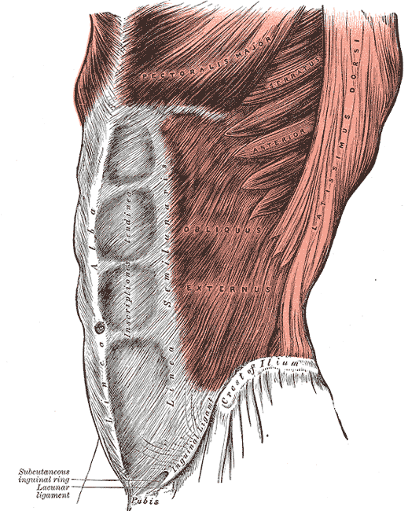
Figure 6. The abdominal wall: rectus abdominis (with tendinous intersections) and the obliques. (Gray's Anatomy, 1918 — public domain, via Wikimedia Commons.)
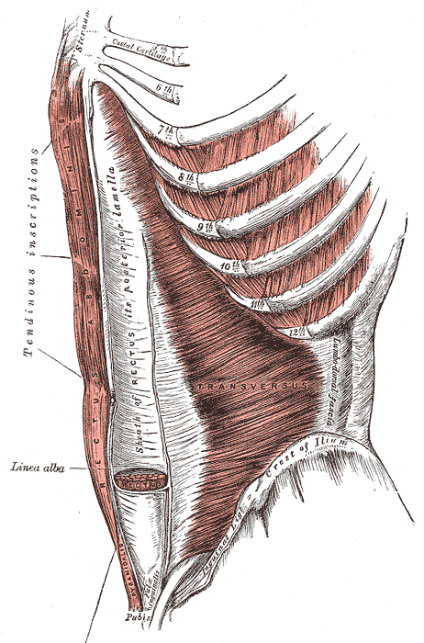
Figure 7. Transversus abdominis, the deepest abdominal muscle, with horizontal fibres running into the posterior rectus sheath and linea alba. (Gray's Anatomy, 1918 — public domain, via Wikimedia Commons.)
Muscle | Attachments | Nerve | Actions on spine / pelvis
Rectus abdominis (RA) | Pubic crest & symphysis → xiphoid and costal cartilages 5–7 | T7–T12 ventral rami | Trunk flexion (largest flexor lever ≈ 8–10 cm); posterior pelvic tilt; no direct vertebral attachment
External oblique (EO) | Outer surfaces of ribs 5–12 → linea alba, pubic tubercle, anterior iliac crest | T7–T12 | Bilateral: flexion, posterior pelvic tilt. Unilateral: rotation to the OPPOSITE side, lateral flexion to the same side
Internal oblique (IO) | Thoracolumbar fascia, iliac crest, lateral inguinal ligament → ribs 10–12, linea alba | T7–L1 | Bilateral: flexion, IAP. Unilateral: rotation to the SAME side, lateral flexion. Posterior fibres tension the TLF
Transversus abdominis (TrA) | Inner surfaces of costal cartilages 7–12, TLF, iliac crest, inguinal ligament → linea alba | T7–L1 | Horizontal "corset" fibres: little torque; raises IAP; tensions TLF; feed-forward stabiliser; compresses SI joints

6.1 Biomechanics of the abdominals
- Rotation is produced by the external oblique on one side working with the internal oblique on the other (e.g., turning to the left uses right EO + left IO). Twisting a flexed spine therefore combines abdominal flexion moments with rotation — a high-risk loading pattern for the disc.
- The obliques and TrA cross the lumbar region via the thoracolumbar fascia and the rectus sheath, so they stiffen the trunk in all directions — the "hoop" effect.
- Rectus abdominis produces large flexion torque; in sit-ups the hip flexors (psoas) add substantial lumbar compression, which is why curl-ups (head and shoulders only) are preferred (McGill, 2016).
- Posterior pelvic tilt: RA and EO pull the pubis upward, flattening the lordosis (Section 11).

6.2 Transversus abdominis and feed-forward control
When a healthy person rapidly raises an arm or leg, TrA contracts before the limb muscle, regardless of the direction of movement — a feed-forward strategy that stiffens the spine in anticipation of the reactive forces (Hodges & Richardson, 1997). In people with low back pain, TrA activation is delayed and no longer precedes the limb movement (Hodges & Richardson, 1996). See Flowchart 1.

6.3 Intra-abdominal pressure (IAP)
The abdomen acts as a pressurised cylinder: roof = diaphragm, floor = pelvic floor, walls = TrA and obliques, back = multifidus/erector spinae. Co-contraction raises IAP, which stiffens the trunk and may unload the spine slightly by pushing the diaphragm and pelvic floor apart. Current evidence suggests the main benefit is increased trunk stiffness rather than a large reduction in compression (Cholewicki et al., 1999). This is the basis of bracing during lifting and of weight-lifting belts.
Hollowing vs bracing: "drawing-in" (hollowing) isolates TrA and is used to retrain motor control; "bracing" (stiffening the whole abdominal wall without drawing in) produces greater spinal stability under load (Grenier & McGill, 2007). Both have a place: hollowing to retrain activation, bracing for functional loading.

7. Diaphragm and pelvic floor

Diaphragm
- Attachments: xiphoid, inner lower six ribs, and — via the right crus (L1–L3) and left crus (L1–L2) — the anterior lumbar vertebral bodies; arcuate ligaments over psoas and QL.
- Nerve: phrenic (C3–C5).
- Spinal role: forms the roof of the abdominal cylinder; contracts tonically during postural tasks while continuing to breathe (Hodges & Gandevia, 2000). Its crura directly pull on the upper lumbar spine. Breathing disorders and LBP are associated (Smith et al., 2006).

Pelvic floor (levator ani, coccygeus)
- Attachments: pubis, obturator fascia (tendinous arch), ischial spine → coccyx, anococcygeal raphe, perineal body.
- Nerve: pudendal nerve and direct branches of S3–S4.
- Spinal role: floor of the abdominal cylinder; co-activates with TrA; contributes to SI-joint force closure. Incontinence and pelvic-floor dysfunction are more common in women with LBP (Smith et al., 2006).
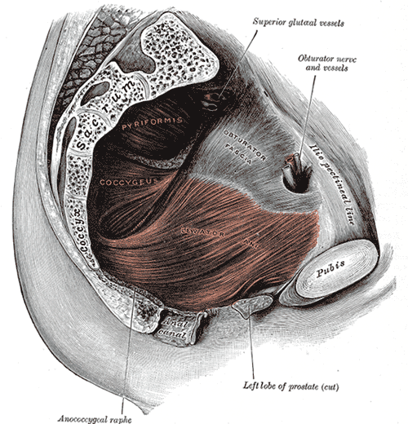
Figure 8. Pelvic floor seen from inside: levator ani and coccygeus form the floor of the abdominal cylinder; piriformis lies on the sacrum. (Gray's Anatomy, 1918 — public domain, via Wikimedia Commons.)

8. Iliopsoas: psoas major, psoas minor, iliacus
Feature | Details
Psoas major — attachments | Anterolateral bodies and discs of T12–L5, and the front of the L1–L5 transverse processes (fascicles at every level) → lesser trochanter of the femur (joined by iliacus)
Nerve | Ventral rami of L1–L3 (psoas); femoral nerve L2–L4 (iliacus)
Action at the hip | Powerful hip flexor (with iliacus); minor lateral rotation
Action on the spine | Bogduk et al. (1992) showed psoas has very small moment arms for lumbar flexion and extension because its fascicles lie close to the axes (Figure 1); it tends to extend upper and flex lower lumbar segments, with a small net effect. Its main lumbar effect is large axial compression (and some anterior shear at the lower levels) whenever the hip is flexed against resistance. Unilaterally it produces some lateral flexion.
Stabiliser? | Psoas activation is governed by hip-flexion demand rather than spinal demand (Juker et al., 1998), so it is not considered a primary spinal stabiliser, although its segmental attachments add stiffness.
Pelvis & lordosis | With the femur fixed, iliopsoas pulls the pelvis and lumbar spine forward — anterior pelvic tilt and increased lordosis. A short iliopsoas (positive Thomas test) increases lordosis in standing.
Clinical | Sit-ups and straight-leg raises load the spine through psoas compression. Psoas cross-sectional area is reduced on the side of symptoms in unilateral sciatica (Barker et al., 2004). Psoas abscess / haematoma can mimic back pain.

- Psoas minor: present in only about 40–60% of people; T12–L1 bodies → iliopubic eminence; weak flexor of the lumbar spine/pelvis.
- Iliacus: iliac fossa → lesser trochanter; hip flexor; tilts the pelvis anteriorly; does not attach to the spine but changes lordosis through the pelvis.
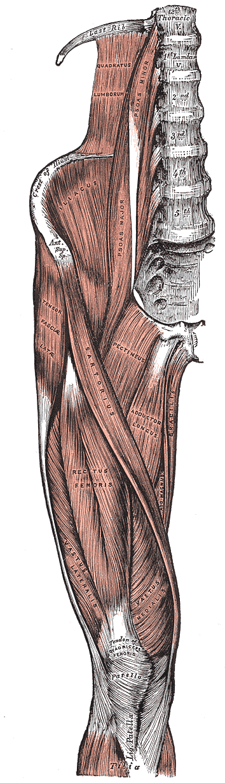
Figure 9. Muscles of the front of the hip and thigh: iliopsoas, sartorius, tensor fasciae latae, rectus femoris and the vasti. (Gray's Anatomy, 1918 — public domain, via Wikimedia Commons.)

9. Hip and thigh muscles that influence the spine
The pelvis is the base on which the lumbar spine sits. Any muscle that moves the pelvis on the femur changes the orientation of the sacrum and therefore the lumbar curve, the loading of the discs and facets, and the lumbopelvic rhythm.
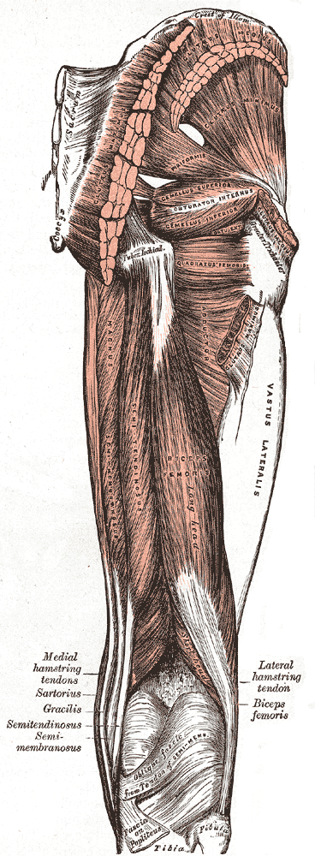
Figure 10. Muscles of the back of the hip and thigh: gluteus maximus and medius, and the hamstrings (biceps femoris, semitendinosus, semimembranosus). (Gray's Anatomy, 1918 — public domain, via Wikimedia Commons.)

9.1 Gluteus maximus
Feature | Details
Attachments | Posterior ilium, dorsal sacrum & coccyx, sacrotuberous ligament, erector spinae aponeurosis and thoracolumbar fascia → iliotibial tract and gluteal tuberosity
Nerve | Inferior gluteal nerve (L5–S2)
Actions | Hip extension and lateral rotation; posterior pelvic tilt (with the femur fixed)
Spinal biomechanics | Shares the extensor moment in lifting and in returning from forward bending — strong hips reduce the moment the lumbar extensors must produce. Fibres crossing the SI joint and blending with the TLF create force closure of the SI joint and link to the opposite latissimus dorsi (posterior oblique sling).
In back pain | Reduced or delayed activation and greater fatigability have been reported in people with LBP (Leinonen et al., 2000); weakness pushes more work onto the lumbar extensors and hamstrings.

9.2 Gluteus medius and minimus
- Attachments: outer ilium → greater trochanter. Nerve: superior gluteal (L4–S1).
- Role: hip abduction; in single-leg stance they hold the pelvis level. Weakness causes the opposite pelvis to drop (Trendelenburg sign) or a compensatory trunk lean to the stance side, which increases lateral bending loads and QL activity. Gluteus medius weakness is common in people with chronic LBP (Cooper et al., 2016).

9.3 Hamstrings
Feature | Details
Muscles | Biceps femoris (long head), semitendinosus, semimembranosus (+ biceps femoris short head, which does not cross the hip)
Attachments | Ischial tuberosity (biceps femoris long head partly continuous with the sacrotuberous ligament) → fibular head (biceps) and medial tibia (semi-)
Nerve | Tibial division of the sciatic nerve (L5–S2); common fibular for the short head
Actions | Hip extension, knee flexion; posterior pelvic tilt
Spinal biomechanics | (1) Control the anterior rotation of the pelvis during forward bending and extend the hip on the way up (lumbopelvic rhythm). (2) Short hamstrings restrict pelvic rotation, so the lumbar spine must flex more to reach the floor — higher disc and ligament strain; in sitting with straight knees they pull the pelvis into posterior tilt and flatten the lordosis. (3) Through the sacrotuberous ligament, biceps femoris tension affects SI-joint stability (Vleeming et al., 1989 — deep longitudinal sling).
Evidence | Associations between hamstring tightness and LBP are inconsistent; reduced hip mobility rather than tightness alone seems to matter, and hamstrings may be protectively over-active in some patients.

9.4 Quadriceps
- Rectus femoris (AIIS & acetabular rim → patella → tibial tuberosity; femoral nerve L2–L4) is the only quadriceps muscle crossing the hip. It flexes the hip and tilts the pelvis anteriorly; shortness (positive Ely or modified Thomas test) increases lordosis, especially in positions with the knee flexed (e.g., prone lying or kneeling).
- Vastus lateralis, medialis and intermedius do not cross the hip, but they determine lifting strategy: strong, pain-free knee extensors allow a squat lift that keeps the trunk upright; weak quadriceps or painful knees push people towards a stoop lift, increasing lumbar flexion, extensor demand and disc load.
- Quadriceps strength and endurance are therefore part of spinal rehabilitation for manual workers.

9.5 Adductors
- Adductor longus, brevis, pectineus, gracilis (pubis → femur/tibia; obturator nerve L2–L4) flex the hip from neutral and can contribute to anterior pelvic tilt.
- Adductor magnus (posterior "hamstring" head from the ischial tuberosity; sciatic nerve) extends the hip and helps posterior pelvic tilt.
- Adductors form part of the anterior oblique and lateral slings, linking the opposite oblique abdominals and gluteus medius to pelvic stability.

9.6 Piriformis and deep lateral rotators
- Piriformis: anterior sacrum → greater trochanter; nerve to piriformis (S1–S2). Lateral rotator/abductor; its sacral attachment means it can exert shear across the SI joint. The sciatic nerve runs beneath (occasionally through) it — "piriformis syndrome" may mimic lumbar radiculopathy.
- Obturator internus/externus, gemelli, quadratus femoris: hip-joint stabilisers; little direct spinal effect.

9.7 Tensor fasciae latae (TFL), sartorius and the iliotibial band
- TFL (ASIS → iliotibial tract; superior gluteal nerve) flexes, abducts and medially rotates the hip and tilts the pelvis anteriorly; a short TFL/ITB (Ober test) can tilt the pelvis laterally.
- Sartorius (ASIS → medial tibia) is a weak hip flexor and contributor to anterior pelvic tilt.

9.8 Calf and foot (indirect)
Calf tightness, foot posture and leg-length differences change the position of the pelvis in standing and gait. Peroneus (fibularis) longus is the distal link of the deep longitudinal sling (Vleeming), connecting the foot through biceps femoris to the sacrotuberous ligament and erector spinae.

10. Latissimus dorsi, thoracolumbar fascia and myofascial slings

10.1 Latissimus dorsi
Feature | Details
Attachments | Spinous processes T7–L5 and sacrum (via the posterior layer of the TLF), posterior iliac crest, lower 3–4 ribs, inferior angle of scapula → floor of the intertubercular groove of the humerus
Nerve | Thoracodorsal nerve (C6–C8)
Actions | Shoulder extension, adduction and medial rotation. With the arm fixed (e.g., pull-ups, crutch walking, pushing up from a chair) it lifts and extends the trunk and tilts the pelvis.
Spinal biomechanics | Its moment arm about the lumbar spine is small, but by tensioning the TLF it adds stiffness and some extensor moment, and it is one of the few muscles that links the arm directly to the lumbopelvic region. McGill (2016) highlights its contribution to lumbar stability during pulling and lifting.

10.2 Thoracolumbar fascia (TLF)
The TLF has three layers. The anterior layer covers QL; the middle layer attaches to the tips of the transverse processes and gives origin to TrA and IO; the posterior layer covers the erector spinae, attaches to the spinous processes and receives latissimus dorsi above and gluteus maximus below. Together with the erector spinae aponeurosis it forms a strong retinaculum around the paraspinal muscles.
- Hydraulic amplifier effect: contraction of the paraspinal muscles inside the closed fascial compartment pushes outward on the fascia, increasing its tension and the stiffness of the extensor mechanism.
- Load transfer: latissimus dorsi and the opposite gluteus maximus pull on the posterior layer in opposite directions, transferring force between the upper and lower limbs across the lumbar spine and compressing the SI joints.
- Sensory organ: the TLF is richly innervated by free nerve endings and may itself generate pain; altered fascial thickness and sliding have been reported in people with chronic LBP (Langevin et al., 2011).

10.3 Myofascial slings (Vleeming et al., 1995)
Muscles do not act in isolation: they are linked through fascia into diagonal and longitudinal slings that transfer load across the pelvis and help close the sacroiliac joints during gait, throwing and lifting.
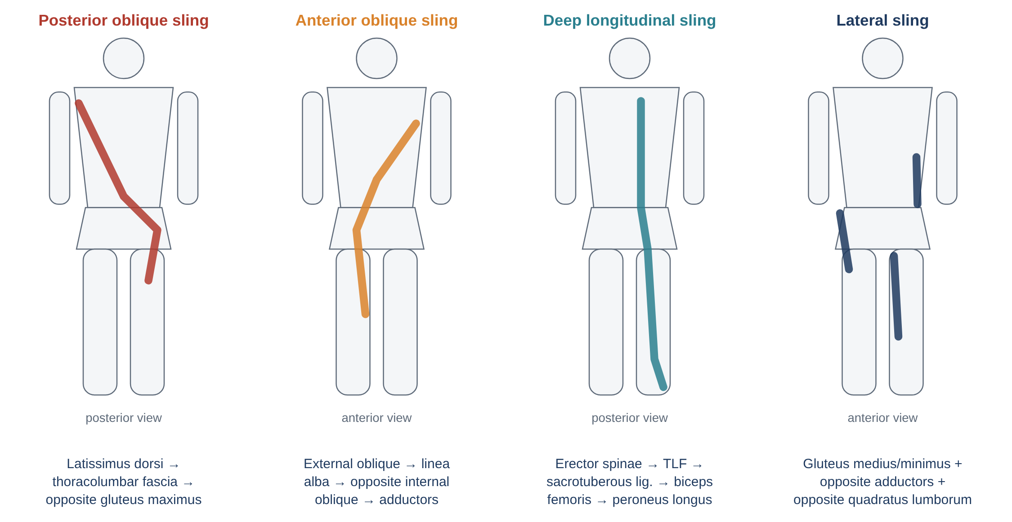
Figure 11. The four myofascial slings that cross the lumbopelvic region.
Sling | Muscles | Function
Posterior oblique | Latissimus dorsi → TLF → opposite gluteus maximus (→ ITB) | Force closure of SI joint in stance; trunk–arm counter-rotation in walking/running; pulling and throwing
Anterior oblique | External oblique → anterior abdominal fascia → opposite internal oblique → opposite adductors | Trunk rotation and flexion; stabilises pelvis in running, kicking and changing direction
Deep longitudinal | Erector spinae → TLF → sacrotuberous ligament → biceps femoris → peroneus longus | Counter-nutation control of sacrum at heel strike; links foot to spine
Lateral | Gluteus medius/minimus + TFL → opposite adductors → opposite QL | Frontal-plane pelvic stability in single-leg stance and gait

11. Pelvic force couples and posture
A force couple is two forces acting in opposite directions on opposite sides of an axis, producing rotation. The pelvis rotates about the hip joints, so muscles above and below the hip on the front and back of the body work in pairs to tilt it — and the lumbar spine follows the pelvis.
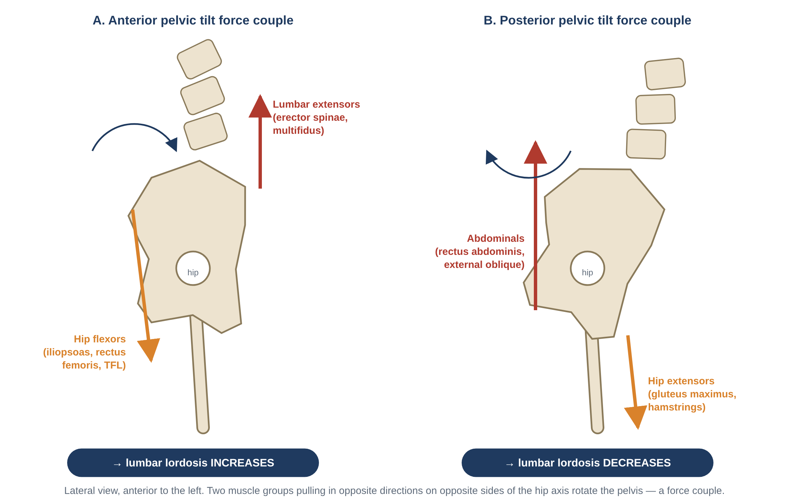
Figure 12. Pelvic tilt force couples: anterior tilt (lumbar extensors + hip flexors) and posterior tilt (abdominals + hip extensors).
Posture | Muscle pattern often described | Effect on the lumbar spine
Hyperlordosis ("lower crossed syndrome", Janda) | Short/overactive hip flexors & lumbar extensors; weak/lengthened gluteals & abdominals | Anterior pelvic tilt; ↑ lordosis; ↑ facet load and L5–S1 anterior shear
Flat back | Short hamstrings & abdominals; weak hip flexors & lumbar extensors | Posterior pelvic tilt; ↓ lordosis; ↑ disc loading in flexed postures
Sway back | Weak hip flexors & external obliques; short hamstrings & upper abdominals; pelvis displaced forward | Hips pushed forward, thorax behind; lower lumbar hyperextension with thoracolumbar flexion
Lateral pelvic tilt | Weak gluteus medius; short QL / adductors on one side; leg-length difference | Lateral lumbar curve (functional scoliosis), asymmetric facet loading

Evidence caution: these postural patterns are logical biomechanically but large studies have found only weak or inconsistent links between static posture, muscle "imbalance" and back pain (e.g., Laird et al., 2014 found no strong difference in lumbar lordosis between people with and without LBP). Use them as clinical hypotheses to test, not as fixed diagnoses. See Flowchart 3.

12. Thoracic and cervical spinal muscles
Although this document focuses on the lumbopelvic region, the same principles apply higher up. The main muscles of the thoracic and cervical spine are summarised below.
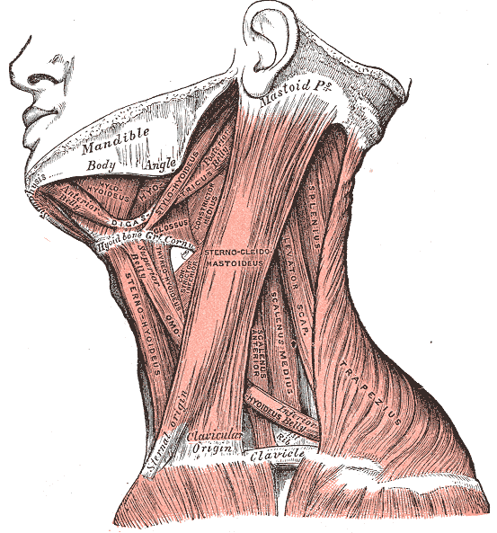
Figure 13. Muscles of the side of the neck: sternocleidomastoid, scalenes, trapezius, levator scapulae and splenius capitis. (Gray's Anatomy, 1918 — public domain, via Wikimedia Commons.)
Muscle | Attachments (simplified) | Main action / biomechanical role
Semispinalis (thoracis, cervicis, capitis) | Transverse processes → spinous processes 4–6 levels above / occiput | Extension of the thoracic & cervical spine and head; semispinalis cervicis is a key deep neck extensor/stabiliser
Splenius capitis & cervicis | Nuchal ligament, C7–T6 spinous processes → mastoid, occiput, C1–C3 transverse processes | Extension; rotation and lateral flexion to the same side
Iliocostalis & longissimus cervicis / capitis | Upper ribs and thoracic transverse processes → cervical transverse processes, mastoid | Extension and lateral flexion of the neck
Suboccipitals (rectus capitis posterior major/minor, obliquus capitis superior/inferior) | C1–C2 → occiput | Fine control of the head on the neck; extremely high spindle density — key proprioceptors for head/eye coordination
Longus colli & longus capitis | Anterior bodies and transverse processes of C1–T3 → occiput | Deep neck flexors: flatten the cervical lordosis and stabilise segments. Impaired endurance in neck pain (Jull et al., 2004)
Sternocleidomastoid (SCM) | Sternum & clavicle → mastoid process | Unilateral: lateral flexion to the same side, rotation to the opposite side. Bilateral: flexes the lower neck, extends the upper neck (forward-head posture)
Scalenes (anterior, middle, posterior) | Cervical transverse processes → ribs 1–2 | Lateral flexion; elevate the ribs in breathing; anterior scalene relates to thoracic outlet syndrome
Levator scapulae | C1–C4 transverse processes → superior angle of the scapula | Elevates scapula; extends and laterally flexes the neck; commonly tender in neck pain
Upper trapezius | Occiput, nuchal ligament → lateral clavicle | Elevates/upwardly rotates scapula; extends and laterally flexes the neck; over-activity common in desk workers
Thoracic multifidus & rotatores | Transverse → spinous processes | Segmental control and rotation of the thoracic spine (rotatores well developed here)

13. Muscles in everyday function

13.1 Lifting
- Stoop lift (straight legs, flexed spine): the extensor moment is produced largely by passive tissues and the thoracic erector spinae; lumbar erector spinae lose their shear-protective obliquity; disc and ligament strain is high.
- Squat / hip-hinge lift (neutral spine): the moment is shared by the hips (gluteus maximus, hamstrings) and knees (quadriceps); the spine is held neutral by the erector spinae and multifidus; abdominal bracing raises IAP. See Flowchart 4.
- Research shows that neither technique is universally "safe"; keeping the load close and avoiding combined twisting and full flexion matter more than the exact style (van Dieën et al., 1999).

13.2 Walking
- Erector spinae fire briefly around heel strike to control the trunk's forward momentum.
- Gluteus medius of the stance leg keeps the pelvis level; QL of the swing side helps lift the pelvis.
- Pelvis and thorax counter-rotate; the obliques and posterior oblique sling (latissimus dorsi + opposite gluteus maximus) transfer energy between arm swing and leg swing.

13.3 Sitting
- Slumped sitting tilts the pelvis posteriorly, flattens the lordosis and switches off multifidus and erector spinae — loading passive tissues instead (O'Sullivan et al., 2002).
- Upright sitting with a neutral lordosis activates multifidus, internal oblique and TrA at low levels.

13.4 Breathing
- The diaphragm must breathe and stabilise at the same time; during heavy loading or breath-holding it prioritises stability. Strenuous breathing (e.g., hyperventilation, exercise) reduces its postural contribution (Hodges et al., 2001).

13.5 Carrying
- Carrying a load in one hand ("suitcase carry") demands strong activation of the opposite QL and obliques to prevent side-bending — a practical frontal-plane stability exercise.

13.6 Sport and rotation
- Rotation power in throwing, golf and racket sports comes mainly from the hips and thorax; the lumbar spine contributes only a few degrees per segment and relies on the obliques and anterior oblique sling to transfer, not generate, rotational force.
- Repeated extension–rotation (fast bowling, gymnastics) loads the pars interarticularis; strong gluteals and abdominals help control pelvic position.

14. Muscle changes in low back pain: what the research shows
Finding | Key research | Interpretation
Rapid, side- and level-specific multifidus atrophy after a first episode of acute LBP | Hides et al. 1994; Hodges et al. 2006 (animal model: atrophy within 3 days of disc injury) | Reflex inhibition — not disuse; does not recover spontaneously when pain resolves
Specific multifidus training reduced recurrence (30% vs 84% at 1 year; 35% vs 75% at 2–3 years) | Hides et al. 1996, 2001 | Supports targeted motor-control retraining after a first episode
Fatty infiltration of multifidus associated with LBP | Kjaer et al. 2007; Goubert et al. 2016 (review) | Muscle quality changes persist in chronic LBP
Delayed feed-forward activation of TrA | Hodges & Richardson 1996, 1998 | Altered motor control; poor preparation of the spine for load
Increased trunk-muscle co-contraction ("guarding") and stiffer movement | van Dieën et al. 2003; Hodges & Tucker 2011 (pain-adaptation theory) | Protective in the short term; may maintain pain and overload long term
Loss of flexion-relaxation | Colloca & Hinrichs 2005 (review) | Objective marker of altered control; improves with recovery
Low extensor endurance predicts first-time LBP (men) | Biering-Sørensen 1984 | Endurance matters more than strength for prevention
Reduced psoas CSA on symptomatic side in sciatica | Barker et al. 2004 | Segmental inhibition involves anterior muscles too
Gluteus medius weakness and gluteus maximus fatigability | Cooper et al. 2016; Leinonen et al. 2000 | Hip muscles are part of LBP rehabilitation
Motor-control exercise is effective but not superior to other exercise for chronic LBP | Saragiotto et al. 2016 (Cochrane review) | Choose exercise to suit the patient; general exercise is also effective

Flowchart 2 summarises how pain changes muscle behaviour and how rehabilitation addresses it.

15. Clinical assessment of spinal muscles
Test | Muscle(s) assessed | How / positive finding
Thomas test | Iliopsoas, rectus femoris, TFL | Supine at edge of bed, one knee to chest: thigh rises off the bed = short iliopsoas; knee extends = short rectus femoris; thigh abducts = short TFL
Ely test | Rectus femoris | Prone knee flexion: hip rises off the bed = short rectus femoris
Straight-leg raise / 90-90 test | Hamstrings (and neural tissue) | Limited hip flexion with knee straight; distinguish from neural tension with sensitising manoeuvres
Ober test | TFL / ITB | Side-lying, upper leg fails to drop into adduction
Biering-Sørensen test | Back extensors (endurance) | Prone, trunk unsupported over bed edge; hold horizontal. Short hold times associated with LBP risk
Flexor endurance test | Abdominals | Sit with trunk at 60°, feet anchored; hold time
Side-bridge test | QL, obliques | Hold side plank. McGill guide ratios: side bridges R:L differ < 5%; flexor:extensor < 1.0; side:extensor < 0.75
Trendelenburg / single-leg stance | Gluteus medius | Opposite pelvis drops or trunk leans over stance leg
Abdominal drawing-in with pressure biofeedback | Transversus abdominis | Prone: pressure under the abdomen should fall 4–10 mmHg without pelvic/spinal movement
Multifidus palpation / rehabilitative ultrasound imaging (RTUS) | Multifidus, TrA | Size, symmetry and ability to contract at each level
Prone instability test | Active stabilisers | Pain on posterior–anterior pressure that eases when the legs are lifted (muscles active) suggests benefit from stabilisation
Active straight-leg raise (ASLR) | Lumbopelvic load transfer | Difficulty lifting a straight leg that improves with pelvic compression
Craniocervical flexion test | Deep neck flexors | Supine with pressure cuff under the neck: staged increase from 20 to 30 mmHg held without superficial muscle substitution

The overall reasoning process is shown in Flowchart 5.

16. Exercise implications
Goal | Example exercises | Muscles emphasised
Restore motor control | Abdominal drawing-in, multifidus "swelling" contraction, 4-point kneeling with neutral spine | TrA, multifidus, pelvic floor, diaphragm
Spine-sparing endurance ("McGill big 3") | Modified curl-up, side bridge, bird-dog | Rectus abdominis & obliques; QL & obliques; erector spinae, multifidus & gluteals
Hip strength & lumbopelvic rhythm | Hip hinge, glute bridge, squats, step-ups, clam/side-lying abduction | Gluteus maximus & medius, hamstrings, quadriceps
Mobility | Hip-flexor stretch (half-kneeling), hamstring stretch, thoracic rotation | Iliopsoas, rectus femoris, hamstrings, thoracic spine
Functional integration | Deadlift pattern with neutral spine, suitcase carry, cable chops/lifts, walking & running | All slings working together

- Progress from control → endurance → strength → power, and from static to dynamic and functional tasks.
- Endurance and coordination usually matter more than maximal strength for back health.
- Over-guarding patients may need relaxation and movement variability rather than more bracing.

17. Flowcharts

Flowchart 1 — Feed-forward and feedback control of the trunk
How the nervous system prepares the spine before a limb moves, and what changes in low back pain.
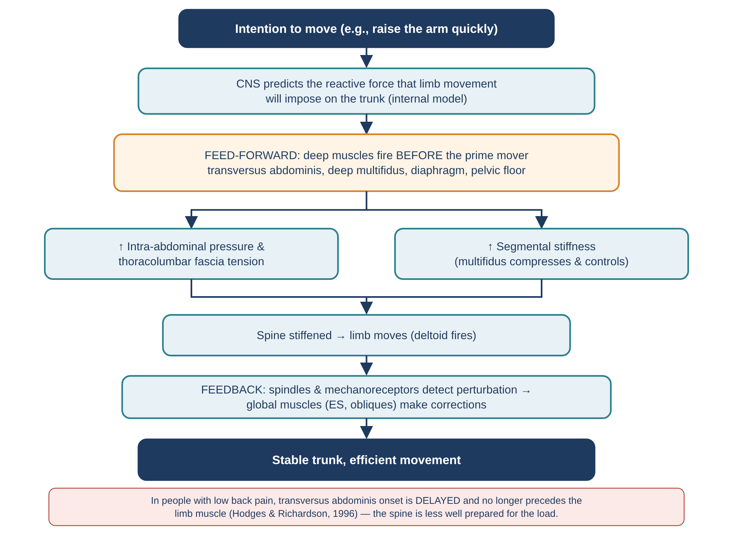
Figure 14. Flowchart 1: feed-forward stabilisation (after Hodges & Richardson).

Flowchart 2 — How pain changes spinal muscle behaviour
Deep muscles are inhibited while superficial muscles guard; the result and the rehabilitation response.
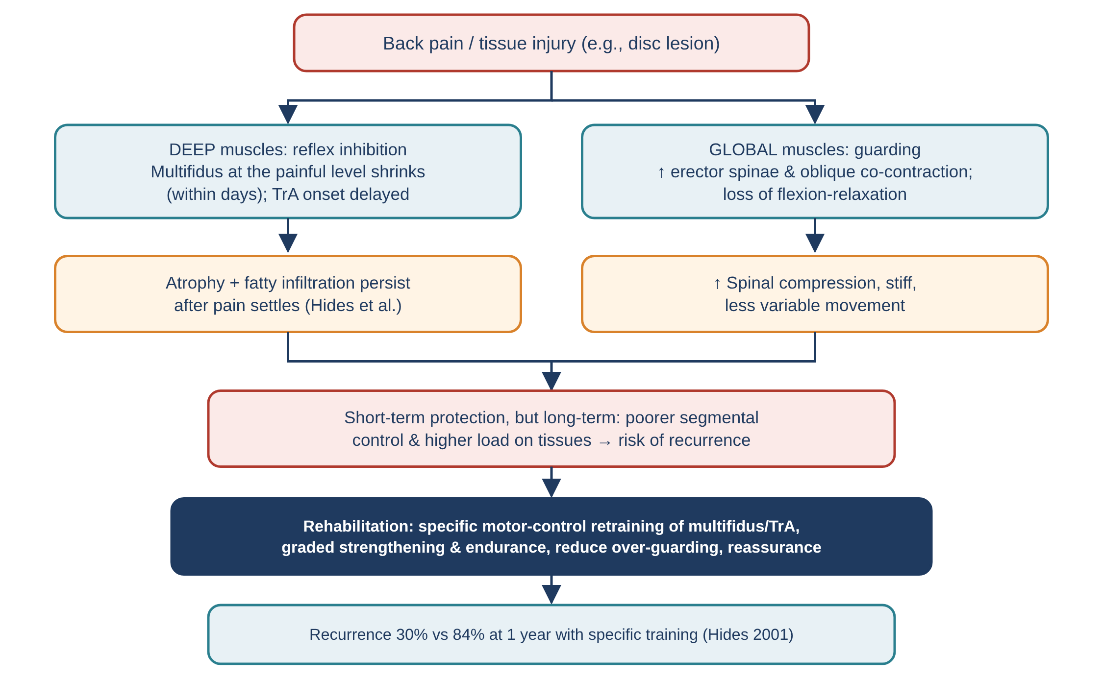
Figure 15. Flowchart 2: pain adaptation in the trunk muscles.

Flowchart 3 — Muscle patterns, pelvic tilt and lumbar loading
How muscle length and strength around the pelvis can change lumbar posture and load.
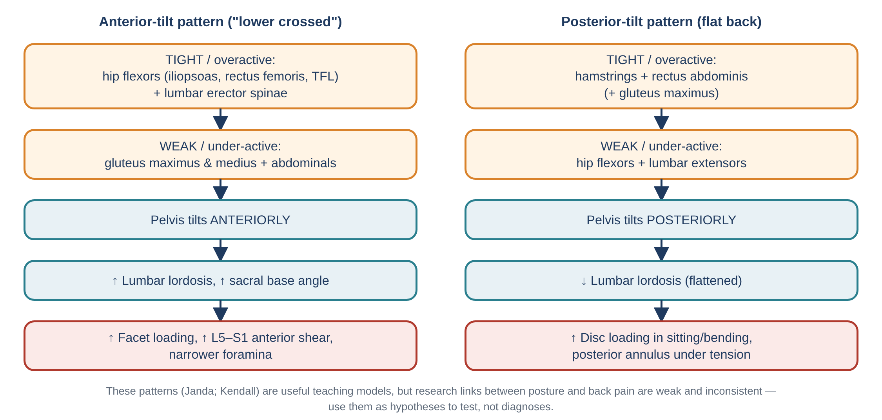
Figure 16. Flowchart 3: muscle patterns and their effect on the lumbar spine.

Flowchart 4 — Muscles in a safe lift
The sequence of muscle actions in a hip-hinge / squat lift and the consequence of weak knee extensors.
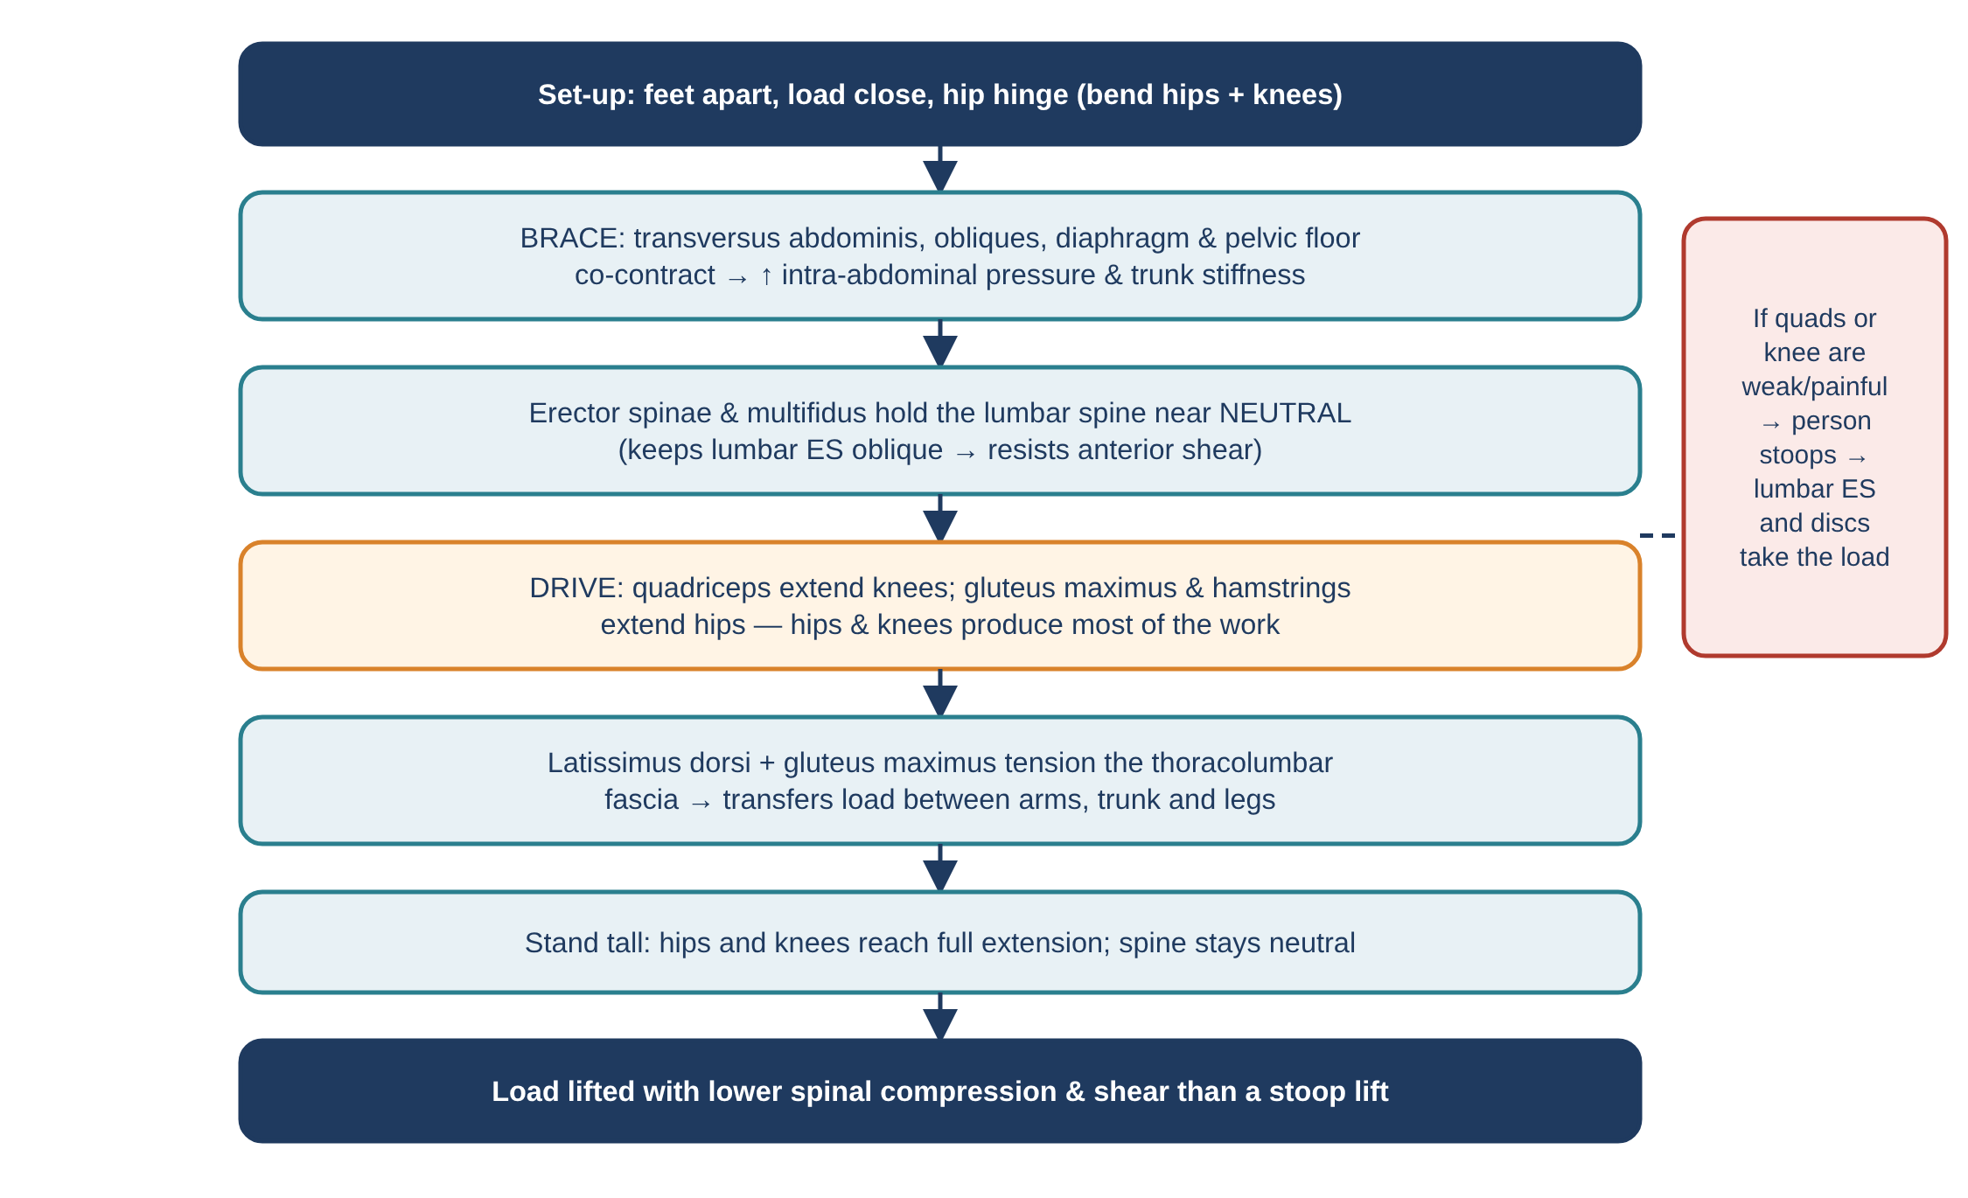
Figure 17. Flowchart 4: muscle sequence during lifting.

Flowchart 5 — Muscle-focused assessment and management
A step-by-step clinical reasoning pathway linking tests to treatment.
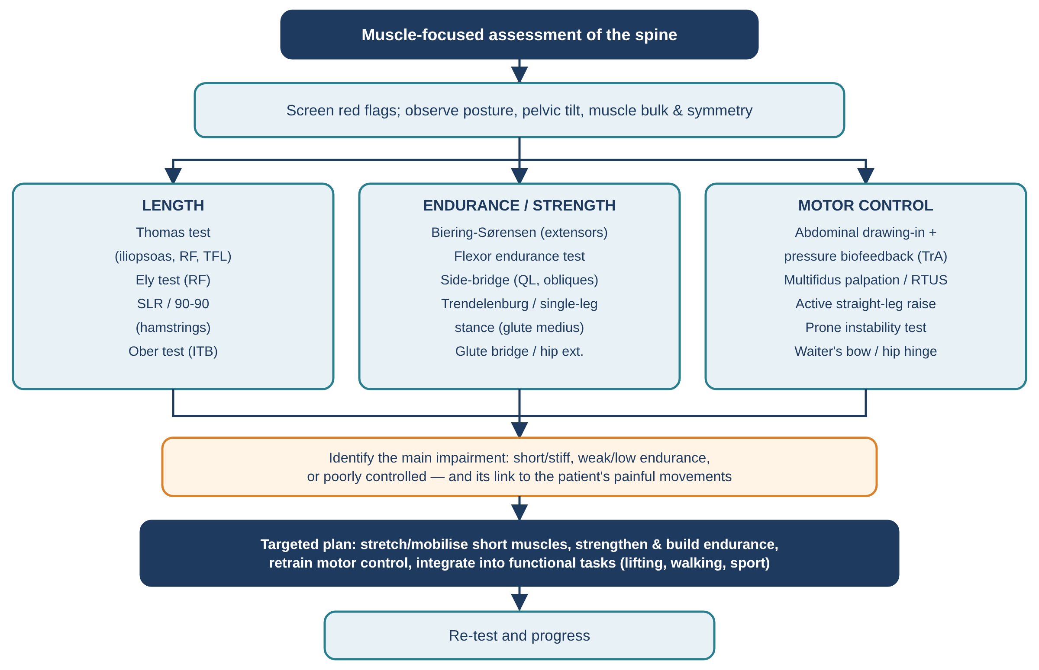
Figure 18. Flowchart 5: assessment and management of spinal muscle function.

18. Master table: every muscle that influences the spine
Muscle | Nerve | Effect on spine / pelvis | Key biomechanical point
Erector spinae — lumbar fascicles | Dorsal rami (lateral/intermediate) | Extension, lateral flexion | Resist anterior shear; lose this in full flexion
Erector spinae — thoracic fascicles | Dorsal rami | Extension of thorax on pelvis, ↑ lordosis | Largest extensor moment arms
Multifidus | Medial branch dorsal ramus (segmental) | Segmental extension, stiffness | Atrophies quickly in LBP; ~2/3 of muscle-derived stiffness at L4–5
Rotatores, interspinales, intertransversarii | Dorsal/ventral rami | Minor movement | Proprioceptors (high spindle density)
Quadratus lumborum | T12–L3 | Lateral flexion, hip hike, rib fixation | Key frontal-plane stabiliser
Rectus abdominis | T7–T12 | Flexion, posterior pelvic tilt | Longest flexor lever
External oblique | T7–T12 | Flexion, opposite rotation, side-flexion | Pairs with opposite IO for rotation
Internal oblique | T7–L1 | Flexion, same-side rotation | Tensions TLF
Transversus abdominis | T7–L1 | IAP, TLF tension | Feed-forward stabiliser; delayed in LBP
Diaphragm | Phrenic C3–C5 | Roof of cylinder; crura pull on L1–L3 | Breathing + stability
Pelvic floor | Pudendal, S3–S4 | Floor of cylinder; SI force closure | Co-activates with TrA
Psoas major | L1–L3 | Hip flexion; spinal compression | Tiny sagittal moment arm; large compression
Psoas minor | L1 | Weak trunk/pelvic flexion | Absent in ~half of people
Iliacus | Femoral L2–L4 | Hip flexion, anterior pelvic tilt | Affects lordosis via pelvis
Rectus femoris | Femoral L2–L4 | Hip flexion, anterior pelvic tilt | Short → ↑ lordosis
Vasti (quadriceps) | Femoral L2–L4 | Knee extension | Enable squat lifting; spare the spine
Sartorius, TFL | Femoral; superior gluteal | Anterior (± lateral) pelvic tilt | Minor tilt contributors
Gluteus maximus | Inferior gluteal L5–S2 | Hip extension, posterior pelvic tilt | Shares extensor moment; SI force closure; posterior oblique sling
Gluteus medius & minimus | Superior gluteal L4–S1 | Frontal-plane pelvic control | Weakness → Trendelenburg, QL compensation
Hamstrings | Sciatic (tibial) L5–S2 | Hip extension, posterior pelvic tilt | Short → ↑ lumbar flexion when bending; deep longitudinal sling
Adductors | Obturator; sciatic (magnus) | Pelvic tilt (direction depends on hip angle) | Anterior oblique & lateral slings
Piriformis & deep rotators | Sacral plexus L5–S2 | Hip rotation; sacral shear | May irritate sciatic nerve
Latissimus dorsi | Thoracodorsal C6–C8 | Trunk extension with arm fixed; TLF tension | Links arm to pelvis; posterior oblique sling
Trapezius, rhomboids | Accessory n.; dorsal scapular | Thoracic/cervical posture | Scapular base for arm loads
Serratus posterior inferior | T9–T12 ventral rami | Rib depression | Minor TLF tensioner
Semispinalis, splenius | Dorsal rami | Neck & thoracic extension, rotation | Deep neck extensors
Suboccipitals | Suboccipital n. (C1) | Head-on-neck control | Proprioception
Longus colli/capitis | C1–C6 ventral rami | Deep neck flexion | Endurance reduced in neck pain
SCM, scalenes, levator scapulae | Accessory; cervical rami | Neck flexion/rotation/side-flexion; rib elevation | Forward-head posture; respiration
Peroneus longus | Superficial fibular L5–S1 | Foot eversion | Distal link of deep longitudinal sling

19. References
Barker, K. L., Shamley, D. R., & Jackson, D. (2004). Changes in the cross-sectional area of multifidus and psoas in patients with unilateral back pain. Spine, 29(22), E515–E519.
Bergmark, A. (1989). Stability of the lumbar spine: a study in mechanical engineering. Acta Orthopaedica Scandinavica, 60(Suppl. 230), 1–54.
Biering-Sørensen, F. (1984). Physical measurements as risk indicators for low-back trouble over a one-year period. Spine, 9(2), 106–119.
Bogduk, N. (1980). A reappraisal of the anatomy of the human lumbar erector spinae. Journal of Anatomy, 131(3), 525–540.
Bogduk, N., Pearcy, M., & Hadfield, G. (1992). Anatomy and biomechanics of psoas major. Clinical Biomechanics, 7(2), 109–119.
Bogduk, N. (2012). Clinical and Radiological Anatomy of the Lumbar Spine (5th ed.). Churchill Livingstone.
Cholewicki, J., & McGill, S. M. (1996). Mechanical stability of the in vivo lumbar spine: implications for injury and chronic low back pain. Clinical Biomechanics, 11(1), 1–15.
Cholewicki, J., Juluru, K., & McGill, S. M. (1999). Intra-abdominal pressure mechanism for stabilizing the lumbar spine. Journal of Biomechanics, 32(1), 13–17.
Colloca, C. J., & Hinrichs, R. N. (2005). The biomechanical and clinical significance of the lumbar erector spinae flexion-relaxation phenomenon: a review. Journal of Manipulative and Physiological Therapeutics, 28(8), 623–631.
Cooper, N. A., et al. (2016). Prevalence of gluteus medius weakness in people with chronic low back pain compared to healthy controls. European Spine Journal, 25(4), 1258–1265.
Crisco, J. J., & Panjabi, M. M. (1992). Euler stability of the human ligamentous lumbar spine. Clinical Biomechanics, 7, 19–26.
Goubert, D., et al. (2016). Structural changes of lumbar muscles in non-specific low back pain: a systematic review. Pain Physician, 19(7), E985–E1000.
Gray, H. (1918). Anatomy of the Human Body (20th ed.). Lea & Febiger. (Plates reproduced from Wikimedia Commons, public domain.)
Grenier, S. G., & McGill, S. M. (2007). Quantification of lumbar stability by using 2 different abdominal activation strategies. Archives of Physical Medicine and Rehabilitation, 88(1), 54–62.
Hides, J. A., et al. (1994). Evidence of lumbar multifidus muscle wasting ipsilateral to symptoms in patients with acute/subacute low back pain. Spine, 19(2), 165–172.
Hides, J. A., Richardson, C. A., & Jull, G. A. (1996). Multifidus muscle recovery is not automatic after resolution of acute, first-episode low back pain. Spine, 21(23), 2763–2769.
Hides, J. A., Jull, G. A., & Richardson, C. A. (2001). Long-term effects of specific stabilizing exercises for first-episode low back pain. Spine, 26(11), E243–E248.
Hodges, P. W., & Richardson, C. A. (1996). Inefficient muscular stabilization of the lumbar spine associated with low back pain. Spine, 21(22), 2640–2650.
Hodges, P. W., & Richardson, C. A. (1997). Feedforward contraction of transversus abdominis is not influenced by the direction of arm movement. Experimental Brain Research, 114(2), 362–370.
Hodges, P. W., & Gandevia, S. C. (2000). Changes in intra-abdominal pressure during postural and respiratory activation of the human diaphragm. Journal of Applied Physiology, 89(3), 967–976.
Hodges, P. W., et al. (2006). Rapid atrophy of the lumbar multifidus follows experimental disc or nerve root injury. Spine, 31(25), 2926–2933.
Hodges, P. W., & Tucker, K. (2011). Moving differently in pain: a new theory to explain the adaptation to pain. Pain, 152(3 Suppl), S90–S98.
Juker, D., McGill, S., Kropf, P., & Steffen, T. (1998). Quantitative intramuscular myoelectric activity of lumbar portions of psoas and the abdominal wall during a wide variety of tasks. Medicine & Science in Sports & Exercise, 30(2), 301–310.
Jull, G., Kristjansson, E., & Dall'Alba, P. (2004). Impairment in the cervical flexors: a comparison of whiplash and insidious onset neck pain patients. Manual Therapy, 9(2), 89–94.
Kjaer, P., et al. (2007). Are MRI-defined fat infiltrations in the multifidus muscles associated with low back pain? BMC Medicine, 5, 2.
Laird, R. A., et al. (2014). Comparing lumbo-pelvic kinematics in people with and without back pain: a systematic review and meta-analysis. BMC Musculoskeletal Disorders, 15, 229.
Langevin, H. M., et al. (2011). Reduced thoracolumbar fascia shear strain in human chronic low back pain. BMC Musculoskeletal Disorders, 12, 203.
Leinonen, V., et al. (2000). Back and hip extensor activities during trunk flexion/extension: effects of low back pain and rehabilitation. Archives of Physical Medicine and Rehabilitation, 81(1), 32–37.
McGill, S. M., et al. (1996). Quantitative intramuscular myoelectric activity of quadratus lumborum during a wide variety of tasks. Clinical Biomechanics, 11(3), 170–172.
McGill, S. M., Hughson, R. L., & Parks, K. (2000). Changes in lumbar lordosis modify the role of the extensor muscles. Clinical Biomechanics, 15(10), 777–780.
McGill, S. (2016). Low Back Disorders: Evidence-Based Prevention and Rehabilitation (3rd ed.). Human Kinetics.
Neumann, D. A. (2017). Kinesiology of the Musculoskeletal System (3rd ed.). Elsevier.
Nitz, A. J., & Peck, D. (1986). Comparison of muscle spindle concentrations in large and small human epaxial muscles acting in parallel combinations. American Surgeon, 52(5), 273–277.
O'Sullivan, P. B., et al. (2002). The effect of different standing and sitting postures on trunk muscle activity in a pain-free population. Spine, 27(11), 1238–1244.
Saragiotto, B. T., et al. (2016). Motor control exercise for chronic non-specific low-back pain. Cochrane Database of Systematic Reviews, CD012004.
Smith, M. D., Russell, A., & Hodges, P. W. (2006). Disorders of breathing and continence have a stronger association with back pain than obesity and physical activity. Australian Journal of Physiotherapy, 52(1), 11–16.
van Dieën, J. H., Hoozemans, M. J., & Toussaint, H. M. (1999). Stoop or squat: a review of biomechanical studies on lifting technique. Clinical Biomechanics, 14(10), 685–696.
van Dieën, J. H., Selen, L. P., & Cholewicki, J. (2003). Trunk muscle activation in low-back pain patients, an analysis of the literature. Journal of Electromyography and Kinesiology, 13(4), 333–351.
Vleeming, A., et al. (1989). Load application to the sacrotuberous ligament; influences on sacroiliac joint mechanics. Clinical Biomechanics, 4(4), 204–209.
Vleeming, A., et al. (1995). The posterior layer of the thoracolumbar fascia: its function in load transfer from spine to legs. Spine, 20(7), 753–758.
Ward, S. R., et al. (2009). Architectural analysis and intraoperative measurements demonstrate the unique design of the multifidus muscle for lumbar spine stability. Journal of Bone and Joint Surgery (Am), 91(1), 176–185.
Wilke, H. J., et al. (1995). Stability increase of the lumbar spine with different muscle groups: a biomechanical in vitro study. Spine, 20(2), 192–198.

