THE MUSCLES OF THE BACK
Muscle-by-muscle anatomy, mechanics and pathomechanics
Trapezius · latissimus dorsi · levator scapulae · rhomboids · serratus posterior · splenius · iliocostalis · longissimus · spinalis · semispinalis · multifidus · rotatores · interspinales · intertransversarii · levatores costarum · suboccipitals · quadratus lumborum

Contents
PART A — FOUNDATIONS
1. How to use this document
2. Organisation of the back muscles
3. Principles of muscle mechanics
4. General mechanisms of muscle pathomechanics
PART B — INDIVIDUAL MUSCLES
5. Superficial layer: trapezius, latissimus dorsi, levator scapulae, rhomboids
6. Intermediate layer: serratus posterior superior and inferior
7. Spinotransversales: splenius capitis and cervicis
8. Erector spinae: iliocostalis, longissimus, spinalis
9. Transversospinales: semispinalis, multifidus, rotatores
10. Segmental muscles: interspinales, intertransversarii, levatores costarum
11. Suboccipital muscles
12. Quadratus lumborum
13. Thoracolumbar fascia and myofascial slings
PART C — SYNTHESIS
14. Pathomechanics flowcharts
15. Master summary table
16. Assessment quick reference
17. References
Educational document. Attachments follow standard anatomical texts (variations are common); research findings are summarised from the studies cited and should be read in their original context.

1. How to use this document
Every muscle in Part B follows the same structure: a drawing showing where the muscle runs and which way it pulls, an anatomy table (attachments, nerve, blood supply, relations), a mechanics section (what it does and why, based on its line of action and leverage), a pathomechanics section (how it goes wrong and what the research shows) and a clinical section (tests and exercises).

Drawing conventions
- All muscle drawings are schematic posterior views. The muscle is drawn on the right side of the body (the right of the picture); the left side is left bare so the bony landmarks can be seen.
- Vertebral levels are marked down the left edge (Occ = occiput, C1–C7, T1–T12, L1–L5).
- Dots mark attachments and are linked to labels. Arrows show the line of pull — the direction in which the muscle pulls its insertion when it contracts.
- Muscles with several parts are colour-coded, with a legend under each drawing. Faded grey shapes are neighbouring muscles shown for orientation.
- Several drawings, plates and flowcharts from the companion documents (lumbar biomechanics; longissimus, multifidus and QL) are reused where they add detail.

2. Organisation of the back muscles
The back muscles are best understood in layers, and the layers make sense once you know their embryological origin and nerve supply. The "true" (intrinsic, epaxial) back muscles develop from the dorsal part of the myotomes and are supplied by the dorsal rami of spinal nerves; they act on the vertebral column and head. The superficial and intermediate muscles are "immigrant" (extrinsic) muscles that develop elsewhere — limb or respiratory muscles that have spread onto the back — and are therefore supplied by ventral rami (or, for trapezius, the accessory nerve).
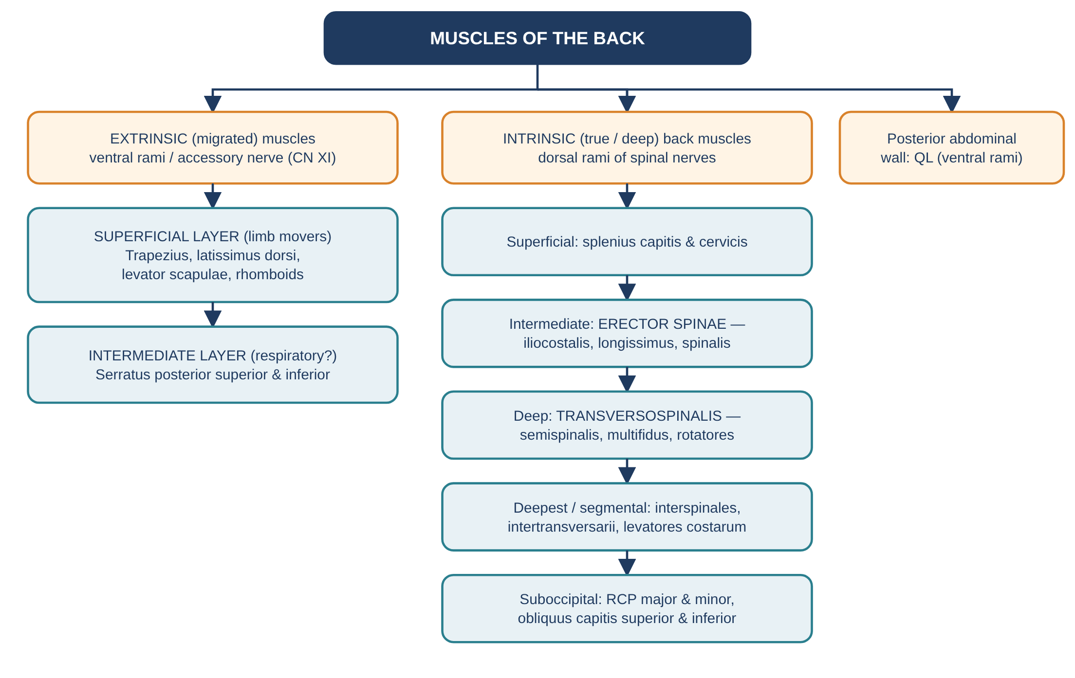
Figure 1. Layers of the back muscles and their nerve supply.
Layer | Muscles | Nerve supply | Main role
Superficial (extrinsic) | Trapezius, latissimus dorsi, levator scapulae, rhomboid major & minor | Accessory nerve (CN XI), thoracodorsal, dorsal scapular (ventral rami) | Move and stabilise the upper limb and scapula; secondary effects on the spine
Intermediate (extrinsic) | Serratus posterior superior & inferior | Intercostal nerves (ventral rami) | Classically respiratory; possibly proprioceptive
Intrinsic — superficial | Splenius capitis & cervicis | Dorsal rami | Extend and rotate head and neck
Intrinsic — intermediate | Erector spinae: iliocostalis, longissimus, spinalis | Dorsal rami (lateral & intermediate branches) | Extend the spine, control flexion, lateral flexion
Intrinsic — deep | Transversospinales: semispinalis, multifidus, rotatores | Dorsal rami (medial branches) | Segmental extension, stiffness, fine control
Intrinsic — deepest | Interspinales, intertransversarii, levatores costarum | Dorsal (and some ventral) rami | Segmental control, proprioception
Suboccipital | RCP major & minor, obliquus capitis superior & inferior | Suboccipital nerve (C1 dorsal ramus) | Fine control of the head on the atlas and axis; proprioception
Posterior abdominal wall | Quadratus lumborum | Ventral rami T12–L3(4) | Lateral flexion, 12th-rib fixation, pelvic hiking

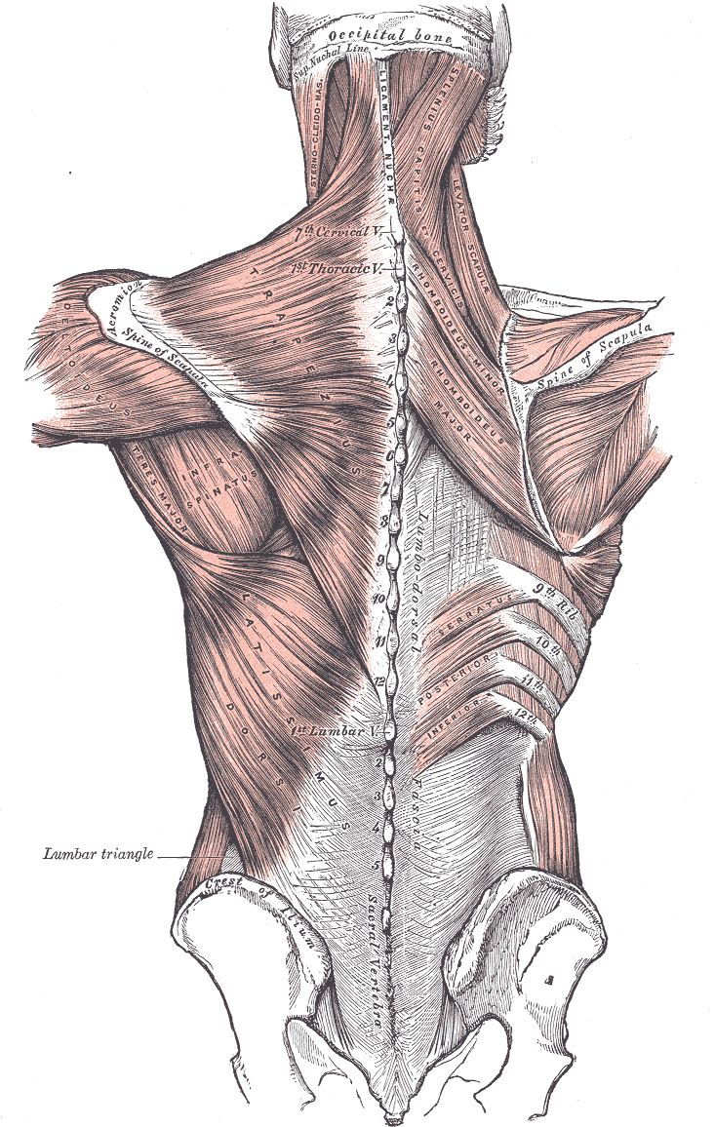
Figure 2. Superficial muscles of the back: trapezius and latissimus dorsi cover the deeper layers. (Gray's Anatomy, 1918 — public domain, via Wikimedia Commons.)
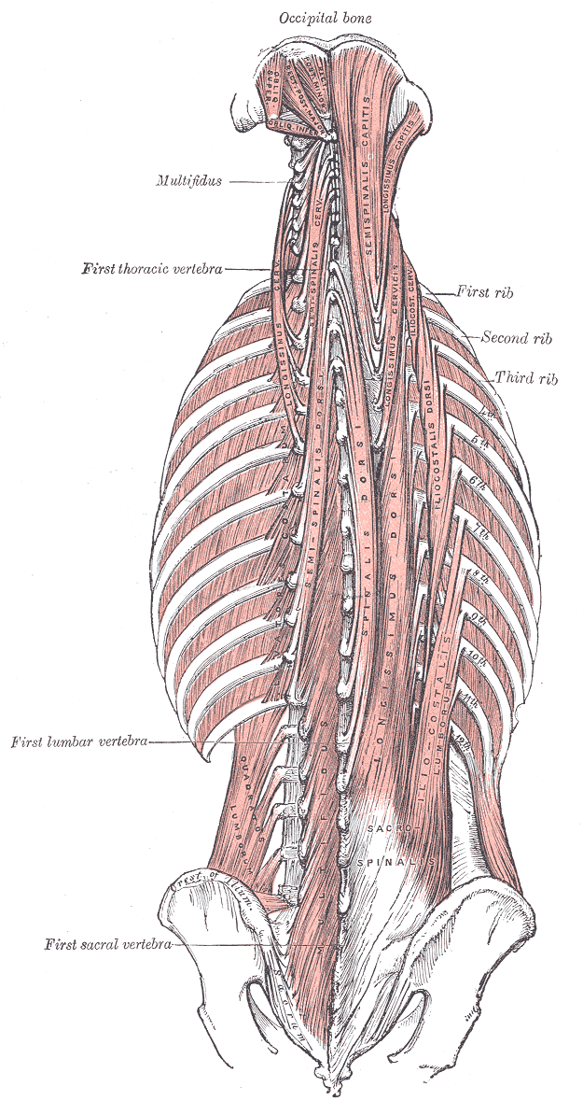
Figure 3. Deep muscles of the back: the erector spinae columns and the transversospinalis group. (Gray's Anatomy, 1918 — public domain, via Wikimedia Commons.)
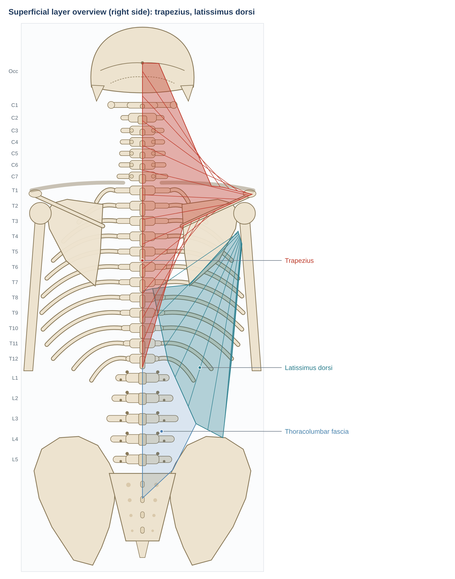
Figure 4. Superficial layer drawn on the skeleton template used throughout this document.
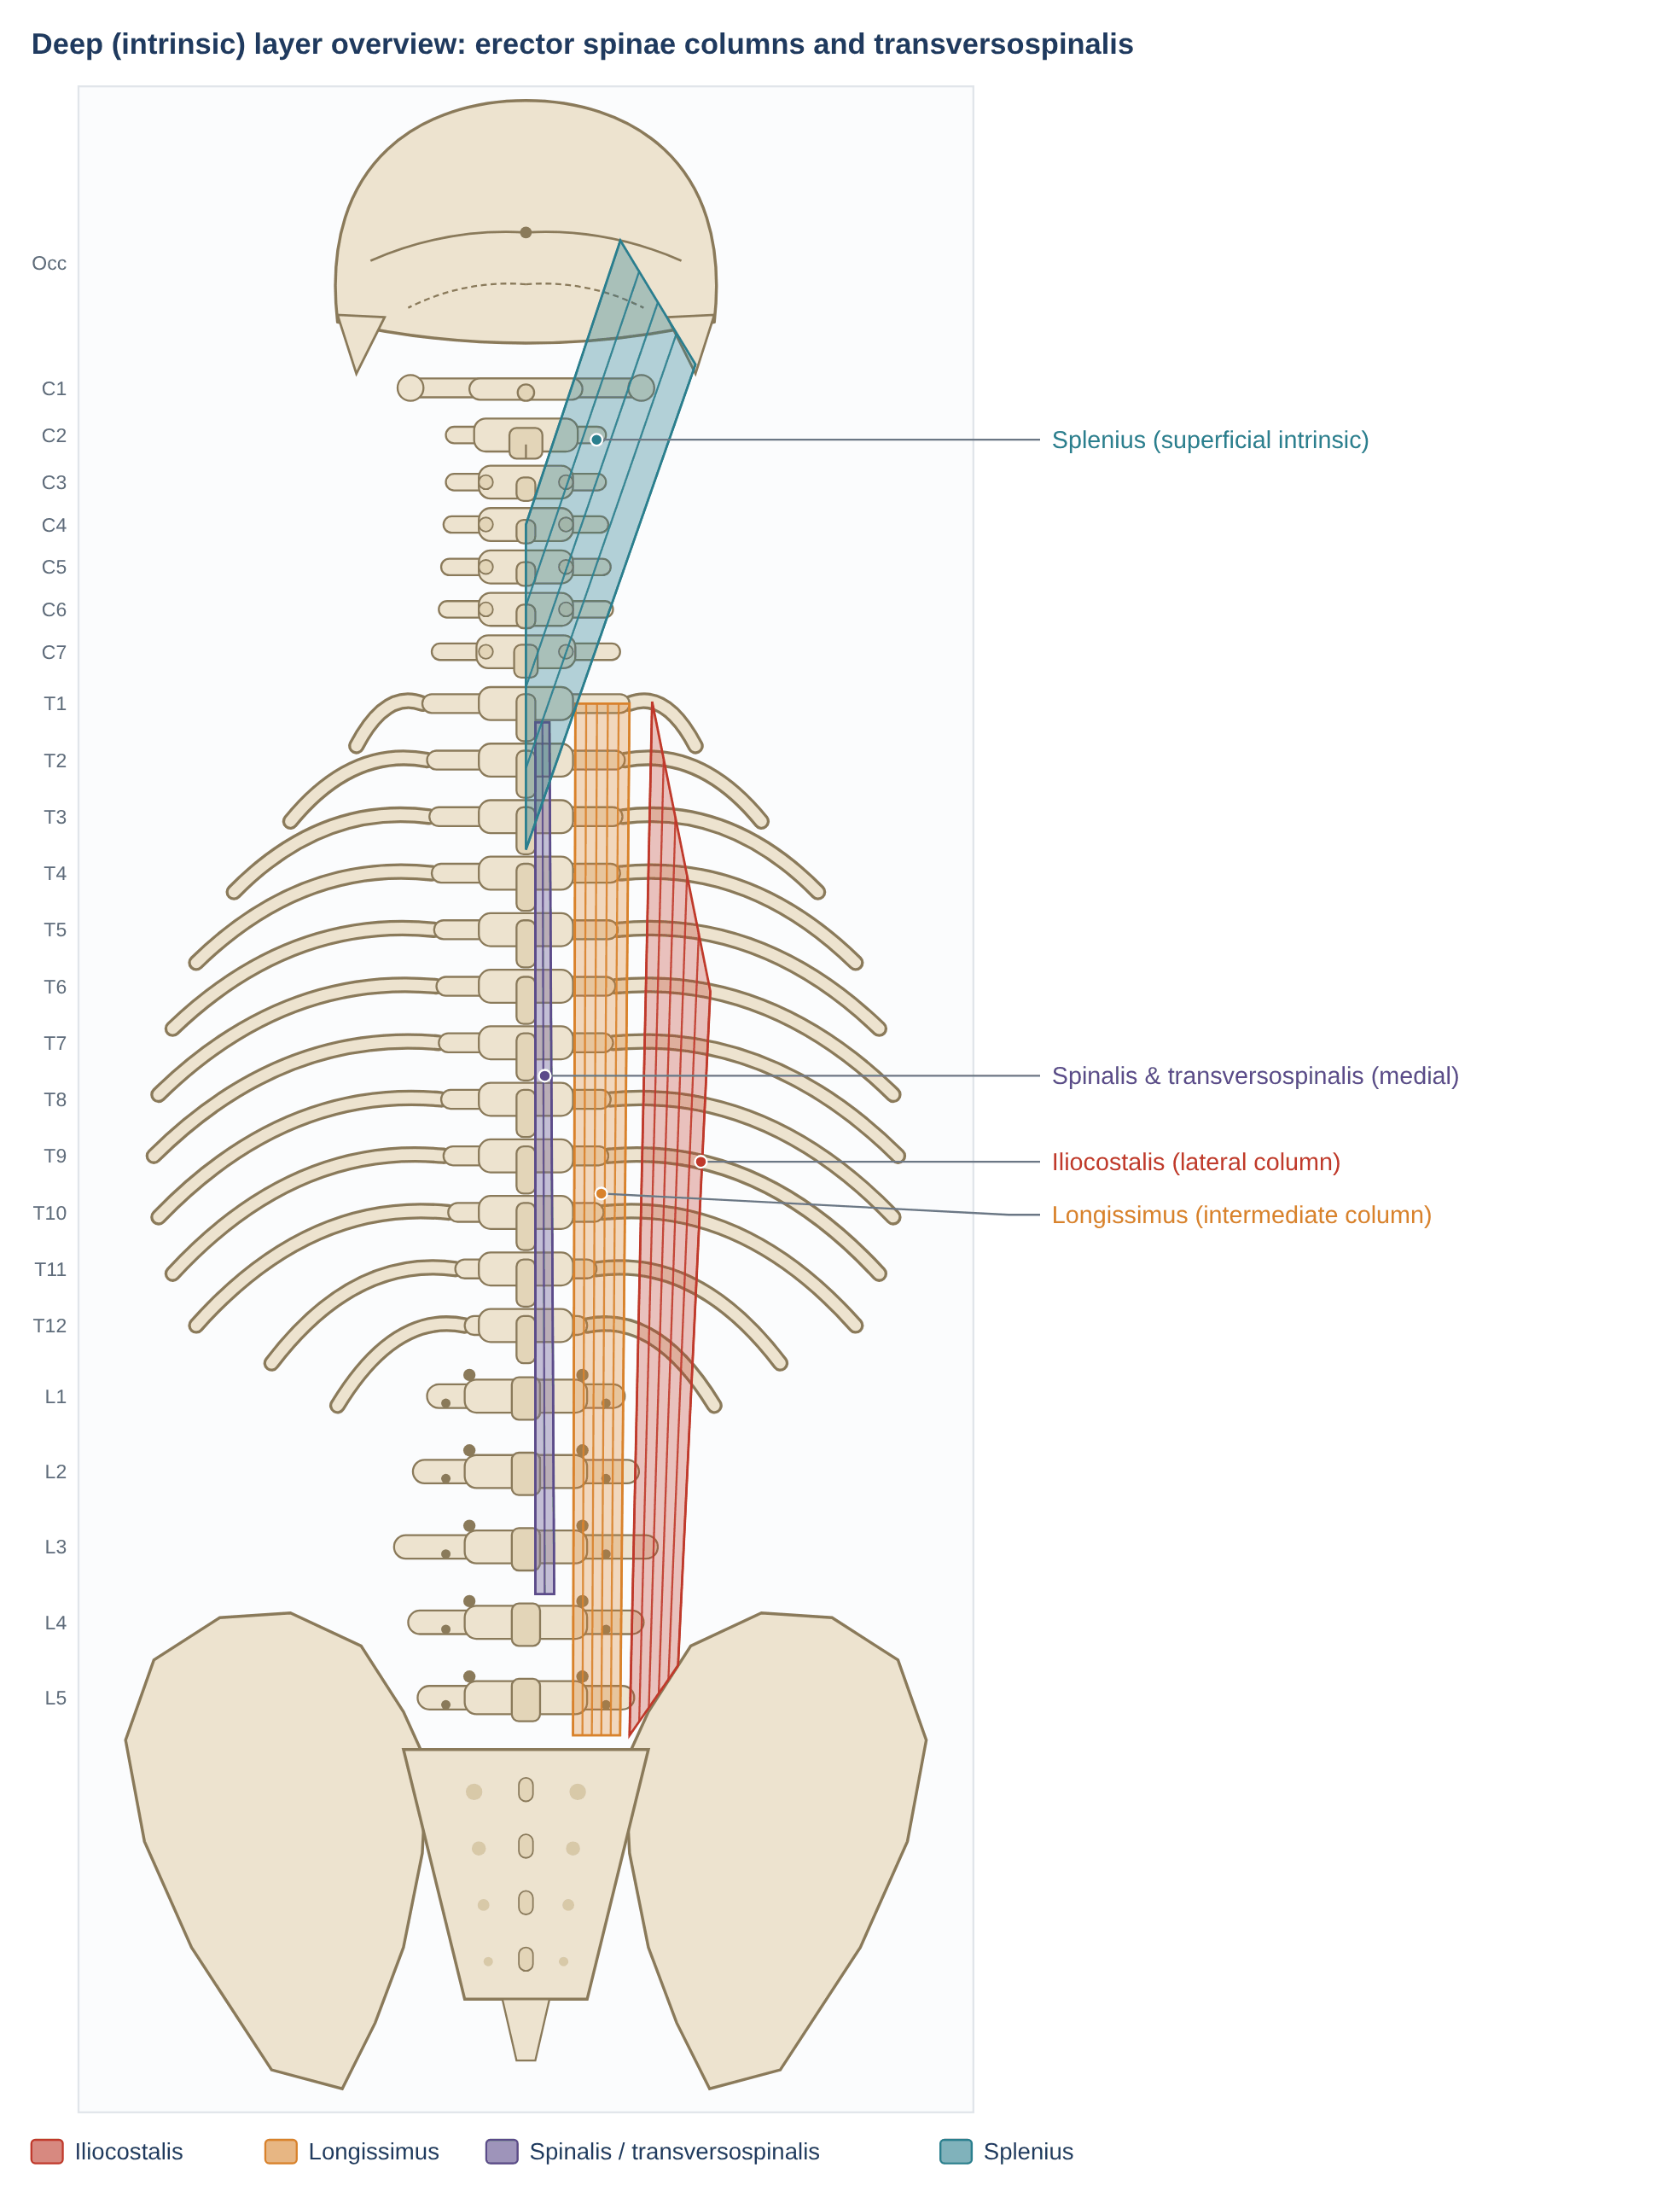
Figure 5. Deep layer: the three columns of erector spinae (iliocostalis laterally, longissimus in the middle, spinalis medially), with the transversospinalis group deep to them, and splenius in the neck.

3. Principles of muscle mechanics
The function of any back muscle can be predicted from a few mechanical principles.
Principle | What it means | Back-muscle example
Line of action | The direction of the muscle's pull decides which movements it produces and whether it adds shear or compression | Lumbar fascicles of longissimus pull the vertebra backward (posterior shear); levatores costarum pull ribs upward
Moment arm | Torque = force × perpendicular distance from the axis. Far from the axis = large torque; near the axis = mainly compression/stiffness | Rectus abdominis and iliocostalis have long levers; rotatores and psoas have tiny ones
Unilateral vs bilateral action | Acting on both sides, left–right components cancel (pure extension/flexion); acting on one side produces lateral flexion and/or rotation | Splenius capitis: both sides extend the head; one side turns the head to the same side
PCSA and fibre length | Force ∝ physiological cross-sectional area; excursion and speed ∝ fibre length | Multifidus: short fibres, huge PCSA (stabiliser); latissimus: long fibres (mover)
Length–tension | Force depends on sarcomere length; a muscle may be stronger in some positions | Multifidus is stronger in flexion (ascending limb)
Force couple | Two muscles pulling in opposite directions on either side of an axis rotate a segment | Upper + lower trapezius + serratus anterior rotate the scapula upward
Fibre type | Type I = fatigue-resistant postural; type II = fast, powerful | Erector spinae and multifidus are mainly type I
Segmental vs multisegmental | Short muscles control individual joints; long muscles control posture across many segments | Rotatores vs longissimus pars thoracis

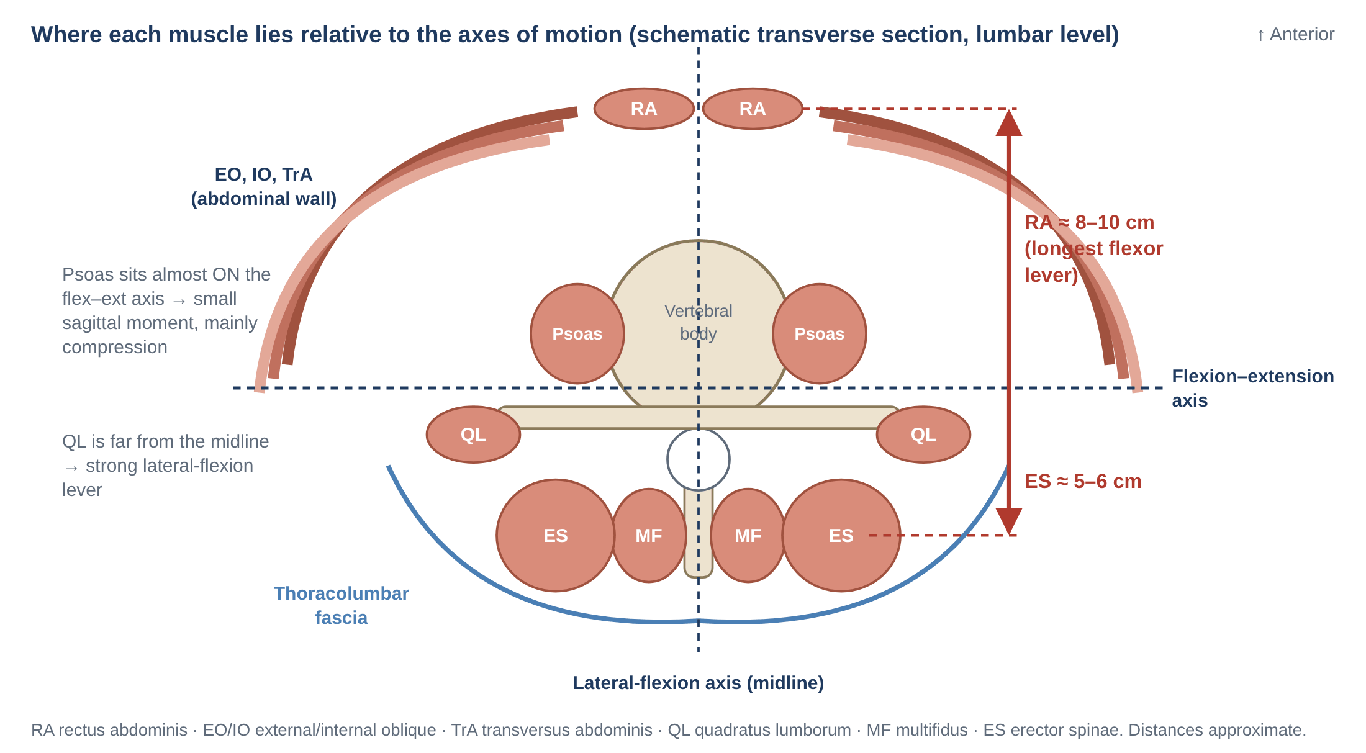
Figure 6. Position of the trunk muscles relative to the lumbar axes of motion (from the companion document).
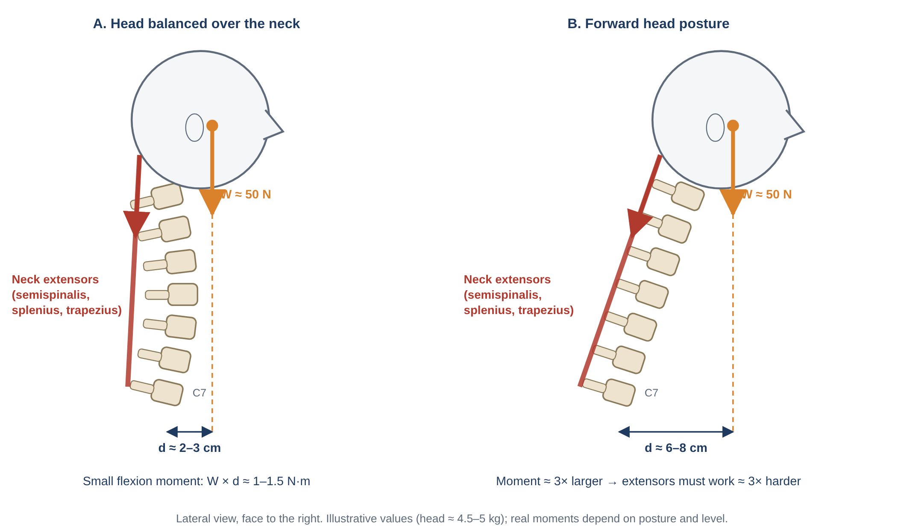
Figure 7. The head as a load on the neck. Moving the head forward increases the flexion moment the posterior neck muscles must resist.
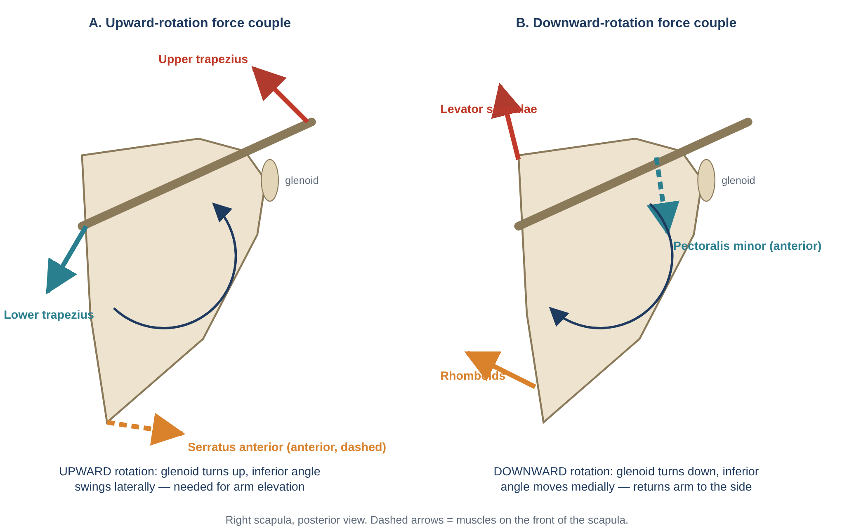
Figure 8. Scapular force couples. Several back muscles (trapezius, levator scapulae, rhomboids) work in pairs with chest-wall muscles to rotate the scapula.
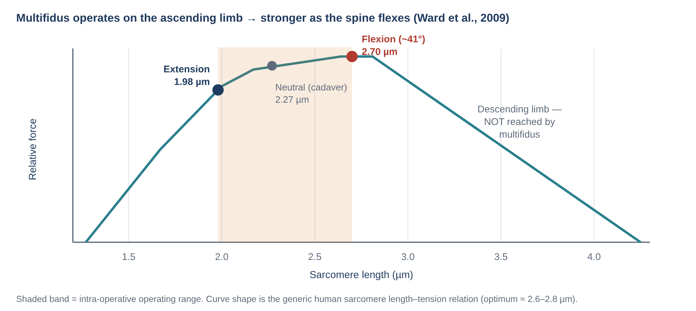
Figure 9. Length–tension behaviour of multifidus (Ward et al., 2009).

4. General mechanisms of muscle pathomechanics
Many different back problems share a small number of muscle-level mechanisms. They recur throughout Part B.
Mechanism | Description | Typical muscles / evidence
Reflex (arthrogenic) inhibition | Pain or joint injury reduces drive to deep segmental muscles at the affected level within hours to days | Lumbar multifidus (Hides 1994; Hodges 2006)
Protective guarding / altered recruitment | Superficial muscles become over-active, co-contract and fail to relax; movements become stiff and less variable | Erector spinae, upper trapezius, SCM (van Dieën 2003; Falla 2004; Hodges & Tucker 2011)
Structural remodelling | Fatty infiltration, fibrosis, fibre-type shift (type I → type II) after injury or with chronic pain | Multifidus (Hodges 2015), cervical extensors (Elliott 2006; Schomacher & Falla 2013)
Fatigue and low endurance | Early fatigue in sustained postures; poor endurance predicts back pain | Back extensors (Biering-Sørensen 1984)
Static overload of low-threshold units | Continuous low-level activation overloads the same motor units | Upper trapezius (Hägg 1991; Veiersted 1993)
Length / position changes | Habitual postures leave muscles short or long, altering moment arms and joint loading | Upper and lower "crossed" patterns (clinical models)
Nerve injury or entrapment | Denervation weakness or neuropathic pain | Spinal accessory (trapezius), dorsal scapular (rhomboids), greater occipital nerve (semispinalis capitis)
Iatrogenic injury | Surgical retraction or denervation | Multifidus and erector spinae after posterior spinal surgery (Kawaguchi 1996); multifidus after medial-branch neurotomy
Myofascial pain | Local tender nodules with characteristic referral patterns | Upper trapezius, levator, suboccipitals (Travell & Simons; diagnostic reliability limited)
Movement disorders | Involuntary overactivity | Splenius capitis, SCM in cervical dystonia

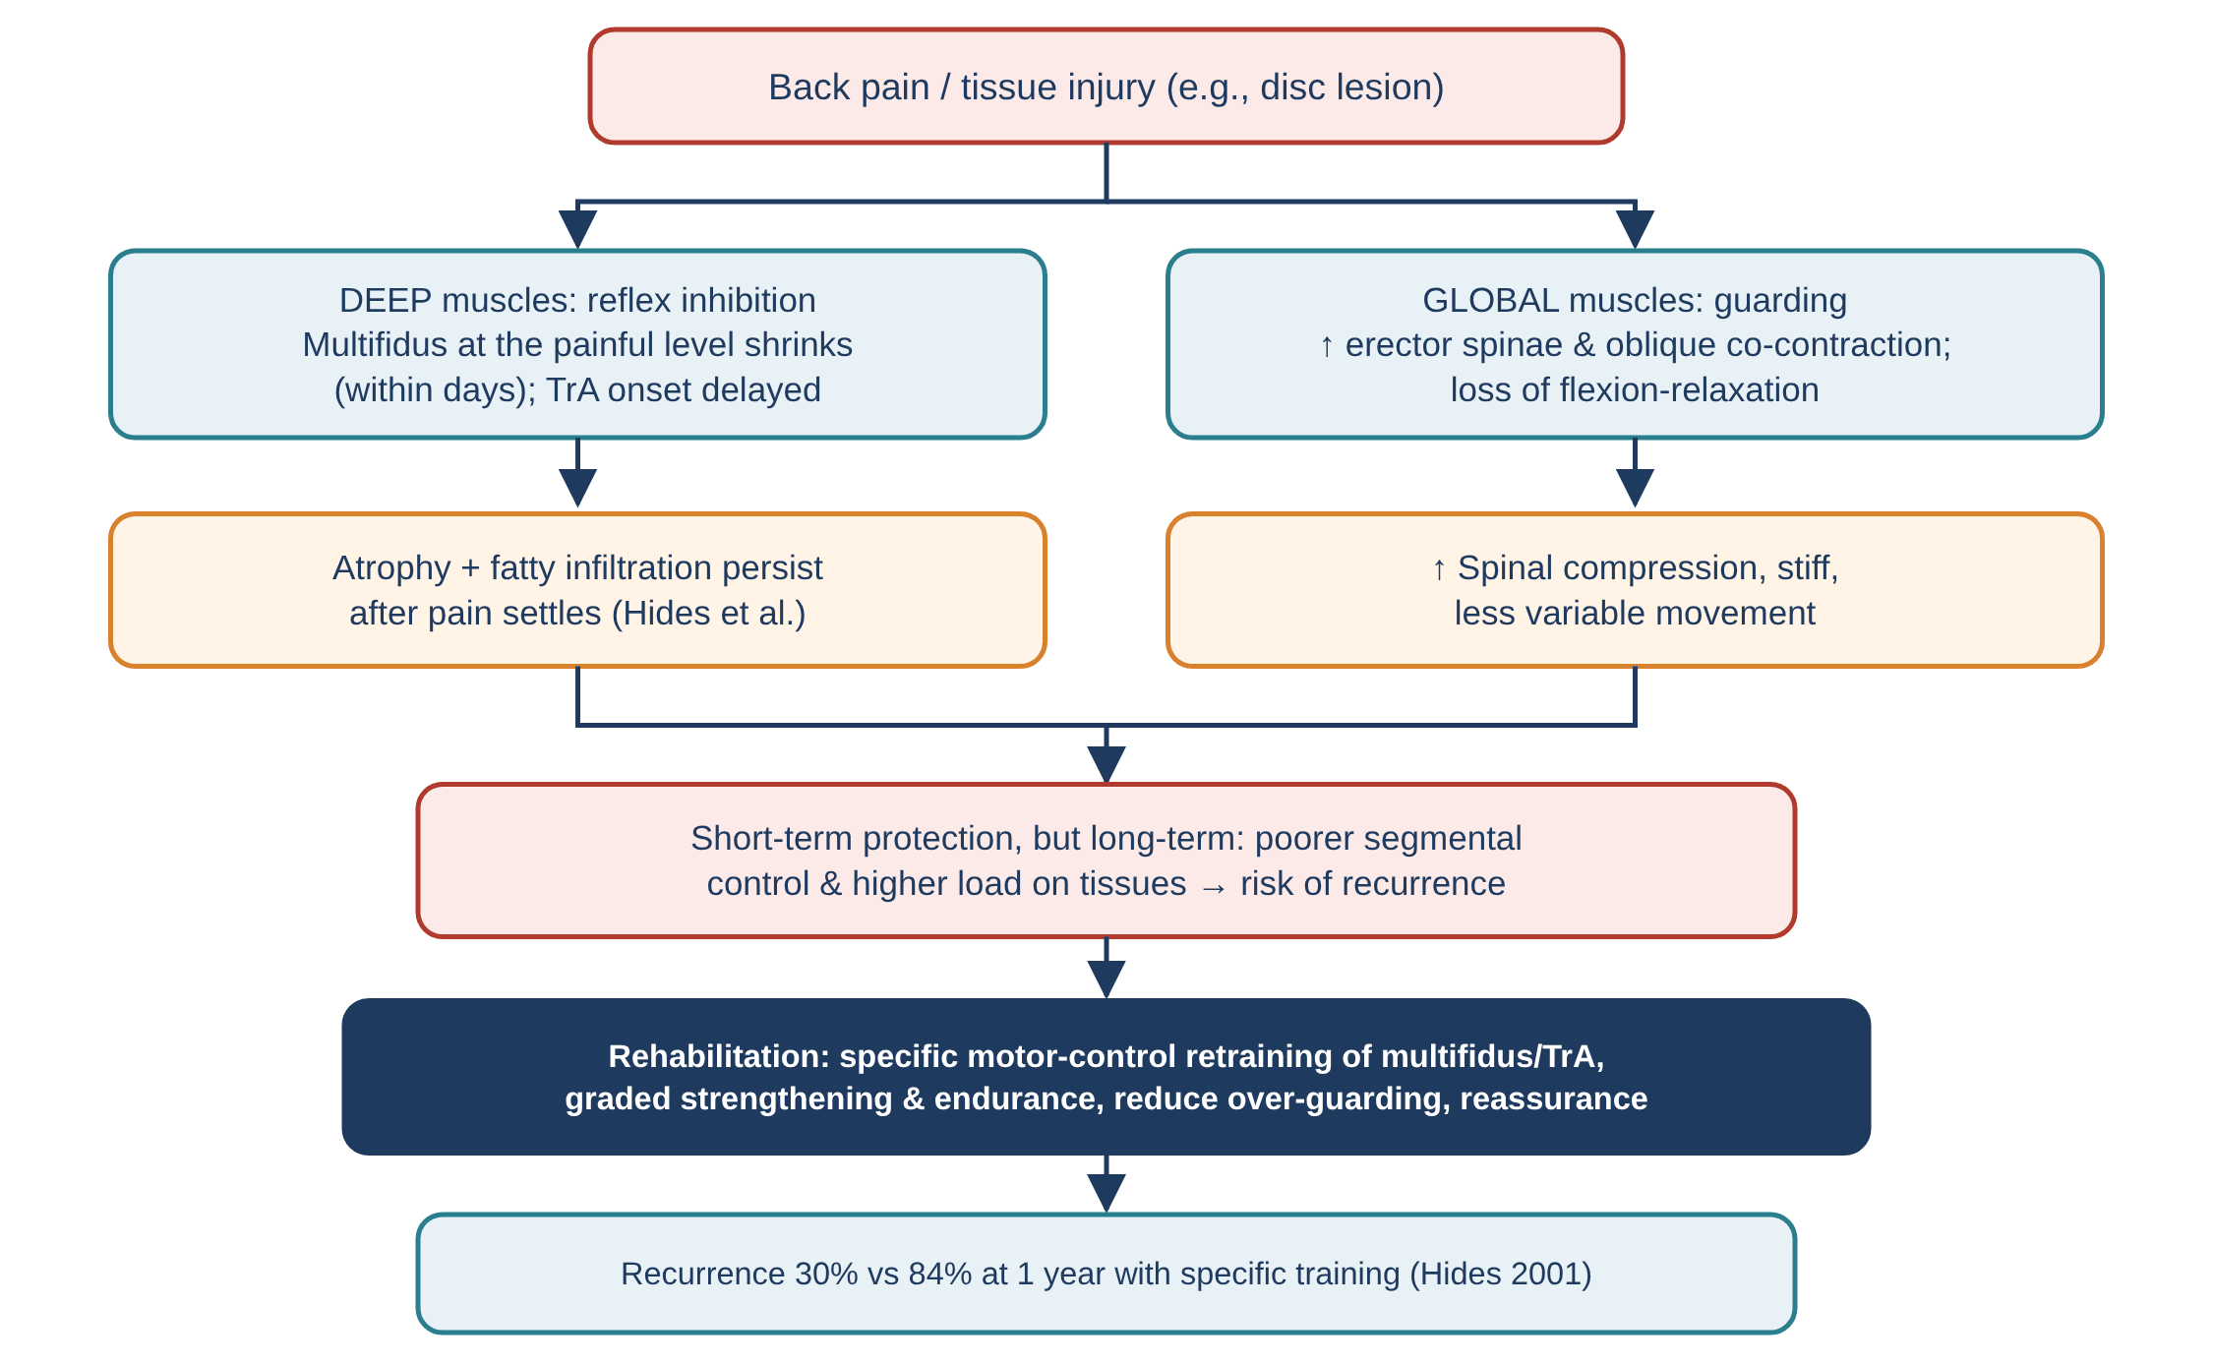
Figure 10. How pain changes trunk-muscle behaviour (from the companion document).

5. Superficial layer
These four muscles attach the upper limb to the axial skeleton. Their primary job is to move and stabilise the scapula and humerus, but because they arise from the spine they also transmit arm loads to the neck and thorax and influence posture.

5.1 Trapezius
Trapezius is a large, flat, diamond-shaped muscle (the two sides together) covering the back of the neck and upper thorax. Functionally it is three muscles — upper, middle and lower — with different directions of pull.
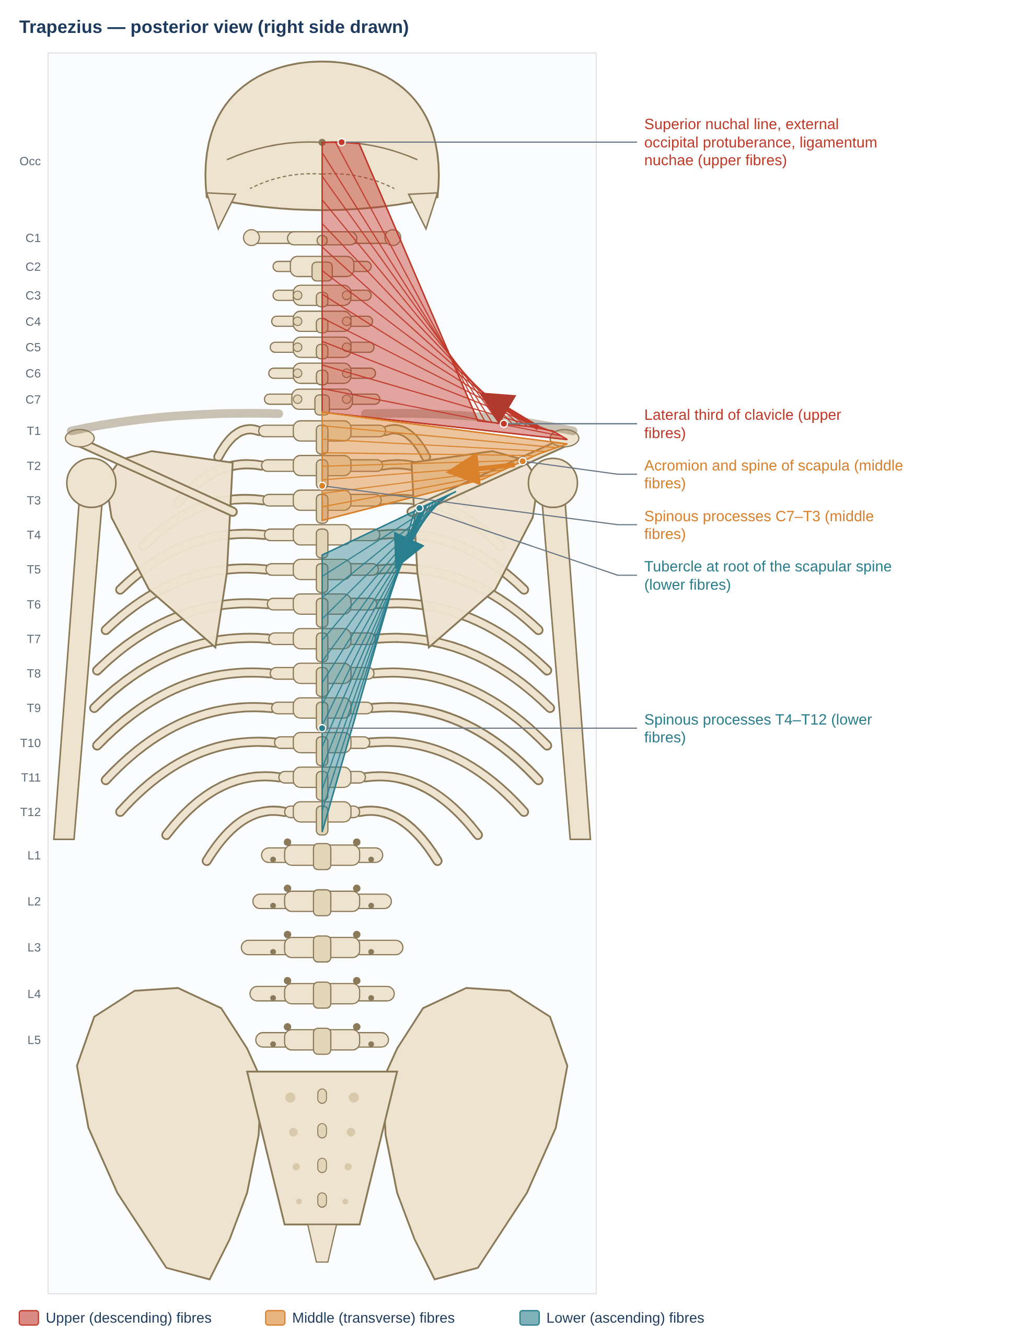
Figure 11. Trapezius. Schematic posterior view; dots mark attachments, arrows show the line of pull on the insertion.

Anatomy
Feature | Details
Upper (descending) part | Medial third of the superior nuchal line, external occipital protuberance and ligamentum nuchae → posterior border of the lateral third of the clavicle
Middle (transverse) part | Spinous processes and supraspinous ligaments of C7–T3 → medial margin of the acromion and superior lip of the spine of the scapula
Lower (ascending) part | Spinous processes of T4–T12 → tubercle at the medial end (root) of the scapular spine, via a triangular aponeurosis
Innervation | Motor: spinal accessory nerve (CN XI). Proprioceptive/sensory: ventral rami of C3–C4
Blood supply | Superficial branch of the transverse cervical artery (main); occipital artery; dorsal scapular artery; dorsal branches of posterior intercostal arteries
Relations | Most superficial muscle of the upper back; covers levator scapulae, rhomboids, splenius, semispinalis capitis and upper erector spinae; forms the posterior border of the posterior triangle of the neck
Fibre type | Mixed, with a slight predominance of type I fibres in the upper part — suited to sustained postural work

Mechanics
- Upper fibres: elevate the shoulder girdle and contribute to upward rotation of the scapula. Johnson et al. (1994) showed that most upper fibres arise from the lower ligamentum nuchae and C7 and run almost horizontally to the clavicle; rather than "lifting" the scapula vertically, they draw the clavicle backward and medially and rotate it upward about the sternoclavicular joint, carrying the scapula with it.
- Head and neck: acting bilaterally the upper fibres extend the head and neck; unilaterally they produce ipsilateral lateral flexion and contralateral rotation of the head.
- Middle fibres: retract (adduct) the scapula and stabilise it against protraction during pushing, pulling and arm elevation.
- Lower fibres: depress the scapula, contribute to upward rotation and posterior tilt, and are most active in elevation above about 90° — essential for full overhead reach.
- Upward-rotation force couple: upper trapezius (pulling the acromion/clavicle up and medially), lower trapezius (pulling the root of the spine down and medially) and serratus anterior (pulling the inferior angle laterally) together rotate the glenoid upward (Figure in Section 3).
- Load transfer to the neck: carrying loads in the hands or holding the arms forward (typing) requires upper-trapezius activity, which pulls on the ligamentum nuchae and cervical spinous processes — a direct mechanical link between arm work and neck loading.

Pathomechanics
Problem | Mechanism | Evidence / notes
Trapezius myalgia (work-related neck–shoulder pain) | Sustained low-level static activity keeps the same low-threshold motor units ("Cinderella units") continuously active; few rest pauses; mental stress raises activity | Hägg 1991 hypothesis; continuously active units recorded during prolonged computer work; fewer EMG "gaps" predicted myalgia (Veiersted et al. 1993)
Altered activation in chronic neck pain | Increased upper-trapezius activity during arm tasks and reduced ability to relax afterwards | Falla et al. 2004
Scapular dyskinesis and shoulder impingement | ↑ upper trapezius, ↓ serratus anterior, delayed middle/lower trapezius → reduced upward rotation, increased anterior tilt | Ludewig & Cook 2000; Cools et al. 2003; Kibler et al. 2013
Spinal accessory nerve palsy | Iatrogenic injury in the posterior triangle (lymph-node biopsy, neck dissection) or trauma → trapezius paralysis | Shoulder droop, lateral scapular winging that increases with abduction, weak overhead elevation, pain
Myofascial trigger points | The upper trapezius is the most commonly reported site; referral to the posterolateral neck, mastoid and temple | Travell & Simons; trigger-point diagnosis has limited reliability
Forward head / rounded shoulders | Upper trapezius and levator over-active; middle and lower trapezius lengthened and weak ("upper crossed" model) | Janda; links between posture and pain are weak

Clinical assessment and exercise
- Observation and scapular dyskinesis test: watch the scapulae during 5 weighted flexion/abduction repetitions for winging or dysrhythmia (McClure et al. 2009).
- Scapular assistance test: manually assisting upward rotation reduces painful arc → suggests scapular contribution.
- Muscle tests: resisted shrug (upper; CN XI), prone "T" (middle) and prone "Y" (lower) positions (Kendall).
- Exercises that favour middle/lower over upper trapezius: side-lying external rotation, side-lying forward flexion, prone horizontal abduction with external rotation and prone extension (Cools et al. 2007).
- Trapezius myalgia: specific strength training of neck–shoulder muscles reduced pain more than general fitness training (Andersen et al. 2008); add micro-pauses, task variation and forearm support.
- Severe CN XI palsy: nerve repair or, in chronic cases, muscle transfer (e.g., Eden–Lange transfer of levator scapulae and rhomboids).
Key point: Treat trapezius as three muscles. In neck–shoulder pain the usual problem is too much upper and too little lower/middle trapezius activity, and too little rest.

5.2 Latissimus dorsi
Latissimus dorsi ("broadest muscle of the back") is the only muscle that connects the upper limb directly to the spine and pelvis. It is a powerful arm mover with an indirect but important influence on the lumbar spine through the thoracolumbar fascia.
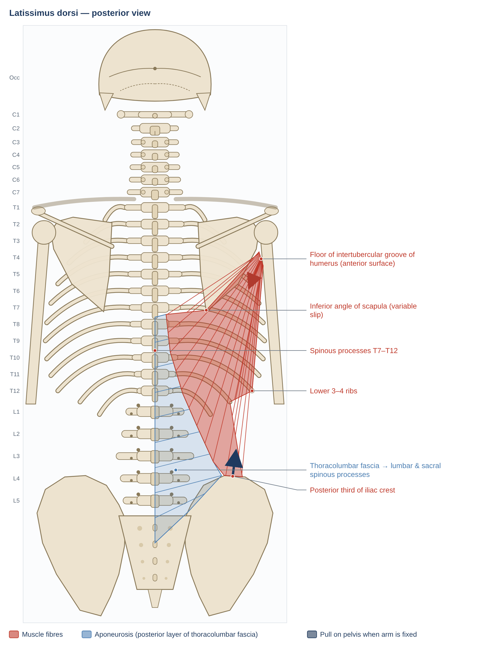
Figure 12. Latissimus dorsi. Schematic posterior view; dots mark attachments, arrows show the line of pull on the insertion.

Anatomy
Feature | Details
Origin | Spinous processes of T7–T12 and their supraspinous ligaments; via the posterior layer of the thoracolumbar fascia from the lumbar and sacral spinous processes; posterior third of the iliac crest; lower 3–4 ribs (interdigitating with external oblique); often a slip from the inferior angle of the scapula
Insertion | Floor of the intertubercular sulcus (groove) of the humerus. The tendon twists so that the lowest fibres insert highest
Innervation | Thoracodorsal nerve (C6–C8) from the posterior cord of the brachial plexus
Blood supply | Thoracodorsal artery (from the subscapular artery); dorsal branches of posterior intercostal and lumbar arteries
Relations | Covers the inferior angle of the scapula and the lower erector spinae; forms the posterior axillary fold with teres major; borders the lumbar (Petit) triangle and the triangle of auscultation
Architecture | Broad, thin, long fibres — large excursion suited to big arm movements

Mechanics
- At the shoulder: extension, adduction and internal rotation of the humerus; depression of the shoulder girdle. Key muscle in pulling, climbing, swimming and the acceleration phase of throwing.
- Arm fixed (closed chain): lifts the trunk towards the arms — pull-ups, crutch walking, wheelchair transfers. In people with paraplegia it can hike the pelvis for swing-through gait.
- Lumbar spine — two views: Bogduk, Johnson & Spalding (1998) showed that latissimus has small moment arms about the lumbar spine and contributes little extensor moment or compression; its main action is on the humerus. McGill (2016) emphasises that, by tensioning the thoracolumbar fascia, it adds stiffness during pulling and lifting. Both are consistent: it is a weak direct extensor but part of the fascial load-transfer system.
- Posterior oblique sling: latissimus and the opposite gluteus maximus tension the posterior layer of the thoracolumbar fascia in opposite directions, transferring load across the lumbar spine and compressing the sacroiliac joints (Vleeming et al. 1995).

Pathomechanics
Problem | Mechanism | Evidence / notes
Short / stiff latissimus (overhead athletes, lifters) | Limits shoulder flexion and external rotation → compensatory lumbar extension and anterior pelvic tilt during overhead reaching | Increases lumbar extension loading (facets, pars interarticularis) — relevant in gymnastics, swimming and weight-lifting
Tendon tear / avulsion | Eccentric overload in throwing | Rare; case series in professional baseball pitchers (Schickendantz et al. 2009)
Posterior oblique sling dysfunction | Poor coupling with the contralateral gluteus maximus → reduced SIJ force closure, altered arm swing | Vleeming et al. 1995 (mechanism); clinical model
Thoracodorsal nerve injury | Axillary surgery → weakness of extension, adduction and internal rotation | Functional loss often limited because of synergists (teres major, pectoralis major)
Rounded-shoulder posture | A short latissimus holds the humerus in internal rotation and depresses the shoulder girdle | Contributes to impingement-type mechanics in overhead work

Clinical assessment and exercise
- Length test: supine, knees bent, lumbar spine flat; raise both arms overhead close to the head. Inability to reach the table without arching the low back suggests a short latissimus (Kendall).
- Functional screen: overhead squat or wall-slide — watch for lumbar extension compensation.
- Strength: resisted extension–adduction–internal rotation.
- Exercise: pull-downs, rows, pull-ups; diagonal "sling" exercises combining a pull with the opposite hip extension; stretching with the pelvis held in posterior tilt.
Key point: Latissimus moves the arm but "borrows" the lumbar spine: when it is short, the low back extends to compensate.

5.3 Levator scapulae
Levator scapulae runs from the upper cervical transverse processes to the upper medial border of the scapula. Because it links the neck directly to the scapula, scapular position changes neck loading — and vice versa.
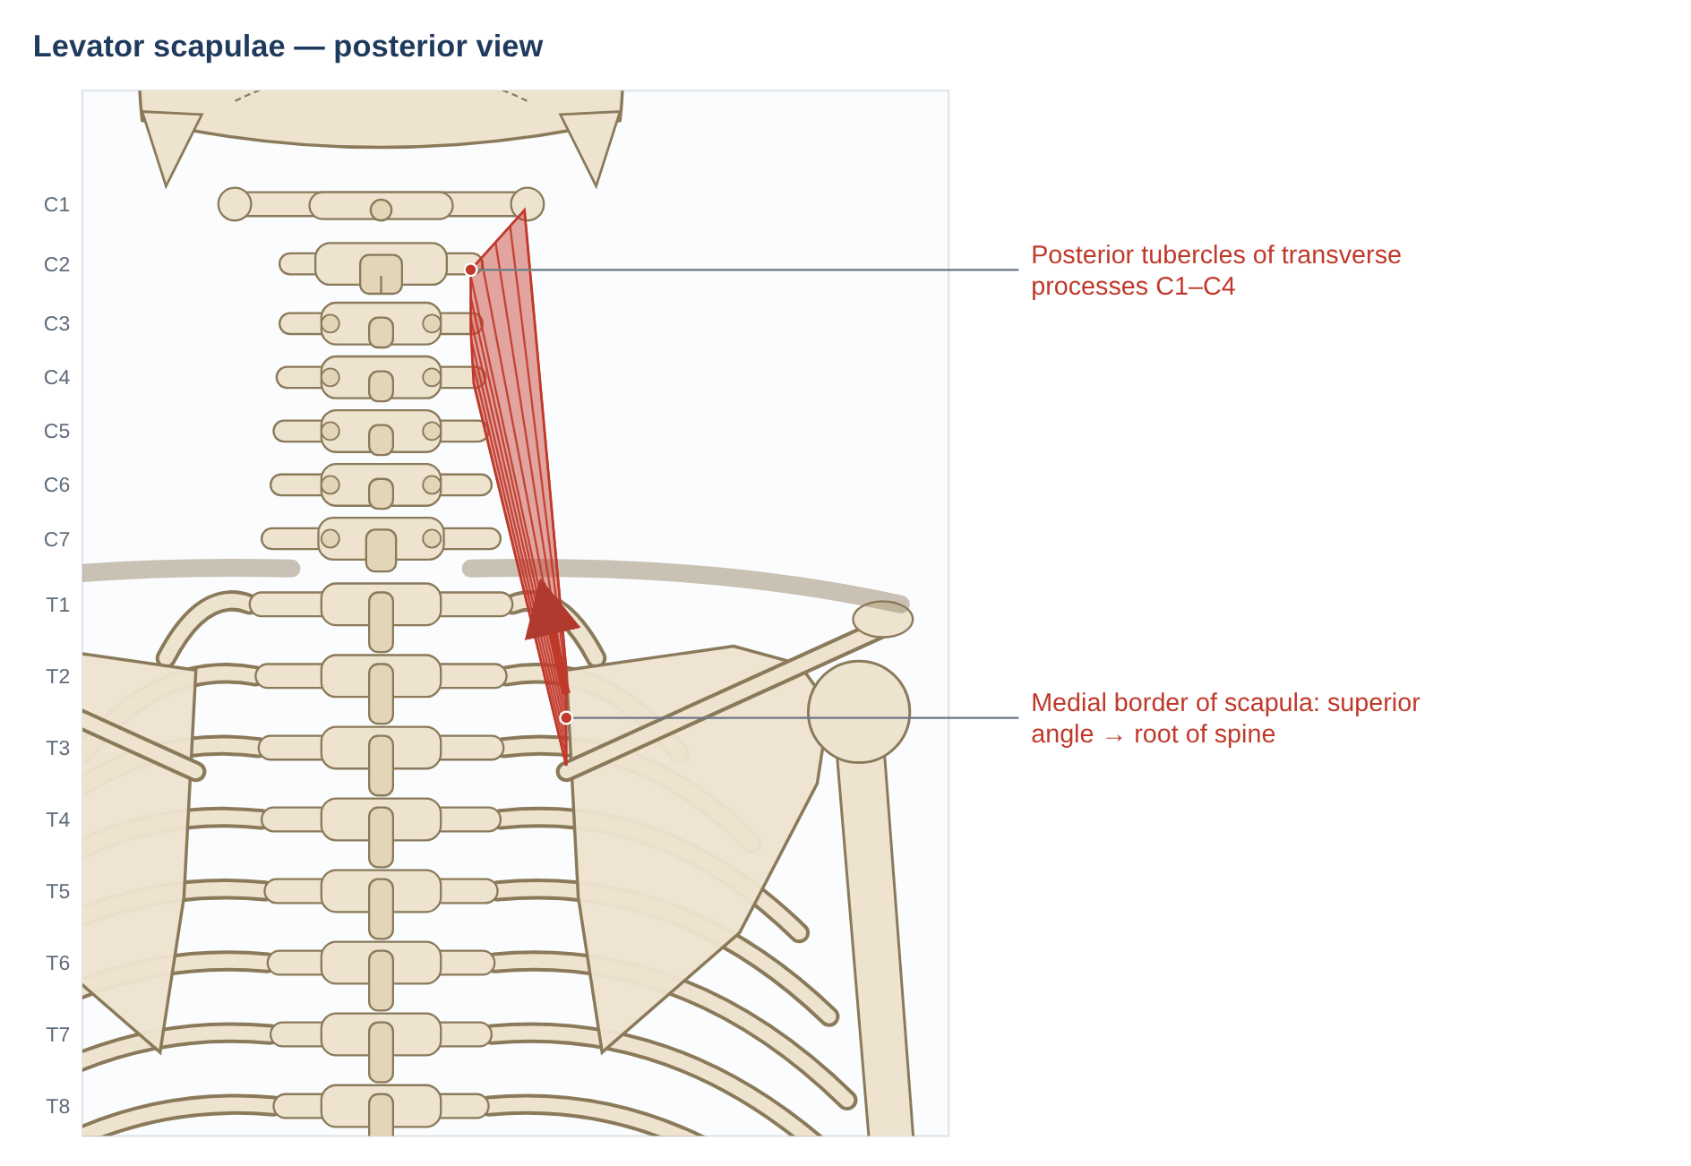
Figure 13. Levator scapulae. Schematic posterior view; dots mark attachments, arrows show the line of pull on the insertion.

Anatomy
Feature | Details
Origin | Posterior tubercles of the transverse processes of C1–C4
Insertion | Medial border of the scapula, from the superior angle to the root of the spine
Innervation | Dorsal scapular nerve (C5) and direct branches of the ventral rami of C3–C4
Blood supply | Dorsal scapular, transverse cervical and ascending cervical arteries
Relations | Upper part deep to SCM, lower part deep to trapezius; lies in the floor of the posterior triangle between splenius (medially) and the scalenes (anteriorly)

Mechanics
- Neck fixed: elevates the scapula and rotates it downward (glenoid turns down), together with the rhomboids and pectoralis minor (downward-rotation force couple).
- Scapula fixed: ipsilateral lateral flexion and ipsilateral rotation of the cervical spine; bilaterally it assists extension.
- Eccentric control: it lengthens and controls the scapula during upward rotation (arm elevation).
- Load transmission: arm loads that depress or downward-rotate the scapula stretch levator scapulae and transmit tension to C1–C4. It has been proposed that this increases compression and shear in the upper cervical spine during arm activities.

Pathomechanics
Problem | Mechanism | Evidence / notes
Acute "stiff neck" / levator scapulae syndrome | Painful spasm; pain at the angle of the neck and superior angle of the scapula; rotation to the opposite side is limited and painful | Clinical; often after sleeping awkwardly or sustained neck rotation (e.g., a side-placed monitor)
Scapular downward-rotation syndrome | A depressed, downward-rotated scapula keeps levator under tension → neck pain with arm use | Sahrmann 2002 (movement-system model)
Superior-angle pain (scapulocostal region) | Insertional overload; bursitis between the superior angle and the ribs | Clinical
Upper crossed pattern | Short, over-active levator with upper trapezius | Janda; limited evidence
Myofascial pain | Trigger points refer to the angle of the neck and along the medial border of the scapula | Travell & Simons

Clinical assessment and exercise
- Palpation: at the superior angle and in the posterior triangle.
- Length test: cervical flexion + contralateral side-flexion + contralateral rotation, with the scapula held depressed.
- Scapular position: look for downward rotation (inferior angle closer to the spine than the superior angle).
- Management: stretching, scapular upward-rotation training (serratus anterior, lower trapezius), central monitor placement and forearm support to reduce static load.
Key point: If the scapula sits low and downward-rotated, levator scapulae is under constant tension — fix the scapula as well as the neck.

5.4 Rhomboid major and minor
The rhomboids lie deep to trapezius and run obliquely downward and laterally from the spinous processes to the medial border of the scapula.
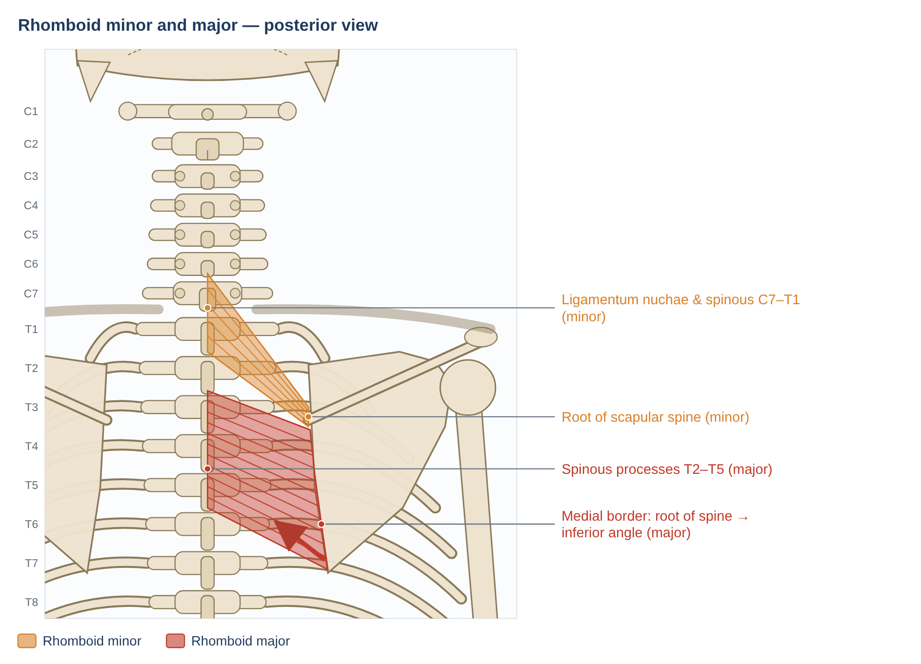
Figure 14. Rhomboid minor and major. Schematic posterior view; dots mark attachments, arrows show the line of pull on the insertion.

Anatomy
Feature | Details
Rhomboid minor | Lower ligamentum nuchae and spinous processes of C7–T1 → medial border of the scapula at the root of the spine
Rhomboid major | Spinous processes and supraspinous ligaments of T2–T5 → medial border from the root of the spine to the inferior angle
Innervation | Dorsal scapular nerve (C4–C5, mainly C5)
Blood supply | Dorsal scapular artery (deep branch of the transverse cervical artery)
Relations | Deep to trapezius; superficial to serratus posterior superior and erector spinae; bounds the triangle of auscultation

Mechanics
- Retraction (adduction) of the scapula; downward rotation; slight elevation.
- Stabilisation: the rhomboids and serratus anterior pull the medial border in opposite directions, holding it against the chest wall while the arm moves.
- Eccentric control of protraction in the follow-through of throwing and in pushing.
- Thoracic posture: by retracting the scapulae they help resist rounded-shoulder posture, but they do not act on the spine directly to any great extent.

Pathomechanics
Problem | Mechanism | Evidence / notes
Interscapular pain in desk workers | Frequently referred from the lower cervical discs or facets (C4–C7) rather than arising in the rhomboids | Cloward 1959 (discogenic referral to the interscapular region) — always examine the neck
Weak, lengthened rhomboids | Sustained protraction with a short pectoralis minor; poor retraction endurance | Clinical model (Kendall, Janda)
Dorsal scapular nerve entrapment | Compression as the nerve passes through scalenus medius → interscapular pain, rhomboid and levator weakness, subtle winging | Case reports/series; confirmed by EMG
Muscle strain | Eccentric overload in throwing deceleration, rowing or heavy pulling | Local pain along the medial border; painful resisted retraction
Myofascial pain | Referral along the medial border of the scapula | Travell & Simons

Clinical assessment and exercise
- Rhomboid test: prone, hand on the low back, lift the hand off the back (retraction + downward rotation) and resist (Kendall).
- Observation: distance of the medial border from the spinous processes; medial-border prominence.
- Exercise: rows, prone retraction, scapular setting; combine with pectoralis minor stretching.
Key point: Interscapular pain is often "rhomboid pain" that comes from the neck.

6. Intermediate layer: serratus posterior
The two serratus posterior muscles are thin, partly aponeurotic sheets between the spinous processes and the ribs. They are classically described as respiratory muscles, but this role is questioned.

6.1 Serratus posterior superior
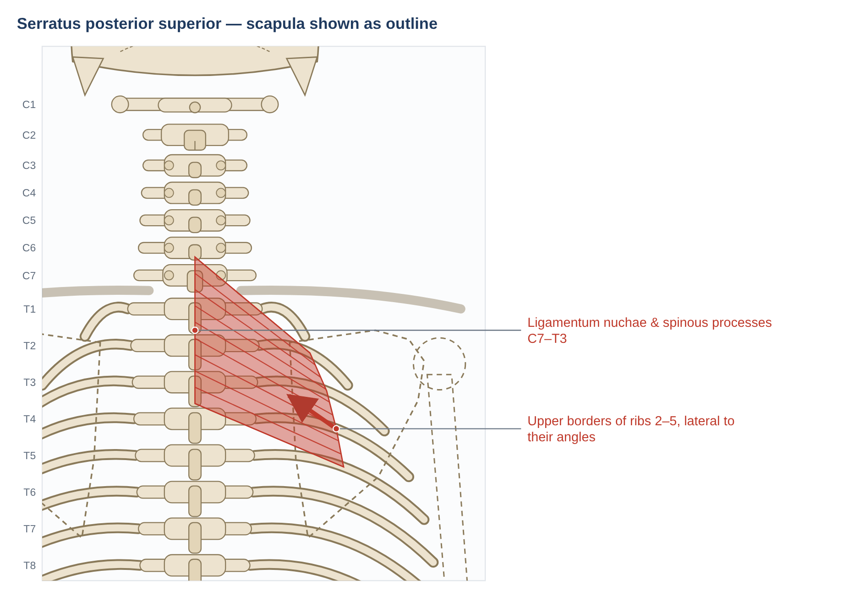
Figure 15. Serratus posterior superior (scapula and humerus shown as dashed outlines because the muscle lies beneath them). Schematic posterior view; dots mark attachments, arrows show the line of pull on the insertion.

Anatomy
Feature | Details
Origin | Lower ligamentum nuchae and spinous processes of C7–T3 (variable C6–T2) with their supraspinous ligaments
Insertion | Upper borders and outer surfaces of ribs 2–5, lateral to their angles
Innervation | Intercostal nerves T2–T5 (ventral rami)
Blood supply | Posterior intercostal arteries
Relations | Deep to the rhomboids, levator scapulae and trapezius; superficial to splenius and erector spinae; lies under the upper medial part of the scapula

Mechanics
- Classical view: elevates ribs 2–5, assisting inspiration.
- Current view: Vilensky et al. (2001) found no electromyographic evidence for a respiratory role and suggested the muscle may serve mainly a proprioceptive function; Loukas et al. (2008) found no morphometric differences in people with chronic obstructive pulmonary disease, also arguing against a respiratory role.
- Being thin and partly aponeurotic, the force it can produce is small.

Pathomechanics
Problem | Mechanism | Evidence / notes
Serratus posterior superior myofascial pain syndrome | Deep ache beneath the upper scapula with referral to the posterior shoulder, back of the arm, ulnar forearm and little finger | Travell & Simons; case reports. Mimics C7–C8 radiculopathy and thoracic outlet syndrome
Hidden trigger area | The tender area lies under the scapula and can only be palpated when the scapula is protracted | Clinical

Clinical assessment and exercise
- Palpation: with the arm across the chest (scapula abducted) to expose the muscle.
- Differential diagnosis: neurological examination for C7–C8 radiculopathy; thoracic outlet tests.
- Management: soft-tissue techniques, scapular mobility; injection has been described in case reports.
Key point: A little-known source of deep interscapular and arm pain — but exclude the neck first.

6.2 Serratus posterior inferior
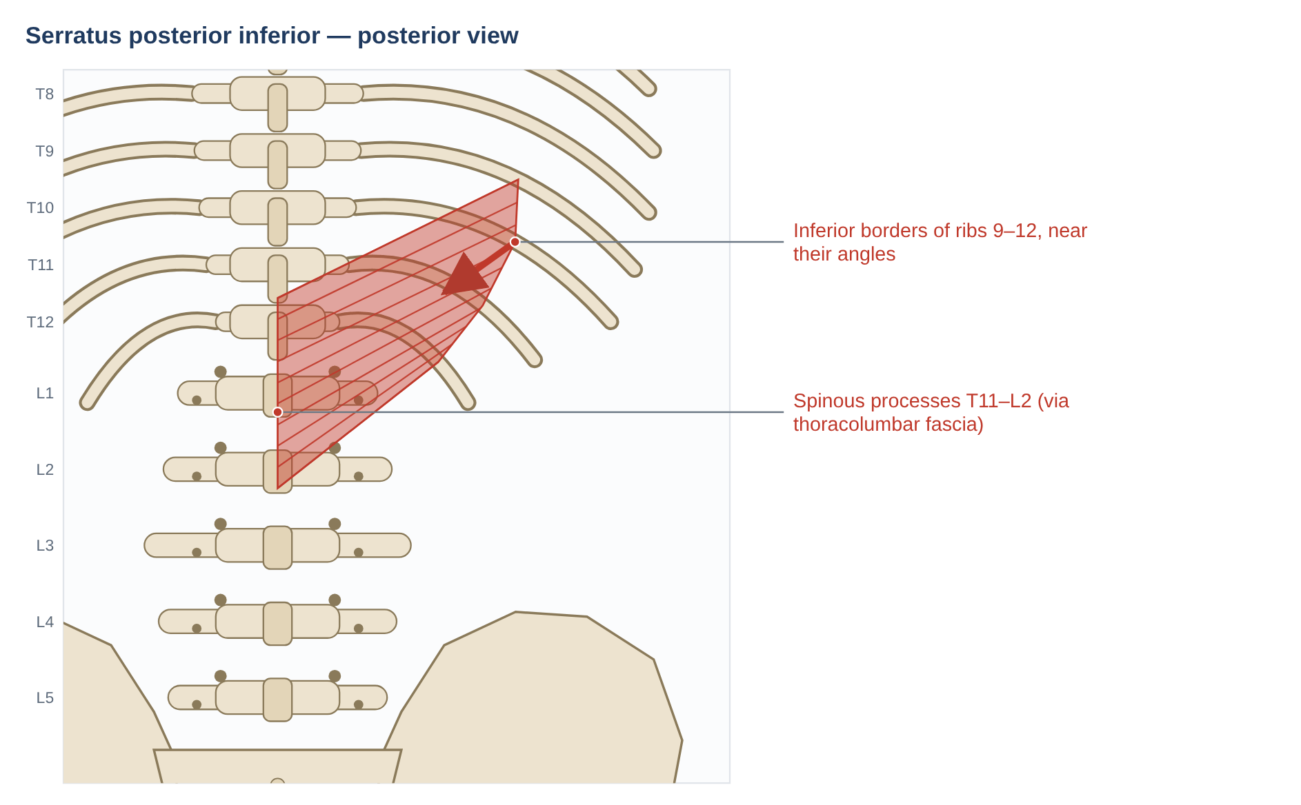
Figure 16. Serratus posterior inferior. Schematic posterior view; dots mark attachments, arrows show the line of pull on the insertion.

Anatomy
Feature | Details
Origin | Spinous processes of T11–L2 via the thoracolumbar fascia
Insertion | Inferior borders of ribs 9–12 near their angles
Innervation | Ventral rami of T9–T12 (intercostal and subcostal nerves)
Blood supply | Posterior intercostal, subcostal and lumbar arteries
Relations | Deep to latissimus dorsi; superficial to erector spinae; its aponeurosis blends with the thoracolumbar fascia

Mechanics
- Classical view: draws the lower ribs downward and backward, steadying them against the pull of the diaphragm (forced expiration).
- Current view: as for the superior muscle, there is little EMG support for a respiratory role; a proprioceptive role and a contribution to thoracolumbar-fascia tension have been proposed (Vilensky et al. 2001).

Pathomechanics
Problem | Mechanism | Evidence / notes
Myofascial pain at the thoracolumbar junction | Nagging ache over the lower ribs, often after exertion | Travell & Simons; limited evidence
Mimic of visceral pain | Pain over ribs 9–12 can be confused with renal pain | Always exclude visceral causes
Lower-rib dysfunction | Painful rib movement with breathing or rotation | Clinical

Clinical assessment and exercise
- Palpation over ribs 9–12 near their angles, lateral to the erector spinae.
- Screen for renal or visceral pathology.
- Management: soft-tissue techniques, thoracic rotation mobility, breathing exercises.
Key point: Small and weak; clinically relevant mainly as a pain source at the thoracolumbar junction.

7. Spinotransversales: splenius
The splenius muscles ("bandage" muscles) wrap obliquely around the deeper neck muscles, running up and laterally from the spinous processes to the skull and upper cervical transverse processes.
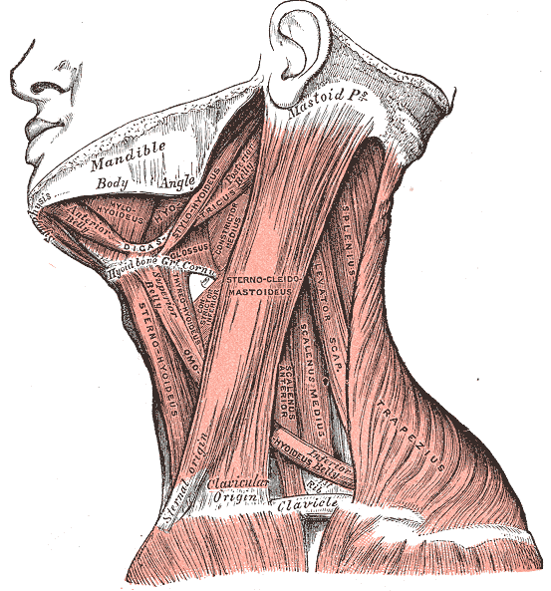
Figure 17. Muscles of the side of the neck: splenius capitis appears in the floor of the posterior triangle between sternocleidomastoid and trapezius, with levator scapulae and the scalenes. (Gray's Anatomy, 1918 — public domain, via Wikimedia Commons.)

7.1 Splenius capitis
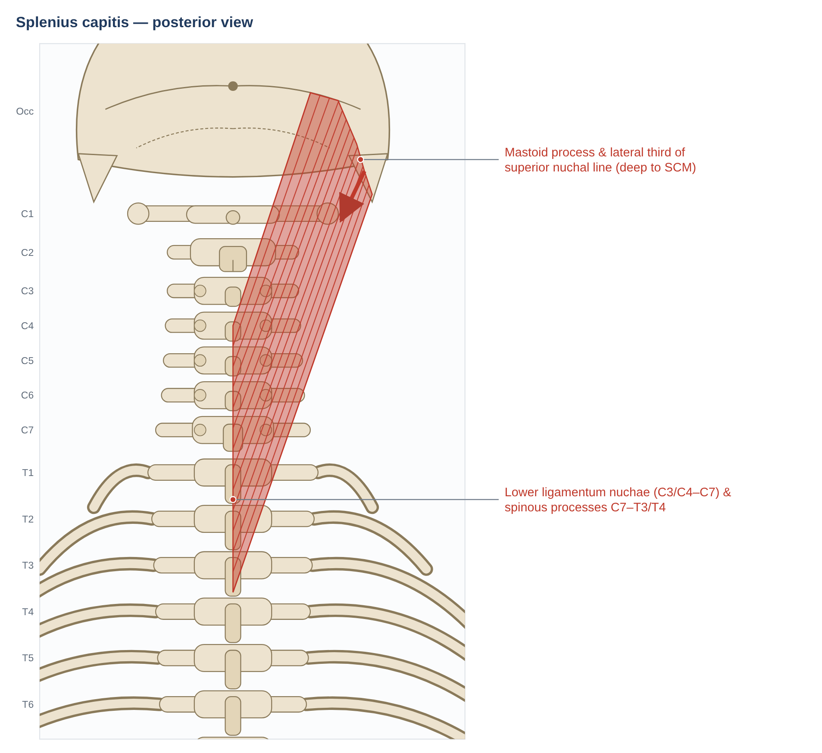
Figure 18. Splenius capitis. Schematic posterior view; dots mark attachments, arrows show the line of pull on the insertion.

Anatomy
Feature | Details
Origin | Lower half of the ligamentum nuchae (C3/C4–C7) and spinous processes of C7–T3/T4
Insertion | Mastoid process and lateral third of the superior nuchal line, deep to sternocleidomastoid
Innervation | Lateral branches of the dorsal rami of the middle cervical nerves
Blood supply | Occipital, transverse cervical and deep cervical arteries
Relations | Deep to trapezius, SCM, rhomboids and serratus posterior superior; superficial to semispinalis capitis and longissimus capitis; forms part of the floor of the posterior triangle

Mechanics
- Bilateral: extends the head and neck and resists flexion.
- Unilateral: lateral flexion and ipsilateral rotation of the head. Because it inserts far laterally (mastoid), it has a large moment arm for axial rotation and works with the contralateral sternocleidomastoid to turn the head.
- EMG studies show it is strongly active in ipsilateral rotation and extension — a prime rotator of the head.
- In forward-head posture it works continuously to hold the head up (Section 3).

Pathomechanics
Problem | Mechanism | Evidence / notes
Cervical dystonia (spasmodic torticollis) | Involuntary over-activity; in rotational torticollis the ipsilateral splenius capitis and contralateral SCM turn the head | Common target for botulinum-toxin injection
Whiplash | Rapid eccentric stretch at impact, then guarding; fatty infiltration of cervical extensors in chronic whiplash | Elliott et al. 2006
Forward head posture | Sustained high extensor demand from the head's weight | Biomechanical; posture–pain links are weak
Myofascial pain / headache | Trigger points refer to the vertex (top of the head) | Travell & Simons
Acute wry neck | Painful spasm limiting rotation | Clinical

Clinical assessment and exercise
- Palpation: in the posterior triangle between SCM and trapezius during resisted ipsilateral rotation.
- Neck extensor endurance testing.
- Management: endurance training of neck extensors, stretching, posture and workstation changes; botulinum toxin for dystonia.
Key point: Splenius capitis turns the head to its own side, partnering the opposite sternocleidomastoid.

7.2 Splenius cervicis
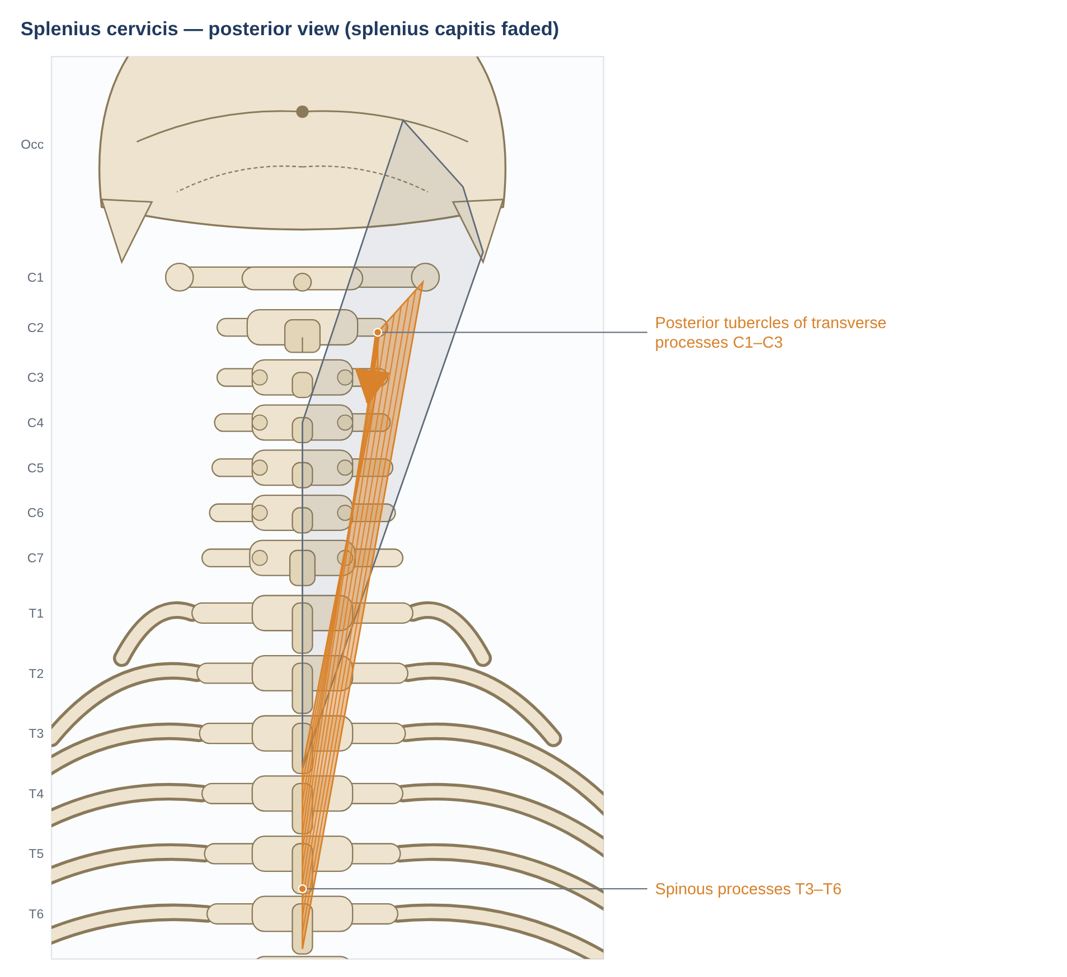
Figure 19. Splenius cervicis (splenius capitis shown faded). Schematic posterior view; dots mark attachments, arrows show the line of pull on the insertion.

Anatomy
Feature | Details
Origin | Spinous processes of T3–T6
Insertion | Posterior tubercles of the transverse processes of C1–C3 (C2–C3)
Innervation | Lateral branches of the dorsal rami of the lower cervical nerves
Blood supply | Deep cervical and transverse cervical arteries; posterior intercostal branches
Relations | Lateral and inferior to splenius capitis; shares the upper cervical transverse-process insertion zone with levator scapulae and longissimus cervicis

Mechanics
- Bilateral: extends the cervical spine.
- Unilateral: lateral flexion and ipsilateral rotation of the neck; its attachment to the atlas lets it rotate C1 on C2.
- Its long lever from the upper thorax makes it effective in controlling the upper cervical spine during trunk movements.

Pathomechanics
Problem | Mechanism | Evidence / notes
Neck pain and stiffness with rotation | Over-activity or guarding of upper-cervical rotators | Clinical
Cervical dystonia | Contributes to rotational and lateral-flexion patterns | Botulinum-toxin target in some patterns
Myofascial pain | Referral toward the occiput and behind the eye | Travell & Simons

Clinical assessment and exercise
- Palpation lateral to the cervical spinous processes, deep to trapezius and levator.
- Management: as for splenius capitis.
Key point: Together with levator scapulae and longissimus cervicis, splenius cervicis makes the upper cervical transverse processes a busy attachment zone — a common site of tenderness.

8. Erector spinae
The erector spinae is a large mass of muscle in three columns on each side of the spine: iliocostalis laterally, longissimus in the middle and spinalis medially. Inferiorly the columns share a thick tendon, the erector spinae aponeurosis, attached to the sacrum, iliac crest and lumbar spinous processes. Bogduk (1980) showed that in the lumbar region each column has separate lumbar and thoracic parts with different mechanics.
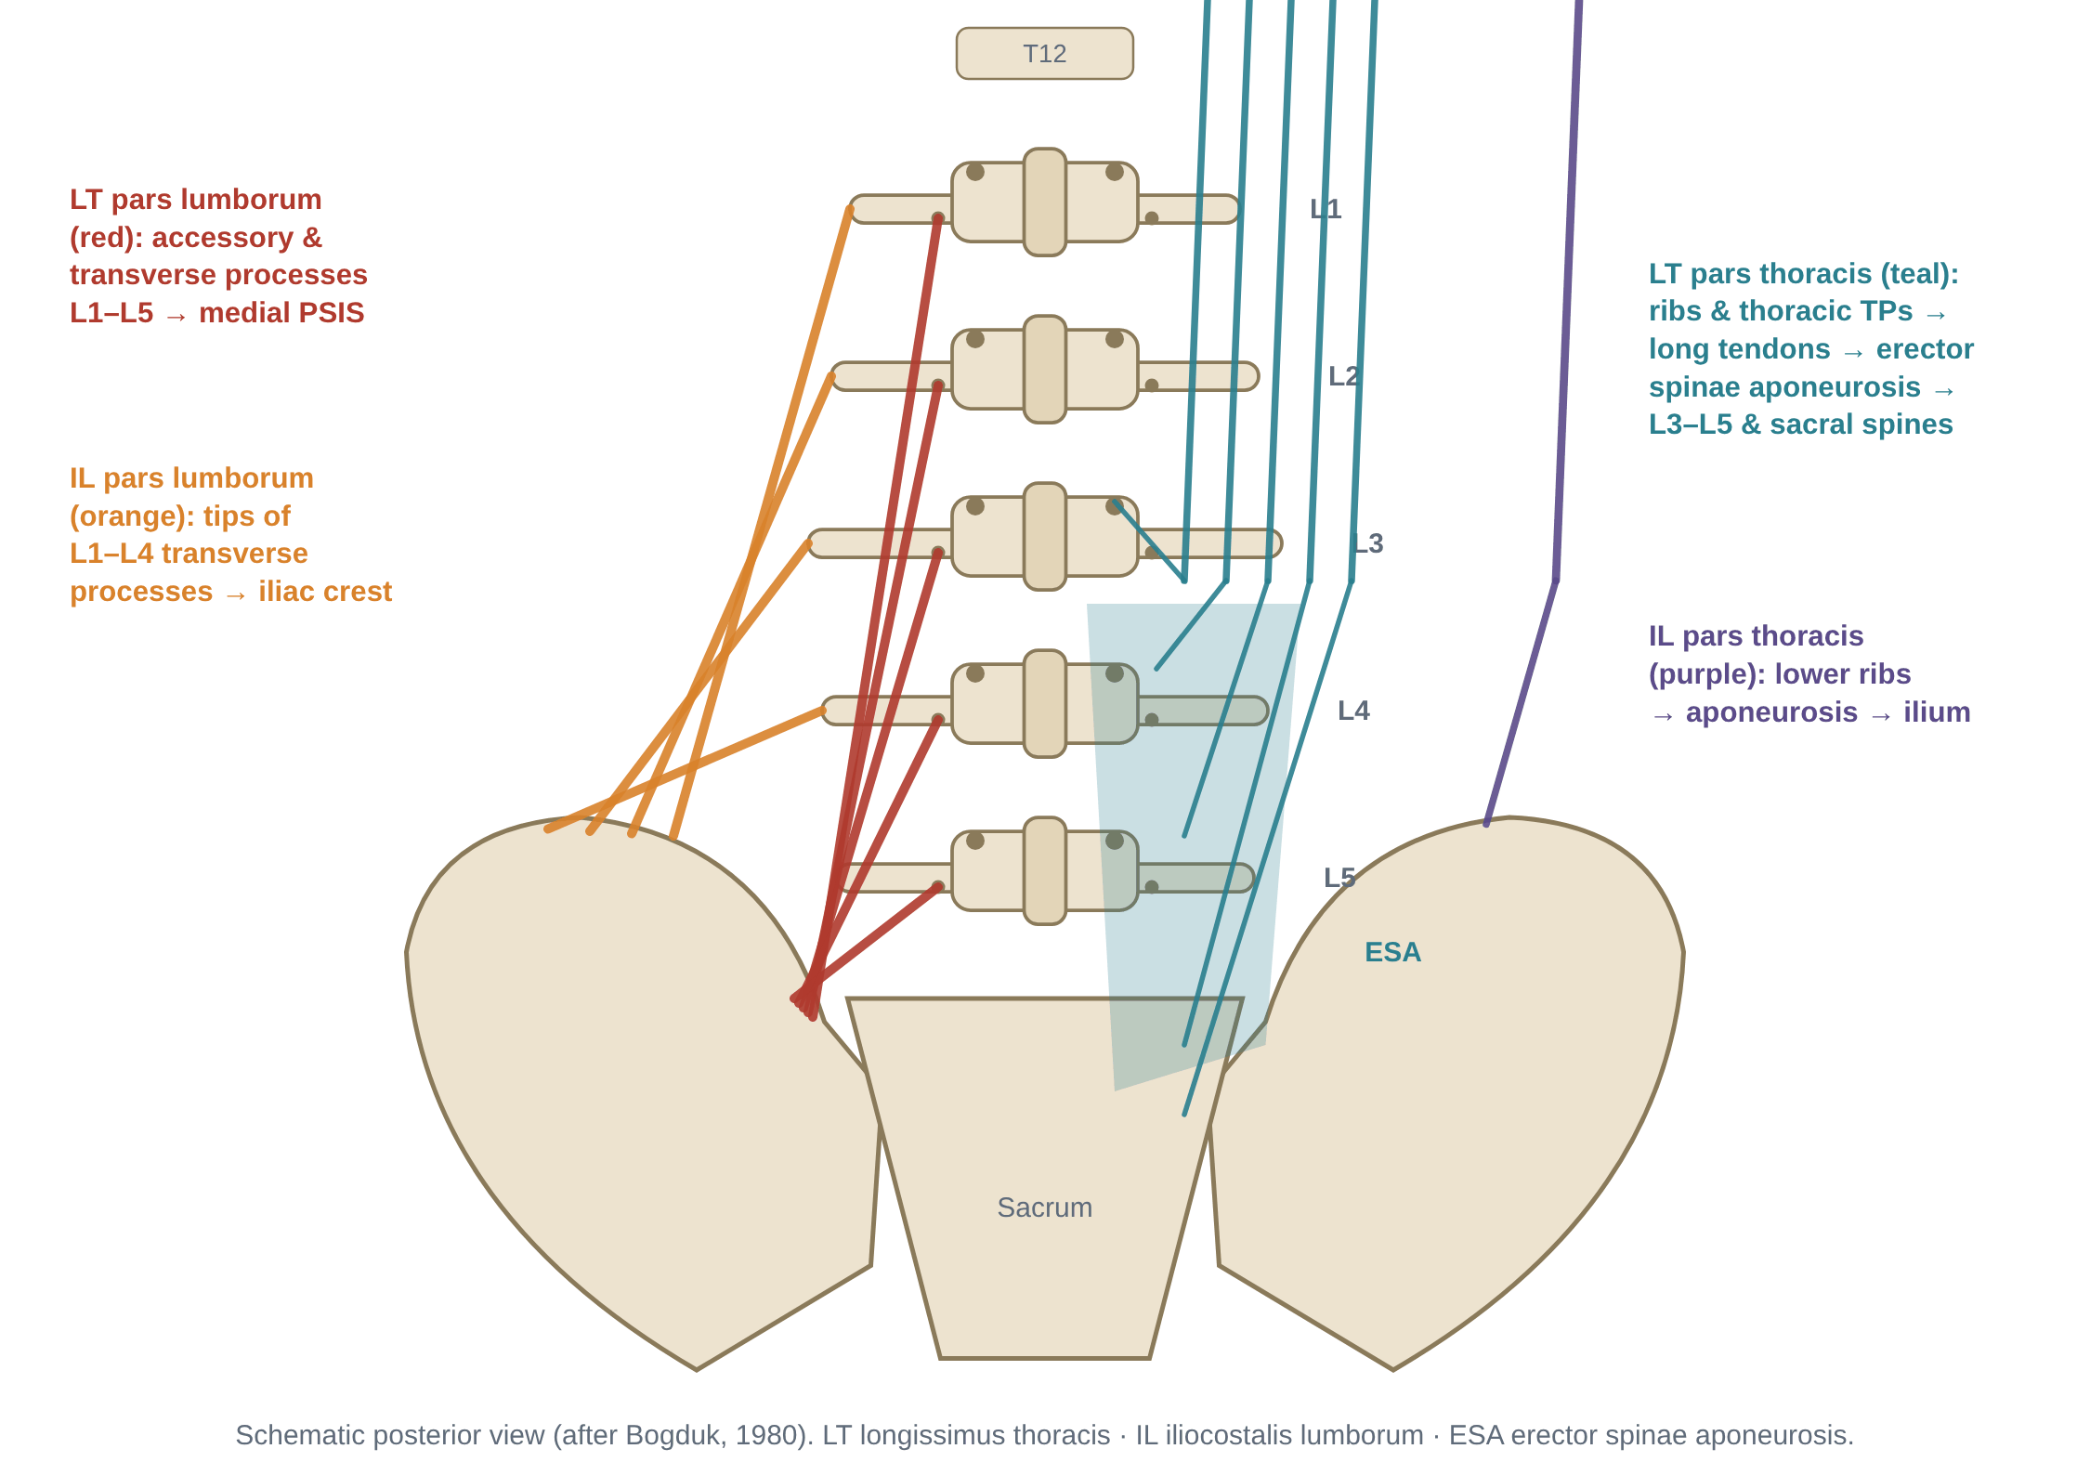
Figure 20. Fascicular anatomy of the lumbar erector spinae (after Bogduk 1980; from the companion document).
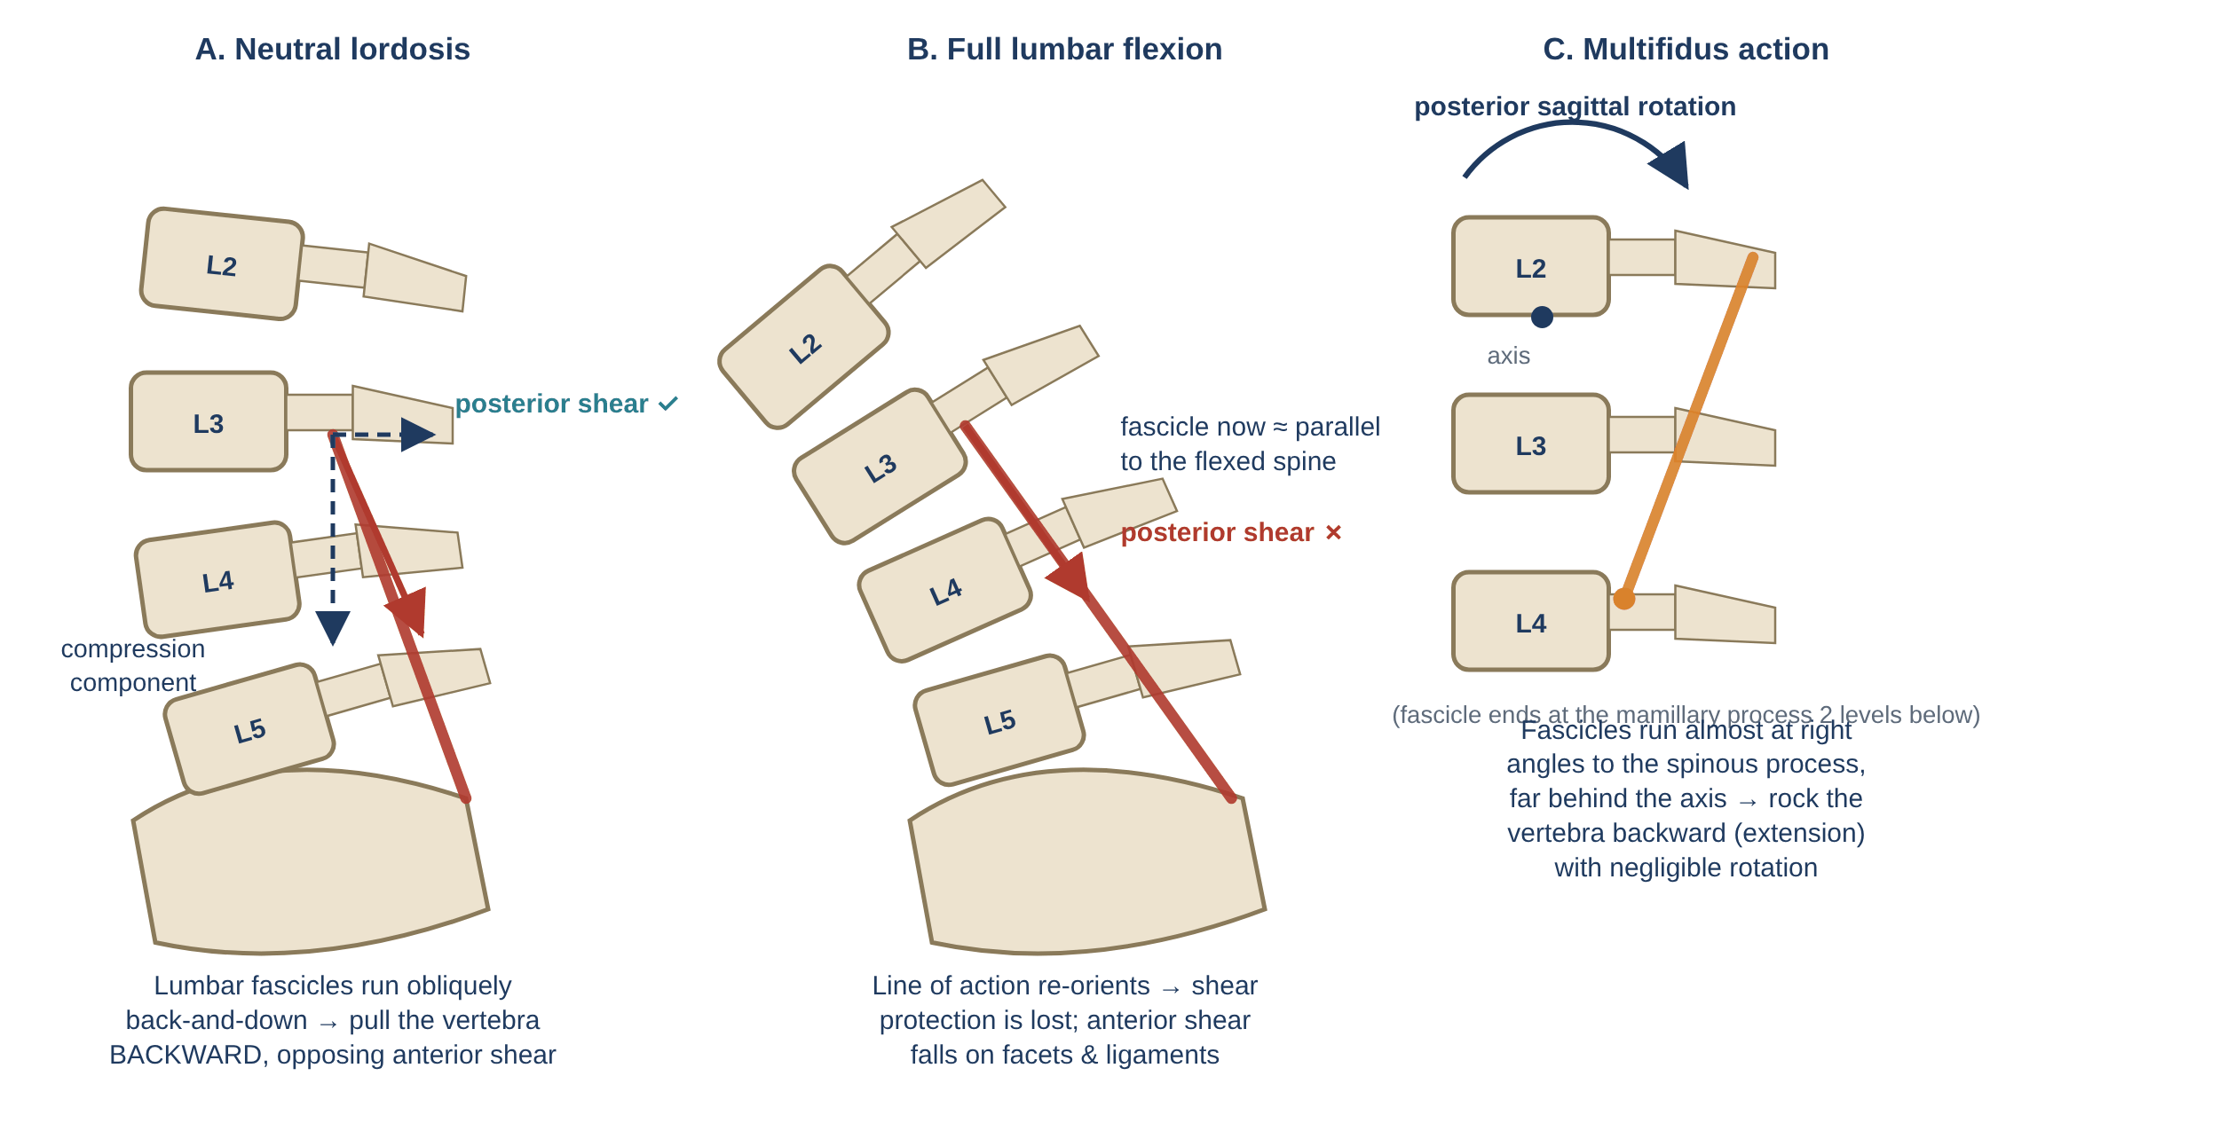
Figure 21. Lines of action of the lumbar erector spinae and multifidus (from the companion document).

8.1 Iliocostalis (lumborum, thoracis, cervicis)
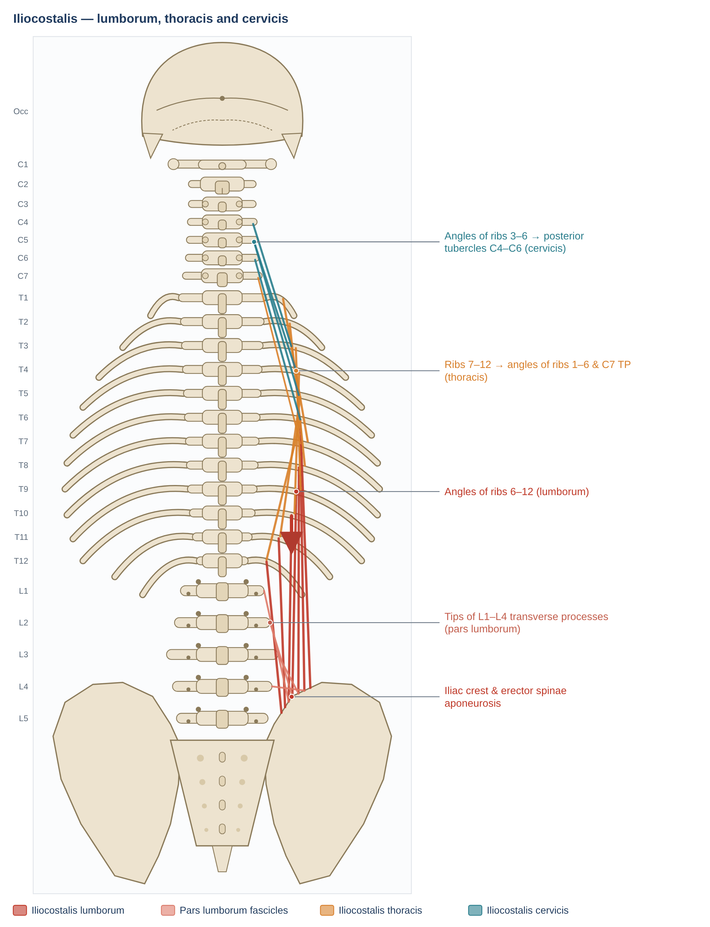
Figure 22. Iliocostalis: the lateral column of erector spinae. Schematic posterior view; dots mark attachments, arrows show the line of pull on the insertion.

Anatomy
Feature | Details
Iliocostalis lumborum | Iliac crest, sacrum and erector spinae aponeurosis → inferior borders of the angles of ribs 6/7–12. Bogduk's pars lumborum: tips of the L1–L4 transverse processes and middle layer of the thoracolumbar fascia → iliac crest
Iliocostalis thoracis | Upper borders of the angles of ribs 7–12 → angles of ribs 1–6 and the transverse process of C7
Iliocostalis cervicis | Angles of ribs 3–6 → posterior tubercles of the transverse processes of C4–C6
Innervation | Lateral branches of the dorsal rami of the corresponding spinal nerves
Blood supply | Lumbar, subcostal and posterior intercostal arteries; deep cervical and vertebral branches in the neck
Relations | Most lateral column; lies on the rib angles; covered by serratus posterior, latissimus dorsi and the thoracolumbar fascia

Mechanics
- Largest lateral lever of the erector spinae (it lies furthest from the midline): strong lateral flexion of the trunk and neck when acting on one side.
- Extension: bilaterally it extends the lumbar, thoracic and lower cervical spine and controls flexion eccentrically.
- Lumbar part: its oblique fascicles pull the lumbar vertebrae backward (posterior shear), as for longissimus pars lumborum (Bogduk 1980; Macintosh & Bogduk 1991).
- Thoracic part: spans the lumbar spine like a bowstring from the ribs to the pelvis, increasing lordosis; acting on one side it helps "derotate" the trunk.
- Ribs: with the spine fixed it can depress the ribs (forced expiration).

Pathomechanics
Problem | Mechanism | Evidence / notes
Guarding, loss of flexion-relaxation, early fatigue | Typical erector spinae response to back pain | van Dieën 2003; Colloca & Hinrichs 2005; Roy et al. 1989
Acute lumbar list / lateral shift | Asymmetric spasm of the lateral column | Clinical
Adolescent idiopathic scoliosis | Paraspinal EMG is often higher on the convex side at the apex; cause and effect are unresolved | Paraspinal EMG and biopsy studies
Thoracic hyperkyphosis with osteoporosis | Weak thoracic extensors allow increasing kyphosis and anterior vertebral loading | Sinaki et al. 2002 (Flowchart 6)
Myofascial pain | Lumbar part refers to the buttock; thoracic part to the scapular region and chest wall | Travell & Simons

Clinical assessment and exercise
- Biering-Sørensen test (extensor endurance).
- Lateral flexion endurance — side-bridge or side-lying trunk raise.
- Palpation of the lateral column over the rib angles.
- Exercise: back extension, bird-dog, side bridge, suitcase carry.
Key point: The lateral column gives the erector spinae its side-bending power and much of its lateral stability.

8.2 Longissimus (thoracis, cervicis, capitis)
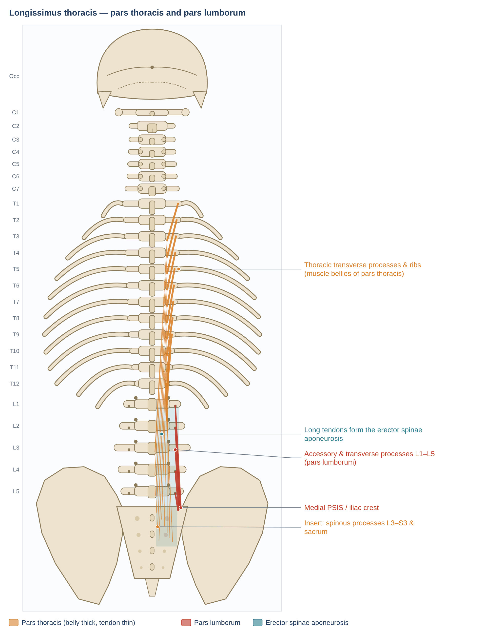
Figure 23. Longissimus thoracis: muscle bellies in the thorax, long tendons forming the erector spinae aponeurosis, and the short lumbar fascicles. Schematic posterior view; dots mark attachments, arrows show the line of pull on the insertion.
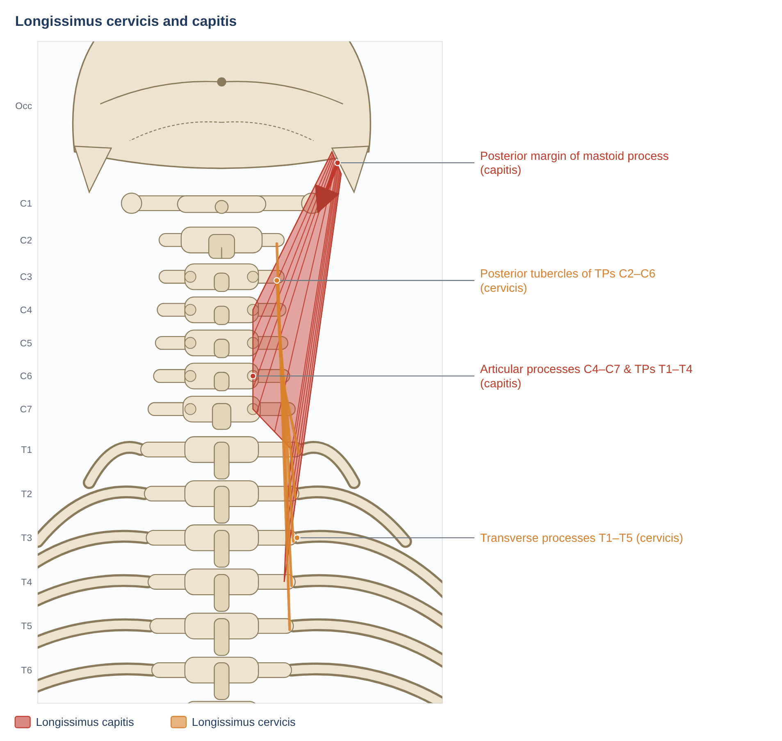
Figure 24. Longissimus cervicis and capitis. Schematic posterior view; dots mark attachments, arrows show the line of pull on the insertion.

Anatomy
Feature | Details
Longissimus thoracis — pars thoracis | Transverse processes and adjacent ribs of T1/T2–T12 → long tendons forming the erector spinae aponeurosis → spinous processes of L3–L5, sacrum (S1–S3). (Classical description: from the aponeurosis to all thoracic transverse processes and ribs 3–12 between tubercles and angles)
Longissimus thoracis — pars lumborum | Accessory and transverse processes of L1–L5 → medial PSIS and iliac crest (via the lumbar intermuscular aponeurosis)
Longissimus cervicis | Transverse processes of T1–T5 → posterior tubercles of the transverse processes of C2–C6
Longissimus capitis | Transverse processes of T1–T4/T5 and articular processes of C4–C7 → posterior margin of the mastoid process (deep to splenius capitis and SCM)
Innervation | Intermediate (and lateral) branches of the dorsal rami
Architecture | Long fibres; mass of longissimus thoracis ≈ 147 g (Ward et al. 2009); predominantly type I fibres (Mannion et al. 1997)

Mechanics
- Pars thoracis: the main producer of lumbar extensor torque; increases lumbar lordosis by bowstringing over the curve.
- Pars lumborum: short oblique fascicles produce posterior shear and segmental extension; this shear protection is lost in full lumbar flexion (McGill et al. 2000).
- Cervicis and capitis: extension, lateral flexion and (capitis) ipsilateral rotation of the head.
- Eccentric control of flexion and flexion-relaxation at end-range (see companion document).

Pathomechanics
Problem | Mechanism | Evidence / notes
Lumbar guarding, fatigue and loss of shear protection | Over-activity in pain; fatigue or full flexion removes posterior-shear protection | van Dieën 2003; McGill et al. 2000 (Flowchart in Section 14)
Fibre-type change and low endurance | Shift toward type II fibres; early fatigue | Mannion et al. 1997 (J Orthop Res); Biering-Sørensen 1984
Iatrogenic injury | Retraction and denervation in posterior spinal surgery | Kawaguchi et al. 1996
Degenerative lumbar kyphosis | Severe extensor atrophy and fatty infiltration in older adults | Takemitsu et al. 1988
Cervical: whiplash, neck pain | Fatty infiltration of extensors after whiplash; guarding | Elliott et al. 2006

Clinical assessment and exercise
- Biering-Sørensen endurance test; observe lifting strategy.
- Exercise: hip-hinge with neutral spine, back extension, bird-dog; neck extensor endurance for the cervical parts.
Key point: Longissimus has two personalities in the low back: a thoracic "torque generator" and a lumbar "shear controller".

8.3 Spinalis (thoracis, cervicis, capitis)
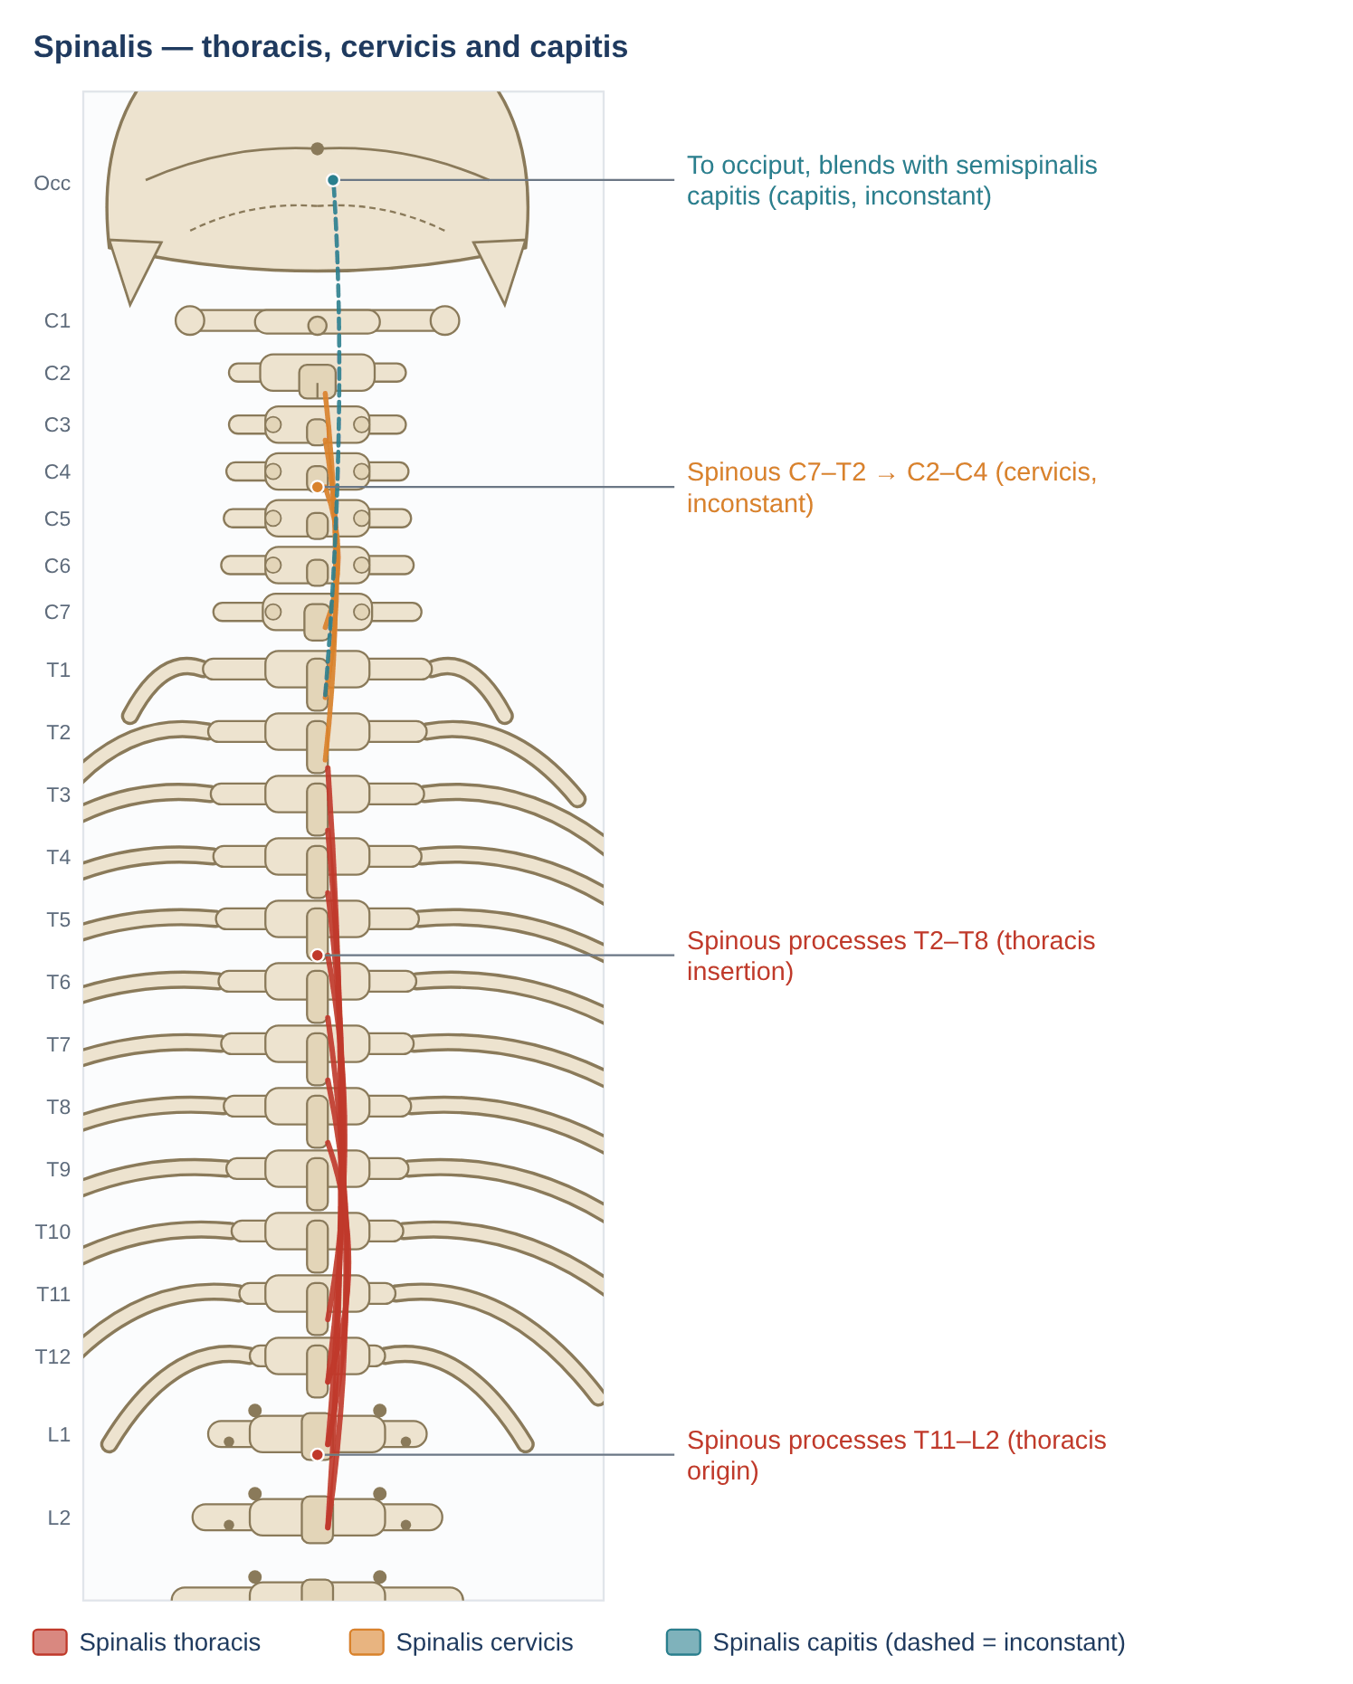
Figure 25. Spinalis: the medial column of erector spinae, running between spinous processes. Schematic posterior view; dots mark attachments, arrows show the line of pull on the insertion.

Anatomy
Feature | Details
Spinalis thoracis | Spinous processes of T11–L2 → spinous processes of T1/T2–T8
Spinalis cervicis (inconstant) | Lower ligamentum nuchae and spinous processes of C7–T2 → spinous process of C2 (C2–C4)
Spinalis capitis (inconstant) | Usually blends with semispinalis capitis to reach the occiput
Innervation | Dorsal rami of the corresponding spinal nerves
Relations | Most medial column of erector spinae, lying against the spinous processes; often hard to separate from semispinalis

Mechanics
- Extension of the thoracic (and upper cervical) spine; helps maintain thoracic posture.
- Its fibres lie very close to the spinous processes, so its moment arm is smaller than that of longissimus and iliocostalis, and it has little lateral-flexion or rotation capacity.

Pathomechanics
Problem | Mechanism | Evidence / notes
Thoracic extensor weakness | Contributes to hyperkyphosis in older adults | Part of the back-extensor weakness–kyphosis cycle (Sinaki et al. 2002)
Local pain | Thoracic paraspinal pain over the spinous processes | Little muscle-specific research

Clinical assessment and exercise
- Not testable in isolation; assessed with thoracic extension strength and endurance.
- Exercise: prone thoracic extension, wall angels, rows with thoracic extension.
Key point: The smallest and most medial erector spinae column — mainly a thoracic posture muscle.

9. Transversospinales
The transversospinales run obliquely upward and medially from transverse processes (or equivalent processes) to spinous processes. They are grouped by length: semispinalis spans about 4–6 segments, multifidus 2–4 and rotatores 1–2. The shorter the muscle, the deeper it lies and the more segmental its role.

9.1 Semispinalis (thoracis, cervicis, capitis)
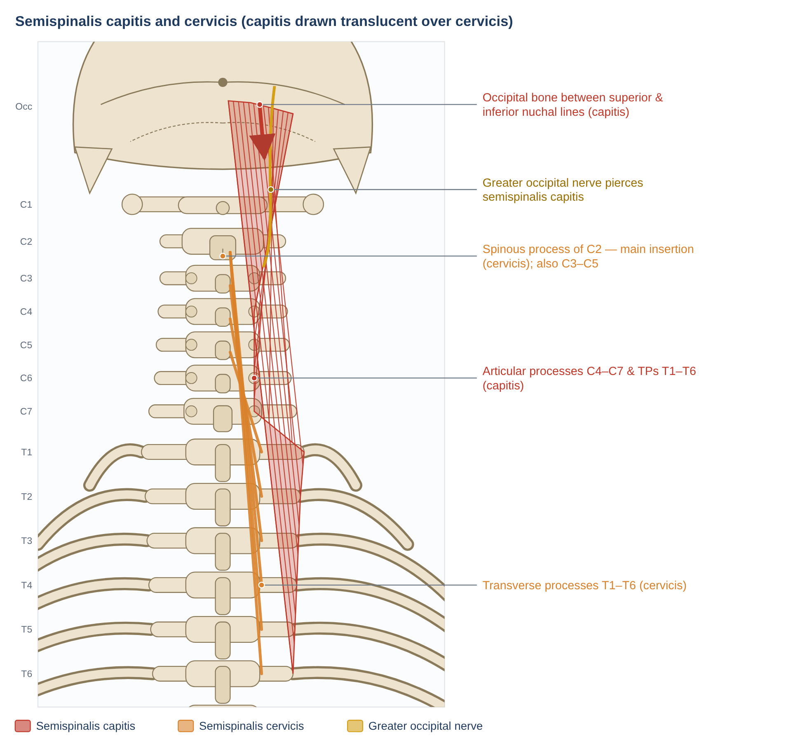
Figure 26. Semispinalis capitis (translucent) over semispinalis cervicis, with the greater occipital nerve piercing semispinalis capitis. Schematic posterior view; dots mark attachments, arrows show the line of pull on the insertion.
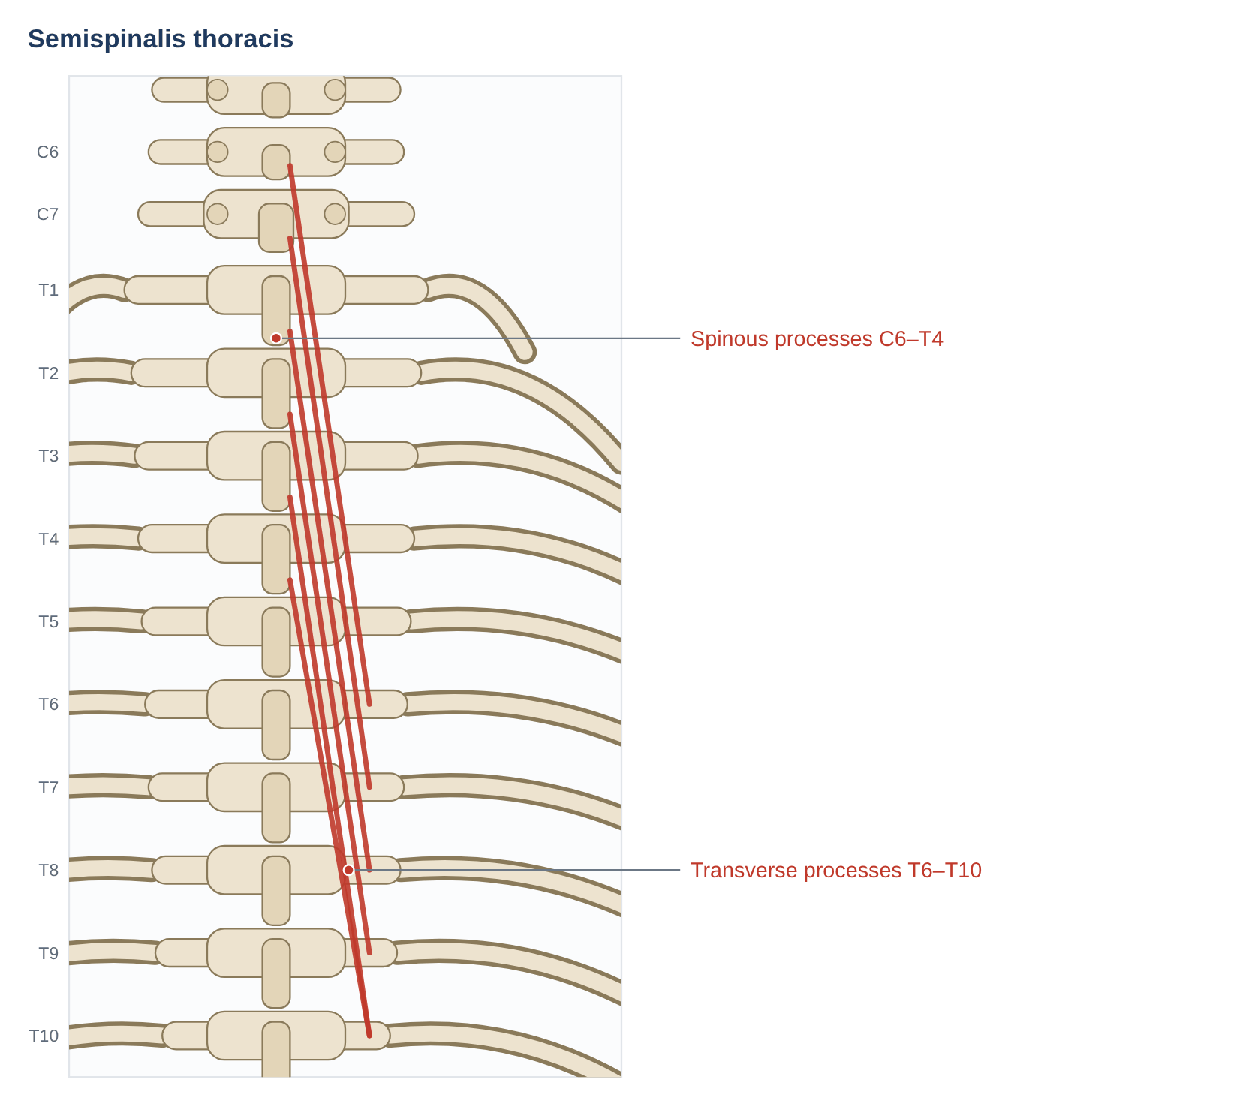
Figure 27. Semispinalis thoracis. Schematic posterior view; dots mark attachments, arrows show the line of pull on the insertion.

Anatomy
Feature | Details
Semispinalis thoracis | Transverse processes of T6–T10 → spinous processes of C6–T4
Semispinalis cervicis | Transverse processes of T1–T6 → spinous processes of C2–C5, mainly the large bifid spinous process of C2
Semispinalis capitis | Transverse processes of T1–T6/T7 and articular processes of C4–C6 → occipital bone between the superior and inferior nuchal lines. Its medial part (biventer cervicis) has an intermediate tendon
Innervation | Medial branches of the dorsal rami; semispinalis capitis also receives branches of the greater occipital nerve (C2)
Relations | Semispinalis capitis is the largest muscle of the back of the neck, deep to splenius and trapezius; semispinalis cervicis lies deep to it on the cervical laminae with multifidus. The greater occipital nerve pierces semispinalis capitis (and trapezius) on its way to the scalp

Mechanics
- Semispinalis capitis: the main extensor of the head and upper neck; retracts the head (craniocervical extension); acting on one side, slight contralateral rotation.
- Semispinalis cervicis: with cervical multifidus forms the deep cervical extensors that control segmental motion of the mid–lower cervical spine and maintain the cervical lordosis; its large insertion on C2 anchors the axis (Schomacher & Falla 2013).
- Semispinalis thoracis: extends the upper thoracic and lower cervical spine; small contralateral rotation.

Pathomechanics
Problem | Mechanism | Evidence / notes
Altered deep extensor control in neck pain | Reduced and less direction-specific activation of semispinalis cervicis; superficial extensors more active and slow to relax | Schomacher et al. 2012; Schomacher & Falla 2013 (review)
Structural changes | More fat, variable size and more type II fibres in the deep cervical extensors of people with neck pain | Schomacher & Falla 2013; Elliott et al. 2006 (whiplash)
Greater occipital nerve entrapment | Compression where the nerve pierces semispinalis capitis and trapezius → occipital neuralgia, cervicogenic headache | Treated with nerve blocks; surgical decompression in selected cases
Forward head posture | Sustained high demand on head extensors (semispinalis capitis) | Biomechanical (Section 3)

Clinical assessment and exercise
- Deep extensor test/exercise: neck extension in four-point kneeling or prone-on-elbows with the upper neck kept neutral (chin slightly tucked) to bias semispinalis cervicis and multifidus over semispinalis capitis.
- Palpation of the greater occipital nerve about 2–3 cm lateral to the external occipital protuberance.
- Neck extensor endurance testing.
Key point: Semispinalis capitis moves the head; semispinalis cervicis (with multifidus) stabilises the neck segments — and is the one that "switches off" in neck pain.

9.2 Multifidus (cervical, thoracic, lumbar)
Multifidus runs the whole length of the spine but is largest in the lumbar region. Its lumbar part is covered in detail in the companion document; here it is described along the entire spine.
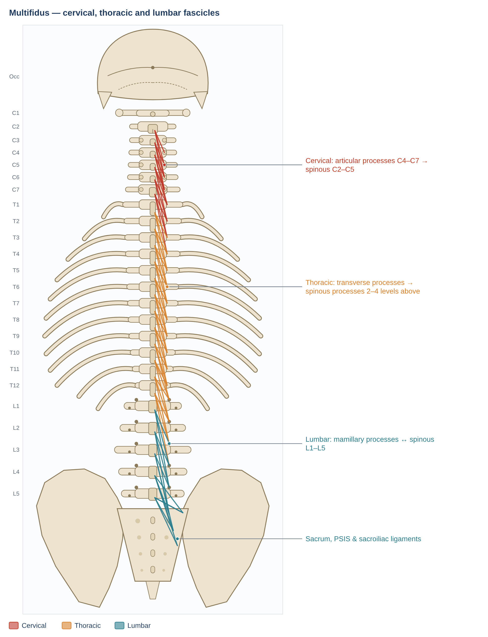
Figure 28. Multifidus along the whole spine: each fascicle runs from a spinous process to processes 2–4 levels below. Schematic posterior view; dots mark attachments, arrows show the line of pull on the insertion.
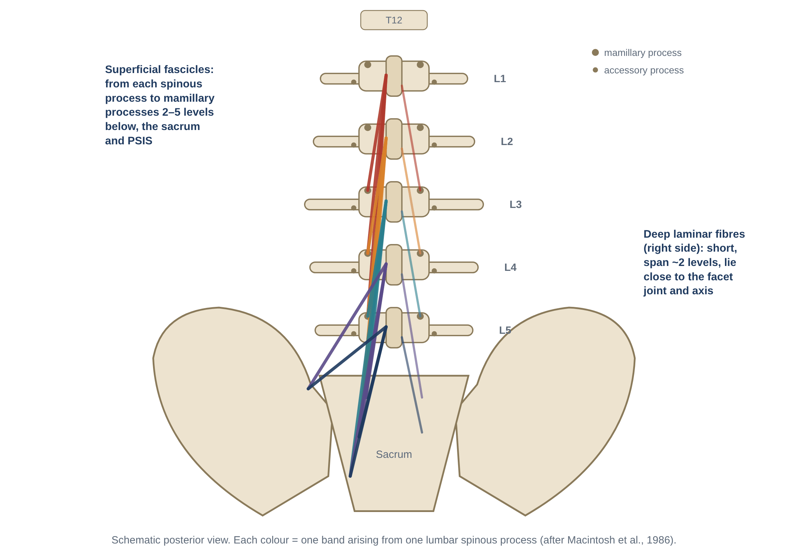
Figure 29. Detail of the five lumbar bands (after Macintosh et al. 1986; from the companion document).

Anatomy
Feature | Details
Cervical | Articular processes of C4–C7 → spinous processes of C2–C5. Deep fibres attach to the facet-joint capsules (Anderson et al. 2005)
Thoracic | Transverse processes of T1–T12 → spinous processes 2–4 levels above (thin)
Lumbar | Five bands: from each spinous process to the mamillary processes 2–5 levels below, the sacrum, PSIS and sacroiliac ligaments (Macintosh et al. 1986)
Innervation | Medial branch of the dorsal ramus of the same segment — strictly segmental; the same nerve supplies the facet joints
Architecture | Lumbar: PCSA 23.9 cm² (more than twice any other lumbar muscle), short fibres, operates on the ascending limb of the length–tension curve (Ward et al. 2009)

Mechanics
- Posterior sagittal rotation (segmental extension) of each vertebra; not a significant rotator — it opposes the flexion that accompanies rotation by the obliques (Macintosh & Bogduk 1986).
- Segmental stiffness: about two-thirds of the muscle-induced stiffness increase at L4–L5 in vitro (Wilke et al. 1995).
- Deep fibres are tonically and anticipatorily active, independent of movement direction; superficial fibres are direction-specific (Moseley et al. 2002).
- Cervical multifidus may protect the facet capsule through its capsular attachment (Anderson et al. 2005).

Pathomechanics
Problem | Mechanism | Evidence / notes
Lumbar: rapid inhibition → inflammation → fat and fibrosis | Level- and side-specific atrophy after first-episode LBP; TNF-α, macrophages, fibre-type shift; chronic fat and connective-tissue replacement | Hides 1994; Hodges 2006, 2014, 2015; James 2018 (Flowchart 7)
Lumbar: recovery not automatic | Specific training reduced recurrence 84% → 30% at 1 year | Hides 1996, 2001
Cervical: whiplash | Fatty infiltration greatest in multifidus at C3 (with RCP major/minor) | Elliott et al. 2006; not seen in insidious-onset neck pain (Elliott 2008)
Cervical: neck pain | Reduced activation of deep extensors | Schomacher & Falla 2013
Iatrogenic | Posterior surgery; denervation after medial-branch radiofrequency neurotomy | Kawaguchi 1996; Dreyfuss et al. 2009

Clinical assessment and exercise
- Palpation and RTUS at each level for size, symmetry and contraction.
- MRI for size and fatty infiltration.
- Exercise: isolated contraction ("swelling") progressed to bird-dog, back extension and loaded functional tasks; deep cervical extensor training for the neck.
Key point: Multifidus is the segmental stabiliser of the whole spine and the muscle most consistently changed in back and neck pain.

9.3 Rotatores (brevis and longus)
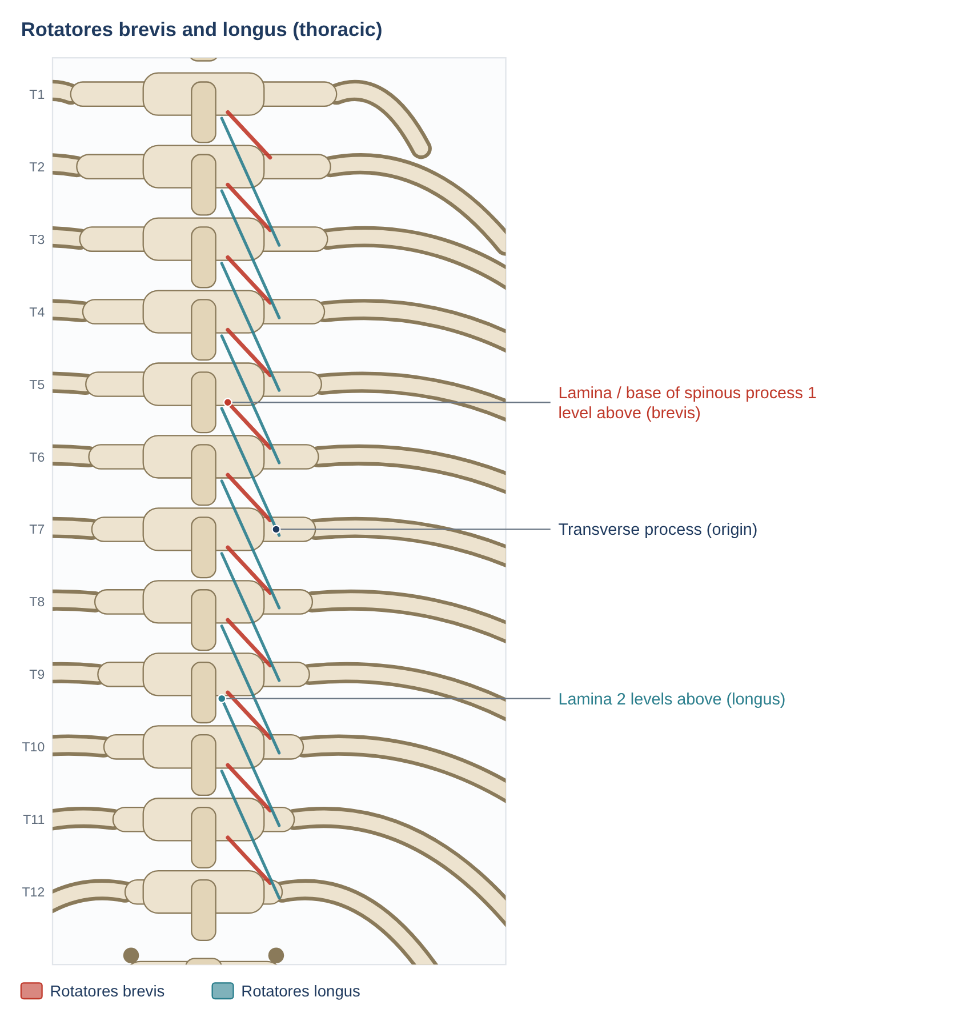
Figure 30. Rotatores brevis and longus in the thoracic region. Schematic posterior view; dots mark attachments, arrows show the line of pull on the insertion.

Anatomy
Feature | Details
Rotatores breves | Upper and posterior part of a transverse process → lamina and base of the spinous process of the vertebra immediately above
Rotatores longi | Transverse process → lamina/spinous base two levels above
Distribution | Best developed in the thoracic region; small and variable in the cervical and lumbar regions
Innervation | Medial branches of the dorsal rami
Relations | The deepest layer of the transversospinales, lying in the groove between the spinous and transverse processes beneath multifidus

Mechanics
- Classical actions: contralateral rotation and extension of the vertebra above.
- Reality: their tiny size and very short moment arms mean they can produce only negligible torque; they are best regarded as length transducers (position sensors) for each segment (Bogduk 2012; McGill 2016).
- High muscle-spindle density: one secondary source attributes to Nitz & Peck (1986) a spindle density 4.5–7.3 times that of multifidus — a figure to verify against the original paper.

Pathomechanics
Problem | Mechanism | Evidence / notes
Impaired segmental proprioception | Altered paraspinal spindle input is linked to poorer position sense; people with LBP show impaired lumbosacral repositioning | Brumagne et al. 2000 (paraspinal spindles and position sense)
Thoracic segmental pain | Local pain in the paravertebral groove | Little direct research

Clinical assessment and exercise
- Not testable in isolation.
- Position-sense training (repositioning tasks, balance) addresses the sensory role of the deep segmental muscles.
Key point: Rotatores are probably more "sensors" than "motors".

10. Segmental muscles

10.1 Interspinales
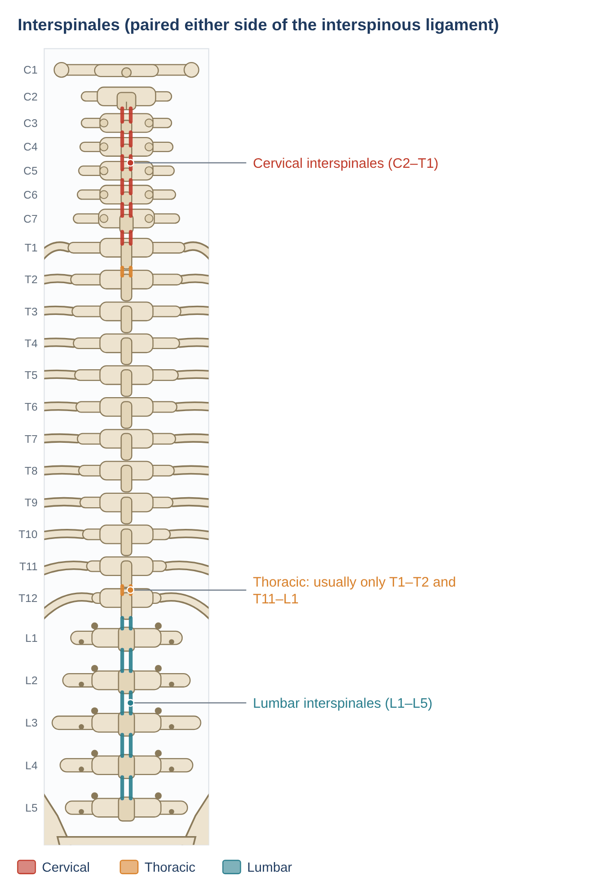
Figure 31. Interspinales, paired on either side of the interspinous ligament. Schematic posterior view; dots mark attachments, arrows show the line of pull on the insertion.

Anatomy
Feature | Details
Attachments | Between the spinous processes of adjacent vertebrae, one on each side of the interspinous ligament
Distribution | Well developed in the cervical (C2–T1) and lumbar (L1–L5) regions; in the thoracic region usually only at T1–T2 and T11–L1
Innervation | Medial branches of the dorsal rami
Relations | Deepest midline muscles; lie beside the interspinous ligament beneath multifidus

Mechanics
- Extension of the segment (weak); they help keep the spinous processes from separating in flexion.
- Mainly proprioceptive, with high spindle density relative to size.

Pathomechanics
Problem | Mechanism | Evidence / notes
Interspinous region pain | Sprain of the interspinous ligament and muscles in forced flexion | Clinical
"Kissing spines" (Baastrup disease) | In marked lordosis, adjacent spinous processes contact; interspinous bursitis; the interspinous soft tissues degenerate | Radiological diagnosis; extension-related midline pain

Clinical assessment and exercise
- Midline tenderness between spinous processes; pain on end-range flexion or extension.
- Management as for segmental pain: load management, motor control, address hyperlordosis.
Key point: Small midline muscles whose main value is probably sensing segmental motion.

10.2 Intertransversarii
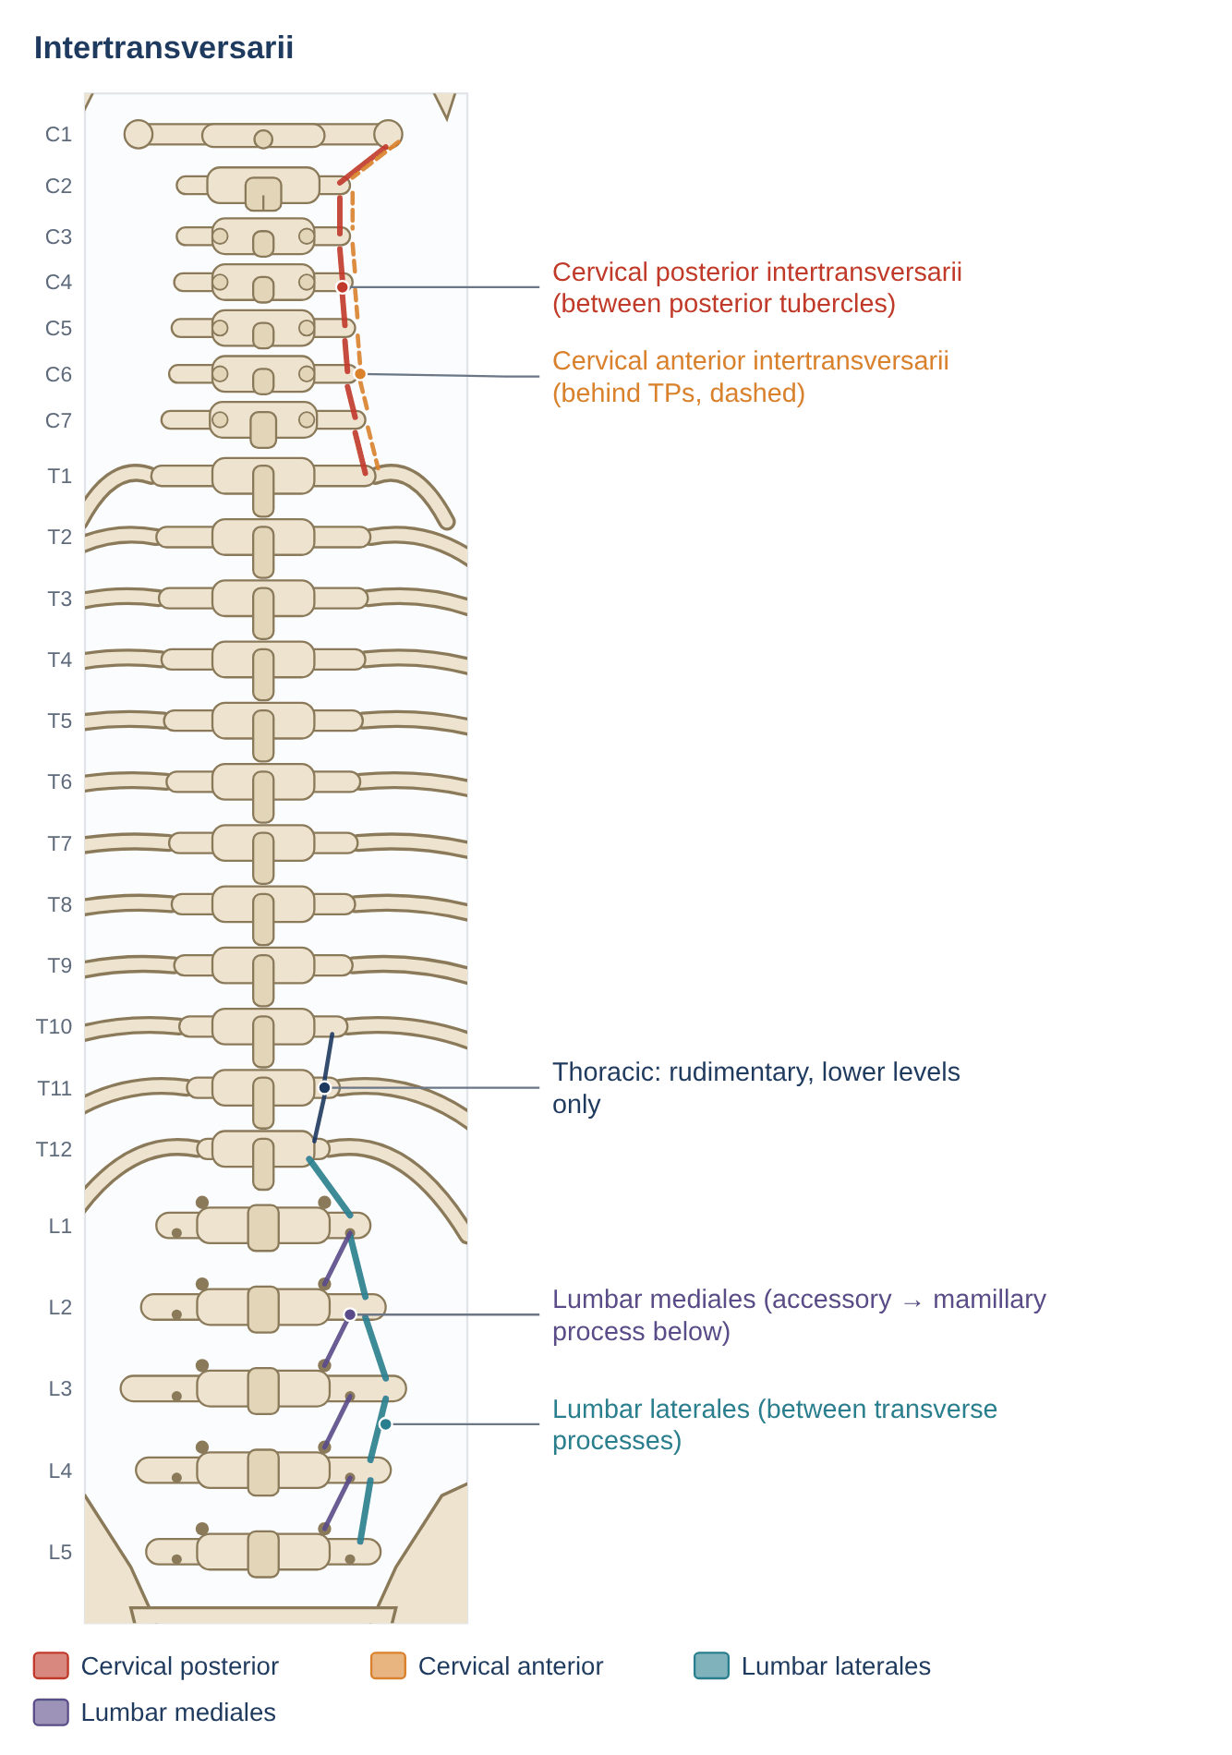
Figure 32. Intertransversarii: cervical anterior and posterior, lumbar laterales and mediales. Schematic posterior view; dots mark attachments, arrows show the line of pull on the insertion.

Anatomy
Feature | Details
Cervical | Anterior and posterior intertransversarii between the anterior and posterior tubercles of adjacent transverse processes (C1–T1). Anterior and lateral posterior parts are supplied by ventral rami; medial posterior part by dorsal rami
Thoracic | Rudimentary; present mainly at T10–L1
Lumbar laterales | Between adjacent transverse processes (ventral and dorsal parts); supplied by ventral rami
Lumbar mediales | Accessory process → mamillary process of the vertebra below; supplied by dorsal rami

Mechanics
- Lateral flexion of the segment (weak) and frontal-plane segmental stability.
- Proprioception, like the other short segmental muscles.

Pathomechanics
Problem | Mechanism | Evidence / notes
Little specific research | Considered with other segmental muscles in lateral-bending pain, lateral shifts and scoliosis | Limited evidence

Clinical assessment and exercise
- Not testable in isolation; assessed indirectly through lateral-flexion control and side-bridge endurance.
Key point: The intertransversarii mirror the interspinales in the frontal plane.

10.3 Levatores costarum
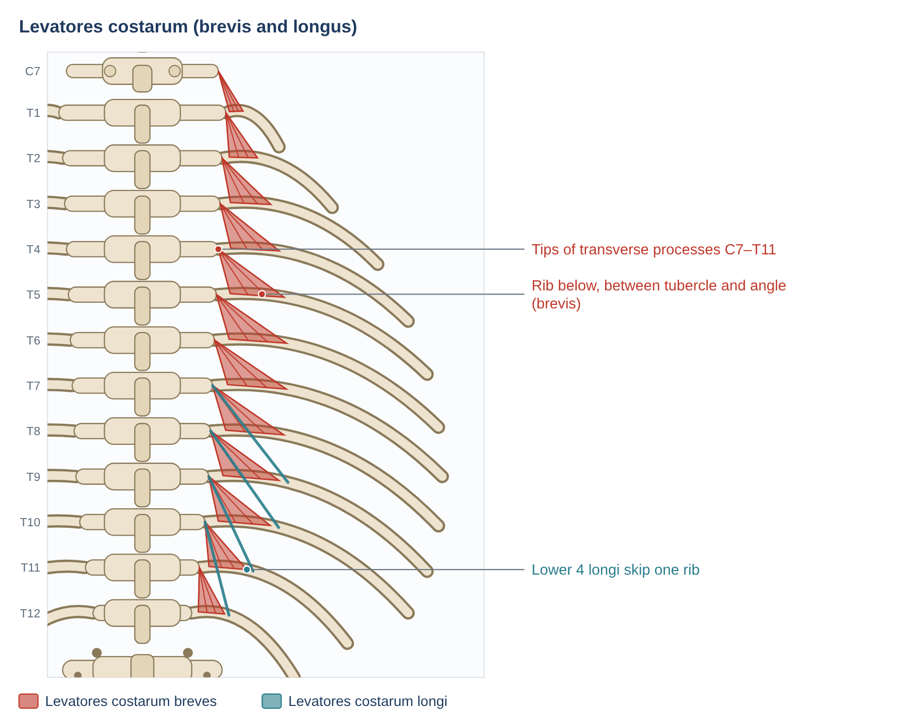
Figure 33. Levatores costarum: short fan-shaped muscles from transverse processes to the rib below. Schematic posterior view; dots mark attachments, arrows show the line of pull on the insertion.

Anatomy
Feature | Details
Origin | Tips of the transverse processes of C7–T11 (12 pairs)
Insertion | Outer surface of the rib immediately below, between the tubercle and the angle (breves); the lower four (longi) skip one rib
Innervation | Lateral branches of the dorsal rami of C8–T11 — unusual for a muscle acting on ribs
Relations | Deep to the erector spinae; lateral to the rotatores

Mechanics
- Elevate the ribs (inspiration) by rotating the rib upward around the costovertebral joints.
- Thoracic spine: with the ribs fixed, small ipsilateral lateral flexion and contralateral rotation.
- Contribute to costovertebral joint control during breathing and trunk rotation.

Pathomechanics
Problem | Mechanism | Evidence / notes
Costovertebral dysfunction | Painful rib motion with breathing and rotation | Clinical; little muscle-specific research
Scoliosis | Asymmetric rib and vertebral rotation involves the costovertebral muscles | Mechanistic proposal

Clinical assessment and exercise
- Rib springing and breathing assessment; thoracic rotation mobility; breathing exercises.
Key point: Small rib elevators with a dorsal-ramus nerve supply — a reminder that the back and breathing are mechanically linked.

11. Suboccipital muscles
Four small muscles connect the occiput, atlas (C1) and axis (C2). They lie deep to semispinalis capitis and control the fine movements of the head on the upper neck. Three of them bound the suboccipital triangle, which contains the vertebral artery and the suboccipital nerve. They have among the highest muscle-spindle densities in the body (Peck, Buxton & Nitz 1984), so they are major sources of proprioceptive information for head and eye coordination.
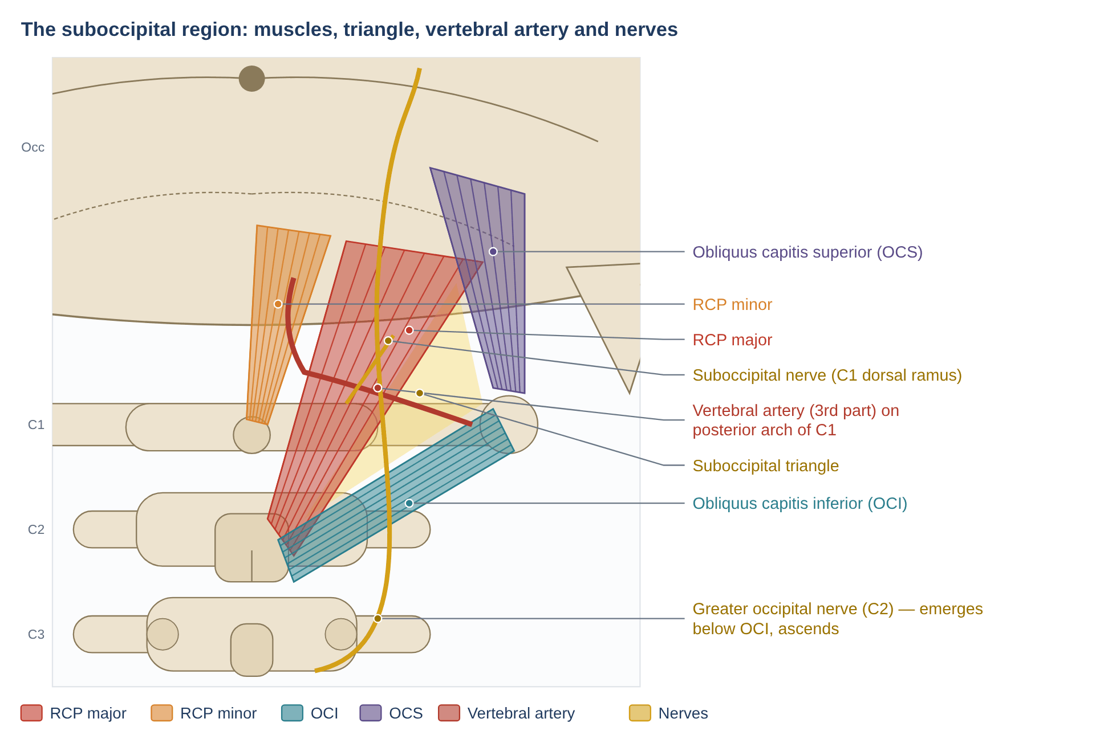
Figure 34. The suboccipital region: rectus capitis posterior major and minor, obliquus capitis superior and inferior, the suboccipital triangle with the vertebral artery and suboccipital nerve, and the greater occipital nerve looping below obliquus capitis inferior.
Muscle | Origin | Insertion | Action
Rectus capitis posterior major | Spinous process of C2 | Lateral part of inferior nuchal line | Extension of the head; ipsilateral rotation of head and atlas
Rectus capitis posterior minor | Posterior tubercle of C1 | Medial part of inferior nuchal line and bone below | Extension at the atlanto-occipital joint; proprioception; myodural bridge
Obliquus capitis inferior | Spinous process / lamina of C2 | Transverse process of C1 | Ipsilateral rotation of the atlas (and head) on the axis
Obliquus capitis superior | Transverse process of C1 | Occiput between superior and inferior nuchal lines | Extension and ipsilateral lateral flexion of the head

All four are supplied by the suboccipital nerve (dorsal ramus of C1). The greater occipital nerve (C2) emerges below obliquus capitis inferior, loops around its lower border and ascends through semispinalis capitis and trapezius to the scalp.

11.1 Rectus capitis posterior major
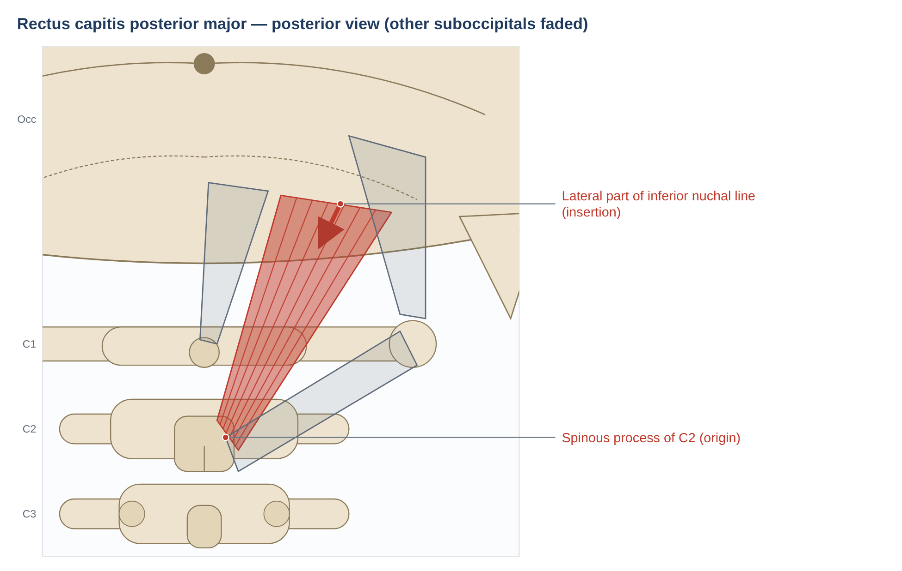
Figure 35. Rectus capitis posterior major. Schematic posterior view; dots mark attachments, arrows show the line of pull on the insertion.

Anatomy
Feature | Details
Origin | Spinous process of C2
Insertion | Lateral part of the inferior nuchal line and the bone below it
Innervation | Suboccipital nerve (C1 dorsal ramus)
Blood supply | Vertebral and occipital arteries
Relations | Superomedial border of the suboccipital triangle; deep to semispinalis capitis

Mechanics
- Extension of the head at the atlanto-occipital and atlanto-axial joints.
- Ipsilateral rotation of the head (it crosses from C2 to the occiput, pulling the occiput around the axis).
- Fine control of head posture and proprioception.

Pathomechanics
Problem | Mechanism | Evidence / notes
Atrophy and fatty infiltration | Seen in chronic neck pain and whiplash; may reduce proprioceptive input | McPartland et al. 1997 (pilot MRI study); Elliott et al. 2006
Cervicogenic headache | Upper-cervical muscle and joint nociception referred to the head | Bogduk & Govind 2009

Clinical assessment and exercise
- Palpation below the occiput lateral to the midline; craniocervical flexion range; joint position error test.
Key point: Major extensor and rotator of the head on the axis.

11.2 Rectus capitis posterior minor
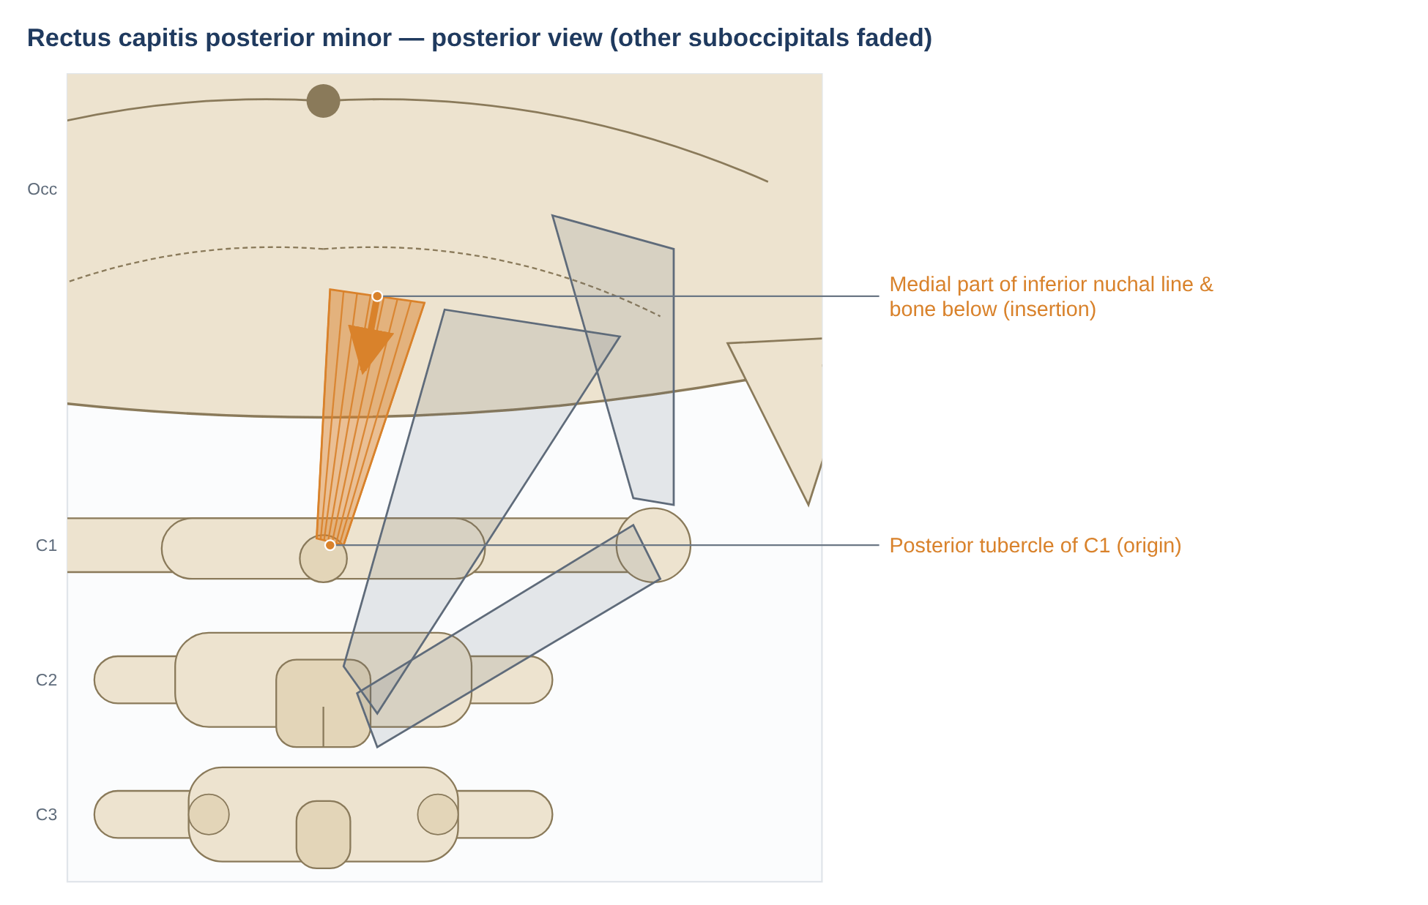
Figure 36. Rectus capitis posterior minor. Schematic posterior view; dots mark attachments, arrows show the line of pull on the insertion.

Anatomy
Feature | Details
Origin | Posterior tubercle of the atlas (C1)
Insertion | Medial part of the inferior nuchal line and the occipital bone between it and the foramen magnum
Innervation | Suboccipital nerve (C1 dorsal ramus)
Special feature | A dense connective-tissue bridge links it, through the posterior atlanto-occipital membrane, to the dura mater (Hack et al. 1995)

Mechanics
- Extension at the atlanto-occipital joint (small torque).
- Proprioception: very high spindle density.
- Myodural bridge: may prevent the dura folding into the canal during head extension; in a cadaver study, loading the muscle reduced dural bulging during hyperextension by about half (2017 study).

Pathomechanics
Problem | Mechanism | Evidence / notes
Atrophy / fatty infiltration | Marked atrophy in chronic neck pain; greatest fat in RCP minor/major after whiplash | McPartland et al. 1997; Elliott et al. 2006
Headache (hypothesis) | Tension transmitted through the myodural bridge to pain-sensitive dura | Hack et al. 1995 (anatomy); clinical link not established
Proprioceptive deficits and dizziness | Reduced input from atrophied suboccipitals → poorer balance | McPartland et al. 1997 (pilot)

Clinical assessment and exercise
- Joint position error and balance tests; craniocervical flexion test.
- Management: craniocervical flexion training, sensorimotor training.
Key point: A tiny muscle with an outsized proprioceptive role — and a direct link to the dura.

11.3 Obliquus capitis inferior
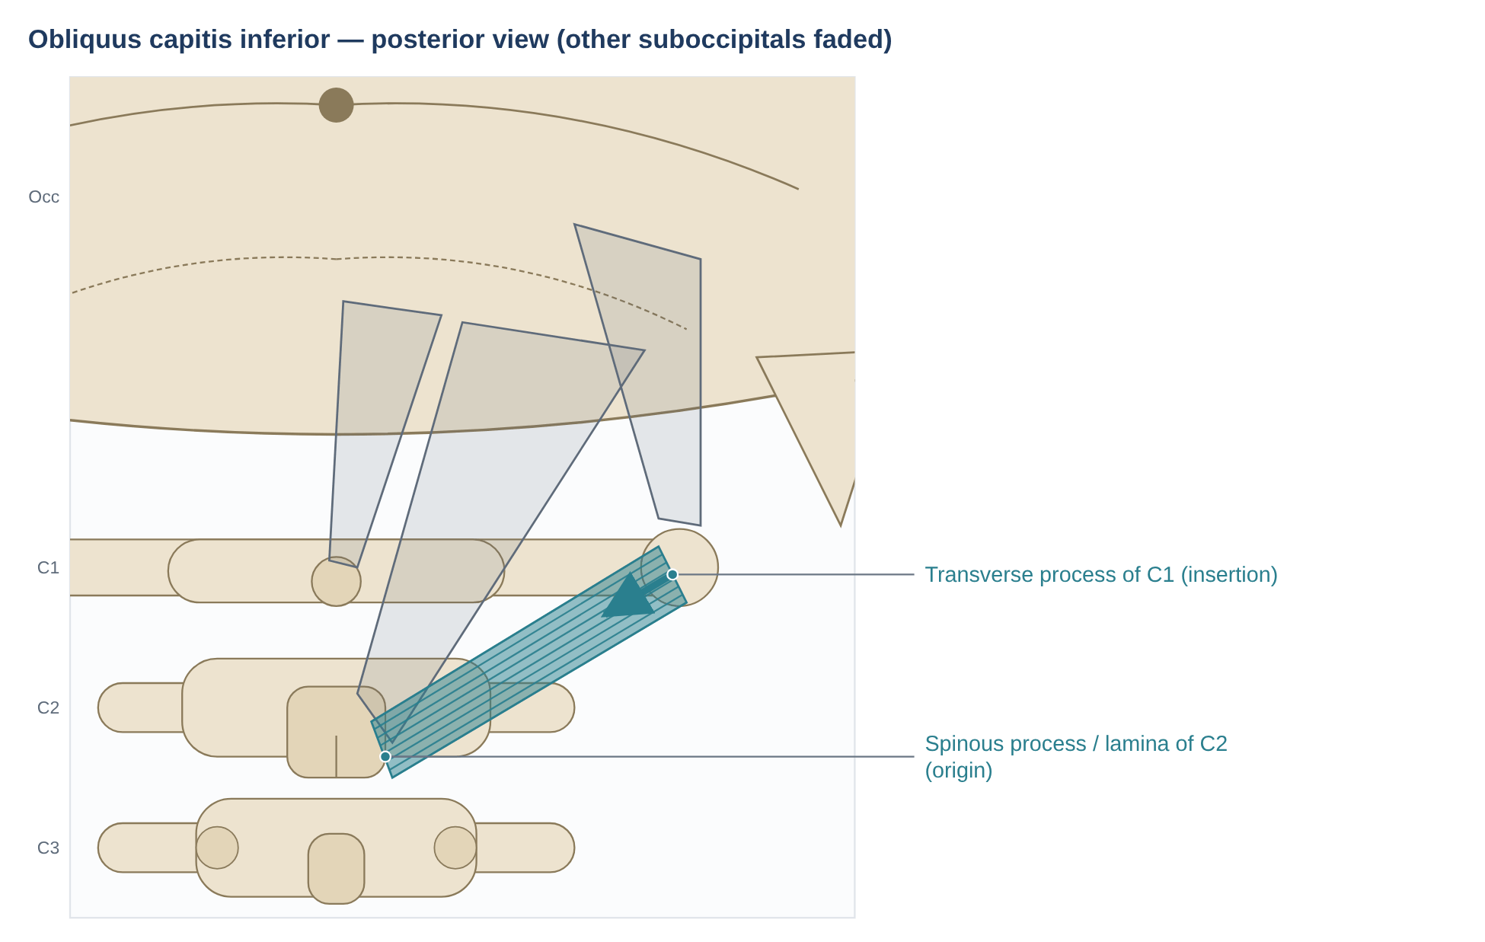
Figure 37. Obliquus capitis inferior. Schematic posterior view; dots mark attachments, arrows show the line of pull on the insertion.

Anatomy
Feature | Details
Origin | Spinous process and lamina of C2
Insertion | Transverse process of C1
Innervation | Suboccipital nerve (C1 dorsal ramus)
Special feature | The only "capitis" muscle that does not attach to the skull. The greater occipital nerve loops around its lower border

Mechanics
- Ipsilateral rotation of the atlas (and so the head) on the axis — the atlanto-axial joint provides about half of all cervical rotation, and this is the muscle that acts most directly on it.
- Stabilises C1 on C2 during head movements; rich in muscle spindles.

Pathomechanics
Problem | Mechanism | Evidence / notes
C1–C2 rotation restriction | Painful or reduced rotation in cervicogenic headache | Flexion–rotation test (Hall & Robinson 2004)
Greater occipital nerve irritation | The nerve loops around the muscle — a possible compression site | Clinical / anatomical

Clinical assessment and exercise
- Flexion–rotation test: with the neck fully flexed, rotation is limited to the C1–C2 level; markedly reduced range on one side suggests C1–C2 dysfunction (Hall & Robinson 2004).
Key point: The atlas's own rotator.

11.4 Obliquus capitis superior
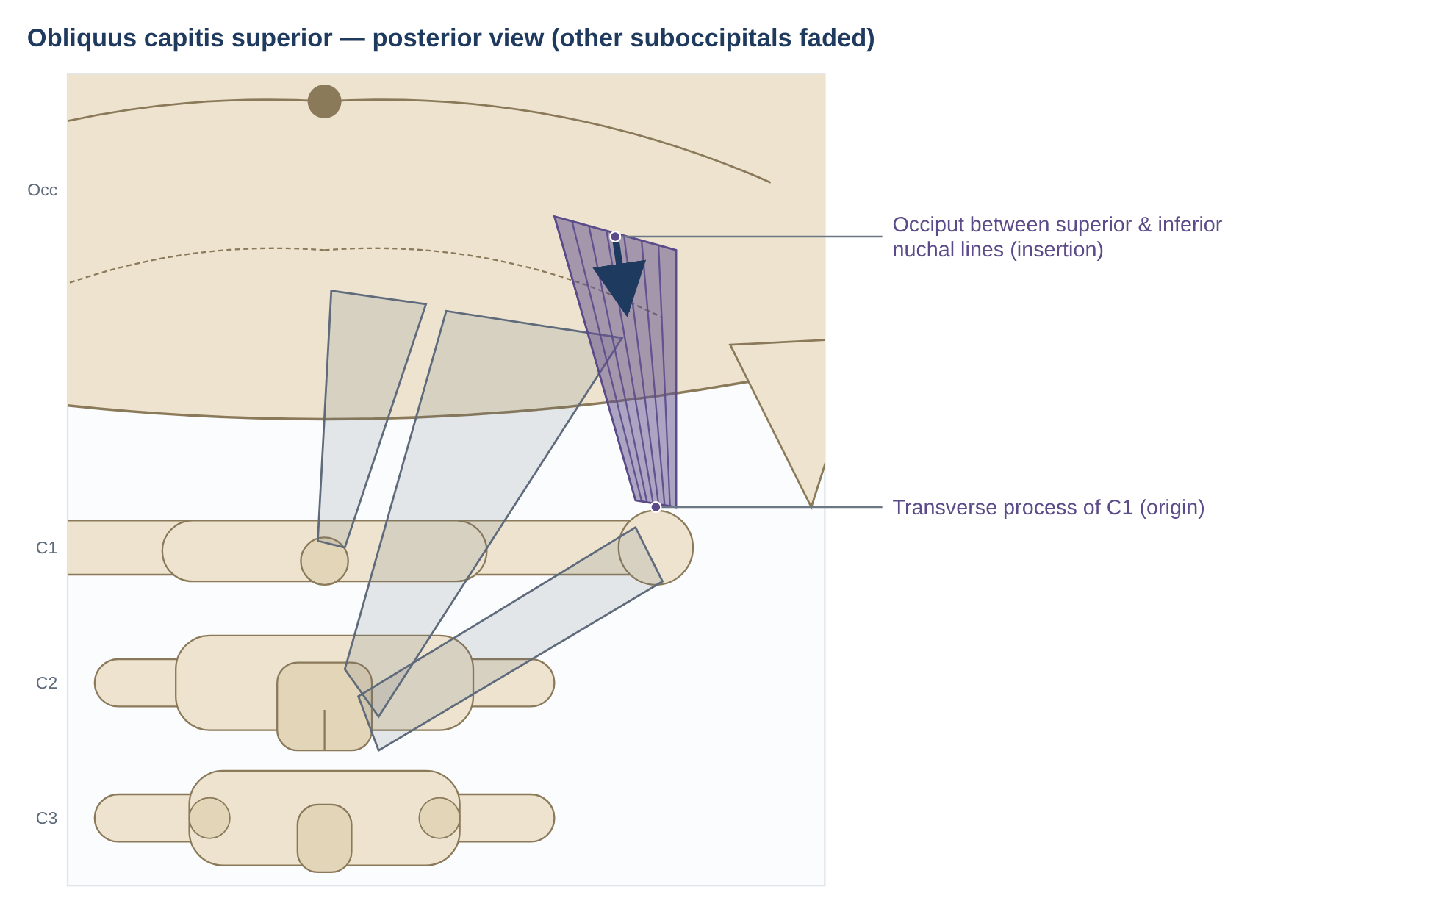
Figure 38. Obliquus capitis superior. Schematic posterior view; dots mark attachments, arrows show the line of pull on the insertion.

Anatomy
Feature | Details
Origin | Transverse process of C1
Insertion | Occipital bone between the superior and inferior nuchal lines, lateral to semispinalis capitis and above RCP major
Innervation | Suboccipital nerve (C1 dorsal ramus)
Relations | Superolateral border of the suboccipital triangle

Mechanics
- Extension and ipsilateral lateral flexion of the head at the atlanto-occipital joint.
- Postural fine-tuning of the head.

Pathomechanics
Problem | Mechanism | Evidence / notes
Suboccipital pain and headache | Part of the suboccipital group involved in cervicogenic and tension-type headache | Fernández-de-las-Peñas et al. 2006 (trigger points and forward head posture in tension-type headache)

Clinical assessment and exercise
- Palpation lateral to RCP major just below the occiput; craniocervical range.
Key point: Completes the suboccipital triangle and fine-tunes head tilt.

12. Quadratus lumborum
Quadratus lumborum is strictly a muscle of the posterior abdominal wall but acts closely with the back muscles. Its detailed anatomy, the stabiliser debate and its pathomechanics are covered in the companion document; the key points are summarised here.
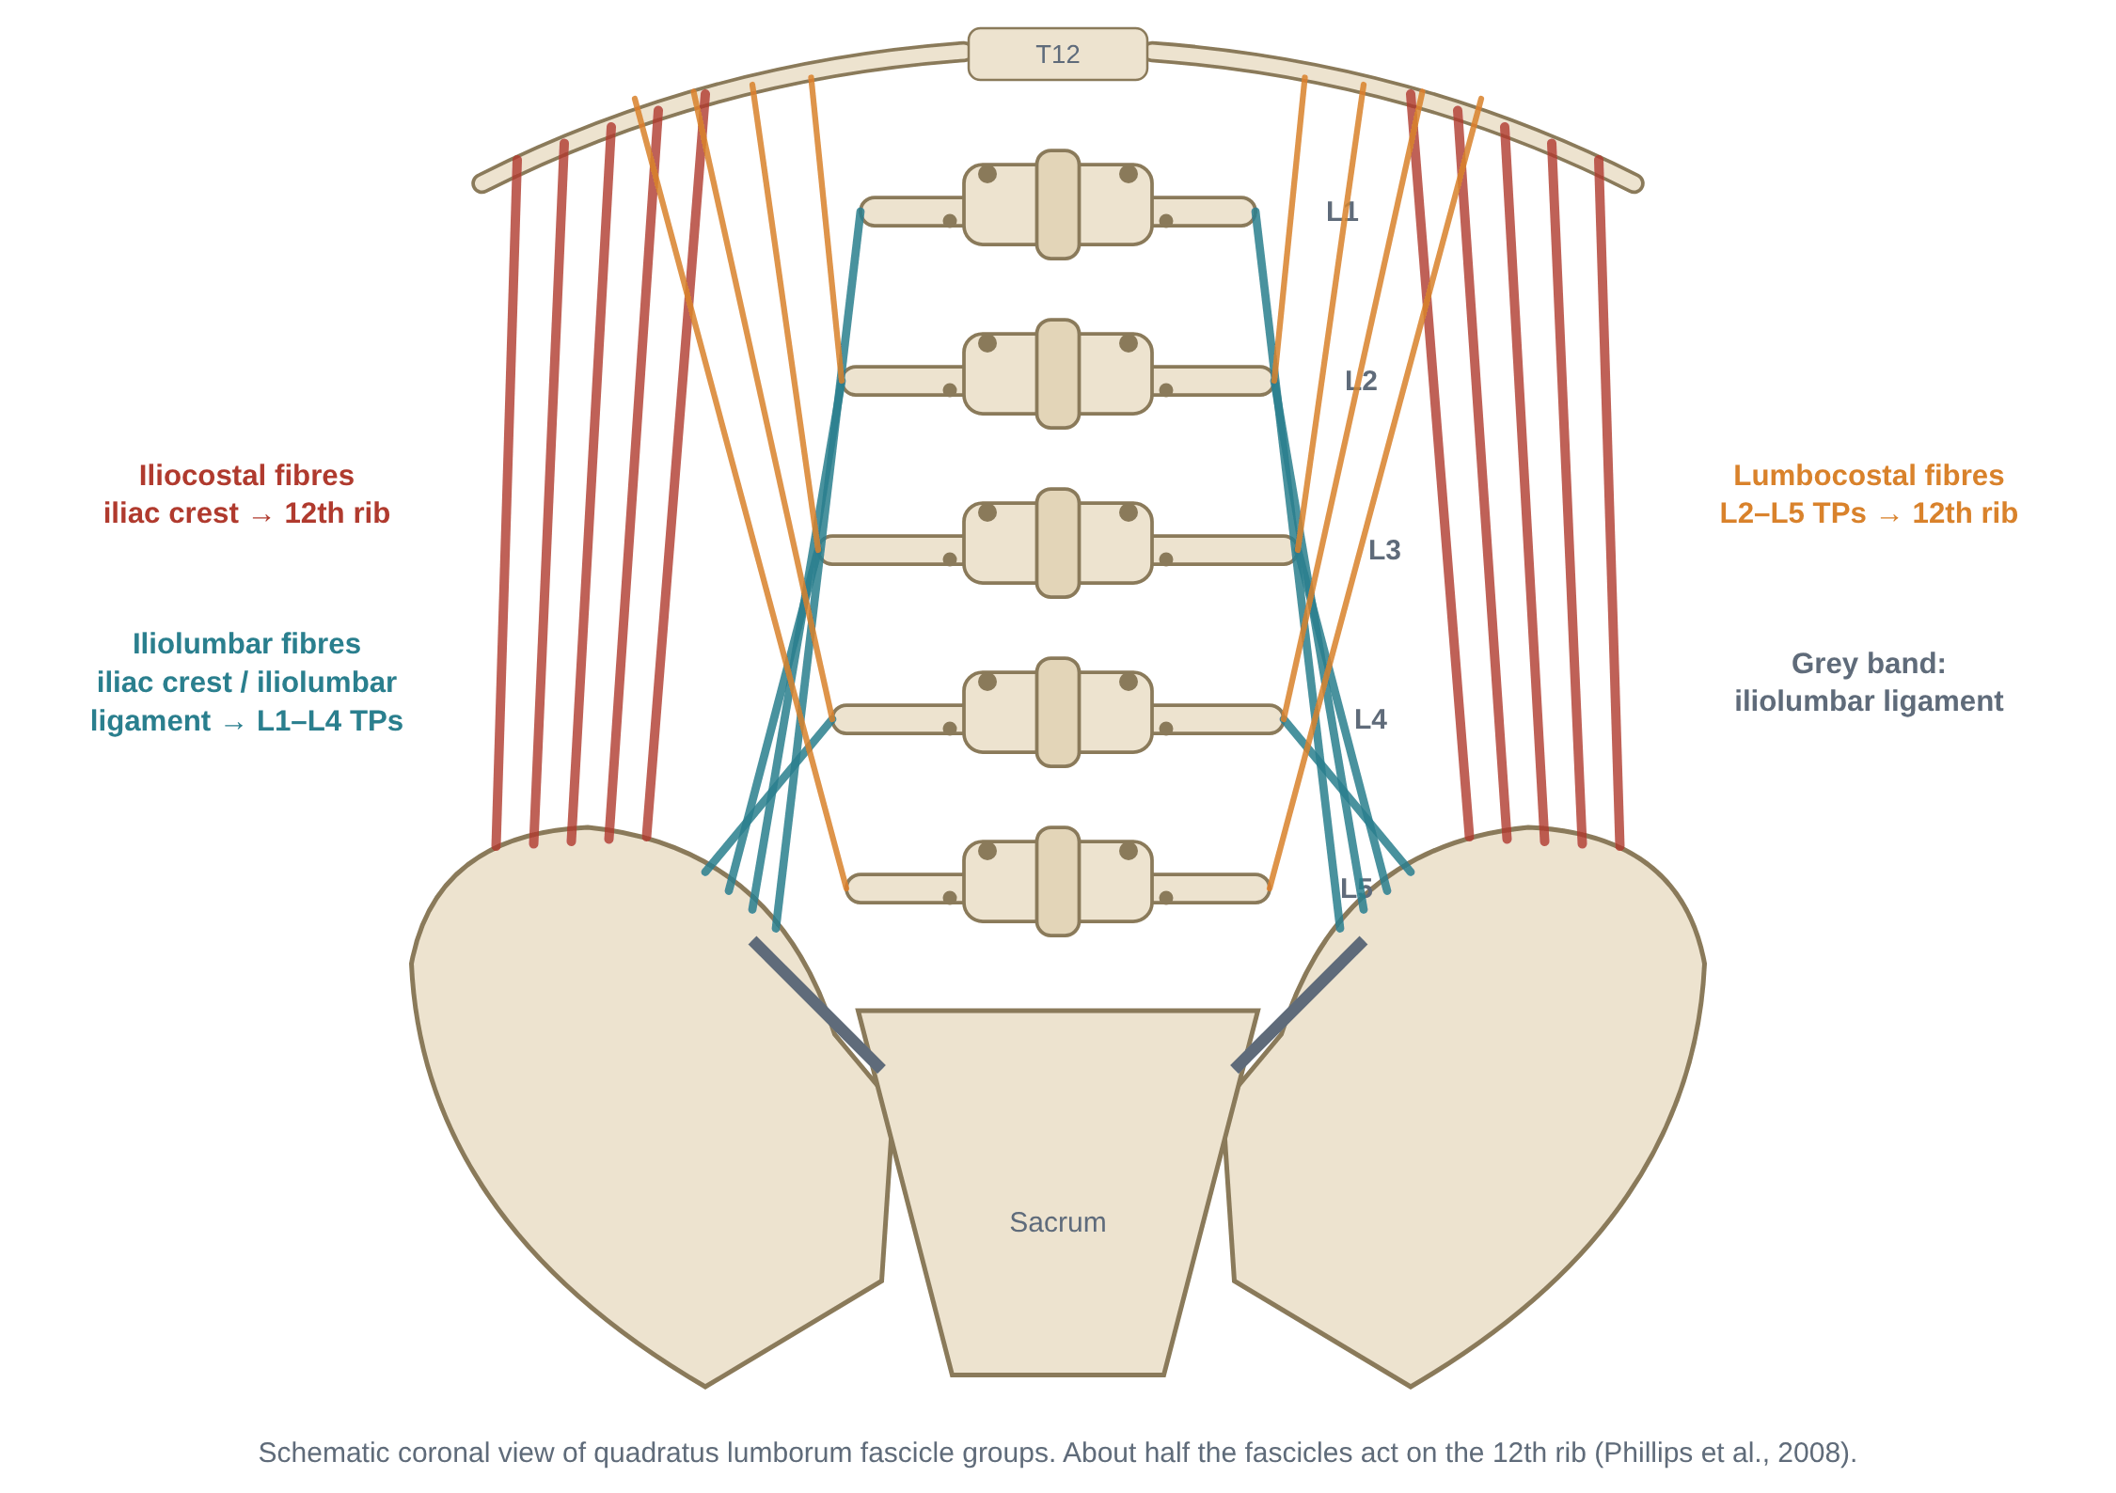
Figure 39. Fascicle groups of quadratus lumborum (from the companion document).
Feature | Summary
Attachments | Iliac crest and iliolumbar ligament → 12th rib and L1–L4 transverse processes (iliocostal, iliolumbar and lumbocostal fascicles)
Innervation | Ventral rami of T12–L3(4)
Actions | Lateral flexion; hip "hiking"; fixes the 12th rib for the diaphragm; weak extension
Stabiliser debate | Active in many tasks, highest in side support (McGill et al. 1996) vs small lumbar forces and moments, ≤ 10% of erector spinae + multifidus (Phillips et al. 2008)
Pathomechanics | Acute guarding and lateral shift; compensation for weak gluteus medius; asymmetry associated with L4 pars injury in fast bowlers (Engstrom et al. 2007); myofascial pain referral to iliac crest, SI region, buttock and greater trochanter
Assessment & exercise | Side-bridge endurance and symmetry; Trendelenburg; side-bridge and suitcase-carry progressions

13. Thoracolumbar fascia and myofascial slings
Many back muscles act through the thoracolumbar fascia (TLF). Its posterior layer receives latissimus dorsi above and gluteus maximus below and covers the erector spinae; its middle layer attaches to the transverse processes and gives origin to transversus abdominis and internal oblique; its anterior layer covers quadratus lumborum. Tension in the TLF stiffens the lumbar spine and transfers load diagonally between the upper and lower limbs (Vleeming et al. 1995).
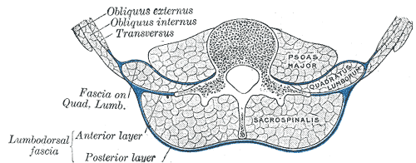
Figure 40. Transverse section of the lumbar region showing the layers of the lumbodorsal (thoracolumbar) fascia around sacrospinalis (erector spinae) and quadratus lumborum. (Gray's Anatomy, 1918 — public domain, via Wikimedia Commons.)
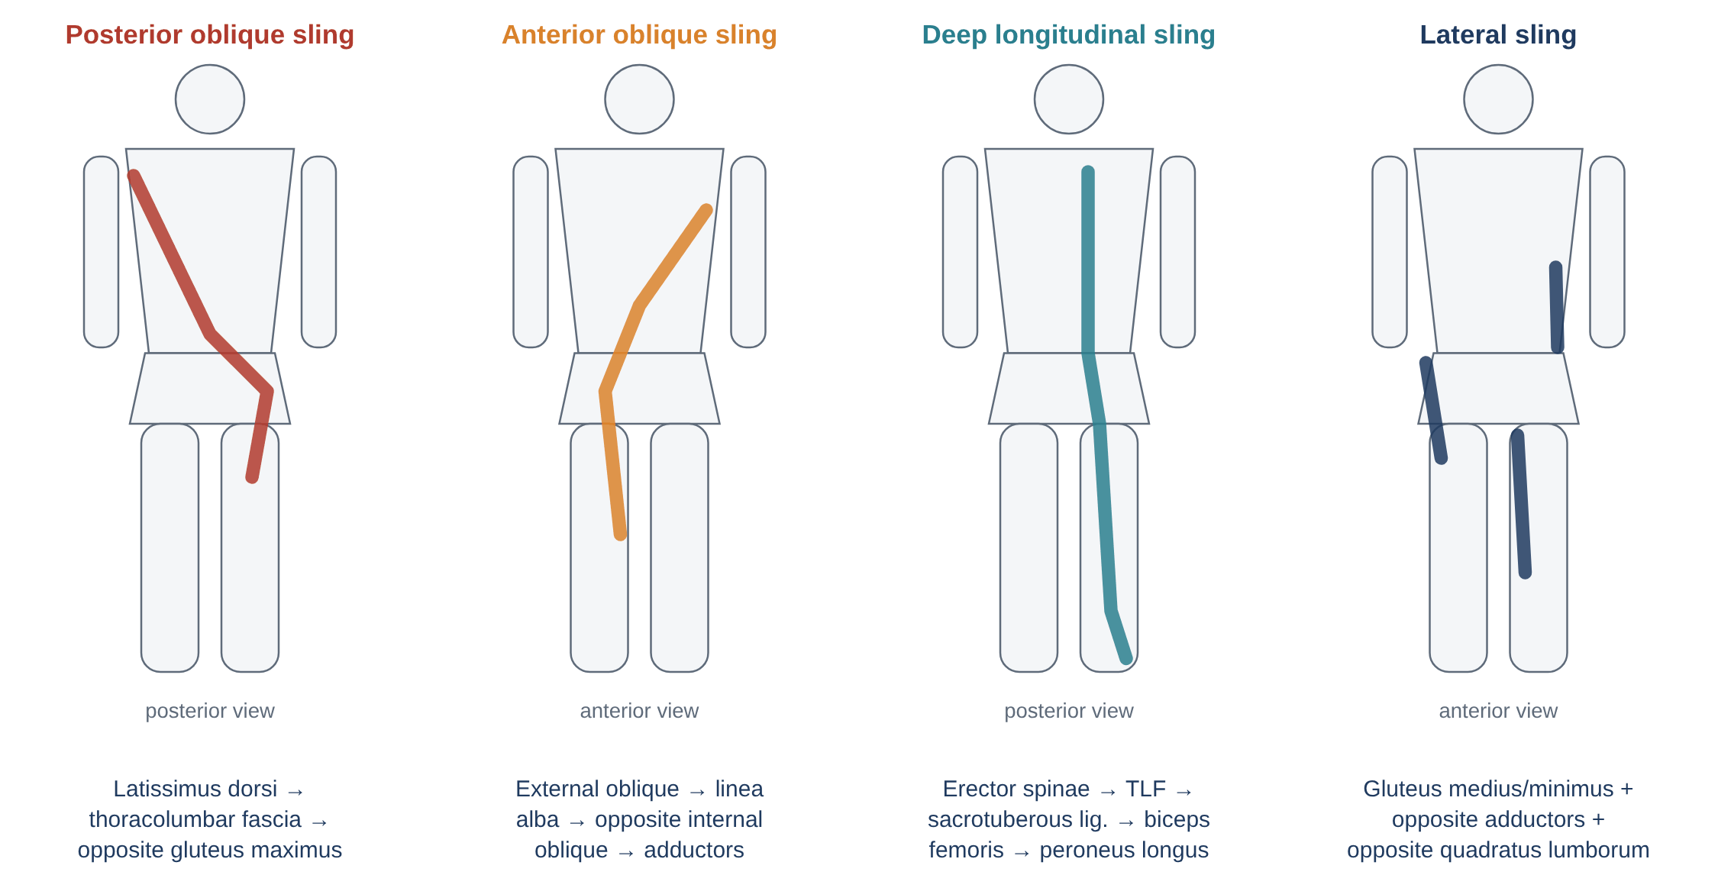
Figure 41. Myofascial slings that cross the lumbopelvic region (from the companion document).

14. Pathomechanics flowcharts

Flowchart 1 — Forward head posture and the "upper crossed" pattern
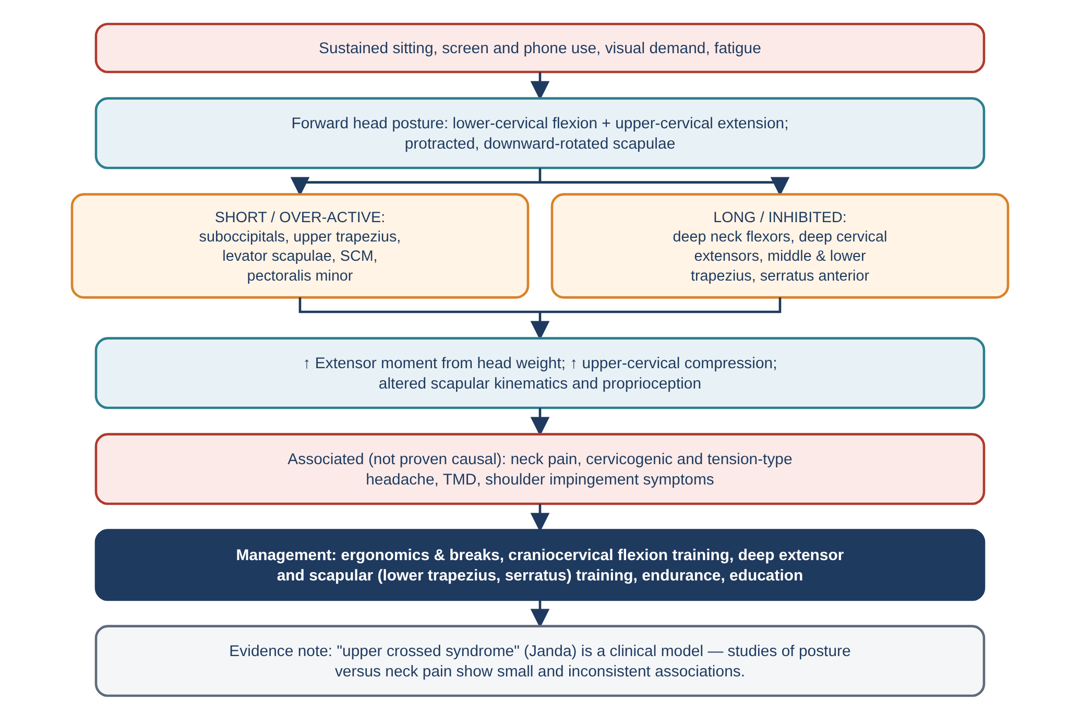
Figure 42. Forward head posture and the "upper crossed" pattern.

Flowchart 2 — Scapular dyskinesis (trapezius, levator scapulae, rhomboids)
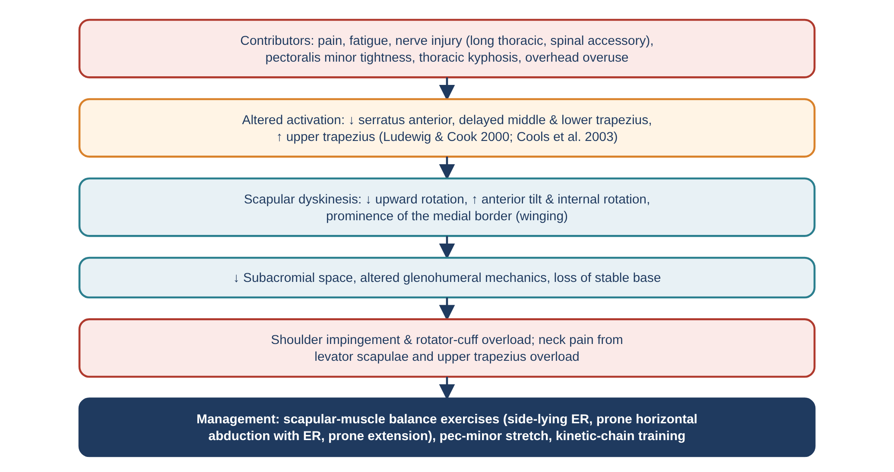
Figure 43. Scapular dyskinesis (trapezius, levator scapulae, rhomboids).

Flowchart 3 — Trapezius myalgia and the Cinderella hypothesis
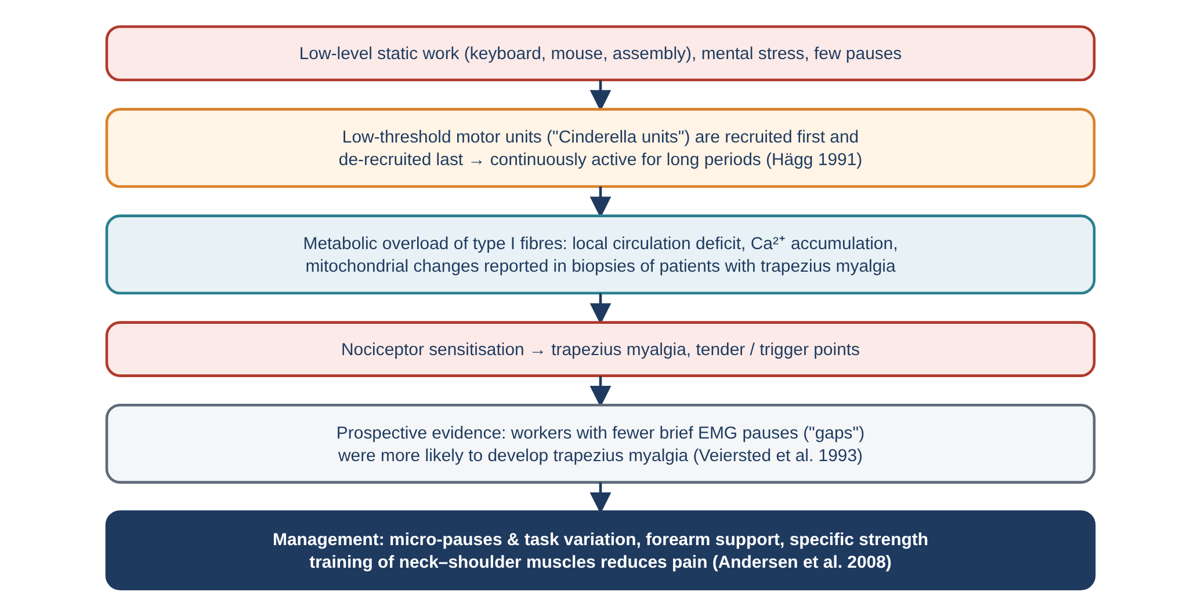
Figure 44. Trapezius myalgia and the Cinderella hypothesis.

Flowchart 4 — Cervicogenic headache and the suboccipital/upper cervical muscles
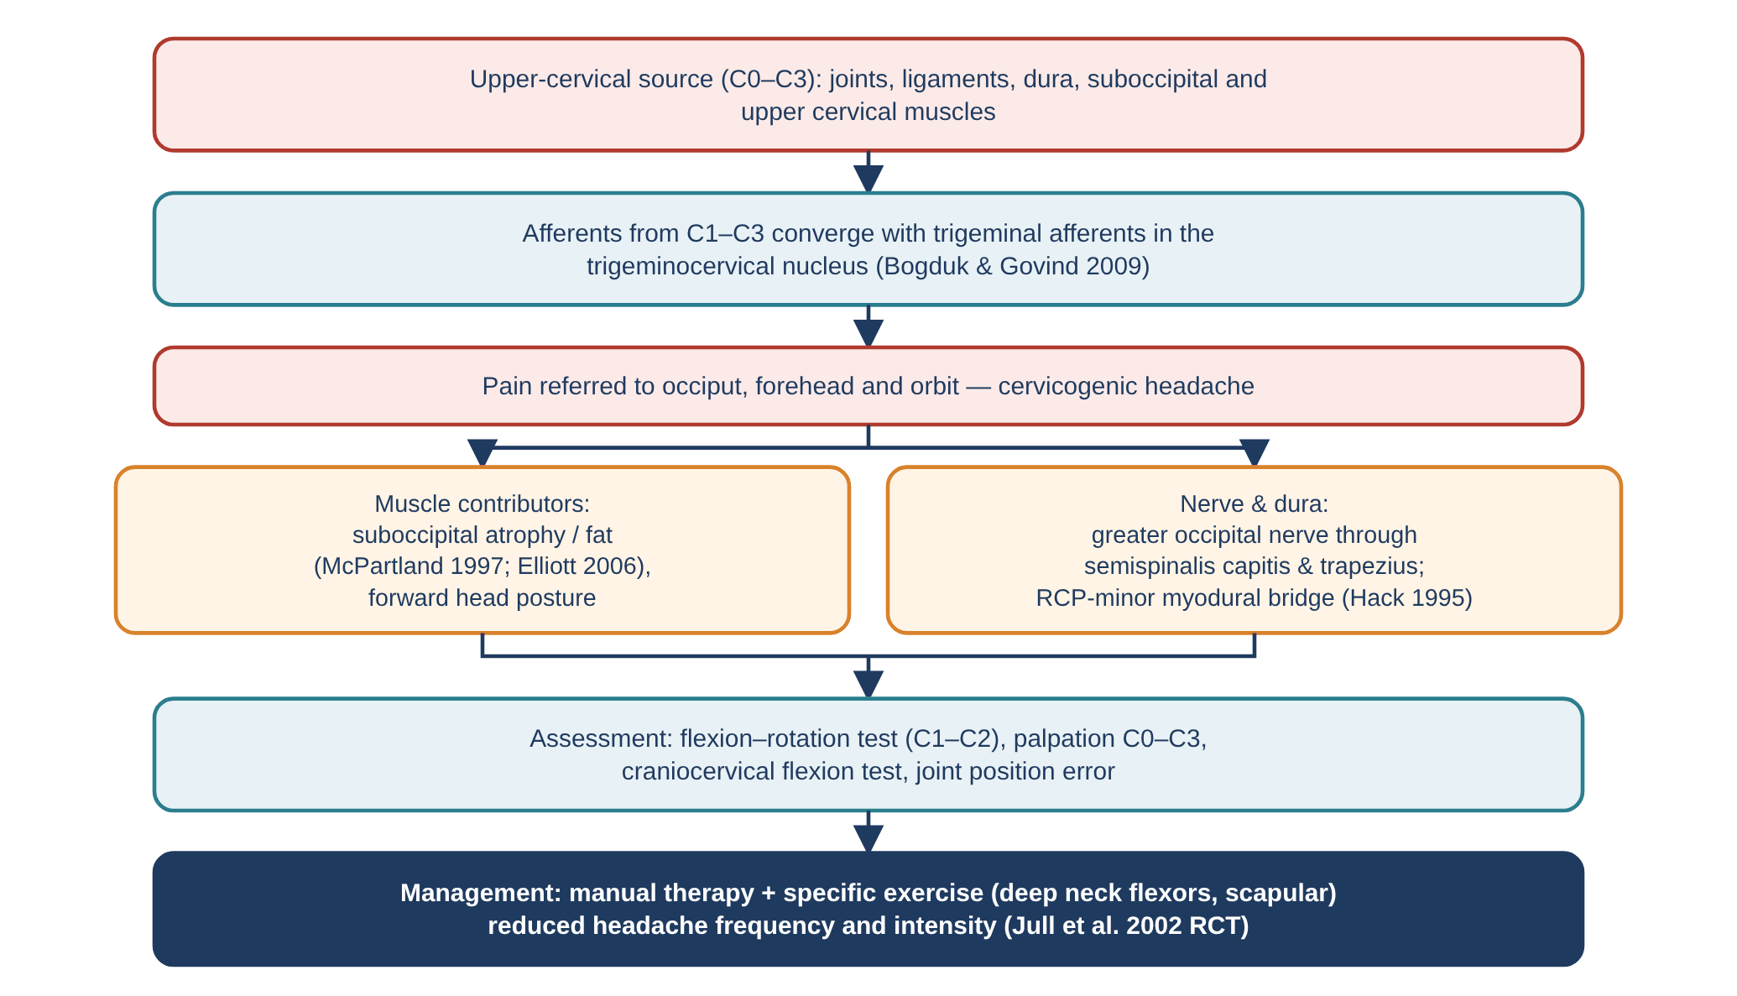
Figure 45. Cervicogenic headache and the suboccipital/upper cervical muscles.

Flowchart 5 — Whiplash and the deep cervical extensors
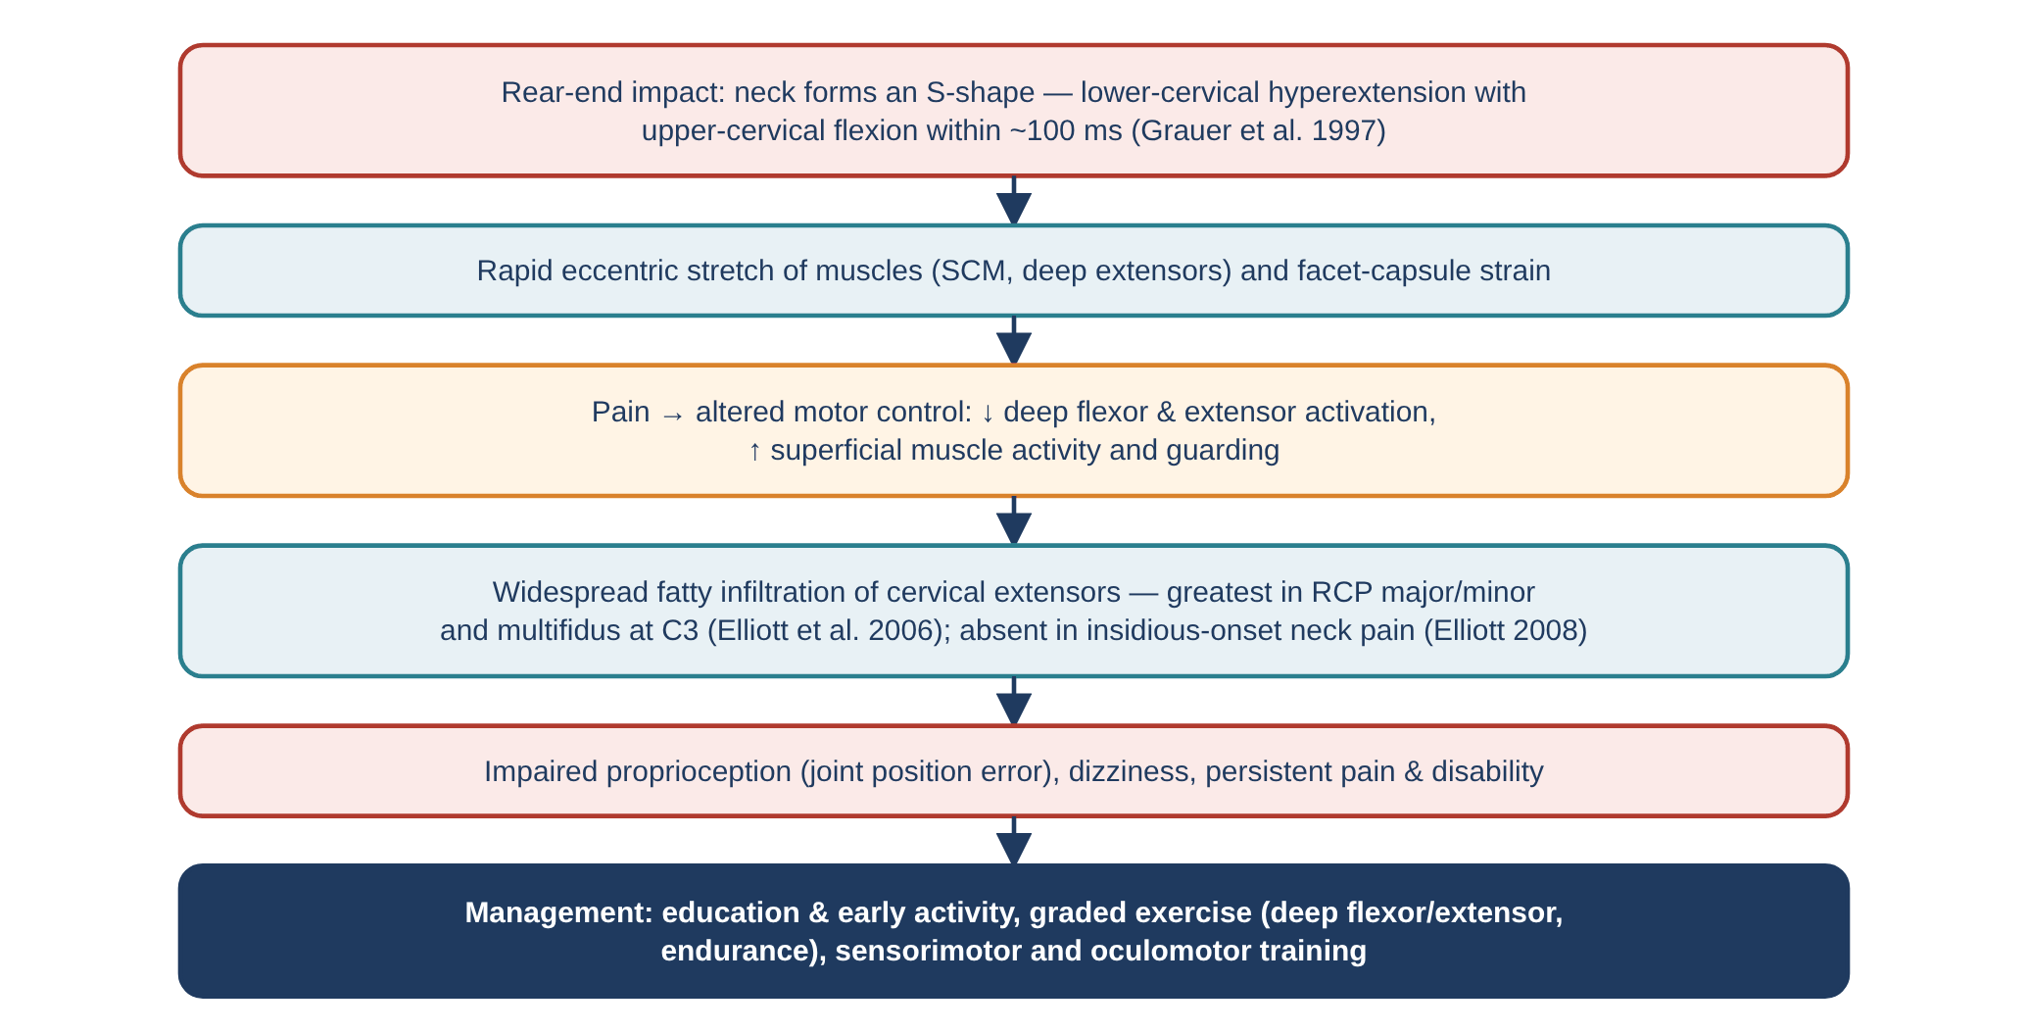
Figure 46. Whiplash and the deep cervical extensors.

Flowchart 6 — Back-extensor weakness and thoracic hyperkyphosis
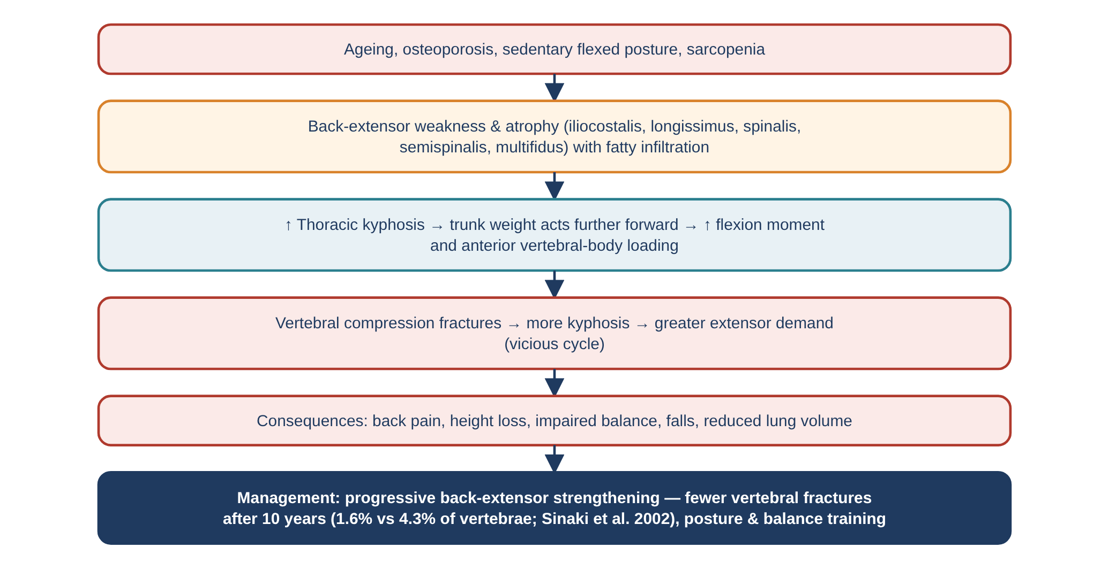
Figure 47. Back-extensor weakness and thoracic hyperkyphosis.

Flowchart 7 — Lumbar multifidus after injury (from the companion document)
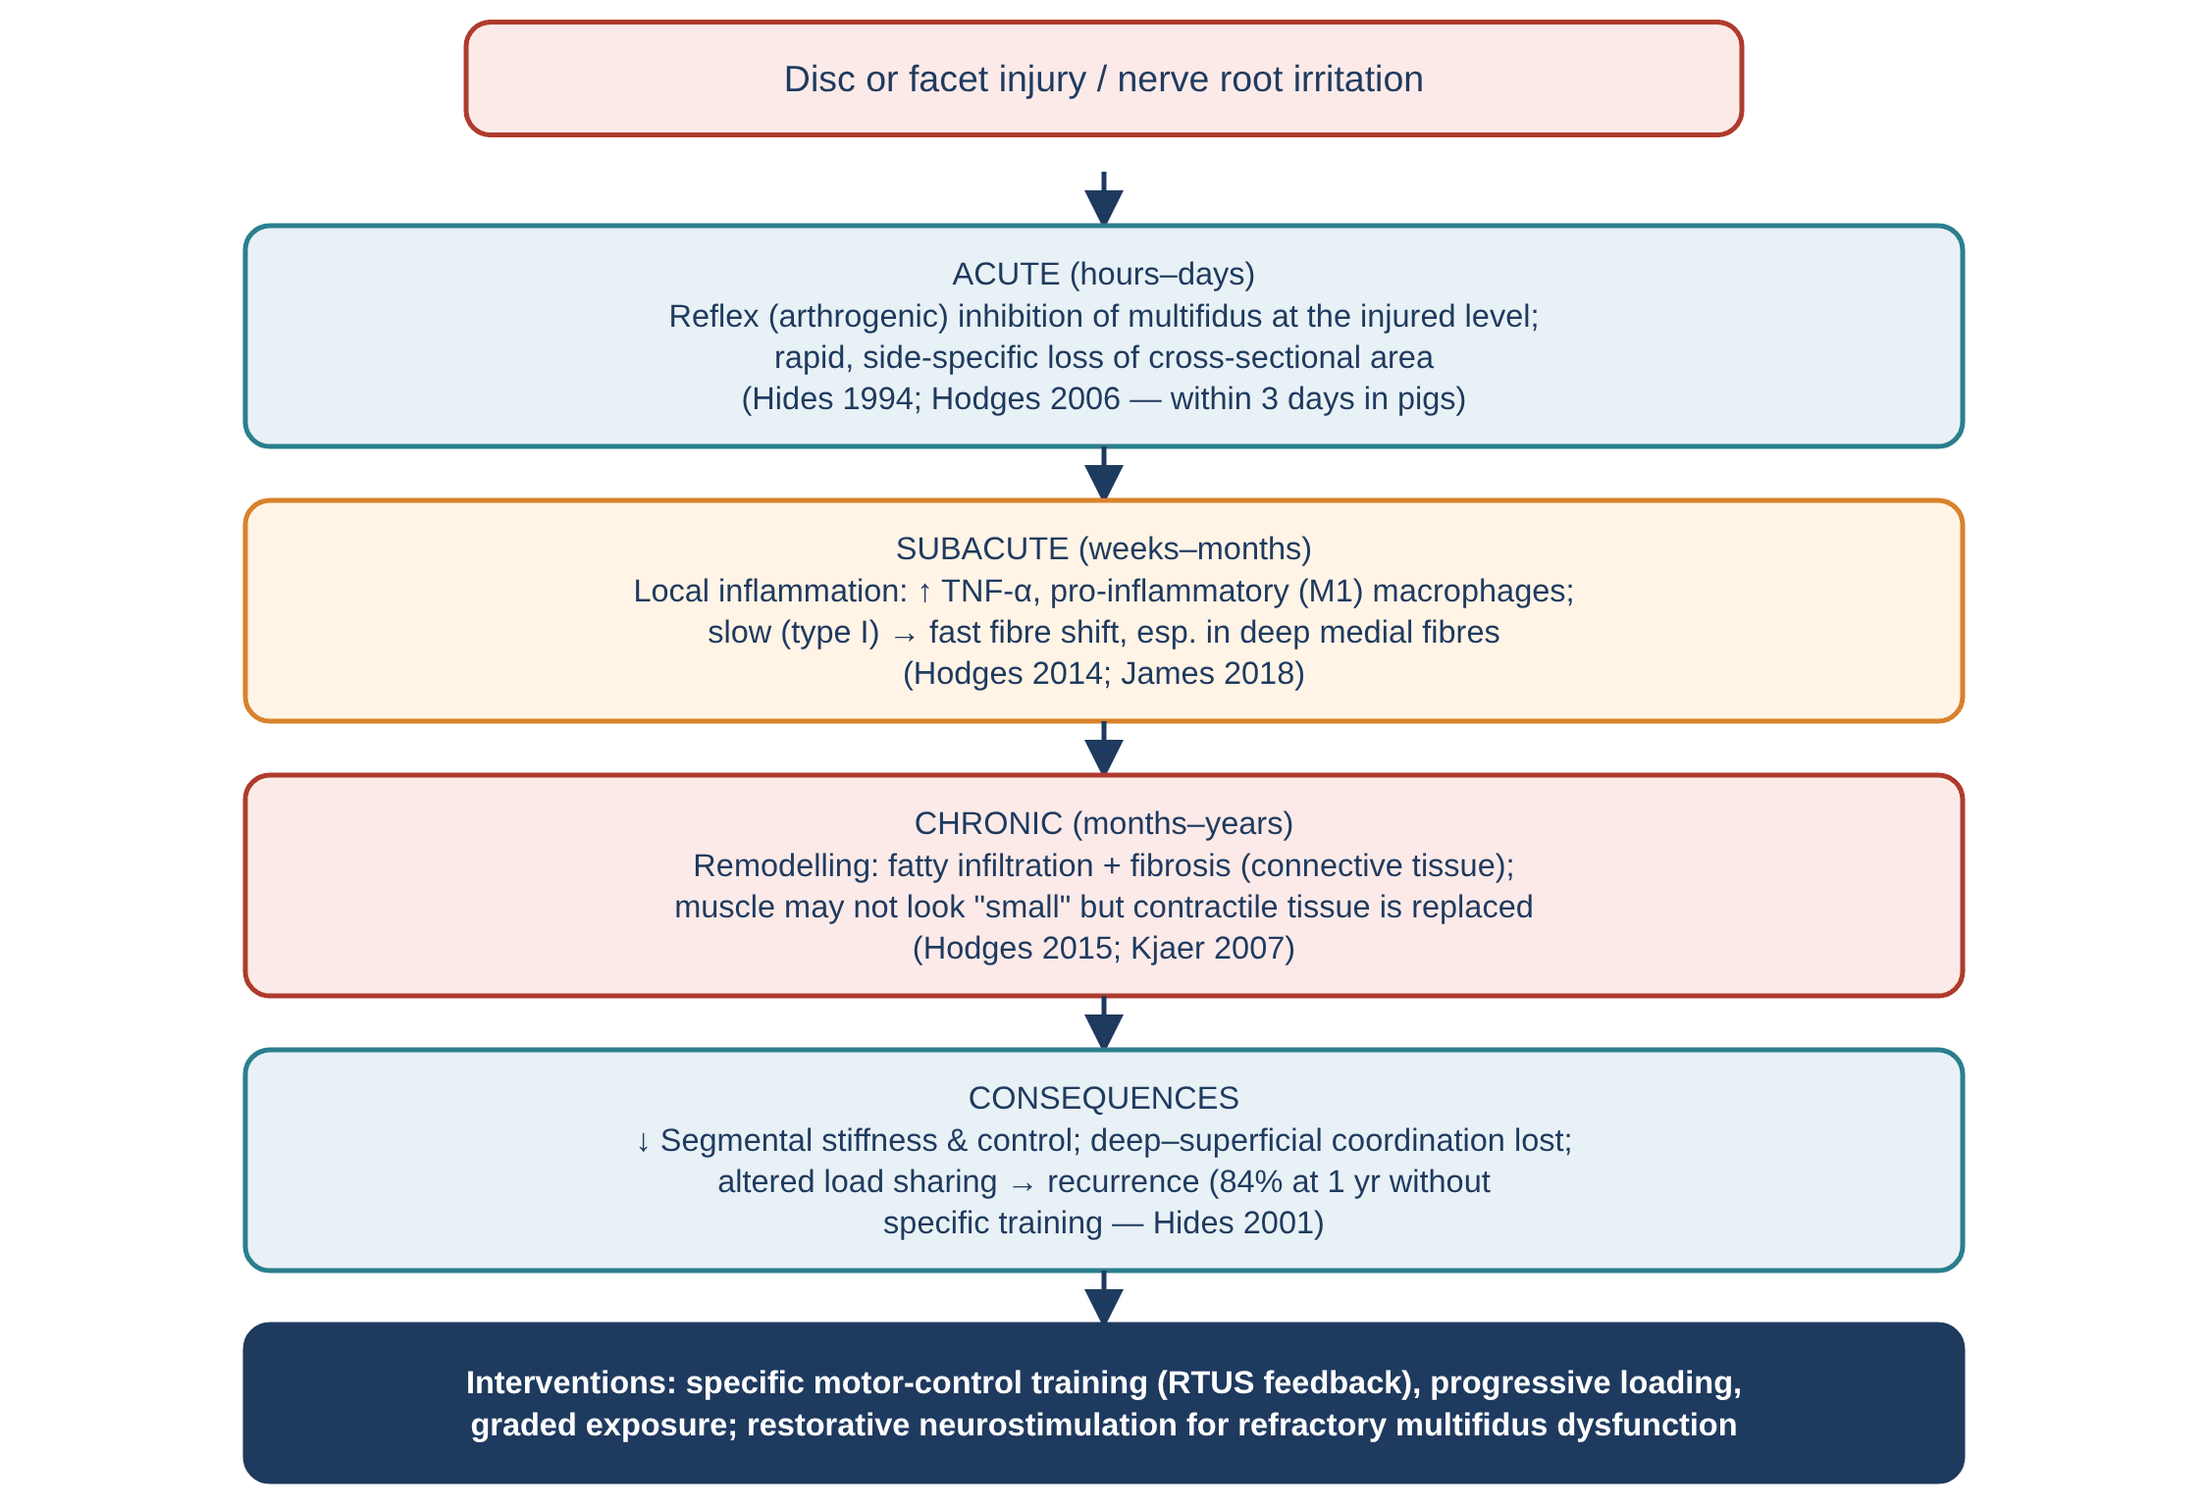
Figure 48. Lumbar multifidus after injury (from the companion document).

Flowchart 8 — Lumbar erector spinae pathomechanics (from the companion document)
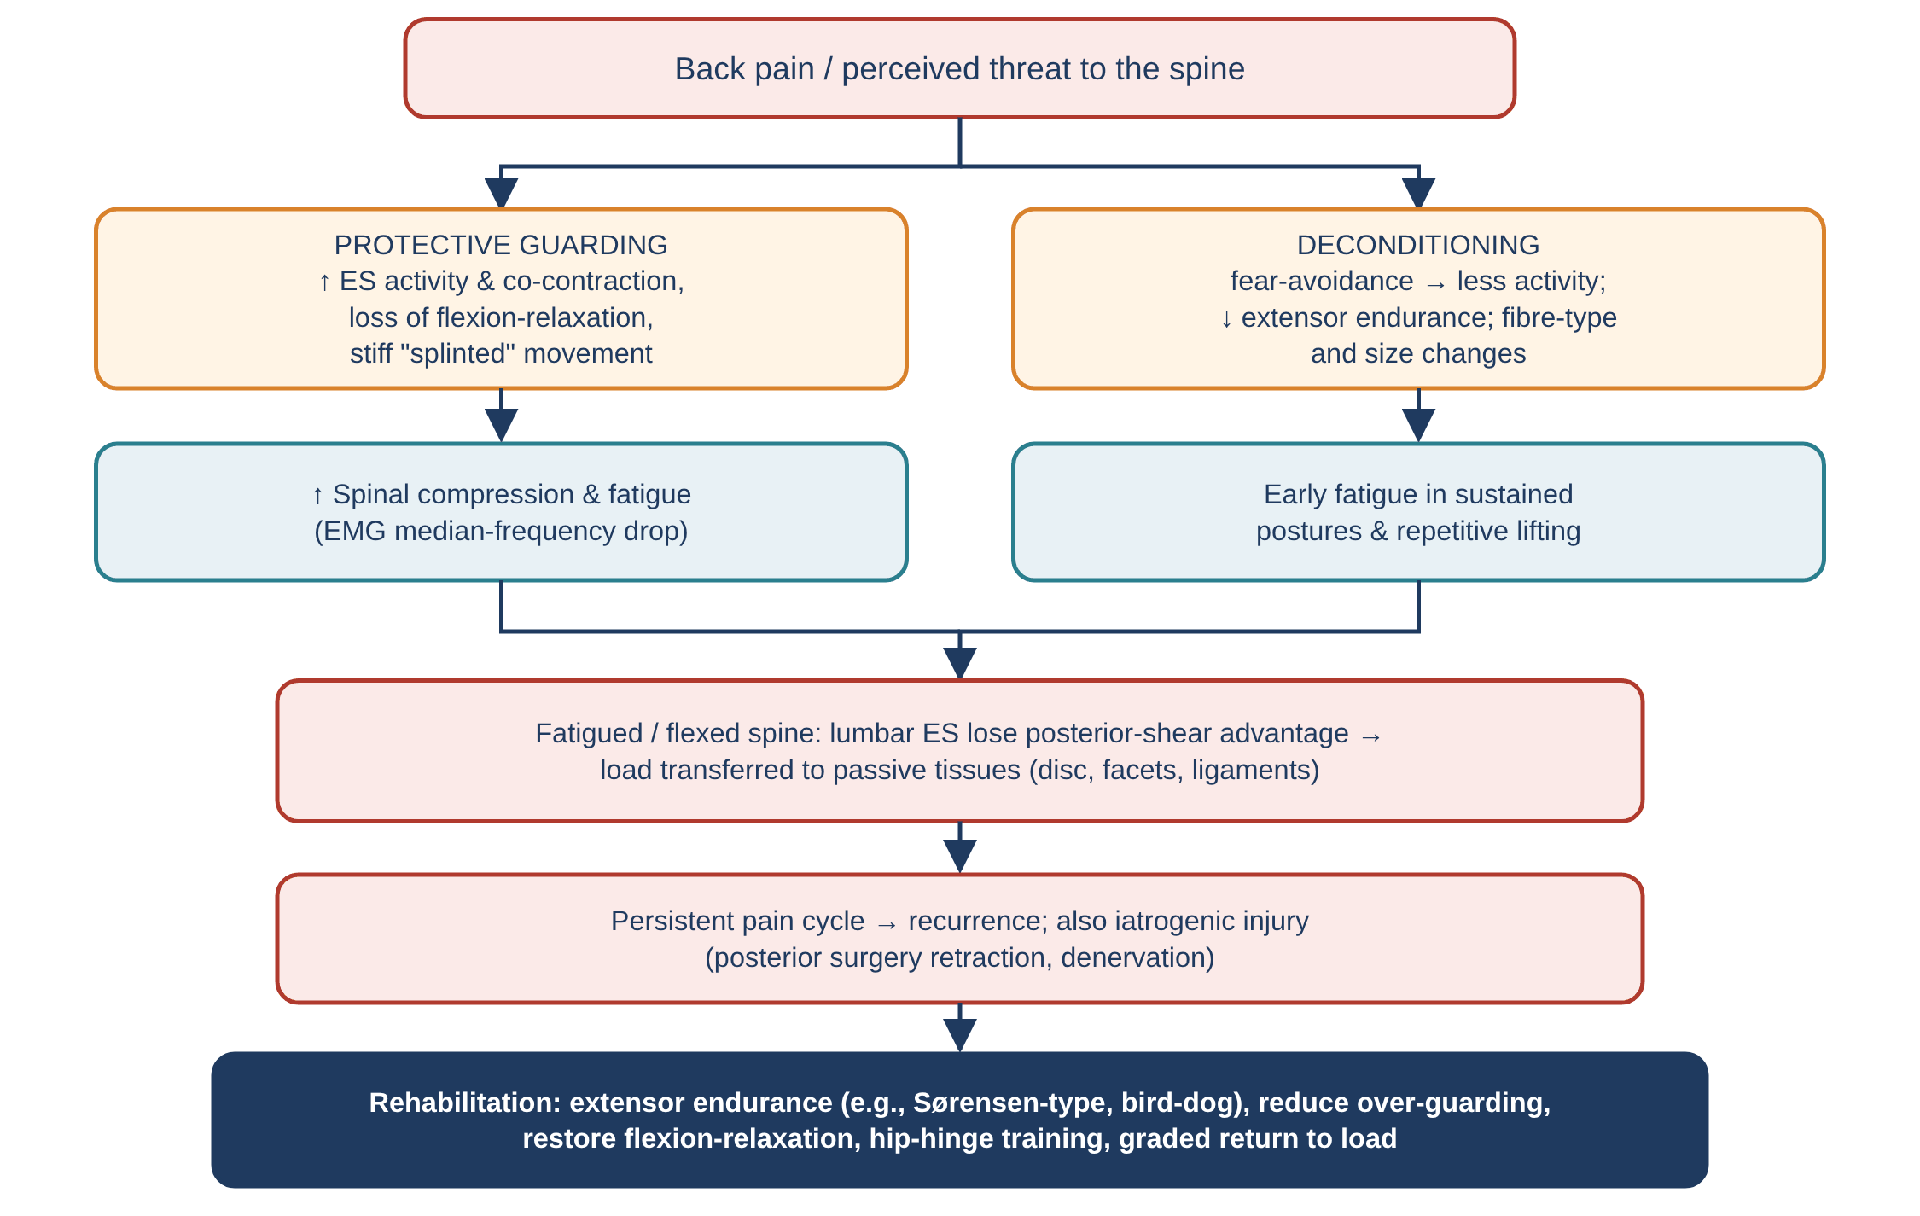
Figure 49. Lumbar erector spinae pathomechanics (from the companion document).

Flowchart 9 — Quadratus lumborum overload (from the companion document)
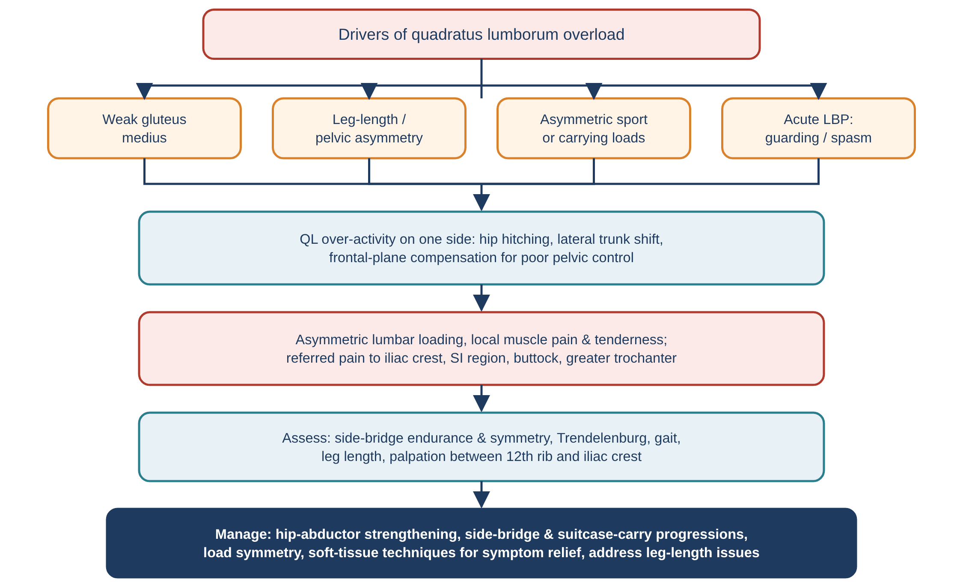
Figure 50. Quadratus lumborum overload (from the companion document).

15. Master summary table
Muscle | Attachments (short) | Nerve | Main action | Key pathomechanics
Trapezius | Occiput, lig. nuchae, C7–T12 SPs → clavicle, acromion, scapular spine | CN XI (+C3–C4) | Scapular elevation, retraction, depression, upward rotation; head extension | Myalgia (Cinderella), dyskinesis, CN XI palsy
Latissimus dorsi | T7–T12 SPs, TLF, iliac crest, ribs → humerus | Thoracodorsal C6–C8 | Shoulder extension/adduction/IR; trunk lift with arm fixed | Short lat → lumbar extension compensation; tears in throwers
Levator scapulae | C1–C4 TPs → superior angle | Dorsal scapular C5 (+C3–C4) | Scapular elevation & downward rotation; neck side-flexion | Stiff neck, downward-rotation syndrome
Rhomboids | C7–T5 SPs → medial border | Dorsal scapular C4–C5 | Retraction, downward rotation | Interscapular pain (often cervical referral), DSN entrapment
Serratus posterior superior | C7–T3 SPs → ribs 2–5 | Intercostal T2–T5 | Rib elevation (questioned) | Deep interscapular/arm pain
Serratus posterior inferior | T11–L2 SPs → ribs 9–12 | T9–T12 | Rib depression (questioned) | Thoracolumbar pain; mimics renal pain
Splenius capitis | Lig. nuchae, C7–T3 SPs → mastoid, SNL | Dorsal rami | Head extension, ipsilateral rotation | Cervical dystonia, whiplash, headache
Splenius cervicis | T3–T6 SPs → C1–C3 TPs | Dorsal rami | Neck extension, ipsilateral rotation | Neck pain, dystonia
Iliocostalis | Crest/ESA → ribs → ribs → C4–C6 TPs | Dorsal rami (lateral) | Extension, strong lateral flexion | Guarding, lateral shift, scoliosis, kyphosis
Longissimus | Lumbar/thoracic TPs ↔ ESA, ilium; T1–T5 → C2–C6, mastoid | Dorsal rami (intermediate) | Extension; lumbar posterior shear | Fatigue, loss of shear protection, surgery
Spinalis | T11–L2 SPs → T2–T8 SPs (+ cervical) | Dorsal rami | Thoracic extension | Extensor weakness in kyphosis
Semispinalis | T1–T10 TPs → C2–T4 SPs, occiput | Dorsal rami (medial) + GON | Head and neck extension; segmental control (cervicis) | Reduced deep extensor activation, GON entrapment
Multifidus | Articular/TPs/mamillary → SPs 2–4 above; sacrum | Medial branch (segmental) | Segmental extension, stiffness | Inhibition, fat, fibrosis; whiplash; iatrogenic
Rotatores | TP → lamina 1–2 above | Medial branch | Proprioception (weak rotation) | Position-sense deficits
Interspinales | Adjacent SPs | Medial branch | Weak extension; proprioception | Interspinous pain, kissing spines
Intertransversarii | Adjacent TPs / accessory → mamillary | Ventral & dorsal rami | Weak lateral flexion; proprioception | Little research
Levatores costarum | C7–T11 TPs → rib below | Dorsal rami C8–T11 | Rib elevation | Costovertebral pain
RCP major | C2 SP → INL lateral | C1 dorsal ramus | Head extension, ipsilateral rotation | Atrophy/fat, headache
RCP minor | C1 tubercle → INL medial | C1 dorsal ramus | Extension; proprioception; myodural bridge | Atrophy, dizziness, headache (hypothesis)
Obliquus capitis inferior | C2 SP → C1 TP | C1 dorsal ramus | Rotation of atlas | C1–C2 restriction, GON irritation
Obliquus capitis superior | C1 TP → occiput | C1 dorsal ramus | Head extension, lateral flexion | Suboccipital headache
Quadratus lumborum | Iliac crest → rib 12, L1–L4 TPs | T12–L3 ventral rami | Lateral flexion, pelvic hike | Guarding, compensation, asymmetry

16. Assessment quick reference
Muscle(s) | Test | What a positive finding suggests
Trapezius, serratus anterior | Scapular dyskinesis test; scapular assistance test | Scapular control deficit contributing to shoulder/neck symptoms
Upper trapezius (CN XI) | Resisted shrug; observation for lateral winging | Spinal accessory nerve lesion
Middle / lower trapezius | Prone T / prone Y manual muscle tests | Weakness of scapular retractors / depressors
Latissimus dorsi | Supine overhead flexion with lumbar spine flat | Short latissimus (lumbar extension compensation)
Levator scapulae | Flexion + contralateral side-flexion + rotation with scapula depressed | Short / painful levator
Rhomboids | Prone hand-lift-off from the low back (resisted) | Weak retraction / downward rotation
Splenius, semispinalis | Neck extensor endurance; resisted rotation | Low endurance; painful extensors
Deep cervical extensors | Extension with upper neck neutral (four-point kneeling) | Poor deep extensor control
Suboccipitals / C1–C2 | Flexion–rotation test; joint position error | Upper-cervical dysfunction; proprioceptive deficit
Erector spinae | Biering-Sørensen test; flexion-relaxation | Low endurance; guarding
Multifidus | Palpation / RTUS; prone instability test | Segmental atrophy; poor activation
Quadratus lumborum | Side-bridge symmetry; Trendelenburg | Frontal-plane weakness / compensation

17. References
Andersen, L. L., et al. (2008). Effect of two contrasting types of physical exercise on chronic neck muscle pain. Arthritis & Rheumatism, 59(1), 84–91.
Anderson, J. S., Hsu, A. W., & Vasavada, A. N. (2005). Morphology, architecture, and biomechanics of human cervical multifidus. Spine, 30(4), E86–E91.
Biering-Sørensen, F. (1984). Physical measurements as risk indicators for low-back trouble over a one-year period. Spine, 9(2), 106–119.
Bogduk, N. (1980). A reappraisal of the anatomy of the human lumbar erector spinae. Journal of Anatomy, 131(3), 525–540.
Bogduk, N. (2012). Clinical and Radiological Anatomy of the Lumbar Spine (5th ed.). Churchill Livingstone.
Bogduk, N., & Govind, J. (2009). Cervicogenic headache: an assessment of the evidence on clinical diagnosis, invasive tests, and treatment. Lancet Neurology, 8(10), 959–968.
Bogduk, N., Johnson, G., & Spalding, D. (1998). The morphology and biomechanics of latissimus dorsi. Clinical Biomechanics, 13(6), 377–385.
Brumagne, S., Cordo, P., Lysens, R., Verschueren, S., & Swinnen, S. (2000). The role of paraspinal muscle spindles in lumbosacral position sense in individuals with and without low back pain. Spine, 25(8), 989–994.
Cloward, R. B. (1959). Cervical diskography: a contribution to the etiology and mechanism of neck, shoulder and arm pain. Annals of Surgery, 150(6), 1052–1064.
Colloca, C. J., & Hinrichs, R. N. (2005). The biomechanical and clinical significance of the lumbar erector spinae flexion-relaxation phenomenon: a review. JMPT, 28(8), 623–631.
Cools, A. M., et al. (2003). Scapular muscle recruitment patterns: trapezius muscle latency with and without impingement symptoms. American Journal of Sports Medicine, 31(4), 542–549.
Cools, A. M., et al. (2007). Rehabilitation of scapular muscle balance: which exercises to prescribe? American Journal of Sports Medicine, 35(10), 1744–1751.
Dreyfuss, P., et al. (2009). The significance of multifidus atrophy after successful radiofrequency neurotomy for low back pain. PM&R, 1(8), 719–722.
Elliott, J., et al. (2006). Fatty infiltration in the cervical extensor muscles in persistent whiplash-associated disorders: a magnetic resonance imaging analysis. Spine, 31(22), E847–E855.
Elliott, J., et al. (2008). Fatty infiltrate in the cervical extensor muscles is not a feature of chronic, insidious-onset neck pain. Clinical Radiology, 63(6), 681–687.
Engstrom, C. M., et al. (2007). Quadratus lumborum asymmetry and L4 pars injury in fast bowlers: a prospective MR study. Medicine & Science in Sports & Exercise, 39(6), 910–917.
Falla, D., Bilenkij, G., & Jull, G. (2004). Patients with chronic neck pain demonstrate altered patterns of muscle activation during performance of a functional upper limb task. Spine, 29(13), 1436–1440.
Fernández-de-las-Peñas, C., et al. (2006). Trigger points in the suboccipital muscles and forward head posture in tension-type headache. Headache, 46(3), 454–460.
Grauer, J. N., Panjabi, M. M., et al. (1997). Whiplash produces an S-shaped curvature of the neck with hyperextension at lower levels. Spine, 22(21), 2489–2494.
Gray, H. (1918). Anatomy of the Human Body (20th ed.). Lea & Febiger. (Plates via Wikimedia Commons, public domain.)
Hack, G. D., et al. (1995). Anatomic relation between the rectus capitis posterior minor muscle and the dura mater. Spine, 20(23), 2484–2486.
Hägg, G. M. (1991). Static work loads and occupational myalgia — a new explanation model. In P. A. Anderson, D. J. Hobart & J. V. Danoff (Eds.), Electromyographical Kinesiology (pp. 141–144). Elsevier.
Hall, T., & Robinson, K. (2004). The flexion–rotation test and active cervical mobility — a comparative measurement study in cervicogenic headache. Manual Therapy, 9(4), 197–202.
Hides, J. A., et al. (1994). Evidence of lumbar multifidus muscle wasting ipsilateral to symptoms in patients with acute/subacute low back pain. Spine, 19(2), 165–172.
Hides, J. A., Richardson, C. A., & Jull, G. A. (1996). Multifidus muscle recovery is not automatic after resolution of acute, first-episode low back pain. Spine, 21(23), 2763–2769.
Hides, J. A., Jull, G. A., & Richardson, C. A. (2001). Long-term effects of specific stabilizing exercises for first-episode low back pain. Spine, 26(11), E243–E248.
Hodges, P., Holm, A. K., Hansson, T., & Holm, S. (2006). Rapid atrophy of the lumbar multifidus follows experimental disc or nerve root injury. Spine, 31(25), 2926–2933.
Hodges, P. W., et al. (2014). Can proinflammatory cytokine gene expression explain multifidus muscle fiber changes after an intervertebral disc lesion? Spine, 39(13), 1010–1017.
Hodges, P. W., et al. (2015). Multifidus muscle changes after back injury are characterized by structural remodeling of muscle, adipose and connective tissue, but not muscle atrophy. Spine, 40(14), 1057–1071.
Hodges, P. W., & Tucker, K. (2011). Moving differently in pain: a new theory to explain the adaptation to pain. Pain, 152(3 Suppl), S90–S98.
James, G., et al. (2018). Macrophage polarization contributes to local inflammation and structural change in the multifidus muscle after intervertebral disc injury. European Spine Journal, 27(8), 1744–1756.
Johnson, G., Bogduk, N., Nowitzke, A., & House, D. (1994). Anatomy and actions of the trapezius muscle. Clinical Biomechanics, 9(1), 44–50.
Jull, G., et al. (2002). A randomized controlled trial of exercise and manipulative therapy for cervicogenic headache. Spine, 27(17), 1835–1843.
Kawaguchi, Y., Matsui, H., & Tsuji, H. (1996). Back muscle injury after posterior lumbar spine surgery: a histologic and enzymatic analysis. Spine, 21(8), 941–944.
Kendall, F. P., et al. (2005). Muscles: Testing and Function with Posture and Pain (5th ed.). Lippincott Williams & Wilkins.
Kibler, W. B., et al. (2013). Clinical implications of scapular dyskinesis in shoulder injury: the 2013 consensus statement from the "Scapular Summit". British Journal of Sports Medicine, 47(14), 877–885.
Loukas, M., et al. (2008). Serratus posterior superior and inferior muscles: a morphometric study in chronic obstructive pulmonary disease. Surgical and Radiologic Anatomy, 30(2), 119–123.
Ludewig, P. M., & Cook, T. M. (2000). Alterations in shoulder kinematics and associated muscle activity in people with symptoms of shoulder impingement. Physical Therapy, 80(3), 276–291.
Macintosh, J. E., Valencia, F., Bogduk, N., & Munro, R. R. (1986). The morphology of the human lumbar multifidus. Clinical Biomechanics, 1(4), 196–204.
Macintosh, J. E., & Bogduk, N. (1986). The biomechanics of the lumbar multifidus. Clinical Biomechanics, 1(4), 205–213.
Macintosh, J. E., & Bogduk, N. (1991). EMG-driven modelling of lumbar erector spinae fascicle forces and anterior shear in squat lifting. Clinical Biomechanics (1991).
Mannion, A. F., et al. (1997). Muscle fibre size and type distribution in thoracic and lumbar regions of erector spinae in healthy subjects without low back pain. Journal of Anatomy, 190(4), 505–513.
Mannion, A. F., Weber, B. R., Dvorak, J., Grob, D., & Müntener, M. (1997). Fibre type characteristics of the lumbar paraspinal muscles in normal healthy subjects and in patients with low back pain. Journal of Orthopaedic Research, 15(6), 881–887.
McClure, P., et al. (2009). A clinical method for identifying scapular dyskinesis, part 1: reliability. Journal of Athletic Training, 44(2), 160–164.
McGill, S., Juker, D., & Kropf, P. (1996). Quantitative intramuscular myoelectric activity of quadratus lumborum during a wide variety of tasks. Clinical Biomechanics, 11(3), 170–172.
McGill, S. M., Hughson, R. L., & Parks, K. (2000). Changes in lumbar lordosis modify the role of the extensor muscles. Clinical Biomechanics, 15(10), 777–780.
McGill, S. (2016). Low Back Disorders: Evidence-Based Prevention and Rehabilitation (3rd ed.). Human Kinetics.
McPartland, J. M., Brodeur, R. R., & Hallgren, R. C. (1997). Chronic neck pain, standing balance, and suboccipital muscle atrophy — a pilot study. JMPT, 20(1), 24–29.
Moseley, G. L., Hodges, P. W., & Gandevia, S. C. (2002). Deep and superficial fibers of the lumbar multifidus muscle are differentially active during voluntary arm movements. Spine, 27(2), E29–E36.
Nitz, A. J., & Peck, D. (1986). Comparison of muscle spindle concentrations in large and small human epaxial muscles acting in parallel combinations. American Surgeon, 52(5), 273–277.
Peck, D., Buxton, D. F., & Nitz, A. (1984). A comparison of spindle concentrations in large and small muscles acting in parallel combinations. Journal of Morphology, 180(3), 243–252.
Phillips, S., Mercer, S., & Bogduk, N. (2008). Anatomy and biomechanics of quadratus lumborum. Proceedings of the Institution of Mechanical Engineers, Part H, 222(2), 151–159.
Roy, S. H., De Luca, C. J., & Casavant, D. A. (1989). Lumbar muscle fatigue and chronic lower back pain. Spine, 14(9), 992–1001.
Sahrmann, S. A. (2002). Diagnosis and Treatment of Movement Impairment Syndromes. Mosby.
Schickendantz, M. S., et al. (2009). Latissimus dorsi and teres major tears in professional baseball pitchers: a case series. American Journal of Sports Medicine, 37(10), 2016–2020.
Schomacher, J., & Falla, D. (2013). Function and structure of the deep cervical extensor muscles in patients with neck pain. Manual Therapy, 18(5), 360–366.
Schomacher, J., et al. (2012). Chronic trauma-induced neck pain impairs the neural control of the deep semispinalis cervicis muscle. Clinical Neurophysiology, 123(7), 1403–1408.
Sinaki, M., et al. (2002). Stronger back muscles reduce the incidence of vertebral fractures: a prospective 10 year follow-up of postmenopausal women. Bone, 30(6), 836–841.
Standring, S. (Ed.) (2020). Gray's Anatomy: The Anatomical Basis of Clinical Practice (42nd ed.). Elsevier.
Takemitsu, Y., et al. (1988). Lumbar degenerative kyphosis: clinical, radiological and epidemiological studies. Spine, 13(11), 1317–1326.
Travell, J. G., & Simons, D. G. (1992, 1999). Myofascial Pain and Dysfunction: The Trigger Point Manual (Vols. 1–2). Williams & Wilkins.
van Dieën, J. H., Selen, L. P., & Cholewicki, J. (2003). Trunk muscle activation in low-back pain patients, an analysis of the literature. Journal of Electromyography and Kinesiology, 13(4), 333–351.
Veiersted, K. B., Westgaard, R. H., & Andersen, P. (1993). Electromyographic evaluation of muscular work pattern as a predictor of trapezius myalgia. Scandinavian Journal of Work, Environment & Health, 19(4), 284–290.
Vilensky, J. A., Baltes, M., Weikel, L., Fortin, J. D., & Fourie, L. J. (2001). Serratus posterior muscles: anatomy, clinical relevance, and function. Clinical Anatomy, 14(4), 237–241.
Vleeming, A., et al. (1995). The posterior layer of the thoracolumbar fascia: its function in load transfer from spine to legs. Spine, 20(7), 753–758.
Ward, S. R., et al. (2009). Architectural analysis and intraoperative measurements demonstrate the unique design of the multifidus muscle for lumbar spine stability. Journal of Bone and Joint Surgery (Am), 91(1), 176–185.
Wilke, H. J., et al. (1995). Stability increase of the lumbar spine with different muscle groups: a biomechanical in vitro study. Spine, 20(2), 192–198.

