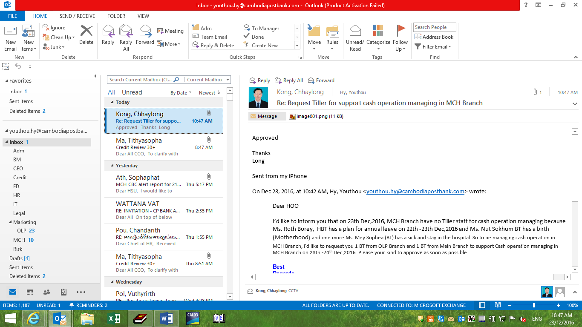

I’d like to inform you that on 23th Dec,2016, MCH Branch have no Tiller staff for cash operation managing because Ms. Roth Borey, HBT has a plan for annual leave on 22th -23th Dec,2016 and Ms. Nun Sokhom BT has a birth (Motherhood) and one more Ms. Mey Sophea (BT) has a sick and stay in the hospital and I had request 1 BT from OLP Branch and 1 BT from MBR for supporting cash operation managing. So I need you to set up USER for Ms. KEV ROMONY ID 1396 from OLP Branch and MS. CHAN THIDAROTH ID 1393 from MBR Branch to support cash operation in MCH Branch.