**API running evidences**

1. 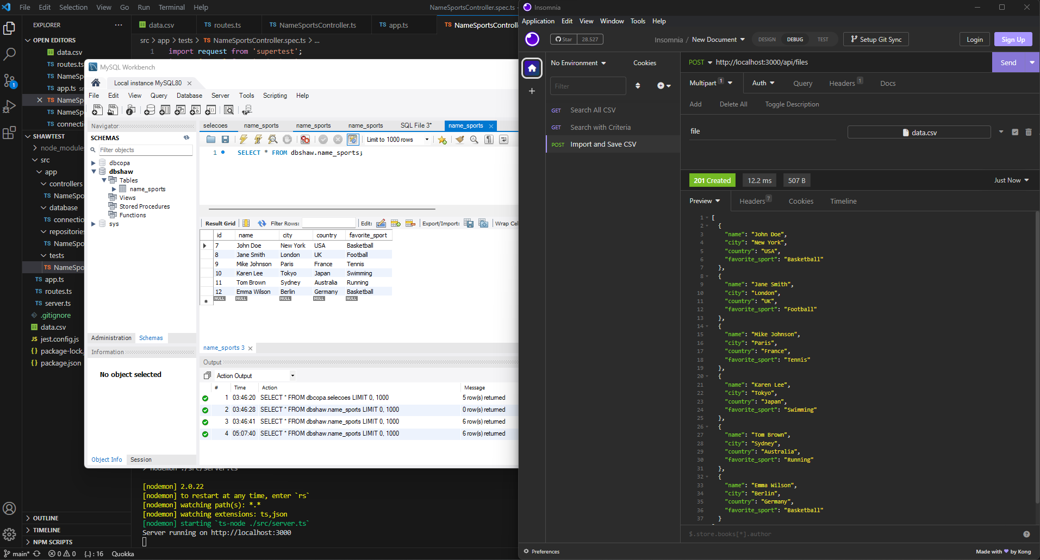Import and Save CSV (returning JSON on response and status 201)
2. Search all CSV data on the database without query parameter (returning JSON on response and status 201)

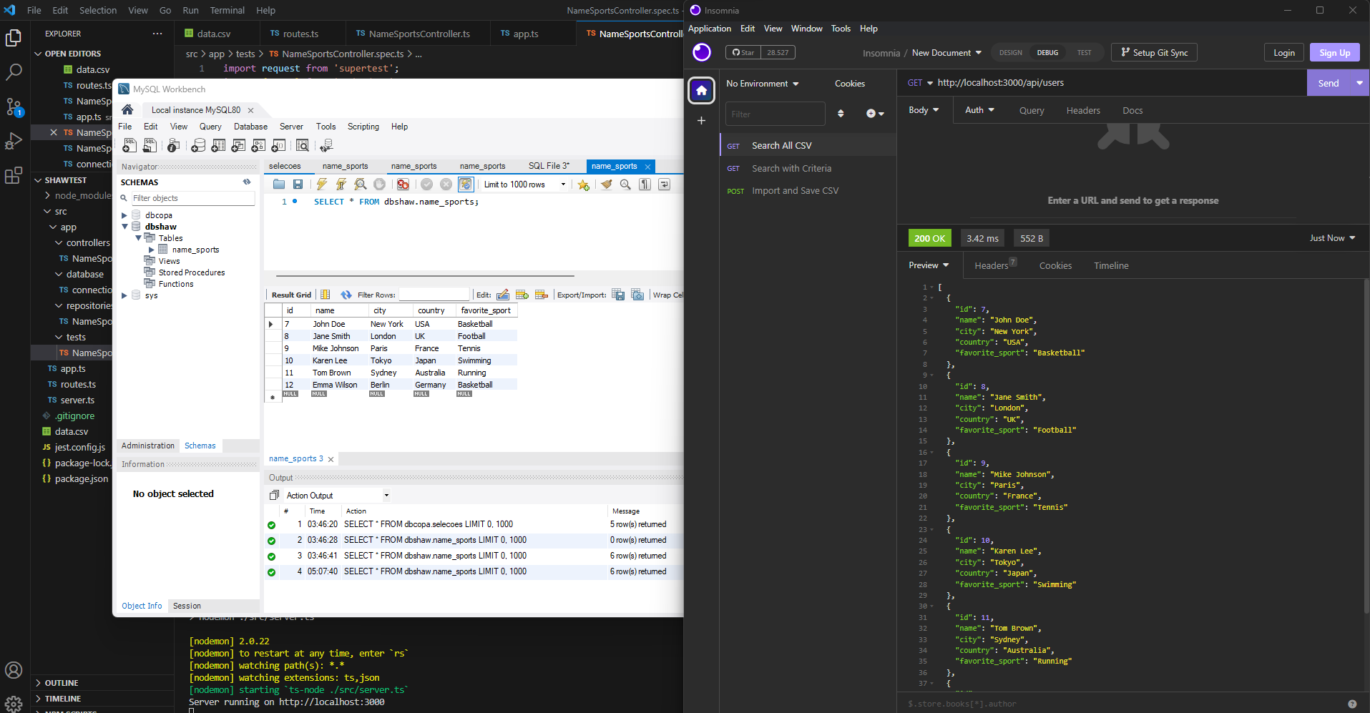

1. Search a specific query parameter CSV data on all the columns (returning JSON with the search on response and status 201)

