OPERATOR & FIELD MANUAL
AgriVision
Fly a field, let the on-board CNN find the disease, and spray only the part of the block that needs it — or leave the drone in the shed and photograph one plant with a phone.
Aircraft link | MAVLink 2 · ArduPilot / PX4
Backend | Flask + OpenCV + PyTorch
App | Flutter · English / हिन्दी
Region | Madhya Pradesh cropping system

00 What it does
Two ways in. One flies; one does not. They share the same knowledge base and end at the same place — a named disease and the product that treats it.
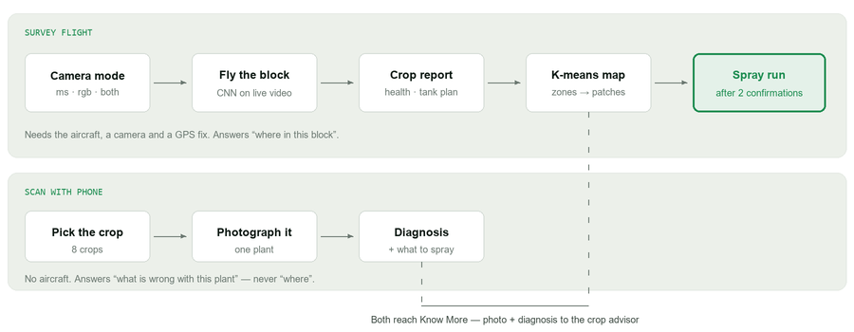
The two paths. The drone path is the only one that can produce a spray run: it is the only one that knows where in the block the problem is.
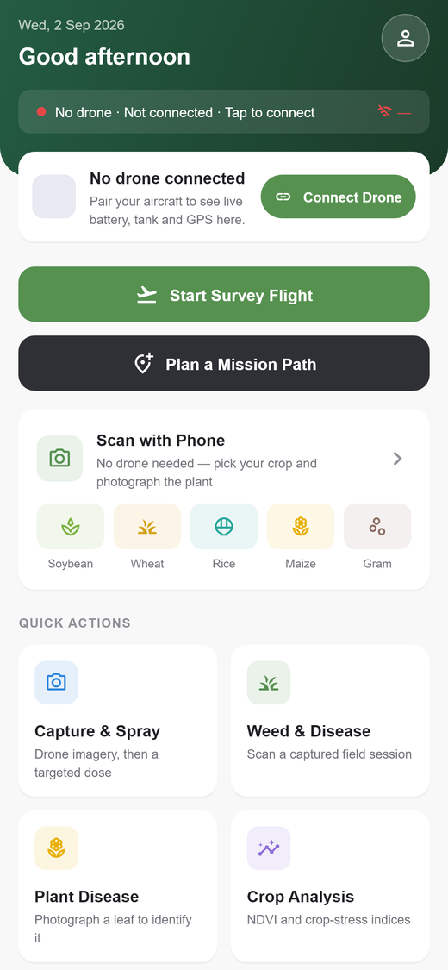  Home — every entry point | 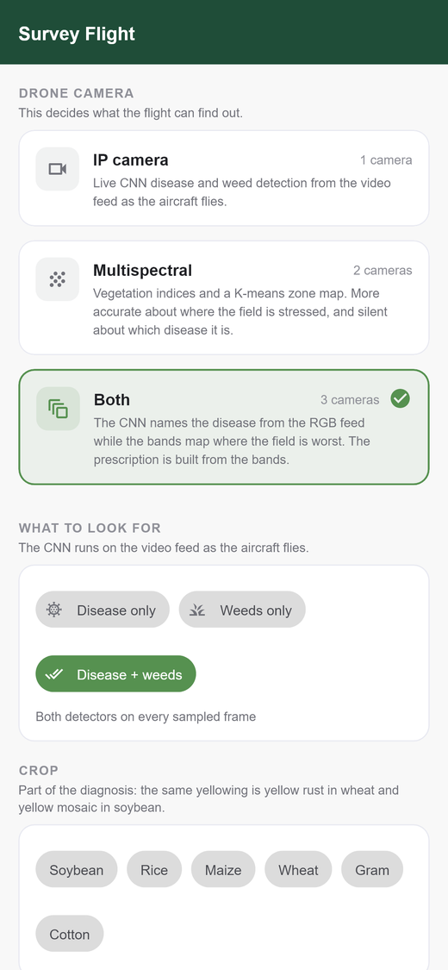  Survey setup — camera mode

01 What aircraft this works with
Anything that speaks MAVLink. The app never talks to a manufacturer's SDK, so the question is not the brand on the airframe — it is what autopilot is inside it.

The requirement
Part | What is needed | Why
Autopilot | ArduPilot (Copter) or PX4, speaking MAVLink 1 or 2 | The mission upload uses standard MISSION_* and COMMAND_LONG messages, and the mission layout follows the ArduPilot/PX4 convention.
Telemetry | A radio (SiK 915/433 MHz), USB, or UDP/TCP over Wi-Fi | The ground station holds one link and reads heartbeats, position and battery from it.
GPS | A 3D fix during the survey | Frames are geotagged as they are scanned. Without a fix a frame still counts towards crop health but cannot become a spray target.
Camera | An RGB IP camera (RTSP/MJPEG/snapshot), or multispectral bands, or both | The backend pulls the feed, not the phone.
Sprayer | A pump on DO_SPRAYER, a servo valve, or a relay | Set by SPRAY_MECHANISM. Only a servo can fly a genuinely variable rate.

IN PRACTICE
Any Pixhawk-class flight controller running ArduCopter — the usual board in an Indian agri-spray drone — works. So does a Cube, a Matek, or ArduPilot SITL on a laptop for a bench run.
A DJI Agras does not: it speaks DJI's own protocol, not MAVLink, and would need a separate MAVLink companion.

ONE GROUND STATION AT A TIME
AgriVision identifies itself as system 255, component 190 — which is also what Mission Planner and QGroundControl use. Two stations sharing an address on one link corrupt mission uploads, because the vehicle addresses its replies to the requesting id and the other station can answer first.
If QGC is watching the same aircraft, set MAVLINK_SOURCE_SYSTEM=254.

02 Connecting the drone
One process owns the link. Everything — telemetry, mission upload, the valve — goes through it.

Connection strings
These are pymavlink's. The direction word is the part people get wrong: udpin means we listen.
String | Use it when
udpin:0.0.0.0:14550 | A simulator or MAVProxy is streaming to the ground station. The default, and the usual SITL setup.
udpout:10.0.0.5:14550 | Pushing telemetry to a fixed endpoint.
tcp:127.0.0.1:5760 | Connecting straight to ArduPilot SITL on the same machine.
COM5 /dev/ttyACM0 | A real radio or USB link. Pass the baud rate (typically 57600).

Steps
- Power the aircraft and wait for a GPS fix. Without one the survey still scans, but nothing it finds can be sprayed.
- Put the ground station on the aircraft's network. The backend holds the camera and MAVLink connections, so it — not the phone — is what must reach them.
- Set MAVLINK_URL in the backend's .env, or pass a url when connecting.
- Tap the link banner on Home (“No drone · Not connected · Tap to connect”) and open the link.
- Check the gauges. Battery, tank and GPS replace the pairing card once heartbeats arrive. A drone that is paired but silent shows as offline rather than as “0%” — the app never presents an unknown reading as a measured one.
curl -X POST localhost:5000/api/mavlink/connect \
-H 'Content-Type: application/json' \
-d '{"url":"udpin:0.0.0.0:14550"}'
WHY ONE WORKER
The deployment runs a single gunicorn worker on purpose. The MAVLink link and the camera hub are process-local objects with their own threads; two workers would mean two links to the same aircraft, two heartbeats claiming the same system id, and two RTSP sessions per camera.

03 Cameras
Register one camera per multispectral band, plus the RGB camera. A camera that does not exist cannot take a picture — nothing is seeded.
curl -X POST localhost:5000/api/capture/cameras \
-H 'Content-Type: application/json' \
-d '{"name":"NIR band","role":"multispectral","band":"nir",
"url":"rtsp://192.168.1.51:554/stream1","fov_deg":62}'
role is rgb or multispectral; band is one of blue, green, red, red_edge, nir. Supported URLs: RTSP, an MJPEG stream, an HTTP snapshot endpoint, or a local file for bench testing.
FIELD OF VIEW MATTERS
fov_deg is what turns pixels into metres on the ground. Leave it out and the prescription still renders — it just cannot be flown, and the app says so rather than sending the aircraft to a guessed coordinate.

What each camera can and cannot tell you
Mode | Answers | Cannot answer
rgb — IP camera | What is wrong, named by the CNN on the live video, and roughly where — clustered from the geotagged detections. | Anything a colour camera cannot see.
multispectral | Where the field is stressed, from a calibrated vegetation index. The stronger of the two maps. | Which disease it is. One band is a greyscale image of one wavelength — not what the CNN was trained on.
both | The CNN names the disease while the bands map the stress. The prescription is built from the bands. | —

The setup screen disables a mode it cannot fly and says why — “A red and an NIR band camera are both needed to compute a vegetation index (registered: green, blue)”. Three green cameras is not a multispectral rig; the pair that matters is red + NIR.

04 The survey flight
Choose the cameras, the crop and what to look for, then fly the block as usual. The scan runs on the ground station, so you can close the screen and come back to it.

Setting the detection target
Disease only, weeds only, or both. This is not a display filter — weeds only genuinely skips the disease CNN, which roughly halves the per-frame cost. On a live feed that is the difference between a readout describing where the aircraft is and one describing where it was.
Whichever half is switched off reports zeroes with a method of not_requested, so nothing downstream can mistake “not measured” for “clean”.

While it flies
- One frame is sampled every 3 seconds and stamped with where the aircraft was at that moment.
- Frames are downscaled to 960 px before scanning — a 4K frame costs seconds through the detectors, which would make the readout describe ground the aircraft has already left.
- A dropped link shows as “Signal lost — reconnecting” and dims the picture. The last good verdict is never left on screen looking current.
- Nothing from the live scan is written to the scan history. It is a moving estimate; the deliberate captures you press the shutter for are what get recorded.
On a multispectral-only run there is no video to scan, so you trigger shots instead — the button fires every band camera at once, filed under that run's own session.

05 Reading the report
End the pass and the whole flight is rolled into one answer.

Crop health, 0–100
Deliberately blunt. Its value is not precision — it is that two flights over the same block a week apart are comparable, which is the question a farmer actually asks. It starts at 100 and is docked for disease incidence, worst severity, and weed cover.
Score | Band | Reads as
85–100 | good | the crop is in good shape
65–84 | fair | mostly healthy, problems starting
40–64 | poor | a real problem is spreading
0–39 | critical | this block needs attention now

A pass that scanned nothing shows no number at all, not a zero — zero reads as a dead crop. Below eight scanned frames the answer is flagged as indicative: that is a summary of a few seconds of hovering, not of a block.

The tank plan
This is the step the app used to stop one question short of. Every detected condition maps to a product named by active ingredient and formulation — not brand, because that is what the label says and what a dealer can match — with a dose per acre, a water rate, the crop stage, and the pre-harvest interval.
Three things it refuses to do:
- Silently mix. A fungal disease, an insect and heavy weeds produce three tanks, and the app says so. Listing five products as one load is how a tank ends up full of unsprayable sludge.
- Promise a cure. A virus has no spray that treats it. Yellow mosaic, cotton leaf curl and sterility mosaic target the vector instead and say so.
- Fly what cannot work. Loose smut and the soil-borne wilts answer “not sprayable” with what to do instead — a seed treatment or a rotation. An aircraft cannot deliver either.

06 How the autonomous spray is planned
K-means turns what the flight found into zones, the zones become patches a boom can fly, and the patches become a MAVLink mission that opens and closes the valve in the right places.

Step 1 — clustering
Both camera modes end at K-means, over different raw material.
Mode | What is clustered
Multispectral | Reflectance → vegetation index (NDVI by default) → K-means over the pixels → severe / moderate / healthy, ordered by vigour.
RGB | No index exists to cluster, so K-means runs over the geotagged detections themselves: position in metres plus a severity score.

Why clustering rather than a fixed threshold: a threshold that is right for irrigated wheat in Vidisha in January is wrong for rainfed soybean in Chhindwara in August. Clustering asks “which parts of this field are worst relative to the rest of it”, which is the question variable-rate spraying needs answered.
THE FAILURE THIS CREATES
A uniformly healthy field still produces a “worst” cluster. When the spread between cluster means is too small to act on, the response carries low_contrast: true and the app shows it above the spray button — walk the block before committing chemical to it.

Step 2 — patches
Clusters are cleaned up morphologically and the connected components become sprayable patches, each georeferenced through a nadir pinhole model and sorted biggest first — if the tank runs out, it should run out on the small ones.

Step 3 — the mission
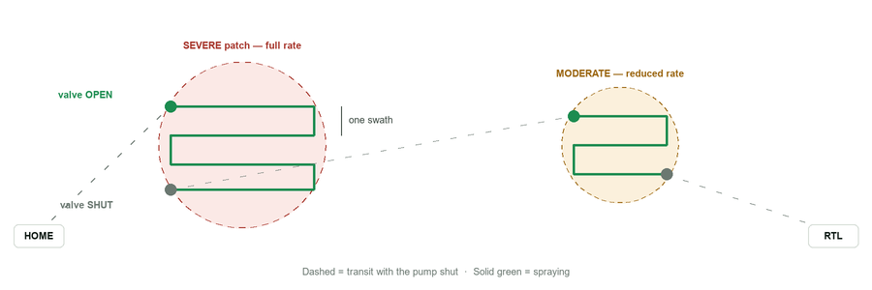
The mission brackets each patch. Approach with the valve shut, open it, fly a boustrophedon one swath apart, close it, transit. The run starts with an explicit valve-off, so a pump left open by a previous flight cannot spray the whole transit.
Seq | MAVLink command | What it does
0 | NAV_WAYPOINT | Home position
1 | NAV_TAKEOFF | Climb to spray altitude (low — not survey height)
2 | DO_CHANGE_SPEED | Spray pass speed
3 | pump OFF | The safety pre-set
… | NAV_WAYPOINT → pump ON → passes → pump OFF | Repeated per patch
last | NAV_RETURN_TO_LAUNCH | Come home

Spray hardware — and what it can honestly do
SPRAY_MECHANISM | Command | Variable rate?
sprayer | MAV_CMD_DO_SPRAYER (216) | No — ArduPilot's pump rate is a vehicle parameter, not a mission argument
servo | MAV_CMD_DO_SET_SERVO (183) | Yes — PWM is interpolated between closed and open
relay | MAV_CMD_DO_SET_RELAY (181) | No — on/off

This distinction is surfaced, not hidden. On an on/off rig the moderate zones get the full rate and the saving comes only from the ground that is skipped — and the plan re-costs the option against the rig's actual hardware before the number is shown to the farmer.

Step 4 — the consent chain
Nothing above opens a valve. The authorise step needs three separate confirmations, because each is a different mistake:
- The tank is filled — a statement about the aircraft. Without it the drone flies the whole prescription pumping air and the operator finds out afterwards.
- Spraying is authorised, by a named person — a statement by the farmer, recorded with the run. A chemical application is a record somebody may need later.
- Launch now — the field being clear is not something the app can check, so the last switch is left to the person who can see it. Without it the mission is uploaded and waits.
BEFORE YOU TAP LAUNCH
Check that nobody is in the field or downwind of it. The app cannot see that for you.
In flight, POST /api/spray/stop shuts the valve first and then holds the aircraft — asking for the loiter first would keep the boom open over whatever it drifts across.

A failed upload keeps the authorisation on record: the farmer did fill the tank and did give permission, and making them do it again because the radio dropped would be its own small cruelty.

Scan with Phone
The drone-free path, and the one most farmers will use most days. No aircraft, no session, no prescription.
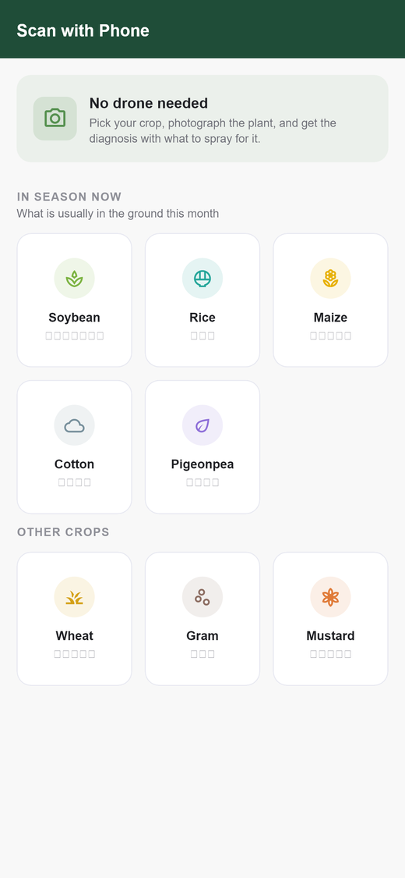  Pick the crop — in-season first | 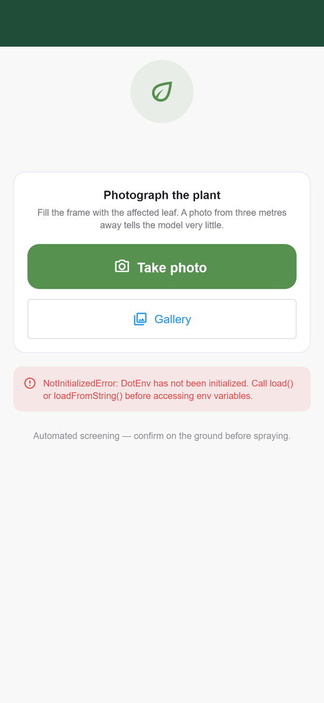  Then the camera — that is the whole screen

The crop is asked for first and is part of the diagnosis, not a label: the same yellowing is yellow rust in wheat and yellow mosaic in soybean. In-season crops sort first — in August a farmer here is looking at soybean and paddy, and scrolling past wheat every time is a small daily tax.
WHY THERE IS NO WEED OPTION HERE
Weed pressure is a measurement over ground — what share of a field is weedy — and a close-up of one plant cannot answer it honestly. The number it produced described whatever patch the farmer happened to be standing over. Weed detection lives on the drone, which can see the whole block.

A phone scan never becomes a spray run, and the result screen says so rather than offering a disabled button. One leaf cannot say where in the block the problem is.

Know More — the crop advisor
The detectors answer a narrow question well. The advisor answers the ones that come after it.
Tapping Know More sends the photo and the app's own diagnosis to Google Gemini, and the farmer can keep asking — is it safe to spray at flowering, what if it rains tomorrow, can I use what is already in the shed. It is offered on all four result screens: the phone crop scan, Plant Disease, Weed & Disease, and the survey report.
- The model is told to build on the CNN's answer and to say so plainly if it disagrees — a farmer shown two disease names with no explanation is worse off than before they asked.
- The photo goes with the first question only. After that the model has seen it, and re-sending it would make each follow-up as slow as the first.
- It answers in the language the app is set to, passed explicitly rather than guessed from the typing — someone set to Hindi still types crop names in English.
THE ONE FEATURE THAT NEEDS INTERNET
Every other part of AgriVision runs on a closed field network. This is also the one place a field photograph leaves the ground station, which is why it is off unless GEMINI_API_KEY is set.
With no key the endpoints answer 503 and the app hides the button — one that exists and fails when tapped is worse than one that is absent.

Model results
Measured on a held-out split, read straight from models/leaf_disease_report.json. Read the second row before the first.
Split | Accuracy | Images
Overall validation | 94.3% | 1,999
Lab photographs (PlantVillage) | 99.1% | 1,582
Real field photographs (PlantDoc) | 76.3% | 417

THE HEADLINE NUMBER IS THE MISLEADING ONE
94.3% is dominated by clean laboratory photographs — a single leaf on a grey background. On photographs that look like what a farmer actually takes, accuracy is 76.3%.
That is the number to plan around, and it is why a diagnosis in this app is always presented as screening to confirm on the ground, never as a result.

Training
Property | Value
Task | Leaf disease classification
Architecture | mobilenet_v3_large, 192 px input
Classes | 39
Images | 13,452
Epochs | 6
Final loss | 0.510
Datasets | PlantVillage (Mendeley, CC0) + PlantDoc (CC-BY-4.0)

Accuracy by epoch
Epoch | Loss | Overall | Lab | Field
1 | 1.211 | 85.1% | 93.1% | 54.7%
2 | 0.782 | 89.6% | 96.7% | 63.1%
3 | 0.682 | 92.5% | 98.2% | 70.7%
4 | 0.597 | 93.6% | — | —
6 | 0.510 | 94.3% | 99.1% | 76.3%

Field accuracy climbed from 54.7% to 76.3% while lab accuracy barely moved — the model spent its training learning to cope with real photographs, which is the only part that was ever in doubt.

Weakest classes (recall)
Class | Recall | Most confused with
tomato___bacterial_spot | 75.0% | septoria leaf spot, early blight
potato___early_blight | 78.8% | potato late blight
tomato___early_blight | 82.7% | —
apple___scab | 84.6% | —
potato___late_blight | 86.5% | potato early blight
corn___gray_leaf_spot | 88.5% | northern leaf blight

The confusions are the agronomically sensible ones — early against late blight in potato, grey leaf spot against northern leaf blight in corn. Four classes reach 100% recall, including corn___healthy and cherry___powdery_mildew.
WHAT THIS MODEL DOES NOT COVER
These 39 classes are PlantVillage's — apple, cherry, corn, grape, potato, tomato and so on. They are not the Madhya Pradesh crops the survey flow is built around.
The MP crop-disease path (soybean, rice, wheat, gram, maize, mustard, cotton, pigeonpea) currently ships no trained CNN. It falls back to a colour-and-pattern heuristic matched against the crop's own diseases, with confidence capped at 0.70 — because a canopy photograph narrows the possibilities but does not confirm a pathogen.
The app reports which engine answered on every result (CNN model vs On-device rules), because the two are not equally trustworthy. Training that model is the single highest-value thing left to do; the pipeline for it already exists in docs/CROP_CNN_TRAINING.md.

Weed detection
No accuracy is claimed. The weed detector is geometric, not learned: it segments vegetation (Excess Green + Otsu), finds the direction the crop rows run by searching rotation angles for the strongest periodicity, and calls the green between the rows weed. Broadcast wheat or transplanted paddy has no row signal, so it falls back to clustering by colour and texture. Every result reports which method answered — inter-row, appearance or inconclusive — because that is what the number's reliability rests on.

Configuration
Everything lives in backend/my_flask_app/.env. Never commit a key; on Railway set the same variables in the service's Variables tab.
# flight link
MAVLINK_URL=udpin:0.0.0.0:14550
MAVLINK_SOURCE_SYSTEM=255 # 254 if QGC shares the link
# spray hardware — rig-specific
SPRAY_MECHANISM=sprayer # sprayer | servo | relay
SPRAY_SERVO_CHANNEL=9 # servo only
SPRAY_SERVO_OFF_PWM=1000
SPRAY_SERVO_ON_PWM=2000
SPRAY_SWATH_M=3.0 # nozzle width on the ground
SPRAY_ALTITUDE_M=3.0 # spraying is low — not survey height
SPRAY_SPEED_MS=3.0
# crop advisor (optional; the button hides without it)
GEMINI_API_KEY=
# GEMINI_MODEL=gemini-flash-latest # leave unset
# live camera relay
LIVE_STREAM_MAX_VIEWERS=8
GUNICORN_THREADS=24
LEAVE THE MODEL UNSET
gemini-flash-latest is an alias that follows whatever the current flash model is. A pinned id rots — gemini-2.5-flash was the default here until Google retired it for new keys, and the feature answered 404 on a ground station nobody was watching.

Troubleshooting
Symptom | Cause and fix
A camera mode is greyed out | No camera registered for it. The row says exactly what is missing — multispectral needs a red and an NIR band, not just any two.
“Know More” does not appear | The server reports the advisor as unconfigured. Set GEMINI_API_KEY and redeploy. The button is hidden on purpose rather than failing when tapped.
The advisor times out | Google's endpoint is slow, not your connection — the app says “busy rather than unreachable”. Transient 429/5xx are retried three times; a timeout is not, because you have already waited 45 s.
Report has no treatment map | No frame carried a GPS fix, so there is nowhere to send the aircraft. Connect the flight link before the survey so frames are geotagged as they are scanned.
Mission upload corrupts or stalls | Two ground stations on one link sharing system id 255. Set MAVLINK_SOURCE_SYSTEM=254.
Spray saving smaller than the report | Working as intended. The plan re-costs against the rig: on an on/off pump the reduced rate over moderate zones does not exist, and the honest saving is smaller.
/api/mavlink/* answers 503 | pymavlink is not installed on the server. pip install pymavlink. The rest of the backend runs without it by design.

Known limits
Stated plainly, because a manual that only lists capabilities is a sales brochure.
- Georeferencing assumes a nadir camera over level ground, at the altitude the autopilot reports — height above launch, not above the canopy. With no heading it falls back to north-up. Every response carries these assumptions and the app asks the operator to confirm before anything opens a valve.
- An RGB detection is a point, not an outline. A cluster's radius comes from how far its member frames spread plus one frame's ground footprint. Treat it as a spray footprint, never as the edge of an infection.
- Product doses are decision support, not a prescription. They are standard package-of-practices guidance. The label on the container and the local KVK outrank this app, and the agronomy in it has not been reviewed by an agronomist.
- The MP crop CNN is not trained — see Model results. Those diagnoses come from heuristics capped at 0.70 confidence.
- Hindi covers the farmer-facing screens — home, the crop scan flow, settings and the advisor. The flight and mission screens stay in English, where the working vocabulary (MAVLink, NDVI, boustrophedon) has no settled Hindi rendering and a half-translation would be less usable, not more.

