AgriVision: An Integrated Unmanned Aerial Platform for Multispectral Crop Diagnostics, Disease Identification and Variable-Rate Spraying
Sahil Choudhary
Madhya Pradesh Council of Science and Technology
Bhopal, Madhya Pradesh, India
juniorresearchfellowmpcst@gmail.com

Abstract—Precision agriculture research has produced a great many accurate individual components—vegetation-index calculators, disease classifiers, weed detectors—and rather fewer systems a farmer can actually fly. This paper describes AgriVision, an end-to-end unmanned aerial platform that joins radiometric calibration, multispectral analysis, leaf- and canopy-level disease identification, weed detection, variable-rate spray prescription and MAVLink flight control into one deployable application. Two design commitments shape the whole system. First, every learned component is optional: each classifier sits behind a seam that falls back to a deterministic OpenCV heuristic, so the software runs usefully on a laptop in a village with no GPU and no model download, and improves the moment a model is supplied. Second, evaluation reports what deployment will actually look like rather than what flatters the model. We demonstrate the value of the second commitment concretely. Training a MobileNetV3-Large classifier on a merged corpus of 58,121 images drawn from PlantVillage and PlantDoc, we score laboratory-background and real-field images separately and observe a gap of 25.5 percentage points between them (98.9% versus 73.4%) on a model whose headline accuracy reads 93.5%. We further identify a subtle corpus-merging defect in which three diseases carry different names in the two source datasets; left unmerged, the resulting class split correlates perfectly with image background, giving a classifier an easy shortcut that inflates reported accuracy while destroying field performance. The complete system comprises 19,560 lines of Python and 26,800 lines of Dart, validated by 177 automated tests.
Keywords—precision agriculture, unmanned aerial vehicles, multispectral imaging, vegetation indices, convolutional neural networks, plant disease detection, weed detection, variable-rate application, transfer learning, dataset bias
I. Introduction
Agriculture in Madhya Pradesh is dominated by a short list of crops—soybean, wheat, rice, chickpea, maize, mustard, cotton and pigeonpea—grown across holdings that are, for the most part, small and fragmented. Two problems follow from that structure. Disease and pest pressure is usually discovered late, because scouting a field on foot is slow and the early symptoms are subtle. And when a problem is found, the response is nearly always a blanket application: the whole block is sprayed because nobody knows which part of it is actually affected.
Both problems are, on the face of it, well suited to unmanned aerial systems. A multispectral camera flown over a block can measure canopy vigour at a spatial resolution no walking survey will match, and the same aircraft can carry a boom that opens only over the patches that need treatment. The research literature reflects this: there is a large and mature body of work on vegetation indices, a very active line of work on convolutional networks for plant disease recognition, and a growing literature on weed discrimination from aerial imagery.
What is scarcer is the integration. A vegetation index tells an operator where a field is stressed but not why; a disease classifier answers why but needs to be pointed at the right place; a spray controller needs both, expressed as geometry, and a flight stack to execute it. Each of these has been solved in isolation, frequently to a high standard, and the joins between them are where deployable systems are won or lost.
This paper describes AgriVision, a system built to occupy those joins. Our contributions are:
1) An integrated pipeline from raw multispectral capture through radiometric calibration, band co-registration, a twenty-index vegetation registry, K-means management zoning, disease and weed diagnosis, spray prescription and MAVLink mission execution.
2) A graceful-degradation architecture in which every learned component is optional. Three independent CNN seams each fall back to a deterministic computer-vision heuristic, so the system has no hard dependency on PyTorch, model files, or network access.
3) An empirical characterisation of the laboratory-to-field gap in plant disease classification, obtained by tagging every training image with its provenance and scoring the two populations separately.
4) Identification of a background-correlated label-split defect that arises when merging plant disease corpora, together with the crop-scoped merge rule that repairs it.
5) A two-tier diagnosis representation that preserves a classifier's fine-grained answer while sourcing treatment guidance from a coarser, agronomically curated knowledge base.
II. Related Work
A. Vegetation Indices and Aerial Crop Monitoring
The normalised difference vegetation index of Rouse et al. [1] remains the reference measure of canopy greenness, and much of the subsequent literature consists of principled corrections to its known weaknesses. SAVI [2] introduces a soil-brightness term for sparse canopies; OSAVI [3] and MSAVI2 [4] refine that adjustment; EVI [5] adds an atmospheric-resistance term and desaturates over dense vegetation; ARVI [6] corrects for aerosol scattering. For nitrogen and chlorophyll status specifically, GNDVI [7] and the red-edge indices NDRE and RECI [8], [9] respond where NDVI has saturated, which matters in exactly the mature, closed canopies where a late-season intervention is still possible. Senescence and pigment indices such as PSRI [10] and MCARI [11] extend the same idea to stress that is not primarily a greenness change.
We take from this literature not a single index but the position that index choice is crop- and stage-dependent, which is why AgriVision implements a registry of twenty indices with declared band requirements rather than hard-coding NDVI.
B. Deep Learning for Plant Disease Recognition
The modern line of work begins with the PlantVillage corpus [12], and with Mohanty et al. [13], who reported 99.35% accuracy over its 38 classes using transfer learning from ImageNet-pretrained networks [14]. Ferentinos [15] extended this to 87,848 images and 58 classes with comparable results. Those numbers are correct and, taken at face value, badly misleading.
Barbedo's analyses [16], [17] identified the reason: PlantVillage images are individual detached leaves photographed against a uniform background under controlled light. A network trained on them can and does learn the acquisition conditions as part of each class. Singh et al. [18] constructed PlantDoc precisely to test this, collecting 2,598 images of diseased plants in real conditions, and reported that models trained on PlantVillage transfer poorly to it.
Our work builds directly on this observation but treats it as an engineering requirement rather than a caveat. Rather than reporting one accuracy and noting the limitation in prose, we make provenance a first-class property of every training image and report the two populations as separate columns of the evaluation table.
C. Weed Discrimination
Weed detection from aerial imagery divides into appearance-based and geometry-based approaches. Dos Santos Ferreira et al. [19] classify soil, soybean, grass and broadleaf from UAV imagery with convolutional networks; Olsen et al. [20] released DeepWeeds for species-level recognition in rangeland. Geometry-based methods instead exploit the fact that a sown crop grows in lines and weeds do not, segmenting vegetation—often with the Excess Green index [21] and Otsu thresholding [22]—and attributing inter-row vegetation to weeds.
AgriVision implements the geometric method as its primary path and appearance clustering as a fallback, and—importantly—reports which one answered, since the two carry very different evidential weight.
D. Variable-Rate Application
The economic argument for site-specific application is well established. In practice most deployed systems threshold a vegetation index at a fixed value. We argue in Section VII that this is the wrong operation for a smallholding context, and use clustering instead.
III. System Architecture
A. Layered Design
AgriVision is organised in four layers, shown in Fig. 1. A Flutter mobile client provides the operator interface; a Flask REST backend holds all domain logic; an analysis layer contains the computer-vision and machine-learning modules; and a hardware layer speaks to the aircraft and its cameras.
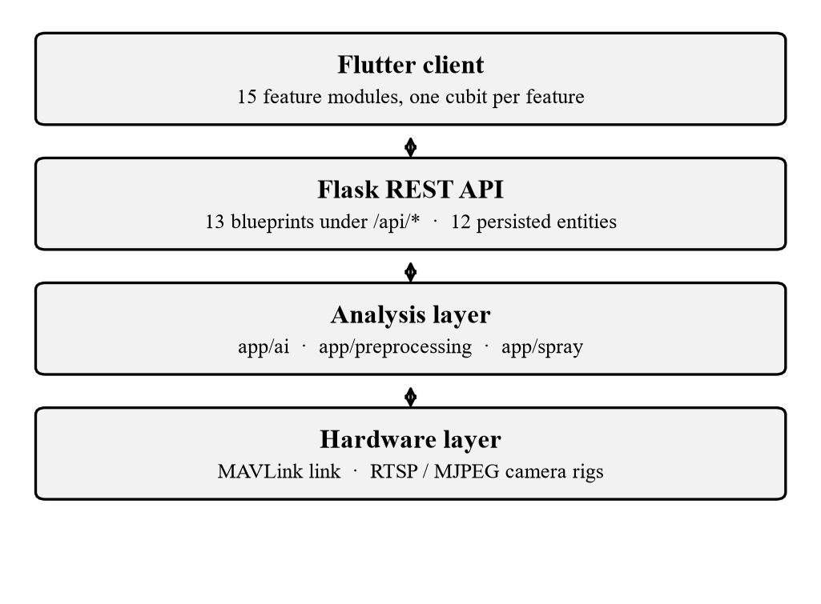
Fig. 1. Layered architecture. The client holds no domain logic; camera and flight links terminate at the backend because the aircraft's network is frequently not reachable from the operator's handset.
One placement decision is worth stating because it is not the obvious one. The camera and MAVLink connections terminate at the backend, not the phone. A drone's IP cameras sit on the aircraft's own network, and the operator's handset is often not on it; putting the connection in the app would work on a bench and fail in a field.
B. Data Model
Twelve persisted entities cover users and credentials, drones and missions, multispectral analysis records, disease scans, field scans, capture sessions and spray prescriptions. Every diagnostic result is persisted with the engine that produced it. This matters over a season: if a trained model is introduced halfway through, records from before and after remain comparable because each one records whether a model or a heuristic answered.
C. Graceful Degradation as an Architectural Rule
Three machine-learning seams exist in the system, all sharing one implementation. Each is configured by a pair of environment variables naming a TorchScript module and a labels file: AI_DISEASE_* for the leaf-photo endpoint, AI_CROP_* and AI_WEED_* for the canopy field scan.
The loading rules are deliberately uniform: loading is lazy and attempted exactly once; any failure whatsoever—PyTorch absent, file corrupt, input shape wrong—is logged and returns a null result, which every caller reads as “use the heuristic”. No endpoint returns a server error because a model was misconfigured.
This is not merely defensive coding. It is what allows the backend to declare no dependency on PyTorch at all, keeping the deployed container small, while the same codebase serves a trained model on a machine where the optional dependency layer has been installed.
A subtle failure this seam originally permitted is worth recording. A model trained at one input resolution and served at another raises no error; it simply becomes quietly less accurate. We closed this by having each trainer emit a report sidecar recording the training resolution, which the loader reads back at load time so the serving resolution is always the trained resolution.
IV. Multispectral Processing Pipeline
A. Radiometric Calibration
Raw digital numbers from a multispectral sensor are not comparable across flights, times of day, or exposure settings. AgriVision implements the standard single-panel reflectance workflow. Raw DN is dark-subtracted and, where exposure and gain metadata are present, normalised so that pixel values are proportional to at-sensor radiance. A photograph of a calibration panel of known reflectance, taken under the same illumination, yields a per-band scale factor F(b) = panel reflectance divided by mean panel signal, with saturated pixels rejected. Scene reflectance follows as the product of that factor and the normalised scene signal, clipped to a physical range. This carries the usual single-panel assumption that illumination is stable between the panel shot and the flight; downwelling-light-sensor data can be folded into the scale factor without disturbing anything downstream.
B. Band Co-registration
Multispectral cameras image each band through a separate lens, so bands arrive with parallax offsets and small rotations. Indices computed on unaligned bands are meaningless at the pixel level. We align every band onto a reference band (green by default) using enhanced correlation coefficient maximisation [23] in a coarse-to-fine Gaussian pyramid, chosen because it is robust to the substantial intensity differences between bands. Where ECC fails to converge—typically on very low-texture scenes—we fall back to ORB features [24] with a RANSAC homography [25].
Alignment quality is scored per band as the zero-normalised cross-correlation of edge maps, and the stack is declared clean when the minimum band score reaches 0.65. Reporting this, rather than assuming success, prevents a misregistered capture from silently producing a plausible but wrong index map.
C. Vegetation Index Registry
Rather than hard-code NDVI, we implement a registry of twenty indices (Table I), each declaring its formula, required bands, polarity and a plain-language description. The API advertises which indices are computable from a given capture's bands, so a three-band rig is offered the subset it can actually support.
Table I. Vegetation Index Registry (selected of twenty)
Key | Formula | Primary use
NDVI | (N−R)/(N+R) | canopy greenness
GNDVI | (N−G)/(N+G) | chlorophyll, nitrogen
NDRE | (N−RE)/(N+RE) | stress in dense canopy
SAVI | 1.5(N−R)/(N+R+0.5) | sparse canopy, soil
OSAVI | (N−R)/(N+R+0.16) | optimised soil adjust.
EVI | 2.5(N−R)/(N+6R−7.5B+1) | dense canopy
ARVI | (N−(2R−B))/(N+(2R−B)) | aerosol resistance
RECI | N/RE − 1 | red-edge chlorophyll
MCARI | ((RE−R)−0.2(RE−G))(RE/R) | chlorophyll
PSRI | (R−G)/RE | senescence, ripening
NDWI | (G−N)/(G+N) | canopy water
ExG | 2G−R−B | RGB-only veg. mask
VARI | (G−R)/(G+R−B) | RGB-only vigour
N: NIR, R: red, G: green, B: blue, RE: red edge.
Where a capture has not been panel-calibrated, each band is rescaled to a robust per-band pseudo-reflectance so that soil-adjusted indices still behave sensibly. Results are then explicitly relative—adequate for zoning, inadequate for absolute comparison across flights—and the system labels them as such rather than presenting them as calibrated values.
D. Management and Risk Zoning
Zone maps are produced by K-means [26] over an index map, with k = 3 by default. A detail that matters in practice: K-means assigns cluster identifiers arbitrarily, so raw labels do not correspond to low, medium and high vigour. We reorder clusters by mean index value so that zone 0 is always the lowest-vigour group. Risk zoning inverts this mapping—low vigour becomes high risk—and renders a stoplight map, from which a structured field report and a prioritised action plan are generated. Every recommendation is accompanied by an instruction to ground-truth before acting.
V. Leaf-Level Disease Identification
A. Corpus Construction and a Background-Correlated Defect
We construct a training corpus by merging PlantVillage [12] (55,448 usable images, 39 classes, uniform laboratory background) with PlantDoc [18] (2,673 images, 28 classes, real field conditions). The rationale is straightforward: PlantVillage supplies class coverage and volume, PlantDoc supplies the acquisition variability without which a model learns the background.
The two corpora name their classes differently, so both are normalised into a shared crop-and-condition identifier by a rule-based mapper that extracts a crop token and performs a longest-match scan over a condition vocabulary. Any folder the mapper cannot place is reported and skipped rather than assigned to the nearest class. Across all 67 source directories, zero were unmapped.
Normalisation alone, however, is not sufficient, and the reason is the most practically important finding of this section. Three diseases carry genuinely different names in the two corpora while being the same pathogen: apple common rust versus cedar apple rust; pepper leaf spot versus bacterial spot; and corn leaf blight versus northern leaf blight.
Left unmerged, each of these becomes two classes whose only systematic difference is which corpus the image came from—which is to say, whether the background is a grey sheet or a real field. A classifier presented with such a split will learn the background, because the background is the easier signal, and will report excellent validation accuracy while having learned nothing about the disease. The defect is insidious precisely because it improves the headline metric. We repair it with a crop-scoped merge table applied after crop and condition are resolved, and verify the invariant in the automated test suite.
We additionally retain PlantVillage's background class as an explicit “not a leaf” category. This earns its place: without it, a model answers a photograph of bare ground with a confident disease name.
B. Class Balancing that Preserves Scarce Provenance
The merged corpus is severely imbalanced—5,507 images of citrus greening against 152 of healthy potato—and also imbalanced in provenance, since field images are only 4.6% of the total. We cap each class at C images, but the naive cap is actively harmful: sampling uniformly from a class holding 2,000 laboratory and 80 field images preserves the 96:4 ratio and reduces the field images to a handful, discarding exactly the data the merge was performed to obtain.
We therefore cap laboratory images only, retaining every field image and filling the remaining budget from the laboratory pool. With C = 350 this yields 13,452 images across 39 classes, retaining 2,673 of 2,673 available field images (100%) and raising field representation from 4.6% to 19.9%. Every image's provenance is encoded in its filename so that the trainer can recover it at evaluation time.
C. Two-Tier Diagnosis Representation
The classifier predicts fine-grained crop-and-condition classes because that is the granularity the corpora label at and the granularity a farmer can act on. The system's agronomic knowledge base, by contrast, is deliberately coarse: seven conditions whose treatment guidance holds across crops.
Collapsing one into the other loses information in whichever direction it is done. Reducing the model's answer to its category discards the crop and the pathogen—reporting “Blight” when the model knows it is late blight on tomato, which is the difference between generic advice and a decision about whether to abandon the crop. Fabricating per-crop treatment text the project does not possess would be worse.
We therefore carry both. The response names the specific finding as the headline and states the knowledge-base category the guidance was drawn from. It additionally carries ranked runners-up. This is not decoration: a single frame frequently cannot separate early from late blight, and “0.52 versus 0.44” is a materially different message to an operator than a confident single answer. A predicted label the mapper cannot place is returned flagged as unmapped, so the operator reads “the model said X and we do not recognise X” rather than a confident misdiagnosis.
Severity is measured from the image on both paths, never from the classifier. The class identifies which disease; the pixels measure how much of the leaf it has taken, and the second determines urgency.
D. Model and Training Protocol
We fine-tune MobileNetV3-Large [27] from ImageNet-pretrained weights at 192×192 resolution. The architecture was selected on deployment grounds rather than benchmark performance: it is roughly an order of magnitude cheaper per image than ResNet-18 at 224×224 for a small accuracy cost, and it is the backbone that can plausibly run on a companion computer aboard the aircraft.
The first 35% of network parameters are frozen. Early convolutional blocks encode generic edge and texture filters that a leaf corpus will not improve upon, and omitting their gradients is the single largest saving on a CPU-only machine. Augmentation targets the variability a handheld camera actually produces: random resized cropping (scale 0.5–1.0), horizontal and vertical flips, ±30° rotation, and colour jitter standing in for the difference between a nine o'clock and a two o'clock photograph.
The loss is inverse-frequency weighted with label smoothing of 0.05 [28], optimised with AdamW [29] at a base learning rate of 6×10⁻⁴ under a cosine annealing schedule [30]. Weighting is essential: an unweighted objective on this corpus reaches a respectable average by answering “healthy” to everything, which is precisely useless to a farmer looking for the diseased minority.
The train/validation split is stratified per class at 85/15. A global random split can leave a small class with no validation representation, and its recall then reads as undefined—precisely the class one most wanted to check.
VI. Canopy Diagnosis and Weed Detection
A. Why the Leaf Extractor Fails on Canopy Frames
A frame from a low, slow pass is a different photograph from a leaf against a sheet: it contains soil between plants, several plants at once, and no clean silhouette. Applying the leaf feature extractor to it fails in a specific and instructive way—bare soil is brown, so “necrotic tissue” is reported at around 60% on a perfectly healthy field.
The canopy extractor therefore builds its plant mask in the opposite order. Unambiguously green pixels are located first using Excess Green [21]; these are closed and hole-filled into a canopy silhouette; and only then are discoloured pixels inside that silhouette added. The third step is what allows a yellow rust stripe or a brown blight blotch to be measured as diseased crop while the same colours on the soil between rows are ignored.
B. Weed Detection
The difficult part of aerial weed detection is not finding plants but deciding which plants are the crop; a photograph of a weedy field is mostly green either way. Two signals separate them, and the module uses whichever the frame supports.
Row geometry is the preferred path. A sown crop grows in lines and weeds do not respect them. Vegetation is segmented, the dominant row direction recovered by autocorrelation, and green material falling between rows attributed to weeds. This is species-agnostic and mirrors the inference a farmer makes walking a field. An autocorrelation strength threshold guards the method: below it, an apparent period is noise, and acting on it would label random stripes of crop as weeds.
Appearance clustering is the fallback. Broadcast-sown wheat and transplanted paddy present no usable row signal. There the vegetation is clustered into two groups by colour and texture and the minority group treated as weeds. This is a materially weaker inference, and is reported as such: the response carries a method field reading inter-row, appearance or inconclusive, and confidence is reduced with a note explaining why.
Distinguishing these is not a presentational nicety. A trained species classifier changes which weed is named; it does not change whether the plant was a weed, and conflating the two would misrepresent the evidence underlying a herbicide decision.
VII. Variable-Rate Spray Prescription
The spray module converts a multispectral capture into geometry: which patches to treat and which to skip. Bands are calibrated and aligned, a vegetation index computed, and K-means with k = 3 partitions the field into severe, moderate and healthy classes. Morphological cleanup yields contiguous sprayable patches, which are costed so the operator can choose among options.
The choice of clustering over a fixed index threshold is deliberate and, we argue, the correct one for this context. A threshold calibrated for irrigated wheat in Vidisha in January is wrong for rainfed soybean in Chhindwara in August. Clustering asks a different and more answerable question—which parts of this field are worst relative to the rest of it—which is what a variable-rate application actually requires. The trade-off is real and is handled explicitly: a uniformly healthy field still yields a “worst” cluster, so the module reports the spread between cluster means and flags a prescription as low-contrast when there is no genuine difference to act upon.
Chemical saving is the point of the feature. A blanket application treats 100% of the block; this treats the affected fraction, and at a reduced rate over the moderate class, since moderate damage does not require the severe dose. Patches are converted to geographic coordinates and emitted as a spray mission for execution.
VIII. Flight Integration
Missions are planned from an uploaded KML boundary, parsed into ordered waypoints, and uploaded to the aircraft over MAVLink [31] using pymavlink. The service layer joins the two halves of the system: a mission planned in the application, or restored from history, becomes a mission written to the vehicle, and returning telemetry is reshaped for the live-mission screen.
The module degrades on the same principle as the rest of the system. With pymavlink absent, or no vehicle on the wire, endpoints return a readable message rather than a stack trace. Development and validation were performed against ArduPilot SITL, with the documented configuration accounting for a practical constraint—only one process may bind UDP port 14550, so a ground control station and the backend cannot both listen on the same host.
IX. Implementation and Evaluation
A. Implementation Scale
The backend is implemented in Python with Flask and SQLAlchemy; all computer-vision heuristics use OpenCV [32] and NumPy, and the optional learned components use PyTorch [33] exported to TorchScript. The client is a Flutter application. Table II summarises the scale of each part.
Table II. Implementation Summary
Component | Measure
Backend (Python: app, tools, tests) | 19,560 LOC
Mobile client (Dart) | 26,800 LOC
REST blueprints | 13
Persisted entities | 12
Analysis modules (app/ai) | 3,543 LOC
Vegetation indices implemented | 20
Automated tests (all passing) | 177
The test suite is organised around behaviour rather than coverage percentage, concentrating on failures that would be silent in production: mislabelling crop as weed, turning an unrecognised dataset label into a confident diagnosis, losing the pixel-derived severity measurement on the model path, or diagnosing a photograph containing no leaf.
B. Corpus Composition
Table III. Merged Corpus Before and After Balancing
 | Laboratory | Field | Total
PlantVillage (39 cls) | 55,448 | 0 | 55,448
PlantDoc (28 cls) | 0 | 2,673 | 2,673
Merged (39 cls) | 55,448 | 2,673 | 58,121
After cap C = 350 | 10,779 | 2,673 | 13,452
Field proportion | 4.6% | → | 19.9%
The validation split contains 1,999 images, of which 417 are field images—a sample large enough to make the field column a meaningful measurement rather than a rounding artefact.
C. The Laboratory-to-Field Gap
Table IV and Fig. 2 present the central empirical result. Overall validation accuracy behaves as the literature would lead one to expect. Decomposed by provenance, it tells a substantially different story.
Table IV. Validation Accuracy by Image Provenance
Epoch | Loss | Overall | Laboratory | Field
1 | 1.2110 | 0.851 | 0.931 | 0.547
2 | 0.7815 | 0.896 | 0.967 | 0.631
3 | 0.6823 | 0.924 | 0.982 | 0.707
4 | 0.5967 | 0.935 | 0.989 | 0.734
MobileNetV3-Large, 192×192, 35% frozen, CPU-only training. Laboratory: PlantVillage. Field: PlantDoc.
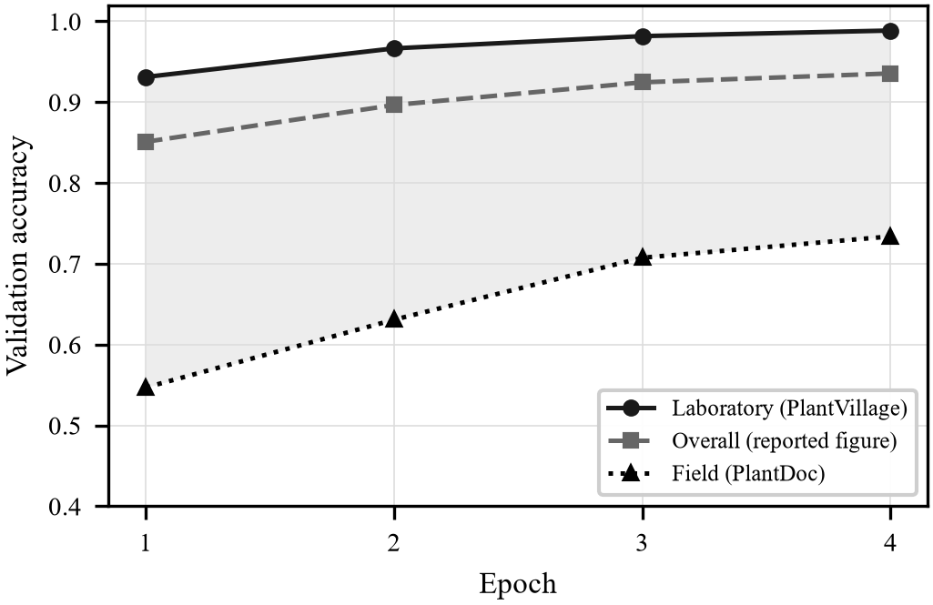
Fig. 2. Accuracy decomposed by image provenance. The headline figure sits close to the laboratory curve because laboratory images dominate the validation set; the field curve is what predicts behaviour on a photograph taken by a farmer. The shaded band is the gap.
At the final epoch the model reports 93.5% overall. That figure is arithmetically correct and operationally misleading: it decomposes into 98.9% on laboratory images and 73.4% on field images, a gap of 25.5 points. Because laboratory images constitute roughly 80% of the validation set even after rebalancing, the aggregate tracks the laboratory curve closely.
Two observations follow. First, this quantifies within a single training run the transfer failure that Barbedo [17] and Singh et al. [18] identified across studies, and it does so without a separate cross-dataset evaluation protocol—provenance tagging alone is sufficient. Second, and more practically, a practitioner reporting only the aggregate would have no indication of how the deployed system will behave on the images it will actually receive.
We consider the field column, not the aggregate, to be the honest headline figure for a system of this kind, and the system's generated evaluation report presents it accordingly alongside per-class recall and the ten most frequent confusions.
D. Training Throughput
Training was performed on a four-core CPU without CUDA acceleration, which we regard as representative of the hardware available in the target deployment context rather than as a limitation to be apologised for. Measured throughput for MobileNetV3-Large at 192×192 with 35% of parameters frozen was 20.5 images per second, giving approximately 9.3 minutes per epoch over the balanced corpus. At 160×160 with heavier freezing, throughput approximately doubles.
These figures determined the corpus cap directly: the full 58,121-image merged corpus would require roughly 47 minutes per epoch, whereas the balanced 13,452-image corpus completes six epochs inside a two-hour budget while allowing the cosine schedule to anneal fully.
E. Deployment Considerations
The deployed backend declares no PyTorch dependency, keeping the container small. A consequence worth stating plainly is that training a model does not by itself cause a deployed instance to use it: without the optional dependency layer installed, the health endpoint continues to report the heuristic engine. This is a working configuration rather than a degraded one—the endpoint contract is identical, and only the reported source field differs—but it is a deployment decision that must be made explicitly. We provide a separate optional requirements layer for hosts where model serving is intended, costing approximately 250 MB of image size.
X. Discussion
A. On Reporting Aggregates
The result in Section IX-C is not a novel phenomenon; it is a well-documented one that conventional reporting practice conceals. What we would emphasise is how cheap the remedy proved to be. Tagging each image with its provenance at corpus-construction time and carrying that tag through to evaluation cost a few dozen lines of code, required no additional data, and converted a known caveat into a number that appears in every training report the system generates.
We would suggest this as general practice for applied agricultural vision work. Where a corpus is assembled from sources with systematically different acquisition conditions—which is nearly always—the aggregate accuracy is a weighted average over populations that behave very differently, and the weights are an artefact of corpus construction rather than of deployment.
B. Crop Coverage
An honest limitation deserves prominence. PlantVillage's fourteen crops overlap only partially with the eight crops that dominate Madhya Pradesh's cultivated area. Tomato, potato, maize and soybean are usefully represented. Wheat, chickpea, mustard, cotton and pigeonpea—the crops the system's agronomic knowledge base is actually built around—are absent from the corpus entirely. For those, the classifier possesses no class with which to answer, and the system's heuristic path remains the operative one.
We regard this as an argument for local data collection rather than for a different public corpus, and the platform is already the collection instrument: every captured frame is stored geotagged with its verdict, so a season of operation produces a labelled corpus matched exactly to deployment conditions.
C. What a Photograph Can and Cannot Establish
Several of the design decisions described above follow from a single constraint: an image shows a pattern, not a pathogen. Early and late blight are close to indistinguishable in some frames. Fusarium wilt and drought stress frequently are not separable at all. Sterility mosaic in pigeonpea is the limiting case—the canopy remains green and healthy-looking and simply never sets pods, so a high vegetation index coexists with zero yield.
This is why canopy heuristic confidence is capped, why runners-up are returned, why the weed detector reports its method, and why every diagnostic response carries a disclaimer directing the operator to confirm before applying chemical treatment. A system that presented these outputs as diagnoses would be more impressive to demonstrate and worse to use.
XI. Limitations and Future Work
The evaluation presented here is computational. The system has been validated against ArduPilot SITL rather than in sustained flight, and the spray module's chemical-saving argument, while arithmetically sound, has not been measured against a blanket-application control in the field. Table V gives illustrative projections for these quantities. These are modelled estimates, not measurements, and are included to indicate the scale of the effects the system is designed to produce rather than to claim them.
Table V. Projected Field Outcomes (illustrative, not measured)
Quantity | Projected
Chemical reduction vs. blanket spray | 40–70%
Survey time vs. manual scouting (2 ha) | 15–25 min
Spray-mission planning latency | < 10 s
Modelled from the affected-fraction arithmetic and observed processing times. NOT validated against field trials. Establishing these figures empirically is the primary item of future work.
Beyond field validation, four directions follow directly. Collecting Madhya-Pradesh-specific imagery through the platform itself would address the crop-coverage gap of Section X-B. Domain-adaptation techniques applied to the laboratory-to-field transfer would attack the gap of Section IX-C at its source, rather than merely measuring it. Deploying the MobileNet backbone to a companion computer aboard the aircraft would remove the round trip to the backend. Finally, the sterility-mosaic case argues for fusing imagery with non-visual evidence, since it is definitionally invisible to a camera.
XII. Conclusion
We have described AgriVision, an integrated aerial platform spanning multispectral calibration and analysis, leaf- and canopy-level disease identification, weed detection, variable-rate spray prescription and flight execution. The system is organised around a principle of graceful degradation: every learned component is optional, falling back to a deterministic heuristic, so that the software is useful without a GPU, a model file, or a network connection.
Its central empirical result is methodological. By carrying image provenance from corpus construction through to evaluation, we show that a plant disease classifier reporting 93.5% validation accuracy achieves 98.9% on laboratory-background images and 73.4% on real field photographs. We further show that merging public corpora without reconciling their disease vocabularies creates class splits that correlate exactly with acquisition conditions, offering a classifier a shortcut that improves the reported metric while destroying the field performance that matters. Both problems are inexpensive to fix once measured, and invisible until they are.
Acknowledgment
This work was carried out under a Junior Research Fellowship at the Madhya Pradesh Council of Science and Technology. The author thanks the maintainers of the PlantVillage and PlantDoc datasets for releasing them under open licences.
References
[1] J. W. Rouse, R. H. Haas, J. A. Schell, and D. W. Deering, “Monitoring vegetation systems in the Great Plains with ERTS,” in Proc. 3rd ERTS Symp., NASA SP-351, 1974, pp. 309–317.
[2] A. R. Huete, “A soil-adjusted vegetation index (SAVI),” Remote Sens. Environ., vol. 25, no. 3, pp. 295–309, 1988.
[3] G. Rondeaux, M. Steven, and F. Baret, “Optimization of soil-adjusted vegetation indices,” Remote Sens. Environ., vol. 55, no. 2, pp. 95–107, 1996.
[4] J. Qi, A. Chehbouni, A. R. Huete, Y. H. Kerr, and S. Sorooshian, “A modified soil adjusted vegetation index,” Remote Sens. Environ., vol. 48, no. 2, pp. 119–126, 1994.
[5] A. Huete et al., “Overview of the radiometric and biophysical performance of the MODIS vegetation indices,” Remote Sens. Environ., vol. 83, no. 1–2, pp. 195–213, 2002.
[6] Y. J. Kaufman and D. Tanre, “Atmospherically resistant vegetation index (ARVI) for EOS-MODIS,” IEEE Trans. Geosci. Remote Sens., vol. 30, no. 2, pp. 261–270, 1992.
[7] A. A. Gitelson, Y. J. Kaufman, and M. N. Merzlyak, “Use of a green channel in remote sensing of global vegetation from EOS-MODIS,” Remote Sens. Environ., vol. 58, no. 3, pp. 289–298, 1996.
[8] E. M. Barnes et al., “Coincident detection of crop water stress, nitrogen status and canopy density using ground-based multispectral data,” in Proc. 5th Int. Conf. Precision Agriculture, 2000.
[9] A. A. Gitelson, Y. Gritz, and M. N. Merzlyak, “Relationships between leaf chlorophyll content and spectral reflectance,” J. Plant Physiol., vol. 160, no. 3, pp. 271–282, 2003.
[10] M. N. Merzlyak, A. A. Gitelson, O. B. Chivkunova, and V. Y. Rakitin, “Non-destructive optical detection of pigment changes during leaf senescence and fruit ripening,” Physiol. Plant., vol. 106, no. 1, pp. 135–141, 1999.
[11] C. S. T. Daughtry, C. L. Walthall, M. S. Kim, E. B. de Colstoun, and J. E. McMurtrey, “Estimating corn leaf chlorophyll concentration from leaf and canopy reflectance,” Remote Sens. Environ., vol. 74, no. 2, pp. 229–239, 2000.
[12] D. P. Hughes and M. Salathé, “An open access repository of images on plant health to enable the development of mobile disease diagnostics,” arXiv:1511.08060, 2015.
[13] S. P. Mohanty, D. P. Hughes, and M. Salathé, “Using deep learning for image-based plant disease detection,” Front. Plant Sci., vol. 7, art. 1419, 2016.
[14] J. Deng, W. Dong, R. Socher, L.-J. Li, K. Li, and L. Fei-Fei, “ImageNet: A large-scale hierarchical image database,” in Proc. IEEE CVPR, 2009, pp. 248–255.
[15] K. P. Ferentinos, “Deep learning models for plant disease detection and diagnosis,” Comput. Electron. Agric., vol. 145, pp. 311–318, 2018.
[16] J. G. A. Barbedo, “A review on the main challenges in automatic plant disease identification based on visible range images,” Biosyst. Eng., vol. 144, pp. 52–60, 2016.
[17] J. G. A. Barbedo, “Impact of dataset size and variety on the effectiveness of deep learning and transfer learning for plant disease classification,” Comput. Electron. Agric., vol. 153, pp. 46–53, 2018.
[18] D. Singh, N. Jain, P. Jain, P. Kayal, S. Kumawat, and N. Batra, “PlantDoc: A dataset for visual plant disease detection,” in Proc. 7th ACM IKDD CoDS and 25th COMAD, 2020, pp. 249–253.
[19] A. dos Santos Ferreira, D. M. Freitas, G. G. da Silva, H. Pistori, and M. T. Folhes, “Weed detection in soybean crops using ConvNets,” Comput. Electron. Agric., vol. 143, pp. 314–324, 2017.
[20] A. Olsen et al., “DeepWeeds: A multiclass weed species image dataset for deep learning,” Sci. Rep., vol. 9, art. 2058, 2019.
[21] D. M. Woebbecke, G. E. Meyer, K. Von Bargen, and D. A. Mortensen, “Color indices for weed identification under various soil, residue, and lighting conditions,” Trans. ASAE, vol. 38, no. 1, pp. 259–269, 1995.
[22] N. Otsu, “A threshold selection method from gray-level histograms,” IEEE Trans. Syst., Man, Cybern., vol. 9, no. 1, pp. 62–66, 1979.
[23] G. D. Evangelidis and E. Z. Psarakis, “Parametric image alignment using enhanced correlation coefficient maximization,” IEEE Trans. Pattern Anal. Mach. Intell., vol. 30, no. 10, pp. 1858–1865, 2008.
[24] E. Rublee, V. Rabaud, K. Konolige, and G. Bradski, “ORB: An efficient alternative to SIFT or SURF,” in Proc. IEEE ICCV, 2011, pp. 2564–2571.
[25] M. A. Fischler and R. C. Bolles, “Random sample consensus,” Commun. ACM, vol. 24, no. 6, pp. 381–395, 1981.
[26] J. MacQueen, “Some methods for classification and analysis of multivariate observations,” in Proc. 5th Berkeley Symp. Math. Statist. Probab., vol. 1, 1967, pp. 281–297.
[27] A. Howard et al., “Searching for MobileNetV3,” in Proc. IEEE/CVF ICCV, 2019, pp. 1314–1324.
[28] C. Szegedy, V. Vanhoucke, S. Ioffe, J. Shlens, and Z. Wojna, “Rethinking the Inception architecture for computer vision,” in Proc. IEEE CVPR, 2016, pp. 2818–2826.
[29] I. Loshchilov and F. Hutter, “Decoupled weight decay regularization,” in Proc. ICLR, 2019.
[30] I. Loshchilov and F. Hutter, “SGDR: Stochastic gradient descent with warm restarts,” in Proc. ICLR, 2017.
[31] MAVLink Development Team, “MAVLink micro air vehicle communication protocol.” [Online]. Available: https://mavlink.io
[32] G. Bradski, “The OpenCV library,” Dr. Dobb's J. Software Tools, vol. 25, no. 11, pp. 120–125, 2000.
[33] A. Paszke et al., “PyTorch: An imperative style, high-performance deep learning library,” in Proc. NeurIPS, 2019, pp. 8024–8035.

