|  |
| --- |
| [ASEN 5044]  Statistical Estimation of Dynamical Systems Progress Report 1 Fall 2020  Group Members:  Joshua Malburg  Junior Sundar |

# Task Breakdown

For this project, we are going for an even allocation of tasks between the members. The breakdown is as shown in the table below:

|  |  |
| --- | --- |
| **Question Number** | **Allocated to** |
| 1 | Joshua |
| 2 | Joshua |
| 3 | Junior |
| 4 | Joshua |
| 5 | Junior |
| 6 | Joshua/Junior |

# Question #1

## Continuous-time System Equations

The non-linear equations of motions of our UGV-UAV two-agent system are provided in the problem description as:

|  |  |  |
| --- | --- | --- |
|  |  | ( 1 ) |
|  |  | ( 2 ) |
|  |  | ( 3 ) |
|  |  | ( 4 ) |
|  |  | ( 5 ) |
|  |  | ( 6 ) |

The inputs to our system are the UGV linear velocity (m/s), UGV steering angle (rad), UAV linear velocity (m/s) and UAV angular rate (rad/s). Our state vector is comprised of the easting position (m), northing position (m) and heading angle (rad) for both the UGV and UAV; each state equation is assumed to be corrupted by AWGN. For measurements we are provide the UAV easting and northing position along with the UGV-UAV relative azimuth angles and range; the output sensing equations are then:

|  |  |  |
| --- | --- | --- |
|  |  | ( 7 ) |
|  |  | ( 8 ) |
|  |  | ( 9 ) |
|  |  | ( 10 ) |
|  |  | ( 11 ) |

Our system can be expressed in standard non-linear state-space form by stacking the NL state equations and measurements from above in to and *h* matrices:

|  |  |  |
| --- | --- | --- |
|  |  | ( 12 ) |
|  |  | ( 13 ) |

To find the linear CT perturbation model of our system we linearize about the nominal operation point provided in the problem description and find the partial derivatives / Jacobians (see Appendix A for supporting derivations):

|  |  |
| --- | --- |
|  | ( 14 ) |
|  | ( 15 ) |
| = | ( 16 ) |
|  | ( 17 ) |

The resulting CT linear matrices F, G and H are , and , where equals the number of states (6), equals the number of inputs (4) and equals the number of measurements (5).

# Question #2

## Linear Discrete-time System Equations

If our time-step is small we can use Euler integration to approximate the state transition function which enables us to define the DT linear matrices as a function of the CT Jacobians found in Question #1. For the provided nominal state vector and input vector our DT linearized matrices are then:

|  |  |
| --- | --- |
|  | ( 18 ) |
| = | ( 19 ) |
|  | ( 20 ) |

Our system is not time-invariant because our matrices are a function of input and state and therefore the nominal point is different at each time step.

# Question #3

## DT Nonlinear Model

We simulate the nonlinear model using the ‘ode45()’ function on MATLAB. We define the nonlinear dynamics model function in the code provided in Appendix C ‘NL_DynModel’. The resulting NL state dynamics simulation assuming no process and measurement noise is shown in Figure 1. Here we set the initial state equal to the specification provided:

|  |  |  |
| --- | --- | --- |
|  |  | ( 21 ) |

This represents the nominal state trajectory.

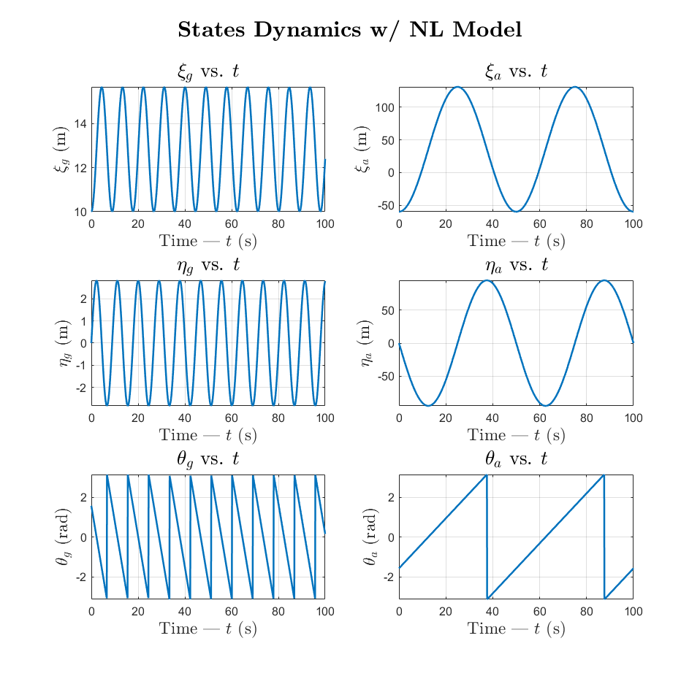

Figure 1 – State dynamics simulation with nonlinear model (using ode45)

Note here that the angles and have been wrapped to within .

The nonlinear measurement model function is defined in Appendix C ‘NL_MeasModel’. This function takes in the states at step and outputs the sensor readings.

The resulting NL measurement dynamics without process and measurement noise is shown in Figure 2. This represents the nominal measurements trajectory.

Again the angles and have been wrapped within .

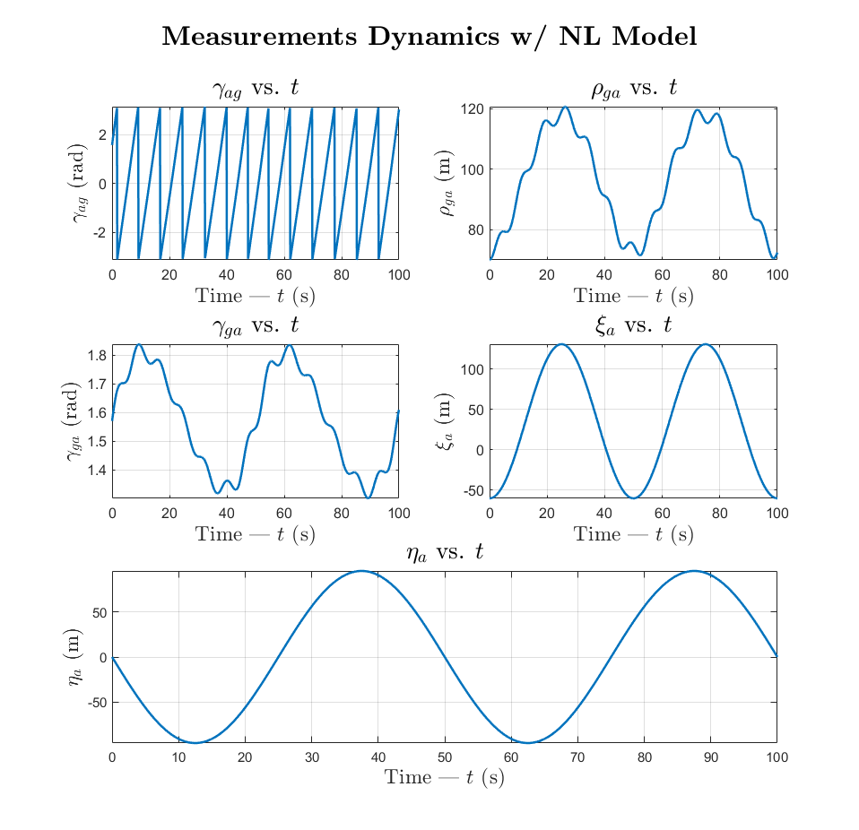

Figure 2 – Measurement dynamics simulation with nonlinear model

## DT Linearized Model

We simulate the linearized DT model using the methodology prescribed in Question #1 and Question #2. To perform the linearization, we define the following from specification:

|  |  |  |
| --- | --- | --- |
|  |  | ( 22 ) |
|  |  | ( 23 ) |
|  |  | ( 24 ) |

The transition matrices for the DT linearization model at step ‘’ are calculated in Appendix C ‘Linearize’ using and . The linearized state and measurement dynamics and perturbations are calculated in Appendix C ‘DT_L_Model’. in Equation ( 24 ) was selected because its small enough to ensure the linearization does not deviate from nominal trajectory

The graph in Figure 3 plots the state evolution of the linearized DT model. Although the state evolution closely matches the NL model’s nominal trajectory, there is in fact a perturbation from the nominal trajectory shown in Figure 5. The graph in Figure 4 plots the measurement dynamics of the linearized DT model and the sensor readings perturbations are shown in Figure 6.

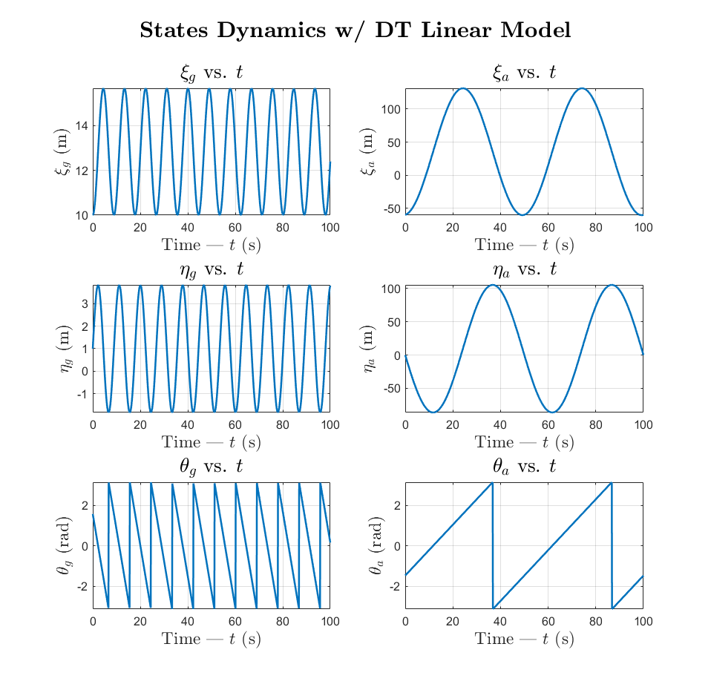

Figure 3 – State dynamics simulation with DT linearized model

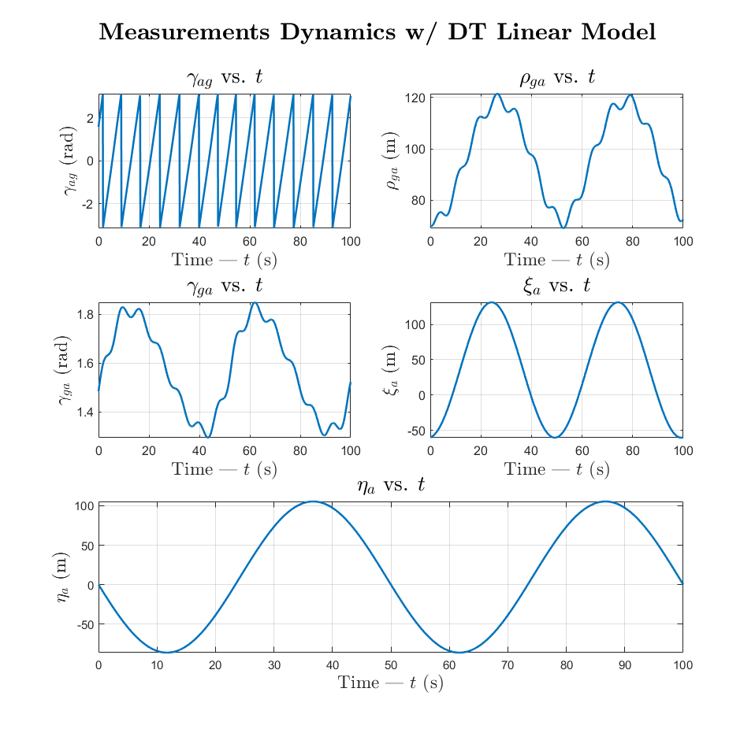

Figure 4 –Measurement dynamics simulation with DT linearized model

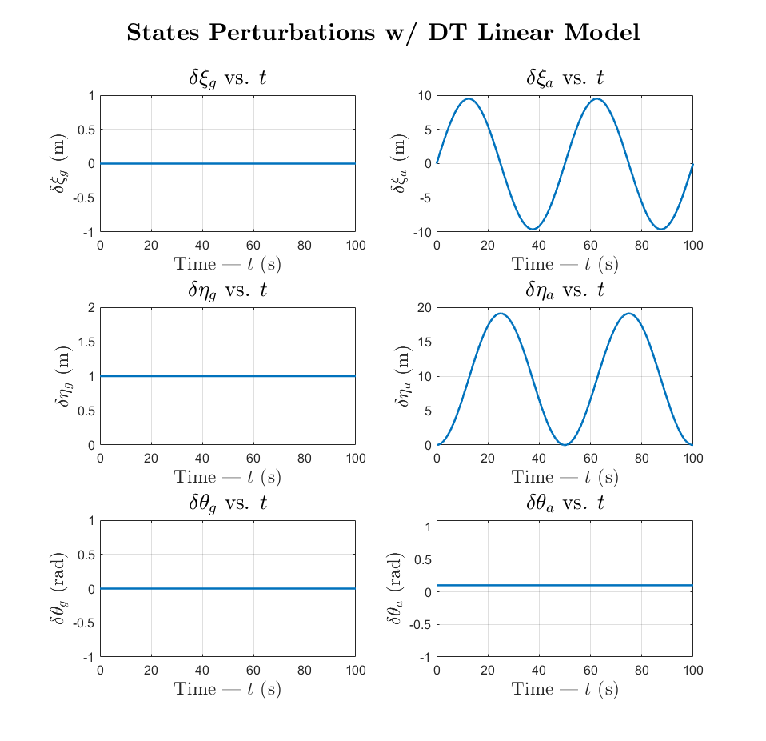

Figure 5 – State dynamics perturbations with DT linearized model

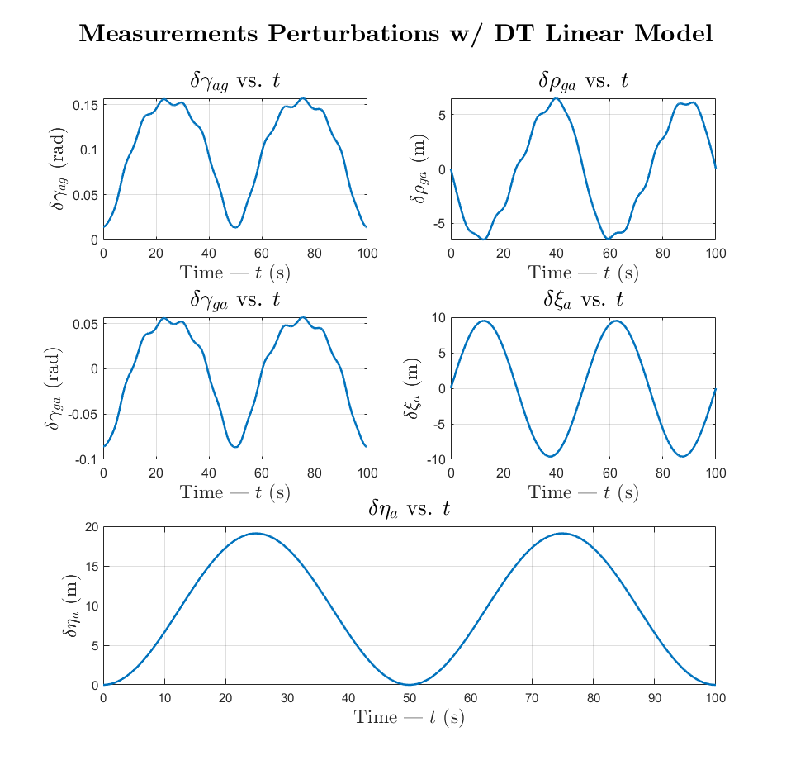

Figure 6 - Measurement dynamics perturbations with DT linearized model\

The state perturbation graphs show that and are constant and unchanging while and are varying in an oscillatory manner. This perturbation is transferred through to the sensor readings as well as all the sensor outputs are calculated using and/or .

We can conclude that the linearization only results in varying degrees of perturbation in the UAV’s states from their nominal trajectory while the UGV’s states deviate by a constant value equal to the initial perturbation. And as a result, the sensor readings relating to UAV’s states contain major perturbations, while the relative sensor readings have a lower amplitude in their variation.

**Appendix A – Supporting derivation for Jacobians**

|  |  |
| --- | --- |
|  | (A.1) |
|  | (A.2) |
|  | (A.3) |
|  | (A.4) |
|  | (A.5) |
|  | (A.6) |
|  | (A.7) |
|  | (A.8) |
|  | (A.9) |
|  | (A.10) |
|  | (A.11) |
|  | (A.12) |

All solutions for equations A.2, A.4, A.10, A.12 all are of the generic form:

All solutions for equations A.1, A.3, A.9, A.11 all are of the generic form:

All solutions for equations A5 through A8 all are of the generic form:

The rest of the math was done by hand, substituting the parameters (a,b,c) and simplifying:

**Appendix C – Codes accompanying Question 3**

|  |
| --- |
| function xdot = NL_DynModel(t,x,u,Pnoise)  %NL_DynModel  % input: t - time model; x - state vector; u - control input vector;  % Pnoise - process noice vector  % output: ___  % Function input for ode45 for NL dynamics model    % u = [v_g, phi_g, v_a, w_a]';  % x = [xi_g eta_g theta_g xi_a eta_a theta_a]';  % ~w = [w_x,g w_y,g w_w,g w_x,a w_y,a w_w,a]';  L = 0.5;    xdot = [u(1)*cos(x(3)) + Pnoise(1);  u(1)*sin(x(3)) + Pnoise(2);  (u(1)/L)*(tan(u(2))) + Pnoise(3);  u(3)*cos(x(6)) + Pnoise(4);  u(3)*sin(x(6)) + Pnoise(5);  u(4) + Pnoise(6)];  end |
| function [y] = NL_MeasModel(x,Mnoise)  %NL_MeasModel  % input: x - state vector; Mnoise - measurement noice vector  % output: y - sensor readings;  % Uses NL state inputs and measurement noise vector to get sensor  % readings    % y = [gamma_ag rho_ga gamma_ga xi_a eta_a]';  % x = [xi_g eta_g theta_g xi_a eta_a theta_a]';  % x = [1 2 3 4 5 6 ]';    y = [atan2(x(5)-x(2),x(4)-x(1)) - x(3);  sqrt((x(1)-x(4))^2 + (x(2)-x(5))^2);  atan2(-x(5)+x(2),-x(4)+x(1)) - x(6);  x(4);  x(5)];    y = y + Mnoise;    end |
| function [A_t,B_t,C_t] = Linearize(x,u)  %Linearize  % input: x - nominal state vector; u - nominal control input;  % output: A_t - A tilde Matrix; B_t - B tilde Matrix; C_t - C tilde  % Matrix  % Obtain the CT linearized state perturbation matrices    % u = [v_g, phi_g, v_a, w_a]';  % x = [xi_g eta_g theta_g xi_a eta_a theta_a]';    L = 0.5;    A_t = [0 0 -u(1)*sin(x(3)) 0 0 0;  0 0 u(1)*cos(x(3)) 0 0 0;  0 0 0 0 0 0;  0 0 0 0 0 -u(3)*sin(x(6));  0 0 0 0 0 u(3)*cos(x(6));  0 0 0 0 0 0];      B_t = [cos(x(3)) 0 0 0;  sin(x(3)) 0 0 0;  tan(u(2))/L (u(1)/L)*sec(u(2))^2 0 0;  0 0 cos(x(6)) 0;  0 0 sin(x(6)) 0;  0 0 0 1];    % x = [xi_g eta_g theta_g xi_a eta_a theta_a]';    C11 = (x(5)-x(2))/((x(5)-x(2))^2 + (x(4)-x(1))^2);  C12 = -(x(4)-x(1))/((x(5)-x(2))^2 + (x(4)-x(1))^2);  C13 = -1;  C14 = -(x(5)-x(2))/((x(5)-x(2))^2 + (x(4)-x(1))^2);  C15 = (x(4)-x(1))/((x(5)-x(2))^2 + (x(4)-x(1))^2);  C21 = (x(1)-x(4))*((x(1)-x(4))^2 + (x(2)-x(5))^2)^-0.5;  C22 = (x(2)-x(5))*((x(1)-x(4))^2 + (x(2)-x(5))^2)^-0.5;  C24 = -(x(1)-x(4))*((x(1)-x(4))^2 + (x(2)-x(5))^2)^-0.5;  C25 = -(x(2)-x(5))*((x(1)-x(4))^2 + (x(2)-x(5))^2)^-0.5;  C31 = -(x(2)-x(5))/((x(2)-x(5))^2 + (x(1)-x(4))^2);  C32 = (x(1)-x(4))/((x(2)-x(5))^2 + (x(1)-x(4))^2);  C34 = (x(2)-x(5))/((x(2)-x(5))^2 + (x(1)-x(4))^2);  C35 = -(x(1)-x(4))/((x(2)-x(5))^2 + (x(1)-x(4))^2);  C36 = -1;  C44 = 1;  C55 = 1;    C_t = [C11 C12 C13 C14 C15 0;  C21 C22 0 C24 C25 0;  C31 C32 0 C34 C35 C36;  0 0 0 C44 0 0;  0 0 0 0 C55 0];  end |
| function [x_DTL, dx_DTL, y_DTL, dy_DTL, F, H, O] = DT_L_Model(t,Dt,x_NL,y_NL,x_pert,u_nom)  %DT_L_Model  % input: t - time; Dt - time increment; x_NL - nominal state trajectory;  % y_NL - nominal sensor readings; x_pert - initial state  % perturbation; u_nom = nominal control input;  % output: x_DTL = discrete time state; dx_DTL = discrete time state  % perturbation; y_DTL = discrete time sensor; dy_DTL = discrete  % time sensor perturbation  % Function for linear DT model    % u = [v_g, phi_g, v_a, w_a]';  % x = [xi_g eta_g theta_g xi_a eta_a theta_a]';  % ~w = [w_x,g w_y,g w_w,g w_x,a w_y,a w_w,a]';    x_nominal = [x_NL(1,:); x_NL(2,:);  wrapToPi(x_NL(3,:)); x_NL(4,:);  x_NL(5,:); wrapToPi(x_NL(6,:))];  y_nominal = y_NL;    F = zeros(6,6,length(t));  H = zeros(5,6,length(t));  O = zeros(6,6,length(t));    % Evaluate F and H matrices with predef nominal state trajectories  for i=1:length(t)  [A_t, ~, C_t] = Linearize(x_nominal(:,i),u_nom);  F(:,:,i) = eye(6) + A_t*Dt;  H(:,:,i) = C_t;  O(:,:,i) = Dt*eye(6,6);  end    dx_DTL = zeros(6,length(t));  dy_DTL = zeros(5,length(t));  x_DTL = zeros(6,length(t));  y_DTL = zeros(5,length(t));  dx_DTL(:,1) = x_pert;  dy_DTL(:,1) = H(:,:,1)*x_pert;  x_DTL(:,1) = x_nominal(:,1)+dx_DTL(:,1);  y_DTL(:,1) = y_nominal(:,1)+dy_DTL(:,1);    for i=2:length(t)  dx_DTL(:,i) = F(:,:,i)*dx_DTL(:,i-1);  dy_DTL(:,i) = H(:,:,i)*dx_DTL(:,i);  x_DTL(:,i) = x_nominal(:,i)+dx_DTL(:,i);  y_DTL(:,i) = y_nominal(:,i)+dy_DTL(:,i);  end  end |