Formatting fixture
An opening paragraph with bold, italic, and a link to KMSC. It has a note.

A section
Text with struck out words, and a commented phrase, plus red yellow comic text.
- first bullet
  - nested bullet
    - deeper bullet
- second bullet
- first step
  - nested step
- second step
Stage | Owner
Plan | Team
Do | Lead
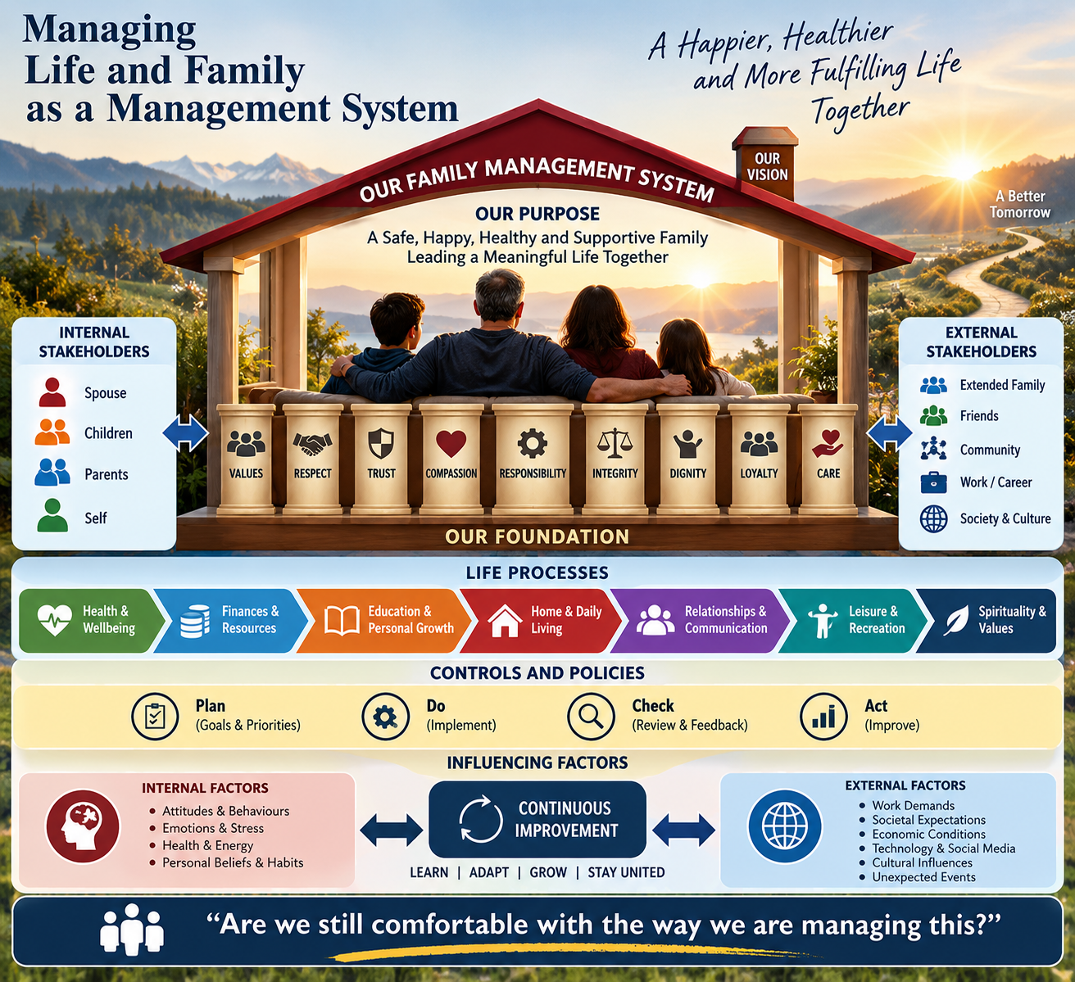
A picture
A line that types <script>alert(1)</script> and & as plain words, then another picture .

Note text with emphasis.

