One image
Opening paragraph.
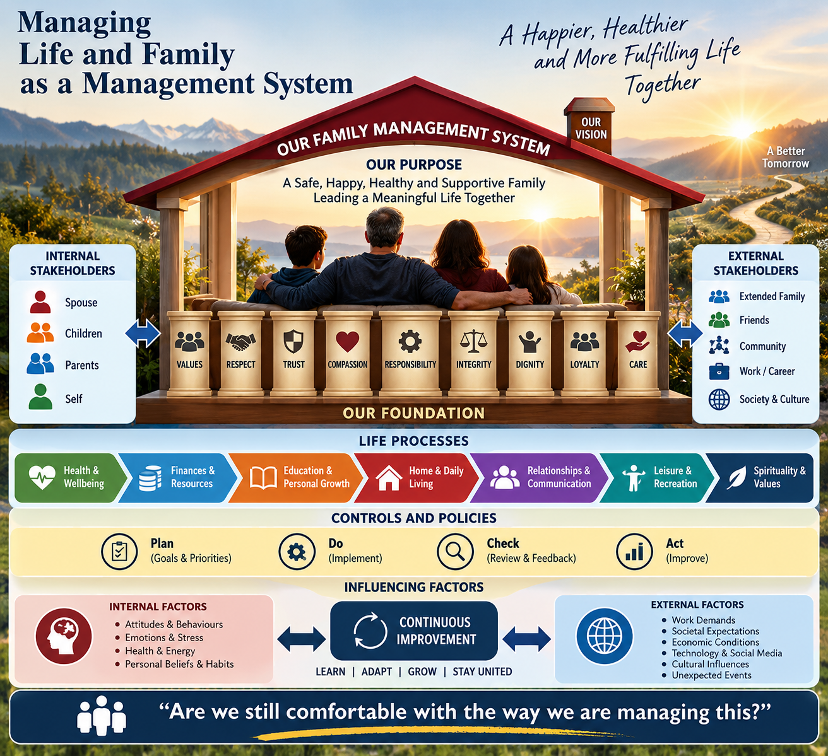
Only

