Wednesday 14th March 2018

THE NEW CITY

Abu Dhabi

Leticia Curteis-Lateo

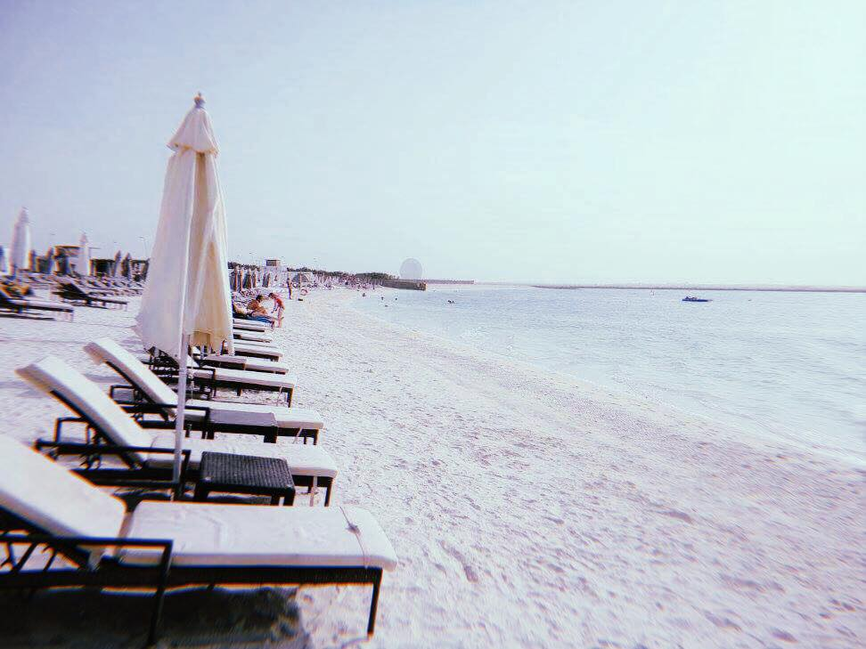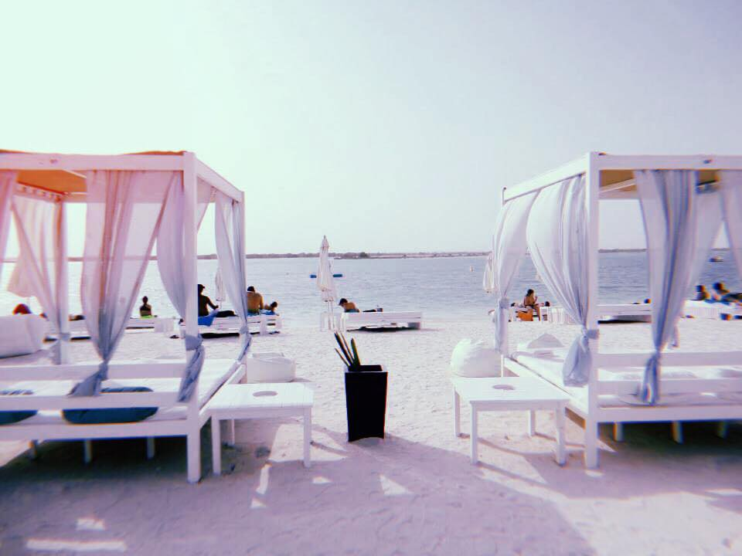

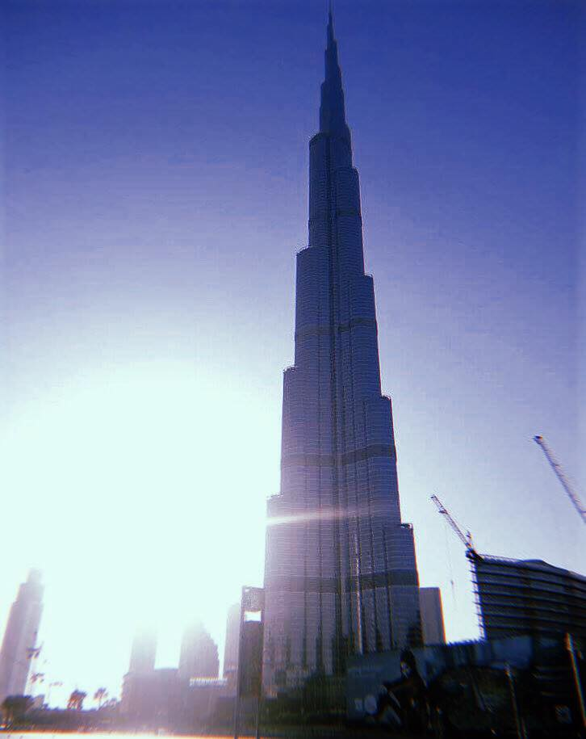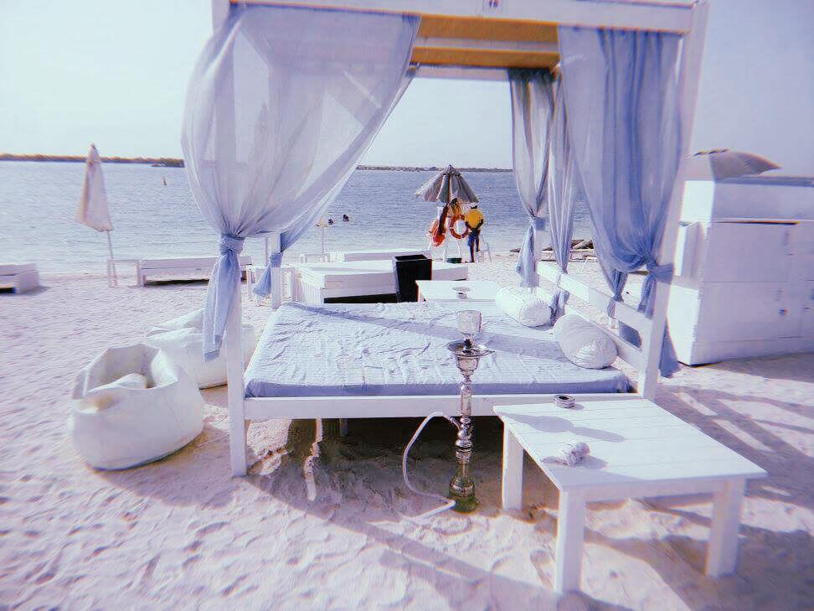

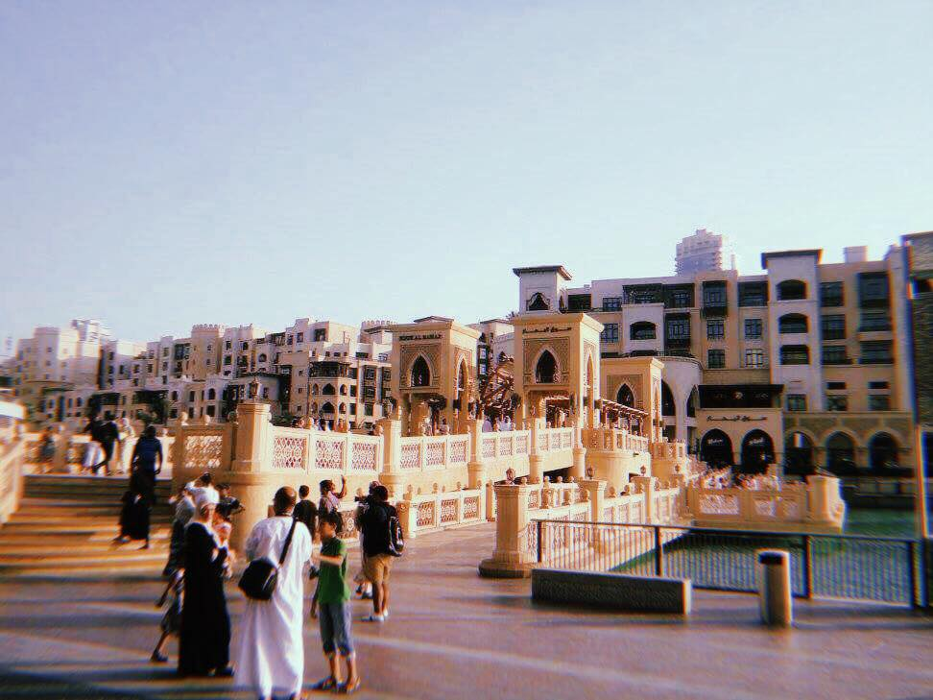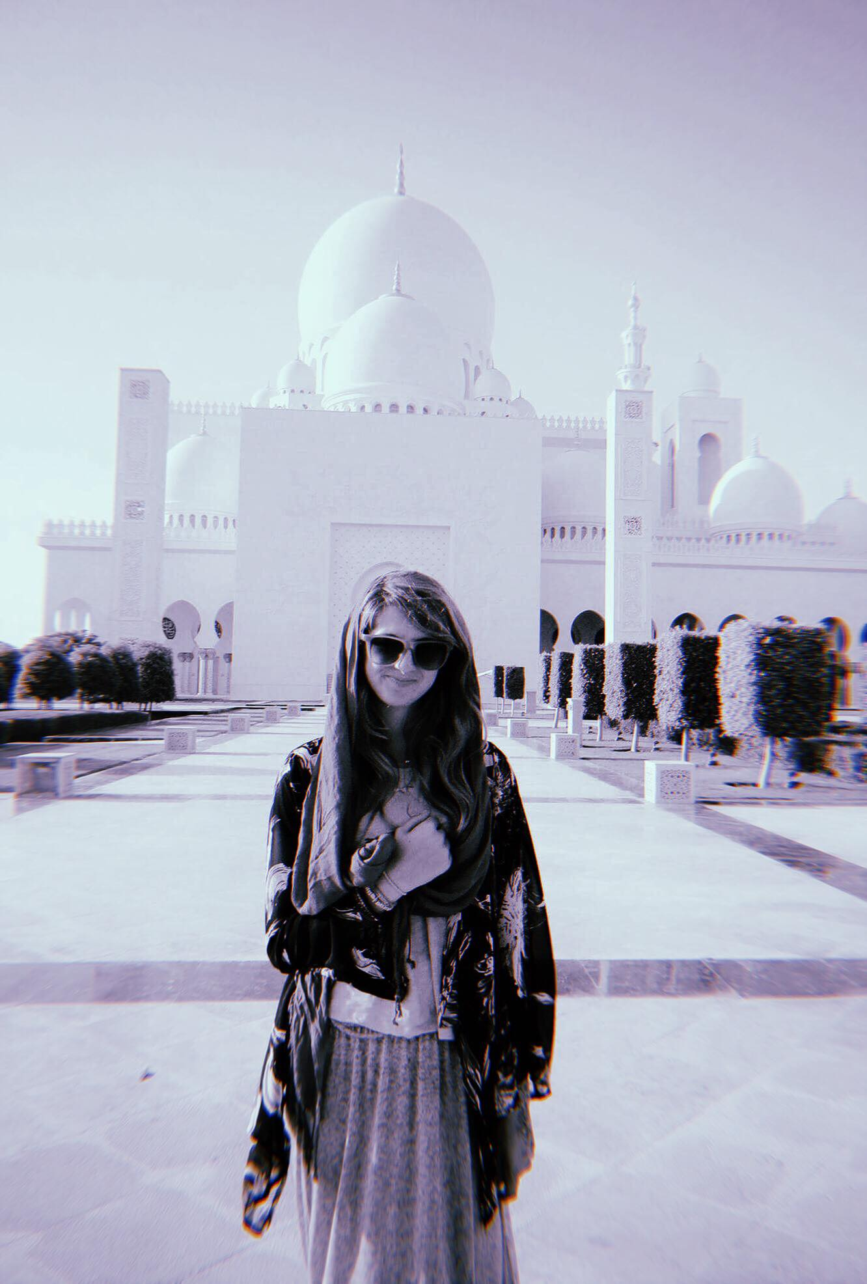

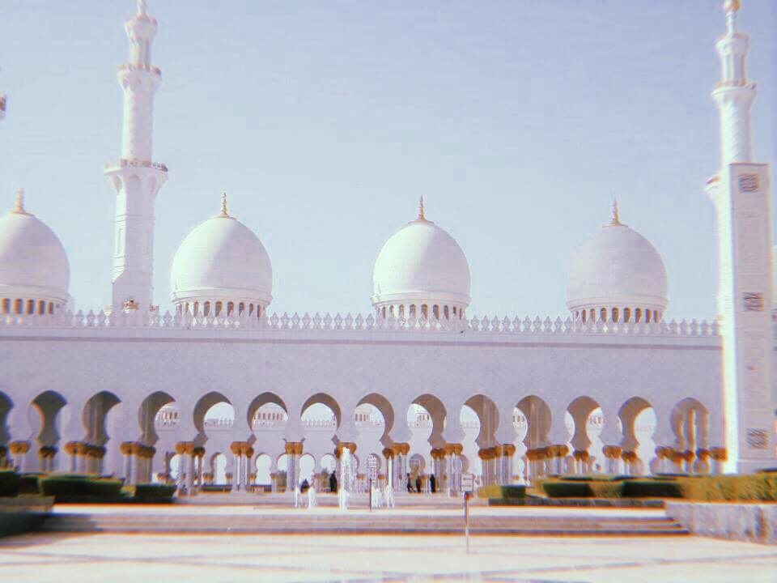

Abu Dhabi is a beautiful hot country made up of deserts and man-made built up areas. It is a beyond picturesque place with diverse culture and plenty of places to visit. It is surreal one minute being surrounding by nothing but sand for miles and then driving past a city skyline.

We stayed in Yas island in a beautiful hotel apartment, even though it was too hot to spend more than a couple of hours by the pool during the day, there are so many things to do. I recommend respecting the culture, by being polite, no public displays of affection and in the stricter areas for women covering up your arms and knees.

I have always had a love for beaches and this was my favourite beach so far. White sands, clear sea, stunning views, sun beds, paddle boarding and fresh cucumber hand towels brought to you, what more could a girl want. Even though it was about 45’C, so when you walk across the sand it burns your feet, it was completely worth it.

Equally the Jumeriah Mosque was the most beautiful place I have ever been too so far, this is in Dubai which allows non-Muslims to visit, defiantly google or search for it as my photos do not do it justice. Out of respect you need to cover up as in most of the country they believe that should be the case for women, however because this is a sacred place it was a little stricter which we did respect. The Mosque is white and gold, such stunning detail that began construction in 1976.

I also recommend visiting the waterpark ‘Yas Water world’ which is a famous waterpark on Youtube. A fun day out and a way to be a bit cooler in the heat, although do not forget the sun cream. Similarly, we went on the world’s fastest roller coaster which goes too 240km/h in 4.9 seconds at Ferrari world. It was a thrilling experience, going from inside with air-conditioning to the heat in full speed, your face literally does that crazy wobbly thing and the glasses they give you are a must to stop things getting inside your eye.

We also went for brunch at the Yas Island Viceroy hotel that is in the centre of the grand prix circuit. There was a beautiful spread of food and from the rooftop there is a view for miles which is so different to anything I have ever seen before. A really great thing to do is cycle around the circuit which we did at night as it would have been far too hot during the day.

We additionally visited the city Dubai and went to ‘The Dubai Mall’ it is a giant shopping place that has the biggest aquarium inside and all the designer shops you could want. We stayed and watched the Dubai fountains and sat by the mega skyscraper the ‘Burj Khalifia’ which is 828m tall, it is the tallest structure in the world.