Monitoring Information Beyond Hazard Grades and Shift Type
Junjie Yang

Question and matched comparison
This study uses the audited UCI Seismic Bumps mirror containing 2,578 records. A hazardous-shift label indicates a seismic bump with energy above 10,000 J in the subsequent eight-hour shift. It identifies a hazardous shift, not an observed accident or an avoided accident. Recorded order is a temporal proxy because timestamps and working-face identifiers are unavailable.
The primary seismic assessment orders a (no hazard), b (low hazard), c (high hazard) and d (danger state). The mirror contains only a, b for this field; c and d are defined levels but are not observed here. Average precision (AP) is the sum of precision values weighted by recall increments, evaluating tied scores as a group. It selects historical model configurations and is distinct from the detection counts evaluated at fixed inspection slots.
Does monitoring information improve hazardous-shift detection beyond three existing hazard assessments and shift type, at identical inspection allocations? This separately specified exploratory supplement compares a four-input base design with the established 17-column design. Both use XGBoost and the same four historical fitting/test splits. Each design independently selects depth 2/3 and 80/160 rounds on the same inner historical split by AP, with negative Brier if that inner set has no positives. Policy-reference and test labels do not enter fitting or tuning; no holdout is added.
Within each test block, K=floor(B*N) slots go to higher seismic grades first; model scores rank records within each grade. Both models use uniform allocation within an exactly tied boundary score group: h slots among m records containing p hazards contribute E(TP)=h*p/m. Reported fractional counts integrate allocation randomness rather than describe fractional shifts. Pooled results sum block allocations; scores are never ranked across fitted blocks.

Expected detections on the shared test records
The four blocks contain 516, 515, 516 and 516 records and 36, 10, 24 and 18 hazardous labels, respectively: 2,063 records and 88 labels in total. At the 20% budget, the pooled extended design detects 32.00 versus base 30.71 expected hazards with 412 alerts each; the difference is 1.29 [-5.48, 7.05]. All pooled intervals across the three specified block lengths include zero.
Table 1. Matched information designs at identical total and seismic-grade allocations. TP and FN are analytic expectations; K is the exact alert count. Positive differences favor the extended design. Brackets are conditional 95% intervals at block length 32.
Block | Budget | K | Base E(TP) / E(FN) | Extended E(TP) / E(FN) | Delta E(TP) [95% CI]
1 | 1% | 5 | 0.94 / 35.06 | 0.00 / 36.00 | -0.94 [-1.53, 0.17]
1 | 5% | 25 | 4.69 / 31.31 | 5.00 / 31.00 | 0.31 [-4.46, 2.42]
1 | 10% | 51 | 9.56 / 26.44 | 11.00 / 25.00 | 1.44 [-4.65, 3.25]
1 | 20% | 103 | 16.47 / 19.53 | 17.00 / 19.00 | 0.53 [-1.41, 4.10]
2 | 1% | 5 | 0.25 / 9.75 | 0.00 / 10.00 | -0.25 [-0.40, 0.00]
2 | 5% | 25 | 1.23 / 8.77 | 0.00 / 10.00 | -1.23 [-1.88, 0.48]
2 | 10% | 51 | 2.51 / 7.49 | 0.00 / 10.00 | -2.51 [-3.25, 1.13]
2 | 20% | 103 | 5.17 / 4.83 | 5.00 / 5.00 | -0.17 [-3.95, 1.55]
3 | 1% | 5 | 0.30 / 23.70 | 0.00 / 24.00 | -0.30 [-0.50, 0.82]
3 | 5% | 25 | 1.48 / 22.52 | 3.00 / 21.00 | 1.52 [-1.23, 3.93]
3 | 10% | 51 | 3.03 / 20.97 | 4.00 / 20.00 | 0.97 [-2.07, 5.09]
3 | 20% | 103 | 6.11 / 17.89 | 6.00 / 18.00 | -0.11 [-4.00, 4.14]
4 | 1% | 5 | 0.14 / 17.86 | 1.00 / 17.00 | 0.86 [-0.32, 1.79]
4 | 5% | 25 | 0.72 / 17.28 | 1.00 / 17.00 | 0.28 [-0.91, 2.55]
4 | 10% | 51 | 1.47 / 16.53 | 2.00 / 16.00 | 0.53 [-1.63, 3.81]
4 | 20% | 103 | 2.96 / 15.04 | 4.00 / 14.00 | 1.04 [-1.49, 3.66]
Pooled | 1% | 20 | 1.62 / 86.38 | 1.00 / 87.00 | -0.62 [-2.20, 0.67]
Pooled | 5% | 100 | 8.12 / 79.88 | 9.00 / 79.00 | 0.88 [-4.95, 4.68]
Pooled | 10% | 204 | 16.56 / 71.44 | 17.00 / 71.00 | 0.44 [-5.40, 7.26]
Pooled | 20% | 412 | 30.71 / 57.29 | 32.00 / 56.00 | 1.29 [-5.48, 7.05]

Block-length sensitivity
The saved scores, tuning choices and models are frozen. Each of 2,000 paired moving-block draws reconstructs a queue separately within each block, recomputes grade allocations and reranks both score sets, including analytic tie expectations. The same sampled records feed both designs and every budget. Zero-positive draws are retained. Length 32 is primary; lengths 16 and 64 are displayed without selecting one from the outcomes. These are record-order blocks, not verified physical time durations. Intervals exclude fitting, tuning and selection uncertainty.

Discussion
The matched baseline changes the interpretation of the earlier complete-score-versus-grade-random pilot: the present increment is specifically relative to a fitted model already using all three assessments and shift type. Positive point differences occur in 3/4, 0/4, 2/4, 4/4 budgets in blocks 1-4, respectively; 16/16 main block-specific intervals include zero. The pooled intervals also include zero at every budget and block length, so these observations do not resolve a consistent monitoring-information increment under the specified workflow. This does not establish that monitoring information is generally uninformative: the comparison concerns these inputs, separately AP-selected configurations and previously examined records. At fixed P and K, E(L)=r*P+K-(r+1)*E(TP), so an additional cost grid would restate detection differences. Recorded order remains a temporal proxy, and the batch allocation is not an observed inspection process or accident-prevention effect. Independent timestamped working-face data with inspection outcomes would test transfer beyond this cohort.

Protocol and computational evidence
The protocol, fitting and allocation code, numerical verifier and saved evidence are linked below. The verifier recomputes the calculations through a separate path and supports full refitting replay. Retained results include row-level scores and inclusion probabilities, all candidate tuning predictions, eight final models, grade allocations, every bootstrap multiplicity and replicate, and version-specific verification. The original stage-specific papers and ranking-pilot experimental results are retained. The integrated report includes the main matched-information finding; this supplement retains the complete design, table and block-length sensitivity.
Scientific code and saved-evidence links identify commit de83319. The integrated-manuscript link identifies the fixed presentation edition manuscript-2026-10-25. This revised report is generated by the current reporting code; its presentation is not claimed to be part of the earlier scientific source edition.
UCI dataset and target definition | Audited source and row mapping
Matched-information protocol | Model fitting and within-grade allocation
Numerical verification and refit replay | Saved results and verification guide
Integrated manuscript in this edition | Author contributions and AI assistance

Increment and interval figure
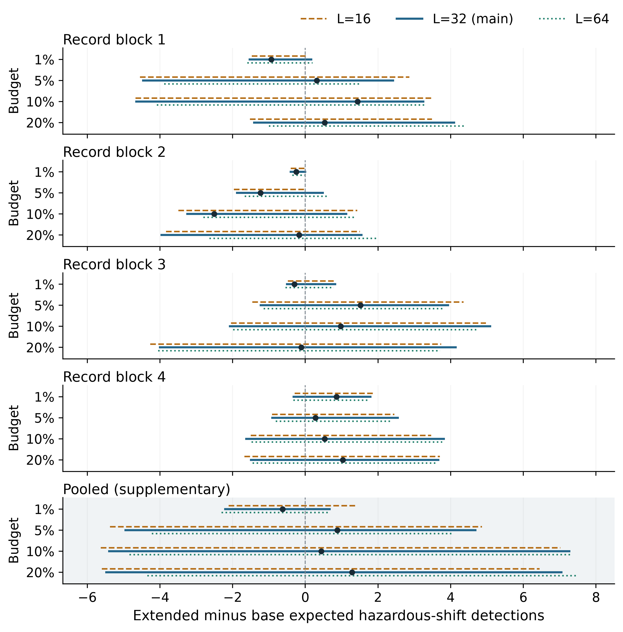
Figure 1. Extended minus base expected detections at identical allocations. Dots are the unchanged original-queue point differences. Lines show paired 95% intervals for lengths 16 (orange dashed), 32 (blue solid, main) and 64 (green dotted). Positive favors added monitoring. The shaded pooled panel is supplementary; block-specific evidence is primary.

