Author: Junji Zhi

Date: Dec 11, 2012

**= Software Document Evolution Visualization =**

This readme accompanies the prototype of the Software Document Evolution Visualization project.

**== Instructions ==**

**=== Prerequisites ===**

This project is built on Eclipse 3.7, JDK SE1.7. You will need to import the *project_src.zip* archive file into an existing or new eclipse project.

After importing the project, you will need to add all necessary external jar files to the project build path. These jar files include Processing core (core.jar), G4P libraries (g4p.jar), POI libraries, etc. Figure 1 shows a snapshot of all needed jar files for the project. **For convenience, ALL needed jars are included in the folder named *lib* accompanied with the source code.**

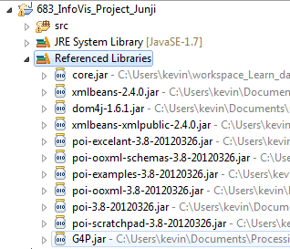

Figure 1-Snapshot of all needed libraries (jars) of for the project

After the above steps, in the package explorer view, you can right click on the *DocEvolutionSpiral.java* file and select “Run as 🡪Java applet”. In this way, the program runs under all default settings and present an applet window like Figure 2.

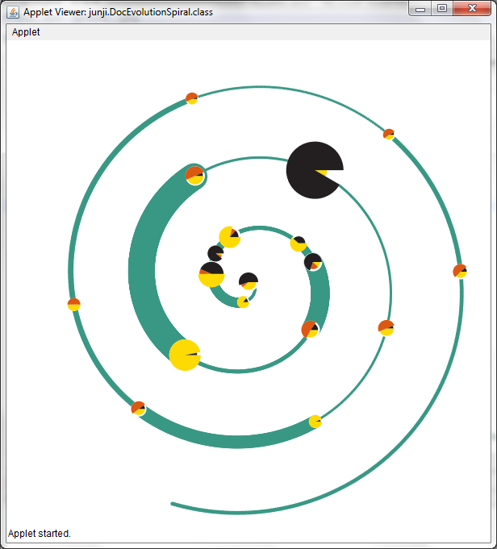

Figure 2-Main View of the Program under default settings;

*If you see this window when you first run your program, it indicates that you are using the default configurations and the development environment is properly set.

**=== Data ===**

The input data file format is MS Excel sheet (i.e., files with ‘.xlsx’ extension) and the file path is set in the *setup.txt* located in the eclipse project folder. The data should be kept in the first sheet of the Excel file with such a structure: (1) The First and second rows specifying the table structure, (Document No., TIME, ChangeWord, AddWord, DelWord , #.VISIT). (2) The third or rows below are data in corresponding format.

Note that the program will read the sheet starting from the 3rd row). Figure 3 is a screen shot of the correct data file. By default, the program will read a file named *data1.xlsx* which is located right in the project root path.

**=== Configuration File ===**

Be default, the configuration file is named *setup.txt*. It is located in the project root path. You can change the file path setting by modifying the field value of *setupFilePath* in the file *DocEvolutionSpiral.java* before running the project. However, modifying this value is NOT encouraged.

The configuration file specifies all necessary parameters needed for the project. Figure 4 shows a snapshot of the *setup.txt.* Table 1 lists the all configuration parameters and their function descriptions.

Table 1-Configuration parameters and their functions

|  |  |
| --- | --- |
| **Parameter** | **Description** |
| DocXclsFilePath | Pointing to the data file path;  By default, It points to a file named *data1.xlsx* which is located right in the project root path. |
| logRowsToRead | Specifying how many rows to read in the Excel sheet; |
| textLeading | Specifying all text leading value for any text shown in the graphic; |
| SpiralLineColorRGB | Specifying the spiral curve color by giving the three RGB value in a row; By default, such value is 57 152 132  *(Note: There are spaces separating each integer)* |
| ChangedWordColorRGB | Specifying the changed-word sector color in pie charts by giving the three RGB value in a row; By default, this value is 220 87 18  *(Note: There are spaces separating each integer)* |
| AddedWordColorRGB | Specifying the added-word sector color in pie charts by giving the three RGB value in a row; By default, this value is 253 218 4  *(Note: There are spaces separating each integer)* |
| DeletedWordColorRGB | Specifying the deleted-word sector color in pie charts by giving the three RGB value in a row; By default, this value is 35 31 32  *(Note: There are spaces separating each integer)* |
| Thetaspeed | Specifying the theta growth speed of the spiral curve; By default, this float value is 0.01 |
| Rspeed | Specifying the radius growth speed of the spiral curve; By default, this float value is 0.14 |

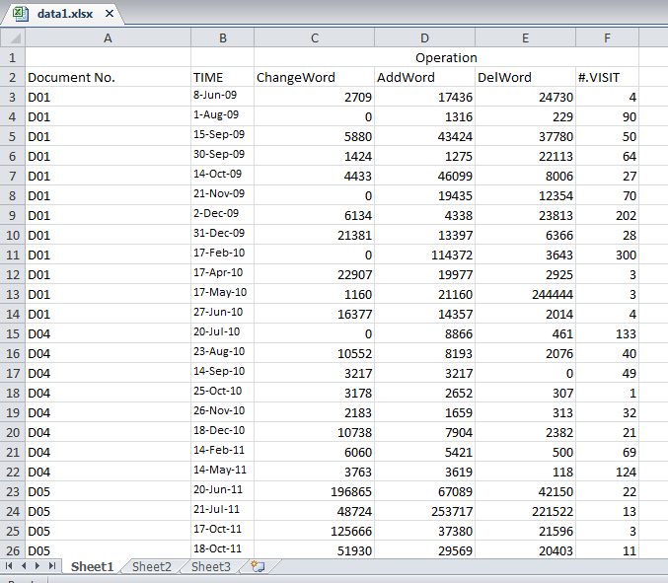

Figure 3-Snapshot of the data sheet

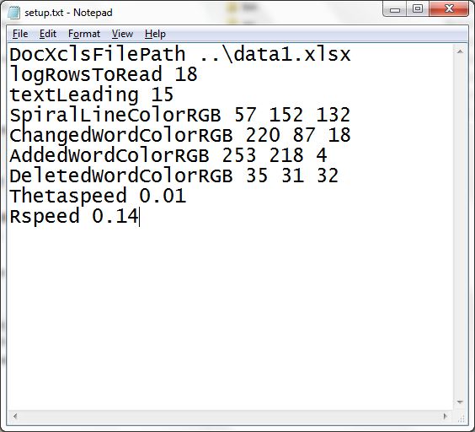

Figure 4-Snapshot of the Setup.txt

**===Interaction Keys===**

During the program running, the supported interaction functions include:

1. **Zoom in & Zoom out**: User can use keys to adjust the scale of the graph
2. **Search**: User can use the key and combined popped up window to accomplish search function;
3. **Move up/down**: Users can use arrow keys or mouse roller to move the graph to different positions;
4. **Mouse hover/display**: When your mouse hovers on the curve or pie chart of interest, the visualization will show the related data, such as number of visits or operations on a particular date;
5. **Click to show more details**: Users can click on one of the pie chart, and then a new popped-up window will show a detailed view;
6. **Comparison**: Users can use keys compare two sets of operations on two different dates;

All keys and its functions are listed in Table 2.

Table 2-Keys pressed and their corresponding functions

|  |  |
| --- | --- |
| Key | Functions |
| ‘c’ | Reset to default scale (all zoom-in or zoom-out effect will disappear) |
| ‘f’ | Find the operations right before the entered date |
| ‘p’ | Compare two operations on different dates |
| ‘x’ | Zoom in |
| ‘z’ | Zoom out |
| Up | Move the graphic up |
| Down | Move the graphic down |
| Left | Move the graphic to the left |
| Right | Move the graphic to the right |