**Technical Description: Time Series Analysis for Financial Forecasting**

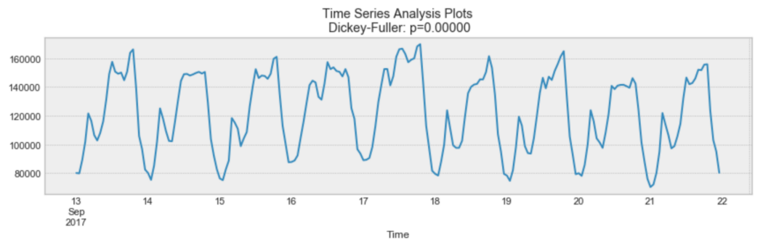

Source: <https://towardsdatascience.com/the-complete-guide-to-time-series-analysis-and-forecasting-70d476bfe775>

Time-series Analysis

A time series is a set of data points that are collected and recorded in order by time. Usually, the data points are taken at regular intervals and form a sequence of discrete time data (discrete data is the opposite of continuous data). In the statistics field, conducting time series analysis is critical to forecast equity values by assessing financial data. This is due to the condition that stock data includes a variable that changes over—time. Consequently, the values in the data are not independent and therefore cannot be randomly assigned. To predict future financial data based on another indicator or security (stocks, bonds, etc), time series analysis is a crucial step.

Now, time-series analysis is a distinctive method of analyzing a sequence of data that is collected over a certain interval of time. This means that the data is recorded by interval instead of being recorded randomly/intermittently. Usually, there are 4 major components of time-series data:

1. Secular trend, which describe the movement along the term.
2. Seasonal variations, which represent seasonal changes.
3. Cyclical fluctuations, which correspond to periodical but not seasonal variations.
4. Irregular variations, which are other nonrandom sources of variations of series.

As a big picture, financial time series forecasting consists of two big components:

• Augmented Dickey Fuller Test (ADF Test)

• Granger Causality Test

Augmented Dickey Fuller Test

What is the Augmented Dickey Fuller Test?

The Augmented Dickey Fuller Test (ADF) one sentence is: unit root test for stationarity because unit roots can cause unpredictable results in the time series analysis.

Before we go into ADF Test,

1. what is a Unit Root?

* A unit root is a characteristic of a time series that changes randomly over time and cannot be predicted. Unit root testing is a statistical method used to determine if a time series data is stationary or non-stationary. The presence of a unit root means that the time series is non-stationary.

1. What is Serial Correlation? (Also known as Autocorrelation)

* Autocorrelation (serial correlation) is a similarity between observations of a random variable as a function of time lag between the observations.

Having said that, ADF Test and Autocorrelation can be used together. The ADF test is also able to handle more complex models than just the Dickey-Fuller test, and it is also more powerful. However, ADF test should be used with caution because—like the majority of unit root tests—it has a high Type I error rate; Type I error is a mistake made in statistics when you reject a correct idea.

Hypotheses of ADF Test

The hypotheses:

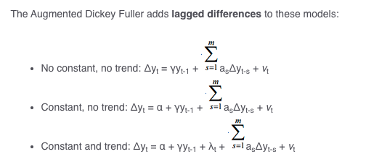

* The null hypothesis for this test is that there is a unit root.
* The alternate hypothesis differs slightly according to which equation you’re using. The basic alternate is that the time series is stationary (or trend-stationary).

Granger causality

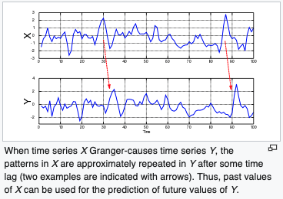

Essentially, Granger causality test is an investigative method to find causality between two variables that are in time series. Because the variables must be in time series, conducting ADF Test before doing assessing Granger Causality Test is essential. The method is a probabilistic account of causality; it uses numeric data sets to find patterns of potential correlation.

Granger Causality Test Formula is as follows:

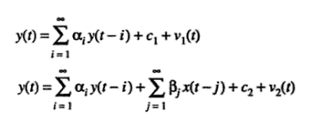

The idea of Granger Causality is closely tied to the concept of cause-and-effect, as everyone knows; however, they are not the same. For example, in cause-and-effect, variable X is casual to variable Y if X is the cause of Y or vice versa. On the other hand, Granger Causality tests if a variable comes before another in the time series; for example, large sales of turkey Granger-cause Thanksgiving.

Bottom-Up / Top-Down Procedure:

The bottom-up and top-down procedures are two distinctively different approaches to problem-solving and making decisions. A bottom-up approach begins with smaller parts of a problem and makes its way up to the more complex and larger parts, cofusing on more details and building prototype step by step. A top-down approach, unlike bottom-up, begins with a big picture and breaks it down to smaller parts, focusing on gaining understanding of the situation and analyzing ways to best tackle the problem.

Granger causality is a *bottom-up* procedure, where the assumption is that the data-generating processes in time series format are all independent variables. The datasets are then analyzed to examine the possible correlation.

Analyzing the Result of Granger Causality Test

If the Granger causality test shows that changes in one stock price have a significant effect on another stock price, then this suggests that there is a causal relationship between the two stocks. This information can be used to make predictions about the future performance of one stock based on the past performance of another stock.

User Testing

The User Testing was conducted as a way of evaluating the technical description of Time-series analysis, a method of analyzing datasets that is collected over a certain interval of time. The purpose of the user test was to examine the accuracy and conciseness of the technical description for the audience who are unfamiliar with the process of time series analysis. The unit test was conducted as peer reviews during class, and my partners were Aidan Ryan and Xingjian Xue with varying levels knowledge in the field of finance and statistics. The test was conducted in the form of zoom call where either of the person will share their screen and proceed to continue to user testing.

The results of the unit test indicated that most of the participants found technical description of what time-series data is to be easy to understand. A significant number of my peer reviewers also mentioned that the steps for time series analysis helped them grasp the big picture, including the steps for Augmented Dickey Fuller Test and Granger Causality Test. They appreciated the concise yet descriptive language in the description. However, the reviewers showed uncomfortability with some of the procedures in the technical description. Those parts were focused in Granger Causality Test, as they described: “I don’t understand the connecton between Augmented Dickey Fuller Test and Granger Causality Test.” Their words made me realize the explanation of the Granger Causality Test was written in statistically technical terms where a student who isn’t majoring in the STEM field might have hard time processing the information. Afterall, I also felt that the formatting could be improved when explaning the hypothesis in ADF test and formula in Granger Causality test.

Based on the feedback from my peer reviewers, I noticed the need for further explaining terms such as ‘unit root test’, ‘stationary data’, and the 4 major components of time-series data: ‘secular trend,’ ‘seasonal variation,’ ‘cyclical fluctuation,’ ‘irregular variation.’ Comprehensively, I plan on making changes to my revision for technical description. First, I will provide a clear explanation of the top-down and bottom-up procedures so that the audience has a clear understanding of what type the Granger Causality test is. Next, I will better incorporate the Granger Causality Test formula to be better presented in simpler format (for those who aren’t familiar with mathematical concepts). Also, I plan on outlining each step; this way, the audience will be able to read through the technical description with ease. Lastly, I will also add examples on Granger Causality test to show an application of the concept.

In conclusion, the test results proved that the technical description of Time-series Analysis was well received by the peer reviewers (Aidan and Xingjian), with most of them finding time series, stationary data, and ADF testing easy to understand. The feedback from the participants will be examined to revise my technical description to ensure that it is understandable for any audience. Overall, I conclude the test to be successful in evaluating the effectiveness of technical description and providing valuable insights for future improvements.